2301-9069 (e)  1829-8370 (p) | KAPAL  Jurnal Ilmu Pengetahuan dan Teknologi Kelautan  journal homepage : http://ejournal.undip.ac.id/index.php/kapal

Numerical Investigation of the Effect of Biodiesel-Biogas Percentage on Performance Characters and Dual Fuel Engine Emissions as Green Technology on Ship
Betty Ariani^{1)*)} Dedy Wahyudi¹⁾

¹⁾ Naval Architecture, Technic Faculty, Universitas Muhammadiyah Surabaya
^{*)} Corresponding Author

Abstract

The discourse on the application of green technology in the maritime sector is an interesting agenda to implement. The development of the world of shipping transportation which continues to experience an increase in numbers and services creates new problems in terms of fuel supply and the resulting emissions. So that the development of innovation and technology for ship machinery should be directly related to fossil fuel substitution technology, operational efficiency technology, improving performance and reducing emissions from the engine itself to be achievements and targets. Good engine performance directly has an impact on increasing the operational efficiency of the ship and being a good carrying capacity in the environment with minimal emission levels. A dual-fuel engine is one of the engine system concepts that has several advantages, such as simple and relatively easy modifications and the use of natural gas which tends to be cleaner. Biodiesel and biogas are examples of alternative fuels that are expected to be promising solutions for marine engineering. This research uses a numerical study on the application of dual fuel engines, the percentage of biodiesel-biogas is carried out with variations of 50:50 and 25:75, at a constant engine speed of 2200 RPM. Simulations were carried out to see the results of how the engine performance, cylinder pressure, heat release rate and HC and NOx emissions were at a constant speed variation of the fuel percentage test NOx emission decreased at a higher biogas percentage, for UHC it increased at a higher biogas percentage, it is possible to add oxygen intake through a turbocharger or supercharger as an auxiliary equipment.

Keywords: Alternative energy, green shipping, dual fuel, Biodiesel, Biogas, emissions

1. Introduction
The complexity of the problems that occur in the field of transportation, where the majority of transportation both land, sea, and air are highly dependent on fossil fuels. In shipping transportation itself, this is the majority. The availability of fossil fuels that continues to run out is not proportional to their increasing use. In addition to the growing gap in demand and availability, another problem that arises is emissions that have local and global impacts. Data (Bows–Larkin et al., 2014) shows that shipping contributes 2% of emissions and will continue to increase as the fleet grows. Global warming and climate change are common problems that must be minimized immediately.
In response to this, the regulations continue to be amended and enforced more and more strictly. Regulations are made internationally through IMO Annexes I – VI. Annex VI contains regulations related to the energy efficiency design index (EEDI), energy efficiency operational indicators, and ship energy efficiency management plan (SEEMP). it was implemented starting in 2011 and applied to ships built-in 2013. The impact of the emergence of these various regulations various responses from the researchers to answer the challenges of energy availability for sea transportation as well as the challenges of tackling the emissions that occur so that the ship can be licensed because it has met the required standards (Königsson et al., 2011)
A dual-fuel is one of the engine modification innovations on the diesel engine. By making slight modifications to the intake manifold with a conversion kit, natural gas can enter the combustion chamber along with the air. For ignition, it comes from the compression of biodiesel fuel that is sprayed into the combustion chamber. The use of gas fuel, in this case, is biogas which is expected to reduce emissions because it is cleaner, while biodiesel is expected to be the driving force for the use of alternative energy that can replace the use of liquid fossil fuels for diesel engines (Hegab et al., 2017) (Abdelaal et al., 2013)(Ariani et al., 2019),(Ariani et al., 2020)
The term green shipping refers to the designation of a ship as an environmentally friendly vehicle. Environmentally friendly on ships is currently defined as efforts to reduce greenhouse gases in ship operations and building. One of the things that are being strived for is the management of fuel efficiency in operations, including efforts to use alternative fuels (Lee & Nam, 2017). The decrease in fossil fuels, the level of price increases and fluctuations, increasingly stringent environmental policies and regulations, as well as the increasing demand for energy conversion as a substitute for fossil fuels, make the discourse of alternative fuels in internal combustion engines a necessity that attracts many parties (Goga et al., 2019) (Rosha et al., 2019)
Biogas is one of the potential renewable energies, has abundant potential availability and will be a sanitary solution for the environment (Barik & Murugan, 2016). Biogas has a low cetane value and high auto ignition so it is difficult to burn with compression, it requires good ignition with spark plugs on the spark engine as well as with pilot fuel on the dual fuel engine (Barik & Murugan, 2014)(Yoon & Lee, 2011). The potential of biogas to replace fossil fuels is still being debated by many circles because the production produced is still very minimal in terms of energy. Biogas consists of 50-80% methane, 15-45% carbon dioxide, water, hydrogen sulfide, and nitrogen. The part that is used as fuel is methane, so many processes are needed to purify biogas.
Biodiesel or vegetable oil ethyl ester is one of the strongest candidates as a substitute for diesel fuel. Biodiesel is the name given to vegetable oil that has been transesterified and replaces diesel fuel (Demirbas, 2009). In addition to its relatively abundant and renewable availability, it is relatively cleaner than diesel fuel (Ghadge & Raheman, 2006). According to (Bala, 2005) biodiesel has advantages when compared to diesel fuel in terms of sulfur content, flash point, aromatic content and biodegradability. However, it produces slightly lower power, and consumes more fuel for the same unit of power.
Various works related to biogas as fuel in diesel engines operated in dual fuel mode are explored in the literature. (Cacua et al., 2012) investigated the effect of oxygen enrichment on the performance of a diesel engine converted to dual mode using biogas with a composition of 60% CH4 and 40% CO2. The concentration of oxygen (O2) was varied with the proportion of 21% to 27% O2 in the intake air. A four stroke, double cylinder with a rated power of 20 kW at a diesel engine speed of 3000 rpm coupled to a generator was used to carry out the experiment. From these results, the authors determined that with the application of oxygen enrichment thermal efficiency increased and methane emissions, as well as ignition delay, decreased. (Tippayawong et al., 2007) analyzed the impact of long-term operation on the performance and wear of a dual fuel engine using a small on-farm diesel engine with dual fuel mode using biogas with a composition of methane concentration 65,6%.
By observing these results, the authors conclude that complete diesel fuel can be substituted using biogas as fuel. Meanwhile, due to the implementation of the supercharger mixing system, pilot fuel substitution, as well as the thermal efficiency of the brakes, has increased. Emissions of exhaust gases such as carbon monoxide and methane were observed to decrease. From the literature survey above, various authors have experienced positive results from the use of biogas as an alternative fuel in diesel engines with dual fuel mode and to reduce greenhouse gas emissions and to replace the depleting fossil fuels (Ambarita, 2017)
In this research, a numerical test will be conducted regarding how the effect of variations in the percentage of biodiesel-biogas in a dual fuel engine on the performance, combustion, and emissions it produces. It is hoped that the results of this study can provide input regarding the ideal conditioning of the biodiesel – biogas ratio that produces good performance and low emission levels.

2. Methods
The research was carried out in the form of CFD simulations to test how the effect of variations in the percentage of biodiesel-biogas on the performance of a dual-fuel engine including power, torque, fuel consumption, and combustion performance in the form of cylinder pressure, heat release rate and emissions that arise. The numerical simulation that will be carried out is used to see how the results of performance, combustion, and emissions when the engine uses 100% biodiesel fuel, hereinafter referred to as single fuel (SF) and 50% Biodiesel + 50% Biogas and 25% Biodiesel + 75% Biogas which hereinafter referred to as dual fuel (DF). The following are the steps involved in the simulation test process in this research:
The following is the engine specification data used:
Table 1. Engine Spesification
Spesifikasi | Value
Cylinder | 1
Combustion Syst | DI
Bore X Stroke | 85x87 mm
Displacement | 493 cc
Compression Ratio | 18:1
Max engine speed | 2200 Rpm
Continuous Power Output | 7,5 kW
Spesific Fuel Consumption | 171 gr/hp.h
Volume per Injection | 0,07 ml

In this process, the model is made using solid work. The image made is an existing picture of the condition of the piston and combustion chamber. The next step is to input the main engine data and import images from solid work to Ansys forte as well as setting the direction of the pilot fuel spray. The activity of meshing or forming into smaller cells for the next calculation process with the Ansys forte solver becomes an advanced process. The calculation process begins with determining the fuel to be used, determining the injection timing and the mass of the injected fuel, determining the boundary conditions and the direction of the piston motion, determining the initial conditions and gas mixture. The simulation control process includes determining the crank angle that you want to display, the running process produces graphic visualization, while the rendering process will produce contour output as we want such as displaying pressure, temperature and velocity visualizations. While the final process is rendering the visual output on the forte monitor according to what we want to display, it can be in the form of velocity, temperature, or pressure contours

Figure.1 The process of determining injection and boundary conditions

3. Results And Discussion

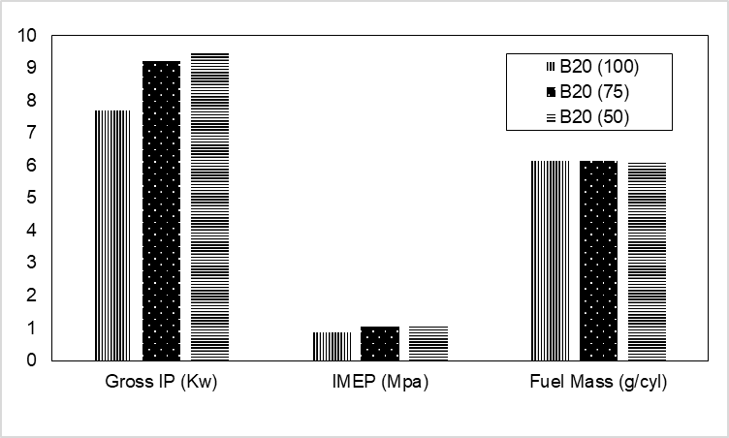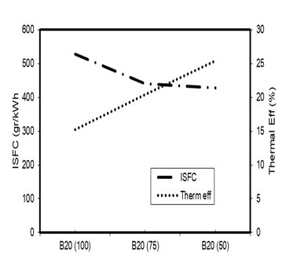
- (b)
Figure 2. Graph of engine performance
In Figure 2 it can be seen that the increase in the percentage of biogas causes an increase in engine performance. The increase in gross indicated power by 23.4% while IMEP increased by 23.2% occurred with a change in the biogas percentage setting from 0% to 50%. This is proof that biodiesel – biogas is worthy of being used as an alternative fuel. Increasing the percentage of biogas has a good impact on the maximum operating speed of the engine rotation. The lower level of fuel consumption for higher power output causes the brake thermal efficiency (BTE) value of dual-fuel with a percentage of 50% biodiesel–biogas to be optimal for DF operations at 2200 RPM. The increase in BTE was 10.25% with a decrease in indicated specific fuel consumption of 19%. The trend of increasing IMEP on increasing biogas injection in dual fuel engines was also found in the research of (Park et al., 2014) and(Jagadish & Gumtapure, 2019) which stated that there was a trend of increasing overall performance by increasing biogas injection on dual fuel engines. The same result was also reported by (Ambarita, 2017) which stated that at the same load and speed, the CI output power running in dual fuel mode was higher than in pure diesel mode.
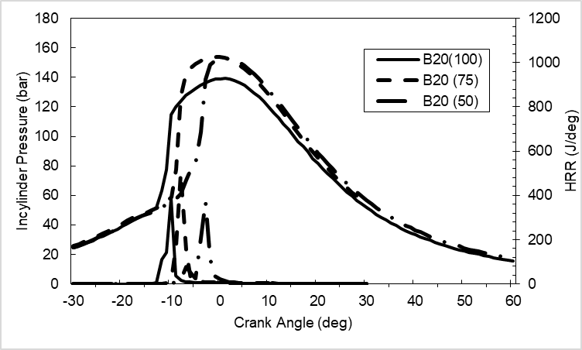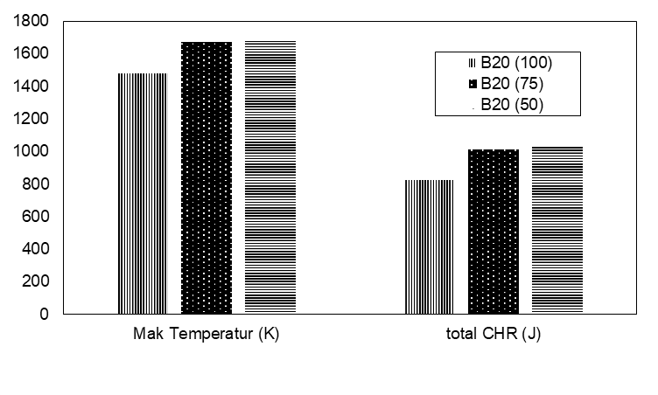
- (b)
Figure 3. Graph of combustion
The increase in-cylinder pressure and temperature make the energy release rate and the combustion process run better at the 50% biodiesel – biogas percentage. The increase in temperature occurs by 13% in conditions of 0% biogas to 50% biogas. While the increase in-cylinder pressure occurs by 10%. This is in conditions of a maximum engine speed of 2200 rpm. The increase in temperature has an impact on the increase in the total cumulative heat release (total CHR). A 13.3% increase in temperature from 0% biogas to 50% causes a 23.9% increase in total CHR. Meanwhile, the combustion pressure decreases with the addition of biogas fuel injection, as is the trend of the results obtained in the research of (Park et al., 2014). The increase in cylinder pressure and temperature makes the energy release rate and the combustion process run better at the 50% biodiesel – biogas percentage.

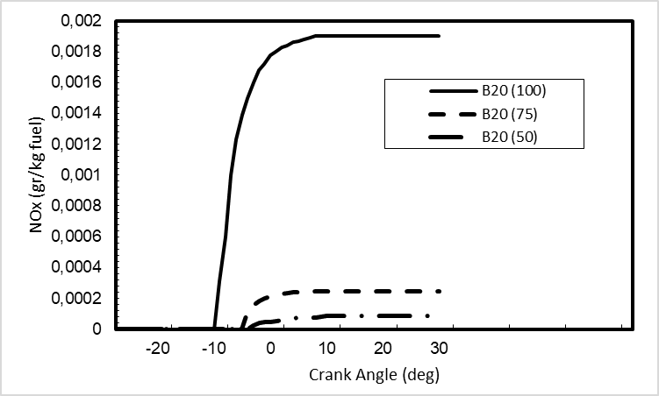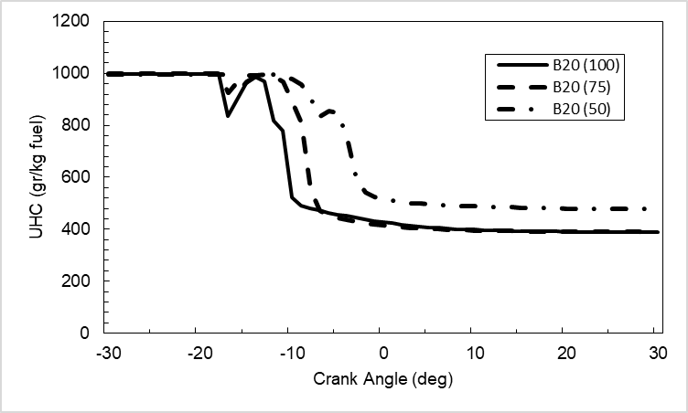
- (b)
Figure.4 Graph of Emission
An increase in biogas intake in a dual fuel engine operating system generally causes a decrease in emissions, a better level of combustion efficiency being one of the factors that underline that the use of dual-fuel can be used as an alternative. The increase in the percentage of biogas causes the concentration of gas in the combustion chamber to become more so that it reduces the portion of the oxygen space. This tends to cause an increase in unburned hydrocarbons at a higher percentage of biogas. The same trend of results was stated by (Ambarita, 2017), (Park et al., 2014) and (Jagadish & Gumtapure, 2019). Meanwhile, NOx decreased with the increasing percentage of biogas in dual fuel, in line with that obtained by(Park et al., 2014) and (Jagadish & Gumtapure, 2019). The presence of CO2 in biogas reduces the peak cylinder temperature because CO2 has a higher specific heat. The combination of these factors promotes lower NOx emissions for mixed biogas. On the other hand, NOx emission levels were found to be equivalent at higher loads due to increased and faster biogas combustion compared to lower loads after high temperatures and peak pressures (Das et al., 2021)
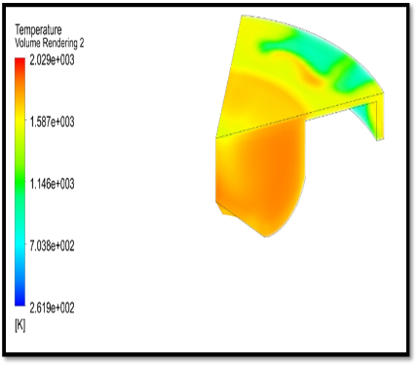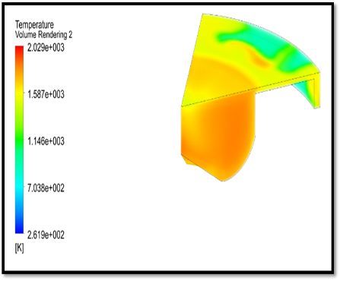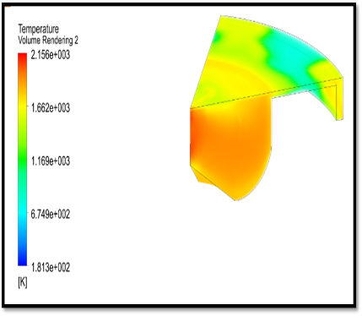

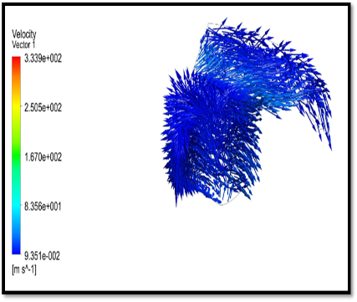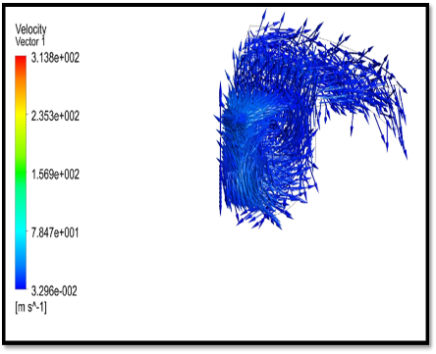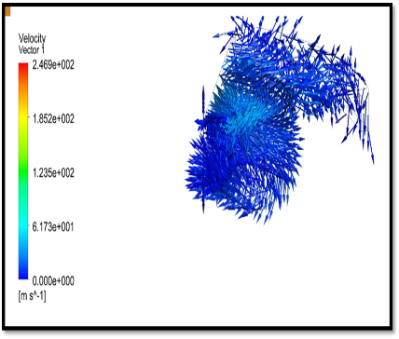

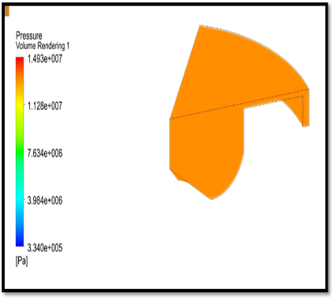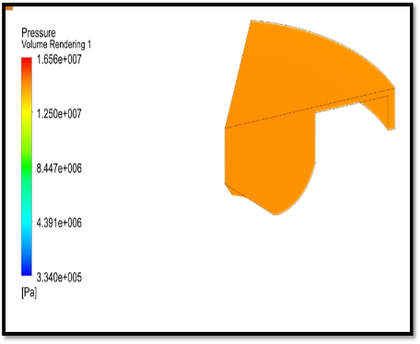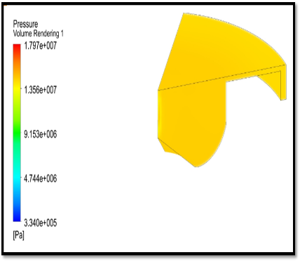
Figure. 4. Contour of Temperature (a), Velocity (b) and contour of pressure (c) from 0% to 50% biogas
In Figure 4, respectively (a), (b), and (c) with variations in the percentage of biodiesel - biogas from 0%, 25%, and 50%, it can be seen that there are several changes in behavior from the temperature and pressure contours. The increase in biogas intake from 0% to 50% at the maximum rotational speed of the DF engine results in an increase in engine performance.

4. Conclusion
In general, there are several conclusions regarding the performance and emission characteristics of the variation in the percentage of biodiesel – biogas from 0%, 25%, and 50% biogas at 2200 RPM engine speed. The increase in engine performance occurs along with the increase in the percentage of biogas from 0% to 50%. The increase in BTE, IMEP and power and a decrease in the level of ISFC indicate that biodiesel – biogas is worthy of consideration as an alternative solution for reducing the use of fossil fuels. Meanwhile, the decreasing value of NOx with an increase in the percentage of biogas from 0% to 50% is good news. The problem of increasing unburned hydrocarbons at a higher percentage of biogas can be tried to add oxygen intake to the engine either through a turbocharger or a supercharger.

Acknowledgment
We would like to thank the PP Muhammadiyah Diktilitbang Council for funding research through the RISETMU Batch V grant, Universitas Muhammadiyah Surabaya, and all colleagues who have assisted in the completion of this research.

References

[1] Abdelaal, M. M., Rabee, B. A., & Hegab, A. H. (2013). Effect of adding oxygen to the intake air on a dual-fuel engine performance, emissions, and knock tendency. Energy. https://doi.org/10.1016/j.energy.2013.09.022
[2] Ambarita, H. (2017). Performance and emission characteristics of a small diesel engine run in dual-fuel (diesel-biogas) mode. Case Studies in Thermal Engineering, 10. https://doi.org/10.1016/j.csite.2017.06.003
[3] Ariani, B., Ariana, I. M., & Fathallah, A. Z. M. (2020). Experimental investigation on natural gas injection to minimize abnormal combustion and methane slip in the diesel-natural gas dual fuel engine at low load. International Review of Mechanical Engineering, 14(9). https://doi.org/10.15866/ireme.v14i9.19821
[4] Ariani, B., Ariana, I. M., & Fathallah, M. A. (2019). Effect of natural gas injection timing on combustion performance & methane slip emission of diesel - NG dual fuel engine: An experimental study. AIP Conference Proceedings. https://doi.org/10.1063/1.5138258
[5] Bala, B. (2005). Studies on biodiesels from transformation of vegetable oils for diesel engines. Energy Educ. Sci. Technol., 15.
[6] Barik, D., & Murugan, S. (2014). Investigation on combustion performance and emission characteristics of a DI (direct injection) diesel engine fueled with biogas-diesel in dual fuel mode. Energy, 72. https://doi.org/10.1016/j.energy.2014.05.106
[7] Barik, D., & Murugan, S. (2016). Experimental investigation on the behavior of a DI diesel engine fueled with raw biogas–diesel dual fuel at different injection timing. Journal of the Energy Institute, 89(3). https://doi.org/10.1016/j.joei.2015.03.002
[8] Bows–Larkin, A., Mander, S., Gilbert, P., Traut, M., Walsh, C., & Anderson, K. (2014). High Seas, High Stakes: High Seas Project Final Report. Tyndall Centre for Climate Change Research.
[9] Cacua, K., Amell, A., & Cadavid, F. (2012). Effects of oxygen enriched air on the operation and performance of a diesel-biogas dual fuel engine. Biomass and Bioenergy, 45. https://doi.org/10.1016/j.biombioe.2012.06.003
[10] Das, L. M., Kaushik, S. C., & Verma, S. (2021). An experimental study on gas-to-liquids and biogas dual fuel operation of a diesel engine. International Journal of Exergy, 36(2/3/4). https://doi.org/10.1504/ijex.2021.10042327
[11] Demirbas, A. (2009). Progress and recent trends in biodiesel fuels. Energy Conversion and Management, 50(1). https://doi.org/10.1016/j.enconman.2008.09.001
[12] Ghadge, S. V., & Raheman, H. (2006). Process optimization for biodiesel production from mahua (Madhuca indica) oil using response surface methodology. Bioresource Technology, 97(3). https://doi.org/10.1016/j.biortech.2005.03.014
[13] Goga, G., Chauhan, B. S., Mahla, S. K., & Cho, H. M. (2019). Performance and emission characteristics of diesel engine fueled with rice bran biodiesel and n-butanol. Energy Reports, 5. https://doi.org/10.1016/j.egyr.2018.12.002
[14] Hegab, A., La Rocca, A., & Shayler, P. (2017). Towards keeping diesel fuel supply and demand in balance: Dual-fuelling of diesel engines with natural gas. In Renewable and Sustainable Energy Reviews. https://doi.org/10.1016/j.rser.2016.11.249
[15] Jagadish, C., & Gumtapure, V. (2019). Experimental investigation of methane-enriched biogas in a single cylinder diesel engine by the dual fuel mode. Energy Sources, Part A: Recovery, Utilization and Environmental Effects. https://doi.org/10.1080/15567036.2019.1647314
[16] Königsson, F., Stalhammar, P., & Angstrom, H. E. (2011). Characterization and potential of dual fuel combustion in a modern diesel engine. SAE Technical Papers. https://doi.org/10.4271/2011-01-2223
[17] Lee, T., & Nam, H. (2017). A Study on Green Shipping in Major Countries: In the View of Shipyards, Shipping Companies, Ports, and Policies. Asian Journal of Shipping and Logistics, 33(4). https://doi.org/10.1016/j.ajsl.2017.12.009
[18] Park, S. H., Yoon, S. H., Cha, J., & Lee, C. S. (2014). Mixing effects of biogas and dimethyl ether (DME) on combustion andemission characteristics of DME fueled high-speed diesel engine. Energy, 66. https://doi.org/10.1016/j.energy.2014.02.007
[19] Rosha, P., Mohapatra, S. K., Mahla, S. K., Cho, H. M., Chauhan, B. S., & Dhir, A. (2019). Effect of compression ratio on combustion, performance, and emission characteristics of compression ignition engine fueled with palm (B20)biodiesel blend. Energy, 178. https://doi.org/10.1016/j.energy.2019.04.185
[20] Tippayawong, N., Promwungkwa, A., & Rerkkriangkrai, P. (2007). Long-term operation of a small biogas/diesel dual-fuel engine for on-farm electricity generation. Biosystems Engineering, 98(1). https://doi.org/10.1016/j.biosystemseng.2007.06.013
[21] Yoon, S. H., & Lee, C. S. (2011). Experimental investigation on the combustion and exhaust emission characteristics of biogas-biodiesel dual-fuel combustion in a CI engine. Fuel Processing Technology, 92(5). https://doi.org/10.1016/j.fuproc.2010.12.021

