2301-9069 (e)  1829-8370 (p) | KAPAL  Jurnal Ilmu Pengetahuan dan Teknologi Kelautan  journal homepage : http://ejournal.undip.ac.id/index.php/kapal

Comparison of the Ultimate Strength with and without Hatch Opening Subjected to Longitudinal Bending

Abstract
The hatch opening has function to enter the load into the cargo hold. One of the ship type like this is Bulk Carrier. The hatch opening must be designed in suitable way because its influence to the ultimate strength since the hull girder under longitudinal bending moment. The application of the hatch opening on the ship’s deck should be considered for the ship design critreria. The objective of the present study is to analyze the ultimate strength with and without hatch opening subjected to longitudinal bending moment. The cross section of box girder is used to analyze the effect of hatch opening to the ultimate strength. This cross section of box girder is adopted for simple calculation. The application of Multiple Point Constrained (MPC) is adopted to analyze the box girder under longitudinal bending moment. The cross section of box girder is assumed remained plane during progressive collapse. The material such as density, yield strength, elastic modulus and poisson ratio are homogeneous. The type and dimensions of the stiffeners are also identic. The only one of the difference for the stiffener is number due to the hatch opening at the top of the box girder. It is found that the ultimate strength of the box girder with hatch opening is smaller than without opening one.

Keywords :
Box Girder, Cross Section, Hatch Opening, Ultimate Strength

1. Introduction
Hatch opening has a function to enter the payload into cargo hold. However, the hatch opening must be considered and designed because its effect to the ultimate strength. Many studies have been explained the important of ultimate strength of ship’s hull with some consideration from the construction it selves. However, the consideration about the effect of hatch opening to the ultimate strength of ship’s hull was very limited.
The research related to the ultimate strength of ship’s hull has been studied by some researchers. Kuznecovs et al presented a methodology called SHARC developed for the simulation and analysis of a ship’s damage stability and ULS conditions following a collision [1]. A novel method was proposed by Zhang et al to calculate strength loss based on stiffness loss [2]. A conceptual design framework for collision and grounding analysis was proposed by Liu et al to evaluate the crashworthiness of double-hull structures [3]. The incidence of collision damage models on oil tanker and bulk carrier reliability was investigated by Campanile et al by considering the IACS deterministic model against GOALDS/IMO database statistics for collision events, substantiating the probabilistic model [4]. The progressive collapse analysis was performed by Muis Alie and Latumahina for the local elements and the ultimate strength of a Ro-Ro ship [5]. Van et al focused on the effect of initial imperfections and corrosion related strength degradation of bulk carriers, the initial imperfections including initial distortions and residual stresses, are employed to assess the ultimate bending moment reduction [6].
In addition, Guia et al assessed the probabilistic characteristics of the hull girder target safety level of a Suezmax tanker derived from a cost-benefit analysis and the target safety level is obtained considering as risk control option the change in the cross section scantlings of the tanker and its effect on risk reduction expressed by the total expected cost of the hull girder failure [7]. Zhang et al addressed the experimental and finite-element simulation studies on scaled double-hull side structures quasi-statically punched at the mid-span by conical and knife edge indenters to examine their fracture behaviors and energy dissipation mechanisms [8]. The ultimate strength of double hull oil tanker due to grounding and collision was conducted by Latumahina and Muis Alie, the collision damaged was modeled by removing the element at the side shell of the ship [9]. The ultimate hull girder strength was analyzed by Muis Alie and Latumahina by considering the section modulus under longitudinal bending, the ship cross section was different in number, type and dimension of the longitudinal stiffeners [10]. Reliability analysis of an oil tanker in intact conditions was performed by Campanile et al to investigate the incidence of load combination methods on hull girder sagging/hogging time-variant failure probability, particularly, Turkstra rule, Ferry Borges and Castanheta method and Poisson square wave model are applied to evaluate the statistical distribution of bending moment, with reference to both one voyage and 1-year period [11].
Xu et al presented a reliable and suitable FE modeling in the explicit dynamic method, which could keep the balance of the acceptable accurate results and computation resources, and several influential factors on the collapse behaviors of hull girder are discussed including boundary conditions, geometric ranges of finite element model, element types, loading methods and loading time [12]. Parunov et al is the assessed the residual ultimate strength of an Aframax-class double hull oil tanker damaged in collision and the contribution to the research of the problem is given in a systematic investigation of the influence of the rotation of neutral axis (NA), which is performed by imposing appropriate boundary conditions [13]. Downes et al presented a new procedure to determine LSE datum based on box girder Finite Element Analyses (FEAs) instead of using finite element model of stiffened panels, and to verify reliability of FEA results, the simple box girder collapse test results are compared with FEA results of same box girders. It reveals one frame-based box girder model is sufficiently accurate in terms of ultimate strengths of the box girders [14].
Liu and Soares presented a simplified analytical method to examine the energy absorbing mechanisms of double-hull ship structures subjected to a flat edge indenter, and the method was validated with a numerical simulation was conducted on a structural module derived from an experimentally scaled stiffened panel [15]. The influence of superstructure on the longitudinal ultimate strength was analyzed by Muis Alie et al [16], the superstructure was include in the model in order to the effect of it. The influence of initial geometric imperfection modes on the ultimate strength of a ship’s hull was studied by Estefen et al, with a focus on the buckling behavior of stiffened panels that initiates the structural hull failure [17]. The finite element analysis on the ship hull girder under longitudinal bending with bottom damaged was investigated by Muis Alie et al [18].
Among them, only few to investigate the effect of hatch opening to the ultimate strength. Therefore, the ultimate strength by considering the effect of hatch opening must be taken into account and this should be a basis contribution to this research.

2. Methods
In the present study, the ultimate strength of box girder considering with and without hatch opening are taken as the object to be analyzed. The length, breadth and depth of box girder are 2 m, 0.35 m and 1 m, respectively as shown in Fig. 1. For the box gider with hatch opening is ilustrated in Fig. 2. The type of stiffener is Tee-Bar and it is applied to whole cross section of box girder. The dimensions of the stiffener are 0,05 m x 0,025 m for depth and breadth of Tee-Bar stiffener. The web and flange plate thickness is 12 mm. The number of stiffeners located at bottom and deck part are 9. While at side shell are 6 stiffeners. The hatch opening is 1 m at top of the box girder. The number of stiffeners located at bottom, side and top are 9, 6 and 4, respectively. The element mesh type and dimension are shell and 0.5 mm, respectively. The material properties are noted in Table 1 as follow

Table 1. Material Properties
Yield Stress | 370 N/mm²
Tangent Modulus | 625 N/mm²
Young’s Modulus | 210000 N/mm²
Density | 7850 N/mm³
Poisson Ratio | 0.3

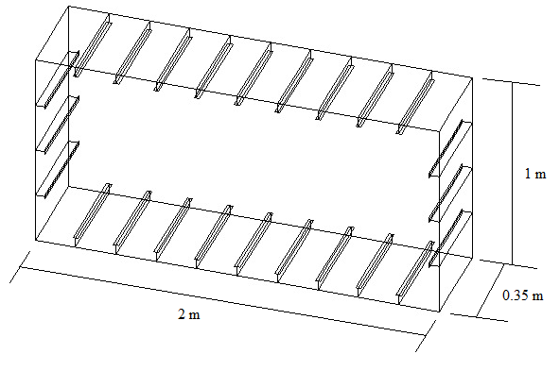

Figure 1. Box Girder Dimension

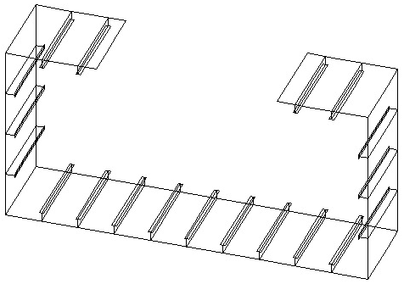

Figure 2. Box Girder with Hatch Opening
The ultimate strength of box girder considering with and without the effect of hatch opening is calculated by adopting the numerical method. The model together with the applied moment of box girder with and without hatch opening are illustrated in Fig. 3. Once the neutral axis position is obtained, the Multiple Pont Constrained (MPC) can be placed where the applied load or rotational force or moment can be put.
Dimension of the stiffeners both two ships.

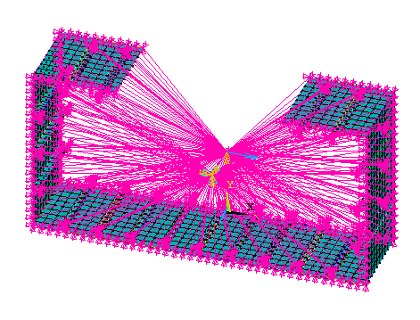
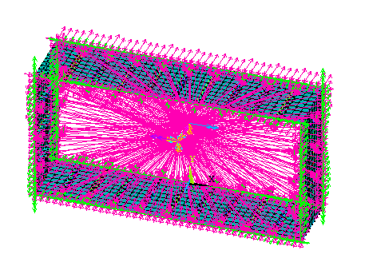

(a) Without Hatch Opening (b) With Hatch Opening

Figure 3. Boundary Condition and Applied Moment

3. Results And Discussion
The ultimate strength of box girder considering with and without hatch opening is analyzed under hogging and sagging conditions. The characteristic of box girder with and witout hatch opening under hogging condition are illustrated in Fig. 4. This characteristic is for the ultimate strength stage since the box girder is under hogging condition. The top part is under tension noted by red color and bottom is under compression noted by blue one. Due to the loss of stiffenes of hatch opening at the top part, the spread of red color moves to the side shell. Compare to this, without hatch opening, the red color is symmetrical at the side shell.
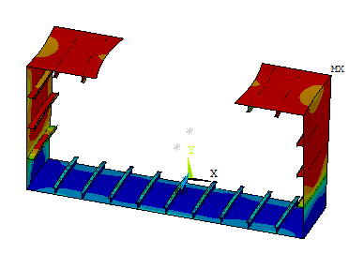
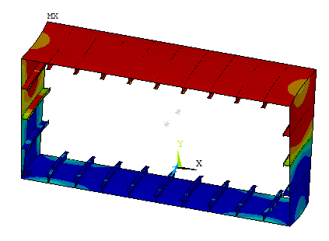

(a) Without Hatch Opening (b) With Hatch Opening

Figure 4. Characteristic of Box Girder Under Hogging-Ultimate Strength
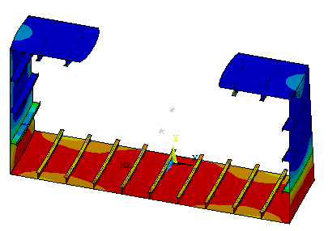
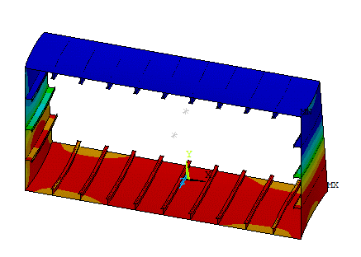

(a) Without Hatch Opening (b) With Hatch Opening

Figure 5. Characteristic of Box Girder Under Sagging-Ultimate Strength

Figure 5 shows the characteristic of the box girder with and without hatch opening under sagging condition for the ultimate strength stage. It is observed that since the box girder cross section is under sagging, the top part is under compression, while the bottom is under tension. The deferomation due to the loss of the element of the box girder at top part, the red color spreads larger without hatch opening compare with hatch opening one. Also at the side shell, the blue color with hatch opening spreds larger than without hatch opening one.

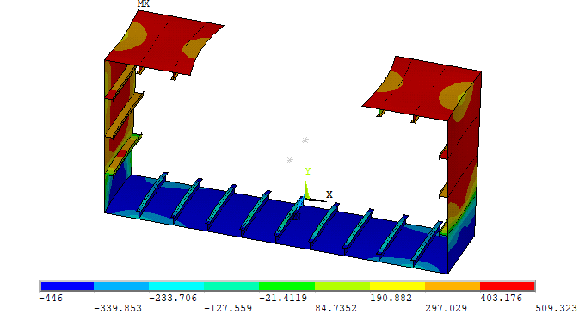
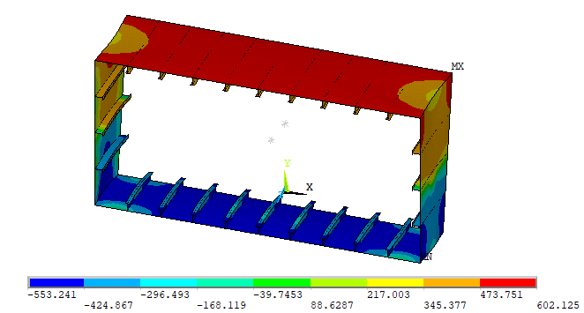

(a) Without Hatch Opening (b) With Hatch Opening

Figure 6. Characteristic of Box Girder Under Hogging-Collapse
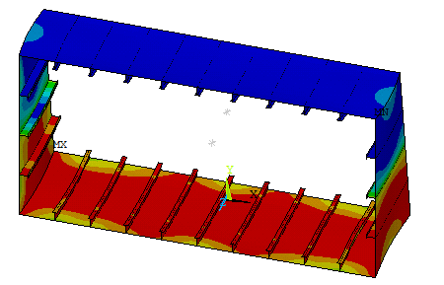

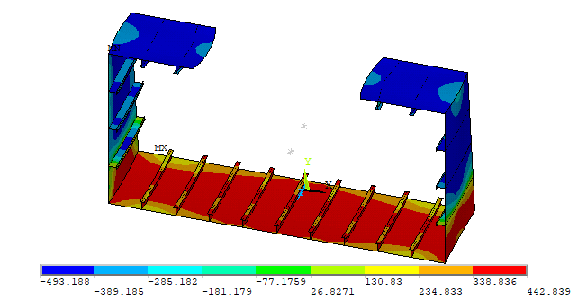

(a) Without Hatch Opening (b) With Hatch Opening

Figure 7. Characteristic of Box Girder Under Sagging-Collapse
Figures 6 and 7 show the characteristics of box girder in Collapse mode under hogging and sagging conditions. The red color of box girder with hatch opening is spread more to the side shell compared to without hatch opening one as hown in Fig. 6 since the box girder is under hogging condition where the top is under tension and the bottom is under compression. For sagging condition, same condition since the box girder where top is under compression and bottom part is under tension. The blue color takes place at the top and spreads more to the side shell of box girder as shwon in Fig. 7.

Figure 8. Moment-Curvature relationship

Figure 8 shows the moment-curvature relationship of box girder under hogging and sagging conditions. The solid line represent the moment-curvature curve obtained for box girder without hatch opening and dashed line describe the moment-curvature relationship gained for box girder with hatch opening. It is observed that the ultimate strength of box girder without hatch opening is larger than with hatch opening one. The bending stiffeness is also completely different due to loss of stiffener at top sinde the box girder is under hogging or sagging. The influence of hatch opening is very significant not only to the ultimate strength but also the bending stiffeness.

4. Conclusion
The ultimate strength analysis of box girder considering the influence of hatch opening has been conducted. The following conclusion can be drawn ; the ultimate strength of box girder without hatch opening is larger than with hacth opening. The bending stiffeness of box girder without hatch opening is also larger than with hatch opening. The influence of hatch opening is significant due to loss of stiffeness related to some elements at top part are eliminated.

Acknowledgment
The authors acknowledge the support received from the Ministry Education and Culture of the Republic of Indonesia through Universitas Hasanuddin with contract number 752/UN4.22/PT.02.00/2022.

References
[1] A. Kuznecovs, M. Schreuder, and J. W. Ringsberg, “Methodology for the simulation of a ship’s damage stability and ultimate strength conditions following a collision,” Marine Structures, vol. 79, no. January, p. 103027, 2021.
[2] Y. Zhang, J. Guo, J. Xu, S. Li, and J. Yang, “Study on the unequivalence between stiffness loss and strength loss of damaged hull girder,” Ocean Engineering, vol. 229, no. November 2020, p. 108986, 2021.
[3] B. Liu, R. Villavicencio, P. T. Pedersen, and C. Guedes Soares, “Analysis of structural crashworthiness of double-hull ships in collision and grounding,” Marine Structures, vol. 76, no. March 2019, p. 102898, 2021.
[4] A. Campanile, V. Piscopo, and A. Scamardella, “Comparative analysis among deterministic and stochastic collision damage models for oil tanker and bulk carrier reliability,” International Journal of Naval Architecture and Ocean Engineering, vol. 10, no. 1, pp. 21–36, 2018.
[5] Muis Alie Z. M. and Latumahina, S. I. “Progressive collapse analysis of the local elements and ultimate strength of a Ro-Ro Ship,” International Journal of Technology, vol. 10, no. 5, pp. 1065–1074, 2019.
[6] T. Vu Van, P. Yang, and T. Doan Van, “Effect of uncertain factors on the hull girder ultimate vertical bending moment of bulk carriers,” Ocean Engineering, vol. 148, no. November 2017, pp. 161–168, 2018.
[7] J. Guia, A. P. Teixeira, and C. Guedes Soares, “Probabilistic modelling of the hull girder target safety level of tankers,” Marine Structures, vol. 61, no. March, pp. 119–141, 2018.
[8] M. Zhang, J. Liu, Z. Hu, and Y. Zhao, “Experimental and numerical investigation of the responses of scaled tanker side double-hull structures laterally punched by conical and knife edge indenters,” Marine Structures, vol. 61, no. March, pp. 62–84, 2018.
[9] Latumahina, S. I, Muis Alie, M. Z and Sitepu, G. “The Ultimate Strength of Double Hull Oil Tanker Due to Grounding and Collision,” Journal of Physics: Conference Series, vol. 962, no. 1, 2018.
[10] Muis Alie, Z. M. and Latumahina, S. I. “The ultimate hull girder strength analysis considering section modulus under longitudinal bending,” Proceedings of the International Offshore and Polar Engineering Conference, vol. 2018-June, pp. 581–587, 2018.
[11] A. Campanile, V. Piscopo, and A. Scamardella, “Incidence of load combination methods on time-variant oil tanker reliability in intact conditions,” Ocean Engineering, vol. 130, no. June 2016, pp. 371–384, 2017.
[12] M. C. Xu, Z. J. Song, and J. Pan, “Study on influence of nonlinear finite element method models on ultimate bending moment for hull girder,” Thin-Walled Structures, vol. 119, no. March, pp. 282–295, 2017.
[13] J. Parunov, S. Rudan, and B. Bužančić Primorac, “Residual ultimate strength assessment of double hull oil tanker after collision,” Engineering Structures, vol. 148, pp. 704–717, 2017.
[14] J. Downes, G. T. Tayyar, I. Kvan, and J. Choung, “A new procedure for load-shortening and -elongation data for progressive collapse method,” International Journal of Naval Architecture and Ocean Engineering, vol. 9, no. 6, pp. 705–719, 2017.
[15] B. Liu and C. Guedes Soares, “Assessment of the strength of double-hull tanker side structures in minor ship collisions,” Engineering Structures, vol. 120, pp. 1–12, 2016.
[16] Muis Alie, M. Z, Sitepu, G, Wahyuddin, Nugraha, A. M and Alamsyah, A. “The influence of Superstructure on the longitudinal ultimate strength of a RO-RO ship,” Proceedings of the International Offshore and Polar Engineering Conference, vol. 2016-Janua, pp. 1022–1029, 2016.
[17] S. F. Estefen, J. H. Chujutalli, and C. Guedes Soares, “Influence of geometric imperfections on the ultimate strength of the double bottom of a Suezmax tanker,” Engineering Structures, vol. 127, pp. 287–303, 2016.
[18] Muis Alie, M. Z, Sitepu, G, Juswan, Wahyuddin, Nugraha, A. M and Alamsyah, A. “Finite Element Analysis on the Hull Girder Ultimate of Asymmetrically Damaged Ships,” pp. 1–10, 2016.

