|  |  |  |
| --- | --- | --- |
| **C:\Users\Lenovo\AppData\Local\Microsoft\Windows\INetCache\Content.Word\Logo UNDIPnn.png**  [2301-9069 (e)](http://issn.pdii.lipi.go.id/issn.cgi?daftar&1342508490&1&&)  [1829-8370 (p)](http://issn.pdii.lipi.go.id/issn.cgi?daftar&1180427365&1&&) | **Kapal: Jurnal Ilmu Pengetahuan dan Teknologi Kelautan**  **(Kapal: Journal of Marine Science and Technology)**  journal homepage : <http://ejournal.undip.ac.id/index.php/kapal> |  |
|  | |  |

Reliability-Based Analysis of Main Propulsion Fuel Oil System Maintenance for Tugboats with Qualitative and Quantitative Methods

Imam Pujo Mulyatno1, Keyza Taqi Wafi1, Sarjito Joko Sisworo1 , Tuswan1*

1) Department of Naval Architecture, Faculty of Engineering, Diponegoro University**,** Jl. Prof. Soedarto, SH, Undip Tembalang Campus, Semarang, Indonesia 50275

*) Corresponding Author : tuswan@lecturer.undip.ac.id

|  |  |
| --- | --- |
| **Article Info** | **Abstract** |
| **Keywords:**  Main Engine FO System, Qualitative & Quantitative Analysis, Reliability, Japan Institute of Plant Maintenance  **Article history:**  Received:  Last revised:  Accepted:  Available online:  Published:  **DOI:**  https://doi.org/10.14710/ | Treatment of the material system The fuel of the ship's main propulsion engine determines the performance of the engine and components based on the standards of the Japan Institute of Plant Maintenance. Analysis of this system aims to evaluate each component of the fuel system as a basis for planning maintenance. It takes data on operational time, failure time and frequency, number of vessels served, and fuel system diagrams for tugboats. The data were analyzed qualitatively using the Failure Mode and Effect Analysis (FMEA) and Fault Tree Analysis (FTA) methods and quantitatively using the Overall Equipment Effectiveness (OEE), Markovian Decision Process (MDP), and reliability methods. The results of the critical component Fuel Oil (FO) purifier with Risk Priority Number (RPN) 294 as one of cut sets from the third orde. The average value of OEE is 47% below the standard of 85% due to the low utility of the ship. MDP analysis produces a probability of mild damage of 0.08 and moderate to severe damage of 0.46 at steady state conditions. The lowes Mean Time to Failure (MTTF) value is found in the FO Purifier component, which is 1658.50 hours. Continuing to calculate the reliability function against time to obtain a graph. The recommended period of treatment based on MTTF and the value of the reliability of each component as well as maintenance actions based on the MDP.  Copyright © 2021 KAPAL : Jurnal Ilmu Pengetahuan dan Teknologi Kelautan. This is an open access article under the CC BY-SA license (<https://creativecommons.org/licenses/by-sa/4.0/>). |

1. **Introduction**

As one of the basic principles in the operation of a diesel engine which is the main propulsion engine of the ship, fuel works in a system called the fuel oil system. In distributing fuel in ships, the fuel oil system generally consists of fuel oil supply, fuel oil purifying, and fuel oil tanks [1]. These components must be able to work optimally so that the distribution of fuel in the system can run properly, considering that the ship will not have utility if the engine is not operating.

A ship that does not have utility means that it does not operate optimally which will bring losses, especially if it happens to a tugboat belonging to a company engaged in ship towing services in Indonesia. A tugboat is a ship whose job is to make movements to pull and push other ships [2]. The operation of the fuel oil system is directly proportional to the utility of the tugboat and the profits obtained by the company, therefore the components of the fuel system must always be in optimal condition.

The condition of the fuel system and its components can be known as has been done in KM. Kelimutu’s fuel oil system research which in its analysis uses FMEA and FTA as qualitative analysis to determine the critical components that is filter and quantitative analysis with Monte Carlo simulation as a reliability calculation which states that the fuel system will fail when the system has operated 317.998 hours with an end timeof 5000 hours [3]. The Monte Carlo simulation is also used in reliability analysis carried out on systems with arbitrary structures states with a fairly simple use gives relatively accurate results which have 99% similarity to the results of calculations using Reliability Block Diagram [4]. The result of Monte Carlo simulation compared with subset simulation using a random failure system for the failure of carbon dioxide storage states the coefficient variation results obtained with Monte Carlo are 10% higher than the subset simulation which shows that the Monte Carlo simulation is more effective for cases with a small probability of failure [5].

Analysis to find out the condition of an object or system other than using Monte Carlo simulation, can also be done using the Markov Decision Process method which has been used in research on multi-state system to prevent system failure. The Markov Decision Process analysis method carried out on the multi-state system resulted in a proposed predictive maintenance action to prevent system failure which saved an average of 26.3% of the original maintenance cost [6].

The data used in this study shows that the fuel oil system has interconnected components and failures often occur with unpredictable times on an ongoing basis. Therefore, the authors are interested in knowing the critical components of the fuel oil system for the main propulsion engine of the tugboat and the proposed maintenance and scheduling actions using the qualitative analysis with FMEA and FTA method either quantitative analysis with OEE, MDP, and reliability. The aim is to determine the critical components of the tugboat fuel oil system, proposed maintenance actions on the tugboat fuel oil system components, and scheduling proposed maintenance actions components of the tugboat fuel oil system so that the company can minimize losses because the system performance value is not below 85% as the minimum standard value [7].

1. **Methods**

In this study, the fuel oil system of one of the 3200 HP Tugboats fueled by Marine Diesel Oilfor the January 2020 - December 2020 period belongs to a ship towing company in Indonesia which is the object of the research. In operation according to the diagrams in Figures 1-3 obtained from the company, the object of this research has components consisting of a FO tank, FO transfer pump, FO transfer pump (stand by hand pump), FO purifier pump, FO purifier, daily tank, sedimentation tank, FO feed pump (stand by), FO feed pump. This study uses supporting data from the fuel oil system for the period 2017 – 2021 which has been operating for 24 years to review the result of reliability value where, the fuel oil system is analyzed using system dynamics modeling with weibull distribution that obtains the condition of the FO tank at starboard (S) & portside (P), sedimentation tank, and daily tank (S&P) when used 5070 hours has a reliability value of 0.5 and 3458 hours has a reliability value of 0.85. FO purifier when used for 458 hours has a reliability value of 0.5 and 378 hours has a reliability value of 0.85. FO transfer pump when used for 5157 hours has a reliability value of 0.5 and 3652 hours has a reliability value of 0.85. FO feed pump (S&P) when using 4870 hours has a reliability value of 0.5 and 3458 hours has a reliability value of 0.85 [8].

.

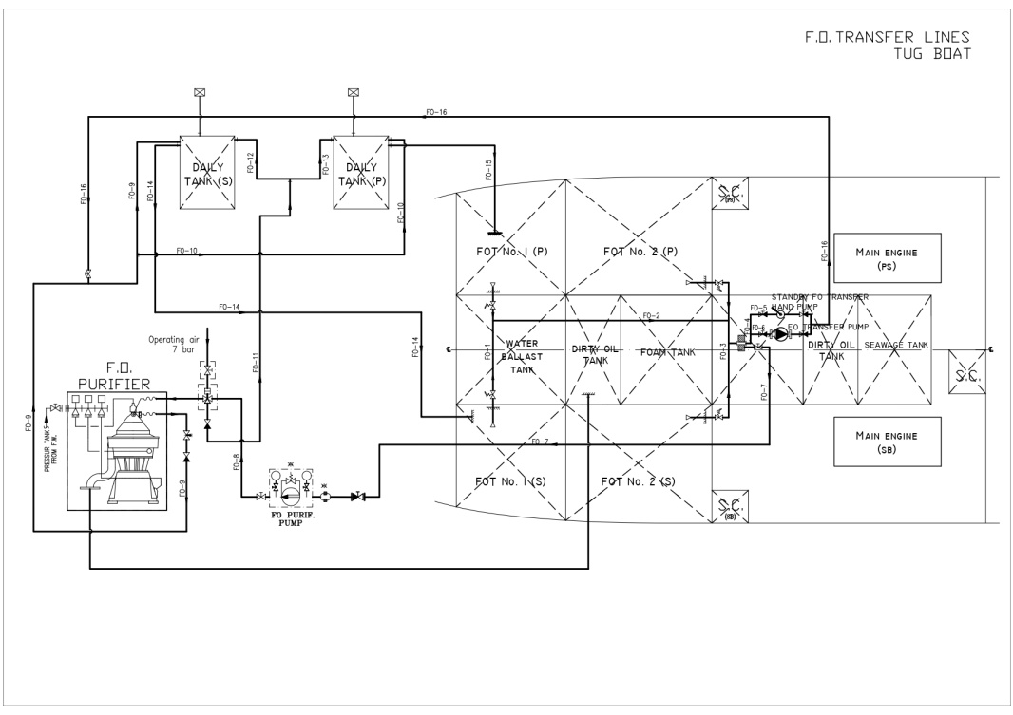

Figure 1. Diagram transfer line of the 3200 hp tugboat fuel oil system

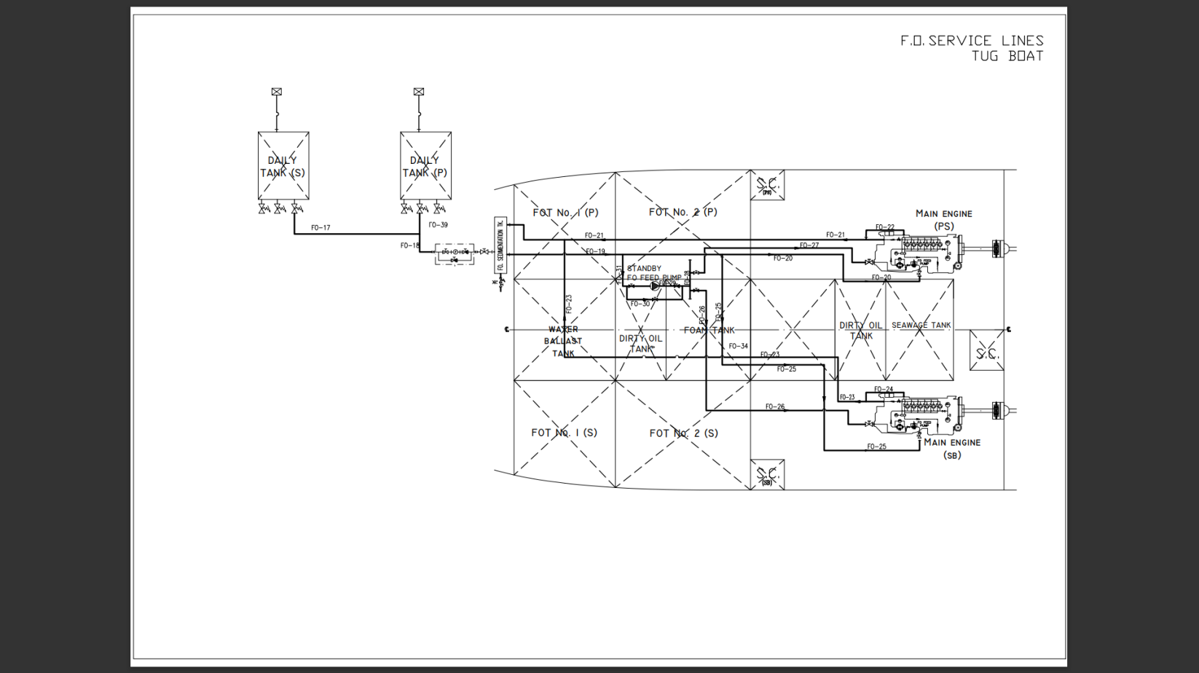

Figure 2. Diagram service line of the 3200 hp fuel oil system

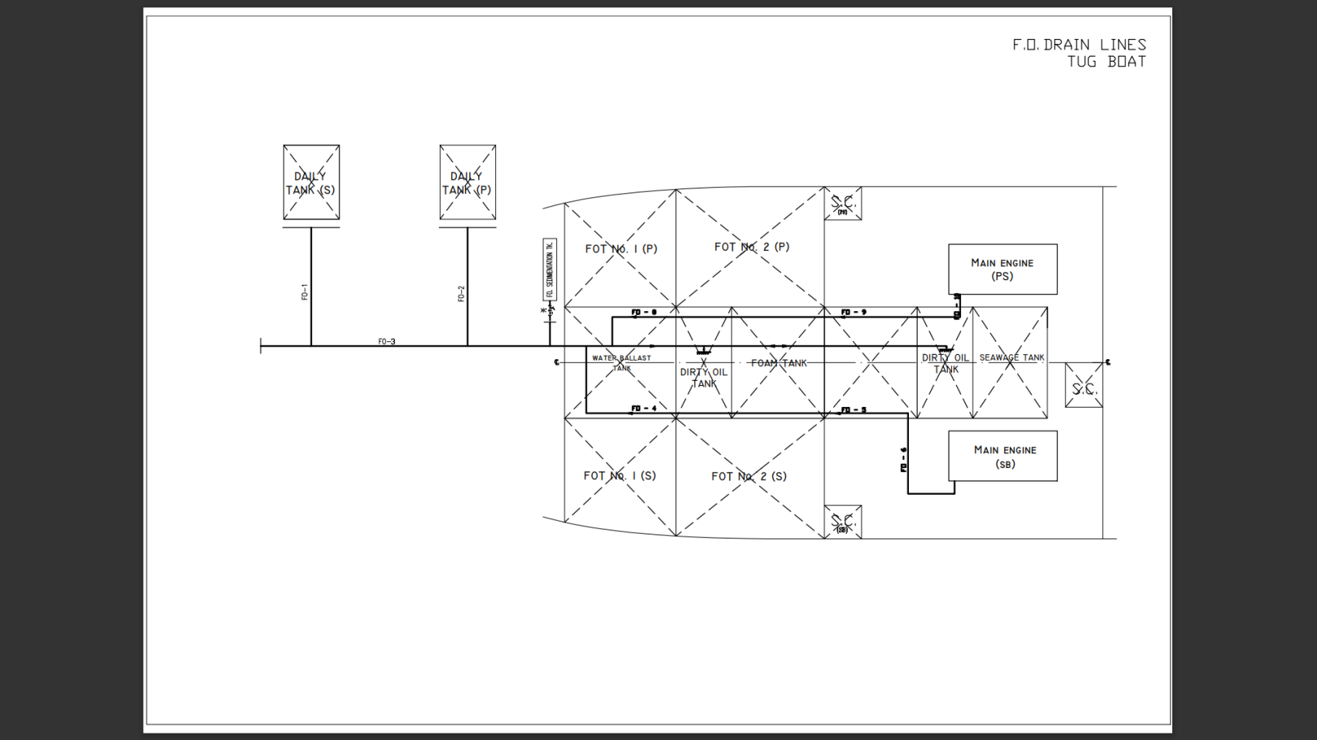

Figure 3. Diagram drain line of the 3200 hp fuel oil system

The analytical methods used in this study to find out include:

* 1. **Qualitative Assessment**

Data analysis is based on facts found in the field in the form of frequency, interval, and duration of downtimewhich can be seen in Table 1. In this study, qualitative analysis of the fuel system was carried out to determine the critical components and their underlying causes using FMEA and FTA.

Table 1. Downtime of 3200 hp tug fuel oil system components

| **No.** | **Component** | **Frequency of Downtime** | **Interval of Downtime**  **(hours)** | **Duration of Downtime**  **(hours)** |
| --- | --- | --- | --- | --- |
| 1 | Fuel Oil Tank (S & P) | 0 | - | - |
| 2 | Fuel Oil Transfer Pump | 1 | 8016 | >24 |
| 3 | Fuel Oil Transfer Pump (Stand By Hand Pump) | 0 | - | - |
| 4 | Fuel Oil Purifier Pump | 1 | 8016 | >24 |
| 5 | Fuel Oil Purifier | 13 | 528 | 4 |
| 504 | 4,5 |
| 1104 | 4 |
| 240 | 5,5 |
| 624 | 4 |
| 360 | 5 |
| 864 | 5 |
| 336 | 4,5 |
| 696 | 5 |
| 600 | 3 |
| 984 | 5,5 |
| 720 | 6 |
| 456 | >24 |
| 6 | Daily Tank (S & P) | 0 | - | - |
| 7 | Sedimentation Tank | 0 | - | - |
| 8 | Fuel Oil Feed Pump (Stand By) | 0 | - | - |
| 9 | Fuel Oil Feed Pump (S & P) | 1 | 8016 | >24 |

FMEA is a structured methodology to identify/analyze failures/errors that have occurred or may occur which will generate a RPN for each component [9]. The RPN value is obtained using the equation as shown in Eq. 1.

$RPN=Severity x Occurrence x Detection$ (1)

With a scale of 1 – 10, the longer the downtime, the greater the value of the severity, the shorter the time interval between downtimes, the greater the occurrence value, and the more difficult the signs of the cause of downtime to be detected will be greater detection value.

FTA is an analysis method, where an unwanted event called undesired event occurs in the system, and the system is then analyzed with the existing environmental and operational conditions to find all possible ways that lead to the occurrence of the undesired event [10]. The system is analyzed to find the possibility of failure in the form of a cut set as basic event that results in a top event.

* 1. **Quantitative Assessment**

Analysis of data based on facts in the field using data recorded by the company in the form of operational time, failure time and frequency, and number of ships served that show in Tables 1 and 2.

Table 2. 3200 hp tugboat operation

|  |  |  |  |  |  |  |  |  |  |
| --- | --- | --- | --- | --- | --- | --- | --- | --- | --- |
| **Month** | **Number of Vessels Served** | **Possible Time**  **(hours)** | **Planned** | | **Actual** | | **Tugboat Availability**  **(hours)** | **Utilities**  **(hours)** | **Tugboat Downtime**  **(hours)** |
| **System Downtime**  **(hours)** | **System Availability**  **(hours)** | **System Downtime**  **(hours)** | **System Availability**  **(hours)** |
| Jan | 323 | 744 | 5 | 739 | 4.41 | 739.59 | 720.67 | 485.67 | 23.33 |
| Feb | 261 | 696 | 5 | 691 | 6 | 690 | 654.08 | 407.75 | 41.92 |
| Mar | 318 | 744 | 6 | 738 | 4 | 740 | 725.08 | 475.08 | 18.92 |
| Apr | 269 | ​​720 | 5 | 715 | 6 | 714 | 680.08 | 407.80 | 39.92 |
| May | 197 | 744 | 5 | 739 | 14 | 730 | 614.83 | 302.33 | 129.17 |
| Jun | 267 | 720 | 18.5 | 701.5 | 5.5 | 714.5 | 691.08 | 377 ,92 | 28.92 |
| Jul | 289 | 744 | 5 | 739 | 5 | 739 | 721.25 | 407.33 | 22.75 |
| Aug | 304 | 744 | 5 | 739 | 8 | 736 | 729.00 | 414.08 | 15.00 |
| Sept | 262 | 720 | 6 | 714 | 3.3 | 716.7 | 706, 33 | 366.25 | 13.67 |
| Oct | 225 | 744 | 5 | 739 | 7 | 737 | 714.50 | 326.17 | 29.50 |
| Nov | 55 | 720 | 5 | 715 | 9 | 711 | 225.33 | 80.92 | 494.67 |
| Dec | Docking | | | | | | | | |

In this study, quantitative analysis of the fuel oil system was carried out to determine the maintenance actions based on the state of the fuel oil system from the sample period and maintenance schedule for the fuel oil system from the age of the fuel oil system components in the sample period using OEE, MDP, and reliability.

OEE serves to identify the level of machine productivity and performance [11]. OEE is obtained the equation as shown in Eq. 2.

$OEE = Availability x Performance x Rate of Quality Product$ (2)

The availability ratio (*A*) is the ratio of available time utilization with system operation as shows as Eq. 3.

$A= \frac{operation time}{loading time}$ (3)

Since the fuel oil system operates only when the tugboat is operating and the tugboat operates only when performing services, the operation time of the fuel oil system is the same as the utility time of the tugboat and loading time is the time available to operate, on tugboats are 70% tugboat availability. Tugboats only use 70% of the availability because the average tugboat performs 13-14 services per day with 1.25 hours for one time service, so tugs have an ideal 70% available time for operation within 24 hours. So that, the equation that will be used shows in Eq. 4.

$A_{T} = \frac{utility}{70\% of tugboat availability}$ (4)

Performance efficiency (*P*) is the ratio of the efficiency or ability of the system performance as shows as Eq. 5.

$P= \frac{processed amount x ideal cycle time}{operation time}$ (5)

The processed amount is amount which successfully processed by the system, on tugboats are the same as the number of services performed because the fuel oil system works only when the tugboat is serving, ideal cycle time is time that supposed to be used for a process, on the tugboats are their ideal time per-service. So that, the equation that will be used shows in Eq. 6.

$P_{T} = \frac{number of services x ideal time per-service}{utility}$ (6)

Quality product (*Q*) is the ratio of the system's ability to produce according to the standard/target as shows as Eq. 7.

$Q= \frac{processed amount-defect amount}{processed amount}$ (7)

Since processed amount is amount which successfully processed by the system and defect amount is the difference between the amount that supposed to be in a process and the actual amount of the process. On the tugboats, the process is their service and the amount is their time, so the equation used is shown in Eq. 8. The utility time of the tugboat is the same as the operating time of the fuel oil system, so that the utility value of the plan is 70% of the availability of the plan system with the assumption that other systems are in a usable condition so that the tugboats can perform services since tugs have an ideal 70% available time for operation within 24 hours.

$Q_{T} = \frac{utility}{plan utility}$ (8)

MDP is a mathematical technique commonly used to model various systems to predict future changes on the basis of past changes in the form of descriptive analysis by determining system status that used to identify all possible conditions of a system [12]. Determination of system status in the MDP calculation can be seen in the Table 3.

Table 3. Assessment criteria for system

|  |  |  |
| --- | --- | --- |
| **Status** | **OEE (%)** | **Condition** |
| 1 | 85.01 to 100 | Perfect (good) |
| 2 | 60.01 to 85 | World Class (damage light) |
| 3 | 40.01 to 60 | Fair (moderate damage) |
| 4 | 0 to 40 | Low (severe damage) |

Then, calculate system status transition data by calculate the change in system status from one condition to another, calculate the number of state transitions to determine the number of system transitions that are in each state, and calculate the state probability to determine the probability of a system state, with first determine the magnitude of the transition probability which can be calculated from the sum of each state of the system. After getting the probability of each system state, the initial probability matrix of the system will be formed. Then, look for the probability of switching the state of the system (*Pxnnn*) to get a transition matrix to n (*Bn*). The calculation of the transition probability matrix ends when the matrix value remains at a certain n called steady state which is the probability matrix of the long-term system status. This calculation can be done using the QM application for Windows V5 or using the Eq. 9.

*Bn= Bn-1.B1* (9)

Using the equation of the long-term system probability matrix result which then refers to the transition probability to get the proposed system maintenance action as preventive maintenancewhere the sum of the probability is 1 refer on Eq. 10.

*x1+ x2+ x3=1* (10)

Decisions in determining proposed maintenance actions can be classified as shown on Table. 4.

Table 4. Classification of determination of treatment actions

|  |  |  |
| --- | --- | --- |
| **Decisions** | | **Conditions** |
| 1 | No maintenance action is carried out | |
| 2 | Preventive maintenance  (system returns to previous status) | |
| 3 | Corrective maintenance  (system returns to state 1) | |

Reliability is defined as the probability that a component or system will operate according to its expected function over a specified period of time under certain operating conditions [13]. This theory can be used to predict when a component will be damaged, so that it can determine when maintenance, replacement or component supply should be carried out.

First, determine the time between component damage by calculating the number of time intervals that occur between the time of the occurrence of the first damage to the occurrence of the second damage, the second to third damage, and so on to find out the best fit distribution of each component. Best fit distribution is known using a Relyence application or by finding the highest correlation value that taken from the Eq. 11. This equation is used for each distribution with the provisions of the values ​​of Xi and Yi.

(11)

There are several types of distribution that can be used to support calculations The component ages include the normal, exponential, lognormal, and weibull distributions. The normal distribution is a distribution with continuous random variables that have a symmetrical curve [14]. This distribution can result in misunderstoodwhich assumes a non-normal distribution to be a normal distribution. The exponential distribution is a distribution that is used as a model of the failure time interval of a component or system in the field of reliability [15]. This distribution is commonly used by components with a constant failure rate. The lognormal distribution is a distribution that has two parameters as the mean failure time. The shape of this distribution curve varies like the Weibull distribution, therefore, the data that is approximated by the Weibull distribution can also be approximated by the lognormal distribution. Weibull distribution is a distribution that has many parameters so that it can model various data, such as component damage data whose rate of damage cannot be predicted. To test a data set of failure time and repair time of a component, several parameters are needed. To perform this test, the ranked regression which can be done using free trial of the Relyence application or using Eqs. 12 and 13.

$\sum_{i=1}^{N}{{(\hat{a }+ \hat{b}x_{i}+ y_{i})}^{2}}=\min{\sum_{i=1}^{N}{{(a+ {bx}_{i}+ y_{i})}^{2}}}$ (12)

$\sum_{i=1}^{N}{{(\hat{a }+ \hat{b}y_{i}+ x_{i})}^{2}}=\min{\sum_{i=1}^{N}{{(a+ {by}_{i}+ x_{i})}^{2}}}$ (13)

Then to find out how long the system has until just before failure can use the Eq. 14 for normal distribution, Eq. 15 for exponential distribution, Eq. 16 for lognormal distribution, Eq. 17 for weibull 3 parameters distribution.

*MTTF* = μ (14)

*MTTF* = $\frac{1}{λ}$ (15)

*MTTF* = $t_{med}.e^{\frac{s^{2}}{2}}$ (16)

*MTTF* = γ + η . Γ (1 + $\frac{1}{β}$) (17)

1. **Results and Discussion**
   1. **Failure Mode Effect Analysis (FMEA)**

Facts obtained on tugboats regarding duration, time interval, and how to detect failure of fuel system components obtained FMEA analysis as shown as Table 5.

Table 5. Worksheet FMEA of 3200 hp tugboat fuel oil system

| **No.** | **Component** | **Function Component** | **Potential Failure** | **Potential Cause Failure** | **Potential Effect** | **Control Failure Detection** | **S** | **O** | **D** | **RPN** |
| --- | --- | --- | --- | --- | --- | --- | --- | --- | --- | --- |
| 1 | Fuel Oil Tank (S & P) | A place to store ship fuel | Corrosion of fuel tank walls | High humidity levels cause metal oxidation in the fuel tank. | The walls of the fuel tank are thin so they can leak | Visual direct observation | 10 | 1 | 4 | 40 |
| 2 | Fuel Oil Transfer Pump | Transfers fuel from the fuel oil tank to the daily tank | Leaky seals, worn shafts, damaged electromotors and capacitors | Component fatigue and overload | Decreased flow pressure fuel so that engine performance decreases | Checking fuel flow pressure | 7 | 3 | 6 | 126 |
| 3 | Fuel Oil Transfer Pump (Stand By Hand Pump) | Replaces the work of the fuel oil transfer pump when it fails | Seal leaks | Component fatigue and overload | Decreases fuel flow pressure resulting in decreased engine performance | Checking fuel flow pressure | 7 | 3 | 6 | 126 |
| 4 | Fuel Oil Purifier Pump | Transferring fuel from the fuel oil tank to the fuel oil purifier | Leaking seal, worn shaft, damaged electromotor and capacitor | Component fatigue and overload | Decreased fuel flow pressure resulting in decreased engine performance | Pressure check fuel flow | 7 | 3 | 6 | 126 |
| 5 | Fuel Oil Pu rifier | Separates fuel from unneeded fine particles | Fuel system clogged and dirty | filter due to the presence of foreign micro particles with high intensity carried along with | fuel Dirty fuel so that it can hinder engine work | Checking by disassembling component parts regularly | 7 | 6 | 7 | 294 |
| 6 | Daily Tank (S & P) | To store ship fuel for daily use | Corrosion of daily tank walls | High humidity levels cause metal oxidation in daily tanks | walls become thin so they can leak | Direct visual observation | 10 | 1 | 4 | 40 |
| 7 | Sedimentation Tank | For deposition of particles that are not needed in the combustion process | Corrosion of the walls of the sedimentation tank | High humidity levels and the presence of microbes that cause corrosion cause metal oxidation in the sedimentation tank | The walls of the sedimentation tank become thin so they can leak | Direct visual observation | 10 | 1 | 4 | 40 |
| 8 | Fuel Oil Feed Pump (Stand By) | Replaces the work of the fuel oil feed pump when it fails | Leaky seal, worn shaft, damaged electromotor and capacitors | Fatigue components and overload | Low fuel flow pressure resulting in decreased engine performance | Pressure check fuel flow | 7 | 3 | 6 | 126 |
| 9 | Fuel Feed Pump (S & P) | Changes fuel pressure so that it can flow to the engine | Leaky seal, worn shaft, damaged electromotor and capacitors | Fatigue components and overload | Low fuel flow pressure resulting in decreased engine performance | Pressure check fuel flow | 7 | 3 | 6 | 126 |

Based on the FMEA worksheet in Table 5, the fuel oil purifier has the highest RPN value of 294 due to its relatively frequent failure intensity, making this component a critical component in the 3200 HP tug fuel system.

* 1. **Fault Tree Analysis (FTA)**

Based on the analysis of the diagram and downtimeof the fuel system components of 3200 hp tugboat using the free trialof the DPL 9 Fault Tree application, an FTA diagram is obtained in Figure 4.

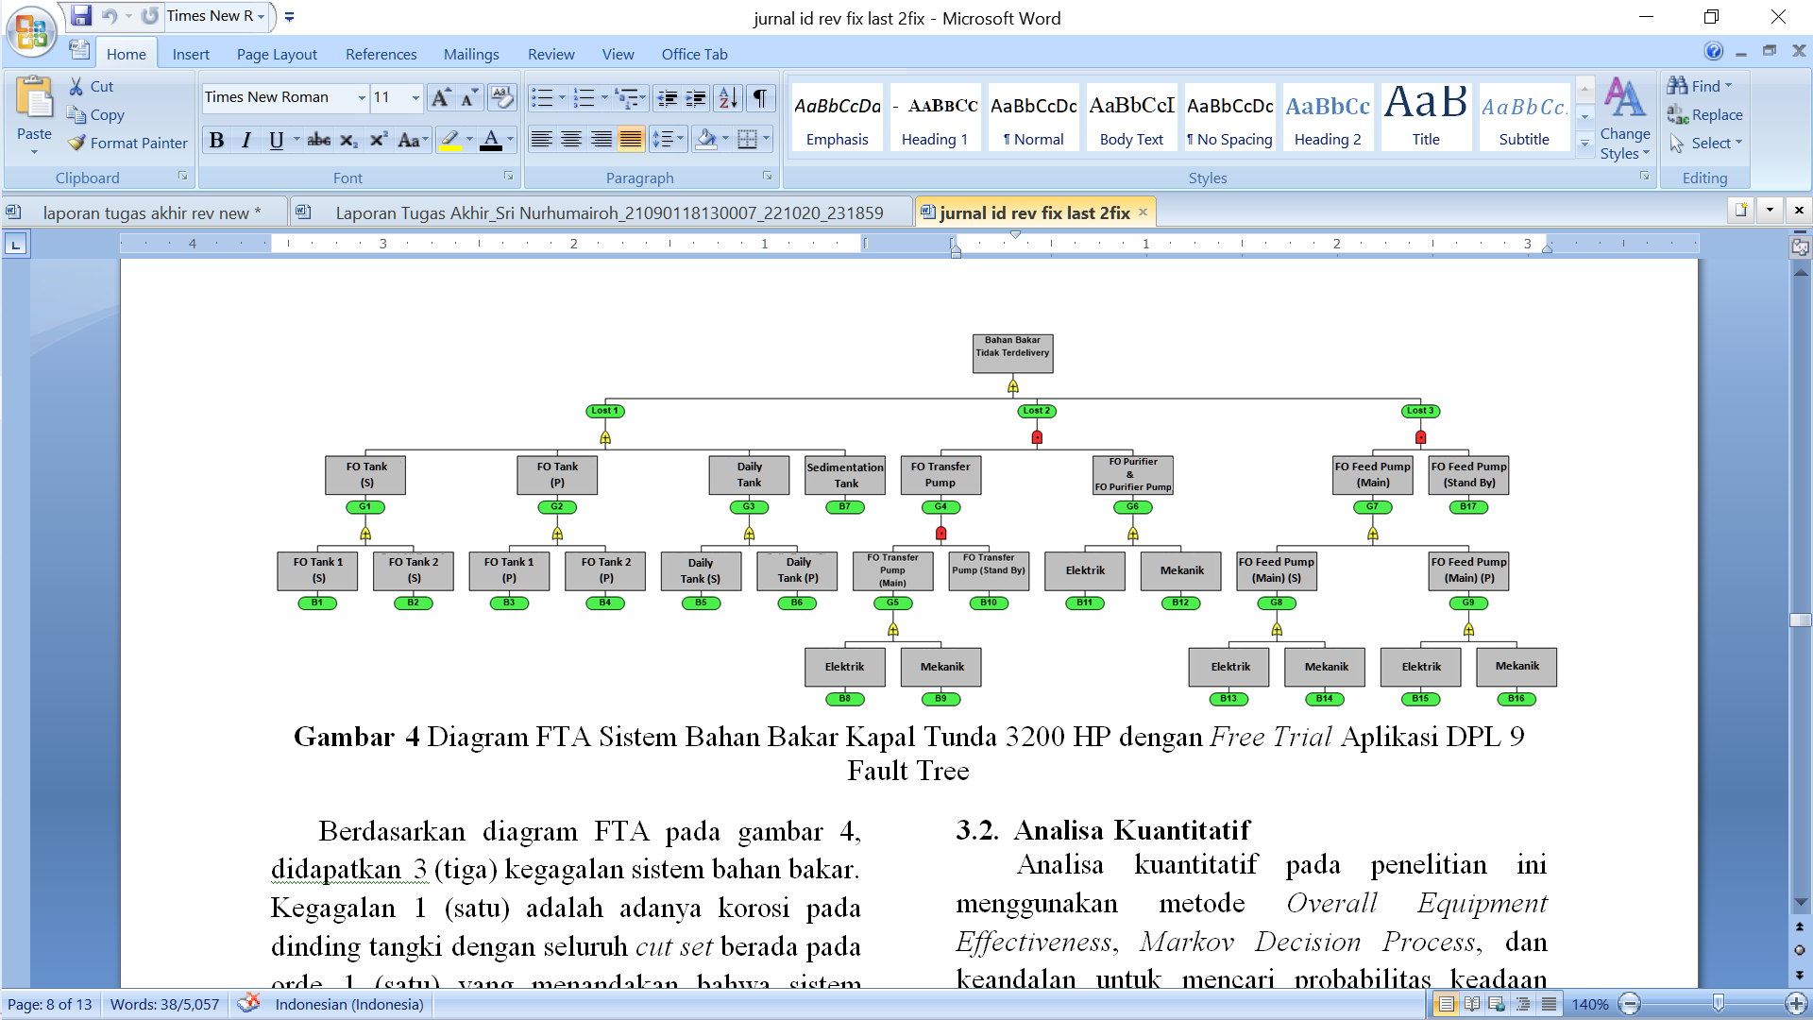

Figure 4. FTA diagram of 3200 hp tugboat fuel oil system

Based on the FTA diagram in Figure 4, there are 3 (three) failures of the fuel oil system. Lost 1 (one) is corrosion on the tank wall with all cut sets on the order of 1 (one) which indicates that the system will immediately fail if one of the cut sets fails, lost 2 (two) and 3 (three) are a lack of pressure fuel flow with cut sets on the order of 2 (two) and 3 (three) which indicates that the system will not immediately fail if one of the cut sets fails, but until at least the cut set fails. The minimum cut set for system failure can be seen in Table 6.

Table 6.Minimal cut sets of 3200 hp tugboat fuel oil system

| **Code** | **Minimal Cut Set** | **Orde** |
| --- | --- | --- |
| B1 | FO *Tank* 1 (S) | 1 |
| B2 | FO *Tank* 2 (S) | 1 |
| B3 | FO *Tank* 1 (P) | 1 |
| B4 | FO *Tank* 2 (P) | 1 |
| B5 | *Daily Tank* (S) | 1 |
| B6 | *Daily Tank* (P) | 1 |
| B7 | *Sedimentation Tank* | 1 |
| {B8 or B9, B10, B11 or B12} | FO *Transfer Pump* Electric or FO *Transfer Pump* Mechanical, FO *Transfer Pump Stand By*, FO *Purifier* & FO *Purifier Pump* Electric or , FO *Purifier* & FO *Purifier Pump* Mechanical | 3 |
| {B13 or B14 or B15 or B16, B17} | FO *Feed Pump* (S) Electric or FO *Feed Pump* (S) Mechanical or FO *Feed Pump* (P) Electric or FO *Feed Pump* (P) Mechanical, FO *Feed Pump Stand By* | 2 |

* 1. **Overall Equipment Effectiveness (OEE)**

By using the availability, performance, and product quality based on the data recorded by the company to obtain the OEE value, these values ​​are generated which can be seen in table 7.

Table 7.Calculation of availability, performance, and product quality of 3200 hp tugboat fuel oil system

| **Month** | **Utility Plan (Hours)** | **Utility (Hours)** | **Tugboat Availability**  **(Hours)** | **Number of Services** | **Ideal Time per-Ship Service**  **(Hours)** | | **Availability** | **Performance** | | **Quality Product** | |
| --- | --- | --- | --- | --- | --- | --- | --- | --- | --- | --- | --- |
| January | 517.30 | 485.67 | 720.67 | 323 | 1.25 | **96%** | | **83%** | **94%** | |
| February | 483.70 | 407.75 | 654.08 | 261 | 1.25 | **89%** | | **80%** | **84%** | |
| March | 516.60 | 475.08 | 725.08 | 318 | 1.25 | **94%** | | **84%** | **92%** | |
| April | 500.50 | 407.80 | 680.08 | 269 | 1.25 | **86%** | | **82%** | **81%** | |
| May | 517.30 | 302.33 | 614.83 | 197 | 1.25 | **70%** | | **81%** | **58%** | |
| June | 491.05 | 377.92 | 691.08 | 267 | 1.25 | **78%** | | **88%** | **77%** | |
| July | 517.30 | 407.33 | 721.25 | 289 | 1.25 | **81%** | | **89%** | **79%** | |
| August | 517.30 | 414.08 | 729.00 | 304 | 1.25 | **81%** | | **92%** | **80%** | |
| September | 499.80 | 366.25 | 706.33 | 262 | 1.25 | **74%** | | **89%** | **73%** | |
| October | 517.30 | 326.17 | 714.50 | 225 | 1.25 | **65%** | | **86%** | **63%** | |
| November | 500.50 | 80.92 | 225.33 | 55 | 1.25 | **51%** | | **85%** | **16%** | |
| December | 0.00 | 0.00 | 0.00 | 0 | 0.00 | **0%** | | **0%** | **0%** | |

Based on the data owned in Table 1 and calculated using the Eq. 2, 4, 6, and 8 in Table 7, the OEE value of the tugboat fuel oil system obtained are as shown as Table 8.

Table 8. Results of calculation of OEE fuel oil system

|  |  |
| --- | --- |
| **Month** | **OEE** |
| January | 75% |
| February | 60% |
| March | 72% |
| April | 58% |
| May | 33% |
| June | 53% |
| July | 56% |
| August | 60% |
| September | 49% |
| October | 35% |
| November | 7% |
| December | 0% |

OEE value tends to be small when the tugboat's utility is small, which means that the level of system productivity is small because the tugboat is not operating.

* 1. **Markov Decision Process (MDP)**

Based on the OEE value that has been obtained, in Table 9 shows the status of the fuel oil system for the main propulsion engine of the tugboat for the period January 2020 – December 2020.

Table 9. Fuel oil system status

| **Month** | **Condition** | **State** |
| --- | --- | --- |
| January | Light Damaged | 2 |
| February | Moderate Damaged | 3 |
| March | Light Damaged | 2 |
| April | Moderate Damaged | 3 |
| May | Severe Damaged | 4 |
| June | Moderate Damaged | 3 |
| July | Moderate Damaged | 3 |
| August | Moderate Damaged | 3 |
| September | Moderate Damaged | 3 |
| October | Severe Damaged | 4 |
| November | Severe Damaged | 4 |
| December | Severe Damaged | 4 |

Then, based on the existing system status, it is necessary to calculate the change from each state to another as shown as Table 10.

Table 10. Status transition of fuel oil system

| **System Status** | **Status to System Status** | | |
| --- | --- | --- | --- |
| **Light Damage**  **(LD)** | **Moderate Damage**  **(MD)** | **Severe Damage**  **(SD)** |
| Light Damage (LD) | 0 | 2 | 0 |
| Moderate Damage (MD) | 1 | 3 | 2 |
| Severe Damage (SD) | 0 | 1 | 2 |

After calculating the transition of each state to another, it is necessary to calculate the number of transitions to the existing state as shown as Table 11.

Table 11. Number of transitions of fuel oil system status

|  |  |  |  |
| --- | --- | --- | --- |
| **Number of Transitions to Status** | | | **Amount** |
| **Light Damage**  **(LD)** | **Moderate Damage**  **(MD)** | **Severely Damaged**  **(SD)** |
| 1 | 6 | 4 | 11 |

Then find the probability that will be a reference for determining the steady state condition by dividing the transition to status by the total number of transitions. The results obtained as shown as Table 12.

Table 12. Probability of fuel system transition

|  |  |  |  |
| --- | --- | --- | --- |
| **Probability** | | | **Amount** |
| **Light Damage**  **(LD)** | **Moderate Damage**  **(MD)** | **Severely Damaged**  **(SD)** |
| 0.09 | 0.55 | 0.36 | 1.00 |

To find the long-term probability, first have to calculate the initial probability by dividing the transition to the state by the number of transitions from the original state obtained from Table 10 thus, the initial probability matrix of the system will be formed. With Eq. (9) calculate the transition probability matrix until the matrix value remains at a certain n (steady state) which is the probability matrix of the long-term system status.

$$B^{1}= \left[\begin{matrix}LD to LD & LD to MD & LD to SD \\ MD to LD & MD to MD & MD to SD \\ SD to LD & SD to MD & SD to SD\end{matrix}\right]$$

$$B^{1}= \left[\begin{matrix}0.00 & 1.00 & 0.00 \\ 0.17 & 0.50 & 0.33 \\ 0.00 & 0.33 & 0.67\end{matrix}\right]$$

$$B^{2} =\left[\begin{matrix}0.17 & 0.50 & 0.33 \\ 0.09 & 0.53 & 0.39 \\ 0.06 & 0.39 & 0.56\end{matrix}\right]$$

$$B^{3} =\left[\begin{matrix}0.09 & 0.53 & 0.39 \\ 0.09 & 0.48 & 0.43 \\ 0.07 & 0.43 & 0.50\end{matrix}\right]$$

$$B^{4} =\left[\begin{matrix}0.09 & 0.48 & 0.43 \\ 0.08 & 0.47 & 0.45 \\ 0.07 & 0.45 & 0.48\end{matrix}\right]$$

$$B^{5} =\left[\begin{matrix}0.08 & 0.47 & 0.45 \\ 0.08 & 0.46 & 0.46 \\ 0.08 & 0.46 & 0.47\end{matrix}\right]$$

$$B^{6} =\left[\begin{matrix}0.08 & 0.46 & 0.46 \\ 0.08 & 0.46 & 0.46 \\ 0.08 & 0.46 & 0.46\end{matrix}\right]$$

The calculation stops at the value of n = 6 because the matrix values ​​at n = 6 and n = 7 are the same, which means the system is in steady state. With QM for Windows V5 application, the long term probability that found by steady state matrix have obtained as shown as Table 13.

Table 13. Probability steady state of fuel oil system by QM for Windows V5 application

|  | **State 1** | **State 2** | **State 3** |
| --- | --- | --- | --- |
| **State 1** | 0.0801 | 0.4644 | 0.4554 |
| **State 2** | 0.079 | 0.4626 | 0.4584 |
| **State 3** | 0.0774 | 0.4584 | 0.4642 |
| **Steady State Probability** | 0.0783 | 0.4609 | 0.4609 |

With reference to the transition probability in Table 12, the status of the steady state probability of fuel oil system show in Table 14 by rounding up the matrix elements.

Table 14. Fuel oil system status of steady state probability

|  | **Probability** | **Condition** | **State** |
| --- | --- | --- | --- |
| $$X_{1}$$ | 0.08 | LD | 2 |
| $$X_{2}$$ | 0.46 | MD to SD | 3 |
| $$X_{3}$$ | 0.46 | MD to SD | 3 |

Proposed maintenance actions that can be taken based on the classification in Table 4 are preventive maintenance including periodic checks and cleaning before components fail and corrective maintenance in the form of cleaning and repair if needed so that the system can return to condition 1 (one).

* 1. **Reliability**

Based on the data of time interval for damage to the fuel oil system components of 3200 hp tugboat for the period January 2020 - December 2020 obtained from company data in Table 1 have been sorted the breakdown time interval from the smallest from each component as shown in Table 15 and using the Relyence application to find the result of best fit distribution for each components that show in Table 16 which has the highest correlation value (*r*).

Table 15. Time interval of 3200 hp tugboat components fuel oil system damage from the smallest

|  |  |
| --- | --- |
| **Component** | **Failure Time** |
| Fuel Oil Purifier | 240 |
| 336 |
| 360 |
| 456 |
| 504 |
| 528 |
| 600 |
| 624 |
| 696 |
| 720 |
| 864 |
| 984 |
| 1104 |
| Fuel Oil Transfer Pump, Fuel Oil Purifier Pump, Fuel Oil Feed Pump (S & P) | 8016 |
| Fuel Oil Tank (S & P), Daily Tank (S & P), Sedimentation Tank | 0 |

Table 16. Best fit distribution of fuel oil purifier in 3200 hp tugboat from free trial relyence application

|  |  |  |
| --- | --- | --- |
| **Rank** | **Distribution** | **r** |
| 1 | Weibull | 0,9964 |
| 2 | Lognormal | 0,992 |
| 3 | Normal | 0,9876 |
| 4 | Eksponensial | 0,9732 |

The difference in distribution of each component is influenced by the time interval between damage and the number of occurrences of damage. Therefore, components that tend to have unpredictable time intervals so that their values ​​become unstable will use the weibull distribution and components that have only one breakdown interval have no distribution.

Then, with Relyence application find the parameters of each components best fit distribution, the results show in Table 17.

Table 17. The parameters of component best fit distribution

| **Component** | **Best Fit Distribution** | **Parameter** |
| --- | --- | --- |
| Fuel Oil Purifier | Weibull 3 | γ (estimation parameter) = 108.81  η (scale parameter) = 580.41 $β$ (shape parameter) = 1.97 |
| Fuel Oil  Transfer Pump, Fuel Oil Purifier Pump, Fuel Oil Feed Pump (S & P) | None, because the damage data is only once during the sample period | - |
| Fuel Oil Tank (S & P), Daily Tank (S & P), Sedimentation Tank | None, because no damage occurred during the sample period | - |

To find the failure time for each components based on the best fit distribution of each components and parameters that found using Eq. 17

MTTF = γ + η . (1 + $\frac{1}{β}$)

= 108.81 + 580.41 . (1 + $\frac{1}{1.97}$)

In the gamma function table the value of (1 + $\frac{1}{1.97}$) = 2.67

= 108.81 + (580.41 . 2.67)

= 1658.50 hours

With an MTTF value of 1658,50 hours, the fuel oil purifier has a reliability value of 0.01 according to the graph which can be seen in Figure 5.

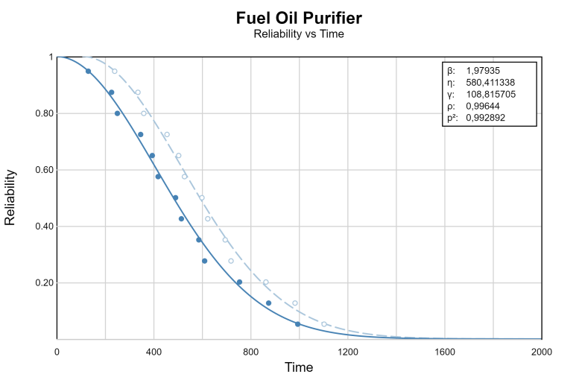

Figure 5.Graph of reliability vs time based on best fit distribution of fuel oil purifier

Fuel oil transfer pump, fuel oil purifier pump, fuel oil feed pump (S & P) have no distribution because the damage only occurs once in the sample period so that the MTTF is the same as the time interval of the damage in the sample period, which is 8016 hours with a reliability value of 0.

Fuel oil tank (S & P), daily tank (S & P), sedimentation tank do not have distribution because there is no damage in the sample period so the MTTF cannot be known.

Based on the quantitative analysis of OEE, MDP and reliability, the recommended time to perform preventive maintenance and corrective maintenance on the fuel system components of the tugboat is as shown as Table 18.

Table 18. Proposed scheduling and action for 3200 hp tugboat fuel oil system components

| **Components** | **Type of**  **Maintenance** | **Schedule** | **Conditions** |
| --- | --- | --- | --- |
| Fuel Oil Purifier | Preventive Maintenance  (Periodic Checks and Cleaning if necessary) | After operating for 340 hours or the equivalent of having served approximately 272 ships. | Has a probability of failure of 15% or a reliability value of 85% and less than the component's MTTF value. |
| Preventive & Corrective Maintenance  (Periodic Checking, Cleaning, and Repairing if necessary) | After operating for 590 hours or the equivalent of having served approximately 472 ships. | Has a probability of failure of 50% or a reliability value of 50% and less than the component's MTTF value. |
| Fuel Oil Transfer Pump, Fuel Oil Purifier Pump, Fuel Oil Feed Pump (S & P) | Preventive & Corrective Maintenance  (Periodic Checking, Cleaning, and Repairing if necessary) | After operating for 8016 hours or the equivalent of having served approximately 6412 ships. | Has a probability of failure of 100% or a reliability value of 0% and equal to the component's MTTF value. |
| Fuel Oil Tank (S & P), Daily Tank (S & P), Sedimentation Tank | Preventive Maintenance  (Periodic Checks and Cleaning if necessary) | After operating for 8016 hours or the equivalent of having served approximately 6412 ships. | - |

This research is reviewed with the results of the reliability analysis of the fuel system components that operate for 24 years with a sample period of 5 (five) years due to components that do not have a distribution effect in the sample period of this study the components did not experience more than one failure times. This shows that the component life at statement values of 0.85 and 0.5 in the 3200 HP tugboat fuel system study using the Weibull distribution which has a sample period of 1 (one) year with qualitative and quantitative methods is not less than the age of the research components which have a period up to 5 (five) years in which all components having distribution.

1. **Conclusion**

The 3200 HP tugboat fuel oil system which serves 2770 ships within one year in the period January 2020 - December 2020 based on the analysis of the FMEA method has a critical component namely the FO Purifier with an RPN value of 294 which is then analyzed using the FTA method stating that this component is one of the cut set of system failure causes of order 3.

The condition of the 3200 HP tugboat fuel oil system for that period was then analyzed using the MDP method which obtained values of 0.08 and 0.46 so that, with these values it is predicted that for the next period of one year the fuel system will have light damage and moderate to severe damage. Based on the classification, with these conditions, it is proposed that maintenance be of the type of preventive maintenance in the form of periodic checking and cleaning if necessary and corrective maintenance in the form of repairs if necessary for each component so that it can meet the Standards of the Japan Institute of Plant Maintenance.

Scheduling the proposed maintenance for each component is analyzed based on the reliability value which is carried out before the MTTF time so that the proposed preventive maintenance FO purifier is carried out no more than 340 hours of use with a reliability value of 85% and no more than 590 hours of use with a reliability value of 50% and corrective maintenance is carried out when component reliability is 50%, proposed preventive and corrective maintenance actions for FO transfer pump and FO feed pump (S&P) carried out before 8016 hours, and proposed preventive maintenance actions for FO tanks (S&P), sedimentation tanks, and daily tanks (S&P) ) before 8016 hours.

**Acknowledgment**

I am much obliged to all of those who support me in the pursuit this work especially one of ship towing company in Indonesia as one who gave me the data for the object of this work, Ir. Imam Pujo Mulyatno MT, Ir. Sarjito Joko Sisworo MT, and Dr. Tuswan ST who enlighted me with their knowledge, patience, spirit, and favor during the process of this work. Without all your kindness, this work will not have done as well.

**References**

1. A.K. Samlawi, "Teori Dasar Motor Diesel." 2015.
2. H. Henk, “Tug use in port: a practical guide”, Nautical Institute, 2003.
3. C.F. Prasetyo, H. Yudo, A.F. Zakki, A.H. Muhammad, "Analisa Perawatan Berbasis Keandalan Sistem Bahan Bakar pada Main Engine di Kapal KM. Kelimutu." Jurnal Penelitian Enjiniring 25, no. 2 (2021): 132-140.
4. M. Jirgl, Z. Bradac, K. Stibor, and M. Havlikova. "Reliability analysis of systems with a complex structure using Monte Carlo approach." IFAC proceedings volumes 46, no. 28 (2013): 461-466.
5. S. Xiao, S. Oladyshkin, and W. Nowak, "Reliability sensitivity analysis with subset simulation: application to a carbon dioxide storage problem." In IOP Conference Series: Materials Science and Engineering, vol. 615, no. 1, p. 012051. IOP Publishing, 2019.
6. C. Guo and Z. Liang, "A predictive Markov decision process for optimizing inspection and maintenance strategies of partially observable multi-state systems." Reliability Engineering & System Safety 226 (2022): 108683.
7. S. Nakajima, "Introduction to TPM: total productive maintenance. (Translation)", Productivity Press, Inc., 1988, (1988): 129.
8. M.F. Gaffar, "Analisa keandalan sistem bahan bakar pada kapal KM Pangrango dengan pemodelan dinamika sistem=Analysis of the reliability of the fuel system on the ship KM Pangrango with system dynamics modeling." PhD diss., Universitas Hasanuddin, 2022.
9. D. Press, “Guidelines for failure mode and effects analysis (FMEA), for automotive, aerospace, and general manufacturing industries”, CRC Press, 2003.
10. S. Kristiansen, “Maritime transportation: safety management and risk analysis”, Routledge, 2013.
11. C.E. Ebeling,  “An introduction to reliability and maintainability engineering”, Waveland Press, 2019.
12. I. Oliver, “Markov processes for stochastic modeling”, Newnes, 2013.
13. D. Kececioglu, “Realiability Engineering Handbook , vol. 2”, Destech Publications, inc, Lancaster, Pennsylvania 17601, U.S.A, 2002.
14. R.E. Walpole, H.M. Raymond, “Ilmu Probabilitas dan Statistik untuk Insinyur dan Ilmuan”, Bandung: ITB; 1995.
15. D.C. Montgomery, “Introduction to statistical quality control”, John Wiley & Sons, 2020.