Study of the Motion Performance of Marine Current Power Plant Turbine Floaters Due To Ocean Current Forces under Moored Conditions

Afian Kasharjanto^{1*}, Erwandi¹,Eko Marta¹,Zulis irawanto¹,Daif Rahuna¹,Cahyadi SJM¹
¹ National Research and Innovation Agency (BRIN),

Abstract

The Paris agreement of April 22, 2016, is an agreement of a number of countries due to the threat of global climate change. The agreement was ratified by at least 55 countries that have contributed at least 55% of greenhouse gas emissions, including Indonesia. To realize the agreement, Indonesia targets carbon emissions to reach 0% in 2060 and is replaced by optimizing the use of renewable energy sources. Indonesia as an archipelago country, with the potential of thousands of straits can be utilized as a source of ocean currents as a source of electrical energy. The electricity generated is obtained from a turbine rotor that rotates due to the force of the ocean current flow. To support the turbine rotor to move in the sea, a floating support structure is needed. In this study, a trimaran tipe support structure is used where on the left and right sides are installed 2 (pieces) turbine rotors @ 50 Kw each, so that the total has a capability of 200 Kw (@4 x 50 kw). The novelty of this study is the utilization of Trimaran technology in marine current power generation turbines, which has good stability,low resistance and a wider deck area rather than monohull structures so it can be used to place electrical, mechanical equipment and operator operational. Numerical study using Computer-aided Fluid Dynamics (CFD)is used to calculated the program. The results showed that the floater only moves backward and then is pulled forward again with a small amplitude of movement in X-direction, while those on the Y and Z axes are so small that they can be ignored, .The turbine floater can be immediately stabilized and the turbine rotor will rotates due to the force of the ocean current received..

Keywords: Marine Current energy, Mooring; Numerical Study; Net Zero Emission; Platform Floater; Resistance

1. Introduction
Environmental health threats due to excessive utilization of fossil energy sources result in health problems, droughts, crop failures, unclear weather changes, world disasters and others. The need to immediately switch to Renewable Energy sources (RE) is an urgent need for the future of our children and grandchildren. At this time, we can feel the threat in our daily lives. The extreme rise in temperature can result in the melting of polar ice caps, increasing the volume of sea water and resulting in the occurrence of el nino, landslides, storms and so on. The increase in population, agricultural and industrial activities contribute to the destruction of the ozone layer in the earth's atmosphere (Juliansari, 2012).
------------------------------------------------------------------
^{*)} Corresponding author.
E-mail: afia001@brin.go.id
In connection with these threats, the Government is trying hard to reduce these impacts through an accelerated program to increase the contribution of renewable energy sources. In 2025, it is planned that the contribution of renewable energy will be 23% and by 2060 it is expected to achieve 0% utilization of fossil energy sources and completely all the energy consume will be from the results of renewable energy sources (NZE 0%). But the target seems difficult to achieve, considering that in this year, the contribution of renewable energy has only reached 11.2% (Pribadi, Menteri ESDM : Perlu Upaya Konkrit dan Terencana Capai Target Bauran 23% Di Tahun 2025, 2021).
Utilization of renewable energy sources will be very important in the future. Researchers from all over the country are competing to contribute the results of research that has been carried out. The country that first succeeds in providing solutions to its research findings will be the winner in the future. We can no longer be just spectators and users of technology resulting from research on renewable energy sources. Countries that master the technology of utilizing renewable energy will become winners in the world's economic and political life. We as a country that has abundant renewable energy sources, must try hard so that the sources in our country are not controlled by other countries.
For Indonesia as a country with thousands of large and small islands, the utilization of renewable energy resources from the sea is quite large but has not been widely explored. The RE sources consist of several energy resources as listed in Table 3 (Pribadi, Potensi Energi baru terbarukan di Indonesia, 2023).
Tabel 1. The potential of renewable energy in Indonesia
No | Energy resource | Potential  (GW) | Utilization  (GW)
1 | Solar | 3.295 | 0.27
2 | Hydro | 95 | 6.69
3 | Bio energy | 57 | 3.09
4 | Wind | 155 | 0.15
5 | Geothermal | 24 | 2.34
6 | Sea | 60 | 0
 | TOTAL | 3.686 | 12.54
Unfortunately, in table 1, it is mentioned that RE sources from the sea, which have a potential of 60 GW, are still not utilized at all (0 GW) compared to other RE sources that have been widely utilized. Meanwhile, in many countries, there has been a rapid development of tidal current energy system to convert the energy in seawater into electrical energy (Melo & Jeffrey, 2018).
This opportunity must be immediately utilized through optimization of research results on the potential of EBT sources from the sea, utilization of the potential for energy sources from the sea is so important, as stated by Yeti Rochwulaningsih et all (Rochwulaningsih, Sulistiyono, Masruroh, & Maulany, 2019) that even though Indonesia is very rich in natural resource potential, Indonesia is very vulnerable to price change shocks and easily enters the global economic crisis compared to other developing countries, this is due to errors in the management of the utilization of existing potential including errors in managing the potential for natural resource wealth in the form of islands and marine wealth as well as the potential for human resources and other potentials. Therefore, the Government must encourage the utilization of the potential of the sea including the potential energy sources from the sea for the welfare of the nation. The turbine is supported by a fixed of floating system to prop and keep the turbines in a specific site. According to several study, the floating system is more suitable to extract tidal current energy potentials near the seawater surface (Junianto, Mukhtasor, Prastianto, & Jo, Effects of demi-hull separation ratios on motion responses of, 2020). In its development, the turbine rotor operation can be supported by a mast placed on the seabed (fixed) or supported by a catamaran or trimaran-shaped float where the turbine rotor is installed in the center between the hulls.
The monohull ship type have been widely used in many years. But nowadays, the use of multihull ship is significantly increase due to its better transverse ability. The use of the catamaran type has a number of advantages, namely in terms of good stability, small resistance and a large enough deck area compared to monohull ships. The trimaran ship has multihull which tend to be shorter in size and are located on both side of the main hull. The design of trimaran hull is aimed to form a less resistance at high speeds (Tupan & Luhulima, 2020).
The utilization of catamaran or trimaran type ships has been used for researchers in ship design because of the small resistance element. Besides having advantages in transverse direction stability and having a wider deck than the monohull type of ship. This type also has a smaller total resistance value so that it can be applied to almost all types of ships that require small resistance values, such as fast boats, cruise ships, fishing boats, warships and others. Murdijanto et al (Murdijanto, Utama, & Jamaludi, 2011) has carried out testing of resistance differences between monohull, catamaran and trimaran ships in the Indonesia hydrodynamics laboratory (LHI)-BRIN. The results of the analysis show that catamaran and trimaran ships produce smaller resistance values than the monohull type. This shows that the addition of empty space at the bottom of the ship is able to accelerate the flow of water and reduce the resistance value. From the advantages mentioned above, trimaran technology is more widely used in ship operations, both for warships, ships, fish, passenger ships, tourist ships, research ships and others
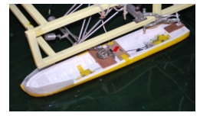
(a)

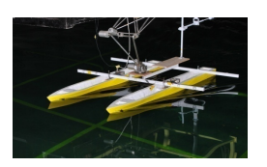
(b)

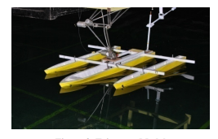
(c)
Figure 3. The (a). monohull vessel, (b). catamaran vessel, and (c). trimaran vessel (Murdijanto, Utama, & Jamaludi, 2011)
Since 2006 Indonesian Hydrodynamic Laboratory (IHL) BPPT (now BRIN) has conducted research and developed a technology converts the ocean energy resources into electricity, the kinetic energy of marine current and the potential energy of wave (Erwandi, 2018). BRIN has conducted studies on the development of ocean current turbines with catamaran-type floaters through model testing and prototype testing of 2 Kw and 10 Kw scales. Sony Junianto (Junianto, Mukhtasor, Prastianto, & Wardhana, Motion Responses Analysis for Tidal Current Energy Platform: Quad-Spar and Catamaran Types, 2020) conducted a design study of a catamaran-type ocean current turbine that was refined into a quadspar. Floater Turbine on mooring where the results showed that in the previous design, the monohull turbine showed a turbine rotation that was not too significant in influencing the motion response of the floating structure of the power plant. In addition, the motion response system of the floating support structure can reduce the performance of the turbine. Also, the rotation of the turbine can actually increase the tally stress of the mooring system used. After being modified into a catamaran type (quad spar) the turbine is able to provide a small motion response while producing better rotor rotation and greater rope tension when the rotor rotates.
In this study, a trimaran type floater is used where in the middle between the hulls 2 (two) turbine rotors @ 50 Kw are installed so that the turbine is designed 200 Kw (@ 50 Kw x 4).

2. Methodology
BRIN has conducted studies on the development of ocean current turbines with catamaran-type floaters since 2009 through model testing and 2 Kw and 10 Kw scale prototype testing. Sony Junianto (Sony Junianto et al., 2020) conducted a design study of a catamaran-type ocean current turbine that was refined into a quadspar. Floater Turbine on mooring where the results showed that in the previous design, the monohull turbine showed a turbine rotation that was not too significant in influencing the motion response of the floating structure of the PLTAL, as well as the motion response system of the floating support structure could reduce the performance of the turbine. Also, the rotation of the turbine can increase the talli stress of the mooring system used.
Under practical operation conditions, hydrodynamic characteristics of floating horizontal-axis turbine are affected by the wave-induced motion response of the floating platform for the turbine system (Zhang, Wang, Sheng, Jing, & Ma, 2015). Ship resistance is defined as the force required to tow the ship in calm water at a constant velocity. The element of ship resistance occurs on a moving ship consists of wave resistance (Wave making resistance and wave breaking resistance) and fluid resistance (Viscous resistance). Wave making resistance occurs due to energy lost because it is used in the formation of waves as an interaction between the hull that moves water along with the movement of the ship. Wave breaking resistance is the energy required for ships moving against ocean waves.
In mooring an ocean current turbine, the mooring system is an important component, because it is to keep the turbine in stable condition (not moving position) (Shueei-Muh Lin et al., 2022) . Kai et al (Kai Wang et al., 2023) explains that the performance of the mooring system will affect the cost of floating offshore wind turbines in shallow water and the durability in extreme conditions so that the turbines can be dragged by the current. It is claimed that the concept has maximum strength against the risk of rope breakage, reduces the length of mooring ropes, and can withstand extreme conditions in shallow water areas.
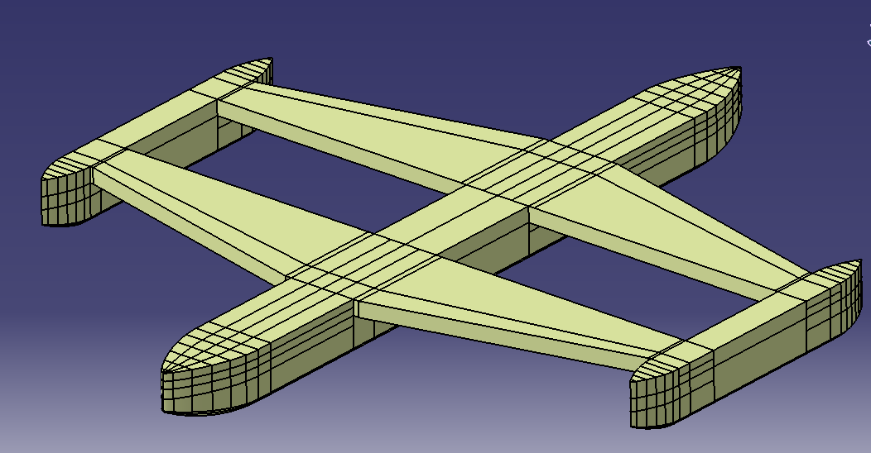
Figure 4. Isometric design of the 200 Kw marine current turbine

Figure 4 and 5 are the process design of 200 Kw- marine current turbine which is implemented by BRIN. It shows the numerical design and manufacturing process at laboratory workshop. The turbine are designed as a trimaran.

The holes between the left and right hulls are for the placement of turbine rotors, 2 (two) each on the left side @ 50 Kw and 2 (two) on the right side @ 50 Kw. Floater size data as follows:
Length (main Hull) : 25.00 meter
Length (side Hull) : 10.00 meter
Breadth (main hull) : 21.88 meter
Breadth (side hull) : 1.00 meter
Height : 1.70 meter
Draught : 0.55 meter
Displacement : 69,47 m3

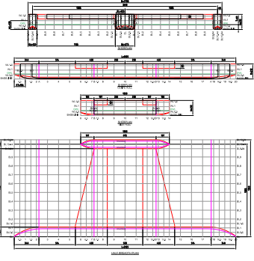
Figure 5. Main design of the current turbine

Results and discussions
In this study, a trimaran support structure is used where on the left and right sides are installed 2 (pieces) turbine rotors @ 50 Kw each, so that the total has a capability of 200 Kw (@4 x 50 kw). The novelty of this study is the utilization of Trimaran technology in marine current power generation turbines, which has good stability and a wider deck area than monohull structures for the purposes of placing electrical, mechanical and operator operational equipment.
The numerical process of the installation of an ocean current turbine when moored were generated. The direction of the ocean current is assumed to only come from the front of the turbine (x-axis) so that the movement in the direction of the Y and Z axes is very small (so it is ignored). Numerical calculations of the resistance of the 200 kW Marine current turbine platform were carried out using Computer Fluid Dynamic (CFD) software. The turbine platform is conditioned to be moored at sea so that it is at rest. However, the floater platform still has a movement force in the X, Y and Z axis directions due to the force of ocean current pressure. The graph of the movement and force that occurs when the platform receives the force of ocean current velocity in meters per second (mps) of 1 to 5 mps.

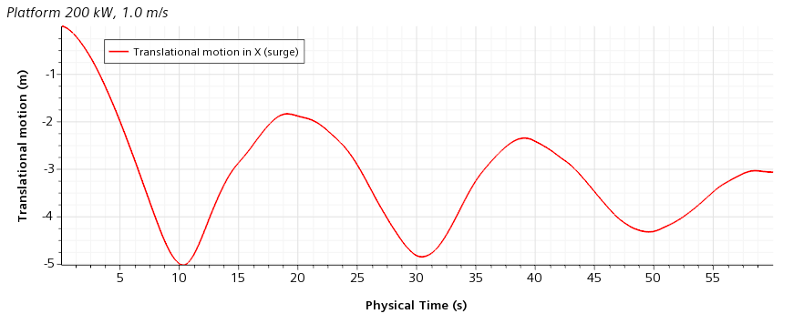
(a)
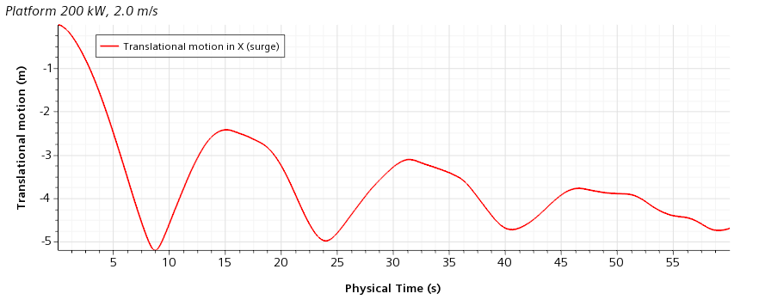
(b)
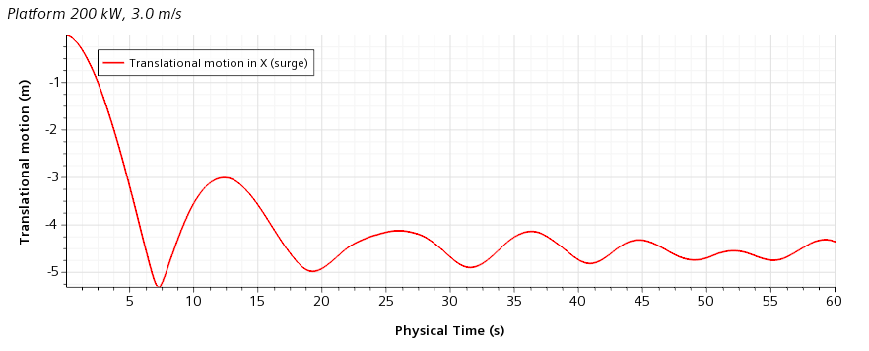
(c)
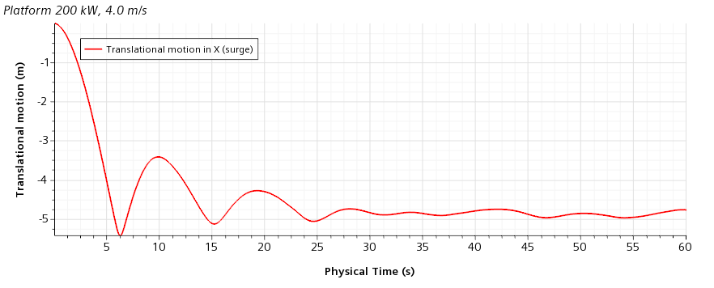
(d)
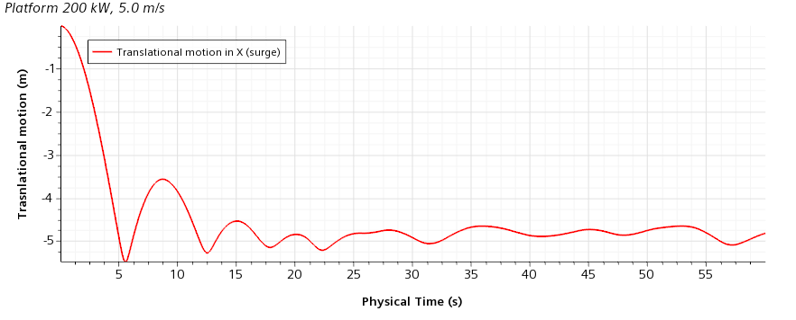
(e)
Figure 6. Translational motion in various velocity - X axis

Figure 6 shows the translational motion in the direction of the X, Y and Z axes (speed 1 mps to 5 mps), while Figure 7 shows a graph of the forces received on the hull of the floater platform due to the force of the ocean currents received.
Figure 6 (a,b,c,d,e) shows the effect of the force of the ocean current received from the front direction (condition of the moored platform) so that the platform experiences translational motion (meters) in the longitudinal (X axis), lateral (Y axis) and vertical (Y axis) directions as a function of time (seconds). The current velocity was set at 1 mps, 3 mps and 5 mps (meters per second). At a speed of 1 mps, the time taken to stabilize reached more than 1 minute. At higher current speeds, the time required is lower, reaching 25 seconds at a current speed of 4 mps and 17 seconds at 5 mps. From the results of the simulations carried out, it is shown that the higher the current speed,the faster to the stable position, so that the faster the ocean current is received, the faster the turbine balance position (oscillation movement) is getting better to reach the original position. Figure 7(a), in the X-axis direction, from second 0 to second 5, the platform experiences the initial pressure force of the ocean current from the front of the platform which causes it to be pushed back 5 meters within 5 seconds. Subsequently, the platform moved forward again due to the influence of the mooring ali attraction by 1.5 meters. This condition is repeated until the platform is stable (due to the influence of the pull-press force of the mooring rope). In figure 7(b), relatively experiencing the same phenomenon, namely at the time of the initial pull, the platform experienced a position retreat of 7 meters to the rear and figure (c) shows the platform retreated by 5 meters. While in the direction of the Y and Z axes, the force of the ocean current is not very influential because the force of the ocean current received is the force in the X-axis translation direction so that for the Y and Z axis directions it does not have a significant effect.
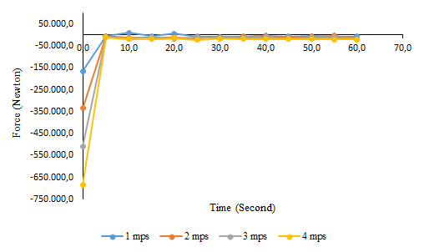
(a)
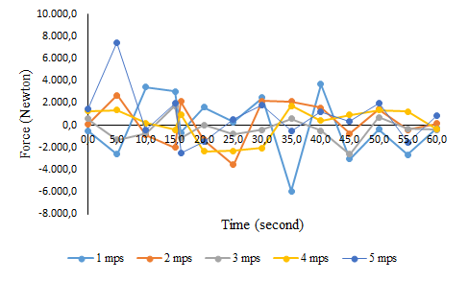
(b)
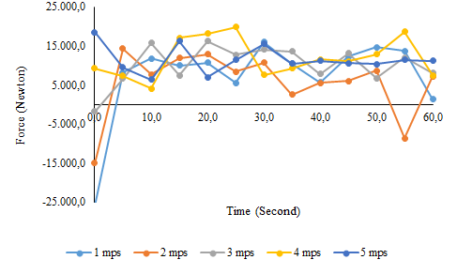
(c)
Figure 7. (a). X-axis direction of current force, (b). Y-axis direction of current force, and (c). Z-axis direction of current force
Figure 7 (a,b,c) generally show the ocean current forces received on the platform (X,Y and Z axis directions) at speeds of 1 mps, 2 mps, 3 mps, 4 mps and 5 mps. In general, it can be seen that the greater the speed of the current received, the greater the thrust force will occur, resulting in the platform being pushed back (which is marked with a negative sign.) After that, due to the force of the mooring rope, causing the platform to be pulled forward again.

5. Conclusion
This study is a study in numerical calculations to determine the performance of resistance due to ocean current forces in the condition of the floater platform moored at sea. At the beginning of the current pressure, the platform is pushed backward. Because the platform is moored, the platform is held until the mooring rope is taut, for the next mooring rope pull force, the floater platform will be "pulled" forward. In this condition, the turbine rotor begins to rotate with the speed of the ocean current. The resulting electrical energy is stored in an electric generator and transmitted to shore.
In the X-axis current force, the force will be greater for the current speed category at the same time. The greater the current velocity, the greater the compressive force will be but as time increases (t) the pressure force will be smaller and turn into a pulling force due to the mooring rope Platform will be pulled forward and the process will continue to repeat periodically until the platform is in a balanced condition (stagnant). The greater the current velocity and the longer the time received, the greater the current force will occur.
The smallest compressive force occurs during the initial push of the ocean current (displacement from second 0 to second 5. In the comparison of the pressure force in the direction of the X, Y and Z axes, the force towards the Y and Z axes is not too large compared to the X-axis direction because the current force received is from the X-axis parallel direction.

Acknowledgment : This paper is part of the activity of “Hydrodynamic Study of Floating Structure Supporting of 200 Kw Marine Current Turbine” research grant DIPA-OREM-BRIN 2023.

References
Erwandi, C. S. (2018). Vertical axis marine current turbine development in indonesian hydrodynamic laboratory-surabaya for tidal power plant. Indonesia Malaysia Research Consortium Seminar, 39.
Juliansari, K. (2012). Global Warming : Sebuah Ancaman bagi Kehidupan Makhluk Hidup di Bumi. Retrieved from Institute for Essential Services Reform: iesr.or.id
Junianto, S., Mukhtasor, Prastianto, R. W., & Jo, C. H. (2020). Effects of demi-hull separation ratios on motion responses of. Ocean Systems Engineering, 10(1), 87-110.
Junianto, S., Mukhtasor, Prastianto, R. W., & Wardhana, W. (2020). Motion Responses Analysis for Tidal Current Energy Platform: Quad-Spar and Catamaran Types. Chinese Ocean Engineering, 34(5), 677-687.
Lin, S.-M., Liauh, C. T., & Utama, D. w. (2022). Design and Dynamic Stability Analysis of a Submersible Ocean Current Generator Platform Mooring System under Typhoon Irregular Wave. Journal of Marine Science and Engineering, 10(4), 538.
Melo, A. B., & Jeffrey, H. (2018). Ocean energy systems annual report: An overview of ocean energy activities in 2018. The Executive Comitte of Ocean Energy Systems.
Murdijanto, Utama, I. K., & Jamaludi, A. (2011). An Investigation Into the Resistance/Powering and Seakeeping. Makara Journal of technology, 15(1), 25-30.
Pribadi, A. (2021, Desember 14). Menteri ESDM : Perlu Upaya Konkrit dan Terencana Capai Target Bauran 23% Di Tahun 2025. Retrieved from ebtke.esdm.go.id
Pribadi, A. (2023, February 4). Potensi Energi baru terbarukan di Indonesia. Retrieved from www.esdm.go.id
Rochwulaningsih, Y., Sulistiyono, S. T., Masruroh, N. N., & Maulany, N. N. (2019). Marine policy basis of Indonesia as a maritime state: The importance of integrated economy. Marine Policy, 108, 103602. doi:10.1016/j.marpol.2019.103602
Tupan, J., & Luhulima, R. B. (2020). A Comparison of Monohull, Catamaran, Trimaran Vessels Based on Operational Review of Fuel Use. International Journal of Engineering Research & Technology, 9(12), 431-436.
Wang, K., Chu, Y., Huang, S., & Liu, Y. (2023). Preliminary design and dynamic analysis of constant tension mooring system on a 15 MW semi-submersible wind turbine for extreme conditions in shallow water. Ocean Engineering, 283(115089).
Zhang, L., Wang, S.-q., Sheng, Q.-h., Jing, F.-m., & Ma, Y. (2015). The effects of surge motion of the floating platform on hydrodynamics performance of horizontal-axis tidal current turbine. Renewable Energy, 74, 796-802.

