|  |  |  |
| --- | --- | --- |
| **C:\Users\Lenovo\AppData\Local\Microsoft\Windows\INetCache\Content.Word\Logo UNDIPnn.png**  [2301-9069 (e)](http://issn.pdii.lipi.go.id/issn.cgi?daftar&1342508490&1&&)  [1829-8370 (p)](http://issn.pdii.lipi.go.id/issn.cgi?daftar&1180427365&1&&) | **Kapal: Jurnal Ilmu Pengetahuan dan Teknologi Kelautan**  **(Kapal: Journal of Marine Science and Technology)**  journal homepage : <http://ejournal.undip.ac.id/index.php/kapal> |  |
|  | |  |

 Enhancing Propulsion Performance for Container Ships through Propeller Adjustments: A Case Study MV. Kendhaga Nusantara 6

Zulfaidah Ariany 1)*), Budhi Santoso 2) , Suharto1) , Sarwoko1)

1. Departement of Industrial Technology, School of Vocational, Universitas Diponegoro, Semarang 50275 Indonsia
2. Department of Naval Architecture Engineering Polytechnic of Bengkalis, Riau, Indonesia

*) Corresponding Author : zariany@live.undip.ac.id

|  |  |
| --- | --- |
| **Article Info** | **Abstract** |
| **Keywords:**  Optimization, Propulsion,  Container ship; Performance ship.    **Article history:**  Received: 21/09/20  Last revised: 11/11/20 Accepted: 13/11/20  Available online: 13/11/20  Published: 28/02/21  **DOI:**  https://doi.org/10.14710/kapal.v18i1.33000 | The ship's service speed performance is prioritized in a ship's propulsion system planning. Motor Vessel. KENDHAGA NUSANTARA 6 is a type of containerized cargo ship built to support the sea toll program in the Tanjung Emas port area, Semarang. The less significant propeller pitch affects the ship's ability to move. The experiment was carried out by operating the machine with maximum capability. The phenomenon of the geometric shape of the propeller provides information on the rotation results and the distribution of the working forces. The structure of the propeller design describes the ability and level of effectiveness when the propeller is submerged in water. The results of this study show that the optimization value of the right propeller pitch is 0.6%, the pitch width is 1660 mm, and the optimization value of the left propeller pitch is 1.2% with a pitch width of 1670 mm; this value can make the ship's rate speed during the docking trial 12.3 knots, following the planned speed.  Copyright © 2021 KAPAL : Jurnal Ilmu Pengetahuan dan Teknologi Kelautan. This is an open access article under the CC BY-SA license (<https://creativecommons.org/licenses/by-sa/4.0/>). |

1. **Introduction**

As a developing country, Indonesia is an archipelago that has a large number of islands. Sea transportation links the needs and the economy of the islands in Indonesia. The area of the sea reaches 2/3 percent of the land area. One of the sea transportation methods that will be discussed more profoundly is the type of container goods ship (Container Ship). This cargo ship has a flat deck type and a container binding system. Construction on this ship is made so the existing items remain safe when operating [1].

Ship service speed performance is a matter that is highly prioritized in ship propulsion system planning. There are several requirements for a shipping system that can operate optimally, such as the shape of the ship's hull, which provides recommendations for friction and resistance. The propulsion performance must be adjusted to the total resistance and thrust requirements to move the vessel that is adapted to the desired speed [2], [3]. The skew angle and blade area ratio influence the pressure distribution on the propeller surface, consequently affecting the efficiency and performance of the propeller. Changes in the skew angle and blade area ratio can help achieve the desired performance characteristics of the propeller at various rotations. This is highly significant in propeller design to attain optimal performance under different operational conditions [4]. The addition of a kort nozzle to the propeller can enhance efficiency and thrust on the ship [5]. A propeller with an optimal thrust-to-torque ratio will enhance the efficiency of the ship's propulsion system, optimize energy consumption, and improve overall vessel performance. [6]. The study varied the advance velocity (Va) and made modifications to Va to understand how it affects hydrodynamic forces and the characteristics of the propeller in open water conditions.[7]. The Wake Deduction Value is a measure of how much the waves generated by the ship's propeller affect other propellers behind it. The lower the wake deduction value, the smaller the impact of the waves generated by the propeller on others. A lower value indicates better efficiency in energy usage and can result in better propeller performance. [8]. The optimum propulsion efficiency is influenced by the correct combination of motor type, propeller type, and appropriate RPM percentage. [9]. The overall weight of the vessel, including the hull weight, harvested fish weight, and passengers, influences the selection of the optimal propulsion system to achieve the desired efficiency. [10].

Based on observations in the field, case studies on container ships ordered by the transportation agency KM. KENDHANGA NUSANTARA 6, in the sea trial operation, found the performance of the vessel after completion of making the difference according to the plan, figure 1 . Full speed at the beginning of the experiment is 10 Knots while the planning reaches 12 Knots. The ship, weighing 1,766 GT, has a loading capacity of 100 TEUs.

The initial estimation of the diameter and pitch of the propeller is less significant, and it affects the power of the ship's ability to move less. Experiments are carried out by operating a machine with maximum capability. The energy wasted by the engine is due to the less optimal propeller rotation. They are resulting in the remaining weakened force. The shipbuilding industry is undoubtedly able to analyze how to avoid wasted energy. From the comparison of previous experimental studies regarding the shape of the propeller, optimization can be influenced by the type of propeller, propeller hub, propeller rotation, and the shape of the underwater surface of the ship [11].

1. **Methods**

As the ship's main propulsion, the propeller is located at the height of the stern, the main component that has the most influence on vessel operations, see Figure 2. The Hydrodynamic force will appear and lead the ship to give pressure to go on the boat. [12]. On this ship, the type of propeller used is a propeller whose placement is fixed on the FPP fixed pitch propeller, with material made of manganese bronze. This material is resistant to corrosion and has rigid properties, so it brands aks and has a tensile strength between 44-60 kg/mm2. For ships with shipping lanes in tropics areas, they usually use propellers with this type of material.

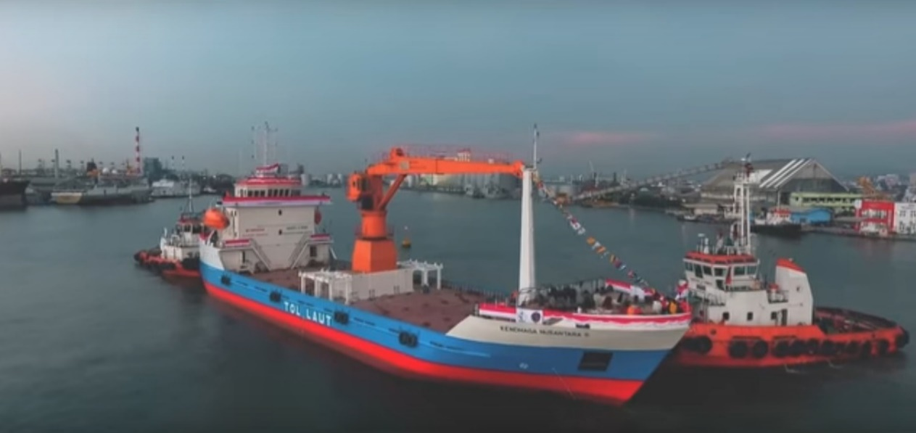

Figure 1. MV. Kendhaga Nusantara 6

. The propeller is divided into three zones based on the effects of defects and the associated risk of fatigue fractures during repairs. These zones are designated as "A," "B," and "C." Zone "A" experiences the most significant operational stress, and welding is generally not allowed in this zone. Therefore, repairs in this zone are recommended to be conducted without welding. Welding is permitted in this zone only with special approval from the ship's classification society; whenever welding is carried out, it is necessary to follow it with stress-relieving heat treatment. Zone "B" experiences high operational stress, and welding should be avoided wherever possible. Welding is allowed in this zone with pre-approval from the ship's classification society. Zone "C" experiences low operational stress, and welding is considered safe in this zone. Welding is approved by the ship's classification society whenever it is carried out using approved methods and procedures.

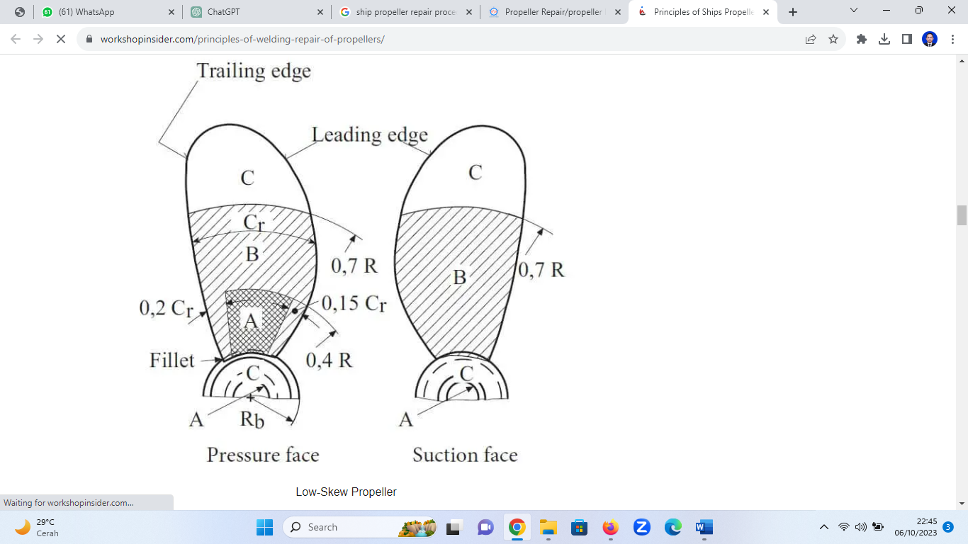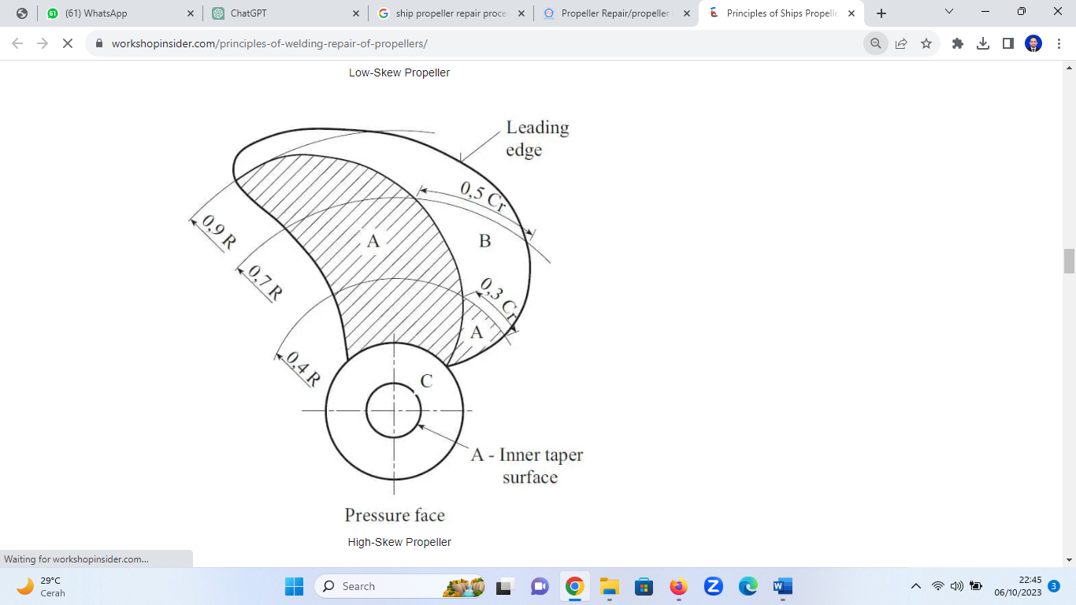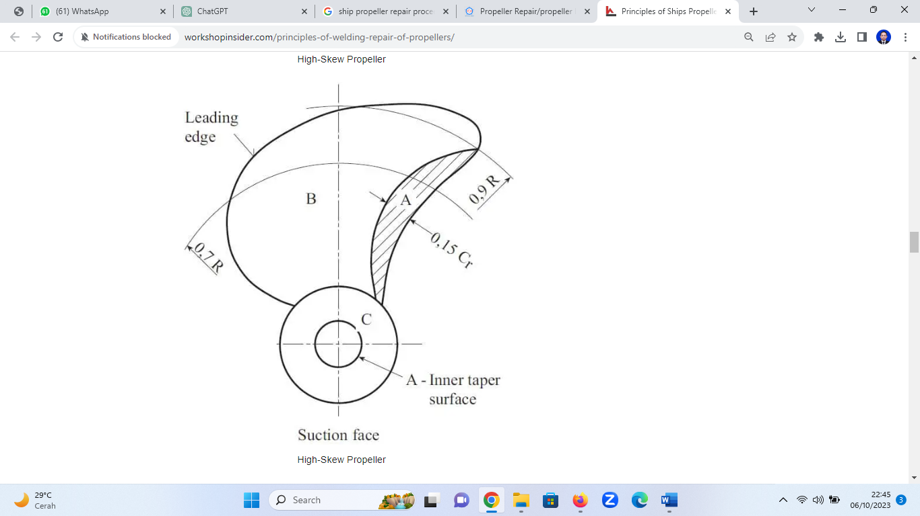

(a) (b) (c)

Figure 2. Propeller Repair Zones

* 1. **Cavitation and stress**

One of the damages that often occur in propellers is cavitation. A comparative study between tengan and cavitation explains the occurrence of cavitation due to the pressure on the back of the propeller. The formation of these tiny bubbles makes the area behind it have a low pressure so that, over time, the material is damaged, see Figure 3. The comparison has a significant value. [13]. Based on the given advance coefficient value, a speciﬁc cavitation ﬂow was set depending on cavitation number σn. The cavitation number σn and pressure coefficient cp can be deﬁned as follows [2].

σn = $\frac{P_{Ref}- P_{v}}{\frac{1}{2} ρ\left(n D\right)²}$ (1)

Cp = $\frac{P- P_{ref}}{\frac{1}{2} ρ \left(n D\right)²}$ (2)

where PRef is the pressure used for reference, Pv is absolute vapor pressure, and P is the local pressure. The basic principle of the cavitation inception criterion is classiﬁed based on σn and cp: If σn ≤ cp, cavitation will occur. The types of cavitation are determined by both the position on the propeller blade and their physical characteristics. Cavitation types related to blade location include back cavitation and face cavitation. On the other hand, cavitation types based on physical appearance encompass tip/hub vortex cavitation, sheet cavitation, bubble cavitation, root cavitation, propeller-hull vortex cavitation, and unsteady sheet cavitation. In this study, our primary focus is on examining sheet cavitation and bubble cavitation, aiming to minimize their occurrence on the propeller. These specific cavitation forms stem from low-pressure regions on the suction side of the blades. Cavitation can manifest on ship components when local pressures fall below the evaporation pressure of water. Due to the generation of high local velocities and low pressures, propellers stand as significant contributors to cavitation in marine vessels. Cavitation on propellers can result in detrimental effects, including performance degradation, noise, vibration, and erosion. This research primarily emphasizes mitigating blade erosion by minimizing cavitation while maintaining consistent propeller performance. Several approaches can be employed to reduce cavitation on the propeller, such as lowering blade rotational speed, adjusting shaft depth, utilizing anti-fouling measures, and reducing pitch. When decreasing the propeller's rotational speed to achieve a reduced local speed distribution around the blade, local pressure values tend to increase. This increase in local pressures offers an opportunity to surpass the vapor pressure of water, potentially minimizing cavitation. However, this reduction in rotational speed also leads to a loss in thrust. Compensating for this thrust loss can be achieved by enlarging the propeller diameter, although physical limitations may impede this solution in certain cases. Increasing the propeller's depth enhances hydrostatic pressure, consequently lowering the risk of cavitation occurrence. However, this depth-increasing approach may not always be applicable in the defined cases presented in this paper. Fouling increases the likelihood of cavitation and diminishes propeller efficiency. Nevertheless, if cavitation occurs in a new propeller, it signifies the necessity to modify propeller characteristics for cavitation reduction. This study specifically addresses cavitation reduction solutions for non-fouled propellers. In both fixed-pitch conventional propellers and controllable pitch propellers, reducing the angle of attack results in a higher local pressure distribution on the suction side of the blade. Figure 1 illustrates a typical pressure distribution on a blade section exhibiting a positive angle of attack.

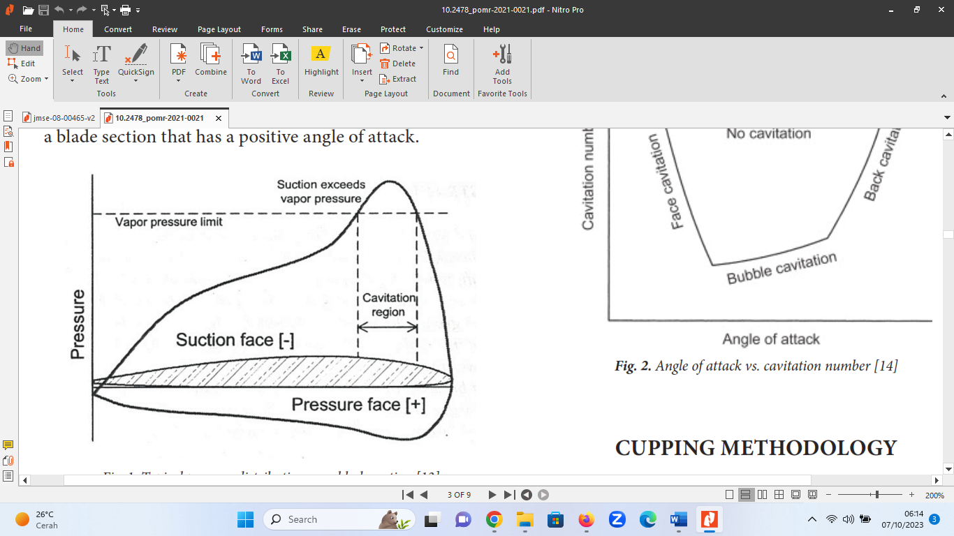

Figure 3. Typical pressure distribution on a blade section[14]

* 1. **Efficiency on the propeller**

These calculations help in evaluating how effectively a propeller converts power into thrust and how efficiently it operates in a given environment. Additional factors like cavitation, wake distribution, and blade design also influence propeller effectiveness and can be considered in a comprehensive analysis. Hull efficiency, also known as hull efficiency, refers to the effectiveness of a ship's hull in converting the propeller's generated thrust (T) at a certain water flow velocity (VA) entering the propeller's disc. Consequently, the ship moves at a speed Vs. The product of T and VA represents the horsepower delivered by the propeller, known as Thrust Horse Power (THP). On the other hand, the product of the total resistance of the ship (RT) and the ship's speed (Vs) represents the effective horsepower of the ship, known as Effective Horse Power (EHP). The ratio of EHP to THP is termed hull efficiency or hull effectiveness, indicating how effectively the hull converts the generated thrust into effective propulsion power, a critical factor in ship performance and design. The phenomenon of propeller geometry forms provides information on the results of rotation and distribution of forces acting. As well as the structure of the propeller design illustrates the ability and effectiveness when the propeller is immersed in water.

Certainly, calculating the effectiveness of propellers involves various parameters and methods. Here are some common calculations and factors used to determine propeller effectiveness Reynolds number calculation from propeller [15].

Rep= (3)

When :

$l_{0.75 }$ = length propeller

$V_{R}$ = relativization speed

- pitch on propeller calculation:

$\frac{360}{∝}∆μ$ (4)

When :

$∝$ = blade thickness

$μ$ = pitch propeller blade

Propeller efficiency is a key metric that assesses the effectiveness of a propeller in converting engine power into thrust. It is calculated as the ratio of useful thrust power to the input power.

η = $\frac{T.V}{P}$ (5)

When:

η = Propeller efficiency

T = Thrust (force generated by the propeller)

V = Velocity of the water

P = Power input

Advance ratio is a dimensionless parameter that relates the speed of the vessel to the rotational speed of the propeller.

J = $\frac{V}{n.D}$ (6)

When:

J = Advance ratio

V = Velocity of the vessel

n = Rotational speed of the propeller

D = Diameter of the propeller

Thrust coefficient is a dimensionless parameter representing the efficiency of a propeller in generating thrust. It is calculated as the ratio of thrust to the dynamic pressure and the swept area

CT = $\frac{T}{0,5ρ A V^{3} }$ (7)

When:

CT = Thrust coefficient

ρ = Density of the water

A = Swept area of the propeller blades

Power coefficient is a dimensionless parameter that signifies the efficiency of a propeller in converting power into thrust.

CP = $\frac{P}{0,5ρ A V^{3} }$ (8)

When:

CP = Power coefficient

ρ = Density of the water

A = Swept area of the propeller blades

* 1. **Metal welding**

Widening of the diameter can be done using the welding method on the propeller blade, see Figure 7. The preparation and implementation of connecting/welding were carried out using the cast metal welding method by melting bronze-based electrodes manually using heating with a cutting blender machine [16]. Using this method has several advantages other than because the material is nonferrous, so it is more effective to use this method. Manual arc welding is the most common welding technique used for welding propellers, irrespective of their material. Metal Inert Gas (MIG) welding is also employed. Additionally, Tungsten Inert Gas (TIG) welding is utilized with caution to prevent excessive heat concentration. For propellers made of casting CU1 and CU2 grades or with material thicknesses less than 30mm, the gas fusion welding method is applied. All propellers undergo welding in a down-hand position (1G) after being removed from the propeller shaft. It is essential to maintain a low inter pass temperature to minimize the risk of distortion and crack formation, especially for casting CU3 grade. A stress-relieving treatment is mandatory for all repair welds to mitigate stress corrosion cracking, except for casting CU3 grade. Stress-relieving treatment for casting CU3 grade is required in cases of significant repairs or when the filler metals used are susceptible to stress corrosion cracking.

* 1. **Balance propeller method**

This process is carried out after the propeller leaf has been repaired. Placing the propeller into a balancing bench was cleaned/polished. On the propeller blade, the welding results are reduced to balance, meaning that each propeller leaf has the same weight [17]. Properly balancing the ship's propeller is essential for efficient and safe maritime operations. It helps reduce vibration, noise, and potential damage to the propulsion system, ensuring a smooth and reliable sailing experience. The precision and accuracy of the calculations depend on the quality of the balancing equipment and the expertise of the individuals performing the balancing process. It's essential to follow safety protocols and use appropriate tools and equipment throughout the entire balancing procedure. Propeller balancing is done by placing a sign or number on each leaf of the propeller and then rotating in the direction or counterclockwise, see Figure 4.

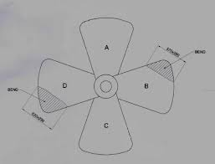

Figure 4. Balancing propeller scheme [6]

Data and Dimension of Ship.

Ship name :MV. KENDHAGA NUSANTARA 6

GT / NT : 1766 GT / 530 NT

IMO Number / Reg : 9840441/22993

Ship type : Container Ship Twin Screws

Builder shipyard : PT. Janata Marina Indah Semarang

Place, year of construction : Semarang, 2018

Indonesian flag Class : BKI

Port of Registration : Semarang

Load capacity : 100 Teus

Main Dimension :

Overall length : 74.05 M

Length between perpendicular : 69.20 M

Maximum width : 17.20 M

Height : 4.90 M

1. **Results and Discussion**

This section explains the steps taken, including propeller repair manual work in the workshop. It was followed by balancing the propeller. Once it is complete, the propeller is reinstalled to the stern of the ship, and trial docking is carried out. Furthermore, in the trial docking activity, we can find the propeller pitch calculation complete details in the following discussion.

* 1. **Propeller Reparation**

The propeller design influences the level of effectiveness and suppresses the amount of cavitation that occurs. This design proves propeller leaf-making and repair methods influence efficiency [18]. Based on studies in previous studies, the performance cases of these vessels can be carried out between ways by changing the size of the propeller, using the method:

* Before repairs are carried out, the propeller blade is grinding/polished to make cracks or surface defects more clearly visible.
* The casting welding is done using a cutting blender machine, by the bronze electrodes, then melting them on the propeller leaf tip, see Figure 5.
* The addition of width is done so that a pitch is fulfilled so that the effectiveness of the propeller can be fulfilled in line with the planned speed of the ship [19].
* After adding material, grinding is done to form a proportional propeller blade.

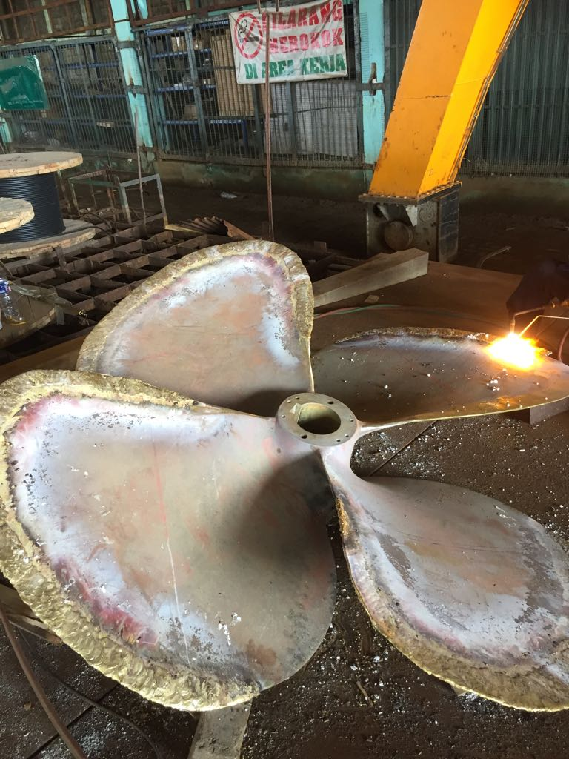 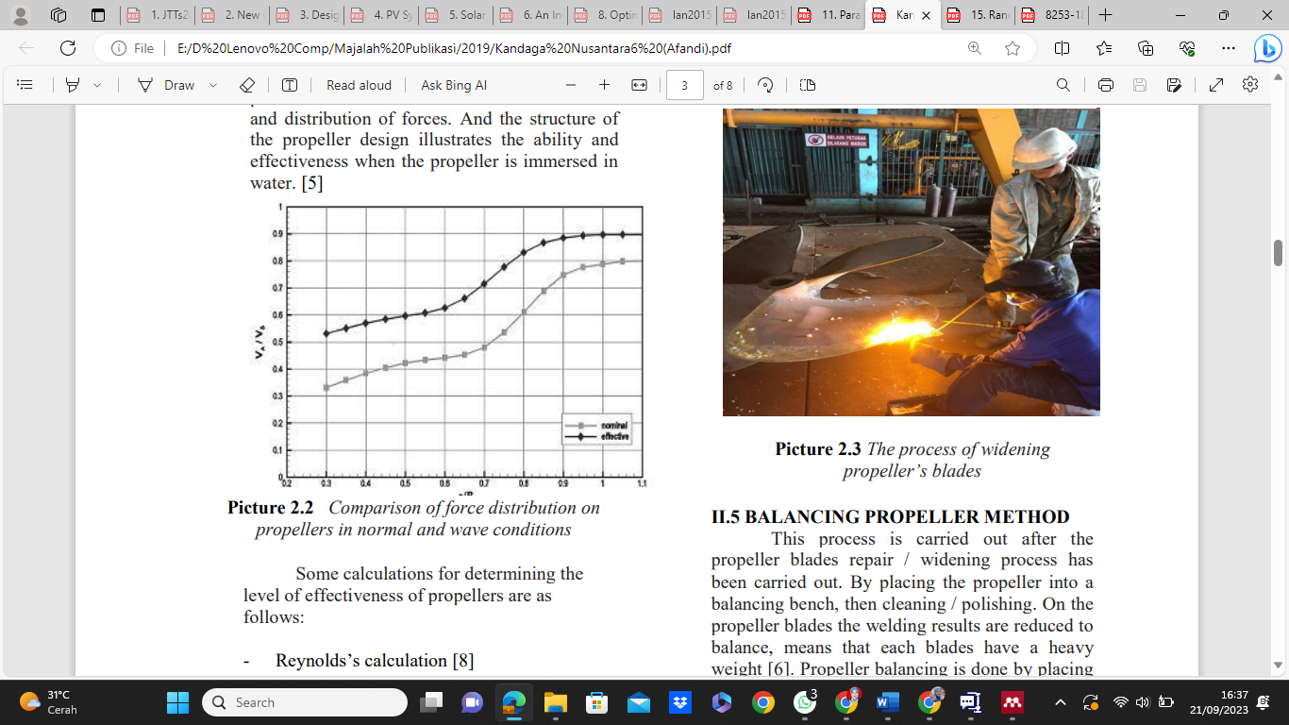

Figure 5. Reparation Propeller Figure 6. The Process of Widening Propeller’s Blades

* 1. **Cavitation**

Based on the calculations, the cavitation number (σn) for a propeller with a diameter of 1850 mm, pitch of 1650 mm, and propeller speed of 500 RPM is approximately 0.041. This assessment is based on the assumption that the reference pressure (P_Ref) and absolute vapor pressure (P_v) are under normal conditions. The fluid density is around 1025 kg/m³, consistent with seawater. The calculation results indicate that the low σn value suggests the likelihood of low cavitation on this propeller under normal operational conditions. Low cavitation is desirable because cavitation can negatively affect propeller performance, including performance degradation, noise, vibration, and erosion. Therefore, understanding and controlling cavitation on the propeller are crucial in ship propulsion system planning.

* 1. **Efficiency propeller**

Certainly, propeller efficiency calculations are crucial in evaluating how effectively a propeller converts power into thrust and how efficiently it operates in a specific environment. This efficiency value depicts the propeller's ability to restore engine power into the necessary thrust to propel the ship. With detailed data such as a thrust of 1900, water velocity of approximately 0.5, and an input power of 2200, the calculation yields a propeller efficiency of roughly 43.18%. This figure is a critical parameter in ship propulsion system design, indicating how well the propeller optimizes power usage to generate the required thrust. High propeller efficiency is a desired goal in designing energy-efficient and performance-optimized ship propulsion systems. High propeller efficiency means that the ship can operate with less power consumption, reducing fuel consumption and environmental impact while maintaining optimal performance during sea journeys.

* 1. **Balance Propeller**

After widening the propeller blade, the examination includes the balancing process by reducing the new material that is smelted on each propeller leaf [20]. With assimilation, each propeller leaf has the same weight and size. This test uses a ban bench where a transverse shaft grips the propeller. Because there are four propeller blades, the optimal balance is in the state of balance: 2 edges are vertical, and two are horizontal, see Figure 7.

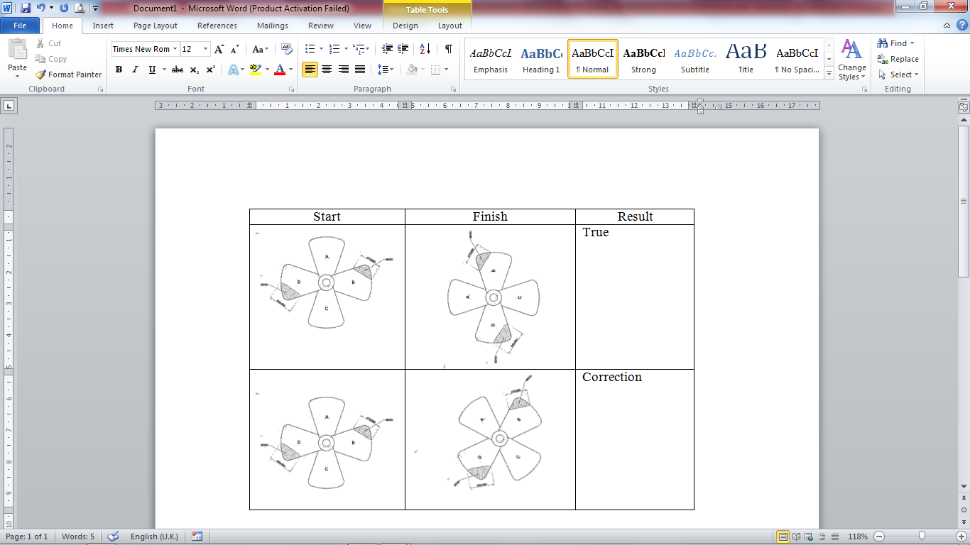

Figure 7. Balancing Propeller [21].

* 1. **Trial Docking**

The trial docking process after the ship has finished repair aims to determine the performance of the vessel's propulsion system. With the previous speed case that has not fulfilled the ship's service speed, it is expected that after the propeller pith has been widened, it can meet the maximum service speed on board the vessel, see Figure 8.

Technical implementation is as follows:

- The ship is positioned in a straight line without obstacles, or there is another passing ship.

- The ship goes at full speed (Full Speed Service).

- Monitoring of the engine room with indicators located on the bridge.

- Record and record data needed, including RPM, cooling system temperature, and propeller shaft rotation.

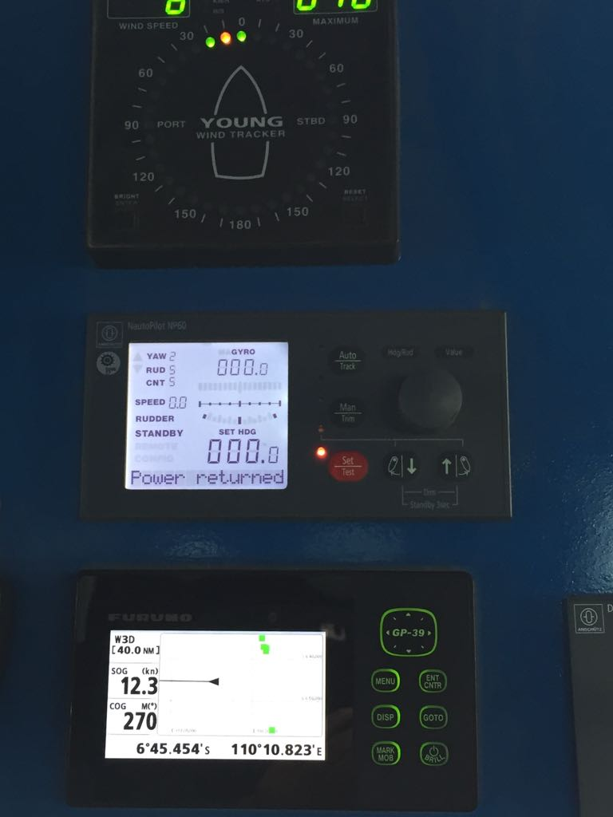

Figure 8. Docking Trial

* 1. **Pitch Propeller Calculations**

Based on the provided data and calculations, an evaluation was conducted regarding the changes in propeller pitch after repair for both the starboard and port sides of the ship. Before the repair, the diameter and pitch of the propeller had their respective values, but post-repair, there was an increase in pitch on both sides of the propeller. This change is necessary to optimize propeller performance and achieve the desired thrust and efficiency. The addition of pitch is a crucial factor in improving the overall efficiency of the ship's propulsion system. Additionally, the alteration in the propeller diameter after the repair also indicates an adjustment in the propeller's geometry, likely aimed at enhancing efficiency and overall performance. In conclusion, the modifications made during the repair process, particularly the increase in pitch, contribute to better propeller performance, ensuring smoother operation and improved propulsion efficiency for the ship. From the process of widening the propeller pitch, they can be calculated using an approach and calculation of the initial size ratio with size after repair. Propeller initial data right and left before modification (according to the stamp on the propeller).

• Diameter of propeller = 1850 mm

• Pitch propeller = 1650 mm

The pitch of the propeller on different blade sections was calculated at 0.7 R (radius) using the given rules and blade angles (∝1 and ∝2). In the context of these calculations, Alpha 1 (∝1) and Alpha 2 (∝2) represent blade angles, while X1 and X2 represent specific positions on the propeller blade. The unit for pitch is millimeters (mm), the diameter is also in millimeters (mm), and the angles are measured in degrees (°). These measurements and changes in pitch and diameter play a significant role in optimizing the vessel's propulsion system and ensuring efficient performance. The pitch values for each blade were determined accordingly. Pitch propeller calculation starboard side on 0,7 R as follows:

$\frac{360}{∝}∆μ$ (9)

With rules:

Propeller blade. 1:

$∝1$ = 79 ° degrees X1 = 190° degrees

$∝$ 2 = 160 ° degrees X2 = 540° degrees

Pitch = 1555 mm

Propeller blade. 2 :

$∝1$ = 169° degrees X1 = 195° degrees

$∝$ 2 = 251° degrees X2 = 557° degrees

Pitch = 1589 mm

Propeller blade. 3 :

$∝1$ = 260° degrees X1 = 199° degrees

$∝$ 2 = 341° degrees X2 = 549° degrees

Pitch = 1555 mm

Propeller blade. 4 :

$∝1$ = 351° degrees X1 = 208° degrees

$∝$ 2 = 71° degrees X2 = 540° degrees

Pitch = 1494 mm

After repair result of the measurement **starboard** side is as follows:

Diameter propeller = 1880 mm

Pitch propeller = 1660 mm

Similarly, the pitch of the propeller on different blade sections was calculated at 0.7 R (radius) for the port side using the provided rules and blade angles (∝1 and ∝2). The resulting pitch values were determined accordingly. Pitch propeller calculation port side on 0,7 R as follows:

Propeller blade. 1 :

$∝1$ = 79° degrees X1 = 195° degrees

$∝$ 2 = 355° degrees X2 = 559° degrees

Pitch = 1560 mm

Propeller blade.2 :

$∝1$ = 349° degrees X1 = 193° degrees

$∝$ 2 = 266° degrees X2 = 556° degrees

Pitch = 1574 mm

Propeller blade. 3 :

$∝1$ = 259° degrees X1 = 190° degrees

$∝$ 2 = 175° degrees X2 = 558° degrees

Pitch = 1577 mm

Propeller blade. 4:

$∝1$ = 168° degrees X1 = 194° degrees

$∝$ 2 = 84° degrees X2 = 565° degrees

Pitch = 1590 mm

After repair, the result of measurement **port** side is as follows:

Diameter propeller = 1885 mm

Pitch propeller = 1670 mm

Comparing the pitch values before and after repair, it is evident that the pitch increased after the repair for both starboard and port sides of the propeller. This increase in pitch is essential for optimizing propeller performance and achieving the desired thrust and efficiency. From the results of these calculations, the results of the comparison between the size of the initial pitch propeller and after addition are as follows. See Figure 9.

**Figure 9. Propulsion Optimation**

This value shows that the right propeller pitch significantly increases in knots from 1651 mm to 1660 mm. The left propeller pitch significantly increases knots from 1651 mm to 1670 mm. The effect of the bearing and lubrication system is also a factor in the occurrence of speed differences so that the geometry design of the propeller after and before repair.

1. **Conclusion**

The vessel's performance in a sea trial experiment has some factors. One of them is a technical factor, and troubleshooting can be sorted from the source of the engine rotation, shaft, and propulsion, whether in the shape of the steering wheel or the shape of the bosh. In this case, the optimization of propulsion performance is more emphasized in the form of a pitch propeller. In the initial measurement data, it can be calculated that the propeller can rotate by generating a service speed that meets the ship's specifications.

The step taken is the process of repairing and widening the pitch propeller. In addition, material factors can also affect propeller performance, and if there is a smooth/smooth propeller leaf surface, it can cause residual energy wasted from the propeller rotation. The propeller's geometry and dimensions also affect the propeller's performance, for which the balancing propeller process is very much needed after the repeller process is carried out. The aim is that the propeller leaf rotation is balanced and not one-sided on one side of the leaf.

From the above problems, the results of the right pitch propeller optimization value of 0.6% and the left propeller pitch optimization value of 1.2% can make the ship's speed when the docking trial is 12.3 knots following the planned velocity.

**Acknowledgments**

Our colleagues in the Study Program of Teknologi Rekayasa Konstruksi Perkapalan, Department of Industrial Technology, and partially supported this research. PT. JMI Semarang. We thank our colleagues from Diponegoro University, who provided insight and expertise that greatly assisted the study.

**References**

[1] I. Kobougias, E. Tatakis, and J. Prousalidis, “PV systems installed in marine vessels: Technologies and specifications,” *Adv. Power Electron.*, vol. 2013, no. i, 2013, httpdoi: 10.1155/2013/831560.

[2] I. B. P. Sukadana and I. W. Suastawa, “Rancangan Propeller Optimum Kapal Ikan Tradisional,” 2009.

[3] D. Mulyana, J. Jamari, and R. Ismail, “Investigasi Efisiensi Propeler Kapal Ikan Tradisional,” *Rotasi J. Tek. Mesin*, vol. 16, no. 4, p. 28, 2014, doi: 10.14710/rotasi.16.4.28-34.

[4] P. B. Setyabudi, D. Chrismianto, and G. Rindo, “Analisa Nilai Thrust Dan Torque Propeller Tipe B-Series Pada Kapal Selam Midget 150M Dengan Variasi Skew Angle Dan Blade Area Ratio (Ae/Ao) Menggunakan Metode Cfd,” *Kapal*, vol. 13, no. 3, p. 109, 2016, doi: 10.14710/kpl.v13i3.12352.

[5] T. Yulianto and R. C. Ariesta, “Analisis Kekuatan Shaft Propeller Kapal Rescue 40 Meter dengan Metode Elemen Hingga,” *Kapal J. Ilmu Pengetah. dan Teknol. Kelaut.*, vol. 16, no. 3, pp. 100–105, 2019, doi: 10.14710/kapal.v16i3.23572.

[6] A. Trimulyono and Kiryanto, “Analisa Efisiensi Propeller B-Series Dan Kaplan Pada Kapal Tugboat Ari 400 Hp Dengan Variasi Jumlah Daun ,” *Kapal*, vol. 12, no. No. 2, June, pp. 112–120, 2015.

[7] A. Macfudin, A. A. . Dinariyana, and D. P. Sari, “Numerical Investigation on The Open Water Characteristics of B-Series Propeller,” *Kapal J. Mar. Sci. Technol.*, vol. 20, no. 2, pp. 270–278, 2023.

[8] I. M. Ariana, A. Iswantoro, and S. A. Fitri, “Combining Optimum Propeller Design on Roro Ship Re-engine,” *Kapal J. Mar. Sci. Technol.*, vol. 20, no. 2, pp. 201–213, 2023.

[9] A. H. Muhammad, A. Thariq, Z. Yusuf, H. Yudo, and M. Yasir, “The Selection of Propeller and Primary Engine Matching Level of a 30 GT Fishing Vessel with Analytic Hierarchy Process (Case Study KM Inka Mina 759),” *Kapal J. Mar. Sci. Technol.*, vol. 19, no. 2, pp. 90–100, 2022.

[10] A. I. Sultoni, M. M. Ali, and Z. P. Aji, “Design of Hybrid(PV/Gasoline) Propulsion for Small Fishing Vessel,” *KAPAL*, vol. 17, no. 1, pp. 1–6, 2020.

[11] G. S. Spagnolo, D. Papalillo, A. Martocchia, and G. Makary, “Solar-Electric Boat,” *J. Transp. Technol.*, vol. 02, no. 02, pp. 144–149, 2012, doi: 10.4236/jtts.2012.22015.

[12] K. Mahmud, S. Morsalin, and M. I. Khan, “Design and Fabrication of an Automated Solar Boat,” *Int. J. Adv. Sci. Technol.*, vol. 64, pp. 31–42, 2014, doi: 10.14257/ijast.2014.64.04.

[13] I. K. A. P. Utama, P. I. Santosa, R. M. Chao, and A. Nasiruddin, “New concept of solar- Powered catamaran fishing vessel,” *Proc. 7th Int. Conf. Asian Pacific Coasts, APAC 2013*, pp. 903–909, 2020.

[14] M. Burak Samsul, “Blade Cup Method for Cavitation Reduction in Marine Propellers,” *Polish Marit. Res.*, vol. 28, no. 2, pp. 54–62, 2021, doi: 10.2478/pomr-2021-0021.

[15] N. V. ali and S. N. njan, “Optimized Electric Propulsion System Modeling and Simulation with Low Voltage DC Hybrid Power Systems,” *Int. J. Adv. Res. Electr. Electron. Instrum. Eng.*, vol. 03, no. 12, pp. 13602–13611, 2014, doi: 10.15662/ijareeie.2014.0312014.

[16] H. Lan, S. Wen, Y. Y. Hong, D. C. Yu, and L. Zhang, “Optimal sizing of hybrid PV/diesel/battery in ship power system,” *Appl. Energy*, vol. 158, pp. 26–34, 2015, doi: 10.1016/j.apenergy.2015.08.031.

[17] P. I. Santosa and I. K. A. P. Utama, “An Investigation into Hybrid Catamaran Fishing Vessel: Combination of Diesel Engine, Sails and Solar Panels,” *IPTEK J. Proc. Ser.*, vol. 0, no. 1, pp. 36–41, 2014, doi: 10.12962/j23546026.y2014i1.383.

[18] A. Nasirudin, R. M. Chao, and I. K. A. P. Utama, “Solar powered boat design optimization,” *Procedia Eng.*, vol. 194, pp. 260–267, 2017, doi: 10.1016/j.proeng.2017.08.144.

[19] K. J. Lee, D. Shin, D. W. Yoo, H. K. Choi, and H. J. Kim, “Hybrid photovoltaic/diesel green ship operating in standalone and grid-connected mode - Experimental investigation,” *Energy*, vol. 49, no. 1, pp. 475–483, 2013, doi: 10.1016/j.energy.2012.11.004.

[20] A. F. Molland, S. R. Turnock, and D. A. Hudson, *Ship resistance and propulsion: Practical estimation of ship propulsive power*, vol. 9780521760. 2011. doi: 10.1017/CBO9780511974113.

[21] M. Ridwan, “Parameter Design Propeller Kapal,” *Kapal*, vol. 5, no. 3, pp. 206–211, 2012.