  2301-9069 (e)  1829-8370 (p) | Kapal: Jurnal Ilmu Pengetahuan dan Teknologi Kelautan  (Kapal: Journal of Marine Science and Technology)  journal homepage : http://ejournal.undip.ac.id/index.php/kapal


Identification of Passenger Ship Accident Risk Management Using the Hazard and Operability Analysis (HAZOP) Approach from a Human Resources Perspective

Anak Agung Istri Sri Wahyuni^{1)*)}, Muhamad Imam Firdaus¹⁾ , Eka Wahyu Ardhi²⁾

¹⁾ Politeknik Pelayaran Surabaya, Surabaya 60294, Indonesia
²⁾ University of Strathclyde, United Kingdom
^{*)} Corresponding Author: Istri.sriwahyuni@poltekpel-sby.ac.id

Article Info | Abstract
Keywords:  Passenger Ship Safety, Risk Management, HAZOP, Human Error, KNKT, Maritime Operations  Article history:  Received:  Last revised:  Accepted:  Available online:  Published:  DOI:  https: | Passenger ship accidents are complex events resulting from multiple interrelated factors, with human error, technical deficiencies, and environmental conditions playing critical roles. Between 2018 and 2022, Indonesia’s National Transportation Safety Committee (KNKT) recorded 108 ship accidents, including 29 Ro-Ro passenger ships and 19 conventional passenger vessels. This study employs the Hazard and Operability Study (HAZOP) methodology to analyze risk factors contributing to passenger ship accidents, with particular emphasis on the human resource (HR) perspective. Primary data were collected through interviews and surveys with ship crew members, while secondary data were obtained from accident reports and maritime literature. The analysis identified key risks, including improper use of LPG stoves, unsafe cargo storage practices, malfunctioning fire detection systems, crew fatigue resulting from excessive workload, and vessel overloading. Each risk was systematically associated with specific mitigation measures through HAZOP analysis, translating human- and technical-related deviations into actionable safety recommendations. The findings underscore the importance of enhancing safety training, strengthening maintenance protocols, and improving HR management practices. The study concludes that reinforcing human factors, particularly through continuous safety training, scheduled maintenance, and more effective workload management, can significantly reduce the likelihood of accidents. Thus, this research not only identifies critical risk sources but also offers practical guidance for improving maritime operational safety and reducing incidents associated with human error.  Copyright © 2021 KAPAL : Jurnal Ilmu Pengetahuan dan Teknologi Kelautan. This is an open access article under the CC BY-SA license (https://creativecommons.org/licenses/by-sa/4.0/).

- Introduction

The work safety factor while on board must always be considered to ensure that shipping activities are carried out safely, smoothly, punctually, and securely to their intended destinations. A work accident can be understood as the risk of unplanned events that disrupt operational activities and result in injury, illness, or death [1]. Shipping accidents are, therefore, a critical issue that must be examined, as they involve multiple complex contributing factors [2]. These accidents may arise from improper workplace actions or actions that deviate from established regulations (human error), often caused by poor environmental conditions or unsuitable equipment [3]. Unsafe conditions may also result from inappropriate tools, personal protective equipment not meeting regulatory standards, and external natural factors [4].
Work safety on board thus represents a crucial element in maintaining safe, smooth, and timely ship operations [5]. Mechanical or structural failures and systemic problems, like poor safety culture, human error, operation slackness, etc., are the sources of accident risks. The Table 1 below shows that the National Transportation Safety Committee (KNKT) data shows that Indonesia had a total of 108 ship accidents between 2018 and 2022 with the largest share being the Ro-Ro passenger ships. Human factors have continued to be a critical issue especially on technical failures and environmental uncertainty. These results demonstrate the relevance of active risk evaluation and risk prevention measures.
Table 2 provides a summary of accident investigations for passenger and Ro-Ro vessels within the same timeframe. They recorded 108 accidents in the period 2018-2022 that included 13 tanker accidents, 19 passenger ship accidents, 28 Ro-Ro passenger ship accidents, 20 general cargo ship accidents, 11 bulk carrier accidents, 12 container ship accidents, and five accidents involving other boats, including patrol and fishing boats. The highest number of accidents occurred on Ro-Ro passenger ships, followed by passenger ships. This indicates that these categories require particular attention to enhance maritime safety.

Table 1. Number of Shipping Accident Investigations by Type of Accident (2018–2022)
It | Description | Year |  |  |  |  | Total
It | Description | 2018 | 2019 | 2020 | 2021 | 2022
1 | Sinking | 10 | 6 | 3 | 5 | 5 | 29
2 | Fire / Explosion | 12 | 6 | 2 | 6 | 5 | 31
3 | Collision | 3 | 9 | 2 | 4 | 1 | 19
4 | Grounding | 7 | 0 | 4 | 2 | 2 | 15
5 | Others | 7 | 4 | 1 | 2 | 0 | 14
Total |  | 39 | 25 | 12 | 19 | 13 | 108
Source: KNKT, Transportation Accident Investigation Statistics Book, 2022.

Based on the KNKT investigation results reported in the 2022 KNKT Transportation Accident Investigation Statistics Book, the factors influencing shipping accidents include technical, weather, and human-related aspects. From 2018 to 2022, a total of 75 causative factors were identified in KNKT-investigated shipping accidents. Technical factors were the most dominant, contributing to 39 accidents during that period. Meanwhile, human factors also played a significant role, accounting for 35 accidents. Weather-related factors represented the smallest proportion of causes of ship accidents [6].

Table 2. Number of Investigations into Accidents on Passenger Ships and Ro-Ro Passenger Ships (2018–2022)
It | Description | Year |  |  |  |  | Total
It | Description | 2018 | 2019 | 2020 | 2021 | 2022
1 | Sinking | 4 | 1 | 1 | 4 | 2 | 12
2 | Fire / Explosion | 6 | 3 | 1 | 2 | 4 | 16
3 | Collision | 1 | 4 | 0 | 0 | 1 | 6
4 | Grounding | 7 | 0 | 1 | 2 | 1 | 11
5 | Others | 1 | 0 | 0 | 1 | 0 | 2
Total |  | 19 | 8 | 3 | 9 | 8 | 47
Source: KNKT Shipping Accident Investigation Reports, 2018–2022 (processed data).

Sinking is the most severe and commonly occurring form of shipping mishap in Indonesian waters. Data from KNKT indicate that the majority of sinking incidents were due to overloading, inadequate stability assessments, insufficient maintenance of hull structures, and human error during cargo operations. Additionally, crew fatigue and insufficient enforcement of operational regulations markedly elevate the risk of accidents. The findings indicate that while external variables may trigger emergencies, human and operational factors often serve as the main determinants influencing a vessel's stability loss and subsequent sinking.
Previous studies have shown that maritime accidents frequently correlate with technological, human, and meteorological factors. As noted by Badri et al. [7], although the use of personal protective equipment (PPE) has been implemented to prevent accidents, it has not reached optimal application. Contributing factors include limited understanding, human error, and natural conditions such as severe weather. Consequently, the safety level on the SV Fiona 38 vessel has not reached an optimal state [7]. The KNKT data further substantiate that technical problems were the primary causes of maritime accidents in Indonesia from 2018 to 2022. Furthermore, human factors, particularly human error, significantly influence the occurrence of accidents. Shipping safety may depend on the meteorological conditions, although not necessarily always, and in bad sea conditions.Prevention of accidents must be done with an integrated approach involving technical, human, and environmental issues [8].
Many studies show that effective safety management could reduce the chances of shipping accidents. According to Zahroh [9], human factors are the most common causal factors of maritime accidents, whereas natural and technology factors also contribute to the causal factors [10]. The importance of the adequate training and crew skill is underlined by the International Maritime Organization (IMO) which publishes the Guidelines on Human Element Training and Watchkeeping to enhance the safety standards of ships [11]. This underscores that enhancements in safety management can substantially reduce accident risks associated with passenger vessels.
Concerning technology, [12] asserts that ship design must prioritize safety, encompassing resilience to severe weather conditions and the dependability of onboard systems. Simultaneously, research like [13] emphasizes the significance of ship resource management and bridge crew management in accident prevention. These factors are crucial in formulating more effective ship safety strategies.
A methodical approach employed to identify and mitigate maritime accidents is the Hazard and Operability Study (HAZOP). This method enables a comprehensive study of diverse operational scenarios that may occur during a vessel's operation. HAZOP helps ship operators to identify potential hazards and develop more efficient preventive measures. On this note, HAZOP is considered to be a methodological analytical tool that may enhance the method of preventing accidents in maritime operations.
However, a number of previous studies have focused more on technology or environmental aspects, and there has not been enough focus on human and working aspects. This also means that there is a lack of research in this area since the interaction between human performance, operation discipline and safety management has not been explored in great detail in a systematic analysis. The HAZOP approach, which was commonly applied in the field of industrial safety engineering, offers a detailed and systematic system of identifying operational hazards and likely failures. Therefore, the application of HAZOP to the marine sector, in particular, through the prism of human-centric perspective, can bring considerable evidence regarding the possibility to mitigate accidents. The novelty applied in the present study is the combination of the HAZOP framework and human resource analysis to close the gap between the technical safety assessment and human performance analysis, which then provides a more respective view on the safety management of passenger ships.
This research paper will use the HAZOP tool to assess the risks posed by a passenger ship disaster, which is the case of Ro-Ro passenger ships that will be used in the study of Indonesian shipping companies. Such strategy will allow having a better understanding of the possible operational deficiencies and the impact on the safety of the passengers. This research aims at enhancing operational security of passenger ships and reducing the likelihood of accidents throughout travels. It is expected that the benefit will be to improve recommendations to management of ship safety, particularly those carrying passengers. The results of this research can be used by the regulatory authorities to create more efficient safety regulations and help ship operators improve the methods of risk management. This project aims to diminish the incidence of passenger ship accidents in Indonesia.

- Methods
This study utilizes a mixed-methods approach, integrating primary data (surveys and interviews with officers and seafarers) with secondary data (KNKT reports, journal articles, and marine safety rules). The research object denotes the principal focus of the study, signifying the thing, phenomenon, or variable under examination in a scientific inquiry [14]. This study's research object is passenger ships, particularly Ro-Ro passenger vessels operating under Indonesian shipping companies. The research focuses on identifying potential hazards and accident risks that may occur during ship operations [15]. The research data consist of two types: primary data and secondary data [16]. Primary data are obtained directly from original sources to answer specific research objectives [17]. This study collected primary data through interviews with ship officers and seafarers with operational experience on Ro-Ro passenger vessels. Secondary data have been collected, processed, and published previously by other parties [18]. Secondary data in this study were sourced from KNKT final accident reports (2018–2022), scientific publications, journals, and books relevant to maritime safety and operational risk.
To gain a holistic approach on the risk of the accidents of passenger ships, different methods were selected in data collection. These are surveys, interviews, documentation and observations [19]. The perceived levels of risk of accidents were measured through carrying out surveys whereby questionnaires were distributed to respondents.Analytics of the quantitative data of the survey were applied on the basis of validity, reliability and error indicators [20]. In-depth interviews were conducted to strengthen survey findings and obtain more detailed information regarding accident risks and prevention measures [21]. Field observations were used to record ship activities and operational conditions relevant to safety objectively [22]. Contrastingly, the supporting data were gathered through documentation methods by reviewing journals, official reports and company regulations [23].
This study has utilized an analytical technique known as Hazard and Operability Study (HAZOP) which is a well-developed technique that is common in industrial industries such as in the maritime industry to determine operational risks in a systematic manner [24]. HAZOP allows one to perform a detailed analysis of the situation, thus contributing to the assessment of the risk, risk management planning, and recording of the results [25]. The main advantage of HAZOP is that it has an ability to identify dangers thoroughly and provide preemptive recommendations, thus reducing the likelihood of future accidents [26]. However, the process requires a lot of work and qualified personnel to present an accurate research.

Start
Preparation

- Setting Research Objectives
- Determination of Study Elements and Parameters
Data Collection
- Literature Review
- Ship operational techniques
- Ship accident data
- Survey (questionnaire)
- Interview (officers and seafarers)
Data analysis
- What if? HAZOP
- Identification of hazards and vulnerabilities
- Risk assessment
- Risk control
- Documentation of results
Conclusion
- Evaluation of HAZOP Resulats
- Discussion of Findings and Recommendations
- Conclusion and Recommendations
Figure 1. Flow Diagram

In this research paper, a survey will use questionnaires, voice recorders will be used to conduct interviews and risk-analysis software will be used in processing the data. Additional sources include KNKT news, scholarly sources and maritime safety sources. The study had 86 participants, including crew members in diverse shipboard positions such as captains, chief officers, chief engineers, machinists, and oilers from 84 Ro-Ro and passenger vessels in Indonesia. A structured questionnaire with 29 items was used to assess accident risk based on respondents’ perceptions of two key dimensions: likelihood and consequence of incidents. The items covered six main risk categories: human factors, cargo handling, emergency drills, engine room hazards, electrical system hazards, and risks associated with water ingress and potential vessel sinking. The methodological framework and research workflow are illustrated in Figure 1.
This study assessed accident risk on passenger vessels with a sequential analytical methodology employing HAZOP. The initial step was to establish the boundaries of the systems and this led to the identification of the essential functional nodes in ship operations as the bridge, engine room, cargo deck, galley, and passenger area. Words of the generic HAZOP (No, More, Less, As well as, Opposite) were then used to define possible anomalies of the usual operation at every node. The causes and implications of these deviations were explored using narrative data from interviews, field observations, and KNKT accident reports. These deviations were subsequently grouped into six major operational risk categories—human factors, cargo handling operations, emergency drills, engine room hazards, electrical failures, and ship-sinking due to water ingress. A final quantitative assessment was conducted using a Likelihood–Consequence matrix.
Risk evaluation was carried out using the Likelihood–Consequence matrix, in which a risk score (Risk = L × C) was calculated for each hazard. Both likelihood (L) and consequence (C) were rated on a five-point scale from 1 (Very Low) to 5 (Very High). This scale follows standard HAZOP methodology and ISO 31000:2018 for operational risk assessment [26]. It uses the five-level classification to provide a clear, comparative, and consistent four-level classification with the International Maritime Organization (IMO) maritime safety codes [11]. The resulting scores were placed into a risk matrix to produce graphical representations of hazard levels (Figs. 2–7), allowing the identification of high-priority risks requiring intervention.

- Results and Discussion

This study's risk assessment of shipping accidents focuses on two primary accident types: fire and sinking. The causal factors are categorized into three components: the cause of the accident (Cause), the source of the hazard (Hazard), and the consequences that may result from the accident (Consequence). Accident data were obtained from previous incident reports, company safety regulations, and the Marine Fire Prevention, Fire Fighting, and Fire Safety reference book. Various cause factors were identified among them fire hazards due to human factors, cargo handling, emergency preparedness, engine room activities, electrical systems, and risk factors that promoted submersion of the vessels. The validity of the assessment statements was tested through the validity and reliability tests in which the validity predetermined that the measurement tool measured what it was intended to measure and the reliability ensured that the results of the measurement process would be consistent.
This research aimed to analyze the risks of fire and sinking in Ro-Ro passenger ships belonging to the Indonesian shipping companies. All questionnaire items were valid based on the validity and reliability testing, with calculated r values exceeding the r table threshold. The reliability test produced a Cronbach’s Alpha value of 0.957, which exceeds the minimum acceptable standard of 0.60. Thus, the questionnaire instrument is considered statistically reliable for assessing accident risks. As shown in Table 3, the reliability results demonstrate that the questionnaire consistently measures risk perceptions related to passenger ship accidents.

Table 3. Reliability Test Result
It | Variable | Cronbach's Alpha | N of Items
1. | Ro-Ro Passenger Ship Accident | 0.957 | 29

The study applied a risk classification system using a three-color scale to facilitate interpretation of the Likelihood–Consequence matrix. The green hue signifies a low-risk level (R < 8), denoting that hazardous conditions are permissible and necessitate only standard monitoring. The yellow hue signifies a medium-risk level (8 ≤ R < 9.5), acceptable while necessitating corrective or preventive measures. The red hue denotes a high-risk level (R > 9.5), signifying that the hazard is unacceptable and necessitates immediate intervention. This color-coded approach is derived from the ISO 31000:2018 risk management standard and IMO safety assessment recommendations to distinctly and uniformly depict operational risk intensity across categories.

  - Human Factor Fire Risk

The analytical results presented in Table 4 indicate that the fire risk associated with human factors is greatest when utilizing LPG gas burners aboard passenger vessels, especially in ship canteens (1C activity). Investigation of the human factor, was carried out on the analysis of 86 filled questionnaires and 75 elements of accidents causation, which KNKT reported in 201812022. There were many possible anthropogenic hazards found, but only three of them, that is, improper use of LPG stoves, cigarette butts sparks, and the lack of checks during cars or cargo inspections, had the largest sums of Likelihood and Consequence rates and, thus, were grouped as the most critical human factor risks.
Although these risks are considered tolerable, appropriate precautions remain necessary. In particular, Widyasto et al. [27] also showed that human error contributed to 26.9% of ship accidents caused by problems in the electrical system, with human resource (HR) health factors as the leading cause, accounting for 32.1%. This human error is a major element leading to ship fires, particularly in the handling of gas or fuel equipment in fire-sensitive regions. The use of LPG without due precautions increases the risk of the occurrence of fire since it may leak and be ignited without any control.The adoption of a risk management strategy that focuses on stringent maintenance and control of flammable substances operations is, therefore, necessary.

Table 4. Analysis of the Possibility of Fire (Human Factor)
It | Risk Statement | Possible Score | Impact Score | Total Score | Ranking
1A | Sparks from cigarette butts | 2.90 | 3.32 | 9.63 | 2
1B | Not checking the vehicle and its cargo as well as documents when boarding the ship | 2.90 | 3.26 | 9.45 | 3
1C | Use of LPG gas stove on board (particularly in ship canteens) | 2.98 | 3.30 | 9.83 | 1

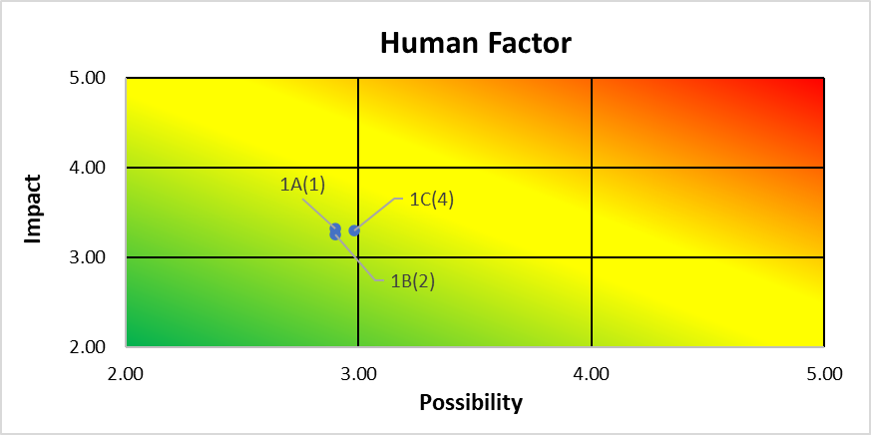
Figure 2. Analysis of the Possibility of Fire (Human Factor)

The fire risk table caused by human factors, as shown in Figure 2, identifies three risk statements with scores indicating both the likelihood of occurrence and the potential impact. The cumulative score of these two elements is thereafter rated accordingly. The initial statement (1A) outlines the hazard of sparks from cigarette butts, assigning a probability value of 2.90 and an impact score of 3.32, culminating in a total score of 9.63. This risk is ranked second in the fire risk assessment. The second statement (1B) reveals that the neglect to inspect cars, cargo, and documents during ship boarding has a likelihood score of 2.90 and an impact score of 3.26, resulting in a total score of 9.45, ranking it third. Meanwhile, the third statement (1C) relates to using LPG gas stoves on board passenger ships, particularly in canteen or galley areas, with a probability score of 2.98 and an impact score of 3.30. This total risk score of 9.83 places it first in the fire risk ranking.
The highest human related risk is the usage of LPG stoves without proper safety control usually in small canteen areas. Other problems include the presence of cigarette remnants and lack of proper vehicle or cargo inspection before embarkation. Such threats are classified as the high-priority threats in the risk matrix. Therefore, more attention should be devoted to the mitigation of these potential threats, including the stricter control and the creation of appropriate safety measures.

  - Cargo Factor Fire Risk

The highest fire threat of the cargo is the irresponsible storage of the hazardous items which can be considered as the medium risk. Life safety implications and damage to vessels and cargo are very high. This outcome corresponds with [28], which suggests that managing hazardous materials without sufficient safety protocols can elevate the risk of incidents, including fires. These conclusions are also supported by the international laws such as the International Maritime Dangerous Goods (IMDG) Code that establishes the parameters of handling dangerous objects in ships to reduce risks of fire and accidents.
The management of hazardous materials should be efficient and meet the proper loading standards as well as consider physical and chemical characteristics of the materials. This is especially vital for effective loading planning. Furthermore, the segregation of various hazardous goods must comply with the segregation table stipulated in the IMDG Code. By implementing these procedures, maritime safety in handling dangerous cargo can be more effectively ensured [29].
Table 5 and Figure 3 represent cargo-related fire risks, displaying a risk analysis based on event likelihood and impact evaluations, with the total accumulated scores then sorted by risk ranking. The first risk statement (2A) concerns careless and misplaced storage or placement of hazardous materials. This risk earned a likelihood score of 2.95 and an impact score of 3.37, resulting in a total score of 9.94 and ranking first as the most significant fire risk. The second risk statement (2B) highlights weaknesses in the construction design of storage shelves that are not strong enough to support hazardous or flammable materials, with a likelihood score of 2.58 and an impact score of 2.94, resulting in a total score of 7.59 and ranking fifth.

Table 5. Analysis of the Possibility of Fire (Cargo)
It | Risk Statement | Possible Score | Impact Score | Total Score | Ranking
2A | Careless and misplaced storage or placement of hazardous materials | 2.95 | 3.37 | 9.94 | 1
2B | Construction design of storage containers (shelves) that are not strong enough to support hazardous or flammable materials | 2.58 | 2.94 | 7.59 | 5
2C | Failure to handle dangerous goods in accordance with procedures | 2.68 | 3.16 | 8.47 | 3
2D | Oil spill or leaking vehicle oil on the ship’s deck | 2.87 | 3.17 | 9.10 | 2
2E | Vehicle engine not switched off | 2.77 | 3.01 | 8.34 | 4

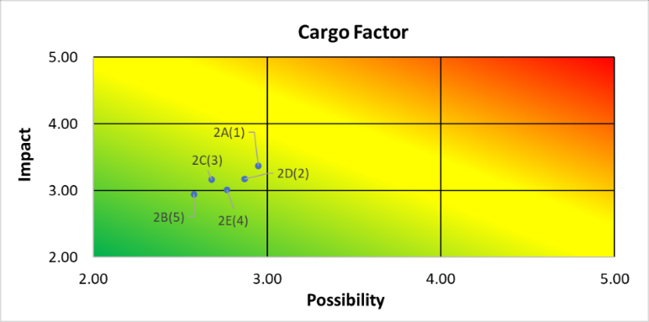
Figure 3. Analysis of the Possibility of Fire (Cargo)

The third risk (2C) relates to the improper handling of dangerous goods, with a probability score of 2.68 and an impact score of 3.16, producing a total score of 8.47 and ranking third. The fourth risk statement (2D) involves oil spills or vehicle oil leaks on the ship’s deck, which obtained a probability score of 2.87 and an impact score of 3.17, resulting in a total score of 9.10 and ranking second. Finally, the fifth risk (2E) concerns vehicle engines not being switched off, with a probability score of 2.77 and an impact score of 3.01, producing a total score of 8.34 and ranking fourth. Careless storage of hazardous materials leads to a risk ranking. Issues such as inadequate shelving and failure to comply with IMDG Code procedures further exacerbate fire hazards. Oil spills and running vehicle engines also pose serious threats to shipboard safety.

  - Fire Risk Emergency Drill Factors

Fire risk factors associated with inadequate emergency preparedness (emergency drills) show the highest risk value in cases involving malfunctioning fire detection systems [30]. This indicates that while fires may occur at any time, the absence of early detection significantly exacerbates their consequences. According to Siregar et al. [31], fire detection systems that do not function optimally are a major cause of delays in fire response on board. These findings underscore the importance of regular maintenance of fire detection systems and continuous evacuation training for all ship crew members [32].

Table 6. Analysis of the Possibility of Fire (Emergency Drill)
It | Risk Statement | Possible Score | Impact Score | Total Score | Ranking
3A | Emergency drill activities have not been carried out according to the emergency drill plan | 2.82 | 3.15 | 8.88 | 2
3B | The fire control plan has not been installed or clearly written on board the ship | 2.63 | 3.06 | 8.05 | 4
3C | Malfunction of the fire detection system so that the fire is not detected at the early stage | 2.98 | 3.40 | 10.13 | 1
3D | Unavailability of the Fire Management System and abandonment of ships | 2.66 | 3.17 | 8.43 | 3

Table 6 and Figure 4 present a fire risk analysis related to emergency drills, in which each risk statement is evaluated based on likelihood and impact scores to generate a total risk score and ranking. The first statement (3A) indicates that emergency training activities have not been conducted according to the established schedule. This risk has a likelihood score of 2.82 and an impact score of 3.15, resulting in a total score of 8.88 and ranking second. The second statement (3B) concerns the absence or unclear placement of a fire control plan on board. The danger possesses a likelihood score of 2.63 and an impact score of 3.06, resulting in a cumulative score of 8.05 and a position of fourth.
The third danger (3C) pertains to the failure of fire detection devices, hindering the prompt identification of fires. This danger possesses the highest likelihood score of 2.98 and an impact score of 3.40, culminating in a total score of 10.13, so establishing it as the preeminent risk factor within the emergency drill category. The fourth risk statement (3D) focuses on the unavailability of adequate safety management systems for fire response and ship evacuation. This risk has a likelihood score of 2.66 and an impact score of 3.17, yielding a total score of 8.43 and placing it third.
This analysis identifies critical issues as failures in fire detection systems and inadequately implemented emergency drills. These inadequacies considerably impede emergency response operations and elevate the probability of deaths and structural damage. Although the lack of a prominently displayed fire control strategy is associated with a lower risk classification, it nonetheless need attention to guarantee preparedness for emergencies.

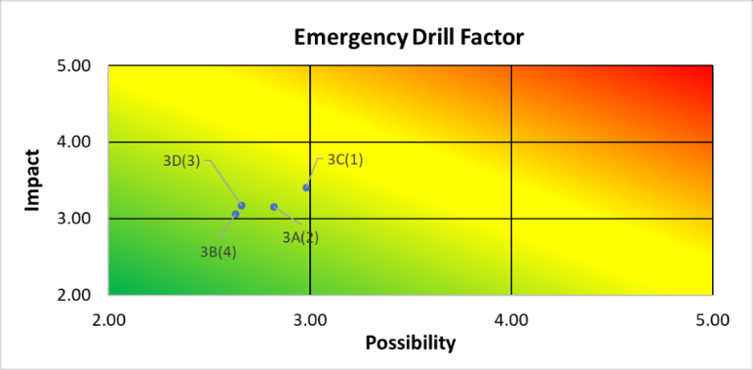
Figure 4. Analysis of the Possibility of Fire (Emergency Drill)

  - Fire Risk Factor in the Engine Room

Regarding fire risk factors arising from activities in the engine room, the highest risk is associated with welding processes that do not adhere to established procedures. Improper welding can generate sparks that may ignite fires in areas with flammable materials [33]. According to maritime safety principles, welding activities must be carried out under strict supervision and with equipment that meets safety standards, particularly because welding in the engine room is often conducted in confined spaces [34–35]. Therefore, risk control through supervision, operator training, and continuous monitoring of engine room conditions is essential in mitigating fire hazards in this area.

Table 7. Analysis of the Possibility of Fire (Engine Room)
It | Risk Statement | Possible Score | Impact Score | Total Score | Ranking
4A | Pipes or machinery that become hot in contact with flammable materials | 2.48 | 2.95 | 7.32 | 3
4B | Bunker refueling process not conducted in accordance with the procedure | 2.78 | 3.16 | 8.78 | 2
4Cs | Welding process not performed according to procedure | 2.82 | 3.26 | 9.19 | 1

Table 7 and Figure 5 present the fire risk analysis of engine room operations. Each risk statement is evaluated based on its likelihood of occurrence and potential impact, producing a total score that is then ranked according to severity. The first statement (4A) refers to the risk of hot pipes or machinery coming into contact with flammable materials. The probability of this risk is 2.48 and the impact is 2.95 and this will give a cumulative effect of 7.32 making it the third most dangerous risk of the engine room, relative to other engine room risks. The second risk (4B) is where the bunker refueling process is not followed as per the standard procedures. This risk has a likelihood score of 2.78 and an impact score of 3.16, yielding a total score of 8.78 and placing it second.

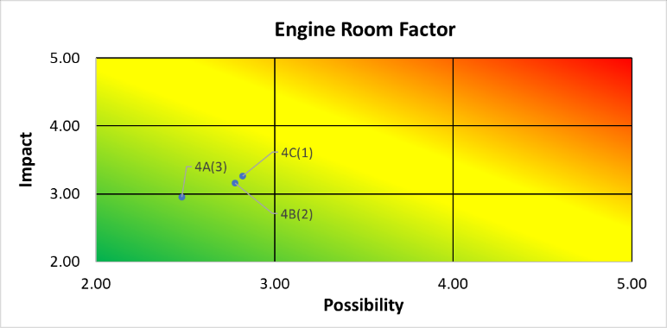
Figure 5. Analysis of the Possibility of Fire (Engine Room)

The highest risk identified in Table 7 is the third statement (4C), which concerns welding processes conducted without adherence to proper procedures. The probability of occurrence of this risk is 2.82 with an impact of 3.26 resulting in a total hazard of 9.19 and relative precedence is the first most important fire hazard in the engine room. This research study reveals that lack of adherence to welding regulations is the major fire risk in the engine room. This investigation indicates that non-compliance with welding protocols constitutes the primary fire hazard in the engine room. This discovery underscores the necessity of enhancing occupational safety measures, enforcing stringent procedures, and providing adequate training to avert potentially disastrous fire events.

  - Electronic Factor Fire Risk (Electrical)

Electronic elements also suggest a significant fire risk, particularly due to discrepancies in the maintenance of electrical equipment [36]. Previous research has indicated that by doing routine maintenance of the electrical systems, there is a significant reduction of the chances of short circuits that could cause fire. Delays or poor maintenance activities can augment fire hazards on board, particularly in regions that have a bunch of electrical and electronic machines [37].

Table 8. Analysis of the Possibility of Fire (Electrical)
It | Risk Statement | Possible Score | Impact Score | Total Score | Ranking
5A | Number of appliances connected to a single outlet (electrical circuit) exceeds allowable power load | 2.77 | 2.99 | 8.28 | 2
5B | Open and illuminated lamp covers | 2.52 | 2.85 | 7.18 | 5
5C | Use of portable lamps without protective safety caps during maintenance, which may break and ignite a fire when near flammable materials | 2.56 | 3.02 | 7.73 | 4
5D | Inconsistent implementation of electrical equipment maintenance according to the scheduled Planned Maintenance System (PMS) | 2.71 | 3.09 | 8.37 | 1
5E | Electrical Equipment Use of electrical equipment and spare parts that do not comply with marine safety standards (non-standard marine) | 2.68 | 3.05 | 8.17 | 3

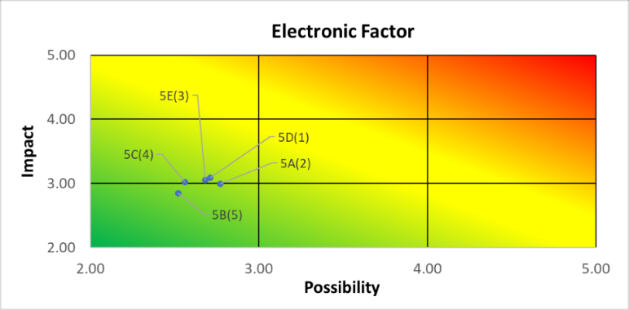
Figure 6. Analysis of the Possibility of Fire (Electrical)

Table 8 and Figure 6 are a study of fire risks in the engine room and more precisely electrical and maintenance related risks. All the risk factors are rated by their likelihood of occurrence and potential effect, and summative scores used to determine the risk ranking of a risk factor. The first risk statement (5A) is related to the number of devices connected to one electrical outlet exceeding the mains power supply. The risk possesses a likelihood score of 2.77 and an impact score of 2.99, culminating in a total score of 8.28, thereby securing the second rank. The second risk statement (5B) indicates the hazard of an exposed and illuminated lamp cover, with a likelihood score of 2.52 and an impact score of 2.85, resulting in a total score of 7.18 and placing fifth as the lowest risk.
The third risk statement (5C) relates to the use of unshielded portable light bulbs which might break and cause fires when in touch with other inflammable materials. The threat has the likelihood score of 2.56 and impact score of 3.02, and a cumulative score of 7.73, hence it is placed at the fourth position. The fourth risk statement (5D) touches upon the differences in implementation of maintenance of electric equipment according to the planned plan (Planned Maintenance System) and has a likelihood score of 2.71 and an impact score of 3.09, which sum to the total score of 8.37. This makes it the most dangerous risk in the table, as it is placed at the top. The final risk statement (5E) concerns the use of electrical equipment and spare parts, which do not comply with the maritime safety regulations (non-compliant maritime). The likelihood score is 2.68, the impact score is 3.05, yielding a total score of 8.17, which ranks third. The primary concern linked to engine rooms is the irregularity in the maintenance of electrical apparatus. This underscores the necessity to enhance the execution and oversight of maintenance activities to mitigate the probability of fire accidents.

  - Risk of Sinking

The highest risk of sinking occurs on ships that depart beyond the maximum load and where there is excessive crew workload [38]. These results are consistent with the theory of ship stability, which states that load distribution and weather conditions greatly affect the stability of a vessel during sailing [39]. According to Zahra [40], negligence by the crew in carrying out critical procedures is a major factor that increases the risk of a ship sinking. Such negligence includes failure to calculate stability after loading, disregard for the amount of cargo transported, failure to prepare a stowage plan, failure to check ship stability after loading, and failure to conduct routine inspections of the hull’s technical condition. This demonstrates the safety of a close control over the ship load limit and appropriate management of the working hours of the crew to guarantee the safety of operations.

Table 9. Analysis of the Possibility of Sinking
It | Risk Statement | Possible Score | Impact Score | Total Score | Ranking
6A | Ship departing exceeds its maximum load | 2.92 | 3.42 | 9.98 | 1
6B | High crew workload not proportional to rest hours | 2.92 | 3.30 | 9.63 | 3
6C | Bad weather and limited visibility | 2.99 | 3.30 | 9.86 | 2
6D | Periodic checks on ship building structures not carried out | 2.71 | 3.07 | 8.32 | 7
6E | Implementation of Bridge Resource Management not maximized | 2.72 | 3.04 | 8.28 | 8
6F | Poor communication between ships | 2.81 | 3.20 | 9.01 | 4
6G | Stability calculations not properly implemented | 2.71 | 3.15 | 8.56 | 6
6H | Vehicle removal not in accordance with procedures | 2.77 | 3.21 | 8.89 | 5
6I | Ramp door not tightly closed | 2.66 | 2.94 | 7.82 | 9

Table 9 and Figure 7 discuss the danger of submersion associated with the vessel operation. Every risk statement is rated based on the likelihood of its occurrence and the possible impact of the risk with cumulative rating used to create a priority. The initial risk statement (6A) delineates the hazard of a vessel departing in excess of its maximum capacity. The likelihood score is 2.92, the impact score is 3.42, resulting in a total value of 9.98, which indicates the highest risk. The next risk statement (6C) about severe weather and limited visibility has a likelihood score of 2.99 and impact score of 3.30 giving a total score of 9.86 and ranked second position. The third threat (6B) is related to the aspect of insufficiently matched the work of the crew with the sufficient rest which scores 9.63 and occupies the 3rd position. The fourth risk (6F) that is associated with poor communication between vessels has a cumulative score of 9.01 and is on position four.

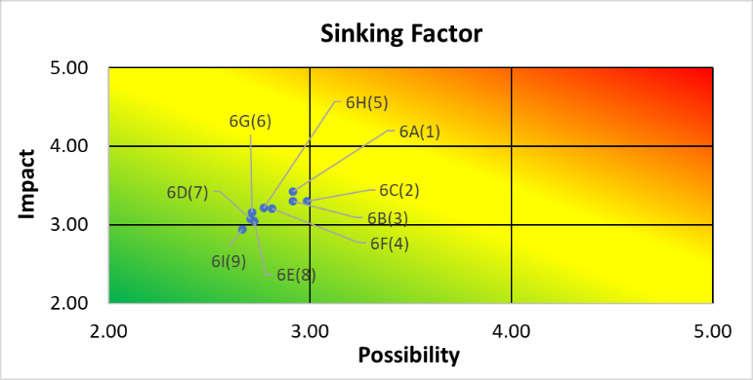
Figure 7. Analysis of the Possibility of Sinking

Other risks include improper vehicle handling (6H), which has a total score of 8.89 and ranks fifth, and incomplete stability calculations (6G), with a total score of 8.56 and ranking sixth. Poor routine inspection of ship structures (6D) has the overall score of 8.32 and is ranked seventh. The total score of Bridge Resource Management (6E) is 8.28, which ranks it in the 8 th position because of a suboptimal implementation. Ramp doors improperly secured (6I) have the lowest total score of 7.82 and are ranked in the 9 th place.The statistics indicate that overloading, extreme fatigue of the crew, lack of proper communication, and weakness of stability checks are the major causes of sinking incidents. This agrees with the past KNKT findings and the need to comply with loading standards and operational procedures.

Table 10. Determination of Risk Matrix Value
 |  | Consequence
 |  | Very Light | Light | Moderate | Heavy | Very Heavy
Likelihood | Very Often
Likelihood | Often
Likelihood | Moderate |  |  | 1B,2B,2C, 2D,2E,3A, 3B,3D,4B, 4C,5A,5B, 5C,5D,5E, 6D,6E,6F, 6G,6H,6I | 1A,1C,2A, 3C,6A,6B, 6C
Likelihood | Infrequently |  |  | 4A
Likelihood | Very Rare

Risk statement evaluation is an important process involved in the risk analysis of shipping accidents, and the value of risk matrix is then determined. The identification of the risk is measured by the severity and probability of the risks and assists in deciding the preventive measures that need to be taken by using the risk matrix. The process of this assessment includes categorizing the risks depending on their level of impact and frequency of occurrence with safety managers given an opportunity to prioritize the risk with the highest level of impact. Among the accident scenarios, fire and sinking incidents were considered as the risk ones, and such particular categories are human error, unsafe cargo handling, deficiency of emergency preparedness (Emergency Drill), engine room hazards, and electronic devices (Electrical) risks. The individual risk factors are rated according to their contribution to the personal safety, ship integrity and the security of cargo. According to the results of the matrix, the risk levels are divided into low, medium, and high categories, each category will need different types of interventions, including increased training and emergency response protocols or improved safety policies and regular technical inspections of the vessels.
Table 10 presents the risk matrix that was applied to evaluate and to identify the degree of risk depending on the probability of its occurrence and the intensity of the impact on each of the risk statements. This matrix divides risks into five Consequence categories (very light, light, moderate, heavy, and very heavy) and five likelihood categories (very often, often, moderate, infrequently, and very rare), which helps determine priority levels in risk management. Each combination of likelihood and impact in this matrix is filled with the corresponding risk statement codes. As an example, in the moderation of 30 percent of moderate likelihood, 30 percent of moderate impact, we have a list of several risk statements: 1B, 2B, 2C, 2D, 2E, 3A, 3B, 3D, 4B, 4C, 5A, 5B, 5C, 5D, 5E, 6D, 6E, 6F, 6G, 6H, and 6I. This indicates that these risks have a moderate probability and impact and require consistent management attention.
In the infrequently and moderate likelihood and impact, there is only 1 risk statement namely 4A, which signifies that this risk is not very common but it can lead to a moderate impact. With the following risk statements, a 1A, 1C, 2A, 3C, 6A, 6B, and 6C, we can see that these risks are frequent and with severe consequences, that is why they are of high priority in the list of mitigated actions. On the whole, this risk matrix offers a clear indication of ranking of risks in terms of their likelihood and impact. The research indicates that the human aspect, cargo handling procedures, and equipment maintenance are central in reducing fire and sinking risks in Ro-Ro passenger ships. Validity and reliability tests indicate that the research tools employed are sound and the analysis gives an all inclusive picture of operational risks that ship operators have to deal with. With appropriate risk mitigation measures, ship and cargo safety can be significantly improved.
The findings of this study are consistent with previous research by Badri et al. [7] and Zahroh [9], which identify human error as the primary cause of maritime incidents. This study also aligns with Hariyanti et al. [28] and Widodo et al. [29], which highlight that the fire risk on passenger vessels increases due to improper cargo storage and handling. On the other hand, Widyasto et al. [27] treated electrical failures as isolated technical issues, while this study shows that such failures are often interconnected with human error and insufficient supervision. This study, consistent with Liolita et al. [38] and Yahya [40], underscores that overloading and crew weariness significantly contribute to sinking incidents, emphasizing the critical role of human and operational variables in marine safety.

- Conclusion

This study uses the HAZOP method to identify various operational aspects of Ro-Ro passenger ships that pose high risk. The survey results indicate that the most significant dangers arise from improper use of LPG stoves, unsafe storage of hazardous materials, malfunctioning fire detectors, welding processes that are not performed according to procedures, and ship overloading combined with exhausted crew members. These findings demonstrate that human and institutional factors contribute the largest to accidents at sea. Human decisions directly affect the operational safety of passenger ships.
Therefore, human resource management is a key area requiring systematic improvement. Proposed measures encompass enhancing fire prevention training, enforcing stringent rules for hazardous chemical management, performing regular operational inspections and emergency system evaluations, and maintaining crew physical fitness through rigorously regulated working hours. In particular, the authors propose that, as restrictions on air transport have increased, measures should be introduced to address safety concerns for sea travelers. Simultaneously, the issue of capacity and resource constraints should be collectively resolved by nations like Indonesia and both the government and business communities. Accordingly, this study provides practical insights for shipping companies, maritime authorities, and maritime institutions seeking to enhance safety standards.
This study possesses multiple drawbacks. The analysis will focus on the Ro-Ro passenger ships within a specific period (20182022) using the data obtained on the basis of KNKT reports and responses to the questionnaires among ship employees.Some risk factors outside of this realm were not considered including technical design variations, weather conditions on routes and safety management systems of the company.
Future research should extend the aspects of HAZOP to incorporate quantitative risk modeling techniques such as Fault Tree Analysis (FTA) and Bayesian Network techniques. It is expected that this strategy would increase the precision of visualizing the results and would improve the accuracy of estimating the risk factors. Furthermore, future studies may include a broader range of ship types and sailing routes to develop a more comprehensive risk management model in Indonesia’s maritime passenger transportation sector.

Acknowledgements

We express our sincere gratitude to those who supported completing this article, "Identification of Passenger Ship Accident Risk Management with Hazard and Operational Analysis (HAZOP) Approach." We acknowledge the marine professionals who provided significant insights and data about passenger ship safety. Finally, we are deeply thankful to our family and friends for their encouragement, which played a crucial role in completing this study.

References

- N, N. P., Basuki, M., & S, P. I. (20221). K3 risk assessment on the Ketapang-Gili Manuk crossing uses BOW-TIE Risk Assessment. Earth and Marine Technology Seminar (SEMITAN III), 3(1), 237–243.
- Rahman, H., Satria, A., Iskandar, B. H., & Soeboer, D. A. (2017). Determination of the Dominant Factor Cause of Ship Accidents in Tanjung Priok. Albacore, I(3), 277–284.
- Putraman, D. C. S., Artana, K. B., & Pitana, T. (2019). Analysis of Human Error as the Cause of Ship Collision Accidents in the Port Area of Tanjung Perak Surabaya using the HFACS and AHP Methods. National Marine Seminar XIV, 58–67.
- Priyohadi, N. D., & Achmadiansyah, A. (2021). The Relationship between K3 Management Factors and Unsafe Action in Workers of PT Pelabuhan Penajam Banua Taka. Baruna Horizon Journal, 4(1), 1–13.
- Sahara, S., & Alfian, R. (2023). Analysis of Shipping Safety Improvement Against Ship Accidents by the Office of Municipal Affairs and Port Authority (KSOP). INNOVATIVE: Journal Of Social Science Research, 4(1), 13028–13037.
- National Committee for Transportation Safety. (2022). KNKT 2022 transportation accident investigation statistics book.
- Badri, A.-F. B. A., Wahyuni, A. A. I. S., Susanto, N., & Fatimah, S. (2024). The application of personal protective equipment during lifting on the platform to minimize work accidents on SV ships. FIONA 38. Journal of Patria Bahari, 4(1), 7–16.
- Kendek, M., Iskandar, I., Satria, I. D., & Bayuntara, A. W. (2023). A Case Study Analysis of the Results of the Investigation of the National Transportation Safety Committee (KNKT) into the Cause of Ship Collisions in Indonesia Waters. JPB : Journal of Patria Bahari, 2(2), 1–10. https://doi.org/10.54017/jpb.v2i2.60
- Zahroh, D. A. S. (2023). Analysis of Human Error as an Effort to Prevent Accidents in the Maritime Field: Literature Review. Journal of Scholarly Service, 2(3), 317–324.
- Minarto, D., & Santoso, K. T. (2023). Development of a maritime weather monitoring and prediction system to improve navigation safety. SAMMAJIVA: Journal of Business and Management Research, 1(4), 231–238.
- International Maritime Organization (IMO). (2018). Guidelines on Human Element Training and Watchkeeping (Model Course 7.01).
- Surbakti, A. G., Kamil, A. S., Ginting, B. B., & Darma, Y. Y. E. (2023). Concept design of passenger ships to reduce the number of ship accidents in Lake Toba. Journal of Maritime Technology, 6(2), 28–33.
- Supangat, S. (2024). The role of ship management and communication in improving safety and operations at the port. JESYA: Journal of Sharia Economics & Economics, 7(1), 322–328. https://doi.org/10.36778/jesya.v7i1.1457
- Setiawan, A., Noor, M. A. S., Trisanto, A., John, G. F., Romania, D. D., Emilliano, Wibawa, B. M., Rohadi, N., & Turnip, A. (2024). Pilot Anxiety Detection through Brain Signal Using Naïve Bayes Method. 2024 IEEE International Conference on Artificial Intelligence and Mechatronics Systems (AIMS), Bandung, Indonesia, 2024, 1–6. https://doi.org/doi: 10.1109/AIMS61812.2024.10513237
- Urrohmah, D. S., & Riandadari, D. (2019). Hazard Identification with the Hazard Identification, Risk Assessment and Risk Control (Hirarc) Method in an Effort to Reduce the Risk of Work Accidents at PT. PAL Indonesia. Journal of Mechanical Engineering Education, 8(1), 34–35.
- Sahara, S., & Rizky, N. F. (2023). Priok, The Effect of the Ship and Cargo Service Request Process (PPKB) on the Docking Time at PT. Port of Indonesia (Persero) Tanjung. INNOVATIVE: Journal Of Social Science Research Volume, 3(6), 1970–1979. https://doi.org/10.3138/9781442682795-011
- Wanuri, B. D., Satriyo, G., Khoiruman, M. A., & Komanireng, J. (2023). Procedures for Issuing Online-Based Seafarer Books at the Office of Municipal Affairs and the Tanjung Wangi Port Authority. DISCOVERY: Journal of Maritime and Transportation, 5(2), 82–90.
- Siregar, Z. M., Panjaitan, H., & University, W. S. W. (2023). Responsibility of the Captain in Sea Transportation for Ship Accidents in Indonesia. Journal Syntax Idea, 5(12), 2700–2717. https://www.ncbi.nlm.nih.gov/books/NBK558907/
- Andrew Pradana Putra, Mey Krisselni Sitompul, Tri Mardalena, & Romadani. (2022). Analysis of the Relationship between Sea Transportation and Teluk Dalam's Cargo Port to Support the Economic Activities of the Penyalai Community, Kuala Kampar District, Riau Province. Jalasena Journal, 3(2), 57–71. https://doi.org/10.51742/jalasena.v3i2.54
- Fitriani, R., Fashandika, E., Putra, E., Nailah, H., & Permana, R. (2024). The Effect of Regular Ship Service Quality on Customer Satisfaction at Bakauheni Port. Bisman (business and management): The Journal of Business and Managemt, 7(2), 315–329.
- Jamil, J., Mallapiang, F., & Multazam, A. M. (2023). Analysis of Unsafe Action and Unsafe Condition with Work Accidents on the Crew of the Bira-Pamatata Ferry Ship. Journal of Muslim Community Health (JMCH) 2023, 4(1), 251–264. https://doi.org/10.52103/jmch.v4i1.1285JournalHomepage:https://pasca-umi.ac.id/index.php/jmch
- Murti, R. L., Yuda, A. A. N. A. D. P., Rahmawati, M., & Mustamin. (2024). Analysis of the collision between the ABM Iljin ship and the conveyor room during the shifting berthing activity at the Celukan Bawang PLTU port. Scientific Journal of Science and Technology, 2(8), 282–304.
- Nurdiansyah, A., Rahmawati, M., Purwitasari, D., & Nofandi, F. (2024). Hazard Identification in Bunker Service Activities at the Office of Municipal Affairs and Port Authority Class III of the Surabaya Shipping Polytechnic, Indonesia. Sinar Dunia: Journal of Social Research Humanities and Educational Sciences, 3(3), 191–220.
- Khamid, A., Mulyadi, Y., & Mukhtasor, M. (2018). Occupational Safety and Health Risk Analysis (K3) on Work Accidents and the Environment Using the Hazard and Operability Study (HAZOP) Method in the Ship Scrapping Process in Bangkalan Madura. ITS Engineering Journal, 7(2), 38–43. https://doi.org/10.12962/j23373539.v7i2.33216
- Puadah, J., Hasugian, S., & Haryanto, D. (2021). Risk Analysis of Activities on Board Using the Hazop Analysis Method at KMP. Athaya. Journal of Maritime Science, 22(1), 63–74.
- Pambayun, F. D., Rahmawati, M., & Purwitasari, D. (2024). Analysis of Work Accident Risk Management in the Ship Docking Process at Tanjung Perak Port, Surabaya. Journal of the Star of Education Indonesia, 2(4), 264–288.
- Widyasto, L. A., Sarwito, S., & Zaman, B. (2015). Human Error Analysis of Ship Accidents in Data-Based Electrical Systems on Ships. ITS Engineering Journal, 4(1), G10–G14.
- Hariyanti, R., Kristini, F., Wahyuni, O., Sari, D. K., & Meliana, D. (2024). Efforts to Reduce Risks in Shipping Dangerous Cargo. National Seminar on Transportation and Safety, 1(1), 334–347.
- Widodo, B. L. H., Wahyuni, E. T., & Luhur, M. A. (2023). Dangerous Goods Loading Management for the Safety of Cargo Ships and Crews. Polymarine Maritime Journal, 9(1), 36–44. https://doi.org/10.52492/jmp.v9i1.101
- Eva Susanti, & Citra Kurnia Dewi. (2023). Optimizing the Readiness for the Use of Permanent Fire Extinguishers at KM Bukit Siguntang. Venus Journal, 11(1), 49–62. https://doi.org/10.48192/vns.v11i1.692
- Siregar, R. H., Kurniawan, D., Nurmala, E., Sultan, & Saifudin, I. (2024). Decreased Function of Smoke Detector Performance on board MV Ship. Sarah S. Multidisciplinary Journal of Scientific Research, 1(2), 23–30.
- Sutantyo, E., & Susanti, S. (2022). The Role of Fire Detection Equipment in Supporting Safety on MT Ships. Mabrouk. Polymarine Maritime Journal, 8(1), 88–95. https://doi.org/10.52492/jmp.v8i1.53
- Hitalessy, J. O., Rochyana, M. F., Hidayat, A., & Hidayat, I. (2021). Factors Causing Work Accidents When Welding on a Ship. Journal of Transportation and Logistics Business Management, 6(3). https://doi.org/10.54324/j.mbtl.v6i3.583
- Suryani, D., Hendrawan, A., Pramono, S., & Hendrawan, A. K. (2023). Welding Safety on the Kalimantan Jaya Karya Ship at PT. Samudra Fishing Industry Cilacap. Marine Science and Technology Journal, 3(2), 32–38. https://e-journal.ivet.ac.id/index.php/maristec/article/download/2472/1824
- Bakhtiar, D., & Sulaksmono, M. (2013). Risk Assessment on Confined Space Welding Work in the Ship Building Section of PT Dok and Surabaya Shipping. The Indonesian Journal of Occupational Safety and Health, 2(1), 52–60.
- Marwiyah Nst, M., Sutria, Y., & Taruna, T. (2023). Ship Electrical Safety System in Belawan. Journal of Maritime and Education (JME), 5(1), 456–461. https://doi.org/10.54196/jme.v5i1.100
- Ma'ruf, Amalia Azahra, S., Rammadhani, F. S., Prihadi, A. B., Danuarta, V. Y., & Hasanah, A. (2024). Analysis of Causative Factors and Strategies to Prevent Fishing Boat Fires at Nizam Zachman Fishing Port. Journal of Social Science Research, 4(3), 5776–5788.
- Liolita, S., Amiruddin, W., & Iqbal, M. (2019). Analysis of Seaworthiness of KM Passenger Ships. Nusantara 76 in overload conditions. Ship: Journal of Marine Science and Technology, 16(2), 56–64. https://doi.org/10.14710/kapal.v16i2.23361
- Manullang, S., Irvana, R., Buwono, A., & Patanda, M. (2023). Analysis of the effect of placing solar panels on the deck house of a 30 GT fishing boat on the operational safety of fishing. Journal of Capture Fisheries Science and Technology, 8(1), 39–46.
- Yahya, S. (2022). Identification of Critical Risk of Sinking Ship Accidents (Case Study: accidents in Indonesia's sea waters and Indonesia-flagged ships). Proceedings of the 6th National Seminar on Research & Community Service 2022, 34–39.

