CASSAVA SKIN USAGE (Manihot esculenta L. skin)
AS PHOTOCATALYST TO DEGRADATION
METHYLENE BLUE IN THE RIVER OF TEXTILE INDUSTRIAL ZONE
Kharisma Madda Ellyana^{1*}, Kharisma Luthfiaratri Rahayu¹, Ratri Febriastuti¹, Abdul Haris¹

¹Chemistry Department, Diponegoro University, Jl. Prof.H.Soedarto, S,H. Tembalang, Semarang. Jawa Tengah
*Corresponding author E-mail: kharismamadda25@student.undip.ac.id

Abstract

The progress of the textile industry can increase the amount of dyestuff waste, but often waste disposal is overlooked. The purpose of this research is to provide solution in handling river water pollution by textile industry dye waste. The degradation of textile industry dye waste can be done with TiO₂ semiconductors with UV light as a source of irradiation, but only 5% of sunlight can be utilized TiO₂ to excite its electrons, so degradation process is not effective. It needs a material that can optimize the activity of TiO₂ semiconductor, one of them C-dot coming from cassava skin. The results obtained in this research are TiO₂/C-dot composite can degrade methylen blue where its effectiveness is tested using UV-Vis spectrophotometer instrument. TiO₂/C-dot photocatalyst activity test for methylene blue 0.0001 M showed that the concentration of 20% with the amount of degradation up to 96,99%, best type of rays is sunshine with amount of degradation up to 66,25% and longest radiation in sunshine with the amount of degradation up to 78.77% and UV with the amount of degradation up to 75.99%.

Keywords: Cassava Leather; TiO₂ / C-Dot Composite; Photocatalyst; Methylen Blue; Hydrothermal

- Introduction
Today we know that Indonesia is experiencing rapid progress in the field of industry, one of them in the textile indus-try. The progress of the textile industry can increase the amount of dyestuff waste, but often waste disposal is overlooked. Disposal of dyestuffs into rivers can result in pollution and harmful to public health. Therefore, appropriate solutions are needed to deal with river water pollution by textile industry dye waste.
The photocatalytic process using TiO₂ semiconduc-tors with UV light as a source of irradiation has shown the poten-tial to overcome the problem of dyestuff waste by degrading the dye to a more environmentally friendly compound [7, 10], but only 5% of sunlight can be utilized TiO₂ to excite its electrons due to the large band gap. The formation of a nanocom-posite which is a combination of two distinct components of either one or both scales ≤ 10⁻⁹ m or equivalent to the size of the atom or molecule can enhance the photocatalytic activity of TiO2, one of which is the TiO₂ / C-dot composite [2, 25]. Re-search conducted by Li et al. (2012) showed that the quantum carbon dot (CQDs) attached to TiO₂ surfaces could effectively degrade methyl blue (MB) to close to 100%. Thus, the TiO2 / C- dot composite is also expected to have such photodegradation capability due to the similarity of the C-dot properties to the CQDs.
Only limited as staple food substitutes for rice and raw mate-rials for various processed products, while the skin is often dis-carded. In fact, cassava skin contains starch compounds that can be utilized as carbon sources in the manufacture of carbon nanodot material or better known as C-dot through hydrothermal method [1].
Based on these facts, the innovation to solve the prob-lem of river water pollution by dyestuff waste is the making of cotton-based TiO2 / C-dot nanocomposite (Manihotesculenta L.) as photodegradation material of dyestuff, especially methylene blue compound. The advantages of this innovation are the easy process of making TiO2 / C-dot composites, cheap and abundant raw material sources, and enhanced photodegradation capability against methylene blue compounds.

- Materisals and Methods

2.1. Materials and Procedures
Materials used in this study include methylene blue, TiO₂, NaOH, concentrated HCl, C-dot powder of cassava leather, aquadest, and 96% ethanol obtained from Merck.

2.2. Phase of preparation of materials
The main ingredients in this research, namely cassava leaf waste. Cassava leather as a base material luminescence material has a source of many carbon compounds. The simple synthesis of luminescence material begins with processing the cassava skin into a powder.

2.3. Phase of C-dot synthesis from Cassava Skin
The independent variables used in this study are cassava powder of the material preparation stage. Cassava skin was added in 100 ml 0.1 M HCl solution and stirred in a magnetic stirer for 1 hour with temperature controlled at 30°C. Giving the acid aims to break down polymer compounds such as cellulose, and pectin to form a more simple carbohydrate compounds (hydrolysis). The result of the hydrolysis is then neutralized pH with 100 ml of a strong base of 0.1 M NaOH. At this stage the temperature at the magnetic stirer is raised at 100°C. The exothermic reaction to the addition of this strong base produces heat so that the carbon chain in the material can break and produce C-dot. Furthermore, characterization of C-dot material with XRD was done.

2.4. Synthesis TiO₂ / C-dot Composite
The synthesis of TiO₂ / C-dot composites was performed by sol-gel method (Li et al., 2010). The TiO2 nanoparticles were prepared by heating the commercial TiO₂ at a temperature of 500oC for 1 hour. The second stage, 0.1 g of TiO₂ nanoparticles and various C-dot content of cassava leather (10%, 20%, 30%, 40%, 50%dan 100% (w / w)) added 5 mL of ion free water with stirring for 10 minute and dried in 80ºC vacuum oven for 12 hours. After synthesis process is done characterization with XRD and SEM.

2.5. Photodegradation Activity Test on Methylene Blue
Photodegradation of the dye was carried out by taking 25 mL methylene blue 0.0001 M and then added a c-dot photocatalyst of cassava leather, and irradiated by ultraviolet light for ± 80 min, after the photocatalysis was finished filtrate was analyzed using visible uv spectrophotometer. Photocatalyst activity test was performed by comparing with standard methylene blue 0.0001 M.

2.6. The Effect of Light on Methylene Blue Photodegradation
Four 50 mL cups filled with 25 mL methylene blue 20 mg / L solution with different treatment, ie first glass containing methylene blue solution; the second glass added 50 mg C-dot. Then photodegradation process is done in photoreactor for 50 minutes using UV light. Furthermore, with the same preparation procedure illuminated by sunlight at 10:00 to 10:50 pm and left in dark conditions. The photodegradation process is done triplo. The methylene blue concentration after the treatment was measured by a UV-Vis spectrophotometer at a wavelength of 664 nm.

2.7. Influence of Irradiation on Methylene Blue Degra-dation using TiO₂ / C-dot Composite Photocatalyst
Nine pieces of 50 mL glass of glass filled 25 mL of 20 mg / L methylene blue solution and 50 mg C-dot was added, then radiation was done by sunlight. Furthermore, with the same prepa-ration procedure illuminated by UV light in the photoreactor. Methylene blue absorbance measurements were performed on the first glass at 5 minute irradiation and measured on the other glass at 10, 20, 30, 40, 50, and 60 minutes. The photodegradation process is done triplo. The methylene blue concentration after the treatment was measured by a UV-Vis spectrophotometer at a wavelength of 200 nm - 800 nm.

- RESULTS AND DISCUSSION

3.1. Synthesis of C-dot from Cassava Skin
The results obtained from hydrolysis of HCl neutralized with NaOH produce heat so that the carbon chain in the material can break and produce C-dot.
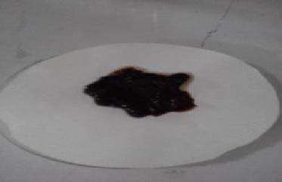

Fig. 1: C-dot

3.2. Making Composite TiO₂ / C-dot
The result of mixing 0.1 gram of TiO₂ nanoparticles and various C-dot grade of cassava leaf 10%, 20%, 30%, 40%, 50% and 100% of TiO₂ / C-dot composite. This composite has a darker color than TiO₂ and is close to a dark brown color.
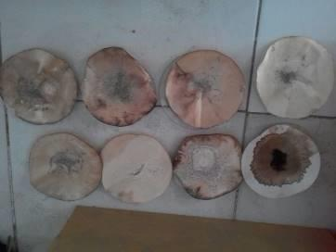

Fig. 2: TiO₂ / C-dot composite

3.3. CharacterizationComposite TiO₂ / C-dot.
The synthesis results were characterized by SEM showing the composite surface morphology of TiO₂ / C-dot Nanoparticles with different magnifications.

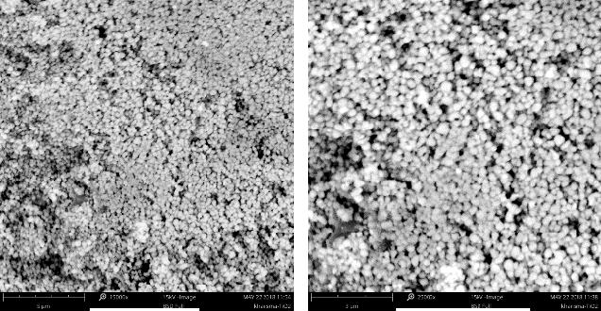
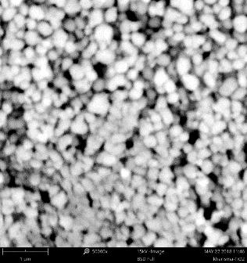

- (b) (c)

Fig. 3: (a) SEM Magnification 15000x (b) SEM Magnification

25000x(c) SEM Magnification 50000x

The C-dot influence in the composite can be known from the XRD diffractogram. The intensity and crystallinity of the TiO₂/C-dot composites were less than that of TiO₂. This decrease was due to the addition of a relatively amorphous C-dot in the composite. However, there were no significant changes in the XRD pattern of the composites compared to the XRD pattern of TiO₂. All peaks on TiO₂/C-dot were similar with the diffraction angle of TiO₂, indicating that there was no new compound formed from mixing C-dot with TiO₂.

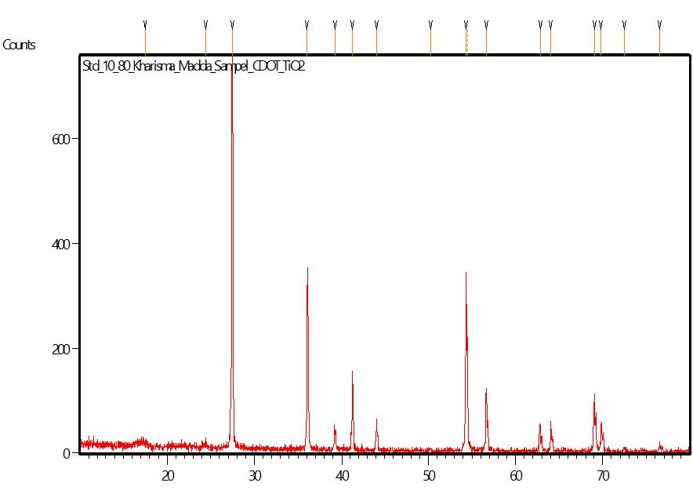

Fig. 4: XRD Spectra of TiO₂/Cdot

3.4. Adsorption Test
In the analysis that has been done can be known the effectiveness of the use of TiO2 / C-dot in dyestuff degradation Methylen Blue.

3.4.1. Effect of Concentration on Photodegradation
The results of the addition of TiO2/C-dot levels in methylene blue (25 mg/L) solution processed by the photocatalytic reactor showed color degradation as shown in the following table.

Table 2: Data of analysis of concentration variation on methylen blue degradation

Concentration Absorption | MB | MB | Effectiveness
(%) | Concentration | concentration | (%)
 | remaining | in
 |  | degradation
10 | 0,858 | 5,546353523 | 14,45364648 | 72,26823239
20 | 0,058 | 0,60197775 | 19,39802225 | 96,99011125
30 | 0,137 | 5,451174289 | 14,54882571 | 72,74412855
40 | 0,286 | 10,05562423 | 9,944375773 | 49,72187886
50 | 0,077 | 3,597033375 | 16,40296663 | 82,01483313
100 | 0,913 | 5,886279357 | 14,11372064 | 70,56860321

Fig. 5: Diagram of the relationship between the concentration of methylen blue degradation

The optimum degradation occurs at 20%. The degra-dation of each dye is not significant, so it takes longer to reach the desired descent percentage. This is because no catalyst plays a major role in dye reduction. The use of UV light without the use of a catalyst can decrease the dye even if the percentage obtained is very small. This is due to the double bond in the reduced dye compound with the help of hv, but the dyestuff compound can not be substantially reduced from the large absorbance value so that the percent value of degradation obtained is very small.
When photocatalysts are exposed to ultraviolet radia-tion that has the appropriate energy or even exceeds the bandit energy of the oxide titan, the electrons in the valence band of the photocatalyst will be attracted to the conduction band which will produce the ekb and vacancies or holes (hvb) acting as positive charges. Furthermore, hvb will react with the metal hydroxide ie the titan hydroxide oxide present in the solution to form a metal hydroxide radical which is a strong oxidizer to oxidize the com-pounds present in said liquid waste. For electrons present on the semiconductor surface will be trapped in the metal hydroxide and can react with H2O or O2 present in the solution to form hydroxy radical (-OH) or superoxide (-O) which will oxidize the com-pounds contained in said liquid waste. This radical will be formed continuously as long as TiO2 / C-dot is still exposed to UV radia-tion and will attack the compound contained in the liquid waste located on the surface of the catalyst so that it will be degraded to produce a harmless compound. So the more photocatalyst is added then the active side that will produce (-OH) more and more (Qodri, 2011).

3.4.2. Effect of Light on Photodegradation
The results of the analysis of the type of light in the methylene blue solution (25 mg / L) processed by the photocata-lytic reactor show the color degradation as shown in the following table.
Table 3: Data analysis of the type of rays on methylen blue degradation

 | Variables | Absorption | MB | MB | Effectiveness
 |  |  | Concentration | concentration | (%)
 |  |  | remaining | in degradation
 | Sun | 0,179 | 6,74907293 | 13,25092707 | 66,25463535
 | UV | 0,205 | 7,552533993 | 12,44746601 | 62,23733004
 | Dark | 0,217 | 7,923362176 | 12,07663782 | 60,38318912

Fig. 6: Diagram of the relation between the variation of rays to degrada-tion of methylen blue

The diagram above shows that the degradation value of methylene blue increases in dark conditions, UV rays into sun-light with various photocatalysts. In dark conditions, the degrada-tion value is low because there is no light source so that the pho-ton energy to produce the radical • OH is weak, therefore meth-ylen blue is only adsorbed on the catalyst surface and its degrada-tion becomes not optimal. In sunlight conditions obtained sunlight results higher than UV light. This is because sunlight has the in-tensity and wavelength between (310-2300 nm) greater than the wavelength of UV light (200-380 nm). In addition, sunlight is a combination of ± 45% visible light and ± 5% of UV light so that sunlight has a relatively large energy and can provide a lot of pho-ton energy on the photocatalyst. Photocatalysts TiO2 / C-dot in-crease photocatalytic activity up to ± 66.25% UV radiation to sunlight resulting in the most optimum degradation of methylene blue. When the photocatalyst is irradiated with greater energy than the bandgap, a strong oxidizing hole is generated to form an OH radical and the radical degrades the blue methylene into a simpler compound. From these light effects data, the sun can be used as a potential light source for photocatalysts in degrading methylen blue dyes.

3.4.3. The effect of long irradiation on photodegradation
The time of radiation in the photodegradation process illustrates the length of the interaction (contact) between photo-catalyst and light (hv) in generating OH radicals and contacts be-tween OH radicals and methylen blue substrates in the degradation process. The results of long and sunlight exposure analysis of methylene shown in the following table.

Table 4: Analyzes of long irradiation data on methylen blue degradation

Variables | Absorption | MB | MB | Effectiveness
(%) |  | Concentration | concentration | (%)
 |  | remaining | in
 |  |  | degradation
M10 | 0,118 | 4,864029666 | 15,13597033 | 75,67985167
M20 | 0,098 | 4,245982695 | 15,75401731 | 78,77008653
M30 | 0,113 | 4,709517923 | 15,29048208 | 76,45241038
M40 | 0,14 | 5,543881335 | 14,45611867 | 72,28059333
M50 | 0,129 | 5,203955501 | 14,7960445 | 73,9802225
M60 | 0,136 | 5,420271941 | 14,57972806 | 72,8986403
UV10 | 0,165 | 6,316440049 | 13,68355995 | 68,41779975
UV20 | 0,224 | 8,139678616 | 11,86032138 | 59,30160692
UV30 | 0,129 | 5,203955501 | 14,7960445 | 73,9802225
UV40 | 0,118 | 4,864029666 | 15,13597033 | 75,67985167
UV50 | 0,116 | 4,802224969 | 15,19777503 | 75,98887515
UV60 | 0,137 | 5,451174289 | 14,54882571 | 72,74412855

Fig. 7: Diagram of the relation between the duration of sun exposure and UV radiation to methylen blue degradation
Diagram shows that degradation of methylen blueop-timum at minute 20 with effectiveness equal to 78,77%. This shows that the irradiation time is 20 minutes, the solution dye becomes faded so that methylen blue is easily degraded
While on UV rays degradation methylen blue opti-mum at minute 50 with effectiveness equal to 75,99%. This shows that the irradiation time is 50 minutes, the solution dye becomes faded so that methylen blue is easily degraded. Photon energy from sunlight can cause photocatalysts to produce OH radicals more than photon energy from UV light. According to Dony, et al and Tang et al that% degradation of methylene blue increases with increasing sun exposure in the photodegradation process using TiO2 / C-dot catalyst. The longer the irradiation time, the adsorp-tion and desorption process will run continuously, until it reaches the optimum condition where adsorption and desorption are equi-librium so that degradation tends to be stable close to 100%.

- Conclusion
Based on the result of research, it can be concluded that:
- Photocatalyst of TiO2 / C-dot with concentration variation of 10,20,30,40,50 and 100% can be synthesized using hydrothermal method
- The results of TiO2 / C-dot photocatalyst characterization using XRD and SEM show that TiO2 has entered the external and inter-nal parts of TiO2 / C-dot .
- TiO2 / C-dot photocatalyst activity test for blue methylene 0.0001 M showed that the best photocatalyst concentration to degrade methylene blue 0.0001 M at 20% level with degradation amount up to 96,99%.
- TiO2 / C-dot photocatalyst activity test for blue 0.0001 M methylene showed that the best type of rays to degrade methylene blue 0.0001 M is sunlight with the amount of degradation up to 66,25%.
- TiO2 / C-dot photocatalyst activity test for blue 0.0001 M methylene showed that the best irradiation time to degrade methylene blue 0.0001 M in sunlight with degradation amount up to 78,77% and UV with amount of degradation up to 75,99 %.

- Acknowledgment
We are grateful for the departments of Chemistry, Faculty of Science and Mathematics, University of Diponegoro and PKM (Progam Kreativitas Mahasiswa) KEMENRISTEKDIKTI for research funding.
And to thank the Indonesian Ministry of Research, Tech-nology, and Higher Education which sponsored this research.

- References

- Amrinah, I. 2011. Effect of chitosan biopolymer and UV/TiO₂ method for the decoloration of acid blue 40 simulated textile wastewater. Skripsi. Universitas Indonesia, Depok. Indonesia.

- Anwar, D. I., 2011, SintesisKomposit Fe-TiO₂-SiO₂ SebagaiFotokatalispadaDegradasiErionyl Yellow, Tesis, FMIPA, UniversitasGadjahMada, Yogyakarta

- Corrent, S., Cosa, G., Scaiano, J.C., Galletero, M.S., Alvaro, M., Gar cia, H., 1999.Chem. Mater. 13, 715-722.

- Damayanti, C. A., S. Wardhani, dan D. Purwonugroho. 2014. Pengaruhkonsentrasi TiO2 dalamzeolitterhadapdegradasi methylene blue secarafotokatalitik. Kimia Student Journal 1 (1) : 8 – 14

- Dony, N., Aziz, H., danSyukri, 2013, StudiFotodegradasiBiruMetilen di BawahSinarmataharioleh ZnO-SnO2 yang dibuatdenganMetodaSolid State Reaction, Media Sains, Vol. 5(1) : 66-74

- Eko, P.H.2000. KetikaTenunMengubahDesaTroso, Semarang : Bendera

[7] Fatimah, I. dan K. Wijaya. 2005. Sintesis TiO₂/zeolitsebagaifotokatalispadapengolahanlimbahcairindustritapiokasec araadsorpsi-fotodegradasi. TEKNOIN 10 (4) 257 – 267.

- Hamdaoui, O., Chiha, M., 2013, Removal of Methylene blue from Aqueous Solutions by Wheat Bran, ActaChim. Slov., 54, 407-418

- Kuo W.S and P.H. Ho. 2012. Solar PhotocatalyticDecolorization of Metilenbiru in Water. J. Chemosphere, 45:77-83.

- Manurung, R dkk. 2012. PerombakanZatWarnaAzoReak-tifSecaraAnaerobAerob. FakultasTeknikJurusanTeknik Kimia USU. Su-matera Utara.
[11] Maranti Sianita, Choiril Azmiyawati, Adi Darmawan, Uji Aktivitas Fotokatalis Genteng Berglasir Silika/TiO₂ terhadap Degradasi Larutan Indigo Carmine, Metanil Yellow Dan Rhodamin, Jurnal Kimia Sains dan Aplikasi 20 (2) (2017) : 53 – 57
https://doi.org/10.14710/jksa.20.2.53-57
[12] Mitoraj, D., 2009, Origin of Visible Light Activity in Urea Modified Titanium Dioxide, Friedrich-Alexander-Universität Erlangen-Nürnberg, Polen

[13] Qodri, A. A., 2011, FotodegradasizatWarnaRemazol Yellow FG denganFotokatalisKomposit TiO2/SiO2, Jurusan Kimia, Fakultas MIPA, UniversitasSebelasMaret, Surakarta

- Riswiyanto, S., R. Bakri, and A. Titis. 2010. Degradasifotokatali-tikzatwarna direct yellow dan direct violet dengankatalis tio2/agi - sinar UV. Valensi 2 (1) : 319 – 324

- Richana, Nur. 2013. MengenaiPotensiUbiKayu&UbiJalar. Nu-ansaCendikia : Bandung.

- Salim E. 2012. PemanfaatanKulitSingkongMenjadiTepungMocaf-sebagaiAlternatifPenggantiTerigu. Yogyakarta: Lily Publisher

- Sari, Intan, dkk. 2012. Adsorpsi Methylene Blue dengan Abu Dasar PT IPMOMI ProbolinggoJawaTimurdanZeolitBerkarbon. Prosiding-Skripsi Semester GasalJurusan Kimia. Surabaya :Fakultas MIPA Institut-TeknologiSepuluh November.

[15] Sofian Ansori , Sriatun, Pardoyo, Modifikasi Zeolit Alam Menggunakan TiO₂ sebagai Fotokatalis Zat Pewarna Indigo Carmine, Jurnal Kimia Sains dan Aplikasi 19 (2) (2016) : 68 – 71
https://doi.org/10.14710/jksa.19.2.68-71

[16] Steffita Rahayuning Purbandini, Abdul Haris, Effect of ZnO Dopant on TiO₂ on Simultaneous Decrease of Phenol, Pb(II) and COD using Photocatalysis Method, Jurnal Kimia Sains dan Aplikasi 21 (1) (2018) : 34 – 38
https://doi.org/10.14710/jksa.21.1.34-38

[17] Sudaryanto, dkk. 2012. “High Surface Area Activated Carbons Pre-pared from Cassava Peel by Chemical Activation. Chemical Engineering”,Widya Mandala Surabaya Catholic University, hal 734-739

[18] Sugiarti, S., and Darmawan, N., 2015, Synthesis of fluorescence carbon nanoparticles from ascorbic acid, Indones. J. Chem., 15 (2), 141– 145.

[19] Sun, Y.P., Zhou, B., Lin, Y., Wang, W., Fernando, K.A.S., Pathak, P., Meziani, M.J., Harruff, B.A., Wang, X., Wang, H., Luo, P.G., Yang, H., Kose, M.E., Chen, B., Veca, L.M., and Xie, S.Y., 2006, Quantum-sized carbon dots for bright and colorful photoluminescence, J. Am. Chem. Soc., 128 (24), 7756–7757.

[20] Tang, Y., Huang, X., Yu, H., Tang, L., 2012, Nitrogen-Doped TiO2 Photocatalyst Prepared by Mechanochemical Method: Doping Mecha-nisms and Visible Photoactivity of Pollutant Degradation, International Journal of Photoenergy

[21] Yaakob, Z., Gopalakrishnan, A., Padikkaparambil, S., 2012, Nanogold Loaded, Nitrogen Doped TiO2 Photocatalysts for the Degrada-tion of Aquatic Pollutants Under Sun Light, Solar Power, Vol 9 : 157-170
- Yang Z, Li Z, Xu M, Ma Y, Zhang J, Su Y, Gao F, Wei H, Zhang L. 2013. Controllable synthesis of fluorescent carbon dot and their detection application as nanoprobes.Nano-Micro Lett. 5(4):247-259.

- Zhang H, Huang H, Ming H, Li H, Zhang L, Liu Y, and Kang Z. 2012. Carbon quantum dot/Ag3PO4 complex photocatalysts with enhanced photocatalytic activity and stability under visible light. J. Mater. Chem. 2012(22):10501-10506.

- C. Giolli, A. Scrivani, G. Rizzi, F. Borgioli, G. Bolelli, and L.Lusvarghi, “Failure mechanism for thermal fatigue of thermal barrier coating systems”, Journal of Thermal Spray Technology,vol.18,pp.223–230,2009.

- C. Zhou, Q. Zhang, and Y. Li, “Thermal shock behavior of nanostruc-tured and microstructured thermal barrier coatings on a Fe-based alloy”, Surface & Coatings Technology,vol.217,pp. 70–75,2013.

