SUPPLEMENTARY FILE
In Silico Analysis for Exploring the Potential Inhibitors Against Breast Cancer (MCF7) Using Curcumin Analogue Compounds
Neni Frimayanti ^{1,*}, Adel Zamri ², Yum Eryanti ²
¹ Sekolah Tinggi Ilmu Farmasi (STIFAR), Pekanbaru, Riau, Indonesia
² Department of Chemistry, Faculty of Mathematics and Natural of Mathematics and Natural Sciences, Universitas Riau, Riau, 28293, Indonesia
* Corresponding author: nenifrimayanti@gmail.com
Table S.1. Molecular structure of curcumin analogue with their biological activity
14.25 | 10.17 | 55.16
Cpd 1 | Cpd 2 | Cpd 33
55.55 | 2.31 | 19.49
Cpd 4 | Cpd 5 | Cpd 6
27.54 | 54.96 | 3.67
Cpd 7 | Cpd 8 | Cpd 9
9.59 | 18.46 | 21.30
Cpd 10 | Cpd 11 | Cpd 12
8.97 | 7.43 | 229.34
Cpd 13 | Cpd 14 | Cpd 15
16.62 | 3.97 | 2.82
Cpd 16 | Cpd 17 | Cpd 18
7.40 | 44.69 | 65.20
Cpd 19 | Cpd 20 | Cpd 21
3.81 | 14.26 | 38.84
Cpd 22 | Cpd 23 | Cpd 24
1.64 | 13.34 | 63.0
Cpd 25 | Cpd 26 | Cpd 27
3.81 | 17.03 | 32.32
Cpd 28 | Cpd 29 | Cpd 30
25.25 | 5.20 | 5.94
Cpd 31 | Cpd 32 | Cpd 33
6.07 | 131.49 | 9.69
Cpd 34 | Cpd 35 | Cpd 36
69.00 | 22.85 | 23.70
Cpd 37 | Cpd 38 | Cpd 39
19.64 | 23.78 | 56.11
Cpd 40 | Cpd 41 | Cpd 42
60.63 | 54.18 | 4.99
Cpd 43 | Cpd 44 | Cpd 45
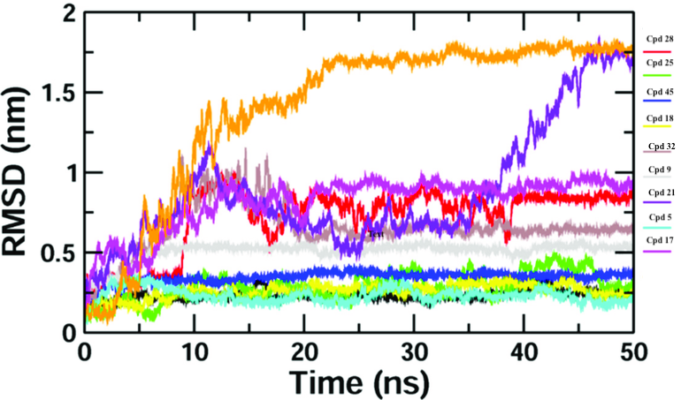
Figure S.1. RMSD graph for active compounds

