SUPPLEMENTARY DATA

Comparison of the Lipoamide Synthesis by Direct Amidation and via Amidation of Fatty Acid Methyl Esters

- TLC Profile of Synthesis of Lipoamides
Table 1. TLC profile during synthesis of lipoamides stearate-p-anisidine and lipoamide stearate-p-nitroaniline every 6 hours for 18 hours
Reaction time (h) | Lipoamide stearate-p-anisidine |  | Lipoamide stearate-p-nitroaniline
 | Direct amidation | FAME | Direct amidation | FAME
6 | 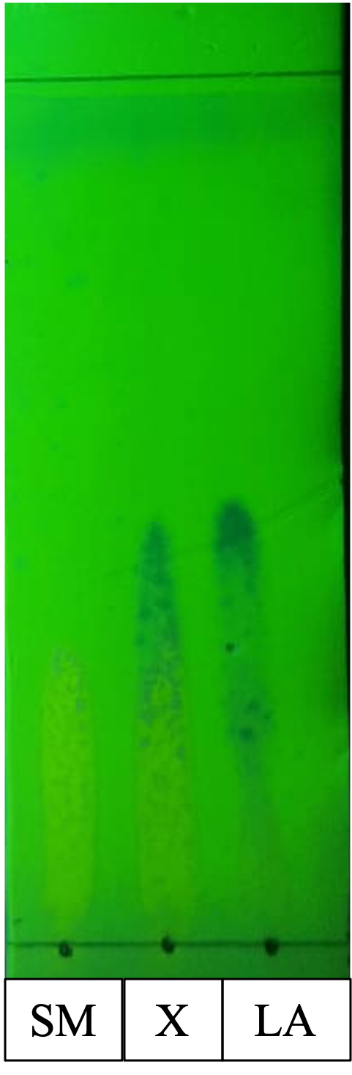 | 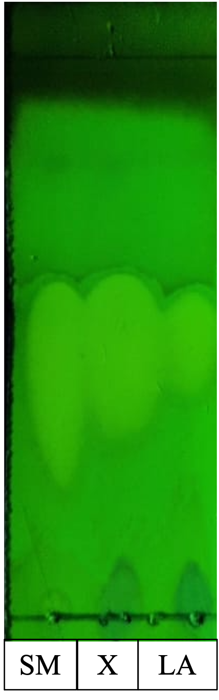
12 | 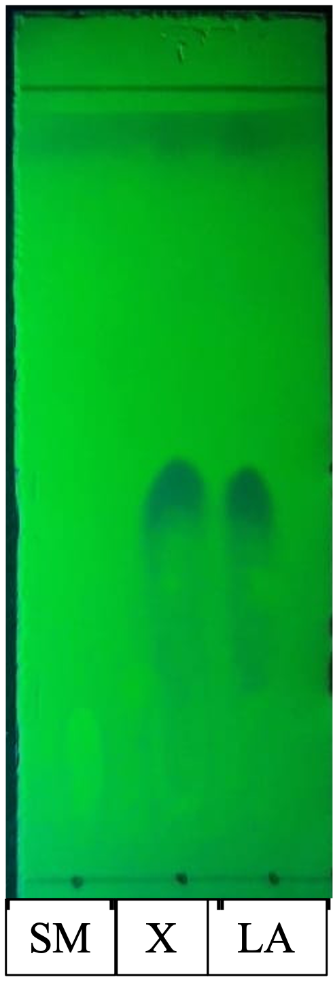 |  | 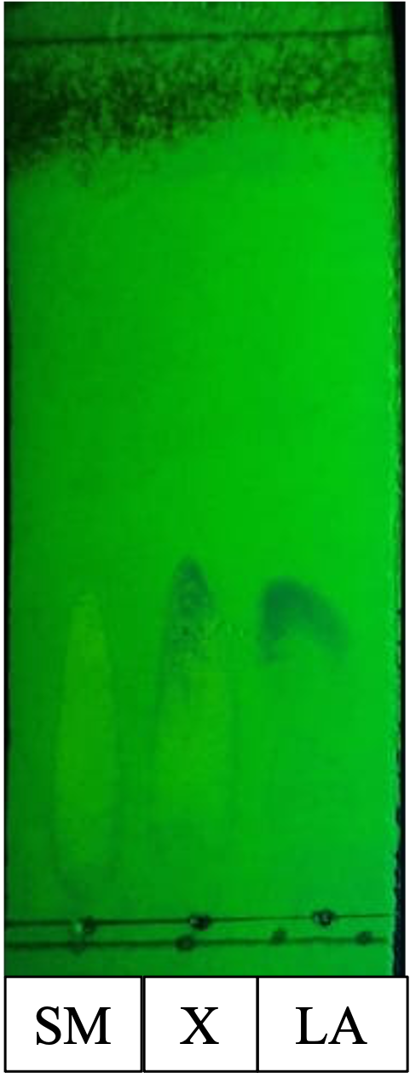 | 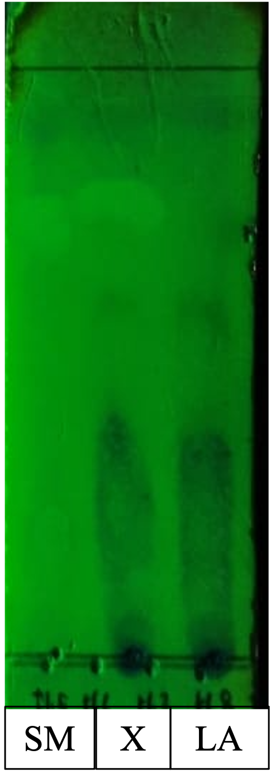
18 | - | - |  | 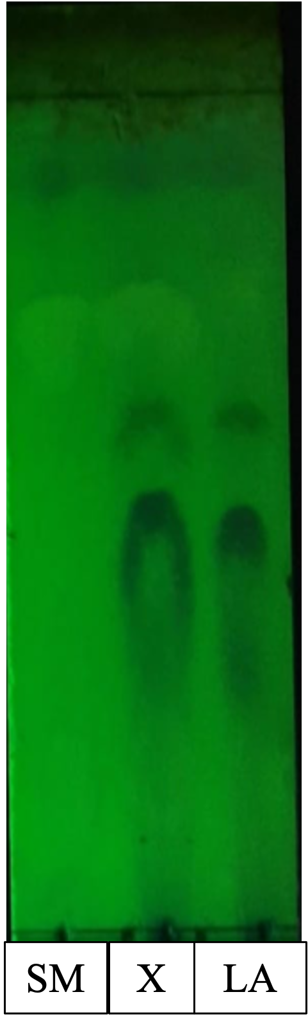
SM = starting material, X = reaction mixture, LA = lipoamide

Table 2. TLC profile during synthesis of lipoamides oleate-p-anisidine and lipoamide oleate-p-nitroaniline every 6 hours for 18 hours
Reaction time (h) | Lipoamide oleate-p-anisidine |  | Lipoamide oleate-p-nitroaniline
 | Direct amidation | FAME | Direct amidation | FAME
6 | 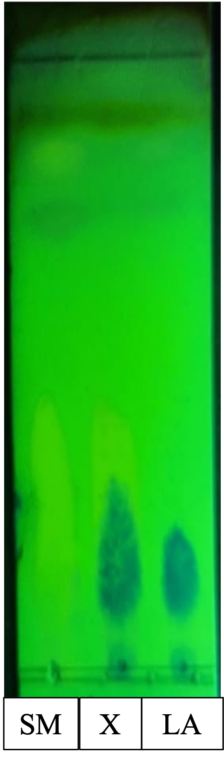
12 |  |  | 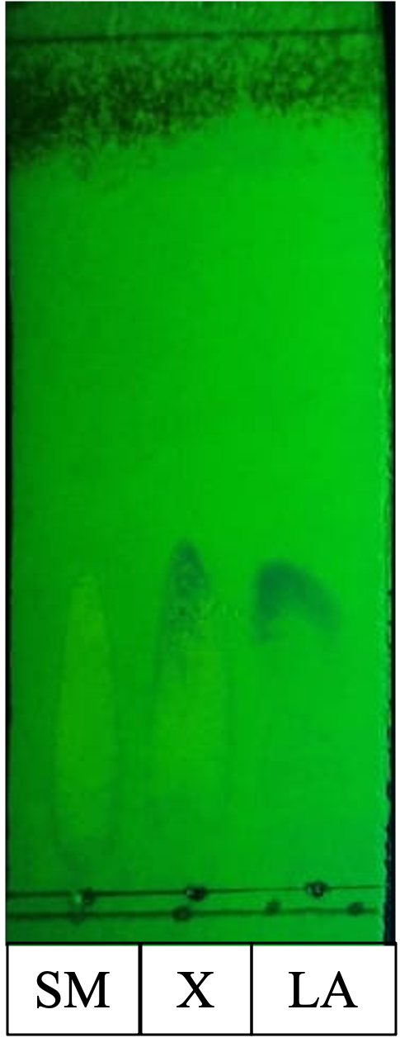 | 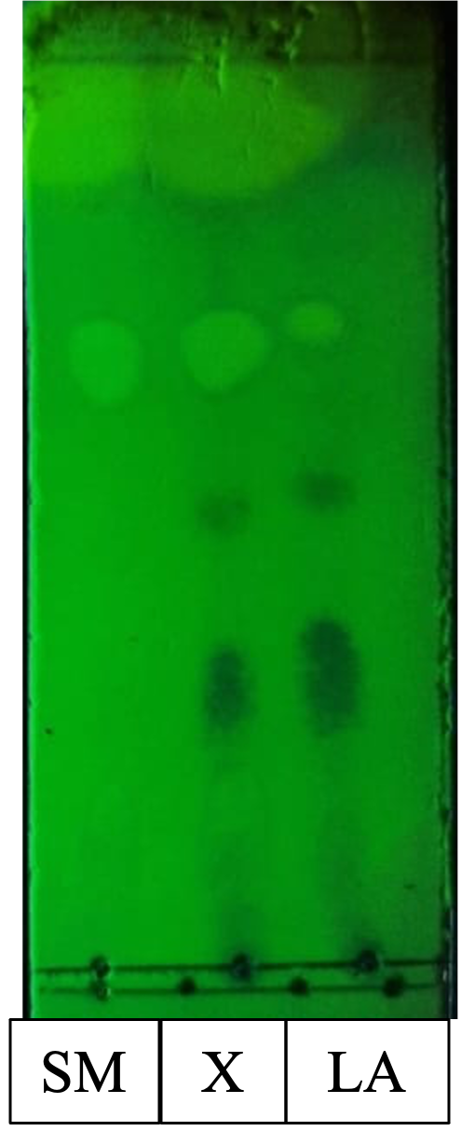
18 | - | - | 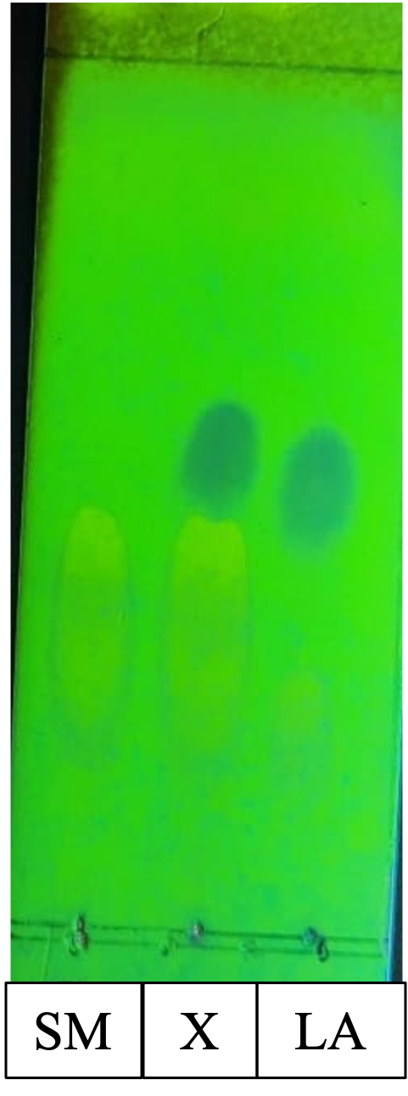
SM = starting material, X = reaction mixture, LA = lipoamide

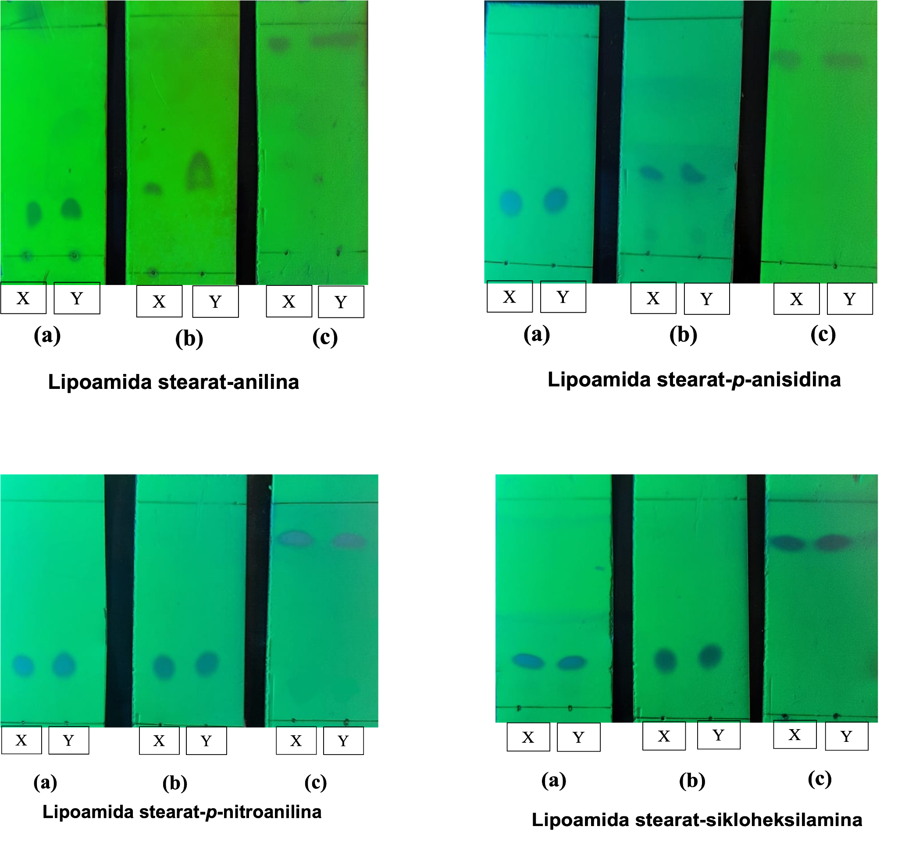
Figure 1. TLC examination on lipoamides stearate obtained from direct amidation and via amidation of FAME using several eluent systems: toluene-ethyl acetate 95:5 (a), hexane-ethyl acetate 95:5 (b), chloroform-methanol 95:5 (c). (X = lipoamides obtained from direct amidation and Y = lipoamides obtained via amidation of FAME)

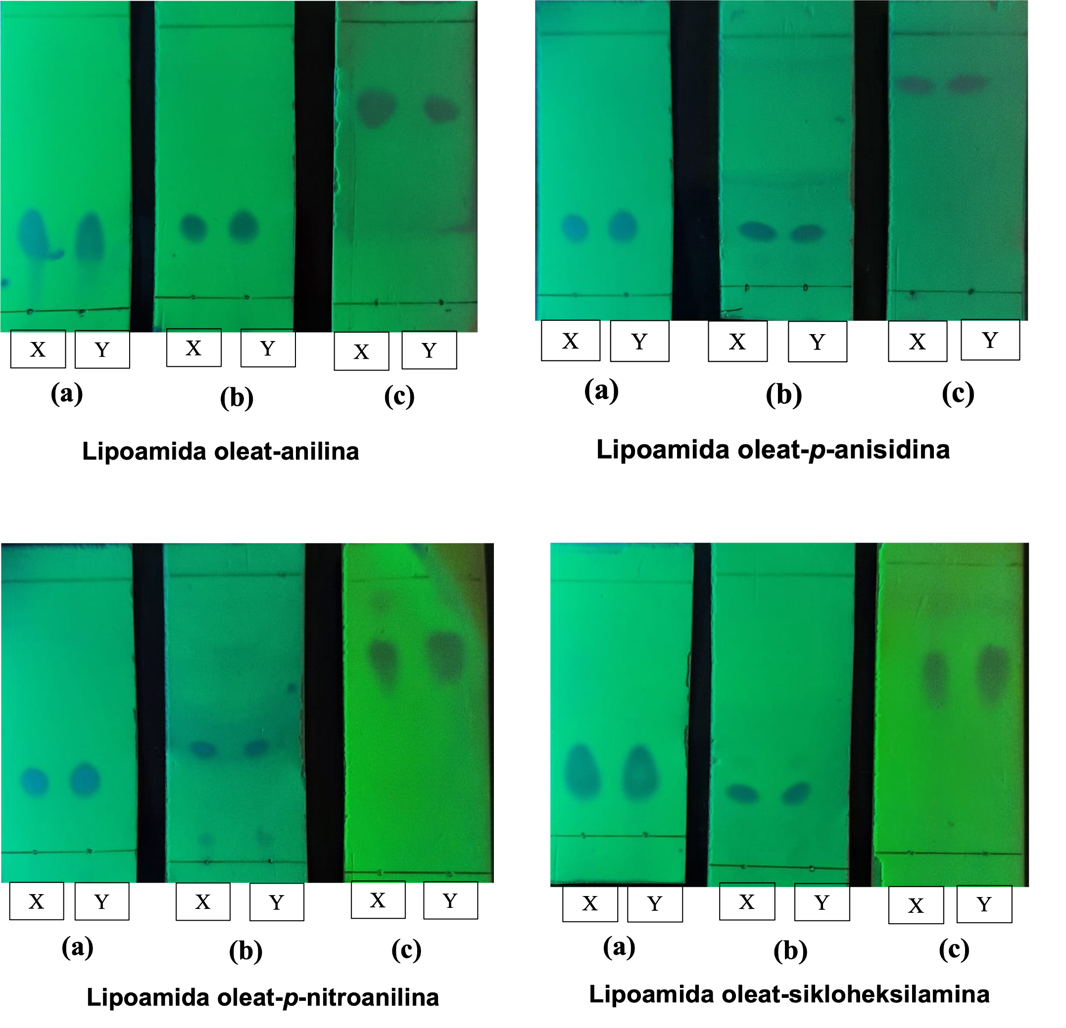
Figure 2. TLC examination on lipoamides oleate obtained from direct amidation and via amidation of FAME using several eluent systems: toluene-ethyl acetate 95:5 (a), hexane-ethyl acetate 95:5 (b), chloroform-methanol 95:5 (c). (X = lipoamides obtained from direct amidation and Y = lipoamides obtained via amidation of FAME)

FTIR Spectra

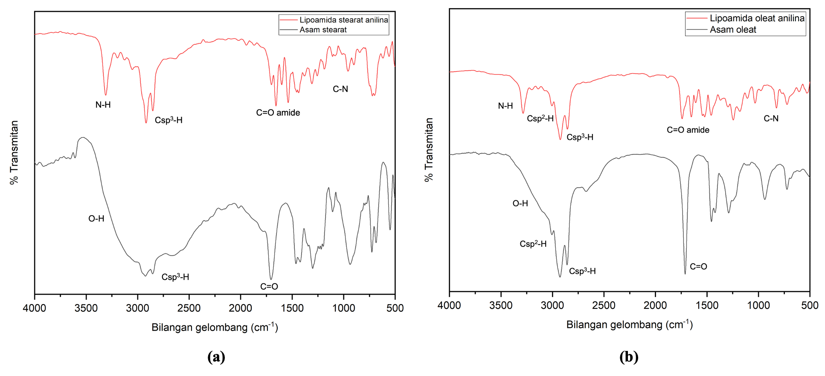
Figure 3. FTIR spectra of lipoamide stearate-aniline (a) and lipoamide oleate-aniline (b) compared to fatty acid.

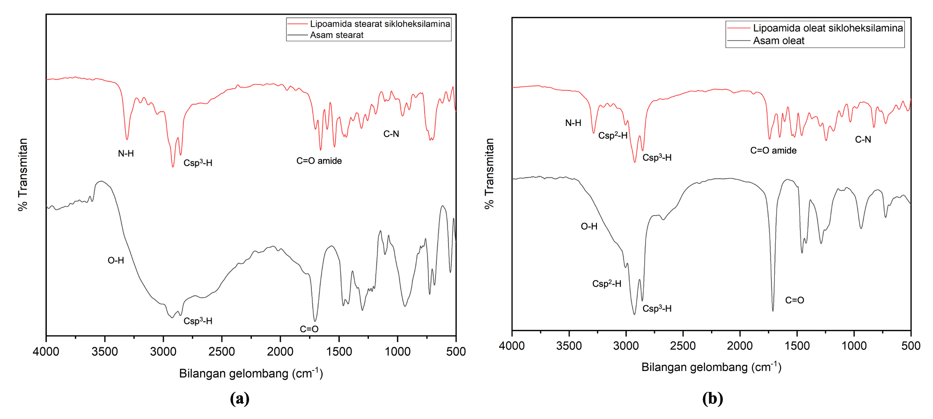
Figure 4. FTIR spectra of lipoamide stearate-cyclohexylamine (a) and lipoamide oleate-cyclohexylamine (b) compared to fatty acid.

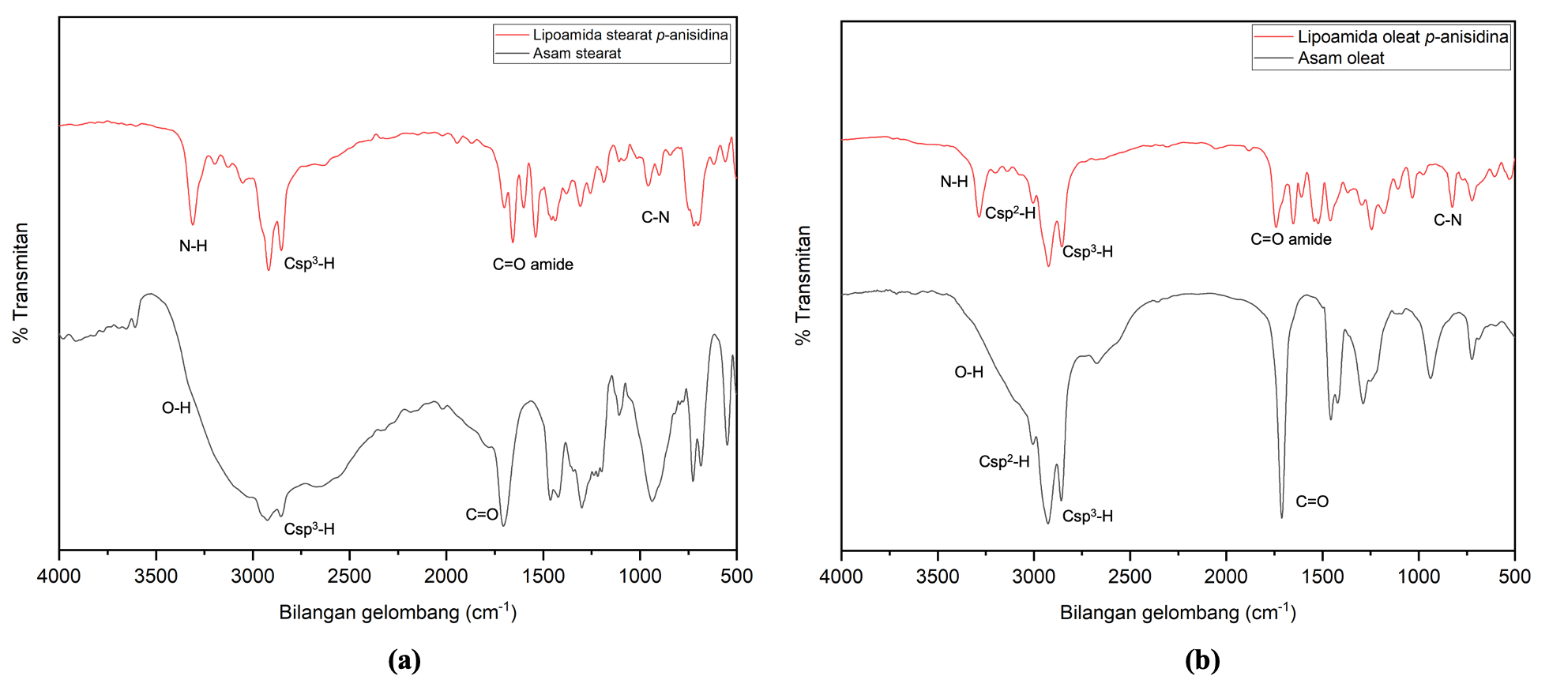
Figure 5. FTIR spectra of lipoamide stearate-p-anisidine (a) and lipoamide oleate-p-anisidine (b) compared to fatty acid.

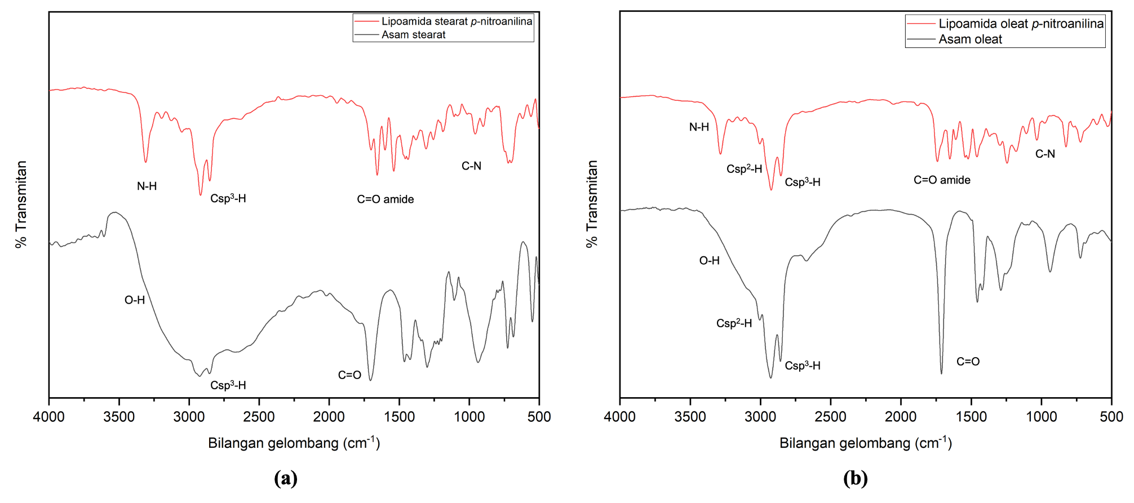
Figure 6. FTIR spectra of lipoamide stearate-p-nitroaniline (a) and lipoamide oleate-p-nitroaniline (b) compared to fatty acid.

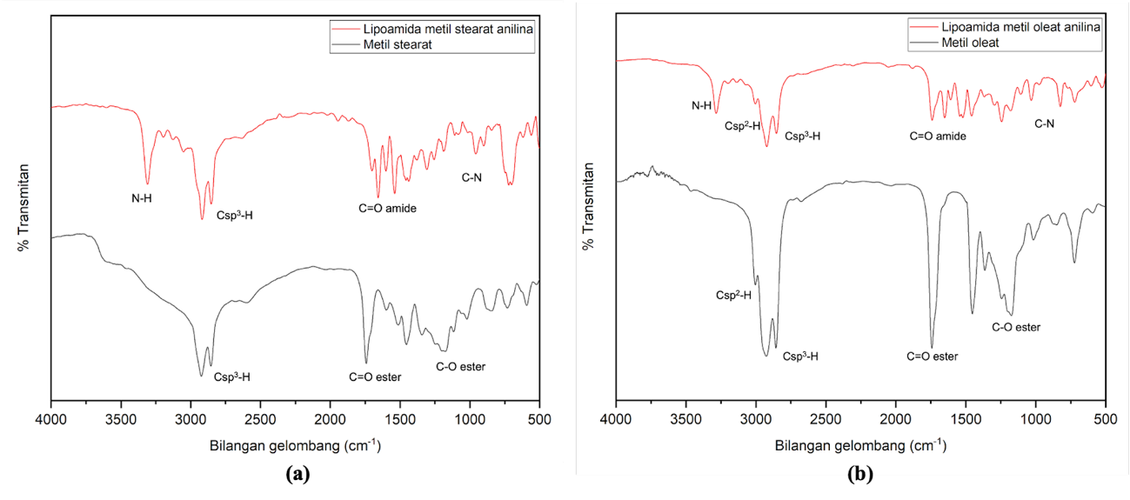
Figure 7. FTIR spectra of lipoamide stearate-aniline (a) and lipoamide oleate-aniline (b) compared to fatty acid methyl ester.

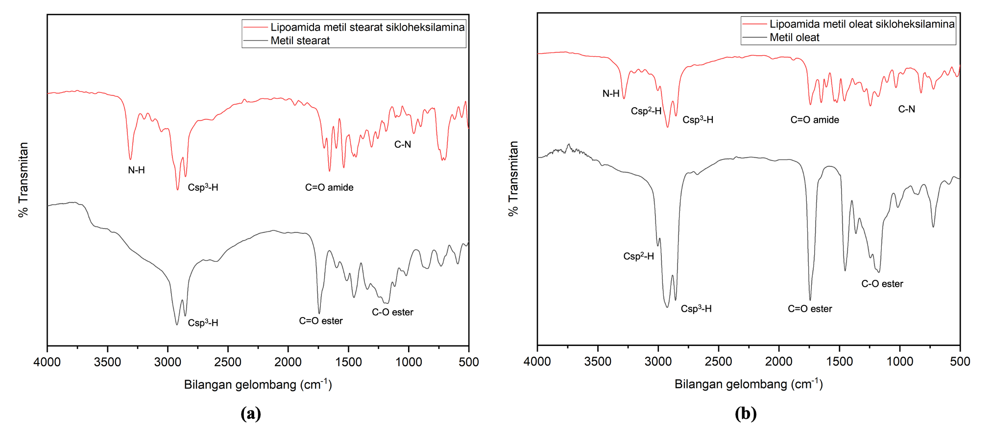
Figure 8. FTIR spectra of lipoamide stearate-cyclohexylamine (a) and lipoamide oleate-cyclohexylamine (b) compared to fatty acid methyl ester.

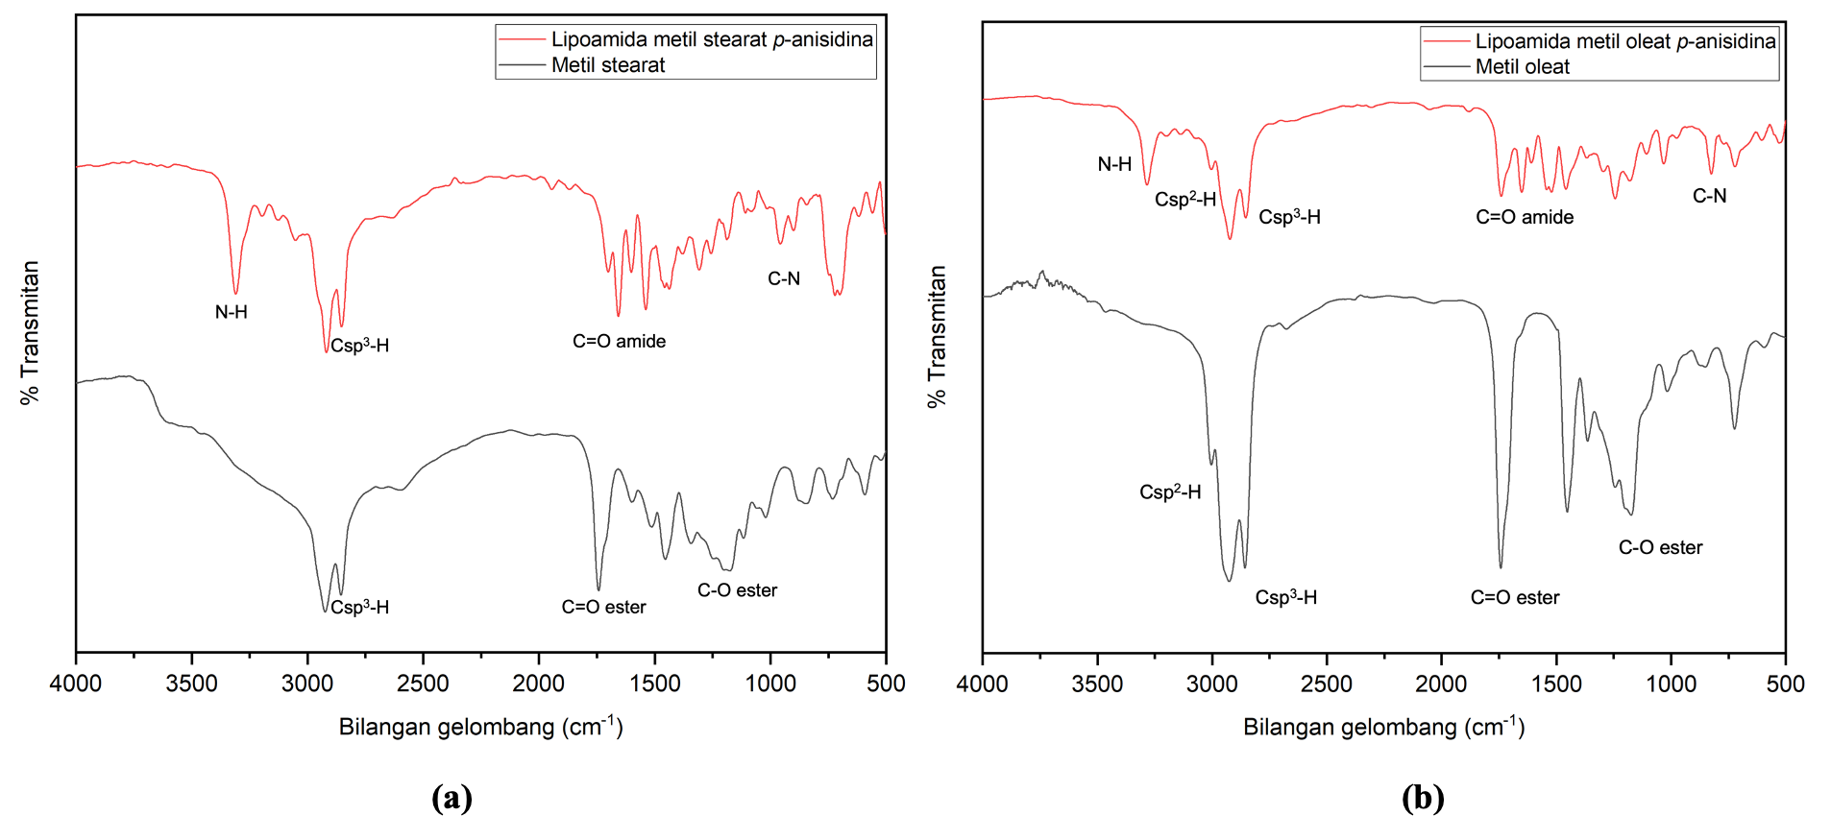
Figure 9. FTIR spectra of lipoamide stearate-p-anisidine (a) and lipoamide oleate-p-anisidine (b) compared to fatty acid methyl ester.

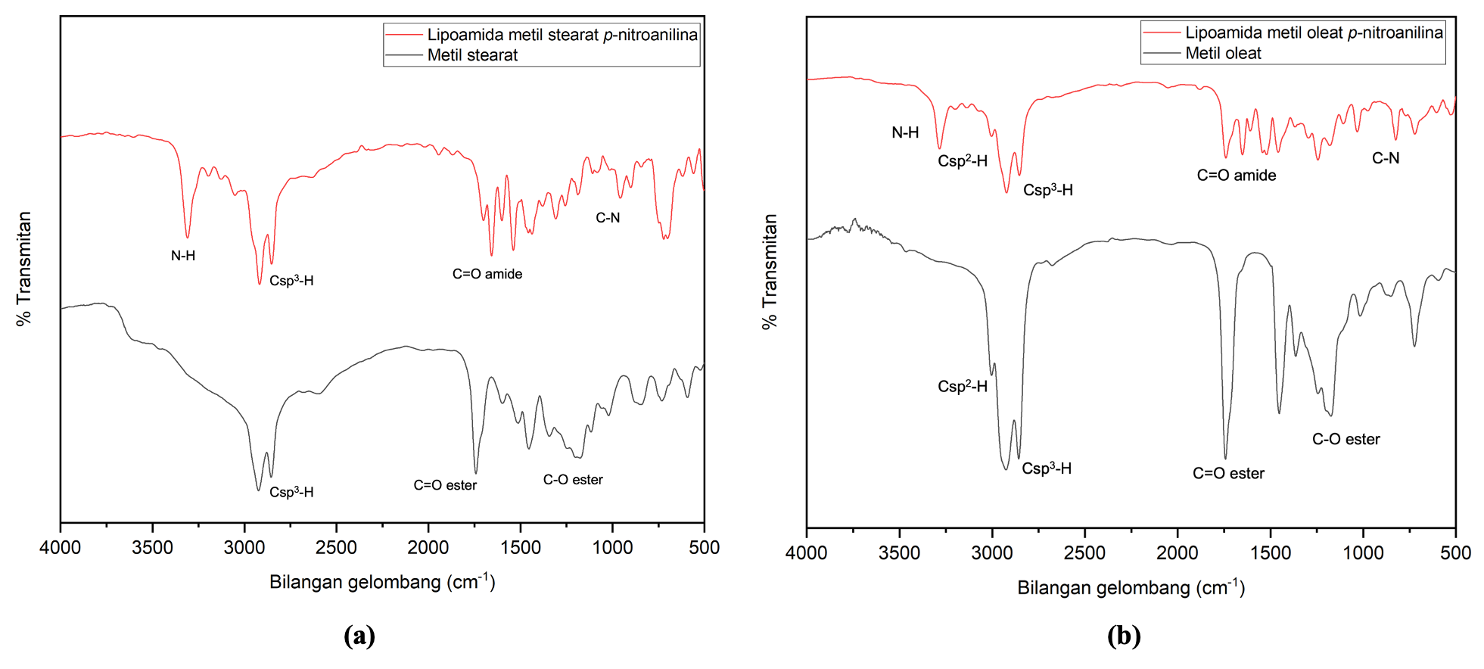
Figure 10. FTIR spectra of lipoamide stearate-p-nitroaniline (a) and lipoamide oleate-p-nitroaniline (b) compared to fatty acid methyl ester.

