SUPPLEMENTARY DATA
Comparison of the Lipoamide Synthesis by Direct Amidation and via Amidation of Fatty Acid Methyl Esters
Chiko Harahap ¹, Tuti Wukirsari ^{1,*}, Sri Handayani ¹, Sumi Hudiyono PWS ¹
¹ Department of Chemistry, Faculty of Mathematics and Natural Sciences, Universitas Indonesia, Pondok Cina, Beji, Depok City, West Java 16424, Indonesia
* Corresponding author: tutiwukirsari@sci.ui.ac.id
- Research Instruments and Materials
The materials used in this study were stearic acid (Pudak Scientific), oleic acid, aniline, cyclohexylamine, p-anisidine, p-nitroaniline, dry methanol, HCl 37%, anhydrous sodium sulfate, dichloromethane, toluene, acetic acid glacial, and silica gel 60 (0.063-0.200 mm) for column chromatography were purchased from Merck (Darmstadt, Germany); p-xylene 99% (Loba Chemie); 2′,7′-dichlorofluorescein and TLC silica gel 60 F₂₅₄ were purchased from Sigma-Aldrich; ethyl acetate and hexane with technical grade. FTIR (SHIMADZU IRPrestige-21) and ¹H NMR (Bruker Avance Neo-Ascend 500) were used for characterization.
- Data Analysis
  - TLC Profile of Synthesis of Lipoamides
Table S.1. TLC profile during synthesis of lipoamides stearate-aniline and lipoamide stearate-cyclohexylamine every 6 hours for 18 hours
Reaction time (h) | Lipoamide stearate-aniline |  | Lipoamide stearate-cyclohexylamine
 | Direct amidation | FAME | Direct amidation | FAME
6 | 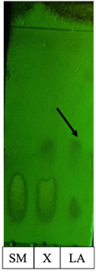 | 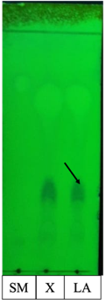 | 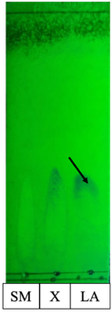 | 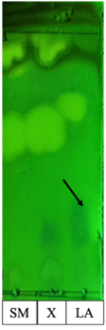
12 | 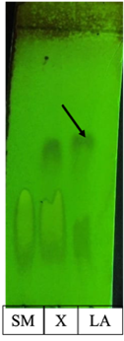 |  | 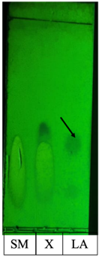 | 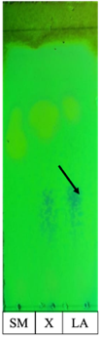
18 | 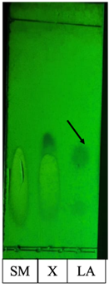 | 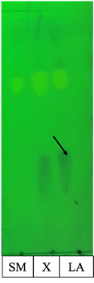 | 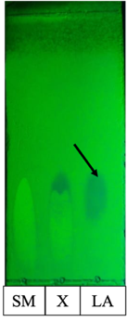 | 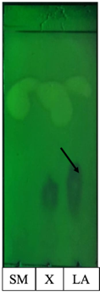
SM = starting material, X = reaction mixture, LA = lipoamide
Table S.2. TLC profile during synthesis of lipoamides oleate-aniline and lipoamide oleate-cyclohexylamine every 6 hours for 18 hours
Reaction time (h) | Lipoamide oleate-aniline |  | Lipoamide oleate-cyclohexylamine
 | Direct amidation | FAME | Direct amidation | Direct amidation
6 | 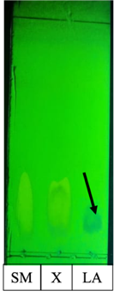 |  | 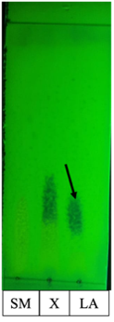
12 | 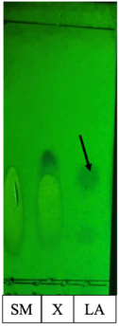 | 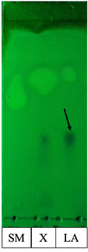 | 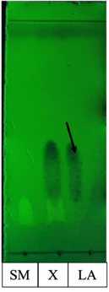
18 | 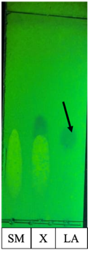 | 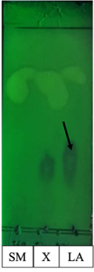 | 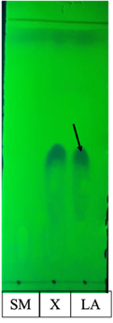
SM = starting material, X = reaction mixture, LA = lipoamide
Table S.3. TLC profile during synthesis of lipoamides stearate-p-anisidine and lipoamide stearate-p-nitroaniline every 6 hours for 18 hours
Reaction time (h) | Lipoamide stearate-p-anisidine |  | Lipoamide stearate-p-nitroaniline
 | Direct amidation | FAME | Direct amidation | FAME
6 | 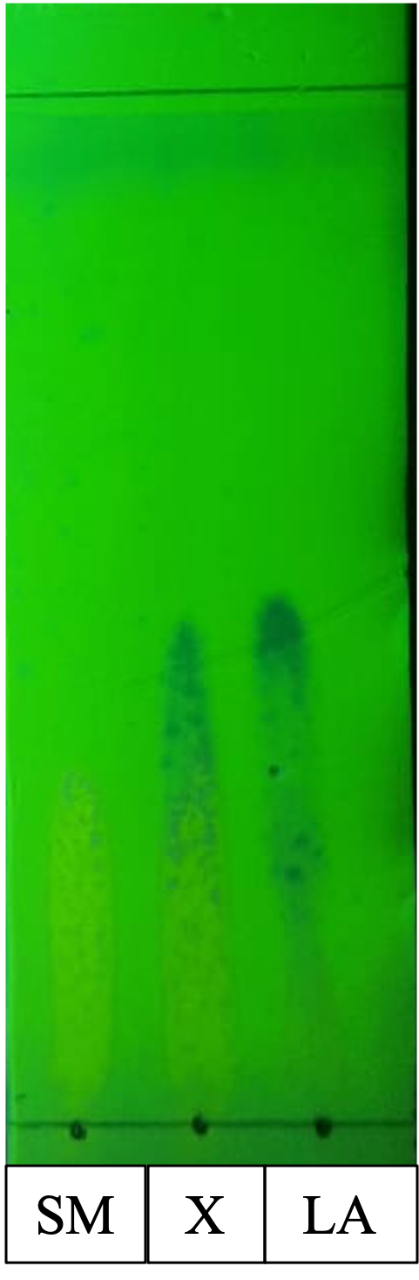 | 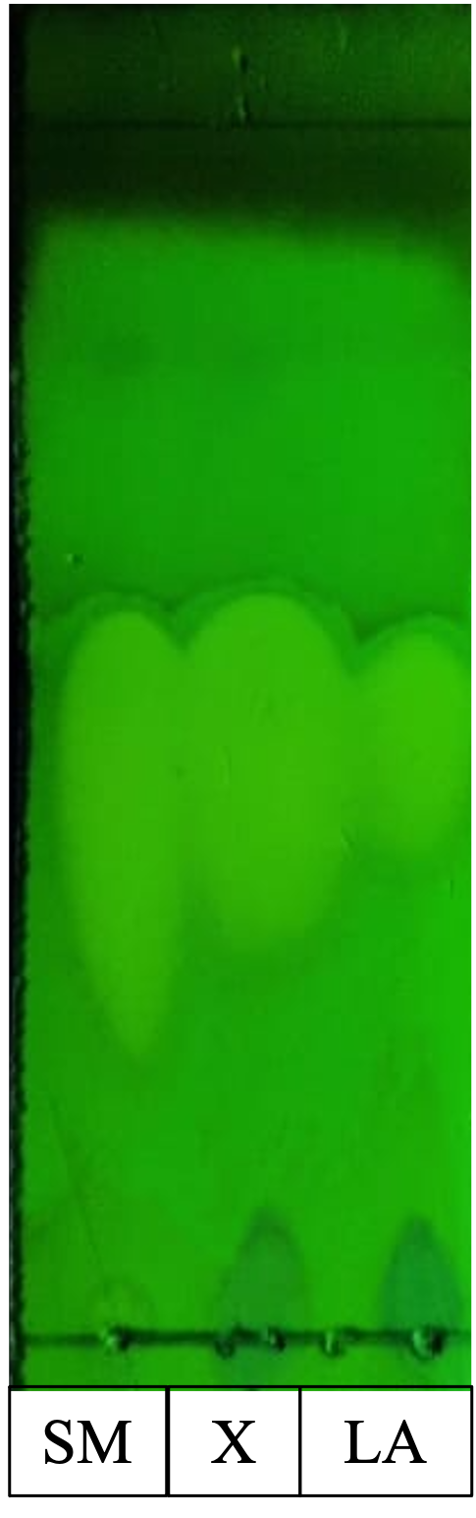
12 | 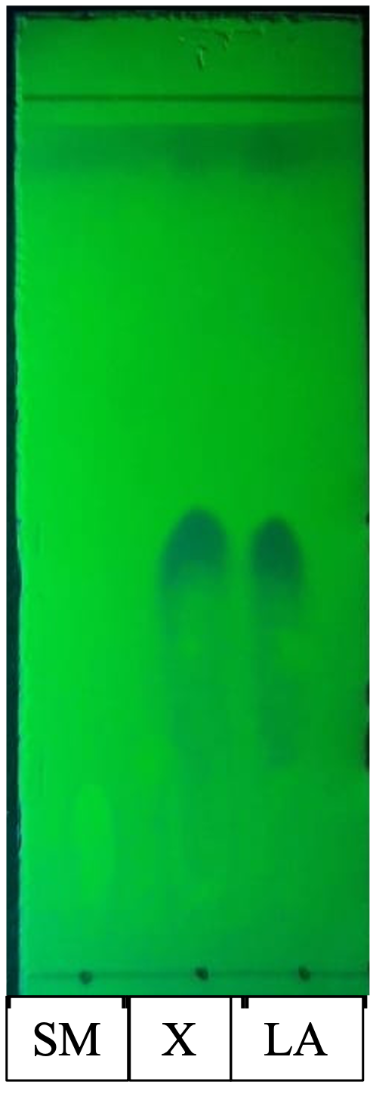 |  | 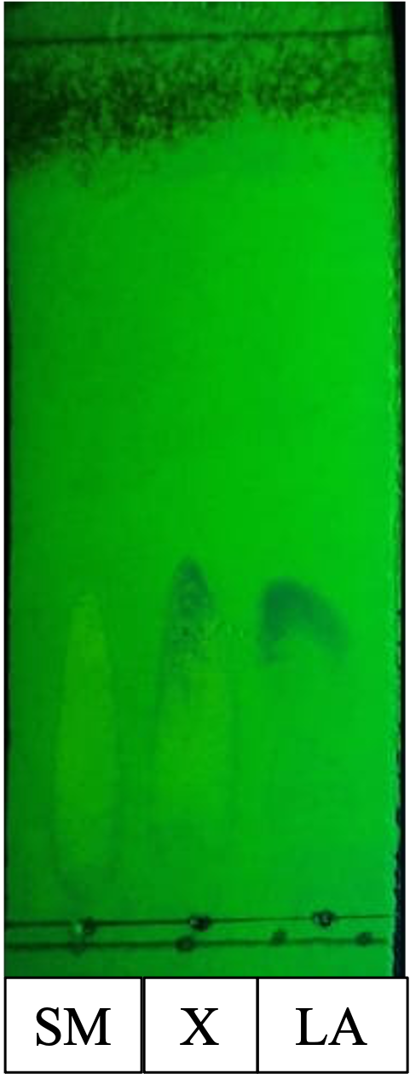 | 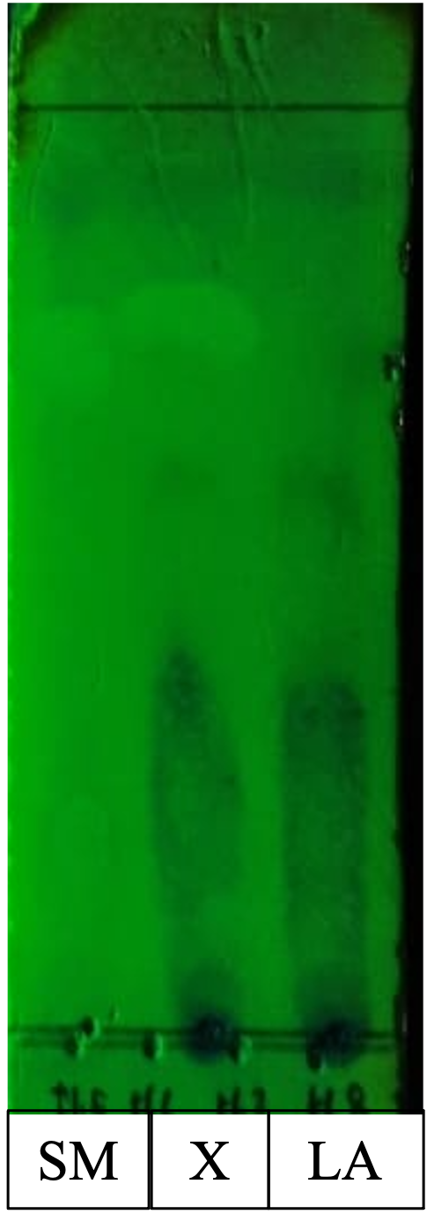
18 | - | - |  | 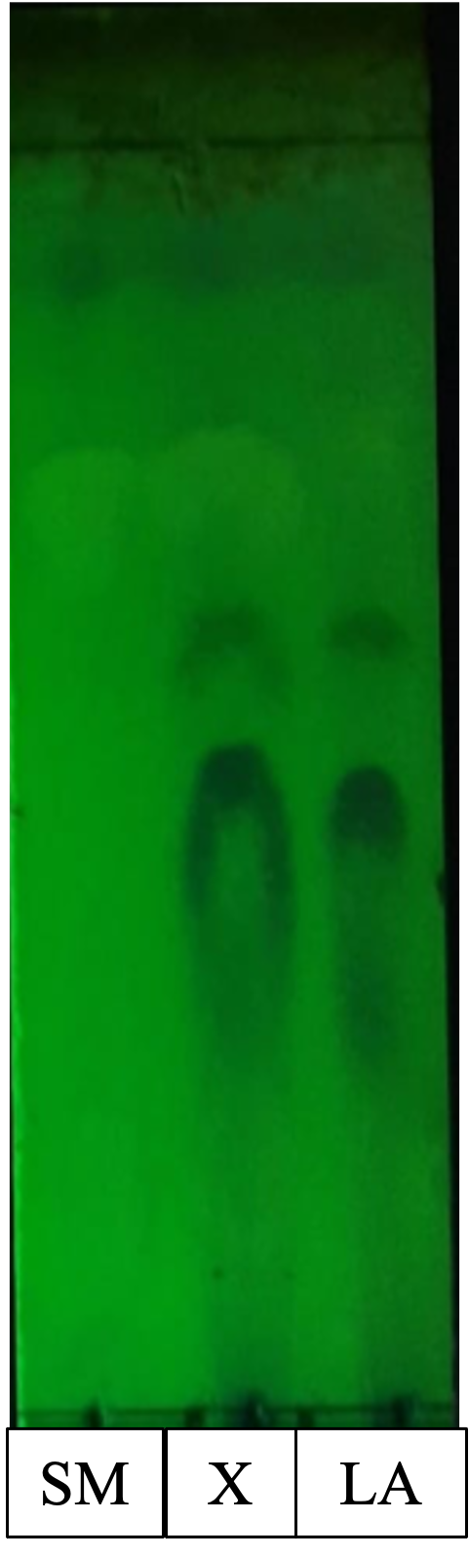
SM = starting material, X = reaction mixture, LA = lipoamide
Table S.4. TLC profile during synthesis of lipoamides oleate-p-anisidine and lipoamide oleate-p-nitroaniline every 6 hours for 18 hours
Reaction time (h) | Lipoamide oleate-p-anisidine |  | Lipoamide oleate-p-nitroaniline
 | Direct amidation | FAME | Direct amidation | FAME
6 | 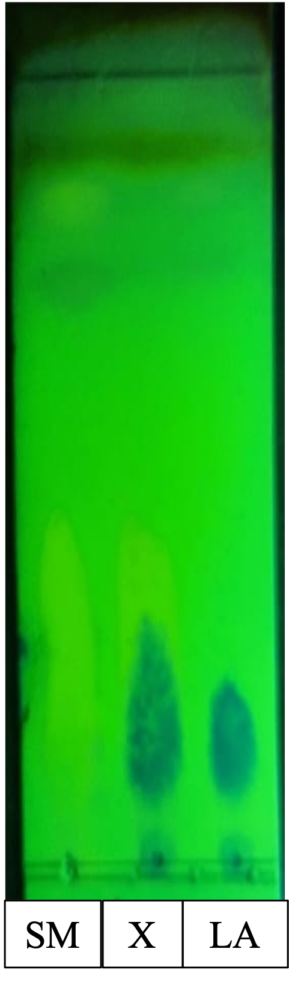
12 |  |  | 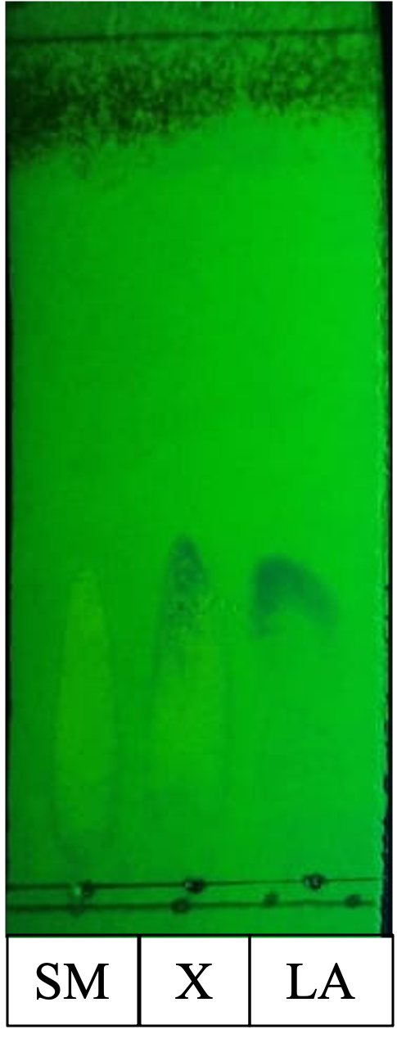 | 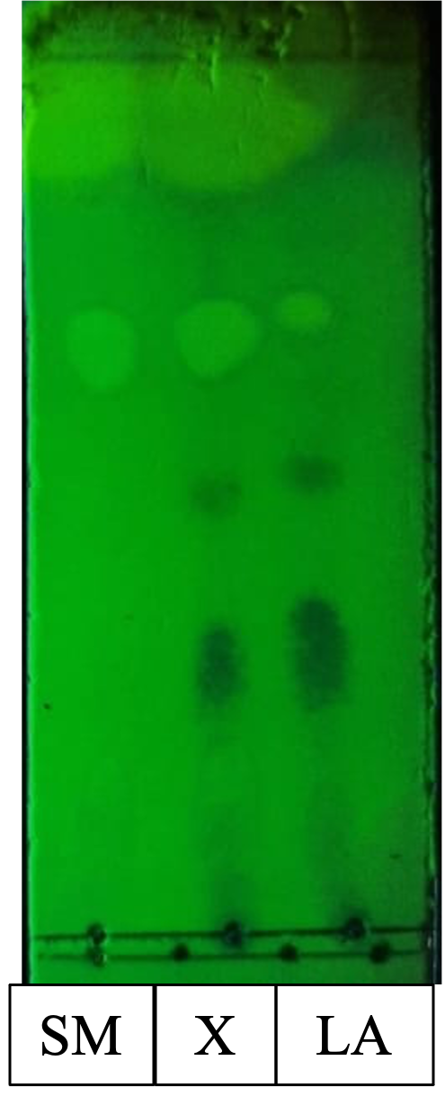
18 | - | - | 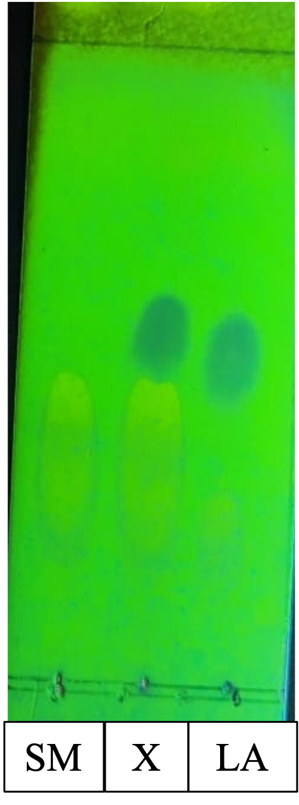
SM = starting material, X = reaction mixture, LA = lipoamide
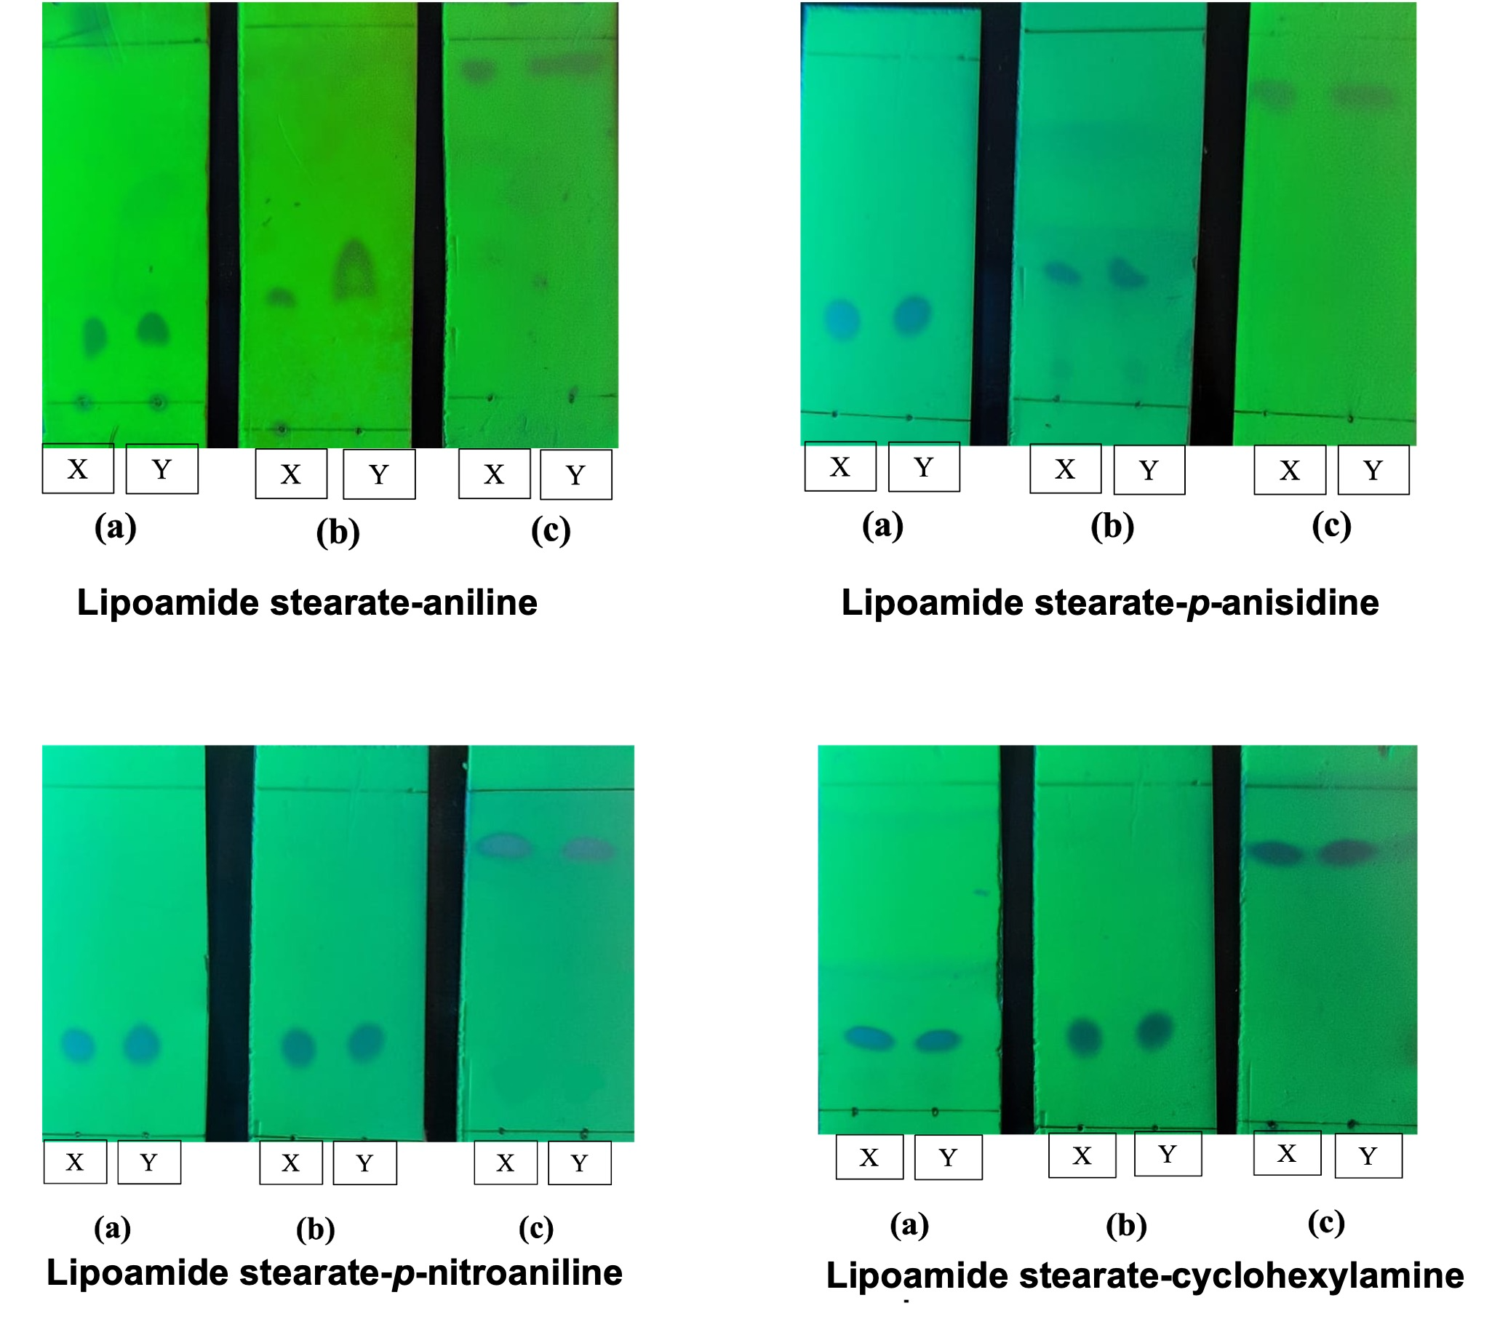
Figure S.1. TLC examination on lipoamides stearate obtained from direct amidation and via amidation of FAME using several eluent systems: toluene-ethyl acetate 95:5 (a), hexane-ethyl acetate 95:5 (b), chloroform-methanol 95:5 (c). (X = lipoamides obtained from direct amidation and Y = lipoamides obtained via amidation of FAME)
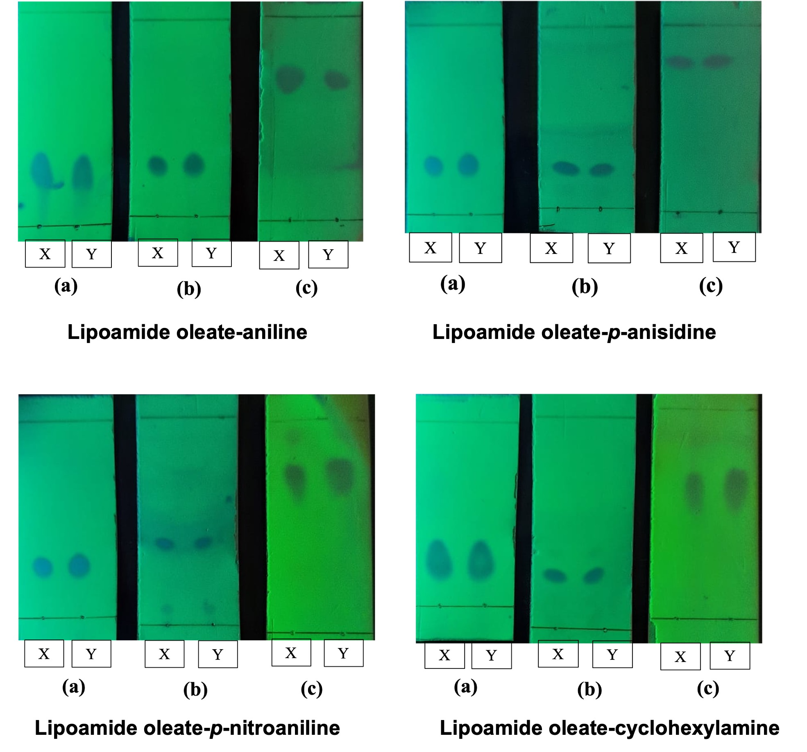
Figure S.2. TLC examination on lipoamides oleate obtained from direct amidation and via amidation of FAME using several eluent systems: toluene-ethyl acetate 95:5 (a), hexane-ethyl acetate 95:5 (b), chloroform-methanol 95:5 (c). (X = lipoamides obtained from direct amidation and Y = lipoamides obtained via amidation of FAME)
  - FTIR Spectra of Lipoamides Synthesis
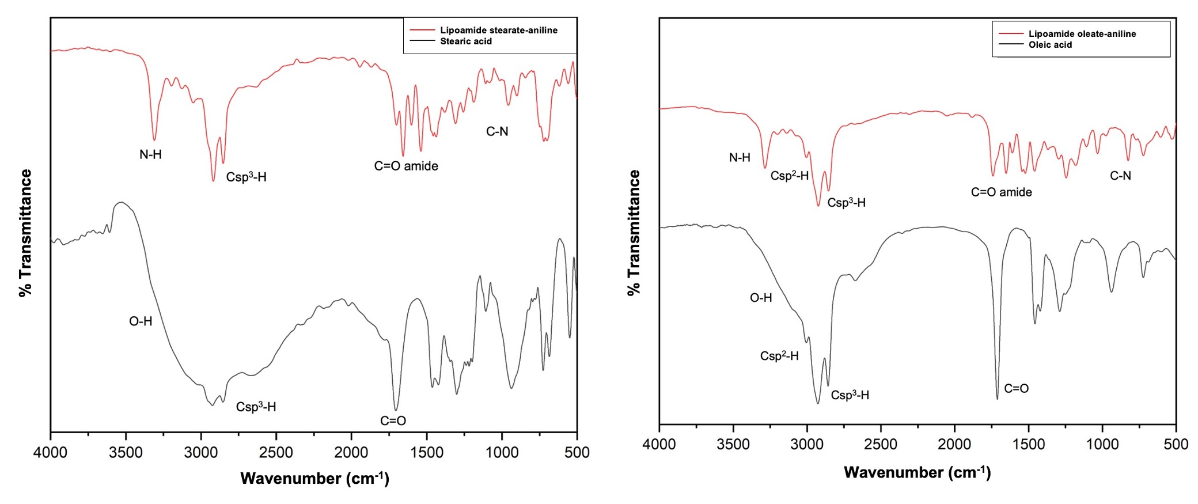
(a) | (b)
Figure S.3. FTIR spectra of lipoamide stearate-aniline (a) and lipoamide oleate-aniline (b) compared to its corresponding fatty acid
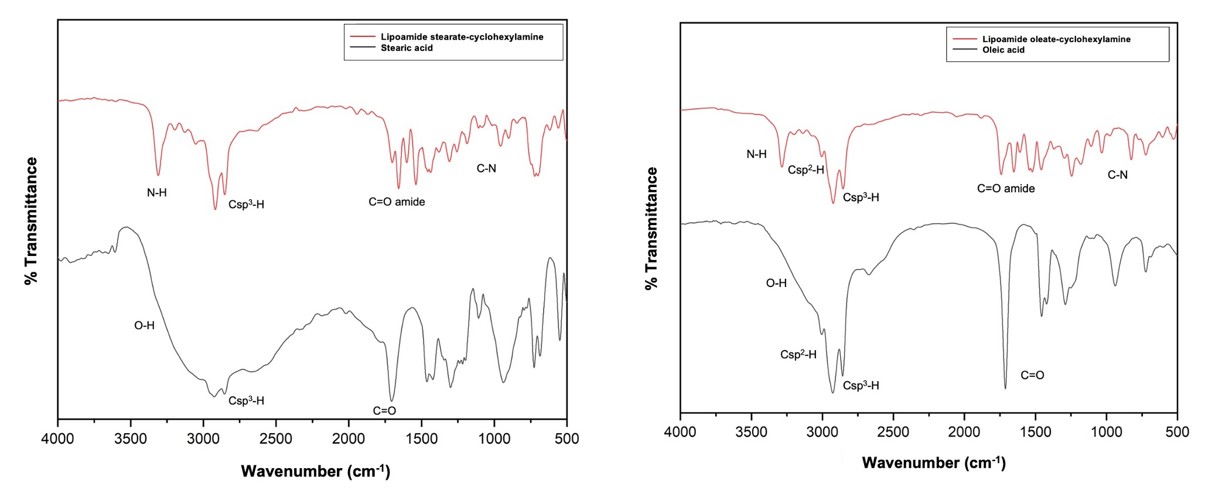
(a) | (b)
Figure S.4. FTIR spectra of lipoamide stearate-cyclohexylamine (a) and lipoamide oleate-cyclohexylamine (b) compared to its corresponding fatty acid
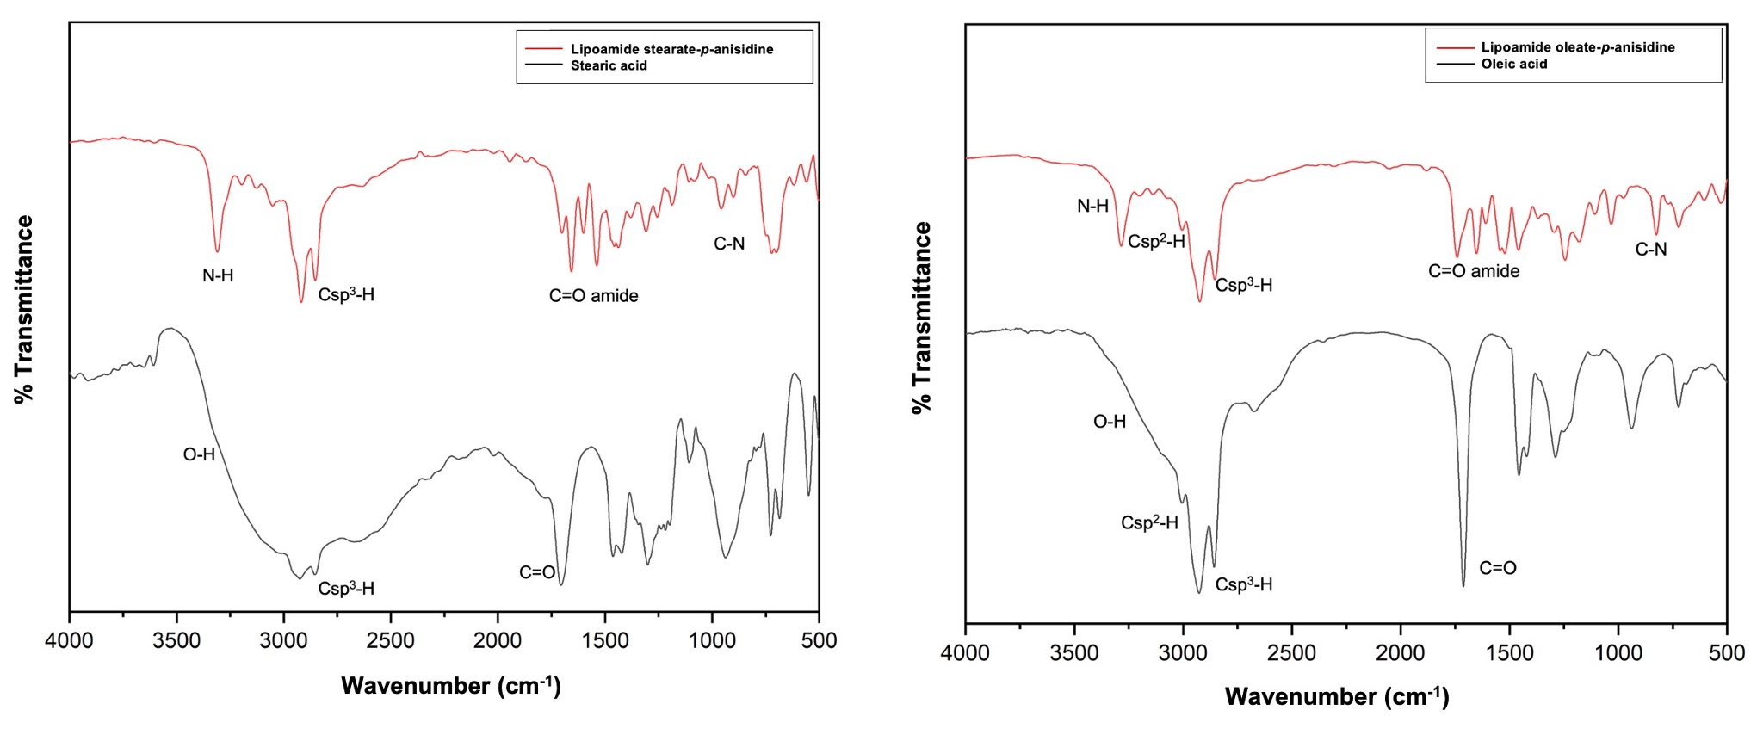
(a) | (b)
Figure S.5. FTIR spectra of lipoamide stearate-p-anisidine (a) and lipoamide oleate-p-anisidine (b) compared to its corresponding fatty acid
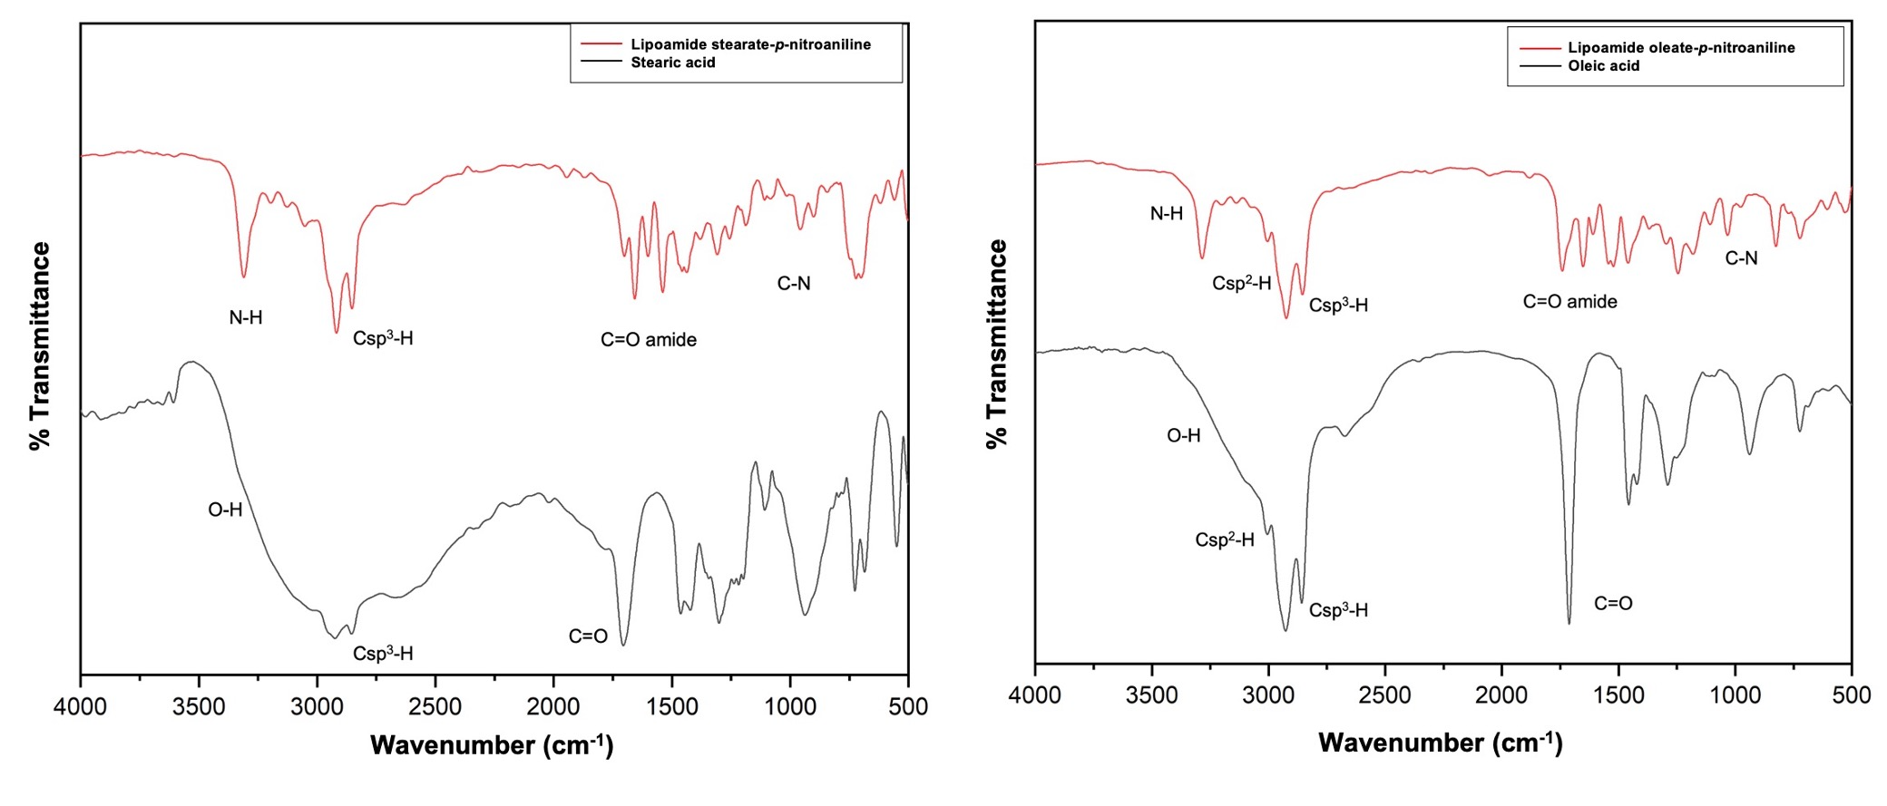
(a) | (b)
(a) | (b)
Figure S.6. FTIR spectra of lipoamide stearate-p-nitroaniline (a) and lipoamide oleate-p-nitroaniline (b) compared to its corresponding fatty acid.
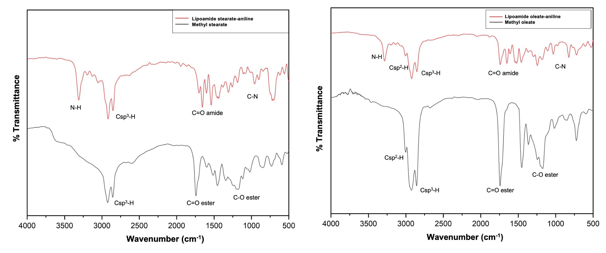
(a) | (b)
Figure S.7. FTIR spectra of lipoamide stearate-aniline (a) and lipoamide oleate-aniline (b) compared to its corresponding fatty acid methyl ester.
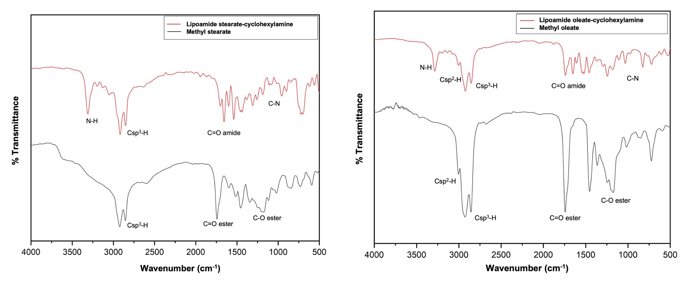
(a) | (b)
Figure S.8. FTIR spectra of lipoamide stearate-cyclohexylamine (a) and lipoamide oleate-cyclohexylamine (b) compared to its corresponding fatty acid methyl ester.
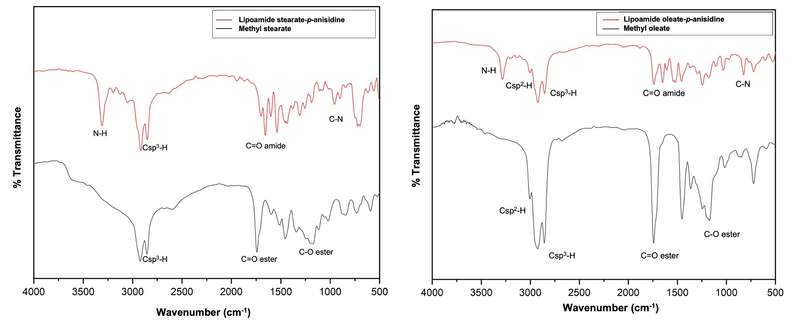
(a) | (b)
Figure S.9. FTIR spectra of lipoamide stearate-p-anisidine (a) and lipoamide oleate-p-anisidine (b) compared to its corresponding fatty acid methyl ester.
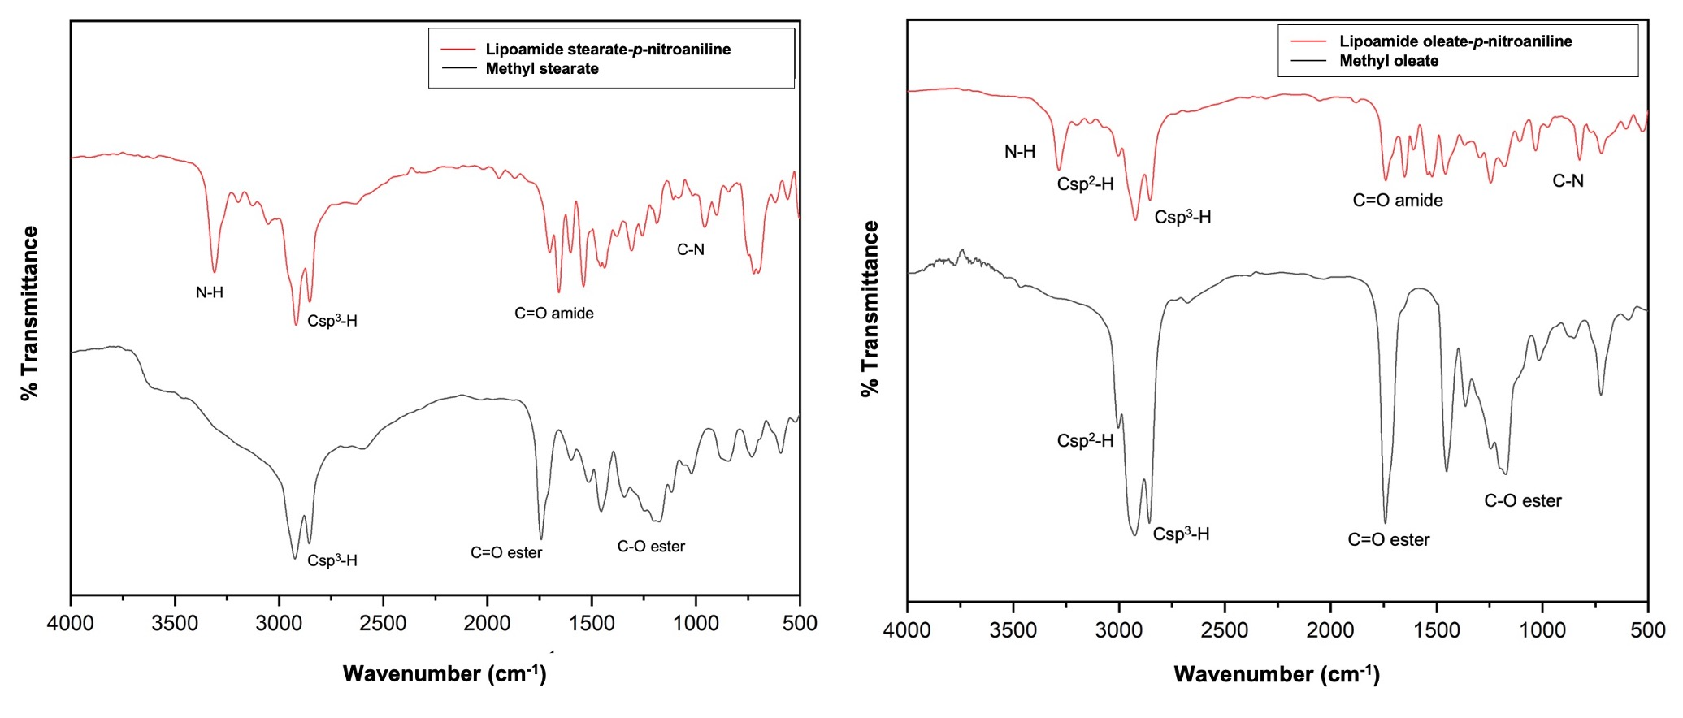
(a) | (b)
Figure S.10. FTIR spectra of lipoamide stearate-p-nitroaniline (a) and lipoamide oleate-p-nitroaniline (b) compared to its corresponding fatty acid methyl ester.

