Supplementary Material for

A Comparative Study of Advanced Oxidation Processes for Pentachlorophenol Degradation
Nurul Alvia Istiqomah ^{a,*}
ª Department of Civil and Environmental Engineering, Universitas Gadjah Mada, Yogyakarta, Indonesia
*Corresponding author: nurulalviaistiqomah@ugm.ac.id
(a) | (b)
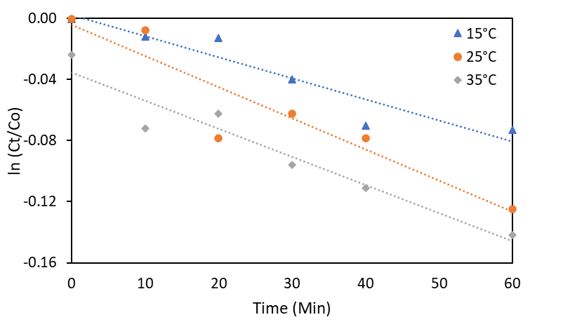 | 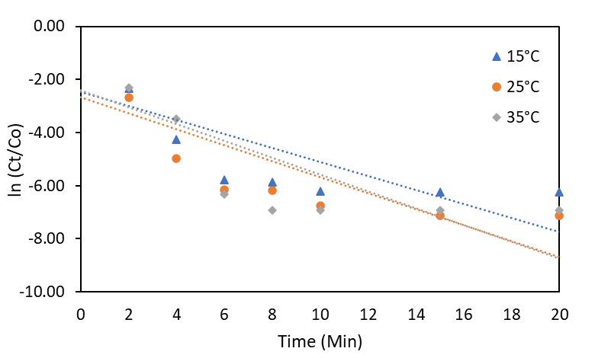
(c) | (d)
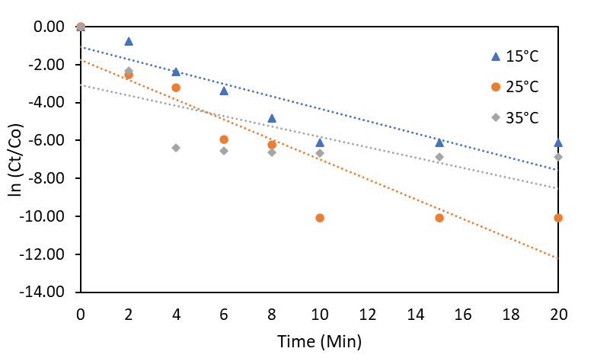 | 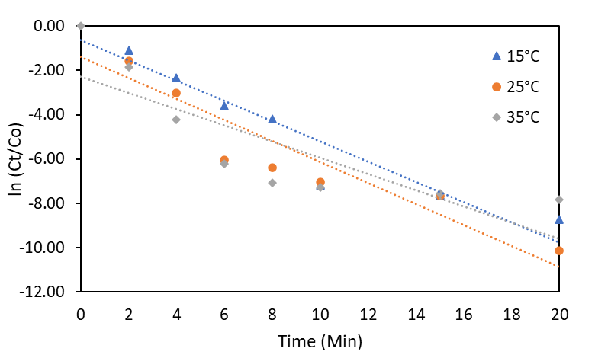
(e) | (f)
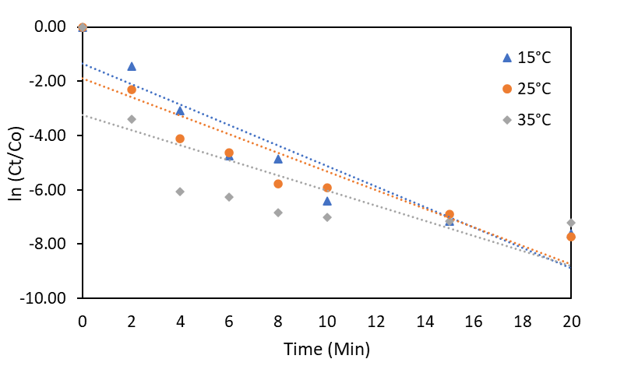 | 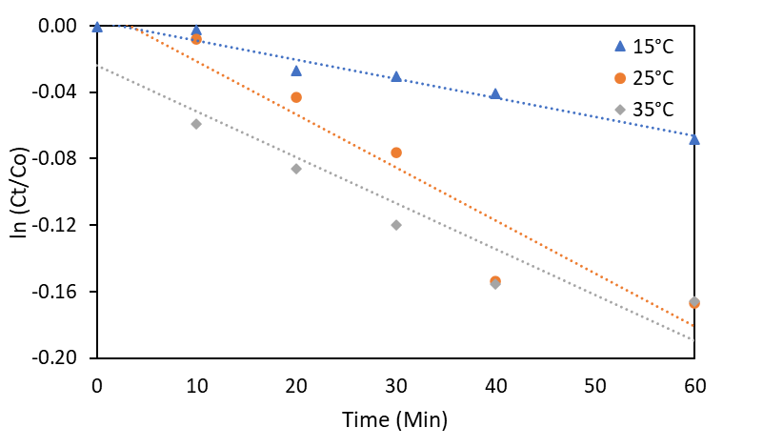
(g) | (h)
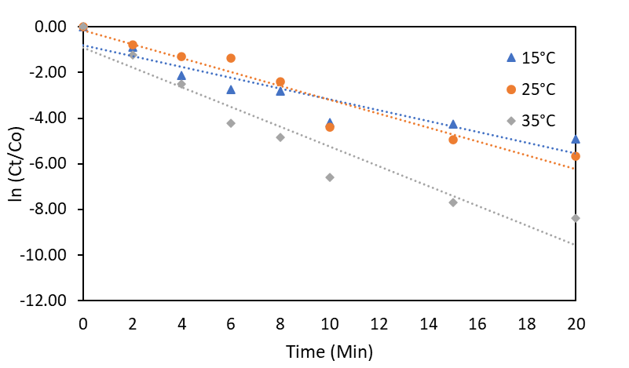 | 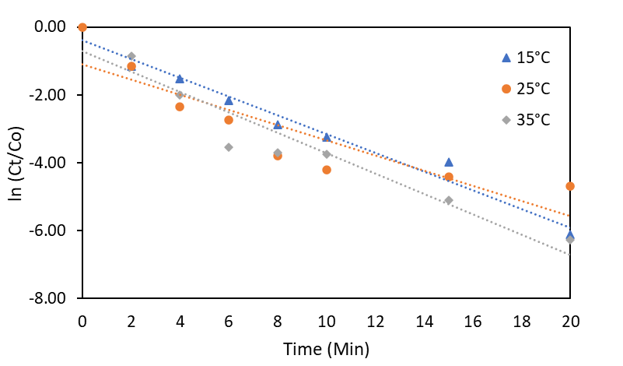
(i) | (j)
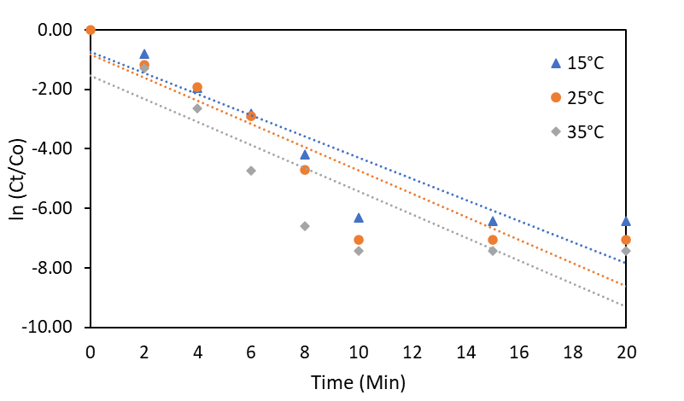 | 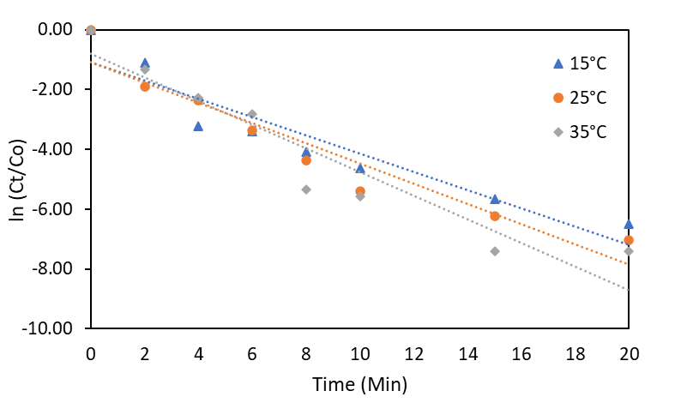
Figure S1. PCP degradation at various temperatures in the systems of (a) US-$H_{2}O_{2}$; (b) VUV-$H_{2}O_{2}$; (c) UVC-$H_{2}O_{2}$; (d) US-VUV-$H_{2}O_{2}$; (e) US-UVC-$H_{2}O_{2}$; (f) US-$S_{2}O_{8}^{2-}$; (g) VUV-$S_{2}O_{8}^{2-}$; (h) UVC-$S_{2}O_{8}^{2-}$; (i) US-VUV-$S_{2}O_{8}^{2-}$; and (j) US-UVC-$S_{2}O_{8}^{2-}$ ([PCP]₀ = 10 mg/L; [$H_{2}O_{2}$]₀/[$S_{2}O_{8}^{2-}$]₀ = 0.004 mM; US frequency = 35 kHz; US power = 70W; UV power = 10 W(each); and initial pH = 6 ± 0.2)

