Supplementary Data for
Quantitative Structure-Activity Relationship of O-methyl Quercetin Analogs, Structure Modification, and Molecular Docking as Lung Anticancer EGFR-TK Inhibitor
Bina Lohita Sari ^{1,*}, Lusi Agus Setiani ¹, Shafana Zahra Aulia ¹
¹ Pharmacy Study Program, Faculty of Mathematics and Natural Sciences, Universitas Pakuan, Bogor, Indonesia
* Corresponding author: binalohitasari@unpak.ac.id

- Data analysis
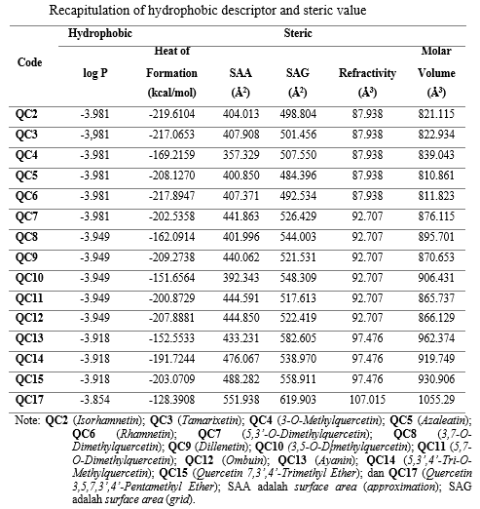
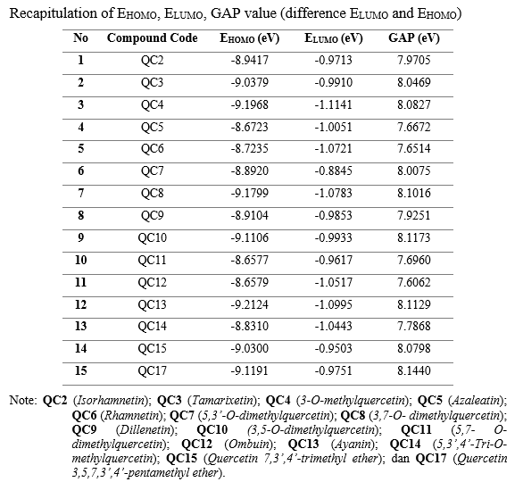
- Data sets graphics
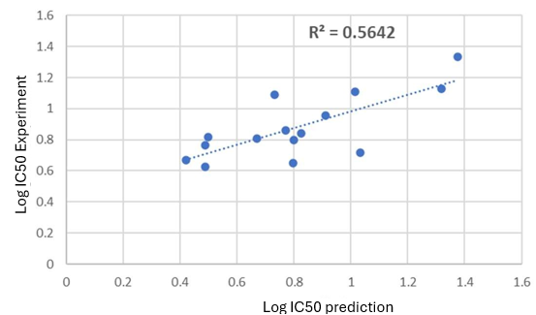
A
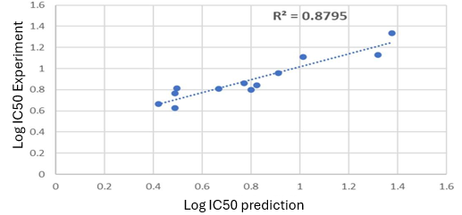
B
Figure S1. R² with linear regression graph (a) before deleting the data and (b) after deleting 3 data points

