Supplementary Materials

Synthesis of a Slow-Release Fertilizer Composite Based on Microcrystalline Cellulose from Coconut Husk Waste
Vicka Andini^{a*}, Yoravika Dwiwibanggaª, Safniyeti^{b}, Nasywa Az Zahraª, Ulfah Anis^{c}, Mega Elfiaª
ª Department of Chemistry, Faculty of Sciences and Mathematics, The University of Bengkulu, Bengkulu, Indonesia
^{b} Department of Biology, Faculty of Sciences and Mathematics, The University of Bengkulu, Bengkulu, Indonesia
^{c} Department of Agricultural Technology, Faculty of Agriculture, The University of Bengkulu, Bengkulu, Indonesia
E-mail addresses: vandini@unib.ac.id*, ydwiwibangga@unib.ac.id, ssafniyeti@unib.ac.id, nzahraaa6@gmail.com, ulfahanis@unib.ac.id, megaelfia@unib.ac.id
Corresponding author: vandini@unib.ac.id

This Supplementary Materials document provides photographic documentation of the sample preparation and synthesis processes, EDX spectrum of elemental composition, and FTIR peak table, to support the characterization results presented in the main manuscript.

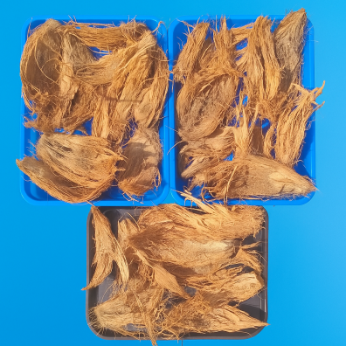
Figure S1. Freshly cleaned and sun-dried coir

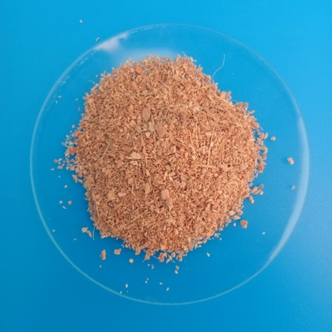
Figure S2. Ground coconut coir powder

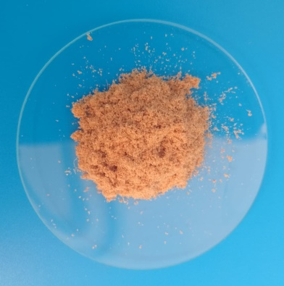
Figure S3. Sieved powder of coconut coir (18 mesh).

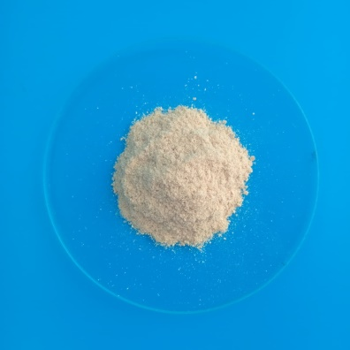
Figure S4. Microcrystalline cellulose (MCC) was obtained from coconut coir after sequential extraction and acid hydrolysis.

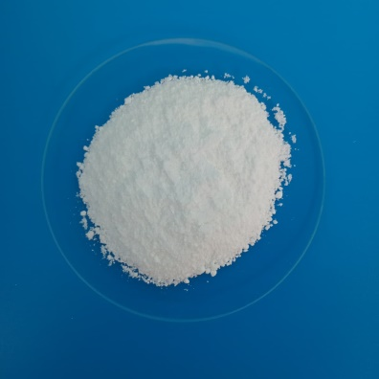
Figure S5. Polydihydroxymethylurea potassium phosphate (PDMU–K) is obtained after polycondensation and thermal curing.

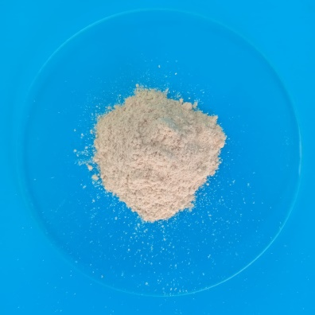
Figure S6. Microcrystalline cellulose-g-poly(maleic acid)/polyhydroxymethylurea potassium phosphate (MCC-g-PMA/PDMU–KP) copolymer synthesized using citric acid as an interaction agent.

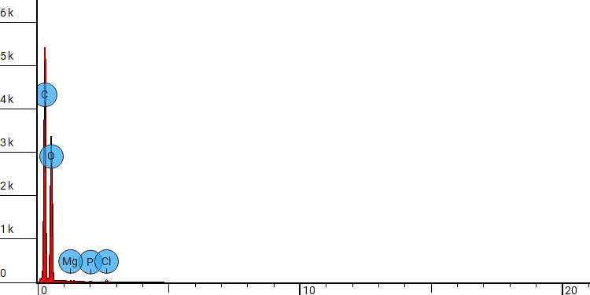
Figure S7. EDX spectrum of elemental composition of coconut husk.

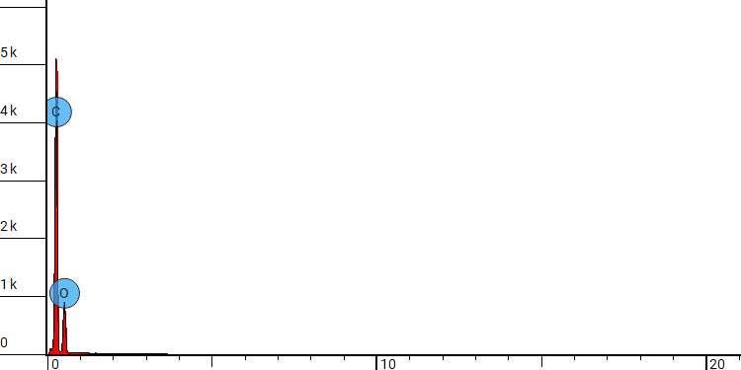
Figure S8. EDX spectrum of elemental composition of MCC.

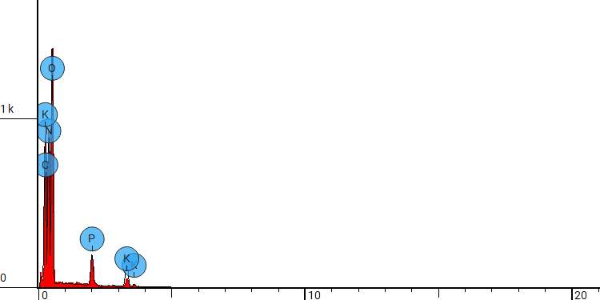
Figure S9. EDX spectrum of elemental composition of PDMU–KP.

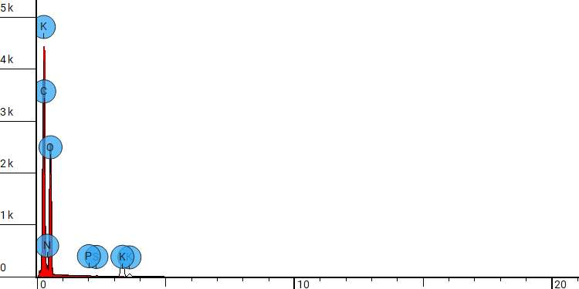
Figure S10. EDX spectrum of elemental composition of MCC-g-PMA/PDMU–KP.

Table S1. FTIR peak assignments of coconut husk
Wavenumber (cm⁻¹) | Functional Groups
3400–3200 | O–H stretching
2922 | aliphatic C–H stretching
1732 | C=O stretching
1609 and 1518 | aromatic C=C skeletal
1247 | C–O stretching
1050–1030 | C–O–C and C–O stretching

Table S2. FTIR peak assignments of MCC
Wavenumber (cm⁻¹) | Functional Groups
3400–3200 | O–H stretching
2889 | aliphatic C–H stretching
1724 | C=O stretching
1625 and 1592 | aromatic C=C skeletal
1430 | CH₂ bending
1370 | C–H bending
1321 | CH₂ wagging
1157 | C–O–C stretching
1026 | C–O stretching
895 | C–H out-of-plane

Table S3. FTIR peak assignments of PDMU–KP
Wavenumber (cm⁻¹) | Functional Groups
3440 and 3325 | O–H and N–H stretching
2955 | aliphatic C–H stretching
1642 | C=O stretching
1551 | N–H bending + C–N stretching
1346 | C–N stretching
1264 | P=O stretching
1133 | P–O stretching
1026 | C–O–P stretching
895 | –P–O bending

Table S4. FTIR peak assignments of MCC-g-PMA/PDMU–KP composite.
Wavenumber (cm⁻¹) | Functional Groups
3400–3200 | O–H/N–H stretching
3300–2500 | O–H stretching
1720–1710 | C=O stretching
1642 | C=O stretching
1568 | N–H bending + C–N stretching
1477 | CH₂ bending
1149–870 | P–O, P=O, C–O–C stretching

