SUPPLEMENTARY FILE
Method Evaluation for Chemical Oxygen Demand (COD) in Wastewater Treatment Plant Samples from an Industrial Estate using Closed Reflux Colorimetry
Junjunan Muhammad Syukur ^{1,*}, Erna Styani ², Muhammad Yanwar Prasetyo ³
¹ Analytical Chemistry Department, Polytechnic of AKA Bogor, Bogor, Indonesia
² Industrial Waste Treatment Department, Polytechnic of AKA Bogor, Bogor, Indonesia
³ Environment Monitoring Department, PT. Jababeka Infrastruktur, Bekasi, Indonesia
* Corresponding author: muhammadjunjunan29@gmail.com
Table S.1. Linear regression parameters and 95% confidence intervals (CI) for the COD calibration curves
Parameter | LR COD (20–90 mg O₂/L) | HR COD (90–700 mg O₂/L)
Calibration range (mg O₂/L) | 20–90 | 90–700
Observations (n) | 6 | 8
Regression equation | Y = −0.0019X + 0.2185 | Y = 0.0003X + 0.0131
Slope (b) | −0.001906 | 0,000287
95% CI Slope | -0,001985 to -0,001827 | 0,000282 to 0,000293
Intercept (a) | 0.218455 | 0,013058
95% CI Intercept | 0,214263 to 0,222648 | 0,010733 to 0,015384
Multiple R | 0.9996 | 0.9998
R Square | 0.9991 | 0.9996
Adjusted R Square | 0.9989 | 0.9996
Standard error of regression (S_{y/x}) | 0.0021 | 0,0015
F-value | 4461 | 15969
p-value | 3.01 × 10⁻⁷ | 1.66 × 10⁻¹¹

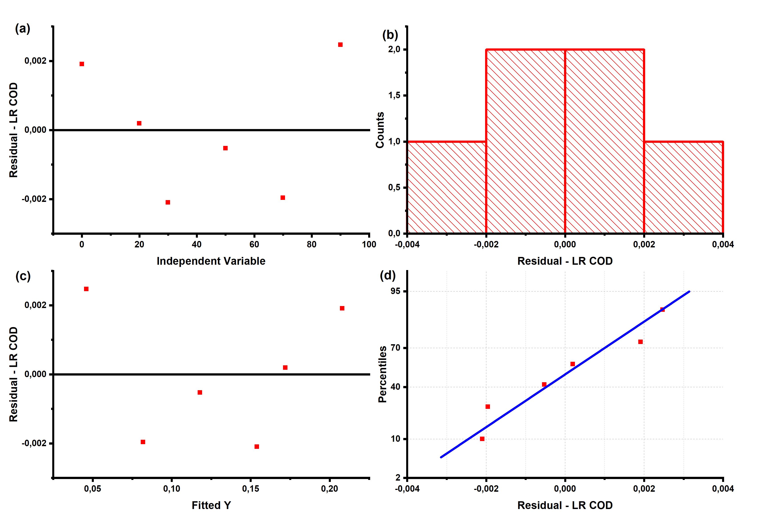
Figure S.1. Residual analysis of the low-range (LR) COD calibration curve. The figure presents (a) residuals versus independent variable, (b) a histogram of residual distribution, (c) residuals versus fitted Y values, and (d) a normal probability plot of the residuals.
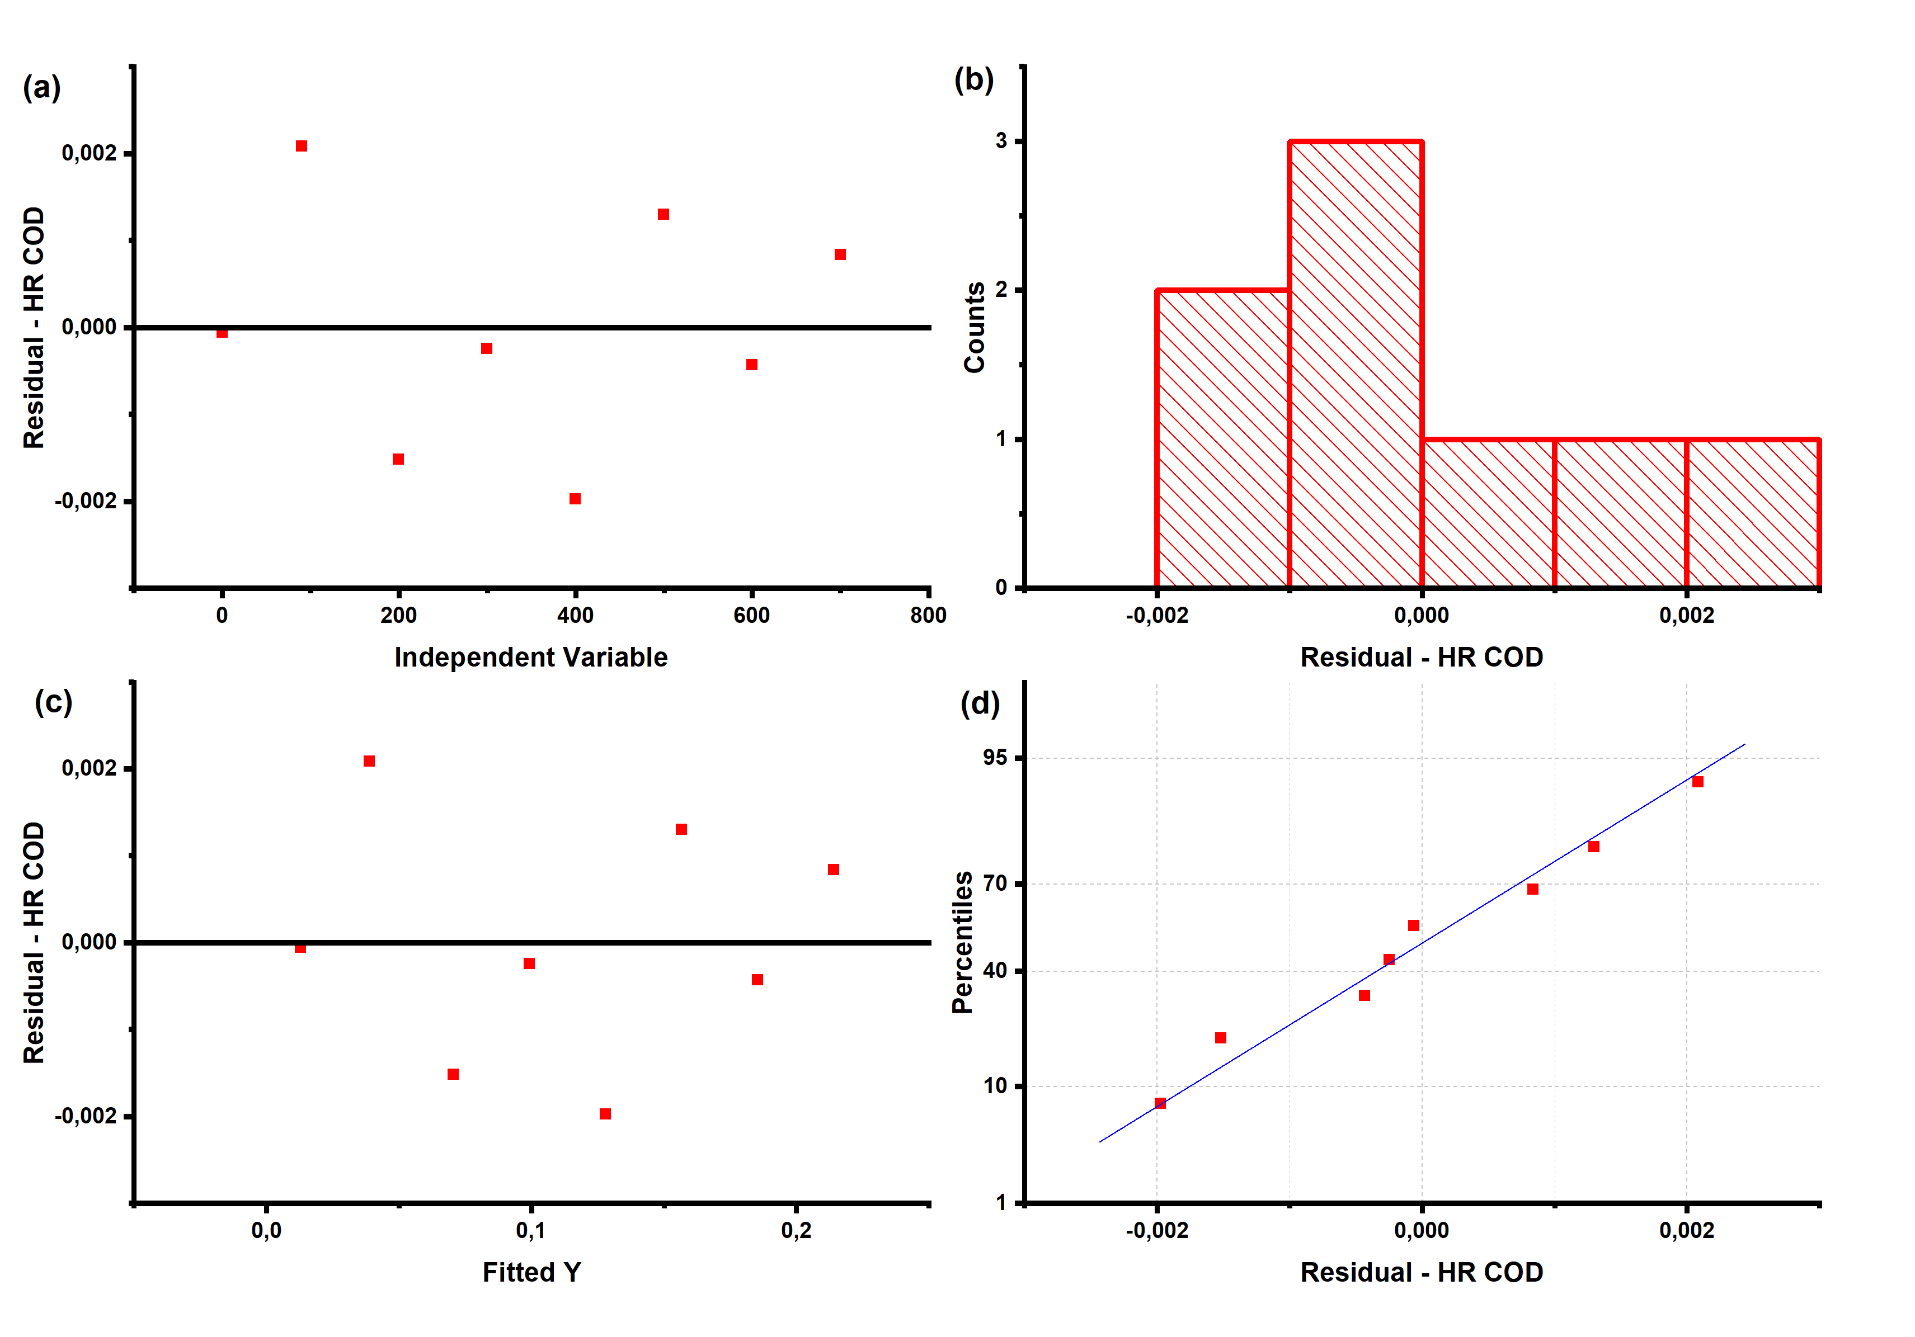
Figure S.2. Residual analysis of the low-range (HR) COD calibration curve. The figure presents (a) residuals versus independent variable, (b) a histogram of residual distribution, (c) residuals versus fitted Y values, and (d) a normal probability plot of the residuals.

