ANALYSIS MULTILEVEL SURVIVAL DATA USING COVARIATE-ADJUSTED FRAILTY PROPORTIONAL HAZARDS MODEL

Krismona Sandelvia¹, Adhitya Ronnie²
^{1,2}Department of Mathematics, Gadjah Mada University, Yogyakarta, Indonesia

e-mail: ²adhityaronnie@ugm.ac.id

DOI: 10.14710/medstat.XX.X.XX-XX

Article Info:  Received:  Accepted:  Available Online:  Keywords:  multilevel survival; frailty; covariate-adjusted proportional hazards; Bayesian MCMC. | Abstract: Multilevel survival data is time-to-event data with a hierarchical or nested structure. This study aims to model the data using the Covariate-Adjusted Frailty Proportional Hazards method, which is an extension of the Cox proportional hazards model with the addition of random effects (frailty). Parameter estimation is performed using a Bayesian approach via Markov Chain Monte Carlo (MCMC). This method is applied to analyze repeated observations of Chronic Granulomatous Disease (CGD) infections, with frailty represented by the hospital and the patient. The results of the data analysis indicate that both hospital and patient frailty significantly influence the time to infection, with patient frailty having a greater effect. Additionally, the treatment variable rINF-g significantly reduces the severity of infection in CGD patients by 68.7%.

- INTRODUCTION
Survival analysis is a statistical approach used to analyze data on the time until a certain event or occurrence takes place. This method is widely applied in various fields, particularly in medical, engineering, and social science research, to examine phenomena such as patient survival time, equipment failure, or the duration until an event occurs^{[3]}.
In practice, the data collected often has a hierarchical or multilevel structure, for example, patients (level 1) nested within hospitals (level 2), or students within schools. This type of data structure causes dependence between observations within a group, so that the assumption of independence commonly used in conventional statistical methods is not fulfilled^{[2]}. Ignoring this hierarchical structure can lead to biased estimates and erroneous conclusions.
To address this issue, a multilevel survival model was developed, one of which is the frailty model. The frailty model introduces a random effect (frailty) that represents unobserved heterogeneity between individuals or groups^{[6]}. The Cox proportional hazards model with frailty is widely used to analyze multilevel survival data, allowing for variation in risk between groups.
Further developments resulted in a covariate-adjusted frailty model, in which the frailty distribution can vary flexibly according to covariates at the cluster level, and parameter estimation is performed using a Bayesian approach^{[7]}. This model allows for more detailed modeling of the influence of individual and group factors on the timing of events.
Previous studies have demonstrated the effectiveness of these models. Noh, Ha, and Lee (2006) applied hierarchical generalized linear models to analyze kidney disease data^{[5]}, meanwhile, Liu, Kalbfleisch, and Schaubel (2011) used a shared frailty model on organ transplant data^{[4]}. Zhou et al. (2015) developed a covariate-adjusted frailty proportional hazards model for breast cancer survival data in Iowa, United States, and highlighted the importance of covariate effects at the regional level^{[7]}.
This study aims to apply the Covariate-Adjusted Frailty Proportional Hazards model with a Bayesian approach to multilevel survival data of patients with Chronic Granulomatous Disease (CGD). This method was chosen because of its ability to handle hierarchical data structures, accommodate heterogeneity at the patient and hospital levels, and flexibly model the influence of covariates at the cluster level. It is expected that this analysis will provide a deeper understanding of the factors influencing the time to infection in CGD patients and demonstrate the advantages of the multilevel survival approach further.

- LITERATURE REVIEW
  - Covariate-Adjusted Frailty Proportional Hazards Model
The Covariate-Adjusted Proportional Hazards model is an extension of the Cox Proportional Hazards model that incorporates random effects (frailty) to accommodate unobserved heterogeneity between individuals or groups^{[6]}. In this model, frailty variance can be influenced by covariates at the cluster level, providing greater flexibility in multilevel survival data analysis^{[7]}.
Multilevel survival data is time-to-event data with a nested structure, where units at the lower level (e.g., patients) are grouped at a higher level (e.g., hospitals)^{[2]}. For example, in health studies, patients are grouped based on the hospital where they were treated. This type of data structure requires a special model so that the analysis accommodates the dependence between observations within a group.
  - Specifications of the Covariate-Adjusted Frailty Proportional Hazards Model in Multilevel Survival Data
The Covariate-Adjusted Frailty PH model was used to analyze multilevel survival data with three levels, namely repeated observation time (level 1) nested within patients (level 2), and patients nested within hospitals (level 3). This model makes it possible to identify unobserved heterogeneity at the patient and hospital levels, and allows for hospital-level frailty variance to be influenced by group covariates.
Let $i=1,…,n_{j}$ denote the number of patients admitted to hospital $j=1,…,J$ and $k=1,…,K_{ij}$ denote the random number of observations of several failure times for patient $i$ in hospital $j$, the hazard function of the frailty proportional hazard model is as follows:
$$h\left(t;i,j,k\right)=h_{0}\left(t\right)\exp{(x_{ujk}^{T}β+u_{ij}+v_{j})}$$ | (1)
with:
$h_{0}$ : baseline hazard function

$x_{ijk}$ : covariate vector for patient $i$ in hospital $j$ at observation $k$ corresponding to parameter $β$
$u_{ij}\sim N(0,σ_{u}^{2})$ : patient frailty
$v_{j}\sim N(0,σ_{v}^{2})$ : hospital frailty
The baseline hazard function $h_{0}(t)$ assumed to follow a Weibull distribution. The Weibull distribution is one of the most flexible distributions and is often used in survival analysis because it can model hazards that increase, decrease, or remain constant over time^{[3]}.
The Weibull hazard baseline function is expressed as:
$$h_{0}\left(t\right)=λρt^{ρ-1}$$ | (2)
with
$λ$ = scale parameter
$ρ$ = shape parameter
The survival function for the Weibull distribution is:
$$S\left(t\right)=\exp{(-λt^{ρ})}$$ | (3)
Thus, the hazard function for the multilevel survival model with frailty is:
$$h_{ijk}\left(t\right)=λρt_{}^{ρ-1}\exp{(x_{ijk}^{T}β+u_{ij}+v_{j})}$$ | (4)
The survival function for observation $k$ in patient $i$ at hospital $j$ is obtained from the hazard function above, as follows:
$$S_{ijk}\left(t\right)=\exp{(-\exp\left(η_{ijk}\right)λt^{ρ})}$$ | (5)
with $η_{ijk}=x_{ijk}^{T}β+u_{ij}+v_{j}$.
This survival function expresses the probability that the time to event for observation $k$ in patient $i$ at hospital $j$ is greater then $t$, taking into account the effects of covariates, patient frailty, and hospital frailty.
In the proportional hazards model, the effect of covariates on hazard is measured using the hazard ratio (HR). The hazard ratio is calculated as:
$$HR=\exp{(β)}$$ | (6)
where $β$ is the regression coefficient of the relevant covariate. The value HR < 1 indicates a decrease in risk, while HR > 1 indicates an increase in risk^{[3]}.
  - Estimation of Covariate-Adjusted Frailty Proportional Hazards Model Parameters
Parameter estimation in the three-level Covariate-Adjusted Frailty Proportional Hazards model was performed using a Bayesian approach. This approach was chosen because of the complex structure of the model, involving frailty at the patient and hospital levels, making the classical approach difficult to apply.
- Likelihood
The likelihood function for all three levels of data is formulated as follows:
$$L\left(β,λ,ρ ,\left\{u_{ij}\right\},\left\{v_{j}\right\}\right)$$ | $=\prod_{j=1}^{J}{\prod_{i=1}^{n_{j}}{\prod_{k=1}^{K_{ij}}{{\left[λρt_{ijk}^{ρ-1}\exp\left(η_{ijk}\right)\right]}^{δ_{ijk}} }}}$
 | $\exp\left(-\exp\left(η_{ijk}\right)λt_{ijk}^{ρ}\right)$ | (7)

In the Bayesian approach, the likelihood function is used to form a posterior distribution together with the prior.
- Prior and Posterior Distributions
In the Bayesian approach, each model parameter is given a prior distribution. The prior used for parameters $\left(β, λ,ρ, \left\{u_{ij}\right\}, \left\{v_{j}\right\}\right)$ is:
- Prior for Regression Coefficient $(β)$
The regression coefficient $β$ is assumed to follow a multivariate normal distribution, which is:
$$π\left(β\right)=\frac{1}{{\left(2πτ^{2}\right)}^{p/2}}\exp\left(-\frac{1}{2τ^{2}}β^{T}β\right)$$ | (8)
where $p$ is the dimension of the parameter vector $β$, which is the number of regression coefficients in that vector.
- Prior for Individual Frailty $(u_{ij})$
Individual frailty $u_{ij}$ is assumed to be normal distribution, i.e., $u_{ij}\sim N(0,σ_{u}^{2})$. The standard deviation of individual frailty $σ_{u}$ follows a positive Cauchy distribution with scale 2,5 ($σ_{u}\sim {Cauchy}^{+}(0 , 2.5))$. The prior distribution for frailty $u_{ij}$ and $σ_{u}$ can be written as:
$$π\left(u_{ij}|σ_{u}\right)=\prod_{i=1}^{n_{j}}{\prod_{j=1}^{J}{\frac{1}{\sqrt{2πσ_{u}^{2}}}\exp\left(-\frac{u_{ij}^{2}}{2σ_{u}^{2}}\right)}}$$ | (9)
$$π\left(σ_{u}\right)=\frac{2}{π∙2,5\left(1+{\left(\frac{σ_{u}}{2,5}\right)}^{2}\right)},σ_{u}>0$$ | (10)

- Prior for Cluster Frailty $(v_{j})$
The cluster frailty $v_{j}$ is also assumed to be normal distributed, i.e., $v_{j}\sim N(0,σ_{v}^{2})$, with standard deviation $σ_{v}$ following a positive Cauchy distribution with scale 2,5 ($σ_{v}\sim {Cauchy}^{+}(0 , 2.5))$. The prior distribution for frailty $v_{j}$ and $σ_{v}$ can be written as:
$$π\left(v_{j}|σ_{v}\right)=\prod_{j=1}^{J}{\frac{1}{\sqrt{2πσ_{v}^{2}}}\exp\left(-\frac{v_{j}^{2}}{2σ_{v}^{2}}\right)}$$ | (11)
$$π\left(σ_{v}\right)=\frac{2}{π∙2,5\left(1+{\left(\frac{σ_{v}}{2,5}\right)}^{2}\right)},σ_{v}>0$$ | (12)
- Prior for Scale Parameter $(λ)$
The scale parameter $λ$ of the Weibull distribution is assumed to follow a Gamma distribution, i.e., $λ\sim Gamma\left(a_{λ},b_{λ}\right).$
- Prior for Shape Parameter $(ρ)$
The shape parameter $ρ$ of the Weibull distribution is also assumed to follow the Gamma distribution, i.e., $ρ\sim Gamma(a_{ρ},b_{ρ})$.
Based on Bayes' Theorem^{[1]}, the posterior distribution of the model parameters combines the prior distribution and the likelihood function, as follows:
$$(π(β,\{u_{ij}\},\{v_{j}\},λ,ρ,σ_{u},σ_{v}|data)$$ | $∝ L(data|β,\{u_{ij}\},\{v_{j}\},λ,ρ)· π(β)$
 | $· π(\{u_{ij}\},σ_{u}) · π(\{v_{j}\},σ_{v})· π(λ) ∙ π(ρ)$ | (13)
By substituting the likelihood function and prior distribution of all parameters into equation (13), the joint posterior distribution is:
$$(π(β,\{u_{ij}\},\{v_{j}\},λ,ρ,σ_{u},σ_{v}|data)∝\prod_{j,i,k}{{\left[λρt_{ijk}^{ρ-1}\exp\left(η_{ijk}\right)\right]}^{δ_{ijk}}\exp\left(-\exp\left(η_{ijk}λt_{ijk}^{ρ}\right)\right)}·\exp{ \left(-\frac{1}{2τ^{2}} β^{T}β\right)}∙\prod_{i,j}{\frac{1}{\sqrt{σ_{u}^{2}}}\exp\left(-\frac{u_{ij}^{2}}{2σ_{u}^{2}}\right)}∙\frac{1}{1+{\left(\frac{σ_{u}}{2,5}\right)}^{2}}∙\prod_{j=1}^{J}{\frac{1}{\sqrt{σ_{v}^{2}}}\exp\left(-\frac{v_{j}^{2}}{2σ_{v}^{2}}\right)}∙\frac{1}{1+{\left(\frac{σ_{v}}{2,5}\right)}^{2}}∙λ^{a_{λ}-1}e^{-b_{λ}λ}∙ρ^{a_{ρ}-1}e^{-b_{ρ}ρ}$$ | (14)
Since the posterior distribution has a complex analytical form, posterior sampling is performed using the Markov Chain Monte Carlo (MCMC) numerical method.
- Estimation Process with Markov Chain Monte Carlo (MCMC)
Model parameter estimation is performed numerically using the Markov Chain Monte Carlo (MCMC) method. In general, the MCMC steps for posterior sampling are as follows:
- Initialize all model parameters with initial values $β^{(0)}, u_{ij}^{\left(0\right)} , v_{j}^{\left(0\right)} ,λ^{\left(0\right)},ρ^{\left(0\right)},σ_{u}^{\left(0\right)} ,σ_{v}^{\left(0\right)}$.
- For each iteration $t$, update the parameters alternately ($β^{(t)}, u_{ij}^{\left(t\right)} , v_{j}^{\left(t\right)} ,λ^{\left(t\right)},ρ^{\left(t\right)},σ_{u}^{\left(t\right)} ,σ_{v}^{\left(t\right)})$
- Repeat step two for many iterations until the Markov chain reaches convergence.
- Discard a number of initial iterations (burn-in) to eliminate the influence of initial values and use samples after burn-in for parameter inference. The final estimate is obtained from the posterior sample after burn-in.

- MATERIAL AND METHOD
  - Data
This study uses secondary data from a study on chronic granulomatous disease (CGD) by Fleming and Harrington (1991) obtained from the R software in the survival package. The data consists of observations of 128 patients in 13 different hospitals over a period of one year. Each hospital had between 4 and 26 patients. The data structure is hierarchical (multilevel) with three levels, namely repeated event observations (level 1) for each patient (level 2) in the hospital (level 3).
  - Research Variables
This study involved two types of variables, namely independent variables and dependent variables. There are six independent variables used in this study: patient ID, center (hospital number), treatment (category of treatment, either gamma interferon (γ-INF) or placebo), sex (category of gender), age (category of patient age), and status (indicating censoring, where 1 = uncensored data and 0 = censored data). The dependent variable in this study is the time to recurrence of survival in infected patients. In this case, t-start indicates the start of the time interval, and t-stop indicates the end of the time interval.
  - Data Analysis Methods
The data were analyzed using the Covariate-Adjusted Frailty Proportional Hazards model for multilevel survival data. In general, the steps for data analysis are as follows:
- Determine data and models in accordance with concepts and theories.
- Describe independent and dependent variables.
- Estimate model parameters using the covariate-adjusted frailty PH method with a Bayesian MCMC approach.
- Interpret results and draw conclusions.

- RESULTS AND DISCUSSION
Multilevel survival data analysis was performed with two frailty and three covariates, namely treatment, sex, and age. The two random effects referred to are center random effects and patient random effects.
To build a sample to the targeted distribution, a large number of iterations were used. A total of 2,000 iterations were used, with an initial iteration (burn-in) of 1,000. The parameter estimation results obtained were as follows:
Tabel 1. Parameter Estimation Results
Parameters | Mean | 95% credible interval (2.5% - 97.5%) | R-hat
$$β_{1}$$ | -1.1623551 | [-1.8243 , -0.5268] | 1.00
$$β_{2}$$ | -0.168745 | [-1.0206 , 0.6494] | 1.00
$$β_{3}$$ | -0.0340056 | [-0.0721 , 0.0023] | 1.00
$$λ$$ | 0.0022229 | [0.0003 , 0.0072] | 1.00
$$ρ$$ | 1.1151701 | [0.8863 , 1.3699] | 1.00
$$σ_{u}$$ | 0.8636716 | [0.4248 , 1.3406] | 1.01
$$σ_{v}$$ | 0.355103 | [0.0440 , 0.9469] | 1.03

Based on Table 1, it can be seen that the treat variable has a negative value of -1.1623, and because the confidence interval does not exceed 0, it is significant. This means that the treat covariate rINF-g as the treatment group is significant in reducing the severity of infection in CGD patients compared to the placebo, which is the control group. This can also be shown through the survival curve.

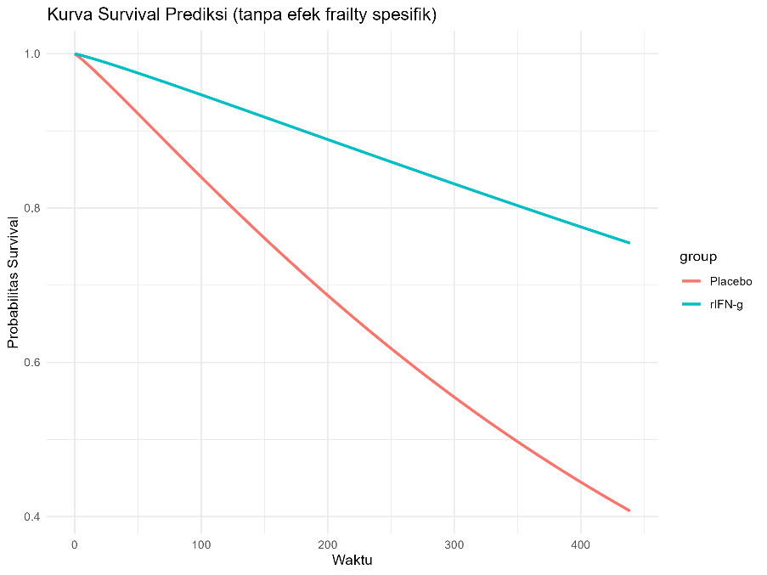
Gambar 1. Survival Curve for Treatment
From Figure 1, it can be seen that at each point in time, the group receiving rINF-g treatment showed a higher probability of survival compared to the group receiving placebo treatment. This indicates that rINF-g treatment has a positive effect on the survival rate of CGD patients.
In addition, based on Table 1, it can also be seen that the confidence intervals for the covariates sex and age exceed 0, so it can be concluded that the covariates sex and age are not significant. This can be shown through the following posterior plot.
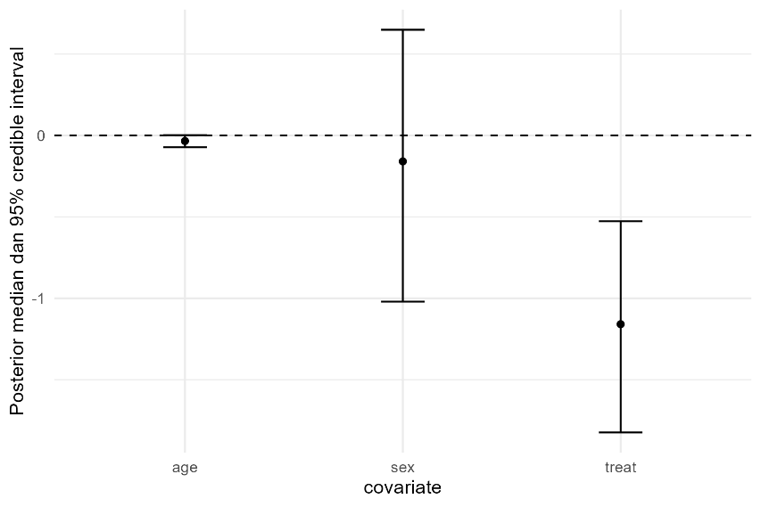
Gambar 2. Posterior Plot of Treatment, Sex, and Age
This posterior plot displays the estimated regression coefficients along with their 95% confidence intervals. From this plot, it can be observed that the treatment coefficient has a confidence interval that does not include zero and is negative, indicating that the treatment variable has a significant effect on reducing the severity of infection in CGD patients. Conversely, the regression coefficients for sex and age, with confidence intervals that include zero, indicate that these two variables have no significant effect.
From Table 1, it can also be seen that the baseline hazard parameter is very small, namely 0.0022229, indicating a very low baseline hazard at the beginning of time that is close to constant. For the hazard distribution shape parameter 1.1151701 > 1, this indicates that the hazard increases over time. The variance of the random effect at level 2 (patients) is quite large, at 0.8636716, and its confidence interval does not include 0, making it significant. This indicates heterogeneity among patients within the hospital (center). The variance of the random effect at level 1 (center) is 0.355103, which is also significant based on the confidence interval not including 0, indicating heterogeneity among hospitals (centers).
Based on the estimation results, the regression coefficient for the treatment covariate rINF-g is -1.1623. Thus, the hazard ratio for treatment rINF-g is:
$$HR=\exp\left(-1.1623\right)≈0.313$$
The HR value of 0.313 indicates that patients receiving rINF-g treatment have a risk of serious infection in CGD patients of approximately 31.3% of the risk of patients receiving placebo treatment. In other words, rINF-g treatment reduces the risk of occurrence by 68.7% compared to placebo.
From these results, the Covariate-Adjusted Frailty Proportional Hazards method can be used as a reference when using multilevel survival data because it provides comprehensive results by analyzing the influence of random effects (frailty) within the data level or tier. The Covariate-Adjusted Frailty PH method in multilevel survival analysis allows for the handling of complex data forms such as repeated event times for each patient while considering variations at the patient and hospital levels.

- CONCLUSION
Based on a case study of factors influencing the severity of infection in CGD patients, it was found that the rINF-g treatment variable was significant in reducing the severity of infection in CGD patients. The hazard ratio (HR) value showed that rINF-g treatment had a 68.7% effect in reducing the risk of occurrence. In addition, the random effects of patients and hospitals were also significant. This means that there is heterogeneity between patients and between hospitals.

REFERENCES
[1] Berger, J. O. (1985), Manual for SOA Exam MLC, Fall 2009 Edition. New Hartford: SRBooks, Inc.
[2] Hox, J. (2002), Multilevel Analysis Techniques and Applications. New Jersey: Lawrence Erlbaum Associates, Inc.
[3] Kleinbaum, D. G., Klein, M. (2005), Survival Analysis A Self-Learning Text 2nd Edition. London: Springer.
[4] Liu, D., Kalbfeisch, J. D., & Schaubel, D. E. (2011), A positive Stable Frailty Model for Clustered Failure Time Data with Covariate-Dependent Frailty. Biometrics, 67(1): 8-17.
[5] Noh, M., Ha, I. D., & Lee, Y. (2006), Dispersion Frailty Models and HGLMs. Statistic in Medicine, 25(8): 1341-1354.
[6] Vaupel, J. W., Manton, K. G., & Stallard, E. (1979), The Impact of Heterogenity in Individual Frailty on The Dynamics of Mortality. Demography, 16(3): 439-454.
[7] Zhou, H., Hanson, T., Jara, A., & Zhang, J. (2015), Modeling County Level Breast Cancer Survival Data Using a Covariate-Adjusted Frailty Proportional Hazards Model. The Annals of Applied Statistics, 9(1): 43-68.

