LAMPIRAN A. 1
NEW FILE.
DATASET NAME DataSet1 WINDOW=FRONT.
* NonLinear Regression.
MODEL PROGRAM B=0.01.
COMPUTE PRED_=7687.25*exp(-B*Cid).
NLR Y
/OUTFILE='C:\Users\acer\AppData\Local\Temp\spss3108\SPSSFNLR.TMP'
/PRED PRED_
/CRITERIA SSCONVERGENCE 1E-8 PCON 1E-8.
Nonlinear Regression Analysis
[DataSet1]
Iteration History^{b}
Iteration Numberª |  |  |  | Residual Sum of Squares |  |  | Parameter
 |  |  |  |  |  |  | B
1.0 |  |  |  | 207762501.080 |  |  | .010
1.1 |  |  |  | 26330403.977 |  |  | .102
2.0 |  |  |  | 26330403.977 |  |  | .102
2.1 |  |  |  | 2581744.341 |  |  | .182
3.0 |  |  |  | 2581744.341 |  |  | .182
3.1 |  |  |  | 923742.922 |  |  | .225
4.0 |  |  |  | 923742.922 |  |  | .225
4.1 |  |  |  | 917155.972 |  |  | .228
5.0 |  |  |  | 917155.972 |  |  | .228
5.1 |  |  |  | 917089.401 |  |  | .228
6.0 |  |  |  | 917089.401 |  |  | .228
6.1 |  |  |  | 917088.475 |  |  | .228
7.0 |  |  |  | 91788.475 |  |  | .228
7.1 |  |  |  | 917088.463 |  |  | .228
8.0 |  |  |  | 917088.463 |  |  | .228
8.1 |  |  |  | 917088.463 |  |  | .228
Derivatives are calculated numerically.
a. Major iteration number is displayed to the left of the decimal, and minor iteration number is to the right of the decimal.
b. Run stopped after 16 model evaluations and 8 derivative evaluations because the relative reduction between successive residual sums of squares is at most SSCON = 1.00E-008.
 | Parameter Estimates
 | Parameter | Estimate |  |  | Std. Error |  |  | 95% Confidence Interval
 | Parameter |  |  |  |  |  |  | Lower Bound |  |  | Upper Bound
 | B | .228 |  |  | .019 |  |  | .179 |  |  | .277
ANOVAª
Source |  |  | Sum of Squares |  |  | df |  |  | Mean Squares
Regression |  |  | 19943279.047 |  |  | 1 |  |  | 19943279.047
Residual |  |  | 917088.463 |  |  | 5 |  |  | 183417.693
Uncorrected Total |  |  | 20860367.510 |  |  | 6
Corrected Total |  |  | 11024078.628 |  |  | 5
Dependent variable: Yª
a. R squared = 1 - (Residual Sum of Squares) / (Corrected Sum of Squares) = .917.

LAMPIRAN A. 1
Data Kedatangan dan Keberangkatan Truk Parkir

Waktu | Jalan Yos Sudarso |  |  |  | Jalan Ronggowarsito
Waktu | Kamis, 28 Juli 2016 |  | Jumat, 29 Juli 2016 |  | Kamis, 28 Juli 2016 |  | Jumat, 29 Juli 2016
Waktu | Datang | Berangkat | Datang | Berangkat | Datang | Berangkat | Datang | Berangkat
06:00-06:15 | 4 | 0 | 4 | 0 | 5 | 0 | 2 | 0
06:15-06:30 | 5 | 0 | 3 | 0 | 6 | 0 | 2 | 0
06.30-06:45 | 4 | 0 | 2 | 2 | 5 | 0 | 3 | 0
06:45-07:00 | 8 | 2 | 2 | 2 | 2 | 0 | 0 | 0
07:00-07:15 | 8 | 3 | 6 | 3 | 2 | 0 | 0 | 0
07:15-07:30 | 3 | 4 | 7 | 2 | 5 | 1 | 1 | 0
07:30-07:45 | 7 | 4 | 9 | 3 | 1 | 1 | 1 | 0
07:45-08:00 | 4 | 2 | 7 | 5 | 2 | 2 | 1 | 0
08:00-08.15 | 6 | 1 | 9 | 3 | 3 | 2 | 0 | 2
08:15-08:30 | 8 | 4 | 8 | 7 | 1 | 3 | 1 | 0
08:30-08:45 | 6 | 5 | 6 | 5 | 3 | 2 | 1 | 0
08:45-09:00 | 6 | 5 | 6 | 3 | 1 | 3 | 0 | 0
09:00-09:15 | 7 | 7 | 6 | 6 | 0 | 3 | 0 | 0
09:15-09:30 | 5 | 6 | 7 | 6 | 0 | 3 | 1 | 0
09:30-09:45 | 6 | 4 | 6 | 6 | 0 | 1 | 0 | 0
09:45-10.00 | 7 | 7 | 5 | 5 | 1 | 1 | 0 | 0
10:00-10:15 | 4 | 7 | 6 | 5 | 2 | 3 | 0 | 1
10:15-10:30 | 7 | 6 | 5 | 5 | 1 | 2 | 1 | 0
10:30-10.45 | 6 | 5 | 6 | 6 | 1 | 0 | 1 | 0
10:45-11:00 | 5 | 6 | 8 | 9 | 2 | 1 | 0 | 0
11:00-11:15 | 7 | 5 | 10 | 9 | 0 | 3 | 0 | 0
11:15-11:30 | 5 | 10 | 7 | 5 | 0 | 5 | 0 | 0
11:30-11:45 | 6 | 3 | 9 | 8 | 2 | 1 | 2 | 1
11:45-12:00 | 5 | 6 | 8 | 7 | 2 | 0 | 0 | 0
12:00-12:15 | 7 | 5 | 7 | 8 | 0 | 1 | 1 | 0
12:15-12:30 | 5 | 6 | 8 | 11 | 3 | 0 | 3 | 3
12:30-12:45 | 6 | 7 | 10 | 6 | 1 | 0 | 1 | 2
12:45-13:00 | 5 | 5 | 7 | 7 | 1 | 0 | 2 | 0
13:00-13:15 | 5 | 7 | 6 | 7 | 0 | 1 | 1 | 1
13:15-13:30 | 6 | 3 | 6 | 7 | 1 | 4 | 0 | 0
13:30-13:45 | 4 | 9 | 8 | 9 | 0 | 0 | 0 | 1
13:45-14:00 | 5 | 3 | 7 | 8 | 0 | 2 | 3 | 3
14:00-14:15 | 7 | 8 | 8 | 8 | 0 | 1 | 0 | 1
14:15-14:30 | 5 | 5 | 3 | 5 | 2 | 2 | 1 | 1
14:30-14:45 | 6 | 4 | 6 | 8 | 2 | 1 | 1 | 0
14:45-15:00 | 7 | 7 | 8 | 9 | 3 | 0 | 2 | 0
15:00-15:15 | 7 | 9 | 10 | 8 | 2 | 3 | 3 | 1
15:15-15:30 | 12 | 11 | 9 | 10 | 3 | 0 | 3 | 0
15:30-15:45 | 8 | 10 | 12 | 11 | 4 | 1 | 4 | 0
15:45-16:00 | 7 | 5 | 9 | 8 | 4 | 0 | 1 | 1
16:00-16:15 | 6 | 6 | 16 | 14 | 4 | 1 | 1 | 0
16:15-16:30 | 7 | 8 | 12 | 12 | 2 | 2 | 1 | 0
16:30-16:45 | 11 | 12 | 9 | 8 | 2 | 4 | 1 | 1
16:45-17:00 | 12 | 11 | 4 | 4 | 0 | 4 | 0 | 1
17:00-17:15 | 14 | 12 | 4 | 6 | 0 | 0 | 0 | 4
17:15-17:30 | 7 | 10 | 3 | 4 | 0 | 2 | 0 | 2
17:30-17:45 | 5 | 6 | 1 | 1 | 0 | 4 | 0 | 2
17:45-18:00 | 2 | 1 | 1 | 2 | 0 | 3 | 0 | 2
Sumber : (Hasil Survey dan Analisis Data, 2016)

LAMPIRAN A. 2
Pengujian Distribusi Kedatangan dan Keberangkatan
NPar Tests
One-Sample Kolmogorov-Smirnov Test
 |  | ArtKam_Dtg | ArtKam_Br | ArtJm_Dtg | ArtJm_Br | RonKam_Dt | RonKam_Br | RonJm_Dt | RonJm_Br
N |  | 48 | 48 | 48 | 48 | 48 | 48 | 48 | 48
Poisson Parameter^{a,b} | Mean | 6.3542 | 5.6667 | 6.7917 | 6.1042 | 1.6875 | 1.5208 | .9583 | .6250
Most Extreme Differences | Absolute | .139 | .083 | .078 | .088 | .128 | .094 | .052 | .090
Most Extreme Differences | Positive | .139 | .081 | .053 | .088 | .128 | .094 | .033 | .090
Most Extreme Differences | Negative | -.095 | -.083 | -.078 | -.084 | -.055 | -.074 | -.052 | -.037
Kolmogorov-Smirnov Z |  | .966 | .575 | .541 | .612 | .883 | .651 | .362 | .622
Asymp. Sig. (2-tailed) |  | .309 | .896 | .931 | .848 | .416 | .790 | .999 | .834
a. Test distribution is Poisson.
b. Calculated from data.
Dari hasil analisis distribusi kedatangan dan keberangkatan dengan aplikasi IBM SPSS Statistics 23, hasil nilai Asymp. Sig. (2-tailed) lebih besar dari batas toleransi 0,05. Sehingga distribusi kedatangan dan keberangkatan termasuk distribusi Poisson

LAMPIRAN A. 3
Pengujian Distribusi Durasi Parkir

Jl. Yos Sudarso, Kamis 28 Juli 2016
x | Class |  |  | Oi | x .Oi | μ | Pi | Ei | X²
1 | 0 | - | 90 | 235 | 235 | 1.66 | 0.31 | 99.96 | 1.82
2 | 90 | - | 180 | 47 | 94 | 1.66 | 0.25 | 78.33 | 0.16
3 | 180 | - | 270 | 13 | 39 | 1.66 | 0.12 | 37.93 | 0.43
4 | 270 | - | 360 | 4 | 16 | 1.66 | 0.07 | 21.89 | 0.67
5 | 360 | - | 450 | 1 | 5 | 1.66 | 0.04 | 14.18 | 0.86
6 | 450 | - | 540 | 3 | 18 | 1.66 | 0.03 | 9.92 | 0.49
7 | 540 | - | 630 | 0 | 0 | 1.66 | 0.02 | 7.33 | 1.00
8 | 630 | - | 720 | 16 | 128 | 1.66 | 0.02 | 5.63 | 2.77 | 0.05
 |  |  |  | 318 | 527 |  |  |  | 8.21 | 12.59

Dengan derajat kepercayaan 95% (α=0,05)
X² hitung = 8,21 ; X² tabel (6;0,05) = 12,59
X² hitung < X² tabel (6;0,05), Ho : diterima (distribusi durasi parkir eksponensial)

Jl. Yos Sudarso, Jumat 29 Juli 2016
x | Class |  |  | Oi | x .Oi | μ | Pi | Ei | X²
1 | 0 | - | 90 | 253 | 253 | 1.51 | 0.36 | 123.98 | 1.08
2 | 90 | - | 180 | 62 | 124 | 1.51 | 0.24 | 81.33 | 0.06
3 | 180 | - | 270 | 7 | 21 | 1.51 | 0.11 | 37.59 | 0.66
4 | 270 | - | 360 | 7 | 28 | 1.51 | 0.06 | 21.30 | 0.45
5 | 360 | - | 450 | 0 | 0 | 1.51 | 0.04 | 13.67 | 1.00
6 | 450 | - | 540 | 0 | 0 | 1.51 | 0.03 | 9.50 | 1.00
7 | 540 | - | 630 | 1 | 7 | 1.51 | 0.02 | 6.99 | 0.73
8 | 630 | - | 720 | 12 | 96 | 1.51 | 0.02 | 5.35 | 0.75 | 0.05
 |  |  |  | 340 | 513 |  |  |  | -2.67 | 12.59
Dengan derajat kepercayaan 95% (α=0,05)
X² hitung = 10,47 ; X² tabel (6;0,05) = 12,59
X² hitung < X² tabel (6;0,05), Ho : diterima (distribusi durasi parkir eksponensial)

Jl. Ronggowarsito, Kamis 28 Juli 2016
x | Class |  |  | Oi | x .Oi | μ | Pi | Ei | X²
1 | 0 | - | 90 | 8 | 8 | 2.99 | 0.08 | 7.63 | 0.00
2 | 90 | - | 180 | 53 | 106 | 2.99 | 0.21 | 18.87 | 3.27
3 | 180 | - | 270 | 11 | 33 | 2.99 | 0.15 | 13.63 | 0.04
4 | 270 | - | 360 | 8 | 32 | 2.99 | 0.10 | 9.25 | 0.02
5 | 360 | - | 450 | 0 | 0 | 2.99 | 0.07 | 6.54 | 1.00
6 | 450 | - | 540 | 0 | 0 | 2.99 | 0.05 | 4.84 | 1.00
7 | 540 | - | 630 | 0 | 0 | 2.99 | 0.04 | 3.71 | 1.00
8 | 630 | - | 720 | 12 | 96 | 2.99 | 0.03 | 2.93 | 5.82 | 0.05
 |  |  |  | 92 | 275 |  |  |  | 12.15 | 12.59
Dengan derajat kepercayaan 95% (α=0,05)
X² hitung = 12,15 ; X² tabel (6;0,05) = 12,59
X² hitung < X² tabel (6;0,05), Ho : diterima (distribusi durasi parkir eksponensial)

Jl. Ronggowarsito, Jumat 29 Juli 2016
x | Class |  |  | Oi | x .Oi | μ | Pi | Ei | X²
1 | 0 | - | 90 | 11 | 11 | 3.84 | 0.04 | 1.99 | 0.25
2 | 90 | - | 180 | 16 | 32 | 3.84 | 0.15 | 8.56 | 0.76
3 | 180 | - | 270 | 9 | 27 | 3.84 | 0.14 | 7.85 | 0.02
4 | 270 | - | 360 | 3 | 12 | 3.84 | 0.11 | 5.90 | 0.24
5 | 360 | - | 450 | 0 | 0 | 3.84 | 0.08 | 4.42 | 1.00
6 | 450 | - | 540 | 1 | 6 | 3.84 | 0.06 | 3.38 | 0.50
7 | 540 | - | 630 | 1 | 7 | 3.84 | 0.05 | 2.66 | 0.39
8 | 630 | - | 720 | 15 | 120 | 3.84 | 0.04 | 2.14 | 5.19 | 0.05
 |  |  |  | 56 | 215 |  |  |  | 8.34 | 12.59
Dengan derajat kepercayaan 95% (α=0,05)
X² hitung = 11,46 ; X² tabel (6;0,05) = 12,59
X² hitung < X² tabel (6;0,05), Ho : diterima (distribusi durasi parkir eksponensial)

LAMPIRAN A. 4
Kapasitas dan Kinerja Jalan Kaligawe

Jam Puncak Pagi

Baris | Tipe Kend | MC |  | LV |  | HV |  | Arus Total
1,1 | emp Semarang-Demak | MC | 0.25 | LV | 1 | HV | 1.2
1,2 | emp Demak-Semarang | MC | 0.25 | LV | 1 | HV | 1.2
2 | Arah | Kend/jam | smp/jam | Kend/jam | smp/jam | Kend/jam | smp/jam | MC (smp/jam) | LV+HV (smp/jam)
 |  | 1 | 2 | 3 | 4 | 5 | 6
3 | 1 | 5256 | 1314 | 1891 | 1891 | 344 | 412.8 | 1314 | 2303.8
4 | 2 | 8059 | 2014.75 | 618 | 618 | 642 | 770.4 | 2014.75 | 1388.4

Jalur Cepat
Arah | Kapasitas Dasar  (Co) | Faktor penyesuaian untuk kapasitas |  |  |  | Kapasitas  ( C ) | Volume  (smp/jam) | DS | Kecepatan Arus Bebas Dasar FV₀ (km/jam) | Kecepatan V_{LV}  (km/jam)
Arah | Kapasitas Dasar  (Co) | Lebar jalur  (FCw) | Pemisah Arah  (FCsp) | Hambatan samping (FCsf) | Ukuran kota  (FCcs)
Semarang-Demak | 3300 | 1.04 | 1 | 0.86 | 1 | 2951.52 | 2303.8 | 0.78 | 57 | 49
Demak-Semarang | 3300 | 1.04 | 1 | 0.86 | 1 | 2951.52 | 1388.4 | 0.47 | 57 | 54

Jalur Lambat
Arah | Kapasitas Dasar  (Co) | Faktor penyesuaian untuk kapasitas |  |  |  | Kapasitas  ( C ) | Volume  (smp/jam) | DS | Kecepatan Arus Bebas Dasar FV₀ (km/jam) | Kecepatan V_{LV}  (km/jam)
Arah | Kapasitas Dasar  (Co) | Lebar jalur  (FCw) | Pemisah Arah  (FCsp) | Hambatan samping (FCsf) | Ukuran kota  (FCcs)
Semarang-Demak | 3300 | 0.92 | 1 | 0.86 | 1 | 2610.96 | 1314 | 0.50 | 47 | 44
Demak-Semarang | 3300 | 0.92 | 1 | 0.86 | 1 | 2610.96 | 2014.75 | 0.77 | 47 | 40

Jam Puncak Siang

Baris | Tipe Kend | MC |  | LV |  | HV |  | Arus Total
1,1 | emp Semarang-Demak | MC | 0.25 | LV | 1 | HV | 1.2
1,2 | emp Demak-Semarang | MC | 0.25 | LV | 1 | HV | 1.2
2 | Arah | Kend/jam | smp/jam | Kend/jam | smp/jam | Kend/jam | smp/jam | MC (smp/jam) | LV+HV (smp/jam)
 |  | 1 | 2 | 3 | 4 | 5 | 6
3 | 1 | 1466 | 366.5 | 660 | 660 | 741 | 889.2 | 366.5 | 1549.2
4 | 2 | 1242 | 310.5 | 769 | 769 | 583 | 699.6 | 310.5 | 1468.6

Jalur Cepat
Arah | Kapasitas Dasar  (Co) | Faktor penyesuaian untuk kapasitas |  |  |  | Kapasitas  ( C ) | Volume  (smp/jam) | DS | Kecepatan Arus Bebas Dasar FV₀ (km/jam) | Kecepatan V_{LV}  (km/jam)
Arah | Kapasitas Dasar  (Co) | Lebar jalur  (FCw) | Pemisah Arah  (FCsp) | Hambatan samping (FCsf) | Ukuran kota  (FCcs)
Semarang-Demak | 3300 | 1.04 | 1 | 0.86 | 1 | 2951.52 | 1549.2 | 0.52 | 57 | 53
Demak-Semarang | 3300 | 1.04 | 1 | 0.86 | 1 | 2951.52 | 1468.6 | 0.50 | 57 | 53

Jalur Lambat
Arah | Kapasitas Dasar  (Co) | Faktor penyesuaian untuk kapasitas |  |  |  | Kapasitas  ( C ) | Volume  (smp/jam) | DS | Kecepatan Arus Bebas Dasar FV₀ (km/jam) | Kecepatan V_{LV}  (km/jam)
Arah | Kapasitas Dasar  (Co) | Lebar jalur  (FCw) | Pemisah Arah  (FCsp) | Hambatan samping (FCsf) | Ukuran kota  (FCcs)
Semarang-Demak | 3300 | 0.92 | 1 | 0.86 | 1 | 2610.96 | 366.5 | 0.14 | 47 | 47
Demak-Semarang | 3300 | 0.92 | 1 | 0.86 | 1 | 2610.96 | 310.5 | 0.12 | 47 | 47

Jam Puncak Sore

Baris | Tipe Kend | MC |  | LV |  | HV |  | Arus Total
1,1 | emp Semarang-Demak | MC | 0.25 | LV | 1 | HV | 1.2
1,2 | emp Demak-Semarang | MC | 0.25 | LV | 1 | HV | 1.2
2 | Arah | Kend/jam | smp/jam | Kend/jam | smp/jam | Kend/jam | smp/jam | MC (smp/jam) | LV+HV (smp/jam)
 |  | 1 | 2 | 3 | 4 | 5 | 6
3 | 1 | 5970 | 1492.5 | 1126 | 1126 | 629 | 754.8 | 1492.5 | 1880.8
4 | 2 | 3460 | 865 | 330 | 330 | 952 | 1142.4 | 865 | 1472.4

Jalur Cepat
Arah | Kapasitas Dasar  (Co) | Faktor penyesuaian untuk kapasitas |  |  |  | Kapasitas  ( C ) | Volume  (smp/jam) | DS | Kecepatan Arus Bebas Dasar FV₀ (km/jam) | Kecepatan V_{LV}  (km/jam)
Arah | Kapasitas Dasar  (Co) | Lebar jalur  (FCw) | Pemisah Arah  (FCsp) | Hambatan samping (FCsf) | Ukuran kota  (FCcs)
Semarang-Demak | 3300 | 1.04 | 1 | 0.86 | 1 | 2951.52 | 1880.8 | 0.64 | 57 | 52
Demak-Semarang | 3300 | 1.04 | 1 | 0.86 | 1 | 2951.52 | 1472.4 | 0.50 | 57 | 53

Jalur Lambat
Arah | Kapasitas Dasar  (Co) | Faktor penyesuaian untuk kapasitas |  |  |  | Kapasitas  ( C ) | Volume  (smp/jam) | DS | Kecepatan Arus Bebas Dasar FV₀ (km/jam) | Kecepatan V_{LV}  (km/jam)
Arah | Kapasitas Dasar  (Co) | Lebar jalur  (FCw) | Pemisah Arah  (FCsp) | Hambatan samping (FCsf) | Ukuran kota  (FCcs)
Semarang-Demak | 3300 | 0.92 | 1 | 0.86 | 1 | 2610.96 | 1492.5 | 0.57 | 47 | 43
Demak-Semarang | 3300 | 0.92 | 1 | 0.86 | 1 | 2610.96 | 865 | 0.33 | 47 | 45

LAMPIRAN A. 5
Perhitungan Akumulasi Parkir

Akumulasi Parkir Jl. Yos Sudarso
Waktu | Kamis, 28 Juli 2016 |  |  |  |  | Jumat, 29 Juli 2016
Waktu | Datang | Kumulatif Kedatangan | Berangkat | Kumulatif Keberangkatan | Akumulasi | Datang | Kumulatif Kedatangan | Berangkat | Kumulatif Keberangkatan | Akumulasi
 | a | b | c | d | e=14+b-d | a | b | c | d | e=16+b-d
06:00-06:15 | 4 | 4 | 0 | 0 | 18 | 4 | 4 | 0 | 0 | 20
06:15-06:30 | 5 | 9 | 0 | 0 | 23 | 3 | 7 | 0 | 0 | 23
06.30-06:45 | 4 | 13 | 0 | 0 | 27 | 2 | 9 | 2 | 2 | 23
06:45-07:00 | 8 | 21 | 2 | 2 | 33 | 2 | 11 | 2 | 4 | 23
07:00-07:15 | 8 | 29 | 3 | 5 | 38 | 6 | 17 | 3 | 7 | 26
07:15-07:30 | 3 | 32 | 4 | 9 | 37 | 7 | 24 | 2 | 9 | 31
07:30-07:45 | 7 | 39 | 4 | 13 | 40 | 9 | 33 | 3 | 12 | 37
07:45-08:00 | 4 | 43 | 2 | 15 | 42 | 7 | 40 | 5 | 17 | 39
08:00-08.15 | 6 | 49 | 1 | 16 | 47 | 9 | 49 | 3 | 20 | 45
08:15-08:30 | 8 | 57 | 4 | 20 | 51 | 8 | 57 | 7 | 27 | 46
08:30-08:45 | 6 | 63 | 5 | 25 | 52 | 6 | 63 | 5 | 32 | 47
08:45-09:00 | 6 | 69 | 5 | 30 | 53 | 6 | 69 | 3 | 35 | 50
09:00-09:15 | 7 | 76 | 7 | 37 | 53 | 6 | 75 | 6 | 41 | 50
09:15-09:30 | 5 | 81 | 6 | 43 | 52 | 7 | 82 | 6 | 47 | 51
09:30-09:45 | 6 | 87 | 4 | 47 | 54 | 6 | 88 | 6 | 53 | 51
09:45-10.00 | 7 | 94 | 7 | 54 | 54 | 5 | 93 | 5 | 58 | 51
10:00-10:15 | 4 | 98 | 7 | 61 | 51 | 6 | 99 | 5 | 63 | 52
10:15-10:30 | 7 | 105 | 6 | 67 | 52 | 5 | 104 | 5 | 68 | 52
10:30-10.45 | 6 | 111 | 5 | 72 | 53 | 6 | 110 | 6 | 74 | 52
10:45-11:00 | 5 | 116 | 6 | 78 | 52 | 8 | 118 | 9 | 83 | 51
11:00-11:15 | 7 | 123 | 5 | 83 | 54 | 10 | 128 | 9 | 92 | 52
11:15-11:30 | 5 | 128 | 10 | 93 | 49 | 7 | 135 | 5 | 97 | 54
11:30-11:45 | 6 | 134 | 3 | 96 | 52 | 9 | 144 | 8 | 105 | 55
11:45-12:00 | 5 | 139 | 6 | 102 | 51 | 8 | 152 | 7 | 112 | 56
12:00-12:15 | 7 | 146 | 5 | 107 | 53 | 7 | 159 | 8 | 120 | 55
12:15-12:30 | 5 | 151 | 6 | 113 | 52 | 8 | 167 | 11 | 131 | 52
12:30-12:45 | 6 | 157 | 7 | 120 | 51 | 10 | 177 | 6 | 137 | 56
12:45-13:00 | 5 | 162 | 5 | 125 | 51 | 7 | 184 | 7 | 144 | 56
13:00-13:15 | 5 | 167 | 7 | 132 | 49 | 6 | 190 | 7 | 151 | 55
13:15-13:30 | 6 | 173 | 3 | 135 | 52 | 6 | 196 | 7 | 158 | 54
13:30-13:45 | 4 | 177 | 9 | 144 | 47 | 8 | 204 | 9 | 167 | 53
13:45-14:00 | 5 | 182 | 3 | 147 | 49 | 7 | 211 | 8 | 175 | 52
14:00-14:15 | 7 | 189 | 8 | 155 | 48 | 8 | 219 | 8 | 183 | 52
14:15-14:30 | 5 | 194 | 5 | 160 | 48 | 3 | 222 | 5 | 188 | 50
14:30-14:45 | 6 | 200 | 4 | 164 | 50 | 6 | 228 | 8 | 196 | 48
14:45-15:00 | 7 | 207 | 7 | 171 | 50 | 8 | 236 | 9 | 205 | 47
15:00-15:15 | 7 | 214 | 9 | 180 | 48 | 10 | 246 | 8 | 213 | 49
15:15-15:30 | 12 | 226 | 11 | 191 | 49 | 9 | 255 | 10 | 223 | 48
15:30-15:45 | 8 | 234 | 10 | 201 | 47 | 12 | 267 | 11 | 234 | 49
15:45-16:00 | 7 | 241 | 5 | 206 | 49 | 9 | 276 | 8 | 242 | 50
16:00-16:15 | 6 | 247 | 6 | 212 | 49 | 16 | 292 | 14 | 256 | 52
16:15-16:30 | 7 | 254 | 8 | 220 | 48 | 12 | 304 | 12 | 268 | 52
16:30-16:45 | 11 | 265 | 12 | 232 | 47 | 9 | 313 | 8 | 276 | 53
16:45-17:00 | 12 | 277 | 11 | 243 | 48 | 4 | 317 | 4 | 280 | 53
17:00-17:15 | 14 | 291 | 12 | 255 | 50 | 4 | 321 | 6 | 286 | 51
17:15-17:30 | 7 | 298 | 10 | 265 | 47 | 3 | 324 | 4 | 290 | 50
17:30-17:45 | 5 | 303 | 6 | 271 | 46 | 1 | 325 | 1 | 291 | 50
17:45-18:00 | 2 | 305 | 1 | 272 | 47 | 1 | 326 | 2 | 293 | 49
Sumber : (Hasil Survey dan Analisis Data, 2016)

Akumulasi Parkir Jl. Ronggowarsito
Waktu | Kamis, 28 Juli 2016 |  |  |  |  | Jumat, 29 Juli 2016
Waktu | Datang | Kumulatif Kedatangan | Berangkat | Kumulatif Keberangkatan | Akumulasi | Datang | Kumulatif Kedatangan | Berangkat | Kumulatif Keberangkatan | Akumulasi
 | a | b | c | d | e=11+b-d | a | b | c | d | e=10+b-d
06:00-06:15 | 5 | 5 | 0 | 0 | 16 | 2 | 2 | 0 | 0 | 12
06:15-06:30 | 6 | 11 | 0 | 0 | 22 | 2 | 4 | 0 | 0 | 14
06.30-06:45 | 5 | 16 | 0 | 0 | 27 | 3 | 7 | 0 | 0 | 17
06:45-07:00 | 2 | 18 | 0 | 0 | 29 | 0 | 7 | 0 | 0 | 17
07:00-07:15 | 2 | 20 | 0 | 0 | 31 | 0 | 7 | 0 | 0 | 17
07:15-07:30 | 5 | 25 | 1 | 1 | 35 | 1 | 8 | 0 | 0 | 18
07:30-07:45 | 1 | 26 | 1 | 2 | 35 | 1 | 9 | 0 | 0 | 19
07:45-08:00 | 2 | 28 | 2 | 4 | 35 | 1 | 10 | 0 | 0 | 20
08:00-08.15 | 3 | 31 | 2 | 6 | 36 | 0 | 10 | 2 | 2 | 18
08:15-08:30 | 1 | 32 | 3 | 9 | 34 | 1 | 11 | 0 | 2 | 19
08:30-08:45 | 3 | 35 | 2 | 11 | 35 | 1 | 12 | 0 | 2 | 20
08:45-09:00 | 1 | 36 | 3 | 14 | 33 | 0 | 12 | 0 | 2 | 20
09:00-09:15 | 0 | 36 | 3 | 17 | 30 | 0 | 12 | 0 | 2 | 20
09:15-09:30 | 0 | 36 | 3 | 20 | 27 | 1 | 13 | 0 | 2 | 21
09:30-09:45 | 0 | 36 | 1 | 21 | 26 | 0 | 13 | 0 | 2 | 21
09:45-10.00 | 1 | 37 | 1 | 22 | 26 | 0 | 13 | 0 | 2 | 21
10:00-10:15 | 2 | 39 | 3 | 25 | 25 | 0 | 13 | 1 | 3 | 20
10:15-10:30 | 1 | 40 | 2 | 27 | 24 | 1 | 14 | 0 | 3 | 21
10:30-10.45 | 1 | 41 | 0 | 27 | 25 | 1 | 15 | 0 | 3 | 22
10:45-11:00 | 2 | 43 | 1 | 28 | 26 | 0 | 15 | 0 | 3 | 22
11:00-11:15 | 0 | 43 | 3 | 31 | 23 | 0 | 15 | 0 | 3 | 22
11:15-11:30 | 0 | 43 | 5 | 36 | 18 | 0 | 15 | 0 | 3 | 22
11:30-11:45 | 2 | 45 | 1 | 37 | 19 | 2 | 17 | 1 | 4 | 23
11:45-12:00 | 2 | 47 | 0 | 37 | 21 | 0 | 17 | 0 | 4 | 23
12:00-12:15 | 0 | 47 | 1 | 38 | 20 | 1 | 18 | 0 | 4 | 24
12:15-12:30 | 3 | 50 | 0 | 38 | 23 | 3 | 21 | 3 | 7 | 24
12:30-12:45 | 1 | 51 | 0 | 38 | 24 | 1 | 22 | 2 | 9 | 23
12:45-13:00 | 1 | 52 | 0 | 38 | 25 | 2 | 24 | 0 | 9 | 25
13:00-13:15 | 0 | 52 | 1 | 39 | 24 | 1 | 25 | 1 | 10 | 25
13:15-13:30 | 1 | 53 | 4 | 43 | 21 | 0 | 25 | 0 | 10 | 25
13:30-13:45 | 0 | 53 | 0 | 43 | 21 | 0 | 25 | 1 | 11 | 24
13:45-14:00 | 0 | 53 | 2 | 45 | 19 | 3 | 28 | 3 | 14 | 24
14:00-14:15 | 0 | 53 | 1 | 46 | 18 | 0 | 28 | 1 | 15 | 23
14:15-14:30 | 2 | 55 | 2 | 48 | 18 | 1 | 29 | 1 | 16 | 23
14:30-14:45 | 2 | 57 | 1 | 49 | 19 | 1 | 30 | 0 | 16 | 24
14:45-15:00 | 3 | 60 | 0 | 49 | 22 | 2 | 32 | 0 | 16 | 26
15:00-15:15 | 2 | 62 | 3 | 52 | 21 | 3 | 35 | 1 | 17 | 28
15:15-15:30 | 3 | 65 | 0 | 52 | 24 | 3 | 38 | 0 | 17 | 31
15:30-15:45 | 4 | 69 | 1 | 53 | 27 | 4 | 42 | 0 | 17 | 35
15:45-16:00 | 4 | 73 | 0 | 53 | 31 | 1 | 43 | 1 | 18 | 35
16:00-16:15 | 4 | 77 | 1 | 54 | 34 | 1 | 44 | 0 | 18 | 36
16:15-16:30 | 2 | 79 | 2 | 56 | 34 | 1 | 45 | 0 | 18 | 37
16:30-16:45 | 2 | 81 | 4 | 60 | 32 | 1 | 46 | 1 | 19 | 37
16:45-17:00 | 0 | 81 | 4 | 64 | 28 | 0 | 46 | 1 | 20 | 36
17:00-17:15 | 0 | 81 | 0 | 64 | 28 | 0 | 46 | 4 | 24 | 32
17:15-17:30 | 0 | 81 | 2 | 66 | 26 | 0 | 46 | 2 | 26 | 30
17:30-17:45 | 0 | 81 | 4 | 70 | 22 | 0 | 46 | 2 | 28 | 28
17:45-18:00 | 0 | 81 | 3 | 73 | 19 | 0 | 46 | 2 | 30 | 26
Sumber : (Hasil Survey dan Analisis Data, 2016)

LAMPIRAN A. 6
 |  | TUJUAN |  |  |  |  |  |  |  |  |  |  |  |  |  |  |  |  |  |  |  |  |  |  |  |  |  |  |  | Total | %
 |  | Bali | Bandung | Banyumas | Batang | Cikampek | Cirebon | Demak | Gresik | Jakarta | Jepara | Kendal | Kudus | Lampung | Lumajang | Madiun | Medan | Pati | Pekalongan | Purwokerto | Salatiga | Semarang | Solo | Sragen | Surabaya | Tegal | Tengarang | Wonosobo | Yogyakarta | Total | %
ASAL | Bandung |  |  |  |  |  |  |  | 1 |  |  |  |  |  |  |  |  |  |  |  |  |  |  |  |  |  |  |  |  | 1 | 1.1%
ASAL | Banten |  |  |  |  |  |  | 1 |  |  |  |  |  |  |  |  |  |  |  |  |  |  |  |  |  |  |  |  |  | 1 | 1.1%
ASAL | Banyumas |  |  |  |  |  |  |  |  |  | 1 |  |  |  |  |  |  | 1 |  |  |  |  |  |  |  |  |  |  |  | 2 | 2.1%
ASAL | Bekasi |  |  |  |  |  |  | 1 |  |  |  |  |  |  |  |  |  |  |  |  |  |  |  |  |  |  |  |  |  | 1 | 1.1%
ASAL | Blitar |  |  |  |  |  |  |  |  |  |  |  |  | 1 |  |  |  |  |  |  |  |  |  |  |  |  |  |  |  | 1 | 1.1%
ASAL | Bogor |  |  |  |  |  |  |  |  |  |  |  |  |  |  |  |  |  |  |  |  | 1 |  |  |  |  |  |  |  | 1 | 1.1%
ASAL | Cirebon |  |  |  |  |  |  | 1 |  |  |  |  |  |  |  |  |  |  |  |  |  |  |  |  |  |  |  |  |  | 1 | 1.1%
ASAL | Demak |  |  |  |  |  |  |  |  |  |  |  |  |  |  |  |  |  |  |  |  | 1 |  |  |  | 1 |  |  |  | 2 | 2.1%
ASAL | Depok |  |  |  |  |  |  |  |  |  |  |  | 1 |  |  |  |  |  |  |  |  |  |  |  | 1 |  |  |  |  | 2 | 2.1%
ASAL | Gresik |  |  |  |  |  | 1 |  |  |  |  |  |  |  |  |  |  |  |  |  |  |  |  |  |  |  |  |  |  | 1 | 1.1%
ASAL | Jakarta | 1 |  |  |  |  |  | 1 | 2 |  |  |  |  |  | 1 |  |  |  |  |  |  | 7 |  |  | 6 |  |  |  |  | 18 | 18.9%
ASAL | Kalimantan |  |  |  |  |  |  |  |  |  |  |  |  |  |  |  |  |  |  |  |  |  | 3 |  |  |  |  |  |  | 3 | 3.2%
ASAL | Karawang |  |  |  |  |  |  |  |  |  |  |  |  |  |  |  |  |  |  |  |  | 1 |  |  |  |  |  |  |  | 1 | 1.1%
ASAL | Magelang |  |  |  |  |  |  | 2 |  |  | 3 |  |  |  |  |  |  |  |  |  |  |  |  |  |  |  |  |  |  | 5 | 5.3%
ASAL | Malang |  |  |  |  |  |  |  |  |  |  |  |  |  |  |  |  |  |  |  |  | 1 |  |  |  |  |  |  |  | 1 | 1.1%
ASAL | Pasuruan |  |  |  |  | 1 |  |  |  |  |  |  |  |  |  |  |  |  |  |  |  |  |  |  |  |  |  |  |  | 1 | 1.1%
ASAL | Pati |  |  |  |  |  |  |  |  |  |  |  |  |  |  |  |  |  | 1 |  |  | 1 |  |  |  |  |  |  |  | 2 | 2.1%
ASAL | Semarang | 1 | 1 | 1 |  |  | 1 | 1 | 1 | 1 | 1 | 1 | 2 | 2 |  | 1 | 1 |  |  | 1 | 1 |  | 2 | 1 | 3 | 1 | 1 | 1 | 3 | 29 | 30.5%
ASAL | SumBar |  |  |  |  |  |  |  |  |  |  |  |  |  |  |  |  |  |  |  |  | 1 |  |  |  |  |  |  |  | 1 | 1.1%
ASAL | Surabaya |  | 1 |  | 1 |  |  |  |  | 11 |  |  |  |  |  |  |  |  |  |  |  | 5 |  |  |  |  |  |  |  | 18 | 18.9%
ASAL | Ungaran |  |  |  |  |  |  | 1 |  |  |  |  |  |  |  |  |  |  |  |  |  |  |  |  |  |  |  |  |  | 1 | 1.1%
ASAL | Wonosobo |  |  |  |  |  |  | 1 |  |  |  |  |  |  |  |  |  |  |  |  |  |  |  |  |  |  |  |  |  | 1 | 1.1%
ASAL | Yogyakarta |  |  |  |  |  |  |  |  |  |  |  |  |  |  |  |  |  |  |  |  |  |  |  | 1 |  |  |  |  | 1 | 1.1%
TOTAL |  | 2 | 2 | 1 | 1 | 1 | 2 | 9 | 4 | 12 | 5 | 1 | 3 | 3 | 1 | 1 | 1 | 1 | 1 | 1 | 1 | 18 | 5 | 1 | 11 | 2 | 1 | 1 | 3 | 95
% |  | 2.1% | 2.1% | 1.1% | 1.1% | 1.1% | 2.1% | 9.5% | 4.2% | 12.6% | 5.3% | 1.1% | 3.2% | 3.2% | 1.1% | 1.1% | 1.1% | 1.1% | 1.1% | 1.1% | 1.1% | 18.9% | 5.3% | 1.1% | 11.6% | 2.1% | 1.1% | 1.1% | 3.2% |  | 100%
Matriks Asal Tujuan Perjalanan Hasil Kuesioner

Sumber : (Hasil Survey dan Analisis Data, 2016)

LAMPIRAN A. 7

Asal-Tujuan Perjalanan Berdasarkan Lokasi Parkir
Asal | Tujuan | Jl.Kaligawe | Jl.Ronggo-warsito | Jl.Terminal Terboyo | Jl.Yos Sudarso | Total
Bandung | Gresik |  |  |  | 1 | 1
Banten | Demak |  |  |  | 1 | 1
Banyumas | Jepara |  |  | 1 |  | 1
Banyumas | Pati |  |  |  | 1 | 1
Bekasi | Demak | 1 |  |  |  | 1
Blitar | Lampung |  |  |  | 1 | 1
Bogor | Semarang |  | 1 |  |  | 1
Cirebon | Demak |  |  |  | 1 | 1
Demak | Semarang |  |  |  | 1 | 1
Demak | Tegal | 1 |  |  |  | 1
Depok | Kudus |  |  |  | 1 | 1
Depok | Surabaya |  |  |  | 1 | 1
Gresik | Cirebon |  |  | 1 |  | 1
Jakarta | Bali |  |  |  | 1 | 1
Jakarta | Demak |  |  |  | 1 | 1
Jakarta | Gresik |  | 1 |  | 1 | 2
Jakarta | Lumajang |  |  |  | 1 | 1
Jakarta | Semarang |  | 5 |  | 2 | 7
Jakarta | Surabaya |  |  | 1 | 5 | 6
Kalimantan | Solo |  |  |  | 3 | 3
Karawang | Semarang |  |  |  | 1 | 1
Magelang | Demak | 1 |  |  | 1 | 2
Magelang | Jepara | 2 |  |  | 1 | 3
Malang | Semarang |  |  |  | 1 | 1
Pasuruan | Cikampek |  |  |  | 1 | 1
Pati | Pekalongan | 1 |  |  |  | 1
Pati | Semarang |  |  |  | 1 | 1
Semarang | Bali |  | 1 |  |  | 1
Semarang | Bandung | 1 |  |  |  | 1
Semarang | Banyumas |  |  |  | 1 | 1
Semarang | Cirebon |  |  |  | 1 | 1
Semarang | Demak |  |  |  | 1 | 1
Semarang | Gresik |  |  |  | 1 | 1
Semarang | Jakarta |  | 1 |  |  | 1
Semarang | Jepara | 1 |  |  |  | 1
Semarang | Kendal |  |  | 1 |  | 1
Semarang | Kudus |  |  | 1 | 1 | 2
Semarang | Lampung |  |  |  | 2 | 2
Semarang | Madiun |  | 1 |  |  | 1
Semarang | Medan |  |  |  | 1 | 1
Semarang | Purwokerto | 1 |  |  |  | 1
Semarang | Salatiga | 1 |  |  |  | 1
Semarang | Solo |  |  |  | 2 | 2
Semarang | Sragen | 1 |  |  |  | 1
Semarang | Surabaya | 2 |  |  | 1 | 3
Semarang | Tegal | 1 |  |  |  | 1
Semarang | Tengarang | 1 |  |  |  | 1
Semarang | Wonosobo | 1 |  |  |  | 1
Semarang | Yogyakarta | 2 | 1 |  |  | 3
Sumatera Barat | Semarang |  |  |  | 1 | 1
Surabaya | Bandung |  |  |  | 1 | 1
Surabaya | Batang | 1 |  |  |  | 1
Surabaya | Jakarta | 2 |  | 3 | 6 | 11
Surabaya | Semarang | 1 |  |  | 4 | 5
Ungaran | Demak | 1 |  |  |  | 1
Wonosobo | Demak |  |  |  | 1 | 1
Yogyakarta | Surabaya |  |  |  | 1 | 1
Total |  | 23 | 11 | 8 | 53 | 95
Sumber : (Hasil Survey dan Analisis Data, 2016)

LAMPIRAN A. 8
Alasan Parkir Berdasarkan Asal-Tujuan Perjalanan

Asal | Tujuan | Bongkar Muat | Istirahat | Menunggu Lengang | Perbaikan | dll | Total
Bandung | Gresik |  | 1 |  |  |  | 1
Banten | Demak |  | 1 |  |  |  | 1
Banyumas | Jepara |  |  |  |  | 1 | 1
Banyumas | Pati |  | 1 |  |  |  | 1
Bekasi | Demak |  | 1 |  |  |  | 1
Blitar | Lampung |  |  |  | 1 |  | 1
Bogor | Semarang | 1 |  |  |  |  | 1
Cirebon | Demak |  | 1 |  |  |  | 1
Demak | Semarang |  | 1 |  |  |  | 1
Demak | Tegal |  | 1 |  |  |  | 1
Depok | Kudus |  |  |  | 1 |  | 1
Depok | Surabaya |  | 1 |  |  |  | 1
Gresik | Cirebon |  | 1 |  |  |  | 1
Jakarta | Bali |  | 1 |  |  |  | 1
Jakarta | Demak |  | 1 |  |  |  | 1
Jakarta | Gresik |  | 2 |  |  |  | 2
Jakarta | Lumajang |  |  |  | 1 |  | 1
Jakarta | Semarang | 5 | 1 |  | 1 |  | 7
Jakarta | Surabaya |  | 2 |  | 4 |  | 6
Kalimantan | Solo |  | 3 |  |  |  | 3
Karawang | Semarang |  | 1 |  |  |  | 1
Magelang | Demak |  | 2 |  |  |  | 2
Magelang | Jepara |  | 2 |  | 1 |  | 3
Malang | Semarang |  | 1 |  |  |  | 1
Pasuruan | Cikampek |  | 1 |  |  |  | 1
Pati | Pekalongan |  | 1 |  |  |  | 1
Pati | Semarang |  | 1 |  |  |  | 1
Semarang | Bali |  |  |  | 1 |  | 1
Semarang | Bandung |  | 1 |  |  |  | 1
Semarang | Banyumas |  |  |  | 1 |  | 1
Semarang | Cirebon |  | 1 |  |  |  | 1
Semarang | Demak |  |  |  |  | 1 | 1
Semarang | Gresik |  |  | 1 |  |  | 1
Semarang | Jakarta |  | 1 |  |  |  | 1
Semarang | Jepara |  | 1 |  |  |  | 1
Semarang | Kendal |  | 1 |  |  |  | 1
Semarang | Kudus |  | 1 |  | 1 |  | 2
Semarang | Lampung |  | 1 |  |  | 1 | 2
Semarang | Madiun |  |  |  | 1 |  | 1
Semarang | Medan |  | 1 |  |  |  | 1
Semarang | Purwokerto |  | 1 |  |  |  | 1
Semarang | Salatiga |  | 1 |  |  |  | 1
Semarang | Solo |  |  |  | 2 |  | 2
Semarang | Sragen |  |  |  | 1 |  | 1
Semarang | Surabaya |  | 2 |  | 1 |  | 3
Semarang | Tegal |  | 1 |  |  |  | 1
Semarang | Tengaran |  |  |  | 1 |  | 1
Semarang | Wonosobo |  | 1 |  |  |  | 1
Semarang | Yogyakarta | 1 | 1 |  | 1 |  | 3
Sumatera Barat | Semarang |  |  |  | 1 |  | 1
Surabaya | Bandung |  | 1 |  |  |  | 1
Surabaya | Batang |  | 1 |  |  |  | 1
Surabaya | Jakarta |  | 6 |  | 5 |  | 11
Surabaya | Semarang |  | 1 | 1 | 3 |  | 5
Ungaran | Demak |  |  |  | 1 |  | 1
Wonosobo | Demak |  |  | 1 |  |  | 1
Yogyakarta | Surabaya |  | 1 |  |  |  | 1
Total |  | 7 | 53 | 3 | 29 | 3 | 95
Sumber : (Hasil Survey dan Analisis Data, 2016)

Alasan Parkir Berdasarkan Lokasi Parkir (Saat Pengisian Kuesioner)
Lokasi | Bongkar Muat | Istirahat | Menunggu Lengang | Perbaikan | dll | Total
Jl. Kaligawe |  | 17 |  | 6 |  | 23
Jl. Ronggowarsito | 7 | 2 |  | 2 |  | 11
Jl. Terminal Terboyo |  | 5 |  | 2 | 1 | 8
Jl. Yos Sudarso |  | 29 | 3 | 19 | 2 | 53
Sumber : (Hasil Survey dan Analisis Data, 2016)

LAMPIRAN A. 10
Dokumentasi Pelaksanaan Survei
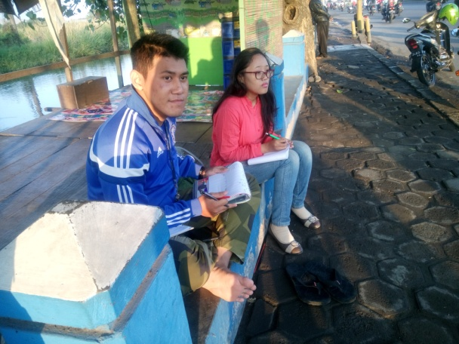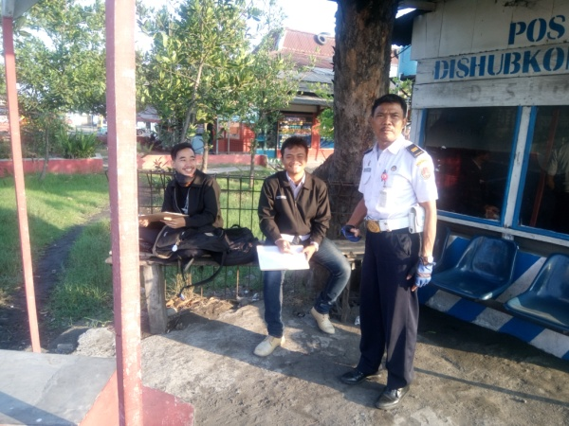
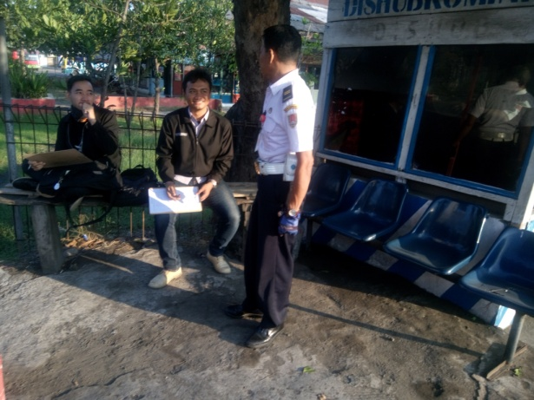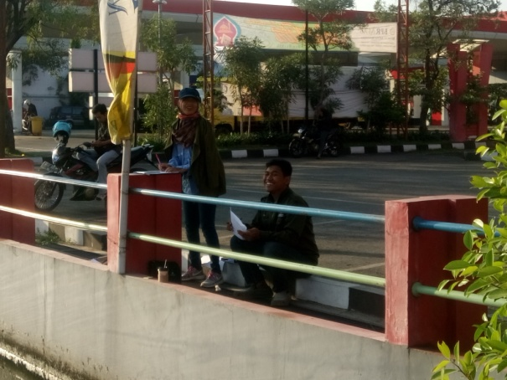
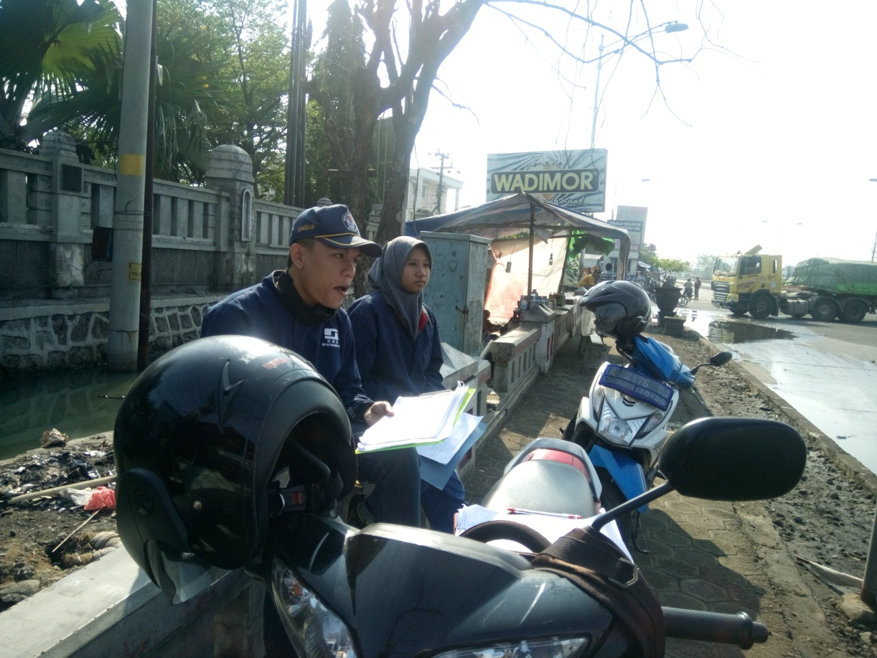

LAMPIRAN 2 CV PENELITI

Curriculum Vitae Peneliti Utama

Nama : Kami Hari Basuki, ST., MT.
Tempat/Tanggal Lahir : Kendal, 31 Mei 1972
Alamat Rumah : Jl. Kelapa Kopyor I/ BG-24, Bukit Kencana Jaya,, Semarang, Telp (024) 70770850
E-Mail : basuki.kh@undip.ac.id
Pekerjaan : Staf Pengajar Fakultas Teknik Jurusan Teknik Sipil, UNDIP, Semarang
NIP : 197205312000031001
Alamat Kantor : Jurusan Teknik Sipil, Fakultas Teknik, UNDIP, Jl. Pedalangan, Tembalang, SemarangTelp (024)7460060

Riwayat Pendidikan:
- S-1 Bidang Teknik Sipil, Universitas Gadjah Mada (UGM), Yogyakarta,1997
- S-2 Bidang Teknik Sipil, Bidang Kekhususan Magister Transportasi, Institut Teknologi Bandung (ITB), Bandung, 2001

Workshop/Training:
- Non Degree Training, National University of Singapore (NUS), 2004
- The Workshop on ITS Toolkits, Highway Industry Development, Organization of Japan, 2005

Riwayat Pekerjaan dan Penelitian:

Riwayat Pekerjaan/Penelitian | Sumber Pekerjaan | Tahun | Lama Pekerjaan
Peneliti Anggota: The Application of Traffic Conflict Technique as a Road Safety  Evaluation Method: a Case Study of Hasselt Intersection | Penelitian Mandiri (Summited on EACEF Conference) | 2015 | 4 Bulan
Peneliti Utama Analisis Permintaan Penggunaan Bus Rapit Transyt (BRT) Antar Kota  (Studi Kasus di Koridor Semarang-Bawen) | HIBAH BERSAING Dana DIPA FAKULTAS TEKNIK UNDIP | 2015 | 4 Bulan
Peneliti Anggota pada Hubungan antara Perilaku Pengendara dan Kondisi Geometrik Jalan yang Berpotensi Menyebabkan Kecelakaan Lalu Lintas pada Tikungan | Penelitian Hibah Bersaing DIPA FT Undip | 2015 | 4 Bulan
Peneliti Utama pada Analisis Potensi Titik Parkir di Badan Jalan,Studi Kasus di Kota Semarang | Penelitian Mandiri | 2014 | 4 Bulan
Peneliti Utama pada Analisis Kinerja Jaringan jalan dengan Simulasi Sistem Satu Arah (SAA) Studi Kasus Jaringan jalan Kota Semarang | Penelitian Mandiri | 2013 | 2 Bulan
Peneliti Utama pada Analisis Optimasi Potensi Antrian pada Simpang Bersinyal dengan Menggunakan Algoritma Genetika | Penelitian Pengembangan Teknologi Fakultas Teknik UNDIP | 2012 | 6 bulan
Peneliti Utama pada Penelitian Analisis Pemilihan Moda antara Sepeda Motor dengan Angkutan Umum dengan Menggunakan Algoritma Genetika | Penelitian Pengembangan Teknologi Fakultas Teknik UNDIP | 2011 | 6 bulan
Peneliti Utama pada Penelitian Studi Komparasi Pelayanan Angkutan Umum Massal di Kota Semarang dan Kota Yogyakarta | Penelitian Pengembangan Teknologi Fakultas Teknik UNDIP, | 2010 | 6 bulan
Tenaga Ahli pada Pekerjaan manajemen Parkir | Bappeda Kabupaten Bekasi, | 2009 | 3 bulan
Peneliti Utama pada Penelitian manajemen Lalulintas pada Sistem Jaringan Jalan Kota Semarang, | Penelitian Pengembangan Teknologi Fakultas Teknik UNDIP, | 2009 | 6 bulan
Tenaga Ahli pada Pekerjaan Penyusunan Tataran Transportasi Lokal | Kabupaten Tegal, Jawa Tengah, | 2008 | 3 bulan
Tenaga Ahli pada Pekerjaan Penyusunan Tataran Transportasi Lokal, | Kabupaten Purwodadi, Jawa Tengah | 2007 | 3 bulan
Tenaga Ahli pada Pekerjaan Penyusunan Tataran Transportasi Lokal Kabupaten Buton, | Bappeda Sulawesi Tenggara, | 2007 | 3 bulan
Tenaga Ahli pada Pekerjaan Perencanaan Rinci/Detail Desain untuk Pengembangan Bus Rapid Transit (BRT) di Semarang, | Direktorat, Jenderal Perhubungan Darat – Departemen Perhubungan, | 2007 | 6 bulan
Tenaga Ahli pada Pekerjaan Penyusunan Tataran Transportasi Lokal | Kabupaten Brebes, Jawa Tengah, | 2007 | 3 bulan
Tenaga Ahli pada Pekerjaan Penyusunan Tataran Transportasi Lokal, | Kabupaten Pekalongan, Jawa Tengah | 2006
Tenaga Ahli pada Pekerjaan Studi Kelayakan Jembatan Tak Sebidang Simpang Jatingaleh Semarang | Ditjen Perhubungan Darat bidang jalan bebas hambatan/ PPJBHJK, Jakarta | 2006 | 6 bulan
Tenaga Ahli pada Pekerjaan Penyusunan Tataran Transportasi Lokal Kabupaten Ungaran, Jawa Tengah, | Dinas Perhubungan Kabupaten Semarang | 2005 | 6 bulan
Tenaga Ahli pada Pekerjaan Perencanaan (DED) Jaringan Jalan Kawasan Reklamasi Pantai Marina, Semarang, Kerja sama antara, | Pemkot Semarang, PT IPU dan Fakultas Teknik UNDIP | 2005 | 6 bulan
Tenaga Ahli pada Pekerjaan Studi Kelayakan Flyover PA Pettarani – Urip Sumoharjo Kota Makasar, | Dinas Pekerjaan Umum Makasar, | 2005 | 3 bulan
Tenaga Ahli pada Pekerjaan Perencanaan (DED) Jembatan Curug, Wonosobo, | P2JJ Dinas Pekerjaan Umum Jateng, | 2004. | 2 bulan
Tenaga Ahli pada Studi Kelayakan Flyover Teras, Boyolali, , | Kerja sama antara PT. Pertamina UPMS IV Jawa Tengah dan DIY dengan Fakultas Teknik UNDIP | 2004 | 3 bulan
Tenaga Ahli pada Pekerjaan Perencanaan (DED) Jembatan Kandang Sapi, Pelebaran Jembatan Gilingan dan Perencanaan Viaduct Gilingan Kota Surakarta, | Dinas Pekerjaan Umum Kota Surakarta, | 2003. | 3 bulan
Tenaga Ahli pada Pekerjaan Studi Penyusunan Rencana Umum Jaringan Transportasi Kabupaten Kebumen dan Pembuatan Sistem Informasi, , | Bappeda Kabupaten Kebumen | 2003 | 6 bulan
Tenaga Ahli pada Studi Pengembangan Angkutan Kontainer Melalui Surakarta – Pelabuhan Tanjung Emas Semarang Dalam Rangka Meningkatkan Sarana Prasarana Penunjang Investasi, , Semarang,. | Badan Peneneman Modal Propinsi Jawa Tengah bekerja sama dengan Pusat Penelitian Sumber Daya Alam dan Energi, Lembaga Penelitian UNDIP | 2002 | 3 bulan
Peneliti Utama pada Analisis Penggunaan Moda Transportasi Becak danPengembangan Moda Becak Bermotor (Studi Kasus : Kota Semarang), Staff Research Grant | Technological and Professional Skills Development Sector Project (TPSDP), ADB Loan 1792, UNDIP, Semarang, | 2002 | 6 bulan
Tenaga Ahli pada Studi Penyusunan Rencana Umum Jaringan Transportasi Jawa Tengah,. | Dinas Perhubungan dan Telekomunikasi Propinsi Jawa Tengah, | 2002 | 6 bulan
Tenaga Ahli pada Penyusunan Studi Kelayakan Jalan Tol Semarang –Batang, | Departemen Pekerjaan Umum, | 2001. | 6 bulan

Hormat saya,

Kami Hari Basuki, ST., MT.
197205312000031001

Curriculum Vitae Peneliti Anggota

Nama | : | WAHYUDI KUSHARDJOKO
Perguruan Tinggi | : | Universitas Diponegoro
Program Studi | : | Teknik Sipil
Jenis Kelamin | : | Laki-Laki
NIM |  | 195912101987031002
Jabatan Fungsional | : | Lektor
Pendidikan Tertinggi | : | S2
Status Ikatan Kerja | : | Dosen Tetap
Status Aktivitas | : | Aktif

Riwayat Pendidikan
1 | Institut Teknologi Sepuluh Nopember | Ir | 1986 | S1
2 | Institut Teknologi Sepuluh Nopember | M.T | 2001 | S2

Riwayat Penelitian
1 | PENERAPAN LAJUR KHUSUS SEPEDA MOTOR PADA RUAS JALAN BRIGJEND SUDIARTO SEMARANG  Sudarmawan, Anang; Khoirina, Rahma; Kushardjoko, Wahyudi; Wicaksono, Yohanes Inigo  JURNAL KARYA TEKNIK SIPIL volume 1, Nomer 1, tahun 2012 page. 1-9  Publisher: Jurusan Teknik Sipil Fakultas Teknik Universitas Diponegoro
2 | ANALISIS LALU LINTAS AKIBAT PEMBANGUNAN JALAN LAYANG CAKUNG CILINCING TANJUNG PRIOK JAKARTA  Fitriani, Intan , Pratiwi, Ratna Manik ,Kushardjoko, Wahyudi , Wicaksono, YI.  JURNAL KARYA TEKNIK SIPIL Volume 2, Nomor 4, Tahun 2013 page. 167-186  Publisher: Jurusan Teknik Sipil Fakultas Teknik Universitas Diponegoro
3 | EVALUASI KINERJA BATIK SOLO TRANS (STUDI KASUS : KORIDOR I KARTASURA-PALUR, SURAKARTA)  Rachma, Nadhia Puspita , S., Purnomo Dwi ,Ismiyati, Ismiyati , Kushardjoko, Wahyudi .  JURNAL KARYA TEKNIK SIPIL Volume 2, Nomor 4, Tahun 2013 page. 333-342  Publisher: Jurusan Teknik Sipil Fakultas Teknik Universitas Diponegoro
4 | ANALISIS KAPASITAS AIR SIDE RENCANA PENGEMBANGAN BANDAR UDARA INTERNASIONAL AHMAD YANI SEMARANG  Aidi, Muchammad Ulil , Anas, Yahya , Setiadji, Bagus Hario , Kushardjoko, Wahyudi  JURNAL KARYA TEKNIK SIPIL Volume 2, Nomor 4, Tahun 2013 page. 127-136  Publisher: Jurusan Teknik Sipil Fakultas Teknik Universitas Diponegoro
5 | PENGARUH PENAMBAHAN PLASTIK BEKAS TIPE LOW DENSITY POLYETHYLENE (LDPE) TERHADAP KINERJA CAMPURAN BERASPAL  Wantoro, Widi , Kusumaningrum, Dyah , Setiadji, Bagus Hario ,Kushardjoko, Wahyudi  JURNAL KARYA TEKNIK SIPIL Volume 2, Nomor 4, Tahun 2013 page. 366-381  Publisher: Jurusan Teknik Sipil Fakultas Teknik Universitas Diponegoro
ANALISIS PERBANDINGAN ANTARA BIAYA OPERASIONAL KENDARAAN (BOK) DI JALAN ARTERI PRIMER DENGAN RENCANA JALAN TOL RUAS : UNGARAN - SALATIGA
Cipto Saputro, Danang Setiyo ,; Wirayoga, Rendy Augusta ,; Purwanto, Djoko ,; Kushardjoko, Wahyudi ,
JURNAL KARYA TEKNIK SIPIL Volume 2, Nomor 1, Tahun 2013 page. 111-121
Publisher: Jurusan Teknik Sipil Fakultas Teknik Universitas Diponegoro

7 | ANALISIS PERBANDINGAN ANTARA BIAYA OPERASIONAL KENDARAAN (BOK) DI JALAN ARTERI PRIMER DENGAN RENCANA JALAN TOL RUAS : UNGARAN - SALATIGA  Wirayoga, Rendy Augusta ; Cipto Saputro, Danang Setiyo ; Purwanto, Djoko ; Kushardjoko, Wahyudi  JURNAL KARYA TEKNIK SIPIL Volume 2, Nomor 2, Tahun 2013 page. 184-194  Publisher: Jurusan Teknik Sipil Fakultas Teknik Universitas Diponegoro
8 | ANALISIS DAMPAK LALU LINTAS AKIBAT PEMBANGUNAN BEST WESTERN STAR HOTEL DAN STAR APARTEMENT SEMARANG TERHADAP KINERJA JARINGAN JALAN SEKITAR  Rahayu, Hayu ; Wijaya, Misi H. ; Setiadji, Bagus Hario ; Kushardjoko, Wahyudi  JURNAL KARYA TEKNIK SIPIL Volume 2, Nomor 1, Tahun 2013 page. 174-181  Publisher: Jurusan Teknik Sipil Fakultas Teknik Universitas Diponegoro
9 | EVALUASI KINERJA BATIK SOLO TRANS (STUDI KASUS : KORIDOR I KARTASURA-PALUR, SURAKARTA)  Sujatmiko, Purnomo Dwi ; Puspita R., Nadhia ; Ismiyati, Ismiyati ; Kushardjoko, Wahyudi  JURNAL KARYA TEKNIK SIPIL Volume 2, Nomor 3, Tahun 2013 page. 273-283  Publisher: Jurusan Teknik Sipil Fakultas Teknik Universitas Diponegoro
10 | EVALUASI TEBAL PERKERASAN LAPIS TAMBAH DENGAN MENGGUNAKAN PROGRAM EVERSERIES DAN METODE BINA MARGA Studi kasus : Jalan Tol JAGORAWI ruas Jalan TMII - Cibubur  Hellyantoro, Grandy ; Fauzi, Mohammad Faldi ; Setiadji, Bagus Hario ; Kushardjoko, Wahyudi  JURNAL KARYA TEKNIK SIPIL Volume 2, Nomor 2, Tahun 2013 page. 150-159  Publisher: Jurusan Teknik Sipil Fakultas Teknik Universitas Diponegoro

Hormat saya,

WAHYUDI KUSHARDJOKO
195912101987031002

Curriculum Vitae Peneliti Anggota
Nama : Andreana Janita
NIM : 21010112130135
Tempat,tanggal lahir : Semarang, 12 April 1994
Alamat rumah : Jalan Lamper Tengah XIV/7 Semarang
Email : andreana.janitaa@gmail.com
Riwayat Pendidikan :
SDN Sompok 03 Semarang | 2000 - 2006
SMP N 2 Semarang | 2006 - 2009
SMA N 3 Semarang | 2009 - 2012
S1 Teknik Sipil Undip | 2012 - sekarang

Nama Pelatihan | Tahun
Autocad Alfabank  Pelatihan dokter kecil  Semiloka kerjasama pengelolaan sumber daya air  LKMMPD  Leadership Training  Toefl Preparation I LBPP LIA  SAP LPK Budiman  Microsoft Project LPK Budiman  Kepala Pengawas Pekerjaan Jalan dan Jembatan  Seminar Nasional Enfution 2014 | 2012  2004  2013  2012  2013  2013  2014  2014  2014  2014
Pelatihan yang Pernah Diikuti
Karya tulis yang pernah dibuat :
Judul | Tahun
Pengaruh Teh Terhadap Tanaman  Mengidentifikasi Kadar Rokok Perokok Aktif (PKM-GT)  Penerapan Sistem Bus Kampus di Kawasan Universitas Diponegoro  Inovasi Paving Block dengan Pemanfaatan Abu Vulkanik | 2007  2013  2014  2014
Pengalaman Asisten :
Mata Kuliah | Tahun
Geometri Jalan Raya  Perencanaan, Pengendalian, dan Manajemen Proyek  Teknologi Sipil Wilayah Pantai | 2015  2015  2015

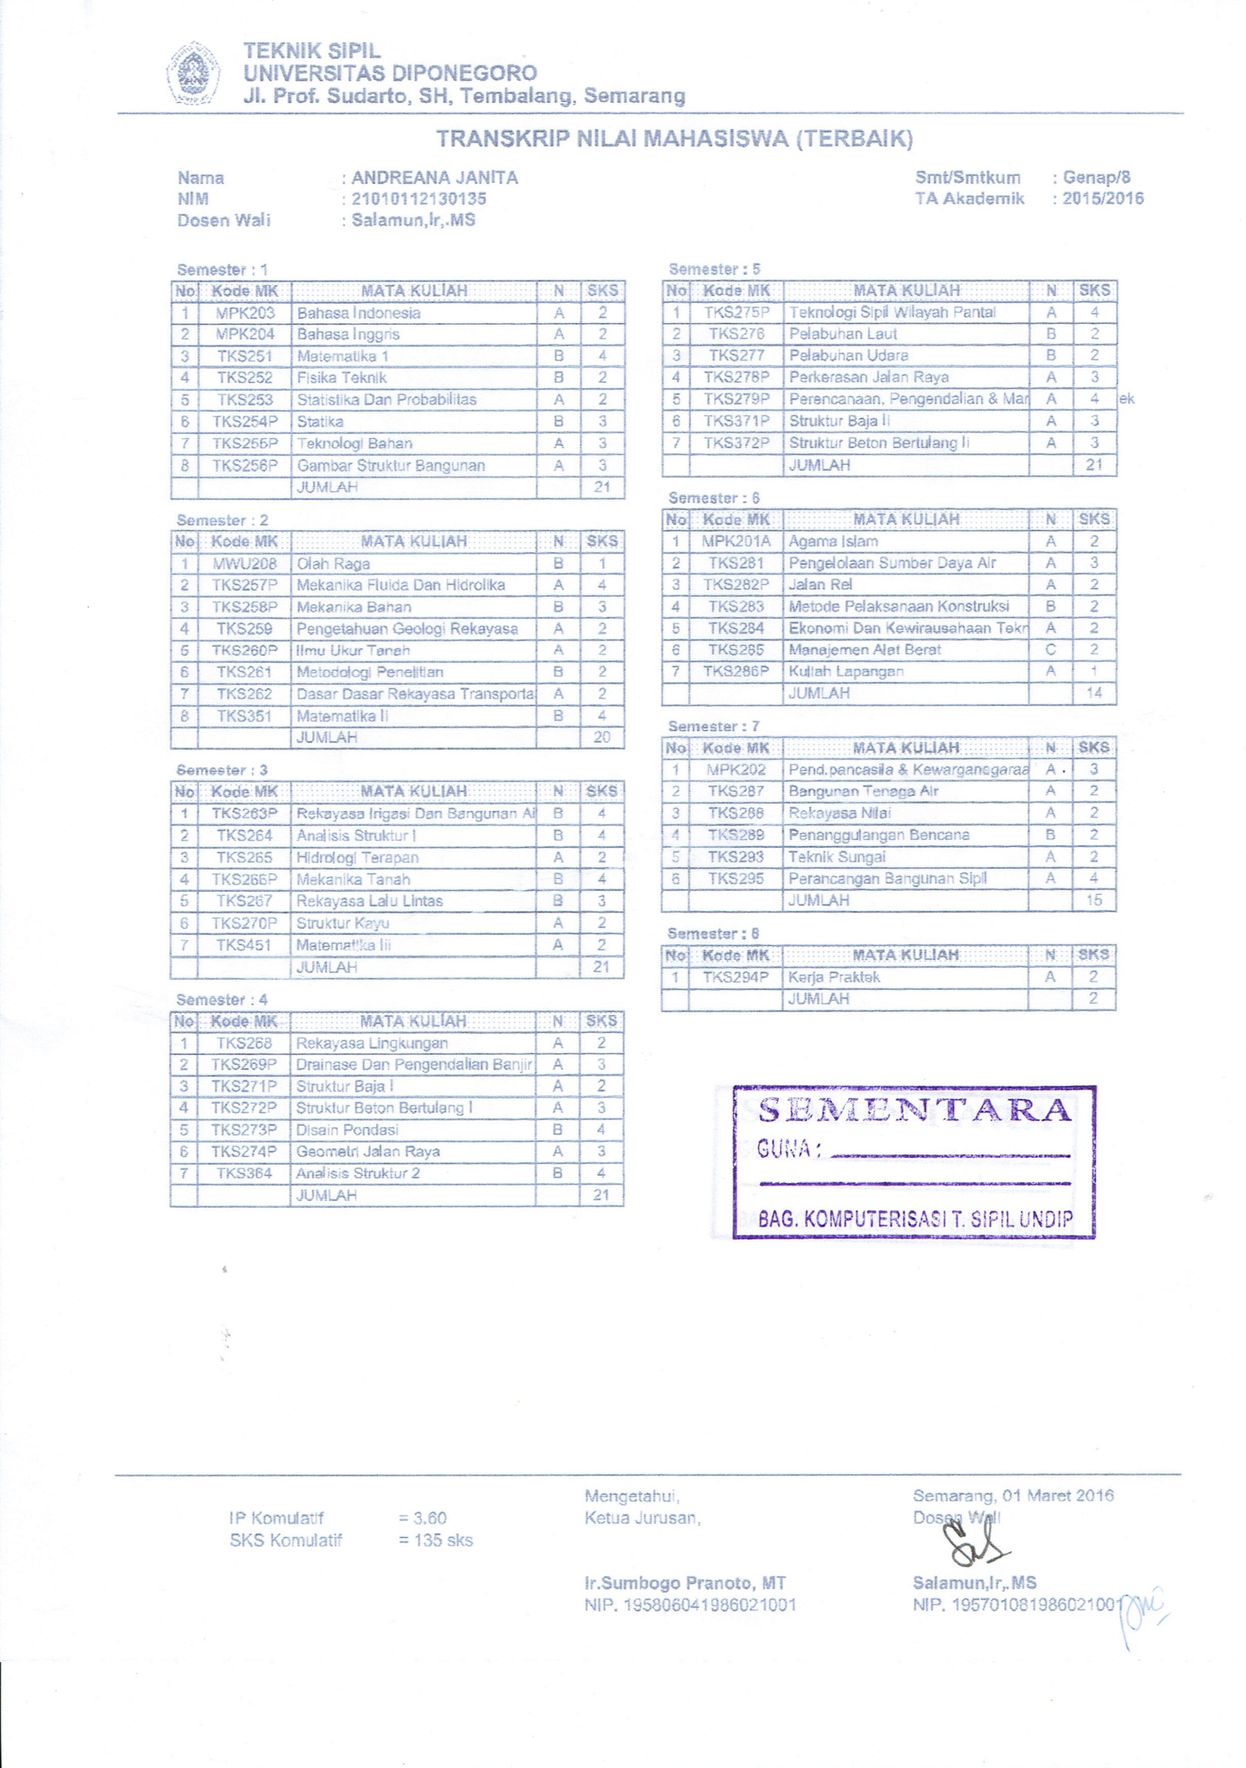

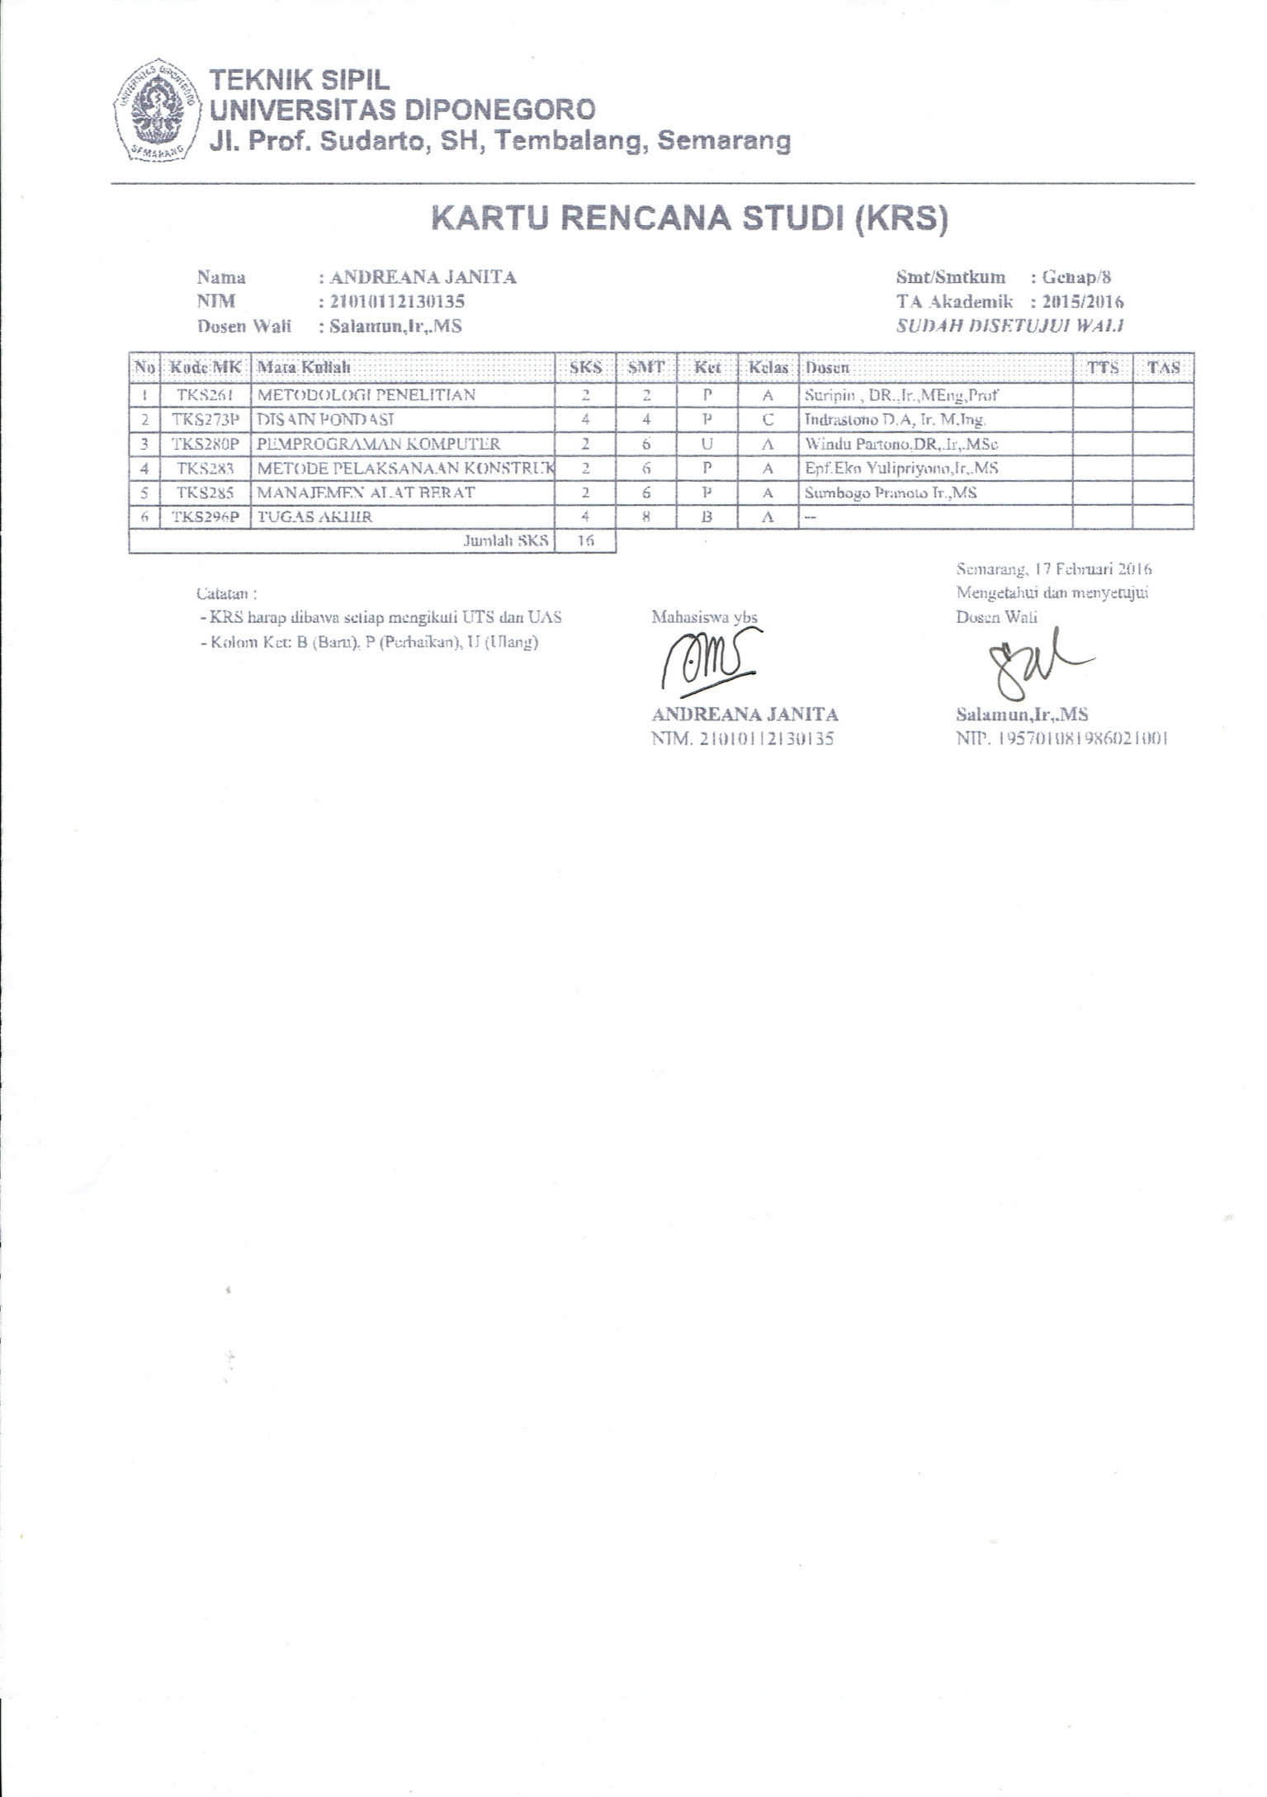
Curriculum Vitae Peneliti Anggota
Nama Lengkap : Ganis Satria Pratama
NIM : 21010112130138
Tempat, Tanggal Lahir : Kulon Progo, 01 Januari 1994
Alamat Rumah : Bogorame RT 03/RW 01, Kel. Mangunjiwan, Kec. Demak, Kab. Demak
E-mail : ganis.satria@gmail.com
Riwayat Pendidikan :
SDN Bintoro 2 Demak | 2000 - 2006
SMPN 2 Demak | 2006 - 2009
SMAN 1 Demak | 2009 - 2012
S1 Teknik Sipil Undip | 2012 - sekarang

Pelatihan dan Seminar yang Pernah Diikuti:
Nama Kegiatan | Lembaga Penyelenggara | Tahun
Teori dan Aplikasi Kestabilan Lereng | Jurusan Teknik Sipil FT UNDIP | 2015
Guest Lectures on Bio-Inspired Engineering and Self-Healing Materials | Fakultas Teknik Undip dan TU Delft Netherland | 2014
Seminar Pembangunan, Dampak, dan Penyelesaiannya Pembangunan Giant Sea Wall. | Fakultas Teknik UNISSULA | 2014
Seminar Peranan Bendungan untuk Kawasan Perkotaan | Fakultas Teknik Undip dan HATHI Jawa Tengah | 2013
Dialog Kebangsaan “Mencari Pemimpin Indonesia, Dari Kampus Untuk Indonesia” | BEM KM Undip dan Political Tracking Institute | 2013
Talkshow Energi Kebijakan dan Advokasi | BEM FT Undip | 2013

Karya Tulis yang Pernah Dibuat:
Judul | Tahun
PKM GT “Penerapan Teknologi Rumah Apung Di Indonesia” | 2015
Proposal Lomba Kuda-Kuda UGM “Kuda-Kuda Berbahan Kayu Ringan” | 2015

Mata Kuliah | Tahun
Gambar Struktur Bangunan | 2014
Pengalaman Asisten :

