
doi: mkts.v22i2.12871

LIQUEFACTION SUSCEPTIBILITY ZONATION IN LEMPUING SUBDISTRICT, BENGKULU CITY, INDONESIA

*Lindung Zalbuin Mase¹
¹Department of Civil Engineering, Faculty of Enginering, University of Bengkulu, Bengkulu, Indonesia.
^{*)} Corresponding author (email: lmase@unib.ac.id)

Received: ……. Revised: …….. Accepted: ……..

Abstract

Zonation of liquefaction potential is the important thing in understanding the liquefaction impact to an area. Liquefaction Severity Index (LSI) method can be applied to determine liquefaction vulnerability level. This paper presents a study of liquefaction using LSI method to compose the liquefaction vulnerability map in a coastal area of Bengkulu City i.e. Lempuing Subdistrict. This study was conducted by analysing CPT data in Lempuing Subdistrict to obtain the Factor of Safety and probability of liquefaction. Peak Ground Acceleration (PGA) was assumed as 0.5 g which refers to SNI 03-1726-2012. Furthermore, the value of liquefaction probability and factor of safety obtained was analysed to obtain LSI index and adjusted to the specified category i.e. very low (0<LSI<15), low (15<LSI<35), moderate (35<LSI<65), high (65<LSI<85), and very high (85<LSI<100). Based on the analysis result, Lempuing Subdistrict was categorized as very high to very low susceptible area to liquefaction. Very susceptible area was located on the eastern Lempuing Subdistrict bordering to the Gading Cempaka Subdistrict. High susceptible area was located on the northern Lempuing Subdistrict bordering the Tanah Patah Subdistrict. Moderate to very low susceptible areas were located in the middle, west, and south of Lempuing Subdistrict.

Keywords: Liquefaction, Vulnerability, Microzonation, Liquefaction Severity Index

Abstrak

Mikrozonasi potensi likuifaksi adalah hal penting dalam upaya penanggulangan likuifaksi pada suatu daerah. Salah satu metode yang digunakan dalam menggambarkan mikrozonasi likuifaksi adalah Liquefaction Severity Index (LSI). Sebagai implementasi pemahamaman likufaksi, sebuah penelitian likuifaksi yang berkaitan dengan metode LSI dilakukan pada kawasan pesisir Kota Bengkulu, yaitu Kelurahan Lempuing. Penelitian ini dilakukan dengan menganalisis data CPT (Cone Penetration Test) untuk memperoleh faktor keamanan likuifaksi dan probabilitasnya. Percepatan tanah puncak (PGA) diasumsikan sebesar 0.5g, yang mengacu pada peraturan SNI 03-1726-2012. Selanjutnya probabilitas likuifaksi dan faktor aman likuifaksi dihitung untuk mendapatkan indeks LSI dan dikelompokkan ke dalam kategori kerantanan, yang terdiri dari very low (sangat rendah) (0<LSI<15), low (rendah) (15<LSI<35), moderate (sedang) (35<LSI<65), high (tinggi) (65<LSI<85), and very high (sangat tinggi) (85<LSI<100). Hasil analisis tersebut selanjutnya disajikan dalam bentuk peta kerentanan dengan bantuan perangkat lunak ArcGIS. Berdasarkan hasil analisis, Kelurahan Lempuing dikategorikan sebagai area dengan kerentanan sangat tinggi sampai dengan sangat rendah. Bagian timur Lempuing yang berbatasan dengan Kelurahan gading cempaka dikategorikan sebagai area dengan kerentanan sangat tinggi. Area dengan kerentanan tinggi terdapat pada bagian utaran Lempuing yang berbatasan dengan Kelurahan Gading Cempaka. Area kerentanan sedang sampai dengan sangat rendah terletak pada bagian tengah, barat, dan selatan Kelurahan Lempuing

Kata kunci: Likuifaksi, Lempuing, Mikrozonasi, Liquefaction Severity Index

INTRODUCTION
Liquefaction is a phenomenon in sandy soil, due to loss of the shear strength caused by dynamic load, such as earthquakes. The loss of shear strength causes the loss of bearing capacity in soil. Then, sandy soils behave, such as liquid. Liquefaction had been detected in many locations in Indonesia, i.e. Bengkulu in 2000 as reported by Mase (2015), Yogyakarta in 2000 as reported by Yogatama and Fathani (2013) and Mase (2017a), Bengkulu in 2007 as reported by Mase (2017b), and Padang in 2009 (Hakam, 2012). In Bengkulu, liquefaction phenomena occurred in 2000 and 2007. Those liquefactions were caused by two large earthquakes in 2000 and 2007 (Mase and Sari, 2015). Liquefaction phenomena, such as ground failures, sand boils, and lateral spreads were found along coastal area in Bengkulu City during the earthquakes.
Lempuing Subdistrict is a coastal area in Bengkulu City, which is dominated by sandy soil. This area experienced liquefaction in 2000 and 2007, which were caused by two large earthquakes. Liquefaction potential in Lempuing Subdistrict had been investigated since last 3 years. Misliniyati et al. (2013) analysed liquefaction potential in Lempuing Subdistrict using cone penetration test (CPT) data. The result of this study explained that liquefaction potentially occurred in this area. Monalisa (2014) continued Misliniyati et al. (2013) study by using the same data of Misliniyati et al. (2013). The study was conducted by performing the probability analysis to investigate liquefaction potential. The result also showed that the area could be liquefied. Mase and Somantri (2016a and 2016b) performed a study of liquefaction potential in Lempuing Subdistrict by using the concept of critical peak ground acceleration (PGA). The result of that study showed that at depth of 0 to 6 m, Lempuing soil sites could undergo liquefaction during the 2007 Earthquake. Mase (2017b) had investigated the liquefaction potential along coastal area of Bengkulu Province based on non-linear analysis of liquefaction potential using Finite Element Method proposed by Iai et al., (1992). One of the areas investigated by that study is Lempuing Subdistrict. Based on the results, Mase (2017b) concluded that the Lempuing Area could be very vulnerable to liquefaction. The excess pore pressure ratio on Lempuing Subdistrict is about one. It indicates that the liquefaction is very possible to happen in Lempuing Subdistrict. Mase (2018) examined the empirical methods of liquefaction to assess the liquefaction potential along coastal area of Bengkulu City. Mase (2018) also compared the empirical methods to the liquefaction evidences found during the 2007 Earthquake in Bengkulu City. The results showed that Idriss and Boulanger (2008) method could be the most appropriate empirical method to predict liquefaction in coastal area of Bengkulu City.
In general, the previous studies were focused on the empirical and analytical methods to predict liquefaction along coastal area of Bengkulu City, whereas the zonation of liquefaction vulnerability has not been performed yet. However, the previous studies have reached a conclusion that along coastal area of Bengkulu City is very vulnerable to undergo liquefaction, including Lempuing Subdistrict.
This study presents a zonation of liquefaction vulnerability in Lempuing Subdistrict. A Liquefaction Severity Index (LSI) method proposed by Sonmez and Gokceoglu (2005) based on the empirical analysis of liquefaction is implemented to generate the liquefaction potential map in Lempuing Subdistrict. Furthermore, this study is expected to provide a deeper understanding in liquefaction vulnerability along coastal area of Bengkulu city in general and Lempuing Subdistrict Region in Bengkulu City in particular.

EMPIRICAL ANALYSIS LIQUEFACTION POTENTIAL
Basically, the liquefaction study was analysed by using the simplified procedure method (Seed and Idriss, 1971). The concept of this method is to compare Cyclic Stress Ratio (CSR) and Cyclic Resistance Ratio (CRR).
Seed and Idriss (1971) proposed the empirical correlation to estimate the liquefaction potential. CSR is the cyclic stress which is produced by the earthquake load. CSR is expressed in Equation 1
(1)
where, r_{d} is depth reduction factor (r_{d} = 1-0.012z), $σ_{v}^{'}$is effective stress of calculated depth, $σ_{v}$is total stress of calculated depth, and a_{max} is maximum peak ground acceleration (PGA).
CRR is the ratio which describes the resistance of the soil under dynamic load. Several researchers such as, Seed and Idriss (1971), Youd and Idriss (2001), and Idriss and Boulanger (2008) had proposed the empirical correlation to estimate CRR value. The value of CRR can be estimated based on the secondary data from CPT, standard penetration test (SPT), and Shear Wave Velocity (V_{s}). In liquefaction studies, the secondary data which is usually used is CPT. The reason why the CPT is generally used, are the economics factor and workability. The formula to determine CRR based on CPT data was proposed based on the Idriss and Boulanger (2008) study. Mase (2018) suggested that for coastal area of Bengkulu City, the Idriss and Boulanger (2008) empirical method could be reasonable to be used to predict liquefaction potential. The CRR equation based on CPT data is expressed in the following equation,
${\text{CRR}}_{M=7\text{.}5}=\text{exp}\begin{aligned}\left(\frac{q_{c1\text{Ncs}}}{\text{540}}+{\left(\frac{q_{c1\text{Ncs}}}{\text{67}}\right)}^{2}−{\left(\frac{q_{c1\text{Ncs}}}{\text{80}}\right)}^{3} | \right) \\ \end{aligned}$
(2)
where CRR_{M=7.5} is the cyclic resistance ratio on M of 7.5 M_{w}, q_{c1Ncs} is normalized overburden corrected cone tip resistance (obtained from Robertson and Wride, 1998). However, the actual formula which is used to estimate the CRR for other different earthquake magnitudes values is expressed in the following equation,
$\text{CRR}={\text{CRR}}_{M=7\text{.}5}\text{.}\text{MSF}\text{.}K_{σ}$ (3)
where, MSF is magnitude scale factor (Idriss, 1999), and K_{σ} is overburden pressure factor (Seed, 1983).
Based on the previous equations, the Factor of Safety against liquefaction (F_{S}) is computed by using the following equation,
$F_{s}=\frac{\text{CRR}}{\text{CSR}}$ (4)
where, F_{S} is Factor of Safety against liquefaction (F_{S} < 1, liquefaction potentially occurs, and F_{S} > 1, liquefaction doesn’t potentially occur.
So far, the analysis of liquefaction potential is not only developed to investigate F_{S} result but also probability of liquefaction (P_{L}). Juang et al. (2003) introduced the equation to determine probability of liquefaction based on F_{S} which is obtained from the comparison between CRR and CSR. The probability of liquefaction based on Juang et al. (2003) is shown in the following equation,
$P_{L}=\frac{1}{1+{\left(\frac{F_{s}}{0\text{.}\text{96}}\right)}^{4\text{.}5}}$ (5)
where P_{L} is probability of liquefaction.

LIQUEFACTION SEVERITY INDEX (LSI)
Analysis of the liquefaction analysis is not only limited to predict probability of liquefaction but also to map of susceptible area to liquefaction or to generate the liquefaction hazard map. Sonmez and Gokceoglu (2005) had proposed a method of Liquefaction Severity Index (LSI) to evaluate the risk level of liquefaction. This method used the value of liquefaction probability as the parameters to integrate LSI level. Nowadays, this method has been widely used in liquefaction study. LSI is quantified based on the equation below,
$\text{LSI}=\int_{0}^{n}{P_{L}(z)\text{.}W(z)\text{.}\text{dz}}$ (6)
The values of $P_{L}(z)$and $W(z)$are obtained from one of these following equations,

$P_{L}(z)=\frac{1}{1+{\left(\frac{F_{s}}{0\text{.}\text{96}}\right)}^{4\text{.}5}}$, for F_{S <} 1.411 (7)
$P_{L}(z)=0$, for F_{S} > 1.411 (8)
$W(z)=\text{10}−0\text{.}5z$, for 0 < z < 20 (9)
$W(z)=0$, for 0 m (10)
where LSI is liquefaction severity index, $P_{L}(z)$is probability of liquefaction based on depth function, n is the analysed depth (maximum up to 20 m) and $W(z)$ is soil depth weight factor.
Once LSI value had been determined, then the level of liquefaction susceptibility would have been obtained. According to Sonmez and Gokceoglu (2005), level of vulnerability in LSI method can be classified into five categories which are shown in in the following Table 1,
Table 1. Level of LSI categories (Sonmez and Gokceoglu, 2005)
No. | LSI Classification | The range of value
1 | Very High | 85<LSI<100
2 | High | 65<LSI<85
3 | Moderate | 35<LSI<65
4 | Low | 15<LSI<35
5 | Very Low | 0<LSI<15

The implementation of LSI method had been used by many researchers in liquefaction studies. This is due to the fact that this method could describe the liquefaction potential and its vulnerability. In this study, concept of F_{S}, probability, and level of susceptible area (LSI) are combined to analysis the liquefaction potential. Therefore, the description of liquefaction potential can be seen and observed easily. In the previous explanation, it has been elaborated that the study of liquefaction in Lempuing Subdistrict was still being the focus on liquefaction study in Bengkulu coastal area. The result of this study also expected can be a consideration in geotechnical problem in Bengkulu related to the earthquake phenomenon that potentially occurs in Bengkulu. This study is expected to be ablte to accomplish the previous study that had been conducted in Lempuing Sub District.

METHOD OF STUDY
In this study, in-situ test had been conducted to obtain the data by using CPT data. Then, the data obtained from in-situ test was analysed by using the equations that elaborated in the previous section. In detail, the methods are elaborated in the sub-chapter as follows:

Data
Data used in this study are secondary data that are collected based on site investigation conducted by using Cone Penetration Test in Lempuing Subdistrict. Layout of CPT points is shown in Figure 1. Maximum cone resistance is assigned to stop at q_{c} of 100 kg/cm². It is caused by the condition of CPT equipment and in order to avoid the broken of equipment. At this resistance, soils were assumed to have reached the stiff material. Based on the data, the depth of stiff soil varies from 2 m to 10 m. CPT 1, 5, and 6 had reached stiff surface at 10 m deep, CPT 2 at 2 m deep, CPT 3 at 2.6 m deep, and CPT 4 at 6.2 m deep.

Analysis
Analysis conducted in this study had been conducted after CPT data collected. Step by step to analyse the liquefaction potential is elaborated in these points below:
- Collecting data of CPT test. Data used in this study are shown in Figure 2.
- Analysing the q_{c1Ncs} and soil type based on Method of Roberson and Wride (1998)).
- Estimating maximum peak ground acceleration. Based on SNI 03-1726-2012, the distribution of peak bedrock acceleration (a_{max} at bedrock) in Bengkulu city is 0.4g to 0.5g. In this study, peak bedrock acceleration is assumed of 0.5g and amplification factor is assumed of 1.1 (It is also taken from SNI 03-1726-2012). Determining maximum peak ground acceleration is computed by multiplying peak bedrock acceleration to amplification factor.
- Calculating CSR using Equation 1. In this study ground water level (GWL) is assumed at the soil surface to reflect the conservative condition. Unit weight in saturated condition (γ_{sat}) is 20 kN/m³. It is obtained from core drill test of the disturbed soil samples.
- Calculation the CRR using Equation 2. CRR final is determined by using Equation 3. The earthquake magnitude is assumed to be M_{w} of 8.6 M_{w} (it is based on the 2007 earthquake magnitude scale (M_{s} of 8.5) and converted to M_{w} scale).
- Calculating F_{S} using Equation 4. Calculating the P_{L} using Equation 5. Calculating the integration of LSI Equation 6. This equation must consider the results from Equation 7 to 10.
- Determining the specification of susceptible level based on Table 1. Interpreting the result of LSI as susceptible map. This step should be assisted by using Geographic Informatic System to depict the distribution of LSI level.

RESULT AND DISCUSSION
Result of this study included i.e. F_{S} at each depth, P_{L} at each depth. Liquefaction severity index mapping also based on F_{S} and P_{L} is also resulted from this study. Detail explanations of the results of this study are elaborated in the following sub-chapter.

Soil Site
Based on site investigation and back analysis to the Robertson and Wride (1988) method for cone resistance, the soil site of this study area is dominated by sandy soil.

Factor of Safety Against Liquefaction in Lempuing Subdistrict
F_{S} of each CPT data are shown in Figure 3. Based on the result interpreted in Figure 3a, F_{S} of all CPT point is less than 1. It can be concluded that Lempuing Subdistrict is unsafe area to liquefaction (F_{S} is less than 1). Based on the overall analysis result, maximum F_{S} obtained is 0.375 and minimum F_{S} is 0.054.
This result also confirms the results of Misliniyati et al. (2013) that analysed F_{S} against liquefaction in the same area. The results are also consistent with Mase and Somantri (2016a and 2016b) and Mase (2017) who stated that at first 5 m depth, the Lempuing Subdistrict could undergo liquefaction. Generally, the results have confirmed the field evidence of liquefaction during the 2007 Earthquake which is reported by Mase (2018) The results of F_{S} analysis are further analysed to determine the distribution of susceptible area using LSI method.

Probability of Liquefaction in Lempuing Subdistrict
P_{L} in Lempuing Subdistrict is interpreted in Figure 3b. Based on the result in Figure 3b, the majority of P_{L} of each CPT data is approximately reaching 1 value. It can be concluded that area is very possible to be liquefied. Likewise, the distribution of the value of probability, based on the total data analysed, minimum P_{L} is 0.828 and maximum P_{L} is 0.946. Those results are consistent with Monalisa (2014) who reported that P_{L} in Lempuing subdistrict is relatively high. In addition, the results also strengthen the study of Mase (2018) that stated that along coastal area of Bengkulu City including Lempuing could have high possibility to undergo liquefaction during the 2007 Earthquake. The result of P_{L} combined with F_{S} is used to the analysis of liquefaction vulnerability.

Liquefaction Severity Index (LSI) in Lempuing Subdistrict
Sonmez and Gokceoglu (2005) suggested that the results of liquefaction probability analysis are capable of describing the distribution of level of susceptible area based on severity index method, which is known as Liquefaction Severity Index or LSI. Iwasaki et al. (1982) also mentioned that the necessary to interpret the micro-zonation of liquefaction potential is important in liquefaction countermeasure and mitigation effort.
In this study, by following the LSI method, the Factor of Safety and probability of liquefaction that obtained from the previous analysis are combined to analyse the Liquefaction severity index (LSI). The result of LSI of this analysis is interpreted in Table 2 as follows:
Table 2. Analysis of Liquefaction Severity Index (LSI)
CPT | Liquefaction Severity Index | Criteria
CPT | (LSI) | Criteria
1 | 68.321 | High
2 | 17.792 | Low
3 | 22.713 | Low
4 | 48.462 | Moderate
5 | 68.567 | High
6 | 68.863 | Very High

Liquefaction Severity Index
Based on the result summarized in Table 1, CPT 1 is categorized as high-risk area to undergo liquefaction. The analysis of liquefaction potential in CPT 5 and CPT 6 also results the same criteria with CPT 1. Moderate risk area is detected in CPT 4, whereas low risk area is detected in CPT 3 and CPT 2. The result summarized in Table 1 is depicted in the susceptibility map, which is shown in Figure 4. Based on the analysis result, Lempuing Subdistrict was categorized as very high to very low susceptible to liquefaction. Very high susceptible area was located on the eastern Lempuing Subdistrict (red shading) bordering Gading Cempaka Subdistrict. High susceptible area is located on the Northern Lempuing Subdistrict bordering the Tanah Patah Subdistrict (orange shading). Moderate (yellow shading), low (dark green shading), and very low (light green shading) susceptible area are located in the middle, west, and south of Lempuing Subdistrict.
According to several studies, the liquefaction might be analysed up to 20 m deep. In CPT 1 to CPT 6, the maximum depth obtained is only at 10 m deep, and it is not fulfilling the suggested analysis depth. Because LSI analysis is based on the function of integration, then analysis using deeper soil data woudl produce better interpretation of liquefaction risk and more accurate. However, this study has given the overview of liquefaction in Lempuing Subdistrict. The result of this study is not only influenced by depth of analysis, but also influenced by distribution of CPT points. The accuracy of map is depending on the number of data available. This is very important to analyse the susceptible area of liquefaction.

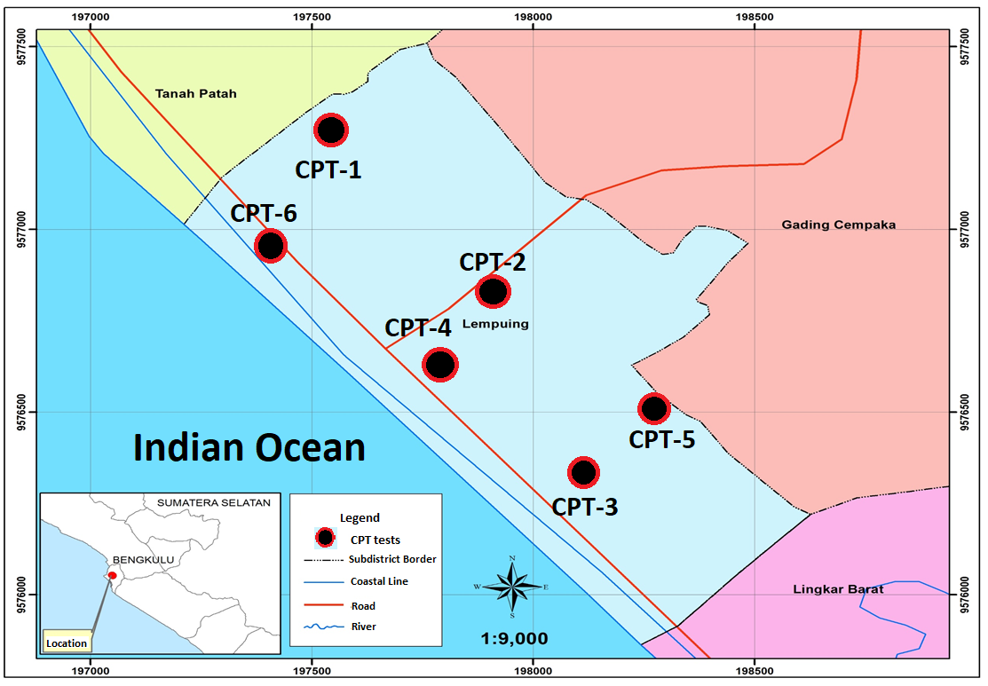
Figure 1. Study area and location of CPT tests

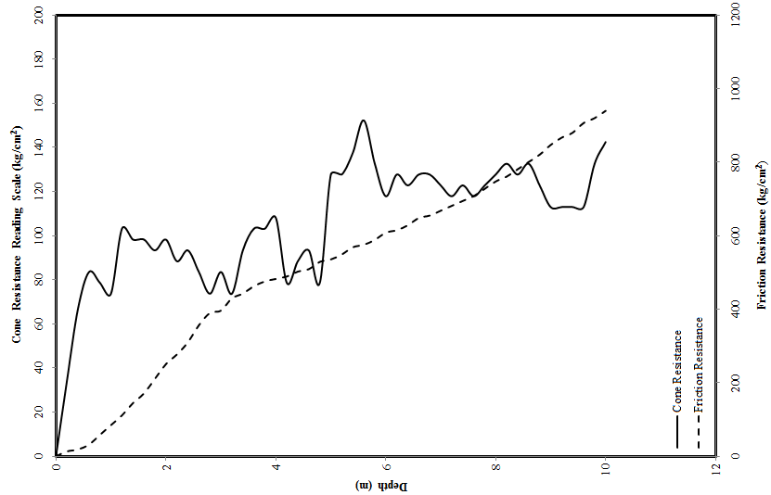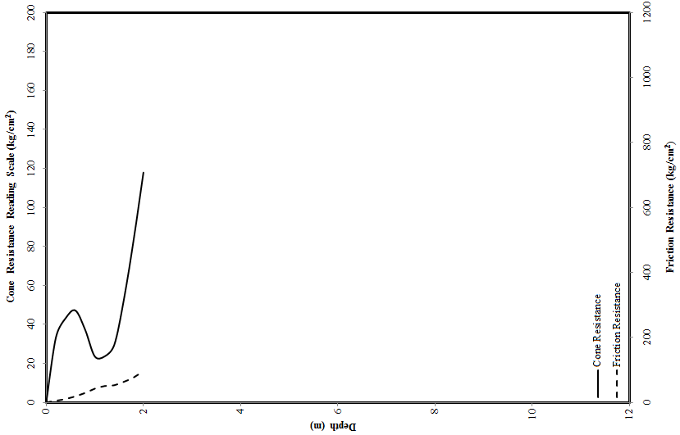
(a) (b)

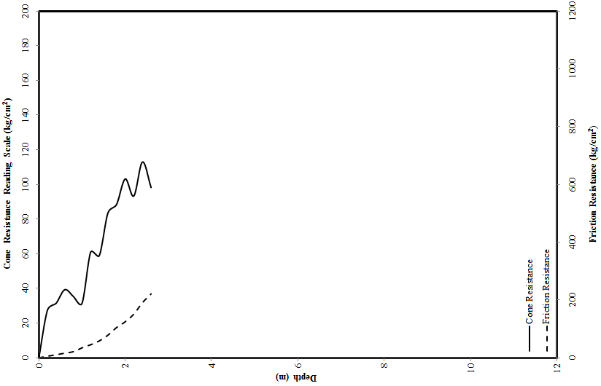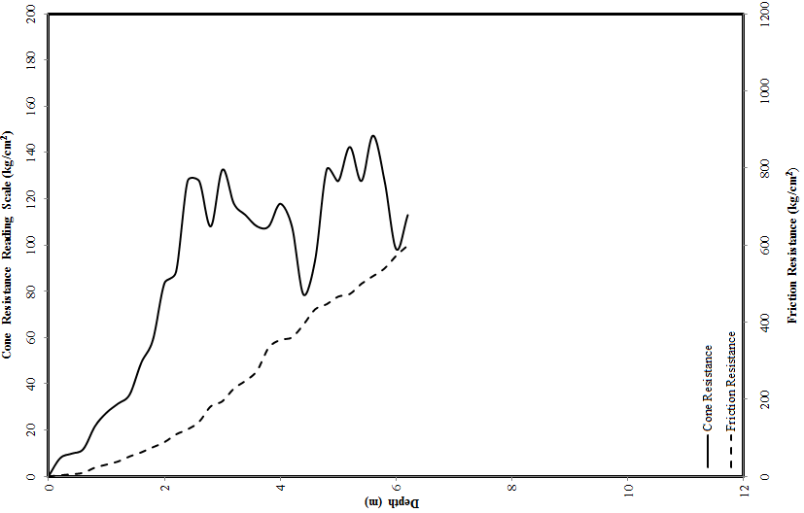
(c) (d)

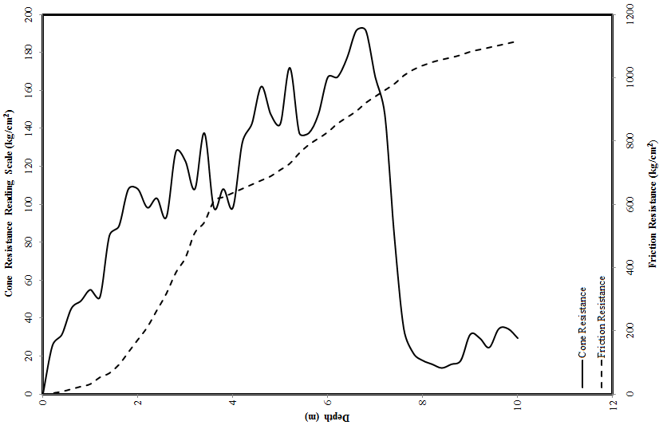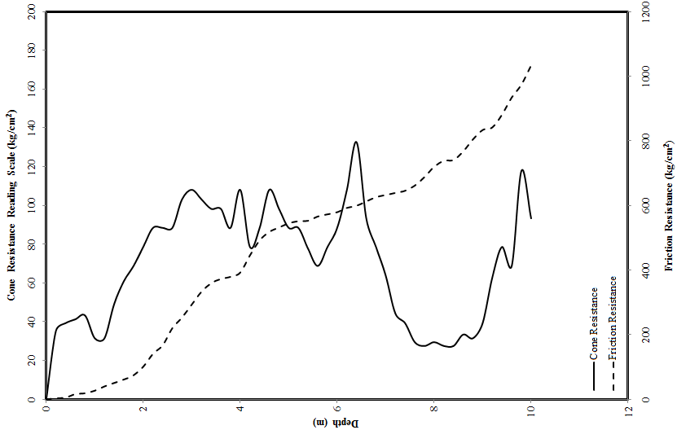
(e) (f)
Figure 2. CPT data (a) point 1, (b) point 2, (c) point 3, (d) point 4, (e) point 5, and (f) point
(a) (b)
Figure 3. Analysis of liquefaction (a) Factor of Safety against liquefaction, (b) probability of liquefaction

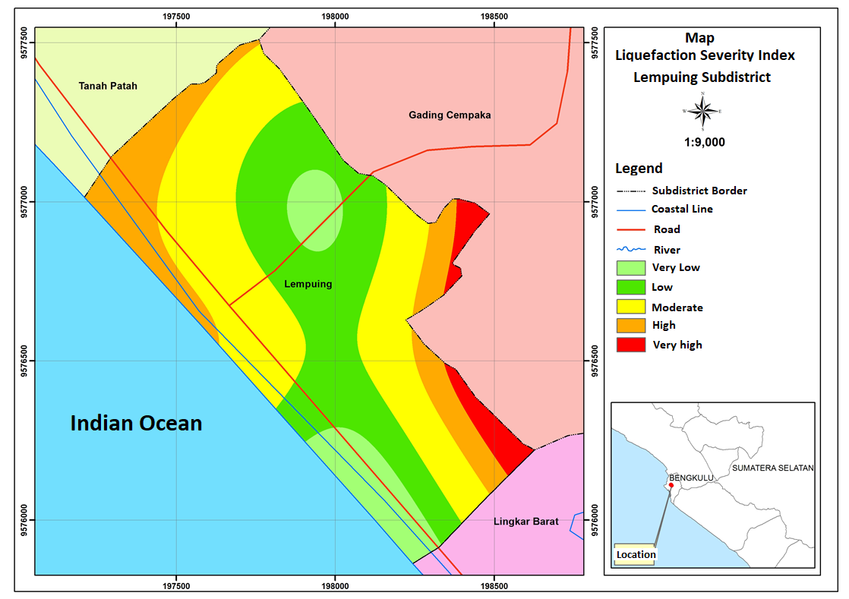
Figure 4. Liquefaction susceptible area based on LSI in Lempuing Subdistrict

CONCLUSION AND RECOMMENDATION
The points remarked as conclusions in this study are as follows:
- Soil condition in Lempuing Subdistrict is clearly dominated by sandy soil. It is very potential to liquefaction. Although index properties test was not performed, but the data of cone resistance confirmed that area dominated by sandy soil.
- Based on the analysis of liquefaction Factor of Safety in Lempuing Subdistrict, it can be concluded that Lempuing Subdistrict is categorized as the susceptibility area to liquefaction. It is confirmed that F_{S} obtained is less than 1.
- Based on the analysis of liquefaction probability, Lempuing Subdistrict is possible to undergo liquefaction. It is confirmed that the average of P_{L} is close to 1.
- Based on the analysis result, Lempuing Subdistrict was categorized as very high to very low susceptible to liquefaction. Very high susceptible area (red shading) was located on the eastern Lempuing Subdistrict bordering Gading Cempaka Subdistrict. High susceptible area (orange shading) is located on the northern Lempuing Subdistrict bordering the Tanah Patah Subdistrict. Moderate (yellow shading), low (green shading), and very low (light green shading) susceptible area are located in the middle, west, and south of Lempuing Subdistrict.
The points remarked as recommendations are as follows:
- The index properties testing should be conducted. It is very important to determine the accurate data related to water content, bulk density, fines content. These factors should not be assumed in analysing liquefaction potential.
- The observation of ground water level in study area should be conducted. The ground water table in this area actually is not at the same level with ground surface.
- In-situ test using CPT data should be added. It will increase the accuracy of analysis, and depict the best approaching of site condition. As additional suggestions, CPT machine should be operated up to minimum of 20 m deep. This is very important to describe the soil site in study area. On the other hand, the maximum cone penetration reading applied is 200 to 250 kg/cm². This is the minimum cone penetration standard for CPT of 2-ton capacity.
- Mapping of liquefaction potential in coastal area of Bengkulu can be conducted to evaluate liquefaction susceptibility in Bengkulu, especially in Bengkulu City.
- The detail study using experimental concept such as shaking table test can be conducted as the advanced study to study liquefaction potential in Lempuing Subdistrict. This further study is expected to give the information of excess pore water pressure build up when earthquake occurs.
- The probability of liquefaction based on reliability should be conducted in this area. The reliability concept can be figured the accuracy of liquefaction. This method also considered uncertainty factors that are not considered in empirical analysis. This is very important to analyse, because of Lempuing Subdistrict is a coastal area which has big enough population and in 2000 and 2007 experienced the extensive damage of earthquake and liquefaction.

ACKNOWLEDGEMENT
Authors would like to express thankful to Soil Mechanics Laboratory of Civil Engineering, Faculty of Engineering, University of Bengkulu for assisting CPT test. Authors also would like to gratitude the biggest thanks to all people who involved in this study.

REFERENCES
Hakam, A. (2012). Soil Liquefaction in Padang due to Padang Earthquake 30 September 2009. Civil Engineering Dimension 14(2), 2012, 64-68.
Iai, S., Matsunaga, Y., and Kameoka, T. (1992). Strain space plasticity model for cyclic mobility. Soils and Foundations 32(2), 1-15.
Idriss, I. M. (1999). An update to the Seed-Idriss simplified procedure for evaluating liquefaction potential, In Proceedings, TRB Workshop on New Approaches to Liquefaction, (pp.FHWA-RD-99-165), USA, Federal Highway Administration.
Idriss, I.M., and Boulanger, R.W. (2008). Soil Liquefaction During Earthquakes, Earthquake Engineering Study Institute (EERI), USA.
Iwasaki, T., Tokida, K., Tatsuoka, F., Watanabe, S., Yasuda, S., and Sato, H. (1982). Microzonation for soil liquefaction potential using simplified methods, In Proceedings of 2nd International Conference on Microzonation, 1319–1330, Seattle, USA.
Juang, C.H., Yuan, H., Lee, D.H., Lin, P.S. (2003). Simplified CPT-based method for evaluating liquefaction potential of soils. Journal of Geotechnical and Geoenvironmental Engineering ASCE 129 (I), 66-80.
Mase L.Z., Somantri, A.K. (2016a). Liquefaction study using shear wave velocity (Vs) data incoastal area of Bengkulu City. In Proceeding of Seminar of Indonesian Geotechnical Engineering Society, Yogyakarta (pp. 81-86), Yogyakarta, Indonesia, Indonesian Geotechnical Engineering Society.
Mase LZ (2018) Studi Kehandalan Metode Analisis Likuifaksi Menggunakan SPT Akibat Gempa 8,6 Mw, 12 September 2007 di Area Pesisir Kota Bengkulu. Civil Engineering Journal 25(1): 53-60.
Mase LZ dan Sari AN (2015) A preliminary evaluation of liquefaction potential in Lempuing Subdistrict, Bengkulu City. Jurnal Inersia 2(15): 21-25.
Mase LZ dan Somantri AK (2016b) Analisis potensi likuifaksi di Kelurahan Lempuing Kota Bengkulu menggunakan percepatan maksimum kritis. Jurnal Potensi 18(1): 51-61.
Mase, L.Z. (2015) Karakterisktik gempa di Bengkulu. Jurnal Teknosia 2 (15): 25-34.
Mase, L.Z. (2017a) Shaking table test of soil liquefaction in Southern Yogyakarta. International Journal of Technology 8 (4): 747-760.
Mase, L.Z. (2017b) Liquefaction potential analysis along coastal area of Bengkulu Province due to the 2007 Mw 8.6 Bengkulu Earthquake. Journal of Engineering and Technological Sciences 49 (6): 721-736.
Misliniyati, R., Mawardi, Besperi, Razali, M.R., Muktadir, R. (2013). Pemetaan Potensi Likuifaksi Wilayah Pesisir Berdasarkan Data Cone Penetration Test di Kelurahan Lempuing, Kota Bengkulu, Journal of Inersia 5(2): 69-75.
Monalisa A. (2014). Analysis of Liquefaction Potential Using Simple Probability Method Based on CPT Data in Lempuing Subdistrict”, Bengkulu City, Bachelor Thesis: Department of Civil Engineering, Faculty of Engineering, University of Bengkulu: Bengkulu.
Robertson, P. K., and Wride, C. E. (1998). Evaluating cyclic liquefaction potential using the cone penetration test, Canadian Geotechnical Journal 35(3): 442–59.
Seed, H. B., 1983. Earthquake resistant design of earth dams, in Proceedings, Symposium on Seismic Design of Embankments and Caverns ASCE (pp.41-64), ASCE, Pennsylvania, New York.
Seed, H.B., and Idriss, I.M., 1971, Simplified Procedure for Evaluation Soil Liquefaction Potential, Journal of Soil Mechanics and Foundation ASCE 97(9): 1249-1273.
SNI 03-1726-2012, 2012. Standard of Earthquake Resistance Design for Building, National Standardization Agency, Jakarta, Indonesia [in Bahasa Indonesia]
Sonmez, H and Gokceoglu, C. (2005). A liquefaction severity index suggested for engineering practice, Environmental Geology 48(1): 81-89.
Yogatama, B.A. and Fathani, T.F. (2013). Liquefaction Potential Analysis on Bantul Regency and Yogyakarta City Area. In: Proceedings of the 17th Annual Scientific Meeting of the Indonesian Geotechnical Engineering Society pp. 206–211, Jakarta, Indonesia, Indonesian Geotechnical Engineering Society.
Youd, T. L., & Idriss, I. M. (2001). Liquefaction resistance of soils: summary report from the 1996 NCEER and 1998 NCEER/NSF workshops on evaluation of liquefaction resistance of soils. Journal of Geotechnical and Geoenvironmental Engineering ASCE, 127(4), 297-313.

