

doi: mkts.v22i2.12871

**Graphene Oxide in Construction: A Comprehensive Review on the Prospects, Challenges, and Sustainable**

**Cement Reinforcement**

Received: ……. Revised: …….. Accepted: ……..

Abstract

*The growing demand for cement production to support the rapid growth of the construction industry has resulted in a significant contribution to global carbon emissions due to the high energy requirements of cement production. Addressing this issue requires the development of eco-friendly cement modifiers/additives. Graphene, known for its exceptional properties, has emerged as a versatile material in various domains, including construction. Its incorporation into cement has exhibited promising prospects, surpassing geopolymer performance and enhancing cement quality. Nevertheless, challenges persist, such as inadequate dispersion in concrete mixtures and quality control issues during large-scale production. Harnessing the potential of graphene oxide can revolutionize cement performance and contribute to a more sustainable construction industry. Addressing dispersion challenges and ensuring successful large-scale production are pivotal steps towards realizing these benefits. This comprehensive review investigates the potential of graphene oxide in the construction sector, specifically focusing on its capacity to reinforce cementitious composites and highlighting the associated implementation challenges, paving the way for more sustainable cement production with a touch of scientific excellence.*

**Keywords:** Cementitious composites, Graphene, Graphene oxide, Sustainable cement reinforcement

Abstrak

*Meningkatnya permintaan produksi semen untuk mendukung pesatnya pertumbuhan industri konstruksi berkontribusi signifikan terhadap emisi karbon global karena kebutuhan energi yang tinggi dari produksi semen. Untuk mengatasi masalah ini diperlukan pengembangan modifier/aditif semen yang ramah lingkungan. Grafena, yang dikenal karena sifatnya yang luar biasa, merupakan bahan serbaguna di berbagai bidang, termasuk konstruksi. Penambahannya ke dalam campuran semen meningkatkan kualitas semen dan menunjukkan prospek menjanjikan, yang melampaui kinerja geopolimer. Namun, masih ada tantangan dalam penerapannya di lapangan seperti dispersi yang tidak memadai dalam campuran beton dan masalah kontrol kualitas pada produksi skala besar. Potensi grafena oksida dapat dimanfaatkan untuk revolusi kinerja semen dan berkontribusi pada industri konstruksi yang lebih berkelanjutan. Mengatasi tantangan mengenai dispersi dan memastikan keberhasilan produksi skala besar merupakan langkah penting untuk mewujudkan manfaat ini. Tinjauan komprehensif ini menelisik potensi grafena oksida di sektor konstruksi, dengan fokus pada perannya menambah kekuatan komposit semen dan membahas tantangannya dalam implementasi di lapangan,meretas jalan bagi produksi semen yang lebih berkelanjutan dengan sentuhan keunggulan ilmiah.*

**Kata kunci:** Komposit semen, Grafena, Grafena oksida, Perkuatan semen berkelanjutan

**Introduction**

The global construction industry has experienced a substantial increase in growth, leading to a significant impact on the consumption of cement and concrete. In 2021, the world's yearly cement production reached 4,4 billion metric tons, an increase of 5% from the previous year (Geological Survey, 2022). The production of cement has been identified as a significant contributor to global warming due to its high energy requirements and CO2 emissions. Cement production is responsible for emitting 5-8% of global CO2 emissions (Bautista-Gutierrez et al., 2019; Ellis et al., 2020), with each ton of cement production resulting in 0.628 to 0.92 tons of CO2 emissions (Ige et al., 2022), Therefore, it is crucial to search for more environmentally friendly alternatives to cement.

One proposed solution is to reduce clinker manufacturing (Maglad et al., 2022), and utilize supplementary cementitious materials (SCM) instead (Antunes et al., 2022; Juhart et al., 2021; Sreejith et al., 2015). SCM can improve the quality of concrete, reducing the need for maintenance and early replacement (Bautista-Gutierrez et al., 2019). Geopolymers are one such material that can be used due to their better availability, easier processing, and less energy consumption and emissions (C. Liu et al., 2020; Maglad et al., 2022; Zhang & Lu, 2018). However, the environmental impact of the production of its raw materials must also be considered.

Graphene and graphene oxide (GO) has been used widely in many applications (Dideikin & Vul’, 2019; Ray, 2015); in medicine (Ławkowska et al., 2022), in the biomedical application (Blessy Rebecca et al., 2022), in wastewater treatment (Obayomi et al., 2022; Paton-Carrero et al., 2022), in energy storage (Velasco Davoise et al., 2022), in water filter (Barker et al., 2020; Gayen et al., 2023; Khaliha et al., 2022; Thebo et al., 2018; Zambianchi et al., 2022). In the construction industry, graphene oxide can overcome the weaknesses of cement-based materials, such as brittleness and high permeability, and can provide better mechanical strength to 120 GPa (Xu, 2018). In addition, graphene oxide can stabilize silty soil and soft clay for the foundation of a building, making it a promising material for construction projects (Fattah et al., 2021; He et al., 2017; Mahmood et al., 2021; Naseri et al., 2016; Yuan et al., 2023)

However, graphene, like other carbon-based nanomaterials, is not soluble in water, which can make it difficult to evenly distribute it in cement mixes (Liang et al., 2018; Suo et al., 2022; Zhao et al., 2020a). In contrast to its origin, graphene oxide (GO), which is composed of single-layer sp2-hybridized carbon atoms with oxygen-containing groups like carbonyl (C=O), hydroxyl (–OH), carboxyl (–COOH), and epoxy (-O-) on its surfaces and edges (Aliyev et al., 2019; Johnson et al., 2015; Suo et al., 2022), has good hydrophilicity and is less expensive, making it a more popular choice for use in concrete mixes (Krystek et al., 2021; Liang et al., 2018, Aliyev et al., 2019; Johnson et al., 2015; Suo et al., 2022). The reduced van der Waals forces between GO sheets made by these hydrophilic groups resulted in a better dispersibility of GO (Johnson et al., 2015; Long, Fang, et al., 2018; Wang & Yao, 2020).

However, the manufacturing of graphene with controlled quality on an industrial scale is challenging, and while graphene nanoplatelets (GNP) can be quickly produced from graphite, most are in the form of flake graphene or low-quality graphite micro platelets (Zhu et al., 2018). The degree of functionalization and size diversity of GO products can affect their dispersibility and interfacial bonding, which, in turn, can impact the mechanical durability of GO-reinforced cementitious composites (GRCC) (Backes et al., 2020; Santhiran et al., 2021). Therefore, it is essential to develop cost-effective methods to use graphene-based nanoparticles as reinforcement in cementitious composites that balance their working performance and product properties for practical uses in infrastructure development.

This paper provides a comprehensive overview of the characteristics of graphene oxide, its multifunctional qualities, and its reinforcing mechanism for cementitious composites. The paper also discusses the opportunities and challenges of using graphene oxide in the construction field.

**Method**

This paper analyzed 136 pieces of literature published between 2013 and 2023, sourced from various academic databases such as Google Scholar, Science Direct, MDPI, Research Gate, IOP Science, and NCBI. The study highlights the importance of GO's unique properties, such as its hydrophilicity, and low cost which makes it a favourable candidate for improving the mechanical and durability properties of cementitious composites. The review paper also provides insights into the opportunities and challenges of using GO in the construction industry and identifies areas for further research in this field.

**Graphene Oxide (GO)**

As a nanomaterial, GO dimensions are no more than 100 nm and are essentially a single-layered material composed of carbon, oxygen, and hydrogen atoms. Unlike pristine graphene, GO has additional hydroxyl groups attached to its hexagonal carbon network (Murali et al., 2022). This single-layered substance is formed when graphite crystals are oxidized. This results in the formation of oxygenated graphene sheets with various oxygen-containing groups, including C=O, –OH, –COOH, and –CH(O)CH (Suo et al., 2022), that alter the van der Waals force between GO particles (Wang et al., 2017). GO possesses exceptional properties, such as a high tensile strength of up to 120 GPa, a large specific surface area of 2630 m2/g, and high thermal conductivity (5300 W/m2K), making it a cutting-edge nanomaterial. (Lu et al., 2018). In comparison to traditional reinforcement materials, GO can effectively manage crack propagation at the nanoscale (Pan et al., 2015). Moreover, unlike carbon nanofibers and nanotubes, GO can act as a chemical modifier for the hydration of cement, leading to the development of composite materials with superior properties to those of traditional cementitious composites.

***Dispersion***

The aggregation caused by the van der Waals interactions in graphene nano-platelets (GNP) due to their large specific surface area can negatively affect composite quality. To mitigate this effect, GNP must be dispersed uniformly within the cement matrix (Kothiyal et al., 2016; Li et al., 2016; Zhu et al., 2017). While high-shear mixing can help separate graphene sheets mechanically, it is often time-consuming and less effective, therefore ultrasonic, ball milling, shear mixing, and calendaring techniques can also be used for this purpose (Kang et al., 2017) as well as intense agitation (Zhu et al., 2017). However, GO has better dispersibility compared to GNP, hence it is more commonly used (Zheng et al., 2017).

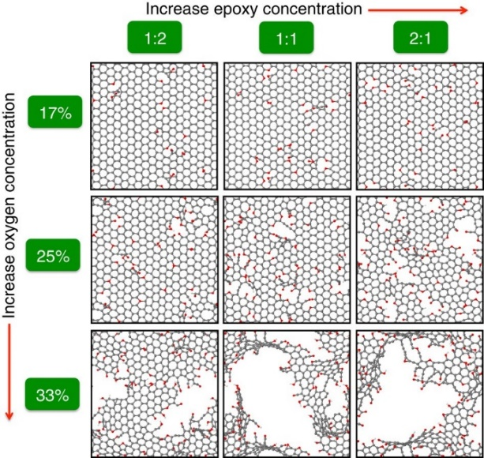

**Figure. 1. The relation of the oxygen and epoxy/hydroxyl ratio variation in a 3 by 3 matrix. Balls illustrate structures that stick with carbon (grey), oxygen (red), and hydrogen atoms (white) (L. C. Lin & Grossman, 2015)**.

The presence of oxygen-containing functional groups on graphene oxide (GO) sheets, as illustrated in Figure 1, increases their solubility in water (Aliyev et al., 2019; Hou et al., 2015; Johnson et al., 2015; Suo et al., 2022). These functional groups, which include hydroxyl, epoxide, and carbonyl groups, decrease the van der Waals force and increase the gap between graphene layers, making GO highly hydrophilic and easily exfoliated in water. This results in a stable dispersion primarily consisting of single-layered sheets. Furthermore, dispersion is improved by increasing the concentration of oxygen in GO.

## ***Synthesis method***

Graphene can be synthesized from graphite using various methods (Figure 2), including chemical, electrochemical, and microbial methods, and chemical vapour deposition (CVD) of carbon (Brisebois & Siaj, 2020). Among these methods, Hummer’s Method (HM) is the most widely used and promising approach for preparing graphene oxide (GO) using potassium permanganate, sulfuric acid, and sodium nitrate (Brisebois & Siaj, 2020, Ikram et al., 2020; Jiříčková et al., 2022). However, HM has some drawbacks, such as generating toxic gases (NO2 and N2O4) during the oxidation process and leaving ion residues (Na+ and NO3−) in wastewater (Ikram et al., 2020). (Jiříčková et al., 2022, Benzait et al., 2021; Brisebois & Siaj, 2020). To address these issues, several modifications to HM have been proposed, such as nitrate-free (Eigler, 2015; Yu et al., 2016), two-step (Eigler, 2015), co-oxidant (Yu et al., 2016), and low-room-temperature methods (Chen et al., 2019). Although these methods produce higher-quality GO, they are designed to produce only small amounts (Murali et al., 2022). Therefore, HM remains the appropriate approach for producing GO on a large scale (Brisebois & Siaj, 2020; Jiříčková et al., 2022).

Furthermore, several factors in GO synthesis should be paid attention to especially at the industrial level e.g., reaction conditions (Ikram et al., 2020), raw materials, purification, and quality control (Lowe & Zhong, 2016). The strategy is to modify production techniques e.g. controlling the degree of oxidation to decrease oxidation time and variation of H2SO4/KMnO4 ratio (Yu et al., 2016), provide a high-yield method that shortens reaction time by controlling the reagents used, by replacing some portion of KMnO4 with K2FeO4 and adjusting the H2SO4 (Yu et al., 2016). An increase in the degree of oxidation reduced oxidation time and increased the number of oxygen functional groups in GO. This similar practice can also be achieved by treating GO with ozone (X. Liu et al., 2016). Won et al. (2017) found that removing H2SO4 can significantly reduce GO production costs (Park et al., 2017). As an alternative, the sonochemical route and electrochemical method are developed to provide less production time and manageable large-scale production (Ikram et al., 2020).

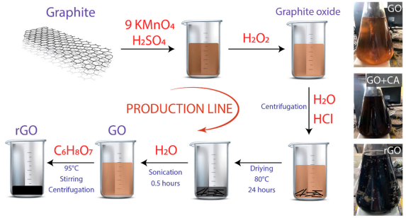

**Figure 2. Production scheme using graphite powder as initial material. The provided image shows graphene oxide (GO), graphene oxide with citric acid (GO+CA), and reduced graphene oxide (rGO) (Tene et al., 2020)**

***Reinforcing Mechanism of Graphene Oxide***

## There have been extensive research studies conducted on the effects of graphene oxide on cementitious materials. Graphene oxide has been found to enhance the mechanical characteristics of such materials through various reinforcing mechanisms, such as creating nucleation sites, reducing permeability through a filling effect, and strengthening the C-S-H matrix in cement via interfacial bonding.

## ***Nucleation Effect***

As shown in Figure 3, numerous nucleation sites are dispersed on the surface of cement particles facilitating the development of the hydration products through nucleation (Jinchang & Yeming, 2018; Meng et al., 2021), which benefits graphene's nanoscale size and ultrahigh specific surface area (Pan et al., 2015; Wu et al., 2021). During the cement hydration process, the high cumulative heat of hydration by the carbon-carbon sp2-bonded networks indicates that it performs as nucleation sites (Qureshi & Panesar, 2020). Oxygen-containing functional groups cause this increase during the early stage of hydration (Li et al., 2017). Furthermore, XRD, FTIR spectroscopy, and XPS help explain that oxygen-containing functional groups are responsible for the increase of the adsorption of water molecules and ions for the acceleration of cement hydration (Li et al., 2017; C. Lin et al., 2016; Z. Lu et al., 2017; Qureshi et al., 2019). Water adsorption has been observed to lower the water-to-binder ratio during early hydration both in the interfacial region around graphene-based fillers and across the entire cementitious composites; In the hydration process, the adsorbed water would be disclosed to support the curing process of cementitious composites and cause spontaneous shrinkage. Furthermore, the adsorption of the ion potentially accelerates nucleation and promotes C-S-H gel aggregation, enhancing cement compactness (Han et al., 2017).

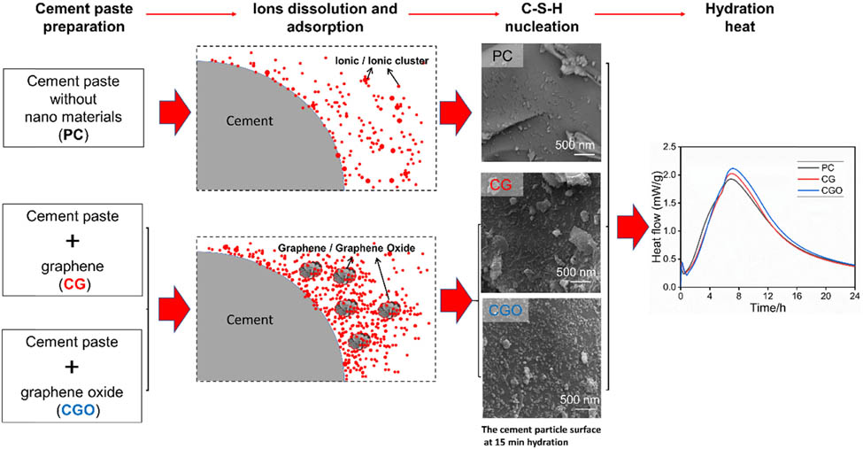

**Figure 3. Graphene oxide nucleation in cement paste and its effect on hydration heat increase (Meng et al., 2021)**

## 

## ***b. Filling Effect***

There are various scales of pores in the hydrated cement paste matrix, which is used as the main parameter to define the mechanical behaviour of cementitious composites (Hilal, 2016; Wu et al., 2021). Graphene-based materials can fill those voids due to their nano-size, as shown in Figure 4. This filler effect reduces internal bleeding (Diagne et al., 2021; Elyamany et al., 2014) while enhancing the bond strength of the aggregate paste and rendering its structure a greater homogeneity (Martínez-García et al., 2022). In the investigation, the sample is immersed in mercury using mercury intrusion porosimetry (MIP). The pressure applied during the test will have an inverse relationship with the size of the available pores filled with mercury (Hilal, 2016). The research conducted by Zheng et al. (2021) shows a reduction of up to 37.3% in pore diameter and 80.2% permeability coefficient (Zeng et al., 2021). Besides giving microstructure improvement, it also doubles the amount of C–S–H gel pores, along with its porosity reduction and filling effect improvement (Wu et al., 2021). The increasing C-S-H gel pore concentration densifies the hydrated cement matrix. Nevertheless, it is important to remember that an excessively high filler content may negatively affect the refinement of porosity, such as overlapping of graphene sheets that potentially produces extra pores between layers (Yuan et al., 2014), higher composite viscosity that builds more pores in the mixing process (Lu et al., 2016) and larger void pores are created due to agglomeration inside the cement matrix (Zhao et al., 2020b). As a result, mechanical characteristics frequently are risked.

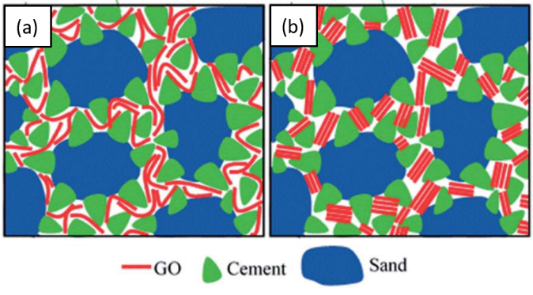

**Figure 4. Visualization of (a) uniformly dispersed GO and (b) aggregated/overlapping GO sheets in cement mortar (Gholampour et al., 2017)**

## 

## ***Toughening Effect***

Graphene oxide has oxygen functional groups that can form a solid interfacial bond with calcium hydroxide or C-S-H gel in cement (Bahraq et al., 2022; Chen et al., 2017; Wang et al., 2020). The ionic interaction of calcium in C-S-H with the oxygen-functional groups attached to GO sheets, as well as the hydrogen bonds made by water molecules in C-S-H and hydroxyl groups of GO, are common sources of these connections (Chen et al., 2017; Hou et al., 2017; Wan & Zhang, 2020). According to molecular dynamics (MD) simulations, it is discovered that hydroxyl groups interact more stronger with C-S-H than carboxyl groups do because the COOH/C-S-H interface forms more stable chemical interactions (Hou et al., 2015). The interaction of C-S-H and GO flakes can be seen in Figure 5. In addition, the presence of hydroxyl groups likewise makes the surface of GO rougher and activates the mechanical interlocking process, thus forming a greater interfacial frictional resistance (Wang et al., 2020). Pull-out simulations demonstrate that mechanical interlocking plays the primary role in the shear strength between GO and C-S-H matrix (Kai et al., 2019). Additionally, the interfacial resistance is also determined by the disproportionate adhesion forces near the crack surface (Chen et al., 2017). The same research revealed that this interfacial shear strength of GO could reach hundreds of MPa up to 9 times higher than GNP by forming van der Waals interactions with C–S–H. Here, GO's high interfacial bonding would enhance the mechanical properties of cementitious composites (Wan & Zhang, 2020).

GO offers not only strengthening mechanisms but also increases the durability of composites due to its ability to control cracks. Normally, cracks occur and propagate into branches and crack deflection. However, it is discovered that the addition of GO can disturb the bamboo-like fracture pattern of pure epoxy resin (Wang et al., 2013). In graphene-reinforced cementitious composites, strong interfacial bonding is shown by the increasing occurrence of crack-bridging (Ramírez et al., 2018), parallel to the smaller size of GO (Belmonte et al., 2016). The crack-bridging contribution is also supported by graphene's character as an impenetrable nanomaterial with geometrical shapes that make it difficult to pull out (Ovid’ko, 2015). The crack bridging of graphene over the sites absorbs more energies that increase crack paths effectively (Wang et al., 2021). That effective energy dissipation causes cracks initiation delay up to hindered propagation that improves toughness, as shown in Figure 6. This toughening effect is also affected by interfacial sliding, which can be observed through pull-out failure under SEM (Liu et al., 2020).

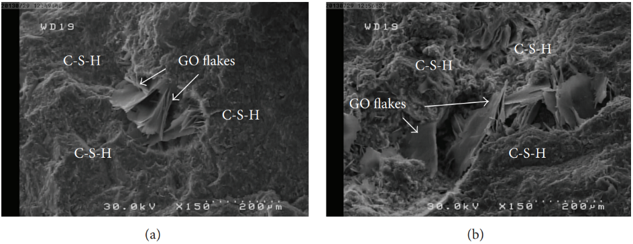

**Figure 5. Nucleation formation of C-S-H by the GO flakes (Babak et al., 2014)**

|  |  |
| --- | --- |
| (a) |  |
| (b) |  |

**Figure 6. Graphene crack bridging (a) and graphene crack propagation (b), where green lines indicate the longitudinal growth of cracks, and red circles indicate the presence of graphene (Rehman et al., 2017)**

***Working Performance***

As a nanomaterial modifier, adding GO to a mixture can increase viscosity and significantly reduce the workability of cement (Devi & Khan, 2020a; Lv et al., 2013). Thus, high viscosity during mixing and casting will likely disadvantage the final mechanical properties of the reinforced composite matrix. Fresh cement composites may be difficult to compact and entrap air spaces, harmful to mechanical performance if there is insufficient fluidity (Pan et al., 2015).

GO contribution in cementitious composite resulted in a steady decrease in fluidity. The amount of GO added to the sample with a w/c value of 0.4 decreased its fluidity by 27%, 46%, 66%, and 75% for samples with additions of 0.05%, 0.10%, 0.15%, and 0.20%, respectively (Suo et al., 2020). This gradual fluidity reduction shows a similar pattern for the sample with w/c values of 0.3 and 0.35. The findings suggest a clear inverse relationship between GO concentration and paste fluidity, as the rising GO content in cement paste causes the fluidity to decline slowly. This reduction is caused by GO which possesses a unique 2D structure and a large specific surface area, including abundant hydrophilic functional groups that require more water to make the surface wet and lower free water for fresh paste mixing (Li et al., 2018). The workability decrease prevents cement hydration reactions from being completed. This condition could lead to the GO sheet’s re-agglomeration in basic mediums, especially when a high GO concentration is utilized (Bai et al., 2018; Birenboim et al., 2019; Li et al., 2016).

GO direct addition to cement paste results in flocculation and difficult uniform mixing. In samples with w/c of 0.3, 0.35, and 0.4, adding 0.05% GO reduced the matrix fluidity by 47%, 33%, and 27%, respectively. While the sample with the lowest w/c of 0.3 had 100% fluidity after the maximal GO addition of 0.2%. GO dispersion in the cement matrix is strongly related to the fluidity of cement paste and has a favourable correlation with compressive strength. It is caused by a higher GO concentration and an increased water-to-cement ratio. Here, the enhanced dispersion occurs by the increasing fluidity (w/c), allowing more free water to lubricate GO sheets and in-between cement particles. As a result, the w/c value has a positive linear connection to fluidity. Hence it can be controlled to reach the appropriate fluidity while maintaining or raising the compressive strength of the cement composite product, as shown in Figure 7. Therefore, adding superplasticizers, such as PCs, has been common practice to increase fluidity with low water usage (Lv et al., 2015). Due to its capability of dispersing cement grains and releasing the trapped water in the cement flocculation through electrostatic repulsion and steric hindrance (Stephens et al., 2016), PCE is considered the most practical and efficient solution (Wang et al., 2015; Guo et al., 2020).

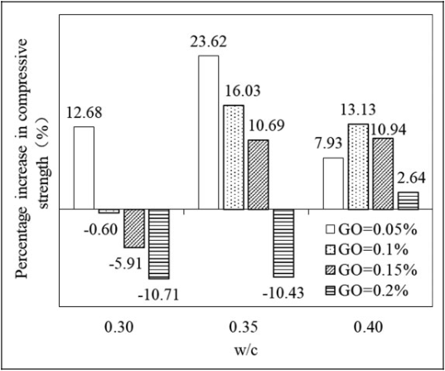

**Figure 7. Graph of w/c Relation to Compressive Strength (Suo et al., 2020)**

**Mechanical Properties**

Various factors were discovered, which make the addition of GO beneficial to the mechanical properties of cement-based materials (Liu et al., 2020, 2021; Murali et al., 2022; Suo et al., 2022; Zhao et al., 2020a). GO-compatible surfactant in cement slurry stabilizes its dispersion which improves the flexural strength (Chuah et al., 2018). Numerous studies demonstrated that adding the right amount of GO to cementitious composites can control the structure of the hydration products, enhancing the mechanical properties of the final product (Lv et al., 2015; Wang et al., 2015). The hydration process is accelerated due to the high availability of nucleation sites in GO (Yang et al., 2017). Here CH crystals are refined and highly cemented with other hydration products, such as C-S-H gel, and contribute more to strength development.

Due to its interlocking mechanism with the C-S-H, GO’s crack-bridging inhibits the expansion of microcracks (Murali et al., 2022). An SEM observation shows that cracks normally formed in a straight line cannot pass through graphene sheets (Pan et al., 2015). In the mentioned paper, it is discovered that adding 0.05 wt% GO will create a strong interfacial bond between GO and the cement matrix, causing an increase of 33% and 59% in compressive and flexural strength of cement sandstone in 28 days. While, low GO content of 0.03 wt% gradually increased the flexural and tensile strength at the maximum of 60.7% and 78.6% rate, respectively, in 28 days. Meanwhile, it reaches the compressive strength peak (47.9% improvement rate in 28 days) at 0.05 wt% GO addition. This peak point is caused by hydrated cement crystals that flocculate for GO and decrease the peak value. A similar decrement was also caused by GO agglomeration that decreased GO surface area and aggregation of GO in the matrix (Gholampour et al., 2017; Z. Lu et al., 2019). Thus, the controlled growth of cement hydration products and aggregation increased in mechanical strength of cement mortar (Lv et al., 2013). While most research was done for the cement matrix of paste and mortar (Zhao et al., 2020a), a similar pattern was also found in concrete, where a certain number of GO addition resulted in a decrease in strength, as shown in Figure 8.

GO has a filling effect that results in pore volume reduction (Devasena et al., 2015; Wang et al., 2015). At the same time, the porosity is inversely proportional to the microstructure density of the cement-based material and the ratio of compressive to indirect tensile strength (Chen et al., 2013). The reduced porosity resulted in a maximum increase of 57% and 48% for compressive and flexural strength, respectively, achieved by adding 0,05% GO by mass of cement (Ullah et al., 2021).

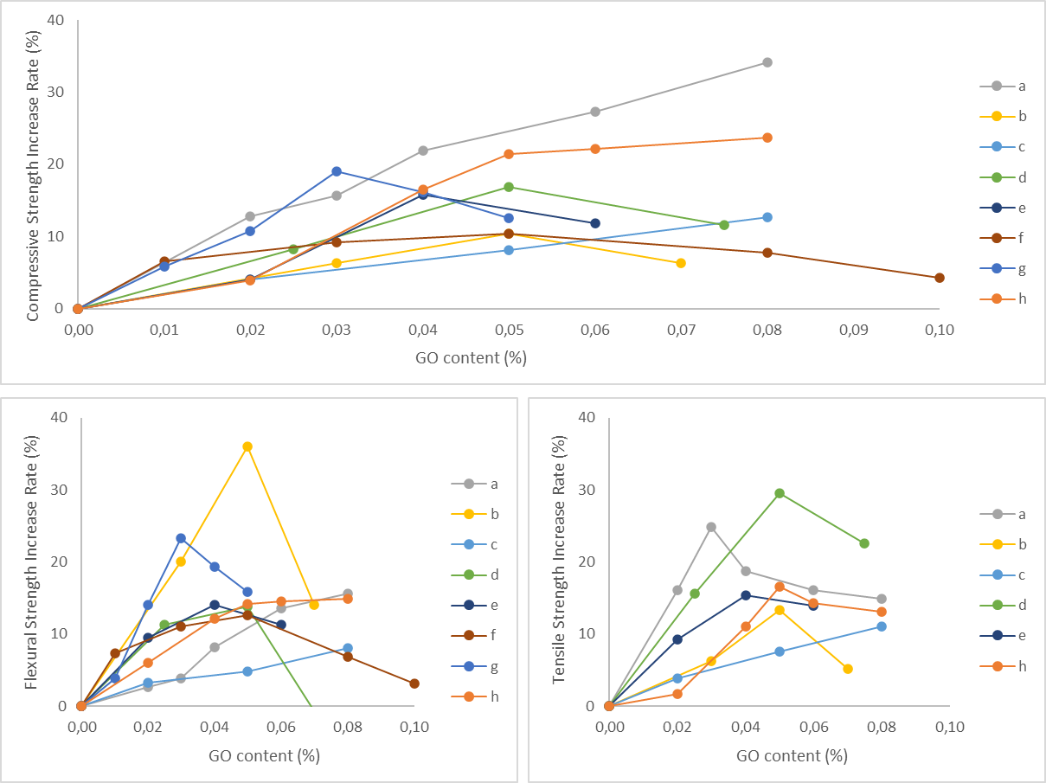

**Figure 8. Mechanical Properties Enhancement of Concrete (a) Wu et al. (2019; (b) Jyothimol et al. (2020); (c) Chen et al. (2020); (d) Chu et al. (2020); (e) Yeke & Yu (2021); (f) Lu & Ouyang (2017); (g) Ellala (2022); (h) Hong et al. (2022).**

# 

# Blockage of Transport Channel of Foreign Media into Concrete

Transport channels (i.e. gel pores, capillary pores, interfaces, and cracks) are responsible for the intrusion of corrosive media into the concrete. Since GO is more hydrophobic, mixing GO in the matrix or coating the cement products can protect the cement matrix from entering CO2, chloride ions, alkalis, acids, and other corrosive substances.

## ***Application of GO by Mixing***

GO addition at 0.03% in cement composite showed the maximum water absorption reduction of 14.5%, while the reduction in water sorptivity was found at the addition of 0.04% which occurs due to the agglomeration of GO nanosheets (Indukuri & Nerella, 2021). While Zeng et al. (2021) found that a larger ratio of GO can decrease the relative permeability ratio of cement mortar up to 80.6% by adding 0.06 wt% GO (Zeng et al., 2021). Increased GO incorporation reduces the cement composite capillary action, and sorptivity, and increases its resistance to water penetration. The reduced water resistivity by increasing GO addition is due to the clustering effect of GO that destroyed the microstructure of the cement matrix (Guo et al., 2019). This clustering also depends on the water-cement ratio and GO size in the cement composite mix (Devi & Khan, 2020a).

The resistance effect by GO addition is also being tested against carbon dioxide. This anti-carbonization ability is connected to the enhanced microstructure by reducing its porosity, which resulted in an easing of the speed rate of carbonation movement (Mohammed et al., 2018). It is revealed by thermogravimetric analysis (TG) on how GO stabilizes C-S-H during early carbonization (Long, Gu, et al., 2018). It is also found that GO addition decreases carbonation depth significantly by 60% to 81.3% for a carbonation time of 6 to 18 months (Devi & Khan, 2020b).

The increasing water penetration resistivity also has a similar impact on the corrosive substance intrusion in cement composites. The average chloride transport depth accompanied by its diffusion in cement mortar is decreased by 28.6% by adding 0.11 wt% of GO (Zhao et al., 2020c). For the same indication as the previous research where GO improves the resistance to chloride ingress (Guo et al., 2019), it was found that the least depth of 11.83 mm at a 28-day concrete sample by adding 0.03% GO (Indukuri & Nerella, 2021). This concentration was also found to have the lowest weight loss in the environment, 2% for HCl and 5% for H2SO4. Moreover, the addition of GO improves the resistance toward acid attack as shown by the significantly lower loss of mass and sectional area of GO/CCs when cement composites are exposed to 67% nitric acid (Muthu et al., 2021a) and 37% hydrochloric acid (Muthu et al., 2021b), as well as to sulfuric acid (Korucu et al., 2019).

## ***Application of GO by Coating***

Besides being mixed in the cement or concrete matrix, GO has also been tested as a coating emulsion. GO cover the surface of concrete; which reduces the capillary adsorption and permeability (Habibnejad Korayem et al., 2020). GO/silane composite emulsion show better and more stable waterproofing properties even for cracked concrete (Chen et al., 2021) due to the production of a silanol hydrophobic layer through silane hydrolysis reaction with hydroxyl groups in the C-S-H gel (Moshiri et al., 2020). At the same time, it also produces a similar substance with SiO2 that reacts with calcium hydroxide and forms a C-S-H gel. Their research shows the potential of silane to undergo a condensation reaction with the hydroxyl groups in ettringite, a primary constituent of hydration of Portland cement concrete, where the decreased water-to-binder ratio reduces the pore size and its porosity (Shi et al., 2022). The thicker coating coverage also has better penetration resistance. In composite with epoxy, an increased percentage of epoxy has a linear relation to its gyration radius. It helps strengthen the connection between GO sheets and epoxy molecules through the hydroxyl donation from GO (Yu et al., 2019).

# Current challenges

Although graphene, and its derivative graphene oxide, have proven benefits, it still faces obstacles in achieving widespread application. Market restrictions, awareness, and advanced technology are factors contributing to this problem (Meister et al., 2017). Carbon nanotubes (CNTs) are the most competitive alternative to graphene, and new technology is expected to surpass existing ones. Quality and pricing are significant concerns in the building industry, and graphene application is limited by its cost of around $85-100 per metric ton of concrete, even at modest loads. Internal contributing factors include quality control, processing, and the supply chain, as well as product mastery and cost-benefit clarity. The various production methods of graphene and its lack of standards make it challenging to ensure product quality and address long-term health and environmental concerns (Santhiran et al., 2021) (Arvidsson et al., 2022; Murali et al., 2022; Pryce et al., 2022). Uncertainty regarding graphene characterization and its application procedure obscures its benefit-cost ratio (Zhao et al., 2020a). While GO has many advantages, its price must be reasonable and efficient processing procedures still need to be developed (Lowe & Zhong, 2016). The health risks of exposure to graphene remain a concern and require further research (Ansari et al., 2019; Y. Lin et al., 2020; Tabish et al., 2018).

**Conclusions and Recommendations**

The growing interest in graphene oxide (GO), the most widely used derivative of graphene, has provided valuable insights into its development. While an efficient method for industrial-scale production has yet to be obtained, the mechanism of GO in reinforcing cementitious composites has been thoroughly discussed. GO's nano-size characteristics decrease porosity and pore size, while its large surface area accelerates the hydration process and creates interlocking connections among C-S-Hs and GO in the composites, preventing crack propagation and increasing compactness. While the optimal amount of GO addition for peak mechanical properties is yet to be determined, on average, the addition of 0.05 wt% of GO has shown the most significant increase in strength. Additionally, GO reinforcement has been developed for other uses due to its transport properties, such as decreasing vulnerability to corrosive environments. However, the widespread use of GO in construction still faces challenges related to cost, quality, and marketing. Industrial-scale production requires better quality control methods, and promotion is necessary to spread awareness of GO's advantages and encourage its further development and application in the construction industry.

**References**

Aliyev, E., Filiz, V., Khan, M. M., Lee, Y. J., Abetz, C., & Abetz, V. (2019). Structural characterization of graphene oxide: Surface functional groups and fractionated oxidative debris. *Nanomaterials*, *9*(8). https://doi.org/10.3390/nano9081180

Ansari, M. O., Gauthaman, K., Essa, A., Bencherif, S. A., & Memic, A. (2019). Graphene and Graphene-Based Materials in Biomedical Applications. *Current Medicinal Chemistry*, *26*(38), 6834–6850. https://doi.org/10.2174/0929867326666190705155854

Antunes, M., Santos, R. L., Pereira, J., Rocha, P., Horta, R. B., & Colaço, R. (2022). Alternative clinker technologies for reducing carbon emissions in cement industry: A critical review. In *Materials* (Vol. 15, Issue 1). MDPI. https://doi.org/10.3390/ma15010209

Arvidsson, R., Peters, G., Hansen, S. F., & Baun, A. (2022). Prospective environmental risk screening of seven advanced materials based on production volumes and aquatic ecotoxicity. *NanoImpact*, *25*, 100393. https://doi.org/10.1016/J.IMPACT.2022.100393

Babak, F., Abolfazl, H., Alimorad, R., & Parviz, G. (2014). Preparation and mechanical properties of graphene oxide: Cement nanocomposites. *The Scientific World Journal*, *2014*. https://doi.org/10.1155/2014/276323

Backes, C., Abdelkader, A. M., Alonso, C., Andrieux-Ledier, A., Arenal, R., Azpeitia, J., Balakrishnan, N., Banszerus, L., Barjon, J., Bartali, R., Bellani, S., Berger, C., Berger, R., Ortega, M. M. B., Bernard, C., Beton, P. H., Beyer, A., Bianco, A., Bøggild, P., … Garcia-Hernandez, M. (2020). Production and processing of graphene and related materials. *2D Materials*, *7*(2). https://doi.org/10.1088/2053-1583/ab1e0a

Bahraq, A. A., Al-Osta, M. A., Obot, I. B., Baghabra Al-Amoudi, O. S., Saleh, T. A., & Maslehuddin, M. (2022). Improving the adhesion properties of cement/epoxy interface using graphene-based nanomaterials: Insights from molecular dynamics simulation. *Cement and Concrete Composites*, *134*, 104801. https://doi.org/10.1016/j.cemconcomp.2022.104801

Bai, S., Jiang, L., Xu, N., Jin, M., & Jiang, S. (2018). Enhancement of mechanical and electrical properties of graphene/cement composite due to improved dispersion of graphene by addition of silica fume. *Construction and Building Materials*, *164*, 433–441. https://doi.org/10.1016/j.conbuildmat.2017.12.176

Barker, D., Fors, A., Lindgren, E., Olesund, A., & Schröder, E. (2020). Filter function of graphene oxide: Trapping perfluorinated molecules. *Journal of Chemical Physics*, *152*(2). https://doi.org/10.1063/1.5132751

Bautista-Gutierrez, K. P., Herrera-May, A. L., Santamaría-López, J. M., Honorato-Moreno, A., & Zamora-Castro, S. A. (2019). Recent progress in nanomaterials for modern concrete infrastructure: Advantages and challenges. In *Materials* (Vol. 12, Issue 21). MDPI AG. https://doi.org/10.3390/ma12213548

Belmonte, M., Nistal, A., Boutbien, P., Román-Manso, B., Osendi, M. I., & Miranzo, P. (2016). Toughened and strengthened silicon carbide ceramics by adding graphene-based fillers. *Scripta Materialia*, *113*, 127–130. https://doi.org/https://doi.org/10.1016/j.scriptamat.2015.10.023

Benzait, Z., Chen, P., & Trabzon, L. (2021). Enhanced synthesis method of graphene oxide. *Nanoscale Advances*, *3*(1), 223–230. https://doi.org/10.1039/d0na00706d

Birenboim, M., Nadiv, R., Alatawna, A., Buzaglo, M., Schahar, G., Lee, J., Kim, G., Peled, A., & Regev, O. (2019). Reinforcement and workability aspects of graphene-oxide-reinforced cement nanocomposites. *Composites Part B: Engineering*, *161*, 68–76. https://doi.org/10.1016/j.compositesb.2018.10.030

Blessy Rebecca, P. N., Durgalakshmi, D., Balakumar, S., & Rakkesh, R. A. (2022). Biomass-Derived Graphene-Based Nanocomposites: A Futuristic Material for Biomedical Applications. In *ChemistrySelect* (Vol. 7, Issue 5). https://doi.org/10.1002/slct.202104013

Brisebois, P. P., & Siaj, M. (2020). Harvesting graphene oxide-years 1859 to 2019: A review of its structure, synthesis, properties and exfoliation. In *Journal of Materials Chemistry C* (Vol. 8, Issue 5, pp. 1517–1547). Royal Society of Chemistry. https://doi.org/10.1039/c9tc03251g

Chen, H., Du, W., Liu, J., Qu, L., & Li, C. (2019). Efficient room-temperature production of high-quality graphene by introducing removable oxygen functional groups to the precursor. *Chemical Science*, *10*(4), 1244–1253. https://doi.org/10.1039/c8sc03695k

Chen, S. J., Li, C. Y., Wang, Q., & Duan, W. H. (2017). Reinforcing mechanism of graphene at atomic level: Friction, crack surface adhesion and 2D geometry. *Carbon*, *114*, 557–565. https://doi.org/10.1016/j.carbon.2016.12.034

Chen, X., Wu, S., & Zhou, J. (2013). Influence of porosity on compressive and tensile strength of cement mortar. *Construction and Building Materials*, *40*, 869–874. https://doi.org/10.1016/j.conbuildmat.2012.11.072

Chen, X., Zhang, Y., Li, S., Geng, Y., & Hou, D. (2021). Influence of a new type of graphene oxide/silane composite emulsion on the permeability resistance of damaged concrete. *Coatings*, *11*(2), 1–14. https://doi.org/10.3390/coatings11020208

Chen, Z., Xu, Y., Hua, J., Wang, X., Huang, L., & Zhou, X. (2020). Mechanical properties and shrinkage behavior of concrete-containing graphene-oxide nanosheets. *Materials*, *13*(3). https://doi.org/10.3390/ma13030590

Chuah, S., Li, W., Chen, S. J., Sanjayan, J. G., & Duan, W. H. (2018). Investigation on dispersion of graphene oxide in cement composite using different surfactant treatments. *Construction and Building Materials*, *161*, 519–527. https://doi.org/10.1016/j.conbuildmat.2017.11.154

Devasena, M., Karthikeyan, J., & Student, M. E. (2015). Investigation on strength properties of Graphene Oxide Concrete. *International Journal of Engineering Science Invention Research & Development*, *I*, 307. www.ijesird.com

Devi, S. C., & Khan, R. A. (2020a). Effect of graphene oxide on mechanical and durability performance of concrete. *Journal of Building Engineering*, *27*. https://doi.org/10.1016/j.jobe.2019.101007

Devi, S. C., & Khan, R. A. (2020b). Influence of graphene oxide on sulfate attack and carbonation of concrete containing recycled concrete aggregate. *Construction and Building Materials*, *250*. https://doi.org/10.1016/j.conbuildmat.2020.118883

Diagne, M., Dia, I., & Gueye, O. (2021). Influence of Types of Fillers on Workability, Bleeding, Compressive Strength, and Degree of Compaction of Hydraulic Concrete. *Materials Sciences and Applications*, *12*(06), 276–296. https://doi.org/10.4236/msa.2021.126019

Dideikin, A. T., & Vul’, A. Y. (2019). Graphene oxide and derivatives: The place in graphene family. In *Frontiers in Physics* (Vol. 6, Issue JAN). Frontiers Media S.A. https://doi.org/10.3389/fphy.2018.00149

Eigler, S. (2015). Graphite sulphate - A precursor to graphene. *Chemical Communications*, *51*(15), 3162–3165. https://doi.org/10.1039/c4cc09381j

Ellala, G. (2022). Performance Characteristics of Concrete With Nano-Graphene Oxide Inundations. *Research Square*. https://doi.org/10.21203/rs.3.rs-1899759/v1

Ellis, L. D., Badel, A. F., Chiang, M. L., Park, R. J. Y., & Chiang, Y. M. (2020). Toward electrochemical synthesis of cement—An electrolyzer-based process for decarbonating CaCO3 while producing useful gas streams. *Proceedings of the National Academy of Sciences of the United States of America*, *117*(23), 12584–12591. https://doi.org/10.1073/pnas.1821673116

Elyamany, H. E., Abd Elmoaty, A. E. M., & Mohamed, B. (2014). Effect of filler types on physical, mechanical and microstructure of self compacting concrete and Flow-able concrete. *Alexandria Engineering Journal*, *53*(2), 295–307. https://doi.org/10.1016/j.aej.2014.03.010

Fattah, M. Y., Al-Haddad, S. A., Shahoobe, A. A., & Al-Khafaji, K. R. (2021). Characteristics of Soft Clays Enhanced by Graphene Oxide. *IOP Conference Series: Earth and Environmental Science*, *856*(1), 012018. https://doi.org/10.1088/1755-1315/856/1/012018

Gayen, S., Bej, B., Sankar Boxi, S., & Ghosh, R. (2023). Synthesis of graphene oxide and its application for purification of river water. *Materials Today: Proceedings*, *72*, 2630–2636. https://doi.org/10.1016/J.MATPR.2022.08.131

Geological Survey, U. (2022). *Mineral Commodity Summaries 2022*. https://doi.org/10.3133/mcs2022

Gholampour, A., Kiamahalleh, M. V., Tran, D. N. H., Ozbakkaloglu, T., & Losic, D. (2017). Revealing the dependence of the physiochemical and mechanical properties of cement composites on graphene oxide concentration. *RSC Advances*, *7*(87), 55148–55156. https://doi.org/10.1039/c7ra10066c

Guo, K., Miao, H., Liu, L., Zhou, J., & Liu, M. (2019). Effect of graphene oxide on chloride penetration resistance of recycled concrete. *Nanotechnology Reviews*, *8*(1), 681–689. https://doi.org/10.1515/ntrev-2019-0059

Habibnejad Korayem, A., Ghoddousi, P., Shirzadi Javid, A. A., Oraie, M. A., & Ashegh, H. (2020). Graphene oxide for surface treatment of concrete: A novel method to protect concrete. *Construction and Building Materials*, *243*. https://doi.org/10.1016/j.conbuildmat.2020.118229

Han, B., Zhang, L., Zeng, S., Dong, S., Yu, X., Yang, R., & Ou, J. (2017). Nano-core effect in nano-engineered cementitious composites. *Composites Part A: Applied Science and Manufacturing*, *95*, 100–109. https://doi.org/10.1016/j.compositesa.2017.01.008

He, K., Chen, G., Zeng, G., Peng, M., Huang, Z., Shi, J., & Huang, T. (2017). Stability, transport and ecosystem effects of graphene in water and soil environments. *Nanoscale*, *9*(17), 5370–5388. https://doi.org/10.1039/C6NR09931A

Hilal, A. A. (2016). Microstructure of Concrete. In *High Performance Concrete Technology and Applications*. InTech. https://doi.org/10.5772/64574

Hong, X., Lee, J. C., & Qian, B. (2022). Mechanical Properties and Microstructure of High-Strength Lightweight Concrete Incorporating Graphene Oxide. *Nanomaterials*, *12*(5), 833. https://doi.org/10.3390/nano12050833

Hou, D., Lu, Z., Li, X., Ma, H., & Li, Z. (2017). Reactive molecular dynamics and experimental study of graphene-cement composites: Structure, dynamics and reinforcement mechanisms. *Carbon*, *115*, 188–208. https://doi.org/10.1016/j.carbon.2017.01.013

Hou, D., Zhao, T., Ma, H., & Li, Z. (2015). Reactive Molecular Simulation on Water Confined in the Nanopores of the Calcium Silicate Hydrate Gel: Structure, Reactivity, and Mechanical Properties. *The Journal of Physical Chemistry C*, *119*(3), 1346–1358. https://doi.org/10.1021/jp509292q

Ige, O. E., Olanrewaju, O. A., Duffy, K. J., & Collins, O. C. (2022). Environmental Impact Analysis of Portland Cement (CEM1) Using the Midpoint Method. *Energies*, *15*(7). https://doi.org/10.3390/en15072708

Ikram, R., Jan, B. M., & Ahmad, W. (2020). An overview of industrial scalable production of graphene oxide and analytical approaches for synthesis and characterization. In *Journal of Materials Research and Technology* (Vol. 9, Issue 5, pp. 11587–11610). Elsevier Editora Ltda. https://doi.org/10.1016/j.jmrt.2020.08.050

Indukuri, C. S. R., & Nerella, R. (2021). Enhanced transport properties of graphene oxide based cement composite material. *Journal of Building Engineering*, *37*. https://doi.org/10.1016/j.jobe.2021.102174

Jinchang, P., & Yeming, W. (2018). Graphene oxide on the microstructure and mechanical properties of cement based composite material. *Frattura Ed Integrita Strutturale*, *12*(45), 156–163. https://doi.org/10.3221/IGF-ESIS.45.13

Jiříčková, A., Jankovský, O., Sofer, Z., & Sedmidubský, D. (2022). Synthesis and Applications of Graphene Oxide. In *Materials* (Vol. 15, Issue 3). MDPI. https://doi.org/10.3390/ma15030920

Johnson, D. W., Dobson, B. P., & Coleman, K. S. (2015). A manufacturing perspective on graphene dispersions. In *Current Opinion in Colloid and Interface Science* (Vol. 20, Issues 5–6, pp. 367–382). Elsevier Ltd. https://doi.org/10.1016/j.cocis.2015.11.004

Juhart, J., Autischer, M., Sakoparnig, M., & Krüger, M. (2021). The realization of clinker-reduced, performance-based sustainable concrete by the micro-filler, eco-filler concept. *Materials*, *14*(17). https://doi.org/10.3390/ma14174958

Jyothimol, P., Hazeena, R., Issac, M. T., & Mathiazhagan, A. (2020). Effect of reduced graphene oxide on the mechanical properties of concrete. *IOP Conference Series: Earth and Environmental Science*, *491*(1). https://doi.org/10.1088/1755-1315/491/1/012038

Kai, M. F., Zhang, L. W., & Liew, K. M. (2019). Graphene and graphene oxide in calcium silicate hydrates: Chemical reactions, mechanical behaviors and interfacial sliding. *Carbon*, *146*, 181–193. https://doi.org/10.1016/j.carbon.2019.01.097

Kang, D., Seo, K. S., Lee, H., & Chung, W. (2017). Experimental study on mechanical strength of GO-cement composites. *Construction and Building Materials*, *131*, 303–308. https://doi.org/https://doi.org/10.1016/j.conbuildmat.2016.11.083

Khaliha, S., Bianchi, A., Kovtun, A., Tunioli, F., Boschi, A., Zambianchi, M., Paci, D., Bocchi, L., Valsecchi, S., Polesello, S., Liscio, A., Bergamini, M., Brunetti, M., Luisa Navacchia, M., Palermo, V., & Melucci, M. (2022). Graphene oxide nanosheets for drinking water purification by tandem adsorption and microfiltration. *Separation and Purification Technology*, *300*, 121826. https://doi.org/10.1016/J.SEPPUR.2022.121826

Kim, B., Taylor, L., Troy, A., McArthur, M., & Ptaszynska, M. (2018). The effects of Graphene Oxide flakes on the mechanical properties of cement mortar. *Computers and Concrete*, *21*(3), 261–267. https://doi.org/10.12989/cac.2018.21.3.261

Korucu, H., Şimşek, B., Uygunoğlu, T., Güvenç, A. B., & Yartaşı, A. (2019). Statistical approach to carbon based materials reinforced cementitious composites: Mechanical, thermal, electrical and sulfuric acid resistance properties. *Composites Part B: Engineering*, *171*, 347–360. https://doi.org/10.1016/j.compositesb.2019.05.017

Kothiyal, N. C., Sharma, S., Mahajan, S., & Sethi, S. (2016). Characterization of reactive graphene oxide synthesized from ball – milled graphite: its enhanced reinforcing effects on cement nanocomposites. *Journal of Adhesion Science and Technology*, *30*(9), 915–933. https://doi.org/10.1080/01694243.2015.1129214

Krystek, M., Ciesielski, A., & Samorì, P. (2021). Graphene-Based Cementitious Composites: Toward Next-Generation Construction Technologies. *Advanced Functional Materials*, *31*(27). https://doi.org/10.1002/adfm.202101887ï

Ławkowska, K., Pokrywczyńska, M., Koper, K., Kluth, L. A., Drewa, T., & Adamowicz, J. (2022). Application of graphene in tissue engineering of the nervous system. In *International Journal of Molecular Sciences* (Vol. 23, Issue 1). MDPI. https://doi.org/10.3390/ijms23010033

Li, W., Li, X., Chen, S. J., Liu, Y. M., Duan, W. H., & Shah, S. P. (2017). Effects of graphene oxide on early-age hydration and electrical resistivity of Portland cement paste. *Construction and Building Materials*, *136*, 506–514. https://doi.org/10.1016/j.conbuildmat.2017.01.066

Li, X., Korayem, A. H., Li, C., Liu, Y., He, H., Sanjayan, J. G., & Duan, W. H. (2016). Incorporation of graphene oxide and silica fume into cement paste: A study of dispersion and compressive strength. *Construction and Building Materials*, *123*, 327–335. https://doi.org/https://doi.org/10.1016/j.conbuildmat.2016.07.022

Li, X., Wang, L., Liu, Y., Li, W., Dong, B., & Duan, W. H. (2018). Dispersion of graphene oxide agglomerates in cement paste and its effects on electrical resistivity and flexural strength. *Cement and Concrete Composites*, *92*, 145–154. https://doi.org/10.1016/j.cemconcomp.2018.06.008

Liang, A., Jiang, X., Hong, X., Jiang, Y., Shao, Z., & Zhu, D. (2018). Recent developments concerning the dispersion methods and mechanisms of graphene. In *Coatings* (Vol. 8, Issue 1). MDPI AG. https://doi.org/10.3390/coatings8010033

Lin, C., Wei, W., & Hu, Y. H. (2016). Catalytic behavior of graphene oxide for cement hydration process. *Journal of Physics and Chemistry of Solids*, *89*, 128–133. https://doi.org/https://doi.org/10.1016/j.jpcs.2015.11.002

Lin, L. C., & Grossman, J. C. (2015). Atomistic understandings of reduced graphene oxide as an ultrathin-film nanoporous membrane for separations. *Nature Communications*, *6*. https://doi.org/10.1038/ncomms9335

Lin, Y., Zhang, Y., Li, J., Kong, H., Yan, Q., Zhang, J., Li, W., Ren, N., Cui, Y., Zhang, T., Cai, X., Li, Q., Li, A., Shi, J., Wang, L., Zhu, Y., & Fan, C. (2020). Blood exposure to graphene oxide may cause anaphylactic death in non-human primates. *Nano Today*, *35*, 100922. https://doi.org/10.1016/j.nantod.2020.100922

Liu, C., Chen, F., Wu, Y., Zheng, Z., Yang, J., Yang, B., Yang, J., Hui, D., & Luo, Y. (2021). Research progress on individual effect of graphene oxide in cement-based materials and its synergistic effect with other nanomaterials. In *Nanotechnology Reviews* (Vol. 10, Issue 1, pp. 1208–1235). De Gruyter Open Ltd. https://doi.org/10.1515/ntrev-2021-0080

Liu, C., Huang, X., Wu, Y. Y., Deng, X., Liu, J., Zheng, Z., & Hui, D. (2020). Review on the research progress of cement-based and geopolymer materials modified by graphene and graphene oxide. In *Nanotechnology Reviews* (Vol. 9, Issue 1, pp. 155–169). De Gruyter. https://doi.org/10.1515/ntrev-2020-0014

Liu, X., Huang, Y., Duan, S., Wang, Y., Li, J., Chen, Y., Hayat, T., & Wang, X. (2016). Graphene oxides with different oxidation degrees for Co(II) ion pollution management. *Chemical Engineering Journal*, *302*, 763–772. https://doi.org/https://doi.org/10.1016/j.cej.2016.05.107

Long, W. J., Fang, C., Wei, J., & Li, H. (2018). Stability of GO modified by different dispersants in cement paste and its related mechanism. *Materials*, *11*(5). https://doi.org/10.3390/ma11050834

Long, W. J., Gu, Y. cun, Xing, F., & Khayat, K. H. (2018). Microstructure development and mechanism of hardened cement paste incorporating graphene oxide during carbonation. *Cement and Concrete Composites*, *94*, 72–84. https://doi.org/10.1016/j.cemconcomp.2018.08.016

Lowe, S. E., & Zhong, Y. L. (2016). Challenges of Industrial-Scale Graphene Oxide Production. In *Graphene Oxide: Fundamentals and Applications* (pp. 410–431). wiley. https://doi.org/10.1002/9781119069447.ch13

Lu, L., & Ouyang, D. (2017). Properties of cement mortar and ultra-high strength concrete incorporating graphene oxide nanosheets. *Nanomaterials*, *7*(7). https://doi.org/10.3390/nano7070187

Lu, L., Zhao, P., & Lu, Z. (2018). A short discussion on how to effectively use graphene oxide to reinforce cementitious composites. *Construction and Building Materials*, *189*, 33–41. https://doi.org/10.1016/j.conbuildmat.2018.08.170

Lu, Z., Chen, B., Leung, ChristopherK. Y., Li, Z., & Sun, G. (2019). Aggregation size effect of graphene oxide on its reinforcing efficiency to cement-based materials. *Cement and Concrete Composites*, *100*, 85–91. https://doi.org/10.1016/j.cemconcomp.2019.04.005

Lu, Z., Hou, D., Ma, H., Fan, T., & Li, Z. (2016). Effects of graphene oxide on the properties and microstructures of the magnesium potassium phosphate cement paste. *Construction and Building Materials*, *119*, 107–112. https://doi.org/https://doi.org/10.1016/j.conbuildmat.2016.05.060

Lu, Z., Li, X., Hanif, A., Chen, B., Parthasarathy, P., Yu, J., & Li, Z. (2017). Early-age interaction mechanism between the graphene oxide and cement hydrates. *Construction and Building Materials*, *152*, 232–239. https://doi.org/10.1016/j.conbuildmat.2017.06.176

Lv, S., Ma, Y., Qiu, C., Sun, T., Liu, J., & Zhou, Q. (2013). Effect of graphene oxide nanosheets of microstructure and mechanical properties of cement composites. *Construction and Building Materials*, *49*, 121–127. https://doi.org/10.1016/j.conbuildmat.2013.08.022

Lv, S.-H., Cui, Y.-Y., Sun, T., Zhao, H.-F., Liu, J.-J., & Ding, H.-D. (2015). Effects of graphene oxide on fluidity of cement paste and structure and properties of hardened cement paste. *Gongneng Cailiao/Journal of Functional Materials*, *46*, 4051–4056. https://doi.org/10.3969/j.issn.1001-9731.2015.04.010

Maglad, A. M., Zaid, O., Arbili, M. M., Ascensão, G., Șerbănoiu, A. A., Grădinaru, C. M., García, R. M., Qaidi, S. M. A., Althoey, F., & de Prado-Gil, J. (2022). A Study on the Properties of Geopolymer Concrete Modified with Nano Graphene Oxide. *Buildings*, *12*(8). https://doi.org/10.3390/buildings12081066

Mahmood, M. R., Al-Haddad, S. A., & Fattah, M. Y. (2021). Compressibility Characteristics of Soft Clays Treated by Graphene Oxide. *Journal of Southwest Jiaotong University*, *56*(1). https://doi.org/10.35741/issn.0258-2724.56.1.35

Martínez-García, R., Sánchez de Rojas, M. I., Jagadesh, P., López-Gayarre, F., Morán-del-Pozo, J. M., & Juan-Valdes, A. (2022). Effect of pores on the mechanical and durability properties on high strength recycled fine aggregate mortar. *Case Studies in Construction Materials*, *16*. https://doi.org/10.1016/j.cscm.2022.e01050

Meister, M., Braun, A., Hüsing, B., Schmoch, U., & Reiss, T. (2017). Composites, bulk applications and coatings. In *Graphene and other 2D materials technology and innovation roadmap* (Vol. 3). Fraunhofer ISI.

Meng, S., Ouyang, X., Fu, J., Niu, Y., & Ma, Y. (2021). The role of graphene/graphene oxide in cement hydration. *Nanotechnology Reviews*, *10*(1), 768–778. https://doi.org/10.1515/ntrev-2021-0055

Mohammed, A., Sanjayan, J. G., Nazari, A., & Al-Saadi, N. T. K. (2018). The role of graphene oxide in limited long-term carbonation of cement-based matrix. *Construction and Building Materials*, *168*, 858–866. https://doi.org/10.1016/j.conbuildmat.2018.02.082

Moshiri, A., Stefaniuk, D., Smith, S. K., Morshedifard, A., Rodrigues, D. F., Qomi, M. J. A., & Krakowiak, K. J. (2020). Structure and morphology of calcium-silicate-hydrates cross-linked with dipodal organosilanes. *Cement and Concrete Research*, *133*. https://doi.org/10.1016/j.cemconres.2020.106076

Murali, M., Alaloul, W. S., Mohammed, B. S., Musarat, M. A., Salaheen, M. al, Al-Sabaeei, A. M., & Isyaka, A. (2022). Utilizing graphene oxide in cementitious composites: A systematic review. *Case Studies in Construction Materials*, *17*. https://doi.org/10.1016/j.cscm.2022.e01359

Muthu, M., Yang, E. H., & Unluer, C. (2021a). Resistance of graphene oxide-modified cement pastes to hydrochloric acid attack. *Construction and Building Materials*, *273*. https://doi.org/10.1016/j.conbuildmat.2020.121990

Muthu, M., Ukrainczyk, N., & Koenders, E. (2021b). Effect of graphene oxide dosage on the deterioration properties of cement pastes exposed to an intense nitric acid environment. *Construction and Building Materials*, *269*. https://doi.org/10.1016/j.conbuildmat.2020.121272

Naseri, F., Irani, M., & Dehkhodarajabi, M. (2016). Effect of graphene oxide nanosheets on the geotechnical properties of cemented silty soil. *Archives of Civil and Mechanical Engineering*, *16*(4). https://doi.org/10.1016/j.acme.2016.04.008

Obayomi, K. S., Lau, S. Y., Danquah, M., Chiong, T., & Takeo, M. (2022). Advances in graphene oxide based nanobiocatalytic technology for wastewater treatment. In *Environmental Nanotechnology, Monitoring and Management* (Vol. 17). https://doi.org/10.1016/j.enmm.2022.100647

Ovid’ko, I. A. (2015). Micromechanics of fracturing in nanoceramics. In *Philosophical Transactions of the Royal Society A: Mathematical, Physical and Engineering Sciences* (Vol. 373, Issue 2038). Royal Society of London. https://doi.org/10.1098/rsta.2014.0129

Pan, Z., He, L., Qiu, L., Korayem, A. H., Li, G., Zhu, J. W., Collins, F., Li, D., Duan, W. H., & Wang, M. C. (2015). Mechanical properties and microstructure of a graphene oxide-cement composite. *Cement and Concrete Composites*, *58*, 140–147. https://doi.org/10.1016/j.cemconcomp.2015.02.001

Park, W. K., Yoon, Y., Kim, S., Choi, S. Y., Yoo, S., Do, Y., Jung, S., Yoon, D. H., Park, H., & Yang, W. S. (2017). Toward Green Synthesis of Graphene Oxide Using Recycled Sulfuric Acid via Couette-Taylor Flow. *ACS Omega*, *2*(1), 186–192. https://doi.org/10.1021/acsomega.6b00352

Paton-Carrero, A., Sanchez, P., Sánchez-Silva, L., & Romero, A. (2022). Graphene-based materials behaviour for dyes adsorption. *Materials Today Communications*, *30*, 103033. https://doi.org/10.1016/J.MTCOMM.2021.103033

Pryce, D., Khalil, A. M. E., & Memon, F. A. (2022). Investigating the environmental costs of utilizing graphene-based adsorbents and pulsed power oxidation for the removal of emerging contaminants from urban wastewater. *Science of The Total Environment*, *817*, 152985. https://doi.org/10.1016/J.SCITOTENV.2022.152985

Qureshi, T. S., & Panesar, D. K. (2020). Nano reinforced cement paste composite with functionalized graphene and pristine graphene nanoplatelets. *Composites Part B: Engineering*, *197*. https://doi.org/10.1016/j.compositesb.2020.108063

Qureshi, T. S., Panesar, D. K., Sidhureddy, B., Chen, A., & Wood, P. C. (2019). Nano-cement composite with graphene oxide produced from epigenetic graphite deposit. *Composites Part B: Engineering*, *159*, 248–258. https://doi.org/10.1016/j.compositesb.2018.09.095

Ramírez, C., Wang, Q., Belmonte, M., Miranzo, P., Isabel Osendi, M., Sheldon, B. W., & Padture, N. P. (2018). Direct in situ observation of toughening mechanisms in nanocomposites of silicon nitride and reduced graphene-oxide. *Scripta Materialia*, *149*, 40–43. https://doi.org/10.1016/j.scriptamat.2018.02.004

Ray, S. C. (2015). *Applications of Graphene and Graphene-Oxide Based Nanomaterials*. William Andrew Publishing. https://doi.org/10.1016/C2014-0-02615-9

Rehman, S. K. U., Ibrahim, Z., Memon, S. A., Javed, M. F., & Khushnood, R. A. (2017). A sustainable graphene based cement composite. *Sustainability (Switzerland)*, *9*(7). https://doi.org/10.3390/su9071229

Santhiran, A., Iyngaran, P., Abiman, P., & Kuganathan, N. (2021). Graphene Synthesis and Its Recent Advances in Applications—A Review. *C*, *7*(4), 76. https://doi.org/10.3390/c7040076

Shi, D., Geng, Y., Li, S., Gao, J., Hou, D., Jin, Z., & Liu, A. (2022). Efficacy and mechanism of graphene oxide modified silane emulsions on waterproof performance of foamed concrete. *Case Studies in Construction Materials*, *16*. https://doi.org/10.1016/j.cscm.2022.e00908

Sreejith, K., Emmanuel, A. C., & Bishnoi, S. (2015). Effective Clinker Replacement Using SCM in Low Clinker Cements. In A. Scrivener Karen and Favier (Ed.), *Calcined Clays for Sustainable Concrete* (pp. 517–521). Springer Netherlands.

Stephens, C., Brown, L., & Sanchez, F. (2016). Quantification of the re-agglomeration of carbon nanofiber aqueous dispersion in cement pastes and effect on the early age flexural response. *Carbon*, *107*, 482–500. https://doi.org/10.1016/J.CARBON.2016.05.076

Suo, Y., Guo, R., Xia, H., Yang, Y., Yan, F., & Ma, Q. (2020). Study on modification mechanism of workability and mechanical properties for graphene oxide-reinforced cement composite. *Nanomaterials and Nanotechnology*, *10*. https://doi.org/10.1177/1847980420912601

Suo, Y., Guo, R., Xia, H., Yang, Y., Zhou, B., & Zhao, Z. (2022). A review of graphene oxide/cement composites: Performance, functionality, mechanisms, and prospects. *Journal of Building Engineering*, *53*, 104502. https://doi.org/https://doi.org/10.1016/j.jobe.2022.104502

Tabish, T. A., Pranjol, M. Z. I., Jabeen, F., Abdullah, T., Latif, A., Khalid, A., Ali, M., Hayat, H., Winyard, P. G., Whatmore, J. L., & Zhang, S. (2018). Investigation into the toxic effects of graphene nanopores on lung cancer cells and biological tissues. *Applied Materials Today*, *12*, 389–401. https://doi.org/10.1016/j.apmt.2018.07.005

Tene, T., Usca, G. T., Guevara, M., Molina, R., Veltri, F., Arias, M., Caputi, L. S., & Gomez, C. V. (2020). Toward large-scale production of oxidized graphene. *Nanomaterials*, *10*(2). https://doi.org/10.3390/nano10020279

Thebo, K. H., Qian, X., Zhang, Q., Chen, L., Cheng, H. M., & Ren, W. (2018). Highly stable graphene-oxide-based membranes with superior permeability. *Nature Communications*, *9*(1). https://doi.org/10.1038/s41467-018-03919-0

Ullah, M., Imtiazi, S. B. A., Khushnood, R. A., Pervaiz, E., Ahmed, W., Ullah, A., & Qureshi, Z. A. (2021). Synthesis, characterization and application of graphene oxide in self consolidating cementitious systems. *Construction and Building Materials*, *296*, 123623. https://doi.org/10.1016/j.conbuildmat.2021.123623

Velasco Davoise, L., Díez-Pascual, A. M., & Peña Capilla, R. (2022). Application of Graphene-Related Materials in Organic Solar Cells. In *Materials* (Vol. 15, Issue 3). https://doi.org/10.3390/ma15031171

Wan, H., & Zhang, Y. (2020). Interfacial bonding between graphene oxide and calcium silicate hydrate gel of ultra-high performance concrete. *Materials and Structures/Materiaux et Constructions*, *53*(2). https://doi.org/10.1617/s11527-020-01467-y

Wang, G., Liu, L., & Zhang, Z. (2021). Interface mechanics in carbon nanomaterials-based nanocomposites. *Composites Part A: Applied Science and Manufacturing*, *141*. https://doi.org/10.1016/j.compositesa.2020.106212

Wang, L., Zhang, S., Zheng, D., Yang, H., Cui, H., Tang, W., & Li, D. (2017). Effect of graphene oxide (GO) on the morphology and microstructure of cement hydration products. *Nanomaterials*, *7*(12). https://doi.org/10.3390/nano7120429

Wang, M., & Yao, H. (2020). Comparison study on the adsorption behavior of chemically functionalized graphene oxide and graphene oxide on cement. *Materials*, *13*(15). https://doi.org/10.3390/MA13153274

Wang, P., Qiao, G., Guo, Y., Zhang, Y., Hou, D., Jin, Z., Zhang, J., Wang, M., & Hu, X. (2020). Molecular dynamics simulation of the interfacial bonding properties between graphene oxide and calcium silicate hydrate. *Construction and Building Materials*, *260*. https://doi.org/10.1016/j.conbuildmat.2020.119927

Wang, Q., Wang, J., Lu, C. X., Liu, B. W., Zhang, K., & Li, C. Z. (2015). Influence of graphene oxide additions on the microstructure and mechanical strength of cement. *Xinxing Tan Cailiao/New Carbon Materials*, *30*(4), 349–356. https://doi.org/10.1016/s1872-5805(15)60194-9

Wang, X., Jin, J., & Song, M. (2013). An investigation of the mechanism of graphene toughening epoxy. *Carbon*, *65*, 324–333. https://doi.org/10.1016/j.carbon.2013.08.032

Wu, S., Qureshi, T., & Wang, G. (2021). Application of graphene in fiber-reinforced cementitious composites: A review. *Energies*, *14*(15). https://doi.org/10.3390/en14154614

Wu, Y. Y., Que, L., Cui, Z., & Lambert, P. (2019). Physical properties of concrete containing graphene oxide nanosheets. *Materials*, *12*(10). https://doi.org/10.3390/MA12101707

Xu, Z. (2018). 4 - Fundamental Properties of Graphene. In H. Zhu, Z. Xu, D. Xie, & Y. Fang (Eds.), *Graphene* (pp. 73–102). Academic Press. https://doi.org/https://doi.org/10.1016/B978-0-12-812651-6.00004-5

Yang, H., Monasterio, M., Cui, H., & Han, N. (2017). Experimental study of the effects of graphene oxide on microstructure and properties of cement paste composite. *Composites Part A: Applied Science and Manufacturing*, *102*, 263–272. https://doi.org/10.1016/j.compositesa.2017.07.022

Yeke, L., & Yu, Z. (2021). Effect of graphene oxide on mechanical properties of UHPC and analysis of micro-control mechanism. *Materials Research Express*, *8*(9). https://doi.org/10.1088/2053-1591/ac2015

Yu, H., Zhang, B., Bulin, C., Li, R., & Xing, R. (2016). High-efficient Synthesis of Graphene Oxide Based on Improved Hummers Method. *Scientific Reports*, *6*. https://doi.org/10.1038/srep36143

Yu, J., Zheng, Q., Hou, D., Zhang, J., Li, S., Jin, Z., Wang, P., Yin, B., & Wang, X. (2019). Insights on the capillary transport mechanism in the sustainable cement hydrate impregnated with graphene oxide and epoxy composite. *Composites Part B: Engineering*, *173*. https://doi.org/10.1016/j.compositesb.2019.106907

Yuan, K., Li, Q., Ni, W., Zhao, L., & Wang, H. (2023). Graphene stabilized loess: Mechanical properties, microstructural evolution and life cycle assessment. *Journal of Cleaner Production*, *389*, 136081. https://doi.org/10.1016/J.JCLEPRO.2023.136081

Yuan, W., Chen, J., & Shi, G. (2014). Nanoporous graphene materials. In *Materials Today* (Vol. 17, Issue 2, pp. 77–85). Elsevier. https://doi.org/10.1016/j.mattod.2014.01.021

Zambianchi, M., Khaliha, S., Bianchi, A., Tunioli, F., Kovtun, A., Navacchia, M. L., Salatino, A., Xia, Z., Briñas, E., Vázquez, E., Paci, D., Palermo, V., Bocchi, L., Casentini, B., & Melucci, M. (2022). Graphene oxide-polysulfone hollow fibers membranes with synergic ultrafiltration and adsorption for enhanced drinking water treatment. *Journal of Membrane Science*, *658*, 120707. https://doi.org/10.1016/J.MEMSCI.2022.120707

Zeng, H., Lai, Y., Qu, S., & Yu, F. (2021). Effect of graphene oxide on permeability of cement materials: An experimental and theoretical perspective. *Journal of Building Engineering*, *41*. https://doi.org/10.1016/j.jobe.2021.102326

Zhang, G., & Lu, J. (2018). Experimental research on the mechanical properties of graphene geopolymer. *AIP Advances*, *8*(6). https://doi.org/10.1063/1.5020547

Zhao, L., Guo, X., Song, L., Song, Y., Dai, G., & Liu, J. (2020a). An intensive review on the role of graphene oxide in cement-based materials. *Construction and Building Materials*, *241*, 117939. https://doi.org/10.1016/J.CONBUILDMAT.2019.117939

Zhao, Y., Liu, Y., Shi, T., Gu, Y., Zheng, B., Zhang, K., Xu, J., Fu, Y., & Shi, S. (2020b). Study of mechanical properties and early-stage deformation properties of graphene-modified cement-based materials. *Construction and Building Materials*, *257*. https://doi.org/10.1016/j.conbuildmat.2020.119498

Zhao, L., Hou, D., Wang, P., Guo, X., Zhang, Y., Liu, J., & Zhang, J. (2020c). Experimental and molecular dynamics studies on the durability of sustainable cement-based composites: Reinforced by graphene. *Construction and Building Materials*, *257*. https://doi.org/10.1016/j.conbuildmat.2020.119566

Zheng, Q., Han, B., Cui, X., Yu, X., & Ou, J. (2017). Graphene-engineered cementitious composites: Small makes a big impact. *Nanomaterials and Nanotechnology*, *7*. https://doi.org/10.1177/1847980417742304

Zhu, X. H., Kang, X. J., Yang, K., & Yang, C. H. (2017). Effect of graphene oxide on the mechanical properties and the formation of layered double hydroxides (LDHs) in alkali-activated slag cement. *Construction and Building Materials*, *132*, 290–295. https://doi.org/https://doi.org/10.1016/j.conbuildmat.2016.11.059

Zhu, Y., Ji, H., Cheng, H. M., & Ruoff, R. S. (2018). Mass production and industrial applications of graphene materials. In *National Science Review* (Vol. 5, Issue 1, pp. 90–101). Oxford University Press. https://doi.org/10.1093/nsr/nwx055