How Do You Comprehend The Tahilalats Comic?: A Pragmatic Study
APPENDIX
- The Result of the Study
The researcher described the study results in two points. The first, the researcher decided the violation or compliance of maxims which occurred in the data.They are the quantity maxim, the quality maxim, the relevance maxim, and the manner maxim (Leech, 2011:11). The second, the data described into the form and function of conversational implicature as follows: (a) the reprensentative implicature has function as the explaining, reporting, showing and mentioning form, (b) the directive implicature has function as the asking/ordering, begging, demanding, suggesting and challenging, (c) the expressive implicature has function as the praising, thanking, criticising/complainig, and beefing, (d) the commissive implicature has function as the promising, swearing, and threatening, and (e) the declarative or isbati implicatures has functioned as the deciding, canceling, prohibiting, and allowing (Rustono, 2000:123). The representative implicature has some function namely explaining, reporting, showing and mentioning. The data analysis are described as follows.
- The representative implicature
- Data 1. Episode 20
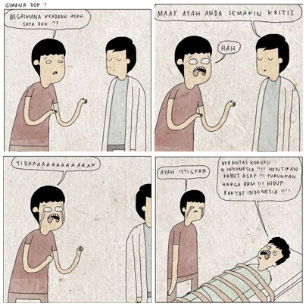
Context : A boy want to ask doctor about his father condition
Boy : Bagaimana keadaan ayah saya dok??
(how is my father condition, doctor??)
Doctor : Maaf ayah anda semakin kritis (1)
(sorry, your father is critical now)
Boy : Hah... Tidaaaaaaaak
(Hah... noooooooooo)
Doctor : Ayah istigfar (2)
(Dad istigfar please)
Father : Berantas korupsi di Indonesia!!! Hentikan kabut asap!! Turunkan harga BBM!!! Hidup rakyat Indonesia!!!!
(combating corruption in Indonesia!!! stop the smog!!! Lower the price of vehicle fuel!!! Stay strong indonesian !!!)

The dialog begun when a boy wanted to know his father condition. However the doctor said that his father has serious condition. Based on number 1 and 2 infrined the quantity maxim because the doctor gave the pelonastic answer. Moreover, The data have two forms implicature. The sentence (2) “Maaf ayah anda semakin kritis” is a representative implicature and the its function was explaining the father’s condition. On the other hand, the sentence (4) “Ayah istigfar” has a directive implicature and The implicature function was begging his father to get aware with his condition.
- Data 14. Episode 309

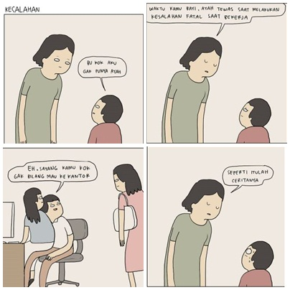

Context : A boy asks to her mother about where is her father
Boy : Bu kok aku gak punya ayah (1)
(mom, why i dont have a dad?)
Mother : Waktu kami bayi, ayah tewas saat melakukan kesalahan fatal saat bekerja (2)
(when you was a baby, your father died when do the fatal mistake in working)
Husband : Eh, sayang kamu kok gak bilang mau ke kantor (3)
(Eh, dear you don’t talk to me if you want to go to office)
Mother : Seperti itulah ceritanya.(4)
(that is the story)

The datum broke the manner maxim because when a kid asked her mother about why he does not have a dad. The mother only responded that “Waktu kamu bayi, ayah tewas saat melakukan kesalahan fatal saat bekerja (2)” and “Seperti itulah ceritanya (4)”. In the sentence (2) and (4) showed that the mother did not answer the question clearly. Thus the information was unclear and it has an ambiguous meaning such as his dad can die because of the accident in office or dismissal from his work or having an affair.
In the sentence “waktu kamu bayi, ayah tewas saat melakukan kesalahan fatal saat bekerja (2)” indicated the representative implicature. the implicature explained his father's death due to a fatal error. It has multiple meanings, such as accidents or getting fired. However the picture on the panel three, when her mother came, dad was holding another woman in the office. It explained that his father had an affair with another woman. Thus the function of the implicature was explaining his father's death due to an affair in the office.

- Data 8. Episode 220

Context : A couple talks when they ride a motorbike.
Boy : Sayang maaf yah? (1)
(dear sorry?)
Girl : maaf kenapa? (2)
(Why you say that?)
Boy : aku masih ajak kamu pakai motor buat jalan-jalan (3)
( I am still using motorbike to ask you going to outside)
Motorbike : Bunuh aku bang!!! Bunuh!!! (4)
(kill me please!!!)

A big couple rode their motorbike and a boy apologized that he still picked up his girlfriend by motorbike. Then a girl responded that she still loved him. The illustration showed the manner maxim. This data has two forms implicature. The first, in the sentence (3) “aku masih ajak kamu pakai motor buat jalan-jalan” contained representative implicature that the boy was shy with his vehicle. It has functioned as showing the boy’s shame. The second sentence in the number 4 “Bunuh aku bang!!! Bunuh!!!” has a directive implicature that the motorbike asked the driver to kill itself because they have much weight. It has functioned as the asking killed.

- Data 20 Episode 307
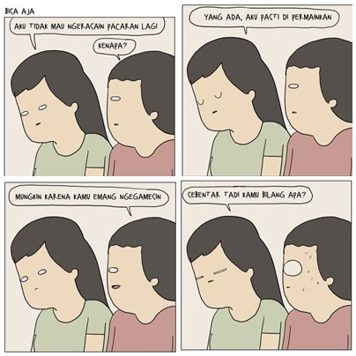

Context : A girl tell about her bad experience in relationship.
Girl :Aku tidak mau ngerasain pacaran lagi (1)
(I do not want to have a boyfriend again)
Boy : Kenapa?(2)
(Why?)
Girl : Yang ada, aku pasti dipermainkan (3)
(I think that I must be betrayed)
Boy : mungkin karena kamu emang ngegamesin (4)
(maybe ... because you are funny)
Girl : sebentar tadi kamu bilang apa?(5)
(Wait what did you say?)
A girl told to her friend that she did not want to have any relationship because the boys betrayed her. However, her friend misunderstood about her words in the number 3 “dipermainkan” and he said that “mungkin karena kamu emang ngegamesin”. She heard the word “ngegamesin” so she become angry to him. The data contravened the relation maxim because the sentnces were not related to each other. In addition, the data have the representative implicature because in the sentence 4, the boy wanted to explain that she was funny or cute. It did not mean to agree her statement in number 3. Thus the data has funtioned as the explaining the boy’s words.
- Data 16 Episode 354
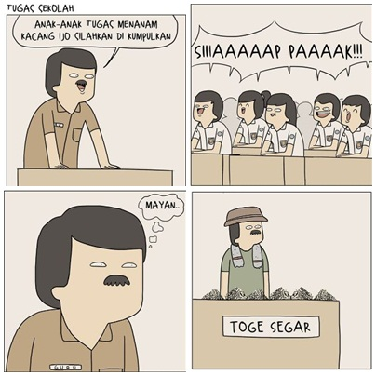

Context : A teacher gave a task to bring the mung bean
Teacher : anak-anak tugas menanam kacang ijo silahkan dikumpulkan (1)
(please collect your task of planting mung bean)
Students : Siaaaap (2)
(Yes )
Teacher : Mayan... (3)
(Great!)

A teacher gave a task to plant mung bean. When the learning was begun, the teacher asked to collect the task because he wanted to sell the mungbean that was showeb in the picture “toge segar”. The sentence 3 “Mayan... “ contravened the manner maxim because the sentence has the multiple meaning that can be purpose to express his happines or to praise students’s task. Moreover, the data also have the representative implicature. The sentence “mayan..” was connected with the picture showed that teacher was happy because he can sell much mung bean. Thus the data has functioned as the showing the teacher’s excitement.

- Data 25. Episode 416

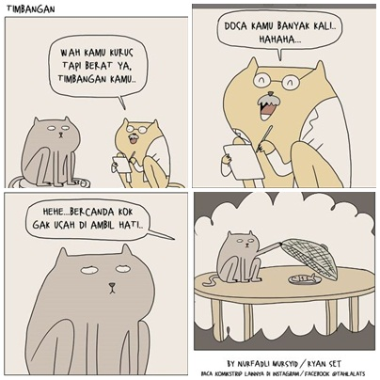

Context : The grey cat consults his problem to doctor
Doctor cat : wah kamu kurus tapi berat ya, timbangan kamu... (1)
(wah you are thin but your weight are heavy)
Dosa kamu banyak kali hahaha... (2)
(Maybe you have much sin hahaha...)
Hehe... bercanda gak usah diambil hati (3)
(Hehe... I am kidding so don’t think it much)
Grey cat : Huft
A gray cat consulted his problem to a doctor and the doctor said that he was thin but his weight was heavy. Then, he felt making the wrong things because he stole the food on the table. the datum contravened the relation maxim because the doctor's answer did not relate to the context. In addition, the sentence "(2) Dosa kamu banyak kali hahaha.. " contained the representative implicature and the function is showing or insinuating the gray cat.

- Data 27 Episode 426
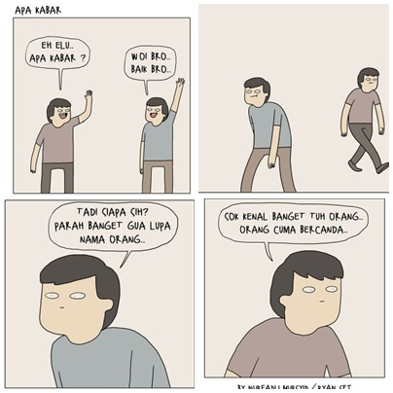

Context : Two men meet each other in the street
Man 1 : Eh elu apa kabar? (1)
(Hi how are you?)
Man 2 : Woi Bro... Baik bro (2)
(Hi... I am good bro)
Man 1 : Tadi siapa sih? Parah banget gua lupa nama orang... (3)
(Who was he? I forgot his name)
Man 2 : Sok kenal banget tuh orang ... orang cuma becanda (4)
(He acts as if he knew anyone, I am just kidding)

The conversation began when two men met and asked about their life. However they did not know each other. The data obeyed the quantity maxim because when a man said “how are you?” and one man answered “i am good”. The information was given suitable with the question. Moreover in the sentence 3 and 4 showed that they did not know each other. Thus, the data has representative implicature and the function was showing that they did not know each other.

- Data 30 Episode 453

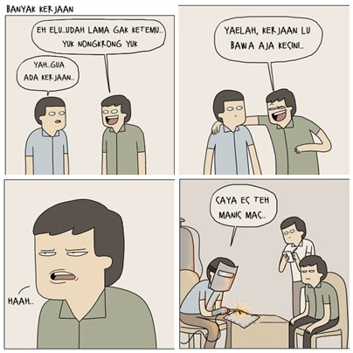

Context : Two men do not meet for a long time
Man 1 : Eh elu.. udah lama gak ketemu yuk nongkrong yuk (1)
(Hi we have not met for a long time. Let’s hang out)
Man 2 : Yah gua ada kerjaan (2)
(Yah... I have a job)
Man 1 : Yaelah kerjaan lu bawa aja kesini (3)
(Yaelah... bring your work here)
Haah...
(Haah...)
Man 2 : saya es teh manis mas (4)
( I order ice tea)

A man did not meet his friend for a long time and suddenly he met him. He invited his friend to hang out outside but his friemd has a job. Then he said “Yaelah kerjaan lu bawa aja kesini” and he brought the job when they were meeting. The data contravened the manner maxim because “the man 2” did not answer the question directly (showed in the sentence 2). In addition, the sentence 3 “Yaelah kerjaan lu bawa aja kesini” meant that described his work can be discussed together when they were hanging out. However in the picture his friend brought the real work when they were meeting. Thus, the data has representative implicature and the function was derscribing the man’s purpose.

- The directive implicature
- Data 7. Episode 163
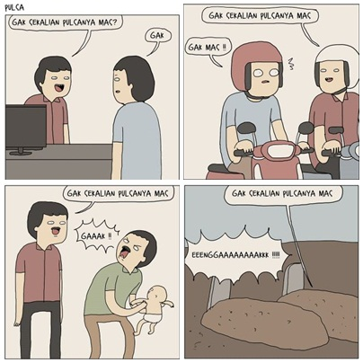

Context : A man goes to the shop and the seller always says the same words.
Seller : gak sekalian pulsanya mas?(1)
(Anything else, credit please?)
Man : Gak
(No)
Seller : gak sekalian pulsanya mas?
(Anything else, credit please?)
Man :Gak!!
(Noo!!)
Seller : gak sekalian pulsanya mas?
(Anything else, credit please?)
Man : Tidaaak!!!
(Noooo!!!)
Seller : gak sekalian pulsanya mas?
(Anything else, credit please?)
Man : Tidaaaaaaaaaaaaaaak!!! (2)
(Nooooooooooooooooooo!!!)

A man buys something in a shop and a seller ask the man who wants to buy credit or not. The datum obeys the quantity maxim. The data have two forms of implicature. The first, in the sentence (1) “gak sekalian pulsanya mas?” has a directive implicature that a seller suggests a man buy his credit. It happens repeatedly in the dialog, so the seller asks the man to buy the credit. It has two functions as the suggesting and asking. The second, in the sentence (2) “Tidaaaaaaaaaaaaaaak!!!” contains representative implicature. The implicature is a man shows that he does not need a credit. Thus the inference is the man does not want to buy a credit but the seller forces the man to buy his pulse by asking many times.

- Data 10. Episode 235
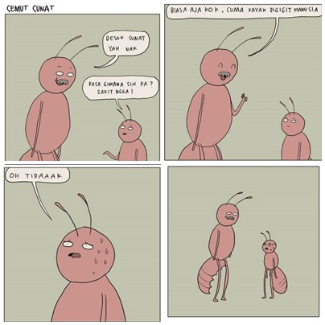
Context : A father asked his son to do a circumcision
Father : Besok sunnat yah nak (1)
(tommorow do circumsion. Ok?)
Son : rasa gimana sih pa? Sakit ngga? (2)
(How is the feel dad?)
Father : biasa saja kok, Cuma kayak digigit manusia (3)
(just fine, it only likes getting bitten from human)
Son : oh tidaaak (4)
(Oh nooo)

From the sentence (2) a son asked how it felt to be circumcised. Then the father answered in the sentence (3) and gave more responds such as “Cuma kayak digigit manusia”. The data violated the quantity maxim because a son only asks about the feel of getting the circumcision, but the answer has the excessive information. If the father obeyed the quantity maxim. He will only answer “yes or no” to describe the question.
In the sentence (3) “Biasa aja kok. Cuma kayak digigit manusia” included to the directive implicature. The implicature was used to ask his son doing the circumcision. In the fact that the father was doing the circumsion and lost his a half of stomach (abdoment) that is showed in the picture. In addition his son knew about how the feeling of doing circumsion through his father stomach. Thus, the implicature has function as the asking his son to get the circumssion.

- Data 15 Episode 340

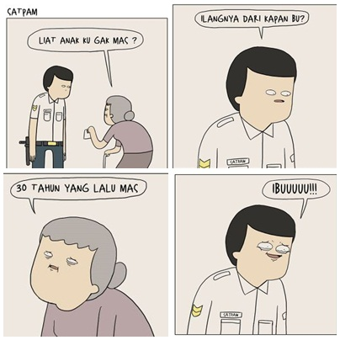
Context : A grandmother goes to police to look for her son
Grandmother : Liat anak ku gak mas? (1)
(do you look my son mr?)
Policeman : ilangnya dari kapan bu? (2)
(when is your son gone mam?)
Grandmother : 30 tahun lalu mas (4)
(30 years ago)
Policeman : Ibuuuu (5)
(mammmm....)

A grandmother looked for her son and she asked to a policeman. He asked when was her son gone? And she said that it was 30 years ago. Then the policeman only said “mom” and he was crying. The data contravened the quantity maxim because the policeman’s answer did not suitable with the grandmother’s question. Besides that, The sentence 5 “Ibuuuu “ showed that the data has the directive implicature. The function was begging to the grandmother to stop searching her son again because he lost for 30 years ago.
- Data 17 Episode 361
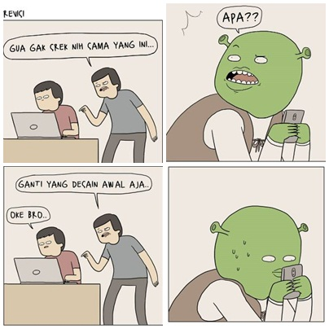
Context : A shreak is looking his phone and suddenly a man calls his name
Man 1 : Gua gak srek nih sama yang ini... (1)
(I dont like (srek) with this one)
Shreak : apa?? (2)
(What??)
Man 1 : ganti yang desain awal aja (3)
(chance with the first desaign)
Man 2 : Oke bro (4)
(Okay Bro)

A shreak was looking his phone and suddenly a man called his name. However, the man did not mean to call his name “Srek”. He said the sentence 1 " Gua gak srek nih sama yang ini” to his friend. The data contravened the relation maxim because there was any misunderstanding between a man and shreak in the picture. Then, the sentence 1 “Gua gak srek nih sama yang ini” showed the directive implicature because the word “srek” meant to order his friend doing what is the man said. Thus the function was ordering his friend to chance the design.
- Data 21 Episode 377


Context : A couple loses in the forest and the boy throws away the compass
Girl : kenapa kompasnya dibuang? (1)
(why did you throw away the compass?)
Boy : Itu ibarat aku yang tak perlu kompas untuk mengarungi hatimu, agar aku tersesat dihatimu selamanya (2)
(I do not need a compass so I can get lost in your heart forever)
Girl : Aaaww co cweet (3)
(ah... so romantic)
A couple lost in the forest and the boy threw away the compass because he did not need a compass to love her. Then they did not have the compass, they were died in the forest. The data contravened the quantity maxim because the boy’s answer was excessive and dis not suitable with the girl’s question. In the sentence 3 “Aaaww co cweet” has the directive implicature because the girl liked the boys’s word and begged to hear it more. Thus the dat has functioned as the begging.
- The expressive implicature
- Data 2. Episode 27
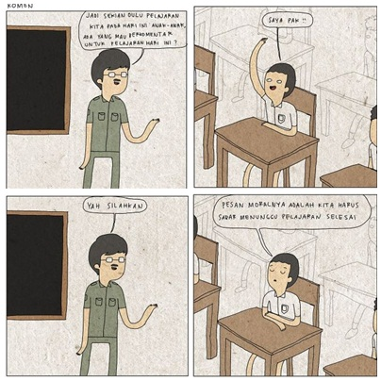
Context : students is listening teacher’s speech in the front of class and teacher wants to close the meeting.
Teacher : Jadi sekian dulu pelajaran kita pada hari ini anak-anak ada yang mau berkomentar untuk pelajaran hari ini?
(So we close our meeting today. Is there any comment for this lesson today?)
Student : saya pak!!
(Yes, sir!!)
Teacher : yah silahkan
(yes please)
Student :pesan moralnya dalah kita harus sabar menunggu pelajaran selesai(1)
(the moral value is we have to be patient waiting the lesson finished)
Before a teacher want to close the meeting, he ask a question about the moral of the material today to his students. A student responds that the moral value is students have to be patient waiting the lesson finished. The datum obeys the quality maxim because the student gives the fact information about the situation in the classroom. IN sentence (1) “pesan moralnya dalah kita harus sabar menunggu pelajaran selesai” has a expressive implicature and the implicature function is beefing about the lesson.
- Data 8. Episode 165
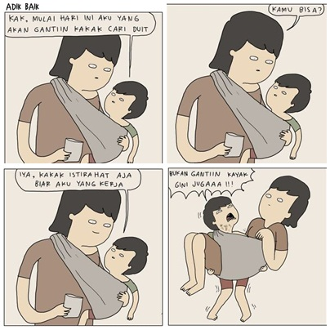

Context : a brother wants to help his sister getting the money\
Brother : kak, mulai hari ini aku yang akan gantiin kakak cari duit (1)
(sis, today I will chance you to get the money)
Sister : kamu bisa? (2)
(are u sure?)
Brother : Iya, kakak istirahat aja biar aku yang kerja (3)
(yes, you take a rest and I work it)
Bukan gantiin kayak gini jugaaa!!! (4)
(it is not like that!!!)
There was a sibling beggar. As a respectful sister, she always got money for her little brother with carrying him. Suddenly her little brother said to his sister that he wanted to help for getting money.However, she just understood that he wanted to replace her position to earn money with holding her as she was done to her brother. The data conravenced the relation maxim because there was any misunderstanding between sister and little brother. Then the sentence 4 “Bukan gantiin kayak gini jugaaa!!!” has an expressive implicature because the brother beefed about his sister action. Thus the function of the data was beefing to his sister.

- Data 3.episode 244
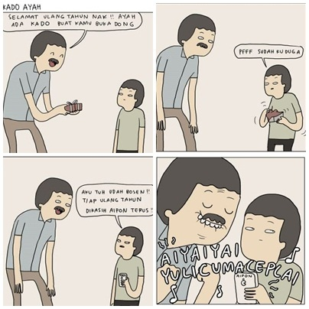

Context :The father give a present for his son in his birthday
Father : Selamat ulang tahun nak! Ayah ada kado buat kamu buka dong (1)
(Happy birthday son! Dad has a gift for you, please open it)
Son : Pfff sudah kuduga (2)
(Pfff I knew it)
Aku tuh udah bosen! Tiap ulang tahun dikasih aipon terus (3)
(I have bored! Dad always give me aipon in my birthday )
“Aiyaiyai yulicumaceplai”

Father gave a present for his son’s birthday, but his son beefed that he alwasy accepted the same present. The data contarvenedd the manner maxim. Moreover, in a sentence number 3 “aku tuh udah bosan!! Tiap ulang tahun dikasih aipon terus” has the expresive implicature. It means that a kid complains about his birthday present because his father always give aipon (one of the handphone brands) to him as the birthday gift. In the fact that it is just a toy. Thus the data has functioned as the criticising to his father.

- Data 26 Episode 419
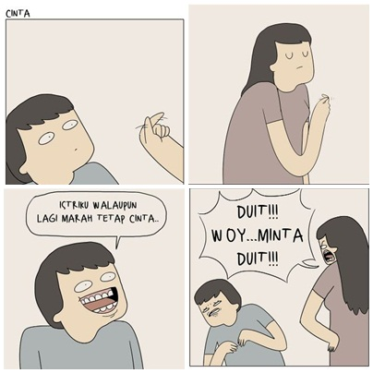
Context : A wife forms a liitle love from her fingers
Husband : Istriku walaupun lagi marah tetap cinta.. (1)
(althought my dear is angry, she still love...)
Wife : Duit !! Woy... minta duit!!! (2)
(Money!!.. I ask money!!!)
A husband looked his wife with the sullen expression but she formed her hand like a little love to the husband. Then the husband assummed that she was not angry anymore. However it meant that she wanted to ask money. The data contravened the relation maxim so there is any misundertanding between husband and wife. In addition the sentence number 1 “Istriku walaupun lagi marah tetap cinta” has the expressive implicature because the husband evaluated his wife that she still loved him though she was angry. Thus , the data has functioned as praising his wife.

- Data 18. Episode 366

Context :A father wake his son to go to school
Father : Hey bangun mandi, sekolah!!! (1)
(hey wake up! Go to school!!!)
Son : Males airnya panas(2)
(I am lazy because the water is hot )
Ya baiklah (3)
(okay)

A father asked his son to take a bath because he must go to the school. However his son was lazy because the water was hot. Father was angry. After that, he bathed in the hell (their home). The data contravened the manner maxim because the sentence was connected each other. The sentence number 2 “males airnya panas” included to the expressive implicature. A father wants to wake his son and asks to his son bathe. The data has functioned as beefing if the water is hot.

- Data 22 Episode 388

Context : A father and his son are in the desert
Son : Pah kebelet pipis (1)
(Dad I want to pee)
Father : Kita cari toilet dulu ya nak (2)
(Wait kid, after we find a toilet )
Son :hmmm (3)

A father and his son were losing in the desert. Suddenly a son wanted to pee but his father said that he can pee after they find a toilet in the desert. The data obeyed the quantity maxim because the opposite speaker answered the question clearly. In addition, the sentence number 2 “Kita cari toilet dulu ya nak” and number 3 “hmmm” have the expressive implicature because the father promised to his son that he can pee after find the toilet. However It was impossible to find toilet in the desert, so his son only said “hmmm” that can mean “yes or impossible”. The data has functioned as the criticising for father’s decision.

- The commissive implicature
- Data 11 Episode 241
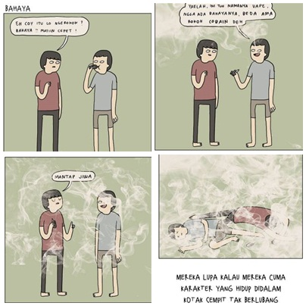
Context : there are two men in the comic panel. Then suddenly a man smokes in the box.
Man 1 : Eh coy itu lo merokok ! bahaya !! matiin cepat! (1)
(Eh Bro.. you are smoking ! dangerous! Throw it !)
Man 2 : Yaelah ini tuh namanya vape, ngga ada bahayanya, beda ama rokok cobain deh (2)
(Yaelah It is a vape that is not dangerous like cigarette. Try it)
Man 1 : Mantap jiwa (3)
(Great)
There were two men in the comic panel. Then suddenly a man smoked in the box. His friend has remembered him if smoking is dangerous now. However, his friend also did the same action like him. Then they were die because they cant breath. The data contravened the quantity maxim. Moreover the data has the commissive implicature because in the sentence number 1 “Eh coy itu lo merokok ! bahaya !! matiin cepat!” meant to threat a man that was dangerous to smoke in the box. Thus the data has functioned as the threating to a man who was smoking.

- Data 10. Episode 368

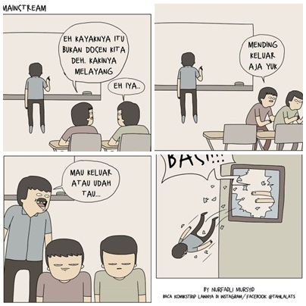
Context : Two students are studying in the classroom
Student 1 : Eh kayaknya itu bukan dosen kita deh. Kakinya melayang (1)
(Eh he is not our lecturer. His foot is flying)
Student 2 : Eh iya...(2)
(yes)
Student 1 : Mending keluar aja yuk (3)
(Let’s go to outside)
Lecturer : Mau keluar atau sudah tau (4)
(Want to go outside or you have known it)
Student 1 &2 : Basi!!!
(awful!!)

Two students were studying in the classroom and they knew that the lecturer was not human because of his legs hovering. When they wanted to get out from the classroom, he came and said that "want to come out or already know ..". However, students reply with the word "basi!!". The word basi or awful meant that there are many stories that tell about the ghost lecturer so they have known about him.The data contravene the manner maxim, because the information did not give directly. It was shown in the sentence (4) “mau keluar atau udah tau...”. The sentence can be meaningful to insinuate that the students were afraid of him. Using a sarcastic phrase was not illustrated the information directly.
In the sentence (4) “mau keluar atau sudah tau” has the commissive implicature because the implicature can influence the partner to do the speaker’s speech. The phrase described that the ghost lecturer threatened the students that he was a ghost and asked his students to get out. Thus, the data has functioned as the threatening the students that know about him as the ghost.

- The declarative implicature
- Data 3. Episode 54
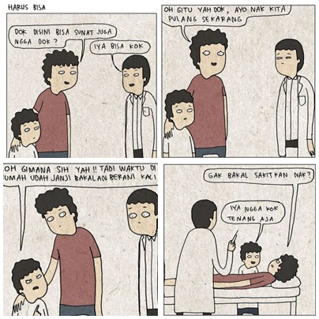
Context : Father and his son come to the doctor
Father : Dok disini bisa sunat juga ngga dok?
(Doctor, can do circumsion here?)
Doctor : Iya bisa kok
(Yes you can)
Father : Oh gitu yah dok, ayo nak kita pulang sekarang (1)
(oh... let’s go home son)
Son : Loh gimana sih yah!! Tadi waktu di rumah udah janji bakalan berani kali ini (2)
(Hey Dad!!, you have promised to me become the brave man)
Father : Gak bakal sakitkan nak?
(Is it not hurt son?)
Son : Iya ngga kok tenang aja
(yes Relax Dad)
A father and his son came to the doctor doing the circumcision, but the father was afraid to do the cicumcision. The his son clamed his father. The datum obeyed the relation maxim because the dialog was connected each other. Moreover, the data have two forms of implicature. The first, in the sentence (1) “Oh gitu yah dok, ayo nak kita pulang sekarang” contains declarative implicature that father wants to cancel the circumsion. The function is canceling the circumsion. The second, in the sentence (2) “Loh gimana sih yah!! Tadi waktu di rumah udah janji bakalan berani kali ini” is a commissive implicature that is threating his father, who has promised to him getting the circumsion, in the front of doctor. The function is threating his father to do the circumsion.
- Data 4 Episode 123
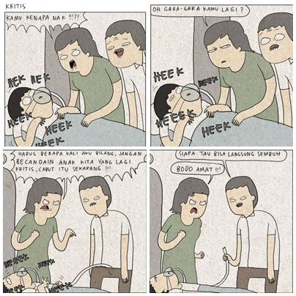
Context : Parents look after their son, who is sick, in the hospital and suddenly his son has a critical condition.
Mother : kamu kenapa nak??
(what’s happen son??)
oh gara-gara kamu lagi?
(oh ... because of you ya?)
harus berapa kali aku bilang, angan becandain anak kita yang lagi (1)kritis, cabut itu sekarang!!!
(How many times I tell that don’t joke our son. he has serious condition, remove it now!!!
Father : siapa tau bisa langsung sembuh
(who knows can heal immediately)
Mother : Bodo amat
(Whatever!)
Parents looked after their son who was sick in the hospital. Suddenly his son has a critical condition because the father did joking with his son. Then, his wife was angry with him because his son has a bad condition. The conversation violates the quantity maxim. The mother asked about why his son has the bead condition to her husband, but his husband has unpropriate answered with the mother’s question. The conversation became well when it obeyed the quantity maxim. Moreover, the sentence (3) “harus berapa kali aku bilang, jangan becandain anak kita yang lagi kritis, cabut itu sekarang!!!” has declarative implicature that mother prohibited her husband to play with her son who has the critical condition. Thus, the implicature function was prohibiting her husband.
- Data 5. Episode 137
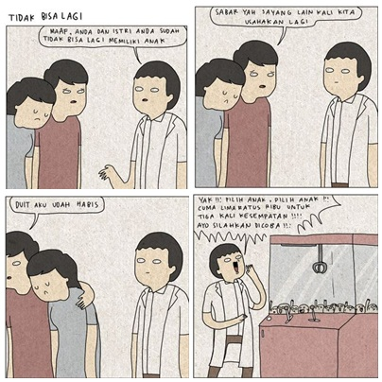
Context : A couple consults to a doctor because they want to get a kid)
Doctor : Maaf anda dan istri anda sudah tidak bisa lagi memiliki anak (1)
(I am sorry you and your wife can not have a baby again)
Husband : (2) Sabar yah sayang lain kali kita usahakan lagi. Duit aku udah habis
(Be patient dear, we can try again next time. I dont have money)
Doctor : Yak!! Pilih anak, pilih anak!! Cuma lima ratus ribu untuk tiga kali kesempatan!!! Ayo silahkan dicoba (3)
(choose child, pick one!! Just five hundred thousand on three occasions !!! Let's try it)

A couple came to a doctor because they wanted to have a baby. However the doctor said that they can not have a baby again, because they were failed to pick up the baby from the machine (in the picture). The data contravanced with the manner maxim. In addition, the sentences "sabar yah sayang lain kali kita usahakan lagi." and " Duit aku sudah habis", included to the declarative implicature. He prohibites his wife to seek an advice from the doctor because the doctror provides an opportunity to have children such as the game "claw machnie "and the price is expensive five hundred thousand. The function is prohibiting his wife.

- Data 5. Episode 155
Context : Parents look after their son, who is sick, in the hospital and suddenly his son has a critical condition.
Mother : kamu kenapa nak??(1)
(what’s happen son??)
oh gara-gara kamu lagi?(2)
(oh ... because of you ya?)
harus berapa kali aku bilang, jangan becandain anak kita yang lagi kritis, cabut itu sekarang!!! (3)
(How many times I tell that don’t joke our son. he has serious condition, remove it now!!!
Father : siapa tau bisa langsung sembuh (4)
(who knows can heal immediately)
Mother : Bodo amat (5)
(Whatever!)
Parents looked after their son who was sick in the hospital. Suddenly his son has a critical condition because the father did joking with his son. Then, his wife was angry with him because his son has a bad condition.
The conversation violates the quantity maxim. The mother asked about why his son has the bead condition to her husband, but his husband has unpropriate answered with the mother’s question. The conversation became well when it obeyed the quantity maxim. Moreover, the sentence (3) “harus berapa kali aku bilang, jangan becandain anak kita yang lagi kritis, cabut itu sekarang!!!” has declarative implicature that mother prohibited her husband to play with her son who has the critical condition. Thus, the implicature function was prohibiting her husband.
- Data . Episode 280
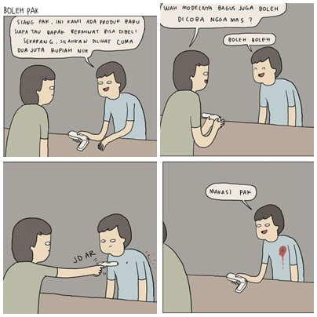
Context : A man wants to buy something and a seller offers him a pistol
Seller : siang pak, ini kami ada produk baru siapa tau bapak berminat bisa dibeli sekarang, silahkan dilihat Cuma dua juta rupiah nih (1)
(Good afternoon sir. We have a new product here. It is only two million rupiah. Are u interested sir?)
Buyer : wah modelny bagus juga boleh dicoba ngga mas?(2)
(Wah.. the model is good. May I try it?)
Seller : boleh boleh (3)
(yes of course)
”Jdar!”
Seller : makasi pak (4)
(Thanks sir)
A man wanted to buy something and a seller offers him a new product that was a pistol . Then the man tried the pistol to the seller. The data obeyed the manner maxim because the communication betwen a man and seller was well. In addition, the sentence number 2 “wah modelnya bagus juga boleh dicoba ngga mas?” included the declarative implicature because the man decided to shoot the seller because he offered the expensive thing. Thus the data has functioned as deciding to kill the seller.
- Data 28 Episode 428
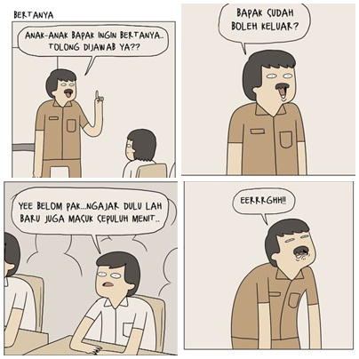
Context : A teacher teaches in the classroom and suddenly he asks something to his students
Teacher : anak-anak bapak ingin bertanya tolong dijawab ya??(1)
(Students, May I ask you a question?)
Bapak sudah boleh keluar (2)
(Can I come out now?)
Student : Yee belom pak... ngajar dulu lah baru masuk sepuluh menit... (3)
(Yee... No sir... you just come 10 minutes in class)
Teacher : Eerrggghh!!

A teacher teaches in the classroom and suddenly he wanted to come out from the class. Then his students did not permit it. The data obeyed the relation maxim because the conversation happens continuously between teacher and student. Moreover the sentence 3 “Yee belom pak... ngajar dulu lah baru masuk sepuluh menit”showed the declarative implicature because the implicature meant to prohibit the teacher.Thus the data have functioned as the prohibiting.

For simplicity, here is a summary of the results of the analyses summarized in table 1. The recapitualtion of the data analysis. It is accompanied also by the maxim of the cooperation principle, and the form and function of the implicature of the conversation.as follows:

Table 1. The recapitulation of data analysis
No  Data | Episode |  |  | The types and forms of Implicature
No  Data | Episode | violation | Compliance | representative | directive | Expressive | commissive | Declarative
1 | 20 | Quantity |  | explaining | begging
2 | 27 |  | Quality |  |  | Beefing
3 | 54 |  | Manner |  |  |  | threating | canceling
4 | 123 | quantity |  |  |  |  |  | Prohibiting
5 | 137 | Manner |  |  |  |  |  | prohibiting
6 | 155 |  | Manner |  |  |  |  | prohibiting
7 | 163 |  | Quantity | Showing | Suggesting  Asking
8 | 165 | Relation |  |  |  | Beefing
9 | 220 | Manner |  | explaining
10 | 235 | quality |  |  | Asking
11 | 241 | Quantity |  |  |  |  | Threating
12 | 244 |  | Manner |  |  | complaining
13 | 280 |  | Relation |  |  |  |  | deciding
14 | 309 | manner |  | explaining
15 | 340 | Quantity |  |  | begging
16 | 354 | Manner |  | Showing
17 | 361 | Relation |  |  | ordering
18 | 366 |  | Relation |  |  | Beefing
19 | 368 | Manner |  |  |  |  | Threating
20 | 307 | Relation |  | Explaining
21 | 377 | Quantity |  |  | begging
22 | 388 |  | Quantity |  |  | Criticising
23 | 397 | Manner |  |  |  | Criticising
24 | 400 | Manner |  |  |  |  |  | prohibiting
25 | 416 | Relation |  | Showing
26 | 419 | Quality |  |  |  | Praising
27 | 426 |  | Quantity | Showing
28 | 428 |  | Relation |  |  |  |  | Prohibiting
29 | 452 | Relation |  |  |  | Praising
30 | 453 | Manner |  | explaining
 | Total | 20 | 10 | 9 | 7 | 8 | 4 | 7

