Available online at: http://ejournal.undip.ac.id/index.php/parole

Naming Places Of Worship In Lamongan:
Language Identity Linguistic Landscape Studies
Muhammad Farihul Qulub*, Roosi Rusmawati, Dany Ardhian
Universitas Brawijaya, Malang, Indonesia

A B S T R A C T A R T I C L E I N F O

This study aims to investigate and reconstruct the language identity in Mataram as Adipura City. The problem focuses on how the form and pattern of language identity in Lamongan to maintain Adipura City in East Java. This research uses Linguistic Landscape Theory, which describes lingual existence, linguistic ideology, and lingual competition. The research method uses a phenomenological approach with a qualitative descriptive type of research, although some information uses numerical data. The target of the study is language identity in Lamongan with the most popular language pattern instruments, namely Indonesian, Arabic, Javanese, Sanskrit. The research target can formulate a pattern of language identity in Lamongan as a cultural and religious center. The results of the study can model the language identity scheme in Lamongan in the pattern of language choice towards naming places of worship, bilingual Indonesian and Arabic are more dominant, but also found Indonesian, Arabic, Javanese to Sanskrit contained in monolingual and multilingual which there are patterns of language choice found in Lamongan
Paper type:
Research Article

Article history:

Keywords:
- Linguistic landscape
- Languange Identity
- Lamongan

Introduction
Language identity is a phenomenon that is widely encountered because there are several experts who say that almost 2/3 of the world's population is estimated to speak two or more languages (Ferdiyanti, 2016; Firdausiyah, 2019). Someone who has differences from their language and tribe always uses being the mother tongue for a way of communicating to find out the identity of their language (Curtim, 2014; Dagenis, et al, 2014). Then, when in an educational institution, a person learns Indonesian because the language is the language of instruction in schools or in government institutions (Abdillah, 2019). Not infrequently when someone enters the international class or because of certain needs there are demands to learn foreign languages, for example English, Arabic, or Chinese and Korean, we become multilingual (Erlita, 2014).
The multilingual phenomenon in society is very strong, this is supported by the phenomenon of nicknames of unique cities or places, not just trademarks in their notifications for the city (Abdillah, 2019; Backhaus, 2009; Auliasari, 2019). Like several regions that have nicknames from the central government with one of the clean cities and good and varied governance (Annisa, Pertiwi & Mulyono, 2021). This is in line with the information on the Lamongan One Data Website (SDL), the number of Javanese living in Lamongan is 70% Javanese and 30% Madurese, Arab, European, Chinese, Banjar and Sumatran, although the majority of people living in Paciran District are Javanese. Lamongan area has facilities for places of worship such as mosques, churches, temples, monasteries and temples. Places of worship are the spiritual needs of religious people in carrying out the obligation to worship God Almighty (Jahdiah, 2018; Rohimi, 2019). Places of worship have consideration of constraints with the condition and location of buildings that are easy to visit against building facilities and infrastructure to be supporting factors for worship activities (Gischa, 2021, Ardhian, et al, 2021).

* muhammadfarihulqulub9@gmail.com (Farih)

This identity is one of the variations of language in society, relations and social activities, as a means of identifying the existence of a community. Language is used as a marker of social change in society (Andriyanti, 2019; Butler, 2015). According to Blommaert "Language, in that sense, is the most immediate and direct identifier of people and the most immediately sensitive indicator of social change". In the sense that when we see, hear or read the use of language around the environment there is a change, then we are able to identify it as a symptom of social change. language used in public spaces accentuates certain language usage behaviors (Daniel, 2016).
According to Shohamy, the language that can be found in public spaces, especially in public signs, is often referred to as the "linguistic landscape" (Shohamy, 2009). Studies in the linguistic landscape often attempt to investigate the responsibilities of multilingualism and analyze the importance of language indicated in public signs (Alex 2015, Gorter 2017). The study of linguistic landscapes has proven how different forms of language are displayed in public spaces (Gorter, 2015). In addition, the notion of linguistic landscape cannot be separated from the definition of linguistic landscape proposed by Landry and Bourhis (1997). They state that linguistic landscapes can be street names, shop signs usually located in front of stores, billboards, and also public signs in government office areas. They also propose a linguistic landscape function, that is, an Informative and Symbolic function. Landscape linguistics (LL hereafter) is a new field of applied linguistics that focuses on language being displayed and exposed in the public sphere. LL was introduced by Landry & Bourhis in 1997 which paid special attention to the various written languages that appear on public road signs, billboards, street names, place names, commercial store signs, and general signs on government buildings in an area, region, or urban agglomeration (Yendra & Artawa, 2020).
According to Gorter (2006), it is explained in more detail that the linguistic landscape analyzes the use of textually formatted language that is displayed and exposed outside public spaces, including the use of various signs displayed together with the language (Purwanto & Filia, 2021). Research in LL studies aims to understand more deeply the role of space and place in relation to language, exploring the relationship between signs and their place in public spaces in more detail, especially in multilingual areas. In LL's research, ethnographic methods are used that focus on the activity of exploding experience or lingual meaning through language variations in naming in public spaces (Mulyawan, 2020).
Public signs do not appear as they are, but of course, public signs have manufacturers who have produced them, such as business people or professional designers who order public signs from certain agencies. This person is called the actor of the linguistic landscape (Gorter, and Cenoz 2017) In his research, Gorter and Cenoz. divide linguistic landscape actors into two actors: Bottom-up and Top-down Linguistics Landscape. In previous research conducted to investigate the field of linguistic landscape. The first is a study conducted by Ben-Rafael (2015). This study analyzes how the use of English as a lingua franca in the city centers of Brussels, Berlin, and Zabarjad in the era of globalization (Albury, 2019; Al-Athwary, 2021). The study found that globalization did not lead to a symbolic decline in society; English became important in the city center; and migration results in environments that speak their language (Mulyawan, 2019; Annisa, 2021; Adnan, 2019), their research lays down the points of landscape linguistic research, especially the use of language for road boards, names of government structures in a place, street names, banners, public road signs, shop names and urban areas or communities. Landscape linguistics examines language signs found in public spaces.
Futhermore, this study is different from some of the previous studies mentioned above. The difference is, this study focuses on the Lamongan area and the naming of places of worship. While some previous research was conducted in the city centers of Brussels, Berlin, and Zabarjad and East Asia focusing on public information boards and signs. This study also used a naming system in the name of places of worship with a focus on the language used to influence the area of worship, socially or economically. This study focuses on naming places of worship both monolingual, bilingual, and multilingual found in naming places of worship in Lamongan. There has been a lot of research on the use of linguistic landscapes in several places. However, previous research using the pattern of planting systems in places of worship, especially in Lamongan, has not existed. Therefore, researchers are very interested in researching the naming system of places of worship in Lamongan. Thus, this study uses linguistic landscape theory as an analysis pattern in the naming system.
This study analyzed the linguistic landscape in Lamongan and border sub-districts. This analysis uses two theories. The first theory is about the functioning of linguistic landscapes developed by Landry and Bourhis (1997). The second theory is the theory of Ben-Rafael (2009), Shohamy and Gorter (2006) which discusses linguistic landscape actors. These theories are used to investigate the problem statement of this research. There are two principle elements of linguistic landscape studies as shown by Landry and Bourhis (1997) Based on the explanation above, that the linguistic landscape of naming places of worship in Lamongan Regency through language identity is related to natural, cultural and social phenomena that can be interpreted as a function of language signs in public spaces in certain groups and can be connected with current language signs. The reason for conducting the LL (Linguistic Landscape) study on the phenomenon of naming places of worship is to clearly know the naming of language identity and strong multiculture on its social.

Methods
Qualitative research is research that intends to understand phenomena about what is experienced by research subjects such as perception, motivation, action and others, holistically, and by means of description in the form of words and language, in a special natural context and by utilizing various scientific methods (Wang, 2015; Yavari, 2016). As pointed out by Backhaus (2007), each LL approaches not only with research questions, but also with research domains (linguistic, historical, sociological, economic, demographic, sociolinguistic). Regardless of the academic field in which the analysis may have been established, research can usually be structured into at least three distinct phases: the initial theoretical construction of the criteria for the "unit of analysis" and the observed context; fieldwork on the chosen context and final examinations and considerations based on the elements collected.
Descriptive qualitative method research design was applied in this study. Qualitative research aims to explain phenomena in depth through the collection of such deep data (Backhaus, 2007), . Therefore, this study is subjective, so researchers need in-depth analysis to get validation of results collectively based on data calculations. Researchers participate in the place to be studied, namely naming places of worship which are central places for worship located in Lamongan and using linguistics as data.
The scope of this research is landscape, meaning that it records in detail the naming of places of worship in Lamongan, both digitally and on records. The primary data from this study is in the form of grammatical texts for naming places of worship in Lamongan. Secondary data include a wide range of factual information and literature that strengthens the investigation. The research was conducted in the Lamongan area as a whole starting from south Lamongan, Lamongan city and north Lamongan. In addition, the choice in naming places of worship is because it is the center of daily community activities and is the identity of diverse religious communities in Lamongan, even East Java.
This study used two instruments. First, the researcher as the core instrument has full control over the research process. In this case, researchers used tables of validity of public spatial language patterns and parameters of lingual mapping categories in Lamongan. Data collection is done using methods, techniques, and strategies. Methods used in the form of documentation and literature. Documentation methods are used to record or photograph various equivalents of language in public spaces. The documentation process is carried out using recording and recording/portrait techniques, namely documenting in writing and visual language in naming places of worship. The strategy used is entangling conversation, meaning that researchers document lingual markers of worship planning language by being directly involved in activities (Mbete, 2010). The library method is used to examine various literature and written sources in the form of data outlets, symposium results, journals, and some of the latest research results. The technique used is to cross-compare, which is to find accurate results from the research conducted, then compared and controlled by several research results and in-depth theoretical dictation. The strategies carried out by researchers in comparing research data and controlling research results are as follows:
- Categorization of language identity patterns in places of worship
- Reconstruction of language dimensions for revitalization in places of worship
- Mapping patterns of language identity construction based on religion
- Perform reductions and latest presentations
Data analysis techniques in this study as a method of analyzing linguistic features of data samples which include the type of language used, meaning, and function of all data samples (Akindele, 2011). Based on the steps as follows: (1) the place was observed by researchers then captured images on the language displayed including, signs of naming places of worship in Lamongan, then conducted interviews to find out identity patterns in naming names in terms of language. (2) The researcher classifies and calculates the data which then exists in a tabulated table of the types of linguistic landscapes of signs naming places of worship. (3) The researcher describes the categories of any type of linguistic landscape and then analyzes them to give a more detailed explanation of the signs obtained. The data found were patterned in the form of categorization based on the genre of information and the number of data appearances in public spaces. As well as using the data validation stage for verification in the stage of concluding and ensuring that data analysis is in accordance with the problems and data findings, each problem does not deviate from the research objectives.

Results and Discussion
Language selection in naming places of worship is one of the variables the namer decided to show that language choice is also a factor that indicates the identity of language in each place of worship of his religion. Language in commercial signs plays both a communicative role and a symbolic function. It shows the power relations and position of language speakers within a region as well as adherents of their religion.
Table 1. Language Choice for Naming Places of Worship in Lamongan Regency

The results of collecting images of language contained in the linguistic landscape of naming places of worship there are three religions that appear in the classification. Islam is a religion that dominates with a variety of languages, Indonesian the highest in use which is then followed Indonesian-Arabic then there is a bilingual-based language that appears with a relatively low percentage. The languages are distributed into monolingual forms, and bilingual and monolingual.
It is quite clear that among the three languages, Indonesian (81%) with the majority religion of places of worship Islam, Christianity and Buddhism each with a relatively small percentage pattern but there are variations with the bilingual pattern system. Of these three religions, it is also a center of observed research, with the most commonly seen in public signs in many places of worship. The second language that appears most in public signs is bilingual Indonesian-Arabic (5%) with a Muslim majority. Meanwhile, bilingual Indonesian-Javanese languages (3%) appear in Islam and Christianity are placed in third place with few marks, and each (2%) is found in bilingual Indonesian-Sanskrit and Javanese-Arabic. There is also the use of multilingual found with a percentage (2%) using Indonesian-Arabic-Javanese. This shows that in every place of worship, the most widely used monolingual sign is Indonesia. This phenomenon could occur due to the lack of unregulated language policies in the area as per information from local area interviews.
Therefore, the language used also only uses Indonesian because the purpose of public signage for society is based only on clarity rather than expanding a globalizing regional landscape (Helty, et al. 2023). When entering another village, one might expect to see many phenomena, such as appeals, road signs etc. to be written in English/Arabic, especially in Lamongan where ilahiyat and human/natural sciences are taught. The global environment is expected to be felt by people who aim to have a position in the placement of language in places of worship. However, judging from the small landscape of the coastal Lamongan area, where some villages have a style of writing places of worship in Indonesian and Javanese/script periodically, this policy refers to most still written in monolingual form, especially in Indonesian.

Monolingual Indonesian
Contrary to the religious and linguistic diversity of the Lamongan people which is one of the tourist destinations, and some places of worship that are icons of worship in Lamongan, the following figure does not represent this diversity in its linguistic landscape.
Table 2. Monolingual Indonesian (BI) Form
Religion | Number | Form
 |  | Mono-BI
Islam | 3 | 5%
Kristen | 1 | 2%
 | Total
 | 4 | 7%

The survey results show that some places of worship have a monolingual form, from 4 places of worship affiliated in Islam and Christianity. This place of worship has a monolingual form found using Indonesian. The use of monolingual in this study shows the results as shown in figures 1 and 2, namely there are Indonesian used. Monolingual use in public spaces refers to the use of a single language. Its general objectives include: facilitating effective communication with a common language; minimize confusion of understanding information in public spaces; assist and maintain the promotion of cultural identity through a particular language

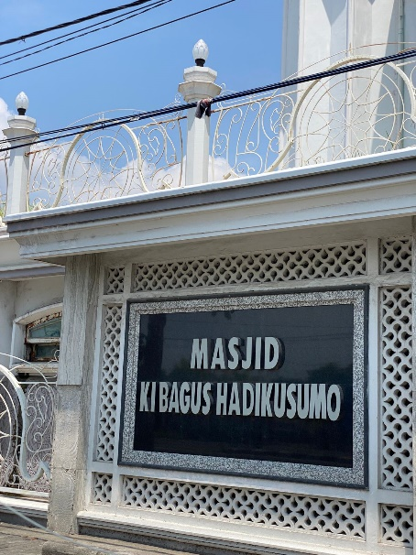 | 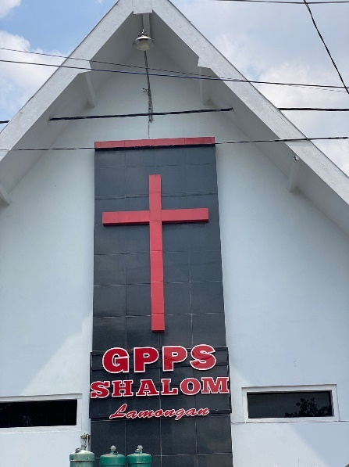
Figure 1. Monolingual in Masjid | Figure 2. Monolingual in Gereja

The landscape in figure 1 is an image that has a symbol as a naming of national figures indicated by the mosque signboard. The use of black around the words "Masjid Ki Bagus Hadikusumo" as a background of the color landscape that states the naming symbol in the landscape is in the form of emphasis on the character. The landscape in figure 1 shows the use of national figures in the naming of mosques. The naming of the mosque was taken from the name of the figure Ki Bagus Hadikusumo as a symbol in the Muhammadiyah organization to make him the Chairman of PP Muhammadiyah in 1944-1953. In addition to his work in the organization of Muhammadiyah, Ki Bagus Hadikusumo is also a member of BPUPKI. In the landscape, the name of the figure is quite familiar to the Lamongan community, especially on the campus of the University of Muhammadiyah Lamongan, as well as people outside the region. The use of the names of national figures in the linguistic landscape at universities can indicate a symbolic function to symbolize the organizational culture of the Muhammadiyah community.
While Figure 2 shows that GPPS is actually centered in Surabaya, but most of it is also in Lamongan with efforts to establish religious communities. This proves that the social aspect in society that has protestant Christianity has a high percentage of existence in Lamongan, but in reality today some people also worship at GPPS Surabaya for reasons of religious policy. Another social tradition is the variety of official communication used in formal contexts, such as in regulations or ways of respecting other religions. Characteristics include explicit and consistent grammatical use, full use of affixes, use of official pronouns, use of standard words, following EYD guidelines, and avoiding elements related to a particular region. While the unofficial variety is used in informal situations, such as in social interactions or personal conversations. Broadly speaking, the variety used by the Lamongan community who have protestant Christianity is contrary to the official variety.

Bilingual Javanese-Arabic
Another finding regarding language selection is Javanese-Arabic. The BJ-BA pattern used is an Arabic name that is identical to Islamic religious identity which is varied with identical Javanese.
Table 3. Bilingual Javenese-Arabic (BJ-BA) Form
Religion | Number | Form
 |  | Bili. BJ-BA
Islam | 1 | 2%
 | Total
 | 1 | 2%

This result has a relatively low frequency in using Arabic sentences in naming places of worship around (2%), this search result is about naming places of worship that are thick using Arabic-Javanese terms that are in accordance with Islam in Lamongan. Seeing this, it is not surprising that there are names that use names in Javanese-Arabic. The presence of names in Javanese-Arabic collaboration.
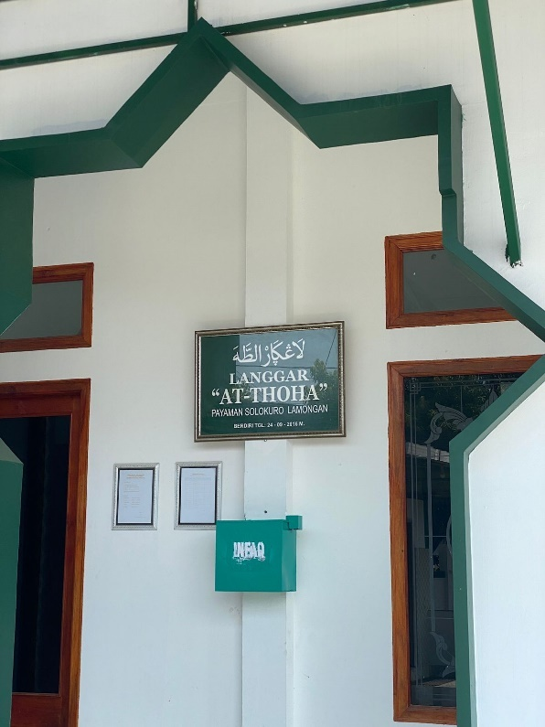
Figure 3. Bilingual in Langgar

Javanese language does not appear much in Lamongan, only a few names of buildings, places of worship or historical places, which are still maintained and preserved as historical tourism (heritage tourism). It is also not used in speech, in all its domains. It is also not learned in formal schools at all levels. So, Javanese is a local language that must be preserved where its function is to connect the history of the past with the present.
Figure 3 is proof that Javanese is able to bridge traditionality and historical preservation. Javanese is not considered an ancient language. In fact, Javanese language is able to enter the joints of preservation which actually substitutes the role of Arabic, especially in Islamic places of worship. As explained above, Langgar is the name of a place of worship with ancient Javanese writing (see picture). Langgar is a substituted phrase of Musholla where this second name is more popularly used in mosques in general. This step of substitution with ancient architecture became a symbol where locality was able to 'call' historical preservation. The local community, which is predominantly ethnic Javanese, is aware that Javanese is able to take part in the midst of modernity.
Figure 3 has a similar meaning to the previous images. Musholla and Langgar refer to the same meaning, which is a place of worship. In these two images, there are two things that can be analyzed, namely the use of Javanese language and the meaning of places of worship. While the meaning of "Thoha" has a sacred definition, where the meaning of the two texts in the picture above, this langar is a symbol of Muslims, especially Javanese people, to seek holiness where this sanctity refers to a place of worship. If Langgar At-Thoha has an ancient meaning in the midst of modern naming in general, in this case it ensures that Javanese language is able to become a bridge between traditional and historical preservation in Lamongan.

  - Bilingual Indonesian-Javanese
Along with the development of the times, language collaboration in the naming system of places of worship is also increasingly massive, this is found about language selection is a combination of BI-BJ.
Table 4. Bilingual Indonesian-Javanese (BI-BJ) Form
Religion | Number | Form
 |  | Bili. BI-BJ
Islam | 2 | 3%
Kristen | 2 | 3%
 | Total
 | 4 | 6%

This bilingual pattern uses the BI-BJ code used in this study, its use is in Islam and Christianity which are both dominant in their names. Although the frequency is relatively the same in naming around (3%), the results of this search are about the long history of Islamic places of worship in Indonesia. Seeing this, it is not surprising that many places of worship use names in Arabic and Indonesian. The presence of Indonesian-Arabic names and especially both Christianity and Islam in the picture cannot be ignored.
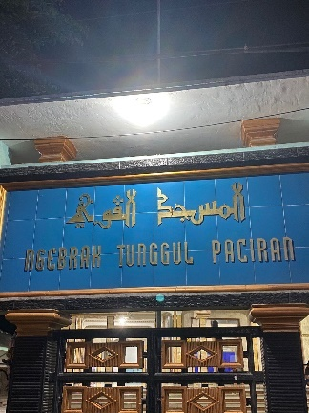 | 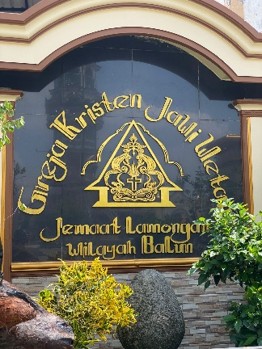
Figure 4. Bilingual in Masjid | Figure 5. Bilingual in Gereja

The bilingual or bilingual use in naming places of worship is indicated by the use of Indonesian-Javanese/. The presence of environmental factors affects the use of bilingual language used. Bilingual in public spaces has a purpose in its use, including facilitating intergroups that communicate using two languages; encourage cultural and linguistic integration especially in public spaces that use different languages; recognize and respect the rights and diversity of languages within a region.
Figures 4 and 5 use bilingual language. Figure 4 is bilingual Indonesian and Javanese. The picture was taken from the "Ngebrak Mosque" section which has the meaning of banging was taken from the northern Lamongan area which is said to be to expel Dutch colonialists from their village. The function of using these two languages as a pointer for visitors or tourists. The use of Indonesian followed by Javanese can be said to be a form of language identity, which is Indonesian as the unitary language of the State of Indonesia, and Javanese as a companion language. Therefore, the placement of Javanese language is under Indonesian. Furthermore, figure 5, the use of two languages, namely Indonesian with Javanese. The selection of the use of Javanese language in the board is a form of identification of the research location. Picture 5 was obtained in the Pancasila ethnic village which has a very high sense of tolerance and is still thick with Javanese culture.
While figure 4 is bilingual between Indonesian and his noble language. The use of Indonesian as a form of warning for visitors in the northern Lamongan Area, while the selection of quotes in Javanese as a form of reflection of the concept of cultural customs used by the ngebrak village community in Lamongan. Finally, in the 5th picture which is a combination of Indonesian and Javanese. Indonesian here only use the word "Lamongan Jama'at", as a form of welcome for Christians who have just entered the area. Then followed by the use of Javanese language written "Jawi Wetan", which is used as a form of identification that the area is in East Java.

  - Bilingual Indonesian-Sanskrit
Lamongan is synonymous with typical culinary. One of the pillars of smooth culinary activities is the image of tourists, both domestic and foreign. Although many foreign tourists are pictures, the results of the picture do not show the dominant use of English in naming places of worship but there is the use of Sanskrit, only one image is found by mixing Indonesian with Sanskrit and even then does not refer directly to the social community there, Although relatively borrowing Indonesian words is more than before, but the naming of Sanskrit is maintained.
Table 5. Bilingual Indonesian-Sanskrit (BI-SKT) Form
Religion | Number | Form
 |  | Bili. BI-SKT
Budha | 1 | 2%
 | Total
 | 1 | 2%

This picture is in the Pancasila Ethnic Village by showing the religion in the region with the existence of various different religions and ethnicities, Sanskrit as a mixture of two languages found in the naming of places of worship.
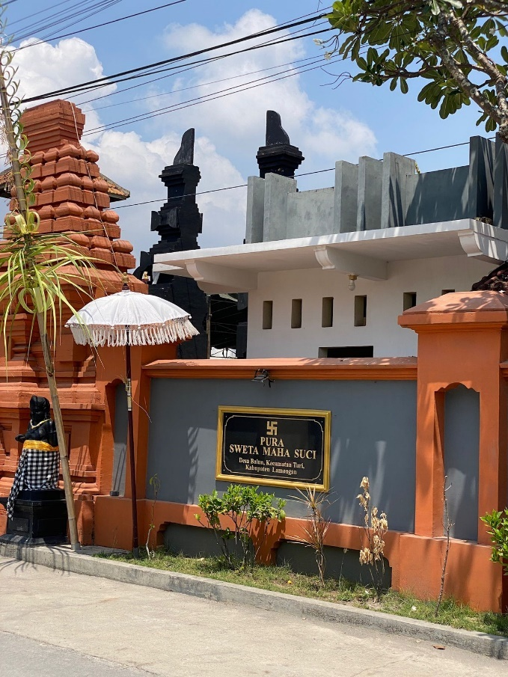
Figure 6. Bilingual in Pura

The picture in picture 6 is located in the hamlet of Pancasila where its existence has a very thick culture. In fact, Hinduism in Pancasila Hamlet has something very personal, so that in its life it is often difficult to analyze using a sociological perspective. It is true that religion is on the one hand individual, but on the other hand it is also social. Hinduism in a sociological perspective is seen as a belief system revealed in certain social behaviors in society, where every behavior it undergoes is always related to the belief system of the religious teachings it adheres to. Individual behavior and social aspects are driven by internal forces that are based on the values of religious teachings that internalize before and sometimes such beliefs bring subjectivity in religion. Sianipar (2021) added that Hindu religion in its subjective place of worship can actually be objectified in various expressions that have a certain structure so that it can be understood. Similarly, the Hindu community (Lamongan) is religious socialistic. His religious subjectivity based on belief (Sradha) is objectified through bhakti in the form of carrying out yadnya ritual activities, which can never be separated from his attachment to the social aspects of society.
Therefore, with the spirit of communality and sociality, Hindus in this pancasila hamlet are very enthusiastic about carrying out yadnya in all social strata that bind them both family ties (pasametonan) on the basis of descent (soroh / wangsa), and regional ties (banjar / traditional villages). The existence of Hindus in a socio-religious context, on the one hand, the yadnya activities carried out in addition to having a transcendental function are related to individual (vertical) obsession with the object of worship, namely Hyang Widhi Wasa/God Almighty, in fact also has a social function (horizontal). That the yadnya ritual activity also aims to intensify social relations between various elements in the strata of society, both those motivated by kinship / kinship ties (genealogical), work / profession (swagina), and territoriality (territorial).

  - Bilingual Indonesian-Arabic
Indonesian and Arabic have a very influential existence in the naming system of places of worship. Researchers found bilingual patterns Indonesian-Arabic very much. Some of the lexicons in this picture refer to the semantic meaning in Arabic in the mention of Islamic places of worship.
Table 6. Bilingual Indonesian-Arabic (BI-BA) Form
Religion | Number | Form
 |  | Bili. BI-BA
Islam | 46 | 81%
 | Total
 | 46 | 81%

This picture uses the BI-BA code with the existence of a Lexicon that is closely related to one of the Islamic cultures in the Lamongan area. This shows the pattern of existence of Indonesian Arabic is widely used along with the development of the times related to places of worship. These results show that most places of worship are bilingual with Arabic Indonesian having a percentage (81%) affiliated mosques.
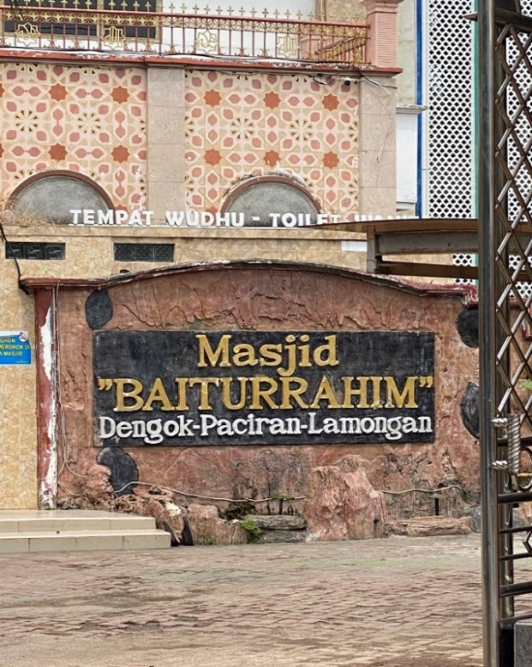 | 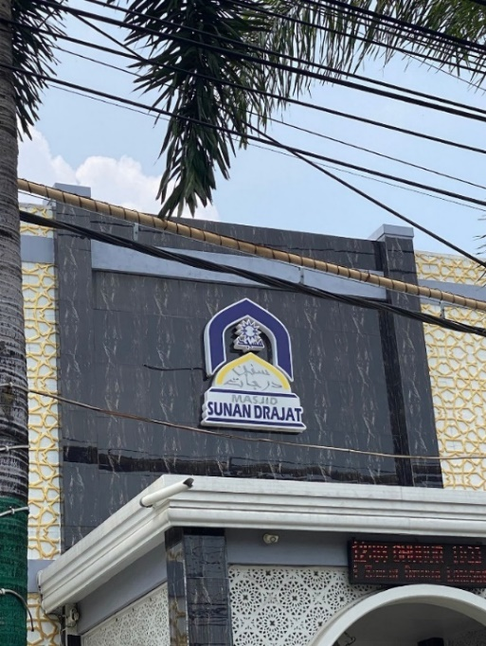
Pigure 7. Bilingual in Masjid | Pigure 8. Bilingual in Masjid
Picture 7 is the inscription on the signboard in the mosque "Baiturrahim Mosque" which in Indonesian is interpreted as a house of brotherhood. While figure 8 The purpose of the writing is as a reminder for Lamongan residents to maintain the values of Sunan Drajat which teaches gentleness and care for everyone. From the naming, it is intended for the creation of a religious and tolerant Lamongan City.
From this, Indonesian contributed in building the strength of religious harmony where this is the attitude of Pancasila, the first precept of 'One Godhead'. In addition to building religious harmony, the distinctive identity of religion is still maintained. This can be seen from the presence of other languages in their contribution in public spaces, especially places of worship.
From this, Indonesian contributed in building the strength of religious harmony where this is the attitude of Pancasila, the first precept of 'One Godhead'. In addition to building religious harmony, the distinctive identity of religion is still maintained. This can be seen from the presence of other languages in their contribution in public spaces, especially places of worship.
The presence of the text in this place of Islamic religious worship provides a strong symbolic message about cultural identity and the essence of religious harmony. Language and policies for using names in mosques have the ability to construct symbols of identity and vitality of meaning groups (Du & Liu, 2021; Gambarng, et al. 2022; Chesnut, et al. 2023). In figure 7 it uses Arabic but is written in Latin Indonesian this is inseparable from the use of different writing meanings. From its name, "Baiturrahim is taken from Arabic. That is, the temple is the house and the womb is merciful. So the house of the Merciful God." This shows that we see the concept of semiotics in the Baiturrahim Mosque building in Dengok village expresses the values of local wisdom that make up the concept of dengok village which is indeed in a remote area. The local wisdom of Baiturrahim Mosque is expressed through the relationship of the concept of the Dengok community with God, its relation as a social creature / community and as a personal being. This concept is read on icon markers, indexes, and symbols. While in figure 8 The meaning that arises from the marker essentially refers to historical values, cultural concepts and Islamic values. "Sunan Drajat" in deepening the concept of semiotics is able to produce meaning in the spread of religion, especially in the transformative Lamongan pantura which stimulates the creativity of the Lamongan people to use it because this is the only mosque symbol in Lamongan with the naming of Wali Songo, this also causes cultural resonances. It is necessary to read the meaning with different methods to provide in-depth information about the meaning of the Sunan Drajat Mosque building because it raises the essence of religious and cultural harmony. Other data that shows bilingual Indonesian-Arabic is also a very deep identity so that Lamongan is one of the Adipura cities in Indonesia that has a very varied religious identity
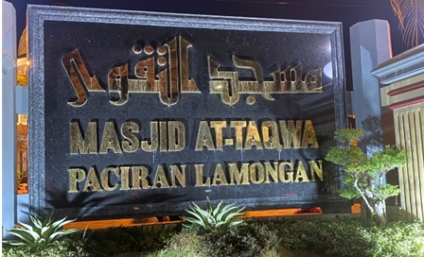
Pigure 9. Bilingual in Masjid

Figure 5 is a form of mosque name marker by showing information on the signboard presenting information about a mosque in which contains Islamic religious identity information (MASJID), the name of the place of worship (AT-TAQWA), address, information center, village. the information needed by the public to find the building is complete.
Masjid At-taqwa in Paciran is the first mosque founded by Raden Qosim Sunan Drajat who is included in Wali Songo. With its history and the virtue of worshiping in the At-taqwa mosque, this mosque has a very spiritual attraction, the meaning of "Taqwa" itself has the meaning of guarding oneself from all sinful deeds by abandoning everything that Allah SWT prohibits and carrying out everything He commands, this naming is intended for the community to be devoted to Allah SWT Of course, this naming intends to replicate Muslims so it is hoped that many worshippers will be able to worship there.

  - Multilingual Indonesian-Arabic-Javanese
Lamongan has a culture that is thick with various languages it has, such as coastal Lamongan people have names that tend to use bilingual and southern Lamongan people often use monolingual in the use of naming places of worship. However, multilingual in places of worship is also found even though the pattern and existence of naming places of worship in Lamongan that use multilingual patterns is still relatively low.

Table 7. Multilingual Indonesian-Arabic -Javanese (BI-BA-BJ) Form
Religion | Number | Form
 |  | Multi. BI-BA-BJ
Islam | 1 | 2%
 | Total
 | 1 | 2%

Table 7 shows the multilingual signs located in the Lamongan area. This multilingual sign is only found in one of several areas in the Lamongan area of worship. This phenomenon is interesting because it is related to the use of multilingual in its limited use in public signage. As per interviews with mosque administrators, this shows that the use of language in places of worship has not affected the community significantly. This multilingual is found in the mosque located in the downtown area of Lamongan.
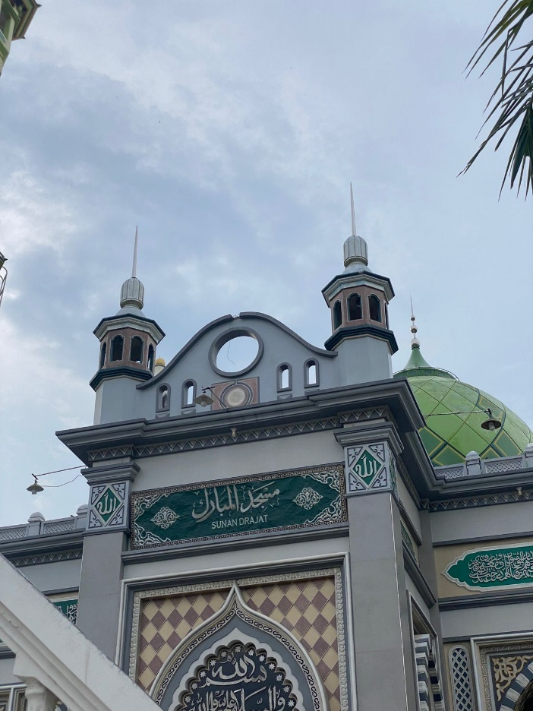
Figure 10. Multilingual in Masjid

The use of multilingual in naming places of worship is only found in the Lamongan area. Multilingual refers to the use of three or more languages in a public space. Some of the functions of using multilingual languages are: supporting communication and interaction between diverse groups and cultures within a region; facilitate trade, tourism, and cultural exchange among the many language communities; emphasizing the importance of cultural and linguistic diversity in public spaces.
Figure 10 is in the Lamongan area of the city which shows the use of Indonesian with Arabic with Javanese language used as a companion language in this area. The choice of this language is also a form of the identity of this region, which shows the identity of Muslims. The results of this study show the diversity of languages in the Sunan Drajat heritage site. Three kinds of language use were identified, namely (1) monolingual; (2) bilingual; and (3) multilingual. Of the three languages, Indonesian became the dominant language used in Sunan Drajat's heritage site. There are 3 languages used, namely Indonesian, Javanese, Arabic. This study also examines the types of signs in public spaces of the Sunan drajat Lamongan heritage area. There are three categories of language signs used in public spaces, namely warning signs, information signs, and place names. The monolingual, bilingual, and multilingual use of each language depends on the region. The linguistic landscape offers the general public an overview of the demographic composition of the region as a multicultural society as well as a form of language as a mirror of a region. This is the result of an interesting linguistic landscape, as it brings to life the confrontation of language and character in royal relics.
From some of the tables above, the multilingual aspect still does not involve how language is used, received, and influences communication in broader contexts, such as mass media, politics, culture, and social interaction. Important aspects of language use in naming places of worship in the Lamongan area can be classified into places of worship such as mosques, prayer rooms, churches and monasteries.
The use of language in the Lamongan region has important aspects in preserving history, culture, and knowledge. The use of language in a place of worship or historical place is very important because it allows visitors to understand and appreciate the history, culture, and knowledge on display. Language is the main communication tool in conveying information and stimulating visitors' curiosity. In addition, the use of diverse languages can increase accessibility and inclusion for different types of visitors.
Based on the images obtained, the focus of this study includes patterns and types of signs in the linguistic landscape. The results and discussion are taken from linguistic landscape images in the form of visual images that are randomly selected and described according to the focus of discussion.
Therefore, bilingual forms predominate in their use which include Indonesian and Arabic. In addition, bilingual signs consist of a combination of languages, namely Indonesian with Arabic or vice versa, Indonesian with Javanese or vice versa, Indonesian with Sanskrit. In comparison, in bilingual form in a language consisting of the use of more than one language (Ardhian &; Soemarlam, 2018; Julisah, 2021). Examples of images obtained include using Indonesian with script language or script with Arabic, and using Indonesian. The images obtained show that the use of language in public spaces falls into two categories. First in the information category is dominated by monolingual use, continued bilingual, and multilingual least used. The second is in the category of naming places, the existence of the use of naming places of worship monolingual Indonesian, Arabic or multilingual there is Indonesian-Arabic-Javanese.
However, bilingual Indonesian-Arabic still dominate the naming of places of worship. The results of observations in the validation test of the naming pattern of places of worship stated, The first question asked in the annex is whether respondents pay attention to public signs shown in Lamongan. According to the Likert Scale interval score, 60%-79.9% is considered "important". Therefore, based on the context of Q1 shows that most people are 'aware' of the presence of language signs in places of worship. Meanwhile, in Q2, the question weighed heavily on the Society's idea of the importance of adding multilingual signage. The response results (80%) showed strong agreement from respondents when it came to signage multilingualism. In the next question of the interview, the researcher asked specifically about people's perceptions of certain foreign languages commonly spoken in the Lamongan region. Therefore, Q3 and Q4 asked for their consent when reacting in adding English and Arabic to the signage of the place of worship. The graph shows decent agreement with both languages.
When asked about people's attitudes towards English being added to public signage in places of worship (Q3), respondents were in the affirmative (76%) while Arabic (71%) was in the affirmative. As the results show, communities are eager to see multilingual signage in their area. A positive response can be seen in (Q5) in asking the importance of administrators knowing the public signage arrangements in multilingual signs. In conclusion, it is clearly implied that the Lamongan community has a high awareness of the importance of multilingual signage to be placed in their area. Of all the questions given, the responses gathered were mostly unanimous regarding the idea of placing foreign languages in public, especially places of worship. Especially when questions are determined into Javanese and Arabic, the dominant responses have a positive attitude towards those languages. However, the community is not only aware of the demands of multilingual but also the importance of preserving Indonesia as a mother tongue even though it is necessary to learn a foreign language. At the end of the appendix section, the researcher added an open-ended question to ask if the respondents had any further comments with respect to the public signage in Lamongan. However, the section is free to decide whether to fill in or not. There are variants of responses obtained from students in expressing their thoughts. Most of them support multilingual signs to welcome the globalization environment. But there was also one response that expressed concern regarding the preservation of the dignity of Indonesian.
Therefore religious and social authorities should consider responses to develop more bilingual or multilingual signage in the area to provide a better international language environment. In addition, these results are in line with Miller's (2000) statement that language and identity are inseparable. Indonesian emerged as the most widely used language in sign proving that the Lamongan area wanted to show identity as a Indonesian or religious language identity rather than showing another identity through foreign languages. These results are also relevant to previous research by Gorter (2013), that LL maintains to have a wealth of information including Language choice, strong and powerless ideologies and others of visual signs solely appearing in the region (Mulyawan &; Erawati, 2019; Mailani, et al. 2022). Thus, by investigating the use of language in places of worship, especially in the Lamongan area, one can generate language preferences of appropriate language selection policy authorities in worship and religion. However, it also has a ranking order of languages in places of worship that must see their religious identity, namely Indonesian first, Arabic as the second and regional languages as the third. This shows that official and unofficial signs have no difference to the most dominant language used. The higher authorities and lower authorities of the two campuses show correspondence on their own sign products. Although the Lamongan Society has the potential to become a rich multilingualism community, it shows that Lamongan is still far from facing a situation of multilingualism as described by Landry and Bourhis (1997). Landry and Bourhis (1997) state that differences in the linguistic landscape situation of top-down and bottom-up signs can occur in multilingual environments where competition presents the most dominant language.

Conclusions
Public spatial planning in Lamongan has several constructions and patterns. Language construction of public space markers in Lamongan is divided into two, namely a) language construction based on regional demographic identity and b) language construction based on religion. The novelty obtained from this research is the discovery of naming places of worship in the LL dimension in Lamongan. The concept of Aadipura city in Lamongan is formed through grammatical structures and patterns in public spaces, such as: religion, culture/tradition, ethnicity, commodities, and nature/geography. This element becomes a public space in speaker interaction. Then, the categorization of literacy includes commercial, revitalization, and educational fields. These three elements become the dimensions of the conversational text in the public space of the speakers. Language markers and identities in Lamongan are built into the structure of LL in Kota Adipura encompassing text entities, populations and communities, and the distribution of places of worship names in texts
The results of this study are in the form of findings on the form of language use in the naming of places of worship in Lamongan, the function of language in the naming of places of worship in Lamongan, and the social aspects of language in the naming of places of worship in Lamongan. The data findings were obtained from Lamongan which had not been validated on the One Data Lamongan (SDL) website. This research focuses on the Lamongan area with the aim of finding research problems that are refocused on the religious sector that has a phenomenon in its naming. The selection of the Lamongan area is based on the religious sector which has a variety that continues to grow with ethnic tribes in it, so that data can be obtained with a variety of religions. In this study, 58 data were obtained, with the form of monolingual, bilingual, and multilingual language use. Data shows that bilingual language use dominates by 81%. The bilingual used includes the use of Arabic-Indonesian. This phenomenon is interesting because Javanese and Sanskrit are seen accompanying foreign languages in naming places of worship.

Reference
Abdillah, M. B. (2019). LL on Surabaya Multilingualism and Diversity of Religionss in Indonesia: Linguistic Landscape of Worship in Surabaya [Tesis]. Surabaya. Universitas Islam Negeri Sunan Ampel.
Adnan, M. S. (2019). Abreviasi pada Berita dalam Surat kabar Jawa Pos. Jurnal Belajar Bahasa Program Studi Pendidikan Bahasa dan Sastra Indonesia. Vol 4 (2). Hal.161-240.Tersedia pada http://jurnal.unmuhjember.ac.id/index.php/BB/article/view/2560/2028
Akindele, D. O. (2011). Linguistic Landscapes as Public Communication: A Study of Public Signage in Gaborone Botswana. International Journal of Linguistics, 3. doi:10.5296/ijl.v3il.1157
Ardhian, D., Purnanto, D., & Yustanto, H. (2021). Religious performance in Malang, Indonesia: Linguistic landscape on worship sign. Journal of Language and Linguistic Studies, 17(2), 983- 1000
Alex. S. (2015). Semiotika Roland Barthes. Jakarta : PT. Remaja Rosdakarya.
Al-Athwary, A. (2017). English and Arabic inscriptions in the linguistic landscape of Yemen: A multilingual writing approach. International Journal of Applied Linguistics and English Literature, 6(4), 149-162. doi:10.7575/aiac.ijalel.v.6n.4p.149
Albury, N. J. (2018). Linguistic landscape and metalinguistic talk about societal multilingualism. International Journal of Bilingual Education and Bilingualism, 1-17. doi:10.1080/13670050.2018.1452894
Auliasari, W. (2019). A linguistic landscape study of state school and private school in Surabaya. Undergraduate thesis. Surabaya: UIN Sunan Ampel
Annisa, P. & Mulyono. (2021). “Penggunaan Bahasa Di Ruang Publik Kota Jombang Sebagai Kota Santri (Kajian Linguistik Lanskap)”. Bapala Volume 8 Nomor 03 Tahun 2021 hlm.146— 156. https://ejournal.unesa.ac.id/index.php/bapala/article/vi ew/40215
Andriyanti, E. (2019). Linguistic landscape at Yogyakarta’s Senior High Schools in multilingual context: Patterns and representation. Indonesian Journal of Applied Linguistics, 9(1): 85–97.
Backhaus, P. (2009). Rules and regulations in linguistic landscaping: A comparative perspective. In E. Shohamy & D. Gorter (Eds.), Linguistic landscape: Expanding the scenery (1st ed.) (pp. 157-172). London, UK: Routledge
Butler, L. (2018). Coffee's Dark Secrets: Linguistic Variation in Starbucks and Dunkin Donuts. Lingua Frankly: the student journal of linguistics at Boston College, 4, 1-22
Curtin, M.L. (2014). Languages on display: Indexical signs, identities and the linguistic landscape of Taipei. In E. Shohamy & D. Gorter (Eds.), Linguistic landscape: Expanding the scenery(1sted.)(pp. 221-237). London, UK: Routledge.
Chesnut, M., Curran, N. M., & Kim, S. (2023). From garbage to COVID-19: Theorizing “Multilingual commanding urgency” in the linguistic landscape. Multilingua, 42(1), 25–53. https://doi.org/10.1515/multi-2022-0009
Dagenais, D., Moore, D., Sabatier, C., Lamarre, P., & Armand, F. (2014). Linguistic landscape and language awareness. In E. Shohamy & D. Gorter (Eds.), Linguistic landscape: Expanding the scenery (1sted.) (pp. 253-269). London, UK: Routledge.
Du, Y., & Liu, Q. (2021). A visualization graphic analysis on Chinese linguistic landscapes researches. Shangdong Foreign Languages Teaching, 42(3), 41–52. https://caod.oriprobe.com/articles/61600132/A_Visualizat
Daniel, K. (2016, July). Public Space. Health Bridge.
Erlita, R. (2014). The language used in the linguistic landscape found in the western part of Surabaya. Undergraduate thesis. Semarang: Diponegoro University
Ferdiyanti, I. N. (2016). Multilingualism of linguistic landscape in urban areas Surabaya. Undergraduate thesis. Surabaya: Airlangga University
Firdausiyah, H. (2019). A linguistic landscape study in pondok pesantren putri mambaus sholihin Gresik. Undergraduate thesis. Surabaya: UIN Sunan Ampel
Gorter, D. (2006). Linguistic Landscape:A New Approach to Multilingualism. Canada: Great Britain. doi:306.44'6–dc22
Gorter, D. 2017. Linguistic Landscape and Trends in the Study of Schoolscapes. Linguistic and Education. Elsevier Inc. Science Direct. Vol 44. Hal 80-85. https://www.sciencedirect.com/science/article/pii/S0898589817302899
Gorter, D., & Cenoz, J. (2015). Knowledge about Language and Linguistic Landscape. Encyclopedia of Language and Education,2nd revised edition. Retrieved from http://link.springer.com/referenceworkentry/10.1007/978-0-387-304243-160
Gischa, S. (2021). “Fungsi Dan Kegunaan Tempat Ibadah.” Compas.Com.
Jahdiah, J. (2018). Penggunaan Bahasa Indonesia Pada Media luar ruang di Kalimantan Selatan. Genta Bahtera: Jurnal Ilmiah Kebahasaan Dan Kesastraan, 4(2), 115-128.
Landry, R., & Bourhis, R. Y. (1997). Linguistic Landscape and Ethnolinguistic Vitality: An Empirical Study. Journal of Language and social psychology https://doi.org/10.1177/0261927X970161002
Mbete, A. M. (2010). Strategi Pemertahanan Bahasa-Bahasa Nusantara. Seminar Nasional
Pemertahanan Bahasa Nuasantara
Purwanto, D., & Filia, F. (2021). Fungsi Strategis Bahasa dalam Kegiatan Ekonomi: Sebuah Kajian Lanskap linguistik Iklan Restoran di Kota Pontianak. Literatus, 3(November), 123–132. https://doi.org/10.37010/lit.v2i2.82
Rohimi, R. (2019). Historis dan ritualisme tradisi ziarah makam Keleang di Dusun Kelambi Desa Pandan Indah: Studi terhadap pendekatan antropologi. SOCIA: Jurnal Ilmu-Ilmu Sosial, 16(2), 161-171.
Shohamy, E., & Gorter, D. (2009). Linguistic Landscape : Expanding the Scenery (2nd ed.). Taylor and Francis: Routledge. doi:418-dc22
Yendra, & Artawa, I. K. (2020). Lanskap Linguistik: Pengenalan, Pemaparan, Aplikasi. Yogyakarta: Deepublish Publisher.
Setiawan, I., Ibrahim, Isnaini, Muallifah Anugrah, Murojatul Aslamiah, & Nurhayati. (2021). Peran Pasar Digital di Era Pandemi pada Wirausaha Muda di Banyumulek. Jurnal Pengabdian Magister Pendidikan IPA, 4(4), 440–447. https://doi.org/10.29303/jpmpi.v4i4.1161
Sianipar, M. O. C. (2021). The dominant language used on landscapes in Medan-Indonesia. International Journal of Linguistics, Literature and Translation, 4(6), 148–154
Wang, Jing J. (2015). Linguistics landscape on campus in Japan—a case study of signs in yushu university. Intercultural Communication Studies 54(1), 123- 144
Yoniartini, D. M. (2021). Lanskap Linguistik Kawasan Pusat Pendidikan di Kota Mataram. Jurnal Ilmiah Telaah, 6(2), 162–168. http://journal.ummat.ac.id/index.php/telaah
Yavari, S. (2012).Linguistic landscape and language policies: A comparative study of Linkoping university and ETH Zurich. Master Thesis. Linkoping: Linkoping University.

