The Acehnese Numerals in the Aceh Jaya District: What are lost and retained?

**ABSTRACT**

Using data from Acehnese lects spoken in the Aceh Jaya district on the west coast of Aceh Indonesia, this study describes and compares the phonological varieties of the Acehnese words of number and uses this comparison to understand the relationship between the Acehnese and Chamic and Malay in the past. Some villages in Aceh Jaya districts were known to have peculiar Acehnese dialects, both on the consonant and the vowel aspects; Sabet (Lamno dialect), Teumareum (Daya dialect) and Alue Punti (Teunom dialect). The informants, aged between 40 and 65, were interviewed to elicit 13 numeral words in their respective dialects, the one to ten, eleven, one hundred and one thousand. The elicit words were recorded, transcribed into IPA symbols, and analysed. The results show that Acehnese and Chamic split around the time the glosses ‘eight’, ‘nine’ and ‘ten’ in Chamic were looking for their stable forms. In addition to that, Acehnese spoken on the west coast maintains evidence of early contact with earlier Sumatran natives, or probably ones that migrated from the Peninsula although some sounds, such as the lamino-dental fricative[stop] could be suspected to be inherited from the Proto-Chamic which is lost in the mainland Chamic languages.

**KEYWORDS**: numerals, Aceh Jaya, Acehnese, linguistics, Southeast Asia

1. **INTRODUCTION**

The Austronesian people are believed to have originated from Taiwan around 5,000 years ago(Blust, 1995). Their language serves as the ancestor of various languages spoken throughout Southeast Asia, numerous islands in the Pacific, and even some languages in Madagascar, Africa. Outside of Taiwan, Austronesian languages are classified as Malayo-Polynesian languages, which include groups such as Malayic, Acehnese, Javanese, Madurese, Sundanese, Bataknese, and others found in the maritime regions of Southeast Asia.

In mainland Southeast Asia, Austronesian languages are present, but there are fewer speakers. Notably, in countries like Cambodia, Vietnam, Laos, and Thailand, there are minority groups that speak Chamic languages, a specific subset of the Austronesian language family that has established its presence on the mainland. Acehnese language of Sumatra, although surrounded by Malayic languages and other Austronesian languages such as Bataknese, Gayonese, and minorities of Javanese variants, is furtherly related to those languages, and closely related to the Chamic languages of the mainland. It is still a debate whether Acehnese was one of the Chamic dialects in the past, or the sister of it. The lack of historical records made it difficult to decide the relationship between these two language groups. Thurgood (1999) claims that Acehnese is Chamic, thus placing Acehnese under the Proto-Chamic (1999). However, researchers like Blench (2010) proposed Acehnese to be a separate group that never migrated to the mainland from both the Malayo and Chamic languages’ original place, the Borneo of SEA Islands. Dyen (1971) proposed a scenario that the mainland Chamic languages originated from Sumatra, opposite to Thurgood’s and other linguists such as Durie (1985), Cowan (1991), and Sidwell (2005, 2006). Recently, Irnanda(2024a) proposed the 8 AD as the Acehnese dispersal to Sumatra using the historical and archaeological evidence of the Srivijaya series of attacks launched to the mainland. Yet, given this date is correct, it is still unknown if the ancestors of Acehnese and other modern Chamic languages were one single community during the split or speakers of a chain of dialects.

Therefore, the status of Acehnese within the Malayo-Polynesian language sub-family is complicated due to its proximity and prolonged contact with other closely related Malayo-Polynesian languages, particularly within the Malayic group, which is a sister language to Chamic. The Acehnese lexicon contains a significant number of Malayic borrowings, making it easy to confuse certain forms with the basic vocabularies derived from Chamic Austronesian sources. Additionally, the Chamic languages on the mainland have historically maintained contact, primarily through trade in and around the Gulf of Thailand, with their Malayic counterparts. To gain a deeper understanding of the linguistic evolution of Acehnese and its modern form as we encounter it today in the northern tip of Sumatra, further studies on Acehnese dialects are essential.

Numerals play a crucial role in historical linguistics, and a comparative study of Acehnese numeral systems could yield valuable insights into the evolution of this Sumatran-Chamic-related language. This research has the potential to enhance our understanding of its historical journey and linguistic connections. Malayo-Chamic people in the past are known to be traders. Thus, the Malayo-Chamic societies developed independent innovation in ‘seven’ etyma, from the PAN *siwa’ to PMP *tuzuq, proposed to have developed from root ‘index finger’ or ‘to point’, or what is known in Modern Malay as *tunjuk*. From this point, the MP developed innovations for etyma ‘eight’ and ‘nine’, but retained the etyma ‘ten’(Blust, 1994).

In Acehnese dialects, the numerals are universal lexically but varied phonologically. From four major dialects proposed in Asyik (1987), most western sub-lects of Great Aceh demonstrate unique phonological characteristics in their numeral items. Similar to the Great Aceh, some sub-lects in the Aceh Jaya areas also demonstrate peculiar pronunciations, including in their numeral systems. Therefore, the present study aims to describe and explain the phonological peculiarities of the Aceh Jaya dialects to understand their position in the Acehnese dialects grouping, and finally to see the implication of this understanding to the study of Acehnese relationship with Chamic.

**2 . METHODS**

Two main sources of data are employed in the analysis. The first one is the field data collected from nine localities within the district of Aceh Jaya from March to July 2024. The other one is the secondary data gathered from previous studies on Austronesian languages. The Chamic language data were from Thurgood (1999), the North Acehnese dialect was from Durie (1985)and Daud and Durie (1999), and Proto-Malayic data was from Adelaar (1992). Sources of other languages, including Old Javanese, Austroasiatic, Sanskrit, Tamil, and other relevant ones are cited whenever they are mentioned in the analysis and discussion.

**3. RESULTS & DISCUSSION**

* 1. Acehnese & Chamic Numerals

The table below compares numeracy systems in the Acehnese with Proto-Malayic, PMP, a modern mainland Chamic (Jarai), and Old Javanese.

Table 1. Numbers in Acehnese and Other Languages

|  |  |  |  |  |  |  |  |
| --- | --- | --- | --- | --- | --- | --- | --- |
| **Gloss** | **PAN**  **Blust (1999)** | **PMP**  **Blust (1993)** | **Proto Malayic**  **Adelaar (1992)** | **Acehnese** | **Proto Chamic**  **Thurgood (1999)** | **Modern Jarai**  **Lafont & n-văn-Trọng (1968** | **Old Javanese**  **Zoetmulder, P.J. (1982)** |
| One | *esa | *esa | *əsaʔ | sa | *sa | sa, ha |  |
| Two | *duSa | *duha | *dua(ʔ) | dua | *dua | dua |  |
| Three | *telu | *telu | *təlu | lhɛə, lhɛ: | *klɔw | klâo |  |
| Four | *Sepat | *epat | *əmpat | pɯət, pɯt | *pa:t | pă |  |
| Five | *lima | *lima | *limaʔ | limʌŋ,  liməŋ,  limɔŋ | *lima | rơma |  |
| Six | *enem | - | *ənəm | nam | *nam | năm |  |
| Seven | *pitu | - | *tujuh | tujoh | *tujuh | tơjuh |  |
| Eight | *walu | - | *dua(ʔ) alap-an/  *(ə)saʔ alap-an | lapan | *dua-lapan | sapăn, sơpăn |  |
| Nine | *Siwa | - | *əsaʔ ambil-an | si-kureueng | *samilan  *sa-lapan | duapăn |  |
| Ten | *sa-puluq | - | *sA-puluh | si-ploh | *pluh | pluh |  |
| Eleven |  | - | - | si-blah | - | pluh-sa |  |
| Twenty |  | - | *dua(ʔ) puluh | dua-ploh | *dua plʊh | duapluh | rwa-ŋ-puluh |
| fifty |  |  |  | lim(ʌ/ɔ/ə) ŋ-ploh |  | rơma pluh | lima-ŋ puluh |

Acehnese numeracy is distinct from the mainland Chamic e.g., Jarai, in two ways; first, the number nine does not follow the Chamic *dua-lapan* (two fours) mechanism, yet it follows the Malay derivational technique which results in the name for the number nine from the words *satu* and *ambilan*, translated as ‘one taken away (from ten)’. Thus in Acehnese, *satu-ambilan* translated as *si-kureueng*. The Acehnese use of different lexical items for the root ‘nine’, ‘kureueng’ instead of ‘ambil-an’ indicates an independent innovation of it from Chamic while this

Secondly, the Acehnese language differs from Jarai in terms of -teen and -ty numbers. Again, Acehnese is more like Malay than Jarai, has *ploh* only for -ty, and *blah* for -teen.

Furthermore, the use of *si-* instead of *sa-* in the word *si-kureueng* also indicated this *si-kureueng* innovation was enacted when the Acehnese morpheme *sa-* , which means ‘one’ had been replaced by *si-*. The morpheme *sa-*, according to the Acehnese Dictionary (Daud & Durie, 1999), has two meanings; ‘one’ and ‘same’. Thus, words like *saban, saho, sapat, saboh*, *saneuk*, *sadum, and sapeu* subsequently mean ‘one destination’, ‘one place’, ‘one thing’, ‘the same amount’ and ‘none’ (for a negative sentence). The morpheme *sa-* was slowly replaced by *si-* due to Malay’s *se-* /sə/ influence. Similarly, the prefix *si-* was used as quantifier for single nouns—usually following the same semantic characteristics of Malay word formation, such as; *sidroe-seorang* ‘one person’*, siblah-sebelah* ‘one side’*, sikrek-sepotong* ‘one piece (for long stick-like object’*, sineuk-sebuah* ‘one piece (for round bead-like object)’*, siulah-seulas* ‘one piece (for thin leaf-like object)’, and many more. *Sa-boh* /sabɔh/ retains in form, while its counterpart, *saneuk* /sanɯʔ/, has almost completely lost. A survey by Irnanda (2023) reported that 92.8% of Acehnese speakers (N=139) chose *saboh* as a quantifier for singular nouns in general, 5.8% chose *sineuk*, and none chose *saneuk*.

The other peculiar thing of Acehnese numeracy is the number five. For the PAN etyma *\*lima*, Acehnese seems to be the only language that has a final -ŋ reflex; *limʌŋ, liməŋ, limɔŋ*. There are two possible reasons for this phenomenon. Firstly, it is an independent innovation occurred to PAN final -a etyma, such as in *ina>inoŋ* ‘mother, woman’, and liŋa>liŋɔŋ ‘sesame’ (See section 3.8). Secondly, this final *-ŋ* could also be the result of mutation due to the PMP final *\*ŋa/*ŋ* linker for multiplying tens. In Old Javanese, *lima-ŋ puluh* means fifty (REF). It then raises a question of why the mutation only occurred in Acehnese’s five *limong*, and did not occur in the other numbers.

Overall, the innovations in the Acehnese numerals indicate that Acehnese is a Western Malayo Polynesian language that split from the Chamic relatives well early. The first had enough time to shift sounds in the first five etyma; the loss of initial velar stop *k-* in ‘three’, the rise of the vowel in ‘four’, and the accretion of the final velar nasal in ‘five’; while the latter retain the initial stop of ‘three’, some lost the final stop *-t* of ‘four’, and shift the initial liquid *l-* to *r-* in ‘five’. The Malayic adoption of *tiga* from Sanskrit for ‘three’ did not affect either Acehnese or Chamic, but the innovations of Malayic-Chamic ‘seven’, ‘eight’, and ‘nine’ seem to have occurred globally in the three languages, hinting a period of global contact between them after sometimes being split; Acehnese and Chamic were one, and Malayic was another. Given the Chamic and Acehnese were hypothesised to have gone from Borneo to the southern of Cambodia and Vietnam about three centuries before the common era, and the Malayic group to Sumatra and the Malay Peninsula around the same time, the reunion of these two groups might have occurred around the mid of the first millennium, probably through trade around the gulf of Siam.

Looking at the discrepancies between the Acehnese and Chamic, especially on glosses ‘three’ and ‘five’, the dialectal variations of Chamic might have existed after the Proto-Chamic was formed. Acehnese might have been one dialect that retained the *tl-* of ‘three’ PAN etyma, yet those that went to the north shifted to /*kl-*/. Acehnese *tl-* initial for the ‘three’ hypothesis is supported by the presence of aspirated *-h-,* which would only logically occur if the pre-form of it was *tl-* instead of *kl-*. Given this was the circumstance, the /*kl-*/ variant of gloss ‘three’ should have been spoken on the northern coast of today’s Vietnam, which is evidently by the Tsat language that reflects the gloss as *kiu33*(Thurgood, 1999).

* 1. Numerals in Acehnese Dialects: The Aceh Jaya District

Numerals in the Acehnese dialects are only varied on the level of phonology. The absence of lexical differences in the Acehnese dialects’ numerals opens the probability that the dialects were developed from long inhabitation. The shifts of the sounds could have happened from the contacts with other language speakers native to the Sumatran area. Table 2 shows the numeral comparison of the Aceh Jaya dialects and the Standard Acehnese.

Table 2. The Numerals of the Aceh Jaya Dialects from the East to the West

|  |  |  |  |  |  |  |  |  |  |  |  |  |
| --- | --- | --- | --- | --- | --- | --- | --- | --- | --- | --- | --- | --- |
| **No** | **GLOSS** | **SA (North Aceh)** | **Sabet** | **Gle Jong** | **Teumareum** | **Seumantok** | **Fajar** | **Lhok Bot** | **P. Seumantok** | **Pulo Ie** | **Tuwi Priya** | **Alue Punti** |
| 1 | *one* | *sa* | *Sə* | *sə* | *Sə* | *Sa* | *Sa* | *Sa* | *sa* | *sa* | *Sa* | *Sa* |
| 2 | *Two* | *dua* | *duə* | *duə* | *duə* | *dua* | *dua* | *dua* | *dua* | *dua* | *dua* | *dua* |
| 3 | *three* | *lhɛə* | *lheiə* | *lhɛiə* | *lhɛ* | *lɛ* | *lhɛ* | *lhɛ* | *lhɛ* | *lhɛ* | *lhɛi* | *lhɛi* |
| 4 | *four* | *pɯət* | *pɯət* | *pɯət* | *pɯt* | *pɯt* | *pɯt* | *pɯt* | *pɯt* | *pɯt* | *pɯt* | *pɯt* |
| 5 | *Five* | *limʌŋ* | *liməŋ* | *liməŋ* | *limʌŋ* | *limʌŋ* | *limʌŋ* | *limʌŋ* | *limʌŋ* | *limʌŋ* | *limʌŋ* | *limʌŋ* |
| 6 | *six* | *nam* | *nam* | *nam* | *nam* | *nam* | *nam* | *nam* | *nam* | *nam* | *nam* | *nam* |
| 7 | *seven* | *tujoh* | *tujoh* | *tujoh* | *tujoh* | *tujoh* | *tujoh* | *tujoh* | *tujoh* | *tujoh* | *tuɟoh* | *tuɟoh* |
| 8 | *eight* | *lapan* | *lapan* | *lapan* | *lapan* | *lapan* | *lapan* | *lapan* | *lapan* | *lapan* | *lapan* | *lapan* |
| 9 | *nine* | *sikurɯəŋ* | *SikuRɯəŋ* | *SikuRɯəŋ* | *SikuRɯŋ* | *Sikurɯŋ* | *SikuRɯŋ* | *Sikurɯəŋ* | *sikuRɯŋ* | *sikuRɯŋ* | *Sikurɯəŋ* | *Sikurɯəŋ* |
| 10 | *ten* | *siploh* | *Siploh* | *Siploh* | *Siploh* | *Siploh* | *Siploh* | *Siploh* | *siploh* | *siploh* | *Siploh* | *Siploh* |
| 11 | *eleven* | *siblah* | *Siblah* | *Siblah* | *Siblah* | *Siblah* | *Siblah* | *Siblah* | *siblah* | *siblah* | *Siblah* | *Siblah* |
| 12 | *Twelve* | *dua blah* | *duə blah* | *duə blah* | *duə blah* | *dua blah* | *dua blah* | *dua blah* | *dua blah* | *dua blah* | *dua blah* | *dua blah* |
| 13 | *Twenty* | *dua ploh* | *duə ploh* | *duə ploh* | *duə ploh* | *dua ploh* | *dua ploh* | *dua ploh* | *dua ploh* | *dua ploh* | *dua ploh* | *dua ploh* |
| 14 | *One hundred* | *sərətoh* | *SəRətoh* | *SiRətoh* | *SəRətoh* | *Sɯrətoh* | *Sərətoh* | *SiRətoh* | *sərətoh* | *sərətoh* | *Sirətoh* | *Sərtoh* |
| 15 | *One thousand* | *sərəbei* | *SəRəbei* | *SiRəbeiə* | *SəRəbei* | *SɯRəbɛ* | *Səribɛ* | *SiRibɛ* | *səRibɛ* | *səribɛ* | *Siribɛi* | *Səribɛi* |

In general, numerals in Aceh Jaya districts are not different to the Standard Acehnese (SA) which is based on the North Aceh dialect (Durie, 1985). Yet, bilingualism of Acehnese and a native language might probably have shifted some sounds of the proto form. The peculiarities on the phonological level in the numerals of the Aceh Jaya dialects are described and compared to the Standard Acehnese and other related languages.

* + 1. Gloss ‘one’

In Aceh jaya, the initial lamino-dental /S/ is dominant and affects the numeral of ‘one’. As illustrated in Figure 2, the lamino-dental sounds /S/, are spread to the whole district from the east to the west. Thus, the Standard Acehense /sa/ whose /s-/ sound is a lamino-dental fricative (Durie, 1985) became a stop in Aceh Jaya.

The presence of these two forms of /s/-/S/ in Acehnese as the initial sound raises a question of whether this fricative-stop lamino sound is the sound of PC before it changes to the fricative apical sound. Durie (1985) described that the Acehnese North Dialect has a fricative lamino-dental /s/ which is realised in the Banda Aceh and Great Aceh dialects as a stop with the same tongue manner. In recent decades, the younger generation who speak less Acehnese and more Indonesian Malay would diminish this laminal position and make the sound apical. Yet, it is clear that the Acehnese laminal fricative/stop sound has been present for a long time considering its widespread in two of the most important Acehnese dialects; the Great Aceh and North Aceh. This sound is also present in Pidie and West Aceh dialects.

However, is this sound inherited from the Chamic family? Or an independent innovation developed in the SEA island?

According to Thurgood (1999), the Written Cham initial /s-/ sound is transcribed as /ts-/. In addition to that, some Malayic basic words, like ‘milk’ *susu* and ‘comb’ *sisir* are respectively transcribed as *tathuw*/*tasou*, and *tasi* in Written Cham inscriptions (Thurgood, 1999). Not limited to Written Cham, this sporadic */S-/* to */t-/* sound shift also occurs in Jarai, Northern Roglai and Phan Rang Cham. Hence, from Thurgood’s data of the mainland Chamic languages /s/, the lamino dental fricative initial in Acehnese, we propose, was the sound inherited from Chamic.

The Standard Acehnese retains this fricativeness for many centuries, which is evidently seen from the lamino-dental stops in the Aceh Jaya dialects. Yet, due to the increased popularity of Malay with its apico-alveodental /s/ fricative sound, the laminal /s/ in Acehnese gradually becomes alveo-dental and apical too.

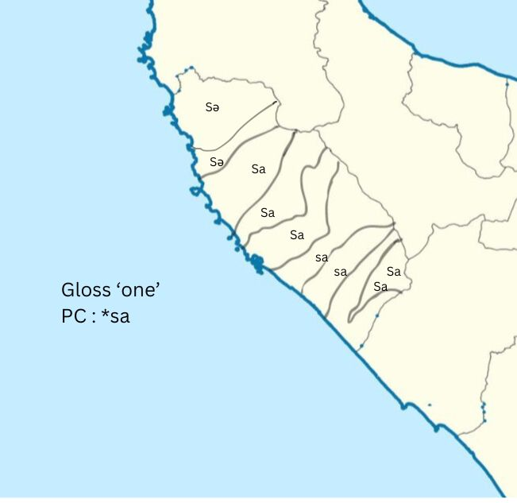

Figure 2. gloss ‘one’

* + 1. Gloss ‘two’

Moreover, in the east dialects, the Lamno and Daya dialects, ‘one’ and ‘two’ are reflexed with a schwa vowel ending instead of low /*a*/ as in the SA dialect. Other than in the east side of Aceh Jaya, this schwa final in open syllables is also common in some dialects in Great Aceh. This final schwa ending is not typical in Sumatra Malayic lects, like Tamiang in the east side of Aceh Province, or the Minangkabau whose speakers are spread on the south coast of Aceh. Instead, this feature is common in the Malay Peninsula leading to an assumption that the phonological feature is borrowed from the Peninsular Malay. The lexical comparative study of the Aslian and Acehnese(Irnanda, 2024b) captures an impression of contact between the Acehnese speakers of Sumatra and the Aslian-Malay bilinguals of the Peninsula in old times, probably as early as 800-1000 AD. The availability of final schwa in Acehnese open syllable might be the product of the bilingualism of Chamic-Acehnese and Peninsular Malayic lect in the past.

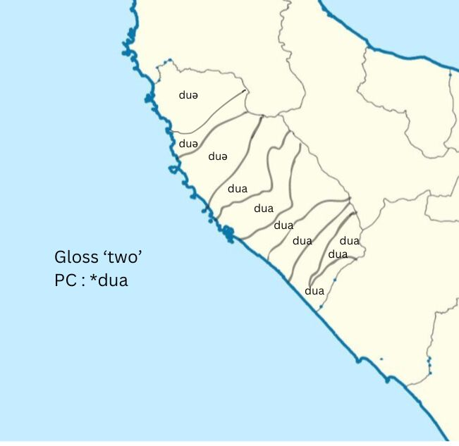

Figure 3. Gloss ‘two’

However, the final schwa is absent in western Aceh Jaya, where the open /a/ is preferred instead (See Figures 2 & 3). In the western area of the district, the final vowels in gloss ‘one’ and ‘two’ are realised as that in the Standard Acehnese and Proto-Chamic, indicating the West Aceh’s closer genetic linguistic affiliation with the northeast coast dialects.

* + 1. Gloss ‘three’

As discussed in the Introduction part, Acehnese liquid /l-/ in gloss ‘three’ is aspirated, thus probably derived from PC *\*tl-* instead of *\*kl-.* Yet, none of the variants with consonant cluster onset for gloss ‘three’ is ever encountered in Acehnese dialects. However, Acehnese spoken in Jaya, specifically the speakers of the Lamno dialect (village of Sabet in Table 1), realise the diphthong of the open syllable slightly distinct from the SA. The peculiarity lies on the first vowel of the diphthong; the Lamno people reflect the PC diphthong’s back open-mid vowel *-ɔ- as a front close-mid vowel /-e-/. Compare this to the SA’s front open-mid /-ɛ-/. See Figure 4.

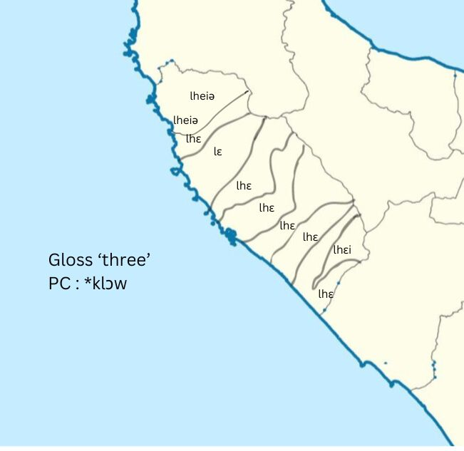

Figure 4. Gloss ‘three’

Based on this finding, it seems logical that the Standard Acehnese reflex of PC *-ɔ- diphthong in the final syllables is an innovation that occurred in the Lamuri area, which included today’s Jaya. The open-mid variants should predate the closed-mid one spoken in Lamno as this form is closer to PC, but a complete comparison using lects of the Pidie and Great Aceh district should be studied to understand the whole journey of this sound change.

* + 1. Gloss ‘four’

In PC, the nucleus of the one-syllable word ‘four’ is a long vowel *\*-a:-*. Meanwhile, in the SA and the Lamno dialect, it is reflected as diphthong /-ɯə-/, and more to the west of the Aceh Jaya district, it becomes a monophthong */-ɯ-/*. This rise of PC open-front vowel *\*a:* to the unrounded back close vowel /ɯ/ occurs in many other main closed syllables of PC */*a:/.* According to Irnanda (2024a) this innovation occurred in the mainland and is parallel with the rise of the same PC vowel in Cac Gia Roglai and Phan Rang Cham to unrounded central close vowel */ɨ:/* for glosses of ‘betel nut’ and ‘gold’ (Lee, 1998).

The PC long vowel /a:/ is not completely lost in the Acehnese ‘four’ as both the Standard Acehnese and the easternmost dialects of the Aceh Jaya district retain it in the form of diphthong. More to the west of the district, the diphthong is reduced to a monophthong. This could have been caused by the employment of Acehnese as a second language by speakers of Karonese or other Austronesian natives that dwelled around the region many centuries ago. Alternatively, this monophthongisation could have started recently with the increasing popularity of Indonesian Malay.

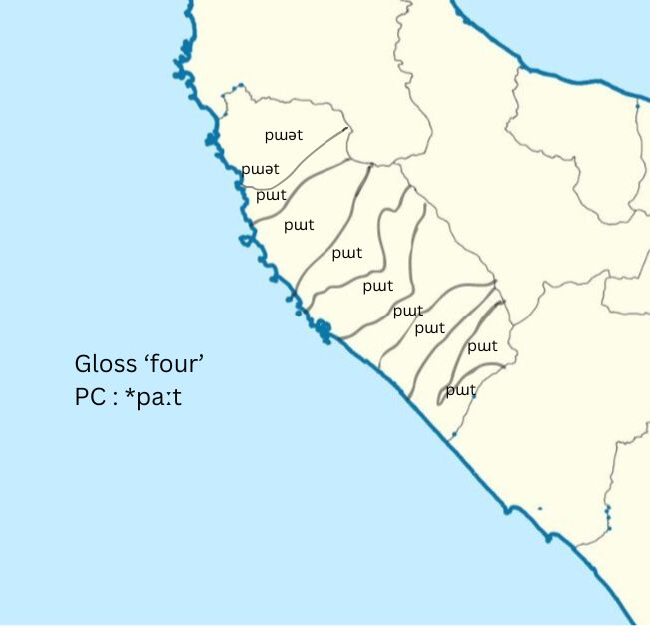

Figure 5. Gloss ‘four’

* + 1. Gloss ‘five’

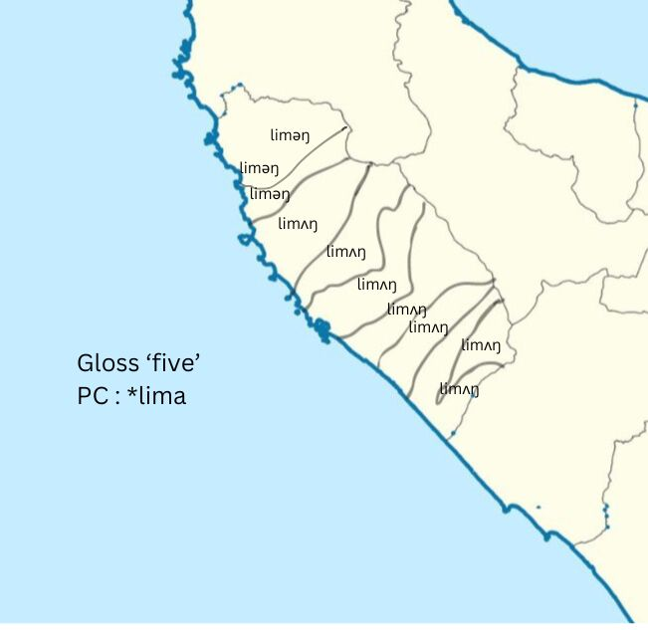

Figure 6. Gloss ‘five’

As root ‘four’, the Acehnese’s root ‘five’ has a feature developed in the mainland but is not widely shared with many of today’s mainland Chamic languages. Again, as the long vowel in the middle position of PC ‘four’, which becomes a diphthong in Acehnese, the velar nasal accretion in root ‘five’ was an innovation that occurred before it reached the Sumatra island. Therefore this final nasal accretion is a dialectal uniformity in Acehnese.

However, the ‘five’ is realised differently by the Acehnese speakers in the Aceh Jaya district in terms of its main syllable vowel. In the eastern area, the vowel is a central unrounded central schwa sound, while in the west, the vowel is unrounded back open-mid /-ʌ-/. From the authors’ observation, in the West Aceh district that borders the Aceh Jaya on the west, the vowel becomes rounded back open-mid /-ɔ-/. Acehnese rounded and unrounded back open-mid /-ʌ-/ and /-ɔ-/ are minimal pairs. Compared to the Malayic languages around it, Acehnese has more complex vowel inventories. The rounded-unroundedness which is minimal pairs in several Acehnese vowels might have been a trouble for the non-Acehnese speakers. The variations on this feature on gloss ‘five’ might have been the result of a language shift from other Austronesian languages in Sumatra to Acehnese.

* + 1. Gloss ‘six’, ‘seven’, ‘eight’, ‘nine’ and ‘ten’

There are not many phonological discrepancies between the SA and the Aceh Jaya dialects numerals, ranging from six to ten. Some, such as ‘six’, ‘seven’, ‘eight’, and ‘ten’ are identical. However, one of the important reasons why the WMP languages were grouped is their ‘seven’ innovation, the Acehnese roots of glosses seven until ten are pivotal data to understand the relationship between the Chamic and Acehnese.

Acehnese ‘seven’ phonologically is closer to Sumatra, Penisular and some Borneo Malay characterised by its main syllable rounded back close-mid /o/ vowel, while the Chamic in the mainlands resembles the Indonesian Standard Malay with its unrounded back close /u/ vowel. This might be a simple characteristic, and this type of sound change could occur easily anywhere, but it could demonstrate the distance of the Acehnese, Peninsular Malay and the mainland Chamic as this gloss was initially circulated. Gloss ‘seven’ in Acehnese is Peninsular instead of mainland material. However, more clues should be encountered. It is useful to also examine the gloss of ‘eight’ and ‘nine’.

While the modern Chamic languages in the mainland are very lexically and semantically varied on glosses ‘eight’ and ‘nine’, *dua-amilan, sa-lapan, dua-lapan and samilan* (Thurgood, 1999), Acehnese dialects are not. There is only one term for ‘eight’, and one term for ‘nine’. The universality in Acehnese dialects in terms of numerals indicates that the language numerals had been settled for a long time before it broke into dialects which once again indicates the Acehnese early dispersal to Sumatra. In contrast, the Chamic dialectal break-up occurred when the numerals eight and nine were still looking for stable forms. Acehnese, too, must have split from Chamic during this time and stayed as a dialect of Chamic on the SEA mainland before they finally migrated to the SEA islands. The root ‘nine’ – *kuraŋ--* in the Acehnese is peculiar, not resembling any of the mainland Chamic or Standard Malay languages of ‘nine’, thus should have come from a different Malayic-speaking community.

* + 1. Gloss ‘one hundred’ & ‘one thousand’

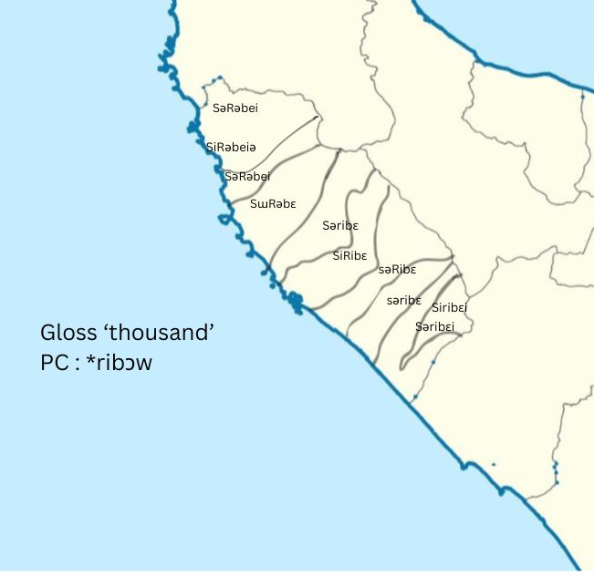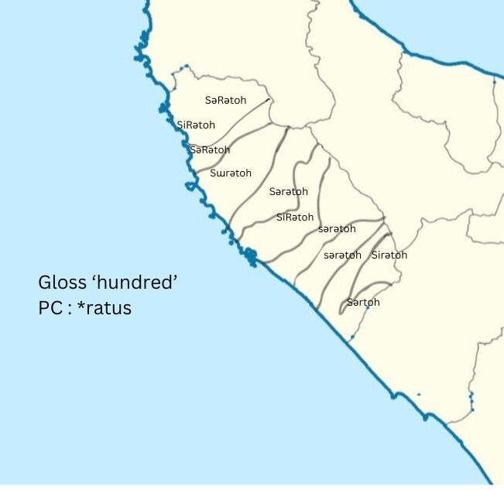

Figure 7. Gloss ‘hundred’ Figure 8. Gloss ‘thousand’

The ‘hundred’ and ‘thousand’ reflexes in the Aceh Jaya district are varied, firstly, on their weak syllables. Comparing them to Standard Malay *si-/sə-/,* it isunderstandable why the weak syllable variants in Acehnese are all unrounded mid or closed vowels *si-/sə-/sɯ-*. Yet, the liquid r[R] is worth a discussion as it reflects the consonants of Austronesian languages. As seen in Figures 7 and 8, the reflexes with uvular /R/ is very dominant in the whole area, except in the west end of the district. As this west end area borders with Pidie district in the north, the alveolar /r/ in their language might be influenced by the Pidie migrants into the area.

**5. CONCLUSION**

The comparison of numerals in the Acehnese Standard and Chamic shows that the Acehnese-Chamic-Malayic ancestors split from each other while developing their 8-10 numerals. The Chamic family also broke into dialects around the same time, as evidenced by the multiple etyma reconstructed for ‘eight’ and ‘nine’. Although semantically sharing the innovation with Malay, thus *lapan, sa-ambilan*, the Acehnese ‘nine’ employed a different word. Moreover, the phonological peculiarities in the Acehnese Jaya dialectal numeral system show evidence of contacts and bilingualism between the Acehnese ancestors and the native people of Sumatra.

**6. ACKNOWLEDGEMENT**

This research is supported by the Indonesian Directorate General of higher education, research and technology.

**7. REFERENCES**

Adelaar, K. A. (1992). *Proto Malayic:The Reconstruction of its Phonology and Parts of its Lexicon and Morphology*. Pacific Linguistics. https://doi.org/10.15144/PL-C119.cover

Asyik, A. G. (1987). *A contextual grammar of Acehnese sentences*.

Blench, R. (2010). Was there an Austroasiatic presence in Island Southeast Asia prior to the Austronesian expansion? *Bulletin of the Indo-Pacific Prehistory Association*, *30*, 133–144.

Blust, R. (1994). The Austronesian Settlement of Mainland Southeast Asia. In K. A. & T. H. (eds.) (Ed.), *Papers from the Second Annual Meeting of the Southeast Asian Linguistics Society 1992* (pp. 25–83). Tempe Arizona, Arizona State University.

Blust, R. (1995). Sibilant assimilation in Formosan languages and the Proto-Austronesian word for’nine’: A discourse on method. *Oceanic Linguistics*, 443–453.

Cowan, H. K. J. (1991). Achenese Dialects in Connection with Chamic Migration. In R. Harlow (Ed.), *Western Austronesian and Contact Languages*. Linguistic Society of New Zealand Auckland New Zealand.

Daud, B., & Durie, M. (1999). *Kamus basa Acèh= Kamus bahasa Aceh= Acehnese-Indonesian-English thesaurus*. Pacific Linguistics, Research School of Pacific and Asian Studies, The ….

Durie, M. (1985). *A grammar of Acehnese: on the basis of a dialect of North Aceh*. Foris Publications Holland.

Dyen, I. (1971). The Chamic languages. *Current Trends in Linguistics. Mouton: The Hague*, *8*, 200–210.

Irnanda, S. (2024a). Acehnese: The Dating of Into-Sumatra Migration. *Jol.r*, *3–4*.

Irnanda, S. (2024b). *Aslian Substratum in Acehnese (Was the Contact Direct or Malay-Mediated?)*.

Lee, E. W. (1998). THE CONTRIBUTION OF CAT GIA ROGLAI TO CHAMIC. In D. Thomas (Ed.), *Papers in Southeast Asian Linguistics No. 15: Chamic Studies* (Issue 15, pp. 31–54). Pasific Linguistics, The Australian National University. https://doi.org/10.15144/PL-A89.31

Sidwell, P. (2005). Acehnese and the Aceh-Chamic language family. In *Chamic and beyond: Studies in mainland Austronesian languages.* (pp. 211–245). Pasific Linguistics.

Sidwell, P. (2006). Dating the separation of Acehnese and Chamic by etymological analysis of the Aceh-Chamic lexicon. *MONKHMER STUDIES*, *36*, 187.

Thurgood, G. (1999). From Ancient Cham to Modern Dialects: Two thousands years of language contact and change. In *Oceanic Linguistics Special Publications* (Vol. 28). University of Hawai’i Press. University of Hawaii Press