POLLUTION LOAD ANALYSIS OF WONOKROMO RIVER WITH PROGRAM
SYSTEM DYNAMICS (STELLA)
Filial Dhiya Thifalina¹*), Badrus Zaman²) , Anik Sarminingsih²)
1) Students of the Environmental Engineering Masters Program FT. UNDIP
2) Teaching Staff of the Environmental Engineering Masters Study Program FT. UNDIP
*)filial.thifalina@gmail.com

Abstract
Population growth, the increase in the industrial sector and the presence of waste from activities that haven’t been treated properly can make a water river being polluted or containing high pollutants, this can lead to a decrease in river water quality. One of the polluted rivers is Wonokromo River which is located in the city of Surabaya, according to the monitoring results of the Balai Besar Wilayah Sungai (BBWS) Brantas in 2021 the pollutant value in Wonokromo River with TSS parameter is 484 mg/L, BOD parameter is 15.96 mg/L, COD parameter 23.91 mg/L, DO parameter 3.67 mg/L, and E.coli parameter 4.283 MPN/100 ml from the monitoring data included in the polluted category. The problem of decreasing the quality of raw water can have a bad impact, because Wonokromo River was used as a source for drinking water in the city of Surabaya and the river flow supports the activities of residents around the river. Therefore, it is necessary to conduct a study on the analysis of river water quality degradation by calculating the load capacity of wastewater in river water bodies. Analysis with dynamic systems can be used in this study as a method. This method analyzes complex problems with various related variables that have dynamic properties or change according to environmental conditions and with time. The dynamic system analysis will describe a problem model of river water conditions using the STELLA 9.1.3 program and is expected to produce output in the form of river water behavior. The results of this study indicate that the water quality of the Wonokromo River is polluted with the parameters TSS, BOD and E. Coli, this result of quality determination refers to Peraturan Pemerintah no. 82 tahun 2001 about “Pengelolaan Kualitas Air dan Pengendalian Pencemaran Air”. So Wonokromo River is not suitable as a source of raw water in that year and a policy scenario is needed to reduce river water pollution.
Keywords: River Water Quality, Wonokromo River, Dynamic System, STELLA
- Introduction
Wonokromo River is one of the raw water sources used for Surabaya people, this river flow has the potential to contain high pollutants caused by domestic, non-domestic and industrial activities. According to Karnaningroem (2018), pollution can be caused by the disposal of wastewater from residential areas that have not been treated effectively. This assumption is reinforced by the results of the monitoring of the Balai Besar Wilayah Sungai (BBWS) Brantas in 2021 that the pollutant value of the Wonokromo River with TSS parameters is 484 mg/L, BOD parameters 15.96 mg/L, COD parameters 23.91 mg/L, DO 3.67 mg/L, and parameter E.oli 4.283 MPN/100 ml, this shows that river water has been included in the polluted class when compared to class II water quality standards based on Peraturan Pemerintah no. 82 tahun 2001 about “Pengelolaan Kualitas Air dan Pengendalian Pencemaran Air”. The main impact of excess pollutants in river water can result in environmental damage to water bodies and health problems for people who use river water.
The purpose of this article is to analyze the water of the Wonokromo River with pollutant parameters, namely TSS, BOD, COD, DO and E.Coli, then processed river water quality data using the Dynamic System method to obtain an assessment of river water quality for the feasibility of raw water sources. The output of this article is an analysis of the water quality assessment of the Wonokromo River as raw water for drinking water in the city of Surabaya.

- Methodology
The condition of the Wonokromo River water, based on the results of Yudo and Said's research in 2019, describes the condition of the river water in poor condition, the results of the study state that the Wonokromo River water has two parameters that do not meet the standards BOD and COD parameters. Meanwhile, according to Karnaningroem in 2019, river water pollution is caused by the disposal of domestic waste and industrial waste along the river which is still in the same discharge as the drainage channel, where this channel will lead directly to the river water.
In general condition of the river in the results from previous studies, it’s necessary to assess the quality of river water in the current condition. The Dynamic System method will be used in this study because according to Muhammadi in 2001, the dynamic system method can understand complex problems by several interrelated variables and having the nature of changing with time or dynamically. The dynamic system will be a problem analysis method, that uses the basis for calculating the pollutant load of waste in river water with the output river water behavior in current conditions for the next few years.
- Research Sites
The research will be conducted in the Wonokromo River located in the Surabaya City. This river flows for approximately 3 km from up stream (Jagir Wonokromo Street) to down stream (Nginden Bridge). The following in Figure 1. is a map of the river.
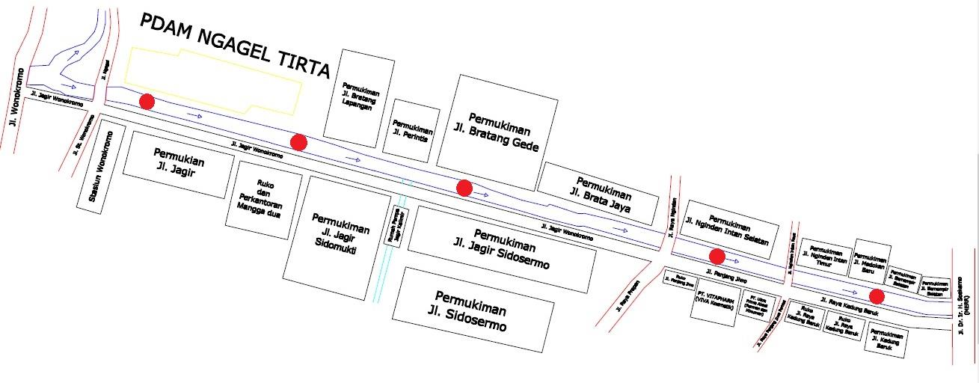
Figure. 1 Wonokromo River Flow Map

River water analysis research will be divided into 3 segments for sampling step. Determination of sampling points make that’s more easier for sampling step of river water. The distribution of location points according from Peraturan Menteri Lingkungan Hidup No. 01 tahun 2007 about “Pedoman Pengkajian Teknis untuk Menetapkan Kelas Air”, research sampling points is determined by clusteration of pollution-producing areas (waste) or point sources. The purpose of taking water samples as a material analyzing river water quality, the sample will be tested for pollutant levels in accordance with predetermined parameters.
- Segment 1
Segment 1 is located at the Water Gate Jagir to the Wonokromo River (Jagir Wonokromo Street) before the PDAM Ngagel Tirto drain outlet. Located at latitude 7°18'2.21"S and longitude 112°44'28.18"S. The length of the segment is 725 meters, has an average river width of 56 meters and the depth of the river reaches 2.90 m. The river flow has a speed in 0.14 m/s and an average flow rate in 16.30 L/s. This segment is the upstream of the Wonokromo River.

- Segment 2
Segment 2 is located after the PDAM Ngagel Tirto drain outlet to the Jagir Kalimir drainage outlet. Located at latitude 7°18'7.14"S and longitude 112°44'50.71"S. The length of the segment is 765 meters, has an average river width of 63 meters and the depth of the river reaches 2.70 m. The river flow has a speed in 0.12 m/s and an average flow rate in 16.10 L/s.
- Segment 3
Segment 3 is located after the Jagir Kalimir drainage outlet to the Prapen Bridge. Located at latitude 7°18'13.49"S and longitude 112°45'10.23"S. The length of the segment is 1,360 meters, has an average river width of 60 meters and the depth of the river reaches 2.50 m. The river flow has a speed in 0.11 m/s and an average flow rate in 15.94 L/s.
- Data collection
The research was conducted in several stages, have two data there is primary data and secondary data. Primary data from river water quality tests, meanwhile secondary data is supporting research data that’s the Wonokromo River map, river hydraulics data, previous river water quality data and population growth data. The purpose of this data collection is as material for analysis of river water models that cover all variables from a technical and technical point of view.
- Primary data
In this study, primary data is the existing data of the Kali Wonokromo river, which includes the existing condition of the river environment, the hydraulics of the river water and the cross-sectional size of the river. The purpose of collecting primary data is to obtain data on the current condition of river water which can describe the physical, chemical and biological properties as the basis of research.
Primary data collection is in the form of field survey activities and river water sampling. Sampling of river water is carried out from upstream to downstream of the river, according to predetermined points, namely 3 sampling points. Technically, sampling is carried out simultaneously in the two peak hours of wastewater discharge, namely in the morning and evening. Sampling is ideally carried out in the dry season and the rainy season. However, in this study the sampling was taken only in the dry season, while in the rainy season using secondary data. Sampling of river water is in accordance with the standard of SNI 6989.57:2009 regarding the method of sampling surface water. The method used is Grab Sampling, namely samples taken directly from river water bodies.
Furthermore, the sample will be analyzed for water quality on a laboratory scale. The purpose of this analysis is to determine the levels of pollutants in river water. The parameters used as research indicators were TSS, BOD, COD, DO and E.Coli.
- Secondary Data
In this study, secondary data is data supporting research in the form of technical and non-technical data. Technical data are river water quality data and river water hydraulics in the rainy season, while non-technical data are river maps, RTRW data and population growth data around rivers. The purpose of adding this secondary data as data related variables that support research analysis.

- Data analysis
- Determination of Waste Pollutant Load
River water that has indicated pollution, requires a calculation step to determine the condition of river water. Calculation analysis uses data that has been collected, then processed in calculating the pollutant load of wastewater. Calculation of the pollution load using the direct calculation method (Rapid Assessment), data using on wastewater discharge and pollutant levels. The following is the formula for calculating the pollutant load based on Mitsch & Goesselink 1993 in Appendix II of the Peraturan Menteri Negara Lingkungan Hidup Nomor 1 Tahun 2010.

BP = Qi x C xf
Information:
BP = Pollution load originating from the source (kg/day)
Q = discharge of waste water or river water (m³ / second)
ci = concentration of the i-th parameter (mg/Liter)
f = conversion factor (86.4)
- Dynamic System
Problem solving in the research will be analyzed using the dynamic system method. In the analysis, a model for depicting river water will be made by including a pollutant reduction scenario. According to Novitasari in 2008, there are 5 steps for making a dynamic system model, here are the steps for modeling.
- Big Picture Mapping
At the beginning of the research, it is necessary to limit the problem. In the dynamic analysis method, the problem limitation is carried out by drawing a frame of mind, namely Big Picture Mapping. The purpose of making this image is to show the focus of the research.
- Cause and Effect Diagram (Casual Loop Diagram)
Cause-and-effect diagrams will show the relationship between variables in the study. This diagram will contain cause and effect variables in the form of input and output diagrams of research variables. The input variable is a controlled and uncontrolled variable. Output variables are desired and unwanted variables. The purpose of this diagram is to clarify the reading of the problem.
- Dynamic System Diagram (Stock and Flow Diagram)
This diagram will describe the flow in a problem model. Consists of two systems, namely stock and flow. Stock in the study is river water and flow in the study contains pollutants.
- Model Formulation and Simulation
The dynamic system model is based on a mathematical formulation according to the required calculations. After the formulation is entered, the model will be run in the running stage with the help of a simulation program.
- Model Verification and Validation
The verification and validation steps of the model are needed to ensure that the model is in accordance with the existing conditions. The model validation test in this study uses the calculation of the Pollutant Index (IP) value, where this calculation will compare the simulation model with the existing conditions of river water. The difference in the deviation value is set at a maximum of 10%.
The data is simulated into a dynamic system model using the STELLA 9.1.3 program. The simulation model will include policy scenarios for reducing river water pollution substances, in the form of technical, non-technical and regulatory policies that are expected to improve river water quality. The river water model that has been simulated is then processed with an analysis of river water quality assessment based on the calculation of the pollutant index as a validation step.
- Results and Discussion
Wonokromo River was chosen as the research location based on the results of field analysis where the condition of river water was feel unworthly as a source of raw water and the needs of the surrounding community. River water quality is the biggest highlight in this study where it’s the main parameter in the use of river water as raw water. The research will process the data that has been collected from primary and secondary data.
The results of the field research show that the river water of the Wonokromo River is not suitable to be used as source of raw water. Based on the parameters that have been determined as pollution indicators, there are parameters that exceed the quality standard values. The following in Table 1. are the results of the existing water quality of the Wonokromo River
Table 1.Wonokromo River Water Quality (Existing)
No | River Segment | TSS | BOD | COD | DO | E. Coli
 |  | mg/L | mg/L | mg/L | mg/L | MPN/100ml
1 | Segment 1 | 685 | 17.5 | 37.5 | 1.76 | 900
2 | Segment 2 | 504 | 33.5 | 74.5 | 4.76 | 1500
3 | Segment 3 | 481 | 40 | 87.5 | 1.4 | 2000
Source: Field Survey Results
The water quality data and other supporting data are then processed using the dynamic system analysis method. This method was chosen in this study because it can provide a conceptual description of the river water system model. The method is applied with model restrictions in the form of Big Picture Mapping (BPM), then proceed with making Casual Loop diagrams and making Stock and Flow diagrams. The limitation of the model is done so that the research does not get out of the discussion and becomes the focus of the research.
- Big Picture Mapping
Figure 2. Big Picture Mapping
The picture above is a Big Picture Mapping model of river water which illustrates the focus of this research. The focus leads on waste disposal generated by residents' activities from the domestic, economic, industrial and office sectors in the area around the river, causing an increase in pollutant loads and impacting on water quality descending river. Improvement of river water quality will be carried out by making scenarios of population behavior and government policy scenarios.

- Casual Loop Diagram
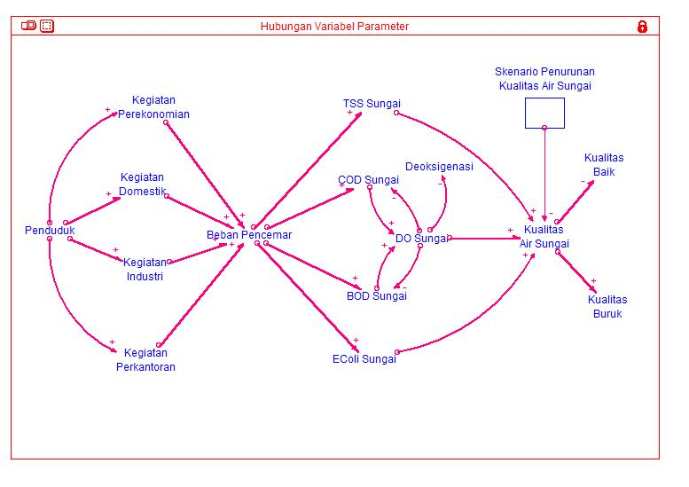
Figure 3. Casual Loop Diagram
The Casual Loop diagram in this study describes the existing condition of the Wonokromo River which has been adjusted to its flow value, the diagram describes the input variable (+) and the output variable (-). In the dynamic system model of river water, the input variable (+) is an uncontrollable variable, originating from the increase in the number of people whose activities cause a decrease in river water quality and for the output variable (-) is the desired variable, namely a decrease in the pollutant load of river water which results in better water quality. good.
- Stock and Flow Diagrams
Dynamic system diagrams or Stock and Flow Diagrams consist of technical aspects and non-technical aspects. Technical aspects will be included in the model simulation, consisting of variables that affect river water quality. Variables of water quality are parameters of pollutant substances, namely parameters of TSS, BOD, COD, DO, and E. Coli substances. The variables of river water quantity and continuity are river water hydraulics, deoxygenation and reaeration. From the simulation of a dynamic system model based on technical variables, it will produce a behavior of river water pollutants and river water quality. The following in Figure 4. to Figure 6. are simulations of the dynamic system model of the Wonokromo River.
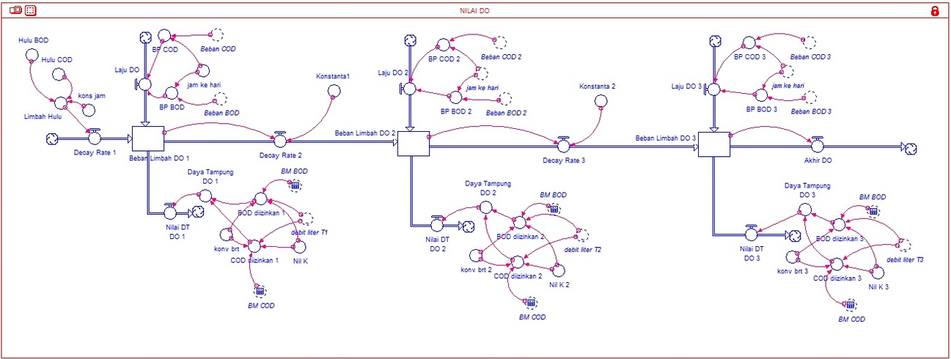
Figure 4. BOD, COD and DO Dynamic System Model Simulation
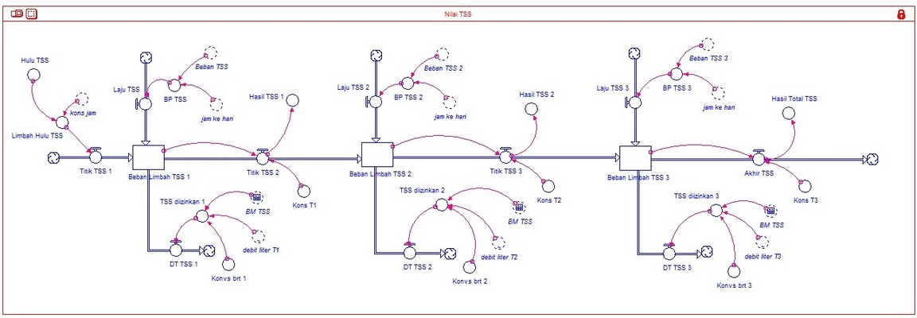
Figure 5. TSS Dynamic System Model Simulation
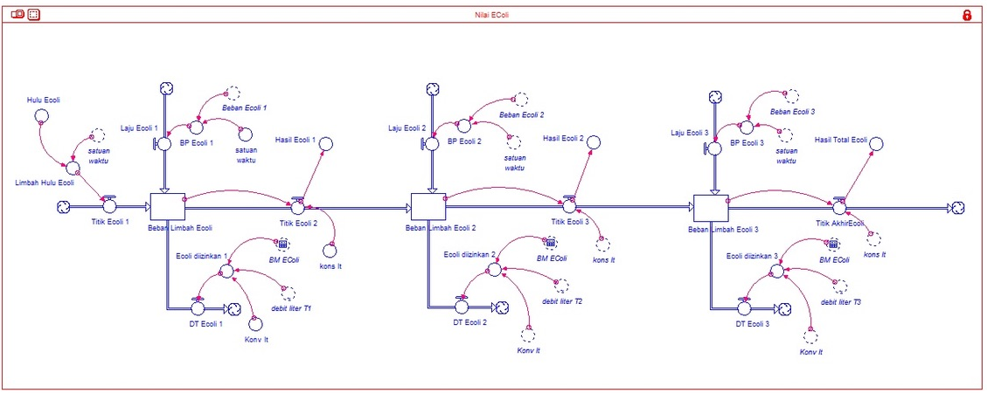
Figure 6. E. Coli . System Dynamics Model Simulation
The dynamic system model that has been created is used to predict the value of the water quality of the Wonokromo River in the existing condition. The model is an existing description the behavior of river water pollutants, namely the parameters TSS, BOD, COD, DO and E.Coli whose formulation has been adjusted to the calculation of the pollutant load of river water. The following is a table of model simulation results listed in Table 2.
Table 2. Wonokromo River Model Simulation Results
No | Parameter | Quality standards | Result Value | Unit | Information
1 | TSS | 50 | 252.7 | mg/L | Exceed
2 | BOD | 3 | 4.08 | mg/L | Exceed
3 | COD | 25 | 10.32 | mg/L | Sufficient
4 | DO | >4 | 4.79 | mg/L | Sufficient
5 | E. Coli | 1000 | 6.023 | MPN/100ml | Exceed
Source: Research Analysis Results
From the analysis of the dynamic system model as in the table above, it is stated that the water quality of the Wonokromo River has been polluted, there are several water quality parameters that exceed the class II quality standards from regulation Peraturan Pemerintah no. 82 tahun 2001 about “Pengelolaan Kualitas Air dan Pengendalian Pencemaran Air”, there are is TSS, BOD and E.Coli parameters.
Model validation step in analyzing the quality status of river water quality, it is necessary to calculate with Pollutant Index (IP) formulation as a proof of the model. The pollution index method will compare the pollutant parameter value with the quality standard used. The results of the calculation of the pollutant index in the Wonokromo River are presented in Table 3. The result it shows that along the Wonokromo River are different, here is the equation for the calculation of the pollution index formula
Table 3. IP Value of Wonokromo River Dynamic System Model
No | Parameter | Score  IP | Information
1 | TSS | 5.24 | Medium Polluted
2 | BOD | 1.67 | Lightly Polluted
3 | COD | 0.41 | Meet Quality Standard
4 | DO | 0.95 | Meet Quality Standard
5 | E. Coli | 4.50 | Medium Polluted
Average IP |  | 2.55 | Lightly Polluted
Maximum IP |  | 5.24 | Medium Polluted
Source: Research Analysis Results

- Research Conclusion
Based on the discussion of the research above, the conclusions in this study are as follows:
- The results of the calculation of the pollutant load using the Dynamic System modeling method obtained the value of the water quality of the Wonokromo River with the TSS parameter of 252.7 mg/L, the BOD parameter of 4.08 mg/L, the COD parameter of 10.32 mg/L, the DO parameter of 3.79 mg/L, and the E.Coli parameter was 6.023 MPN/100ml.
- The parameter values ​​of Kali Wonokromo river water that exceed the quality standard, class II quality standards from regulation Peraturan Pemerintah no. 82 tahun 2001 about “Pengelolaan Kualitas Air dan Pengendalian Pencemaran Air” there are TSS, BOD and E.Coli parameters.
- The results of the pollutant load data analysis using the Pollutant Index (IP) method in the Wonokromo River show that the river water has been lightly polluted to moderately polluted.
- Control of river water quality in Wonokromo River to reduce polluting waste to water bodies is very necessary. Control can be done by technical factors and social factors of society.

Acknowledgement
Thank you a lot all those who help me in this process, collect data and writing this article, especially for my family and my best friends.
References
Alihar, F. (2018) Penduduk Akses Air Bersih Di Kota Semarang . Jurnal Kependudukan Indonesia Vol.13 (1) : 67-76.
Effendi, H. (2003) Telaah Kualitas Air Bagi Pengelolaan Sumber Daya dan Lingkungan. Kasius Publisher. Yogyakarta.
Karnaningroem, N. and Putri FA (2019). Prediction Of Water Pollution in Kali Surabaya River Segment Karang pilang - Ngagel Using STELLA Model. Institut Teknologi Sepuluh Nopember, Surabaya
Karnaningroem, N. et al (2018). Dissolved Oxygen Dynamic System Model For The Determination Of The Assimilating Capacity At Brantas River Malang City. Institut Teknologi Sepuluh Nopember, Surabaya
Kementrian Lingkungan Hidup (2003) Keputusan Menteri Lingkungan Hidup Nomor 115 Tahun 2003 Penentuan Status Mutu Air Dengan Metode Indeks Pencemaran. Jakarta
Kementerian Lingkungan Hidup (2010) Peraturan Menteri Negara Lingkungan Hidup Nomor 01 Tahun 2010 Tata Laksana Pengendalian Pencemaran Air. Kementerian Negara Lingkungan Hidup. Jakarta.
Kementerian Lingkungan Hidup (2011) Indeks Kualitas Lingkungan Hidup Indonesia 2010. Kementerian Negara Lingkungan Hidup . Jakarta.
Kunc, M. (2016) System Dynamics: A Behavioral Modeling Method. Proceedings of the 2016 Winter Simulation Conference, pp: 53 – 64.
Kurniawan, O and Ngatilah, Y. (2017) Kebijakan Perbaikan Kualitas Air Sungai Pegirikan Dengan Metode Sistem Dinamik. Surabaya.
Mitsch W., J. Gosselink, (1993) Wetlands in Water Quality Prevention, Identification and Management of Disfuse Pollution. Van Nostrand Reinhold, New York.
Muhammadi, EA d. BS (2001) Analisis Sistem Dinamis. Jakarta.
Novitasari, R. (2010) Mampukah Kebijakan Pergulaan Nasional Meningkatkan Perolehan Pendapatan Petani Tebu : Sebuah Penghampiran Dinamika Sistem. Institut Teknologi Sepuluh Nopember, Surabaya.
Pavita, KD Widiatmono, BR and Dewi, L. (2017) Studi Penentuan Daya Tampung Beban Pencemaran Sungai Akibat Buangan Limbah Domestik (Studi Kasus Kali Surabya – Kecamatan Wonokromo). Brawijaya University, Malang.
Pemerintah Daerah Provinsi Jawa Timur (2008) Peraturan Daerah Jawa Timur Nomor 2 Tahun 2008 Pengelolaan Kualitas Air dan Pengendalian Pencemaran Air Di Provinsi Jawa Timur. Jawa Timur, Indonesia.
Pemerintah Republik Indonesia (2001) Peraturan Pemerintah Republik Indonesia Nomor 82 Tahun 2001 Pengelolaan Kualitas Air Dan Pengendalian Pencemaran Air. Indonesia.
Suwari. (2010) Model pengendalian pencemaran air pada wilayah Kali Surabaya. Bogor Agricultural University, Bogor.
Salim, H. (2002) Beban Pencemaran Limbah Domestik dan Pertanian di DAS Citarum Hulu. Journal of Environmental Technology. 2 (3) : 107-111.
Yudo, S and Said, NI (2019) Kondisi Kualitas Air Sungai Surabaya. South Tangerang

