Research Article
The Effect of Addition EM4 Solution on Vermicomposting Fish Waste to Increase CNPK Regosol Soil

Vivin Setiani^{1*}, Tanti Utami Dewi², Ayu Nindyapuspa³, Dinda Maya Kristina⁴, Yesica Novrita Devi ⁵

^{1,2,3,4}Study Programe of Waste Treatment Engineering, Shipbuilding Institute of Polytechnic Surabaya, Street on Teknik Kimia, Kampus ITS Sukolilo, Surabaya
⁵Study Programe of Business Management, Shipbuilding Institute of Polytechnic Surabaya, Street on Teknik Kimia, Kampus ITS Sukolilo, Surabaya

* Corresponding Author, email: vivinsetiani@ppns.ac.id

besar

Abstract
The Environmental Service Surabaya noted that waste generation at TPA Benowo reached 1,600 tons/day. 60% of waste generation at TPA Benowo was dominated by organic waste. One of organic waste was fish waste, vegetable waste, and some waste from household business activities such as sawdust. One of method composting to reduce organic waste is vermicomposting. Lumbricus rubellus is a type of worm that eats leaf litter, so it is suitable to be used decompose organic waste. The adding of EM4 solution can make more fast of composting process. The compost could be applied in regosol soil to improve soil CNPK quality. The purpose of this study was to analyze the effect of EM4 variations on the quality of compost based on SNI 19-7030-2004 and the effect of adding the compost to regosol soil. The research result showed that the quality of compost complies with SNI 19-7030-2004. The statistical analysis showed that EM4 has a significantly effect on compost quality and regosol soil improvement.

Keywords: vermicomposting, fish waste, vegetable waste, sawdust , regosol soil

- Introduction
Based on data from Central Statistic Agency 2023, the population in Surabaya City increased by 17,133 people. This condition hurts the environment because if the population increases, the waste generated also increases. Based on data from Environmental Service Surabaya, TPA Benoowo accommodate 1,600 tons of waste every day was 60% of waste generation at TPA Benowo is dominated by organic waste (Kunhadi et al., 2018). This condition can make a negative impact on the environment and human health (Vasilyev., 2016). Some of the organic waste that is frequently encountered is fish waste, vegetable waste, and sawdust from household activities. Composting is an alternative to reduce waste generation. The composting process needs C-Organic content to supply energy and nitrogen content to construct the body tissues of microorganisms during the decomposition process (Yommy et al., 2019)
Sawdust can be used as compost material because has high C-Organic content (Jar, 2021). Based on the research, sawdust has high C-Organic content which is 50.58%. However, the nitrogen content in this material is low (0.39%), so it is necessary to add materials that have high nitrogen content, such as fish waste (Maghfirah, 2021). Fish waste has 2.77% nitrogen and 10.87% C-organic. To improve the quality of compost, vegetable waste can be added because this material has various decomposing bacteria that can help improve the quality of the compost (Sitompul, 2017). Vegetable waste has C-Organic at 3.09% and 0.62% nitrogen content. One composting method that is suitable for decomposing organic waste is vermicomposting because environmentally friendly, economically profitable, and contains various nutrients such as P, K, Ca, Cu, Mg, Fe, and Zn which can improve soil quality (Vunkovic et al., 2021). The type of worm that is suitable for a vermicomposting process is Lumbricus rubellus because this worm can decompose organic matter 4 times body weight per day in 24 hours. To speed up the vermicomposting process, it is necessary to add Effective Microorganism 4 (EM4). This material has several types of microorganisms such as lactic acid bacteria, photosynthetic, fungi, and actinomycetes bacteria which function to prevent pathogens and increase soil nutrients (Hidalgo et al., 2022). Vermicomposting has phospor, nitrogen, potassium, and 13,88% humus. This content has a function to fertilize soil (Kumar et al., 2022).
Regosol soil is one of type soil that has low nutrients and productivity. This soil has coarse-textured, gray in color, and easy to erode (Getahun et al., 2017). Regosol soil contains phospor 48.90 ppm, potassium 43.19 mg/100g, C-Organic 0.48%, and nitrogen 0.06%. Regosol soil has low C-Organic and nitrogen. This soil has high phospor and potassium. This nutrient is harmful to plants. Therefore, in this study, vermicomposting was carried out using Lumbricus rubellus worms with fish waste, vegetable waste, sawdust, and added Effective Microorganism 4 (EM4). Then the results of vermicomposting compost were added to the regosol soil to improve the CNPK quality. The purpose of this study was to determine the physical and chemical quality of compost based on SNI 19-7030-2004 and to determine the quality of regosol soil after adding vermicomposting compost. The reference for land valuation criteria is based on the Soil Research Center in 2009.

- Methods
  - Composting Process
    - Calculate The Compost Material
Fish waste, vegetable waste, and sawdust were analyzed C-Organic and Nitrogen. This step was to obtain the value of the C/N ratio to be used. The C/N ratio was the ratio between C-Organic and nitrogen content. In this study, C-Organic was analyzed by gravimetric method. Then nitrogen was analyzed by the Kjedahl method. Compost materials was 45% food waste (FW), 35% sawdust (S) and 20% vegetable waste (VW).
. There was a formula to calculate C/N ratio (Tchobanoglous., dkk 2002) :
$\frac{C}{N}=\frac{C \left(9 kg Fish Waste \right)+C \left( 7 kg Sawdust \right)+ (4 Vegetable Waste)}{N \left(9 kg Fish Waste\right)+N \left( 7 kg Sawdust \right)+(4 Vegetable Waste)}$ (1)
$\frac{C}{N}=\frac{\left(0.03 x 9 kg\right)+\left(0.46 x 7 kg\right)+(0.002 x 4 kg)}{\left(0.007 x 9 kg\right)+\left(0.004 x 7 kg\right)+(0.00043 x 4 kg)}$ (2)
$\frac{C}{N}=$ 40
The value of the C/N ratio corresponds to the range at the beginning of the vermicomposting process, which was 23-70 (Siswanto et al, 2021). There was Table 1 of the composition of compost material to be used.
Table 1. Compost Material
Variation EM4 (ml) | 45% FW + 35% S + 20% VW  (Lumbricus rubellus worm 100 gr/kg compost material)
0 | C1
10 | C2
15 | C3

    - Design Reaktor
A suitable reactor to use during the vermicomposting process was a Continuous flow bin because this reactor supported by a good supply of oxygen (Manyuchi et al., 2013). The first step before building the reactor was to calculate the density of the waste by weight of waste according to the variation material used. The reference to obtain the density of waste is based on SNI 19-3964-1994. The density of waste obtained was 373 kg/m³ and the total weight of compost material is 12.08 kg. Then calculate the volume of compost material by using the formula :
$Volume of compost material=\frac{Total weight of compost material}{Density of compost material}$ (3)
The volume of compost material in the reactor was 32386 cm³. The dimension of reactor at 45 cm x 50 cm x 15 cm. Reactor design can be seen in Figure 1.
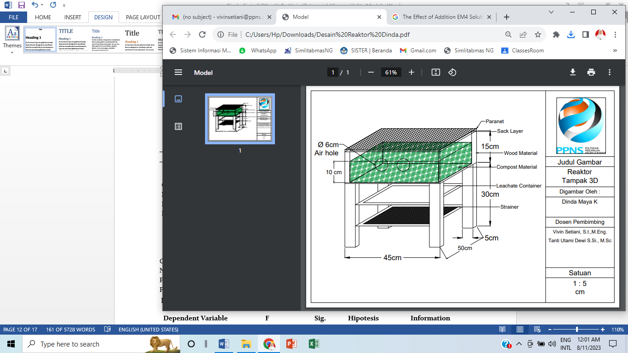

Figure 1 Design of Reactor

    - Pre-Composting Process
The procedure to do the Pre-Composting process was to chop the organic waste into sizes 2-3 cm, then add a variation of EM4. After that stir the material compost evenly distributed and put it in the reactor for 2 weeks while observing the pH, temperature, and water content. This process was important because it can help decompose the compost material so this material can easily be digested by worms, and can suppress the growth of pathogens, so as not to harm earthworms during the vermicomposting process (Grasserova et al., 2020).
    - Acclimatization Process
Acclimatization was carried out by take in Lumbricus rubellus worms into the reactor which already contains bedding and feeding for 2x24 hours. The process aims to adapt the worm to the new environment (Setiani et al., 2021).
    - Vermicomposting Process
The vermicomposting process was carried out by adding 100 grams of Lumbricus rubellus worms per kg of compost material (Setiani et al., 2021). The recommended height of the compost pile was 10 cm (Nurhidayati et al., 2016). Vermicomposting was carried out for 2 weeks. Temperature, pH, and moisture content are monitored daily.
    - Monitoring Compost Process
Compost monitoring aims to determine the rate of decomposition of organic matter. The following was Table 2. Compost Monitoring Method.
Table 2. Compost Monitoring Method
Parameters | Measurement Method | Measurement Equipment | Measurement Period | Standard
Temperature compost | In situ | Soil analyzer tester | Everyday | SNI 19-7030-2004
Moisture compost | In situ | Soil moisture tester | Everyday | SNI 19-7030-2004
pH compost | In situ | Soil analyzer tester | Everyday | SNI 19-7030-2004
pH soil | In situ | Soil analyzer tester | Everyday | Soil Research Center in 2009
C-Organic compost | gravimetric | Oven at 300 C | End of composting | SNI 7763:2018
C-Organic soil | spectrophotometry | Spectrophotometric optimization at a wavelength of 561 nm | End of incubation | Soil Research Center in 2009
Nitrogen compost | kjeldahl | Hidrolysis with sulfuric acid | End of composting | SNI 7763:2018
Nitrogen soil | spectrophotometry | Oksidasi asam sulfat | End of incubation | Soil Research Center in 2009
Rasio C/N compost | Calculate | Comparison of C-Organic content with Nitrogen | End of composting | SNI 7763:2018
Phospor compost | spectrophotometry | Spectrophotometric optimization at a wavelength of 400 nm | End of composting | SNI 7763:2018
Phospor soil | spectrophotometry | Extraction with NaHCO₃ | End of incubation | Soil Research Center in 2009
Kalium compost | AAS | Spectrophotometric optimization at a wavelength of 400 nm | End of composting | SNI 7763:2018
Kalium soil | AAS | Optimasi dengan flamephotometri intensitas sinar emisi | End of incubation | Soil Research Center in 2009

  - Soil Incubation Process
Incubation process was carried out in a closed plastic container. Compost was added to the reactor containing regosol soil, then incubated for 2 weeks. Gusnindar's research, (2013) proved that incubation for 2 weeks can increase soil CNPK content. The following was Table 3 dosage of compost that would be added to the regosol soil
Tabel 3. Kompos Dosage
Variation | Result compost vermicomposting C3  (45% FW + 35% S + 20% VW + Lumbricus rubellus worm 100 gr/kg)
T0 | 0 gr compost/500 gr regosol soil
T1 | 2.5 gr compost/500 gr regosol soil
T2 | 5 gr gr compost/500 gr regosol soil

  - Analyze Data
Statistical analysis has function to determine the effect of EM4 variations on the physical and chemical parameters of the compost. This study using One Way MANOVA analysis because it has one independent variable, and more than two dependent variables. Normality and homogeneity tests are one of the requirements before the MANOVA test. The following is the formula used for normality, homogeneity, and MANOVA test (Usmadi, 2020) :
      - Normality Test
The normality test carried out by compiling data from the smallest, followed by the cumulative frequency (F) of each score. The formula used is :
$Z score=\frac{X-X average}{ρ (Standard deviation)}$ (4)
Note :
ρ : $\sqrt{\frac{\sum{{(Xi-X)}^{2}}}{n-1}}$ (5)
      - Homogenity Test
Homogeneity test using Levene test method. Levene's test is used to test the similarity of the variances of several populations. The formula used is :
$W=\frac{(n-k)\sum_{i=1}^{k}{n_{i{ ({\overline{Z}}_{i}-\overline{Z} ..)}^{2}}}}{(k-1)\sum_{i=1}^{k}{n_{i{ ({\overline{Z}}_{ij}-Z {\overline{Z}}_{i} )}^{2}}}}$ (6)

      - MANOVA Test
The MANOVA test use the following formula :
$P =\frac{Variable number}{degrees of freedom for hypothesis+degrees of freedom for error}$ (7)

- Result and Discussion
  - Physical Parameters
    - Temperature
Temperature increase during the composting process indicatie that there was decomposition activity of organic matter by microorganisms.
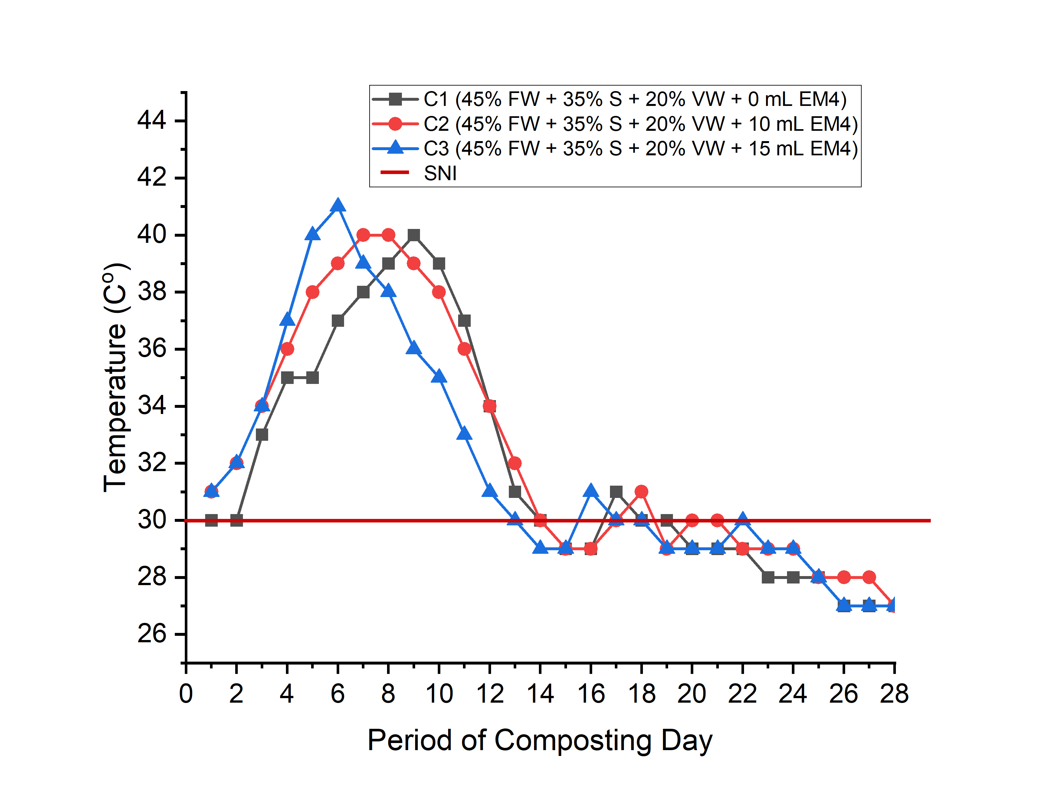 | FW : Fish Waste  S : Sawdust  VW : Vegetable Waste  EM4 : Effective Microorganisme 4
Figure 2. Temperature of Compost
The Figure 2 showed that C3 more a higher temperature than C2 and C1 because activity of microorganisms. In these conditions, organic matter decomposes into carbon dioxide (CO2), water vapor (H2O), humus, and energy. The more microorganisms that break down organic matter. So, the compost temperature increased (Yommy et al, 2021). Temperature can change because of differences in composting phases. The mesophilic phase is at a temperature of 25-40ºC, then the thermophilic phase at 45-70ºC, and the last maturation phase at a temperature of 27ºC (Jain et al., 2019). The temperature compost in this study complies with SNI 19-7030-2004 who has temperature like soil (<30ºC).
3.1.2 Moisture Content
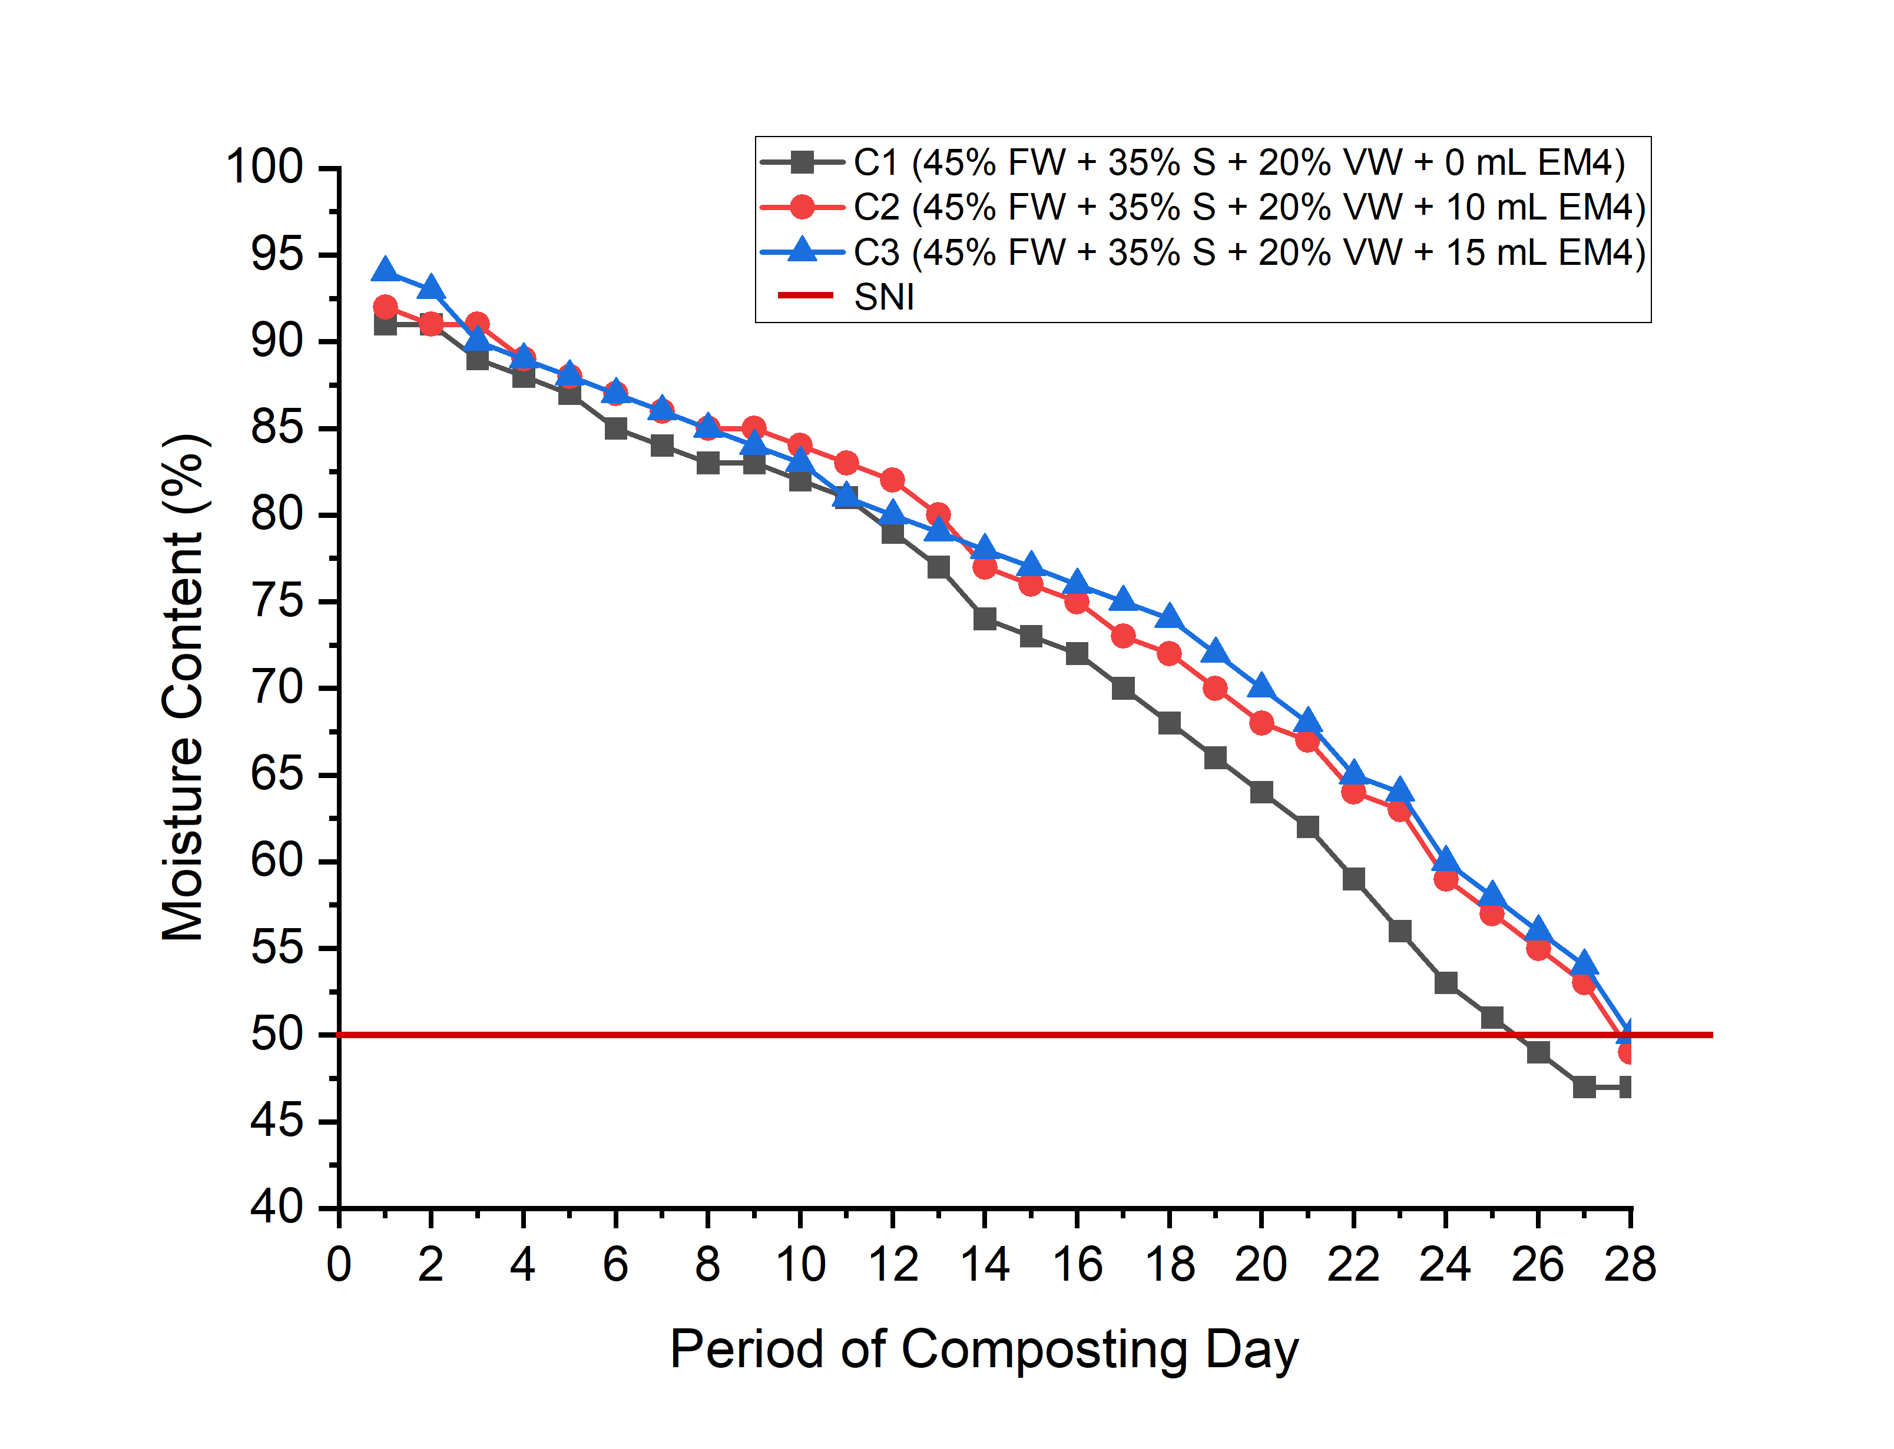 | FW : Fish Waste  S : Sawdust  VW : Vegetable Waste  EM4 : Effective Microorganisme 4
Figure 3. Moisture Content of Compost

Figure 3 showed that there were no changes in moisture content at C1, C2, and C3 due to the sawdust absorbing the moisture content in the compost. Sawdust was known to easily absorb water. However, the moisture content at C1 was the lowest due to environmental temperature conditions. High temperatures can cause evaporation in the reactor, leading to a reduction in moisture content (Yommy et al, 2021). The moisture content in this study met the SNI 19-7030-2004 standard, which requires moisture content to be below 50%.

  - Chemical Parameter
    - pH
pH is one of the parameters that must be monitored every day. If the pH value is too high, it can cause ammonia gas which has a negative impact on the environment.
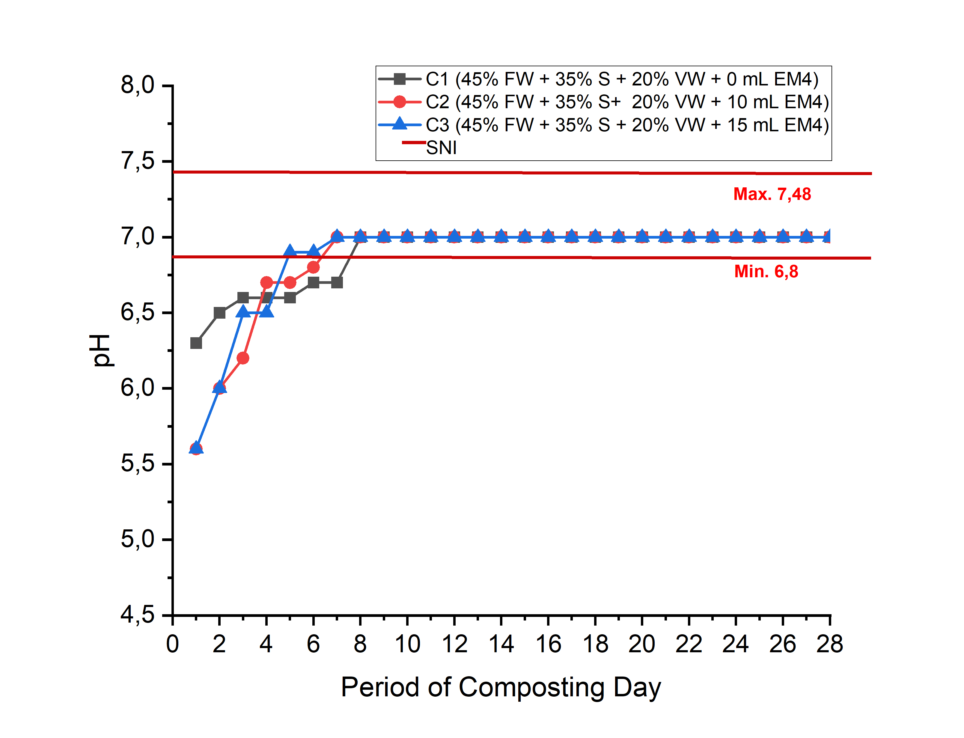 | FW : Fish Waste  S : Sawdust  VW : Vegetable Waste  EM4 : Effective Microorganisme 4
Figure 3. pH of Compost
Figure 3 describe that the pH increased on day 2, then became neutral on day 8. The pattern of the pH chart in Figure 3 wass the same as the research by Setiani et al., (2021) that the pH increased over time and becomes neutral. This condition was caused by the activity of microorganisms in EM4. This material has the function to decompose organic acids, breaking down proteins, and releasing ammonia so that the pH was stable and neutral. It should be noted that ammonia was alkaline so this content can help increase the pH of the compost (Iresha et al., 2022). On days 14 until 28, the pH stabilizes because the worms produce lime (CaCO₃). This material has a function to maintain a neutral pH (Maystreko et al., 2023). The pH in this study accordance with the SNI 19-7030-2004.

    - C-Organic
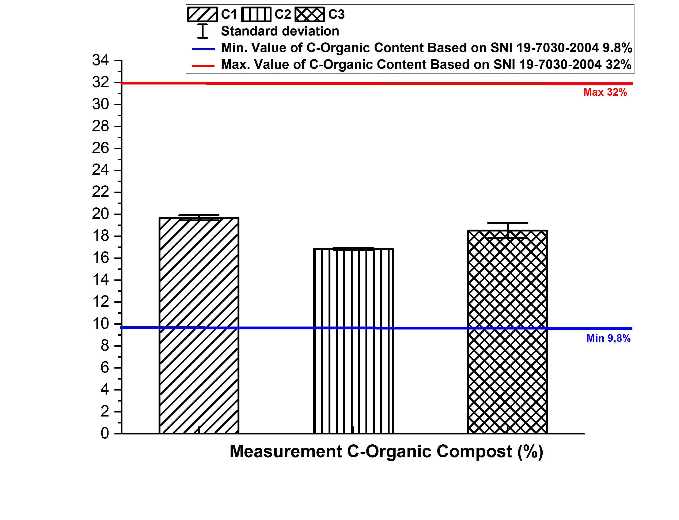
Figure 4. C-Organic of Compost
The Figure 4 explained that C2 has the lowest C-Organic content because of the activity of microorganisms that break down C-Organic content into carbon dioxide (CO2). The results of the decomposition process were mixed with water and evaporated in the air, so this content can decreases (Ghahdarijani et al., 2022). The addition of EM4 can help reduce C-Organic content because this content has been utilized by microorganisms to supply energy during the decomposition process of organic matter. This statement was supported by research (Yommy et al, 2019) that microorganisms consume 2/3 of C-Organic as an energy source, then 1/3 was used to form cells and bacteria. The C-Organic content in this study complies with SNI 19-7030-2004.
    - Nitrogen
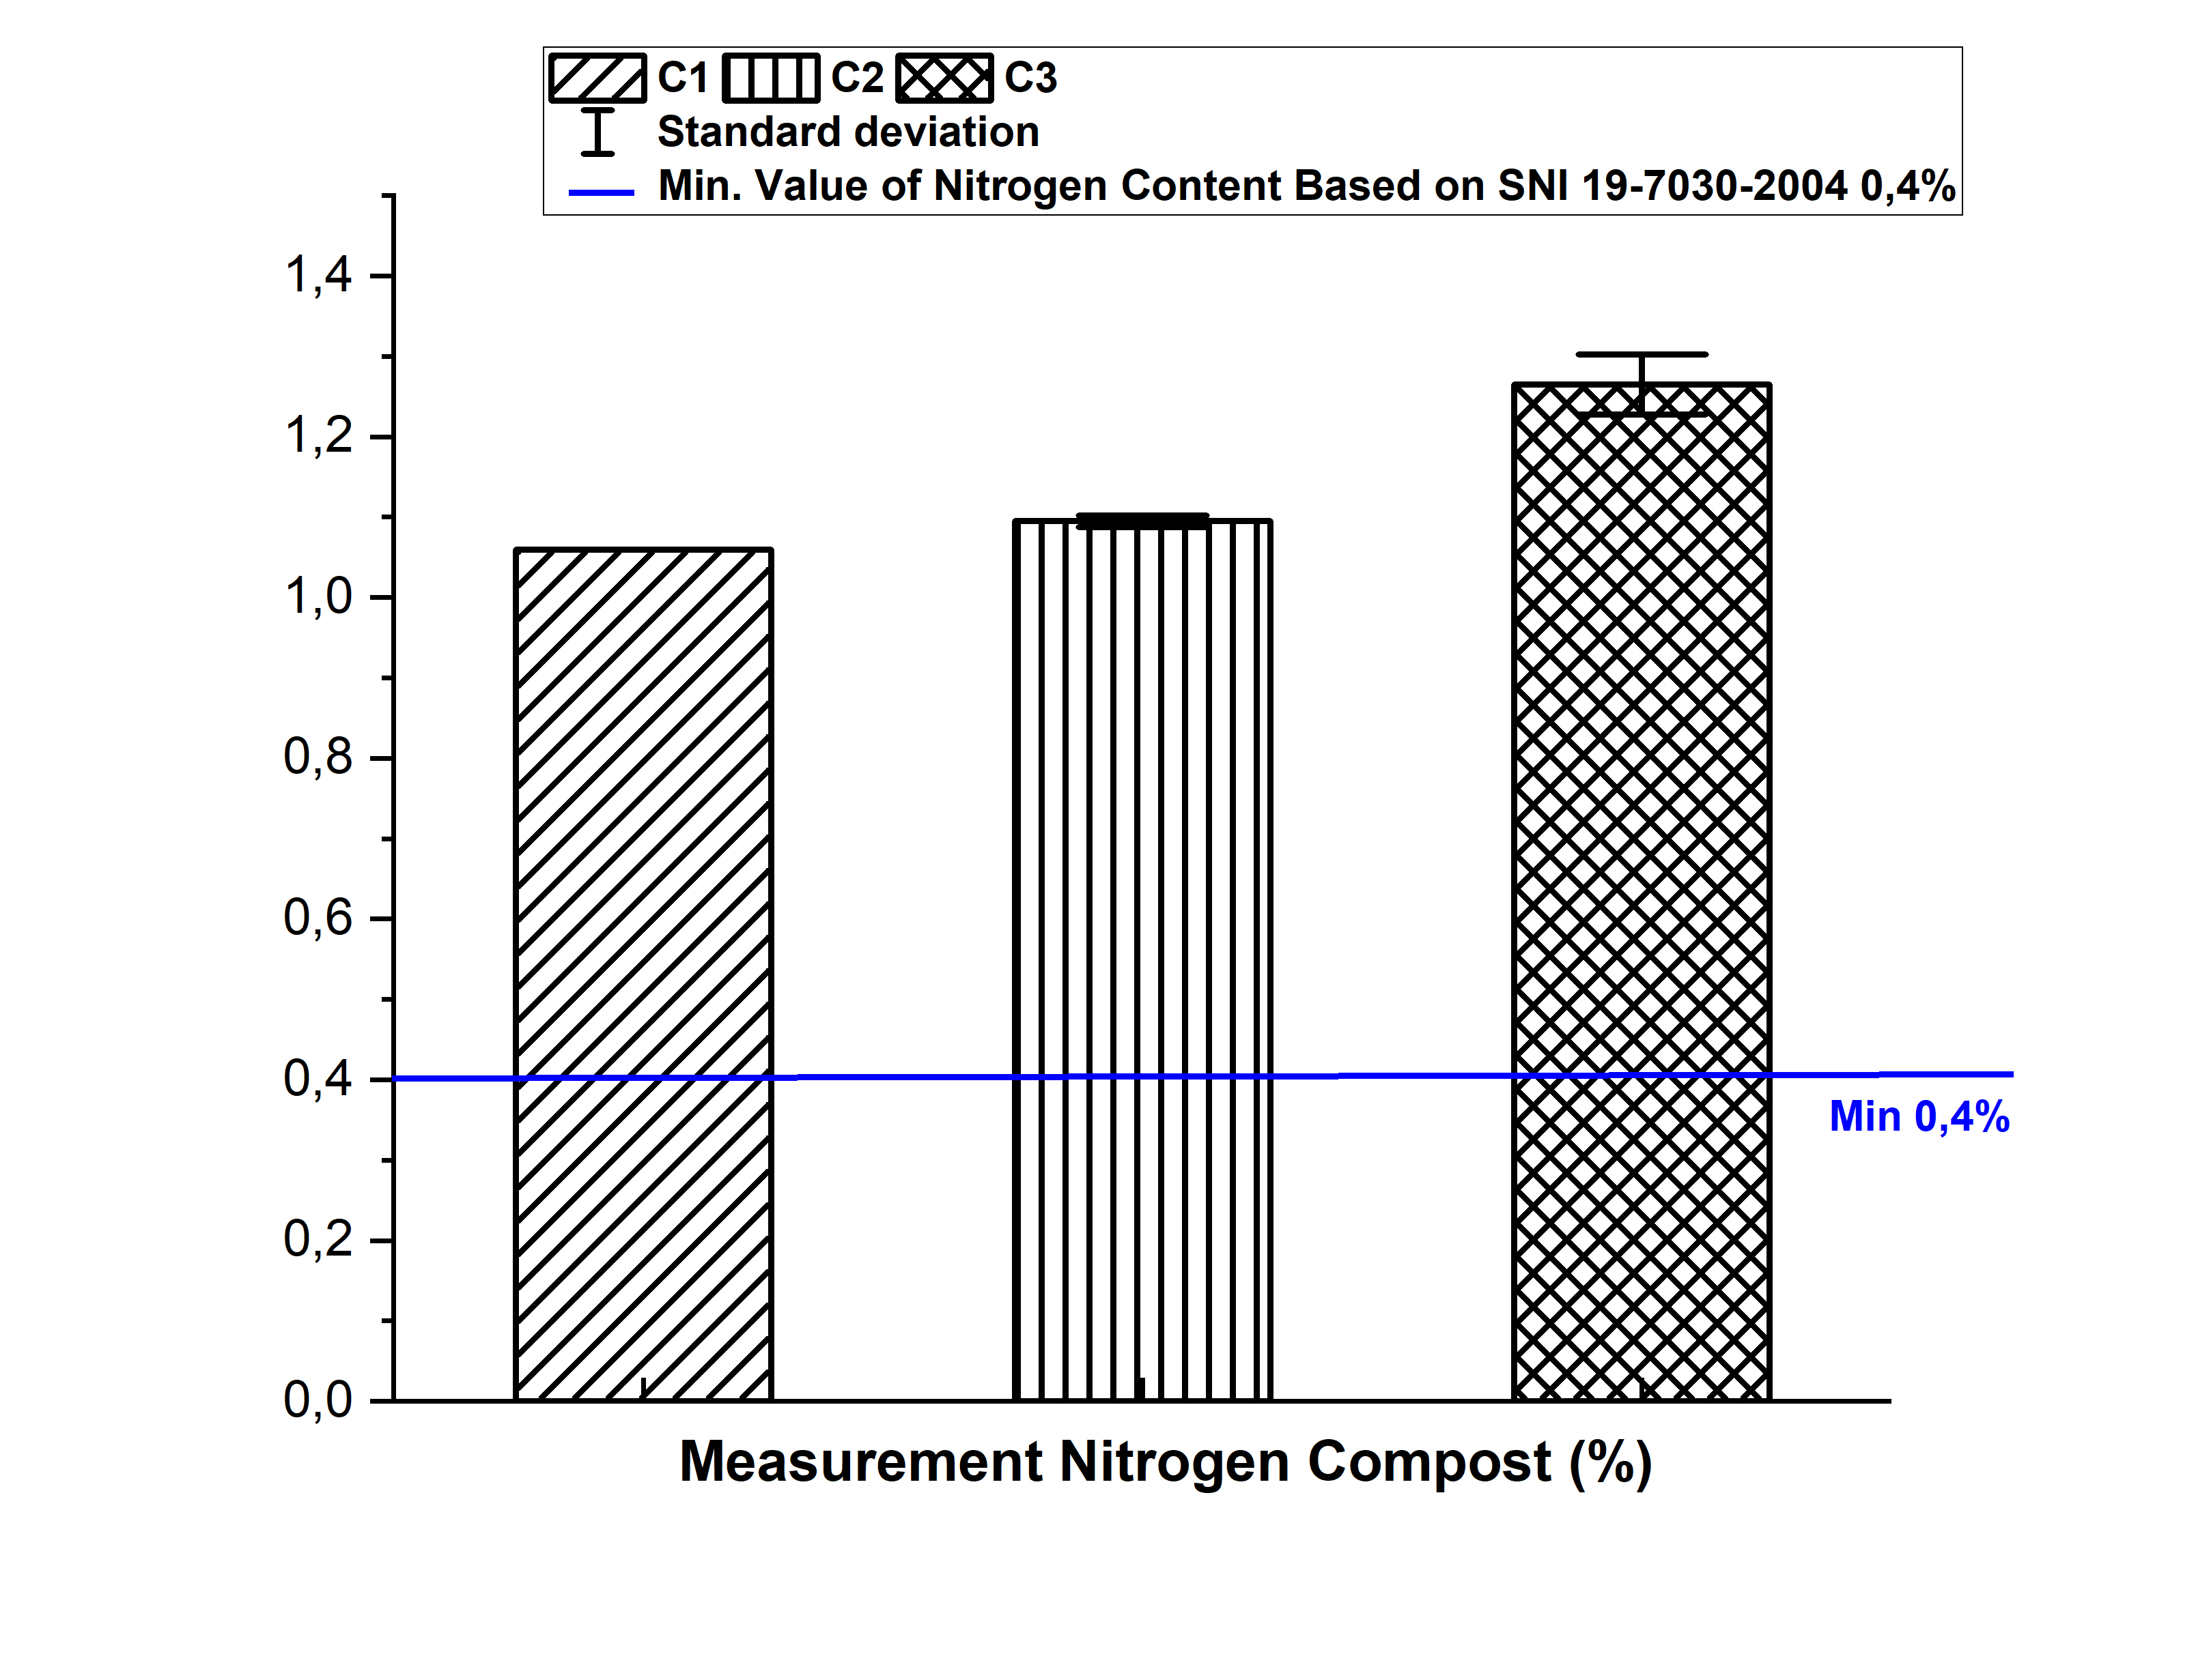
Figure 5. Nitrogen of Compost
The Figure 5, the highest of nitrogen content was in C3 because the activity of microorganisms in EM4 has functions to decompose proteins into amino acids through the ammonification process. During this process, amino acids form ammonium (NH4) and ammonia (NH3). Then ammonia was converted into nitrate (NO3) and nitrite (NO2) to form nitrogen (Vilela et al., 2020). In this study, worm activity can also affect nitrogen content because during the excretion process worms produce nitrobacteria bacteria which function to convert ammonia to nitrate so that it can increase nitrogen content. Nitrobacter bacteria can increase because of worm mucus. Then the lowest nitrogen content was in C1 because the volatilization process. This process can cause nitrogen content to evaporate in the air (Van Stelt et al., 2017). Nitrogen content in this study according to SNI 19-7030-2004.
    - C/N Ratio
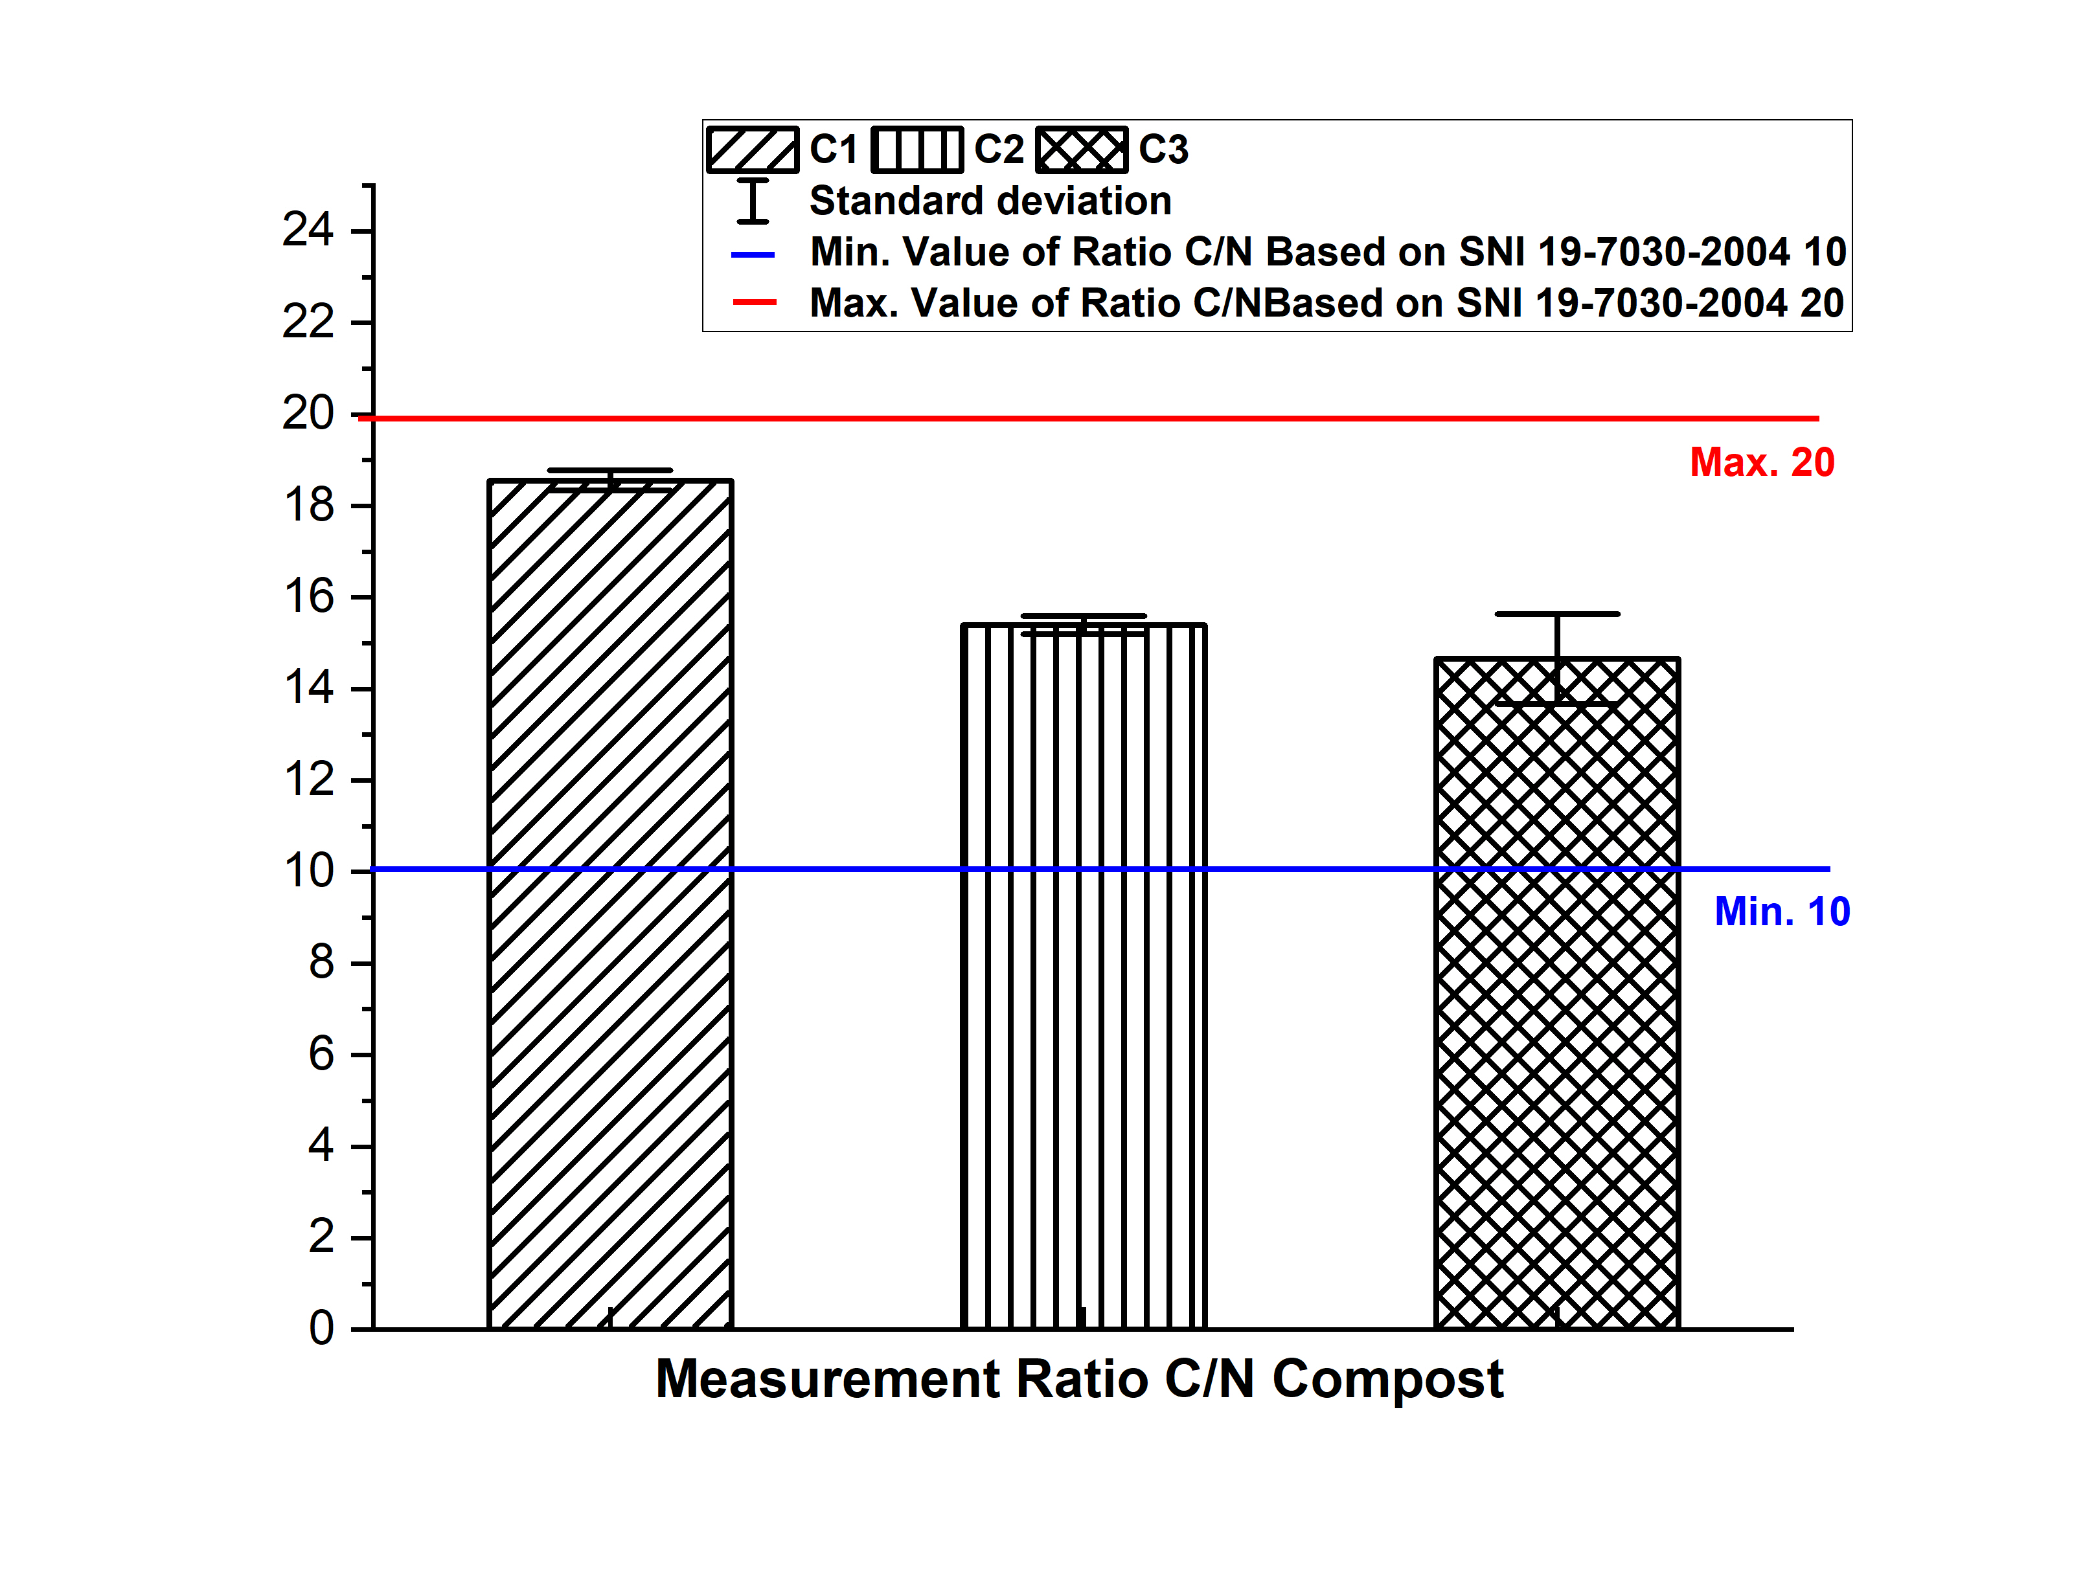
Figure 6. The Value of C/N Ratio
The C/N ratio decreases because carbon content decreases continuously. These elements were used by microorganisms as a source of energy during the decomposition process. The chemical reaction that occurs was (Nivethadevi et al., 2021) :
Organic matter + microorganisms CO₂+H₂O+nutrient+compost+energy (1)

In Figure 6 it was known that the lowest C/N ratio was at C3 because during the decomposition process, the activity of microorganisms occurs evaporation process of carbon dioxide (CO2) which can decrease the C-Organic content and increase the nitrogen content. Therefore the value of the C/N ratio decreases (Yommy et al, 2019. The C/N ratio in this study complied with SNI 19-7030-2004 standards.
    - Phospor
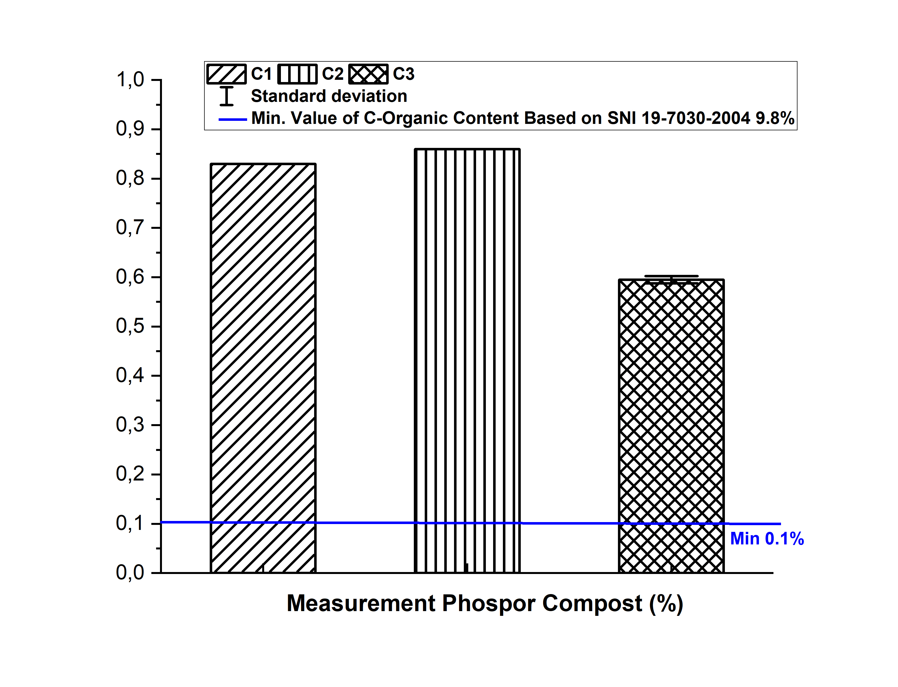
Figure 7. Phospor Content Test of Compost
Phosphor content was available because the ripening phase and material C-Organic and nitrogen compost were available. We must know that the addition of EM4 can help break down phosphor content in the compost material. Solvent microorganisms in EM4 such as Pseudomonas, Bacillus, and Brevibacterum which contain phosphor will die and then be mixed with the compost material. So that the phosphor content can increase (Beny et al, 2017). Lumbricus rubellus worms also have a role to provide phosphor content. Organic materials consumed by worms, then will be digested in the worm's stomach. During this process, the worms will decompose phosphor with phosphatase enzyme. These enzymes help break down organic phosphor into inorganic phosphor so that it is available to plants (Hanc et al, 2013). C3 was the lowest phosphor content because of C-Organic and nitrogen content. C-Organic was used by microorganisms as an energy source so this content decreases. This process affects the nitrogen content because microorganisms lack the energy to bind nitrogen content. It should be noted that nitrogen was a constituent of microorganism tissue (Anam, 2022). If the nitrogen content decreases, the activity of microorganisms to break down phosphor also decreases (Maghfirah, 2021).
    - Potassium
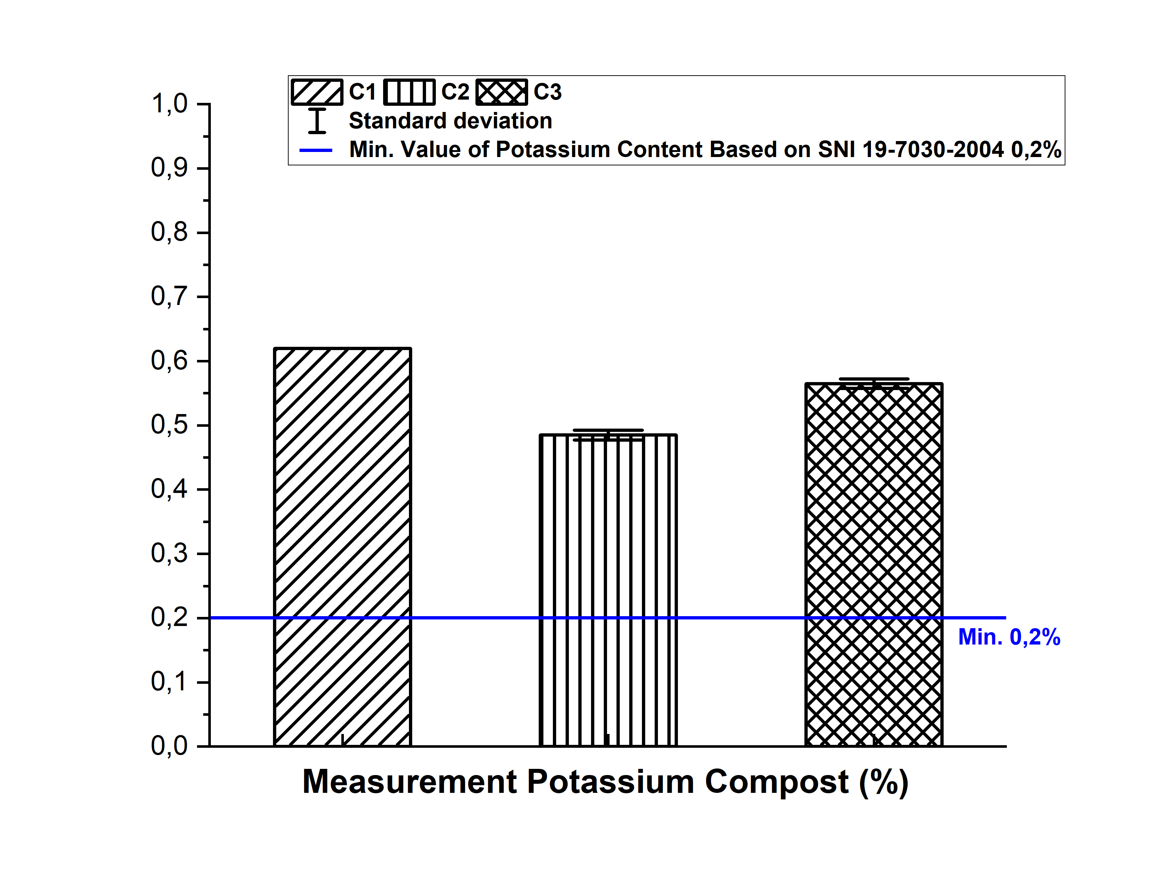
Figure 8. Potassium of Compost
The highest potassium content of compost at C1 because of the activity bacteria in worm eggs and EM4. Some of the type bacteria are Acynomycetes, and Bacillus mucilaginous which help break down potassium. So, that it was available in dissolved form and easily absorbed by plants. The lowest potassium element is C2 because this element is used by microorganisms during the decomposition process so that the potassium content decreases, besides that the vegetable waste used is not specific. So, the potassium content in the compost varies (Nur, 2016). Potassium in this study was complies with SNI 19-7030-2004 standards.
  - The Effect of Variation EM4 to The Characteristic Compost
There was a Table 4 the result normality test, homogeneity test, and MANOVA test to determine the effect of EM4 variations on vermicomposting compost content
Tabel 4. The result normality test, homogeneity test, and MANOVA test Compost
Normality test
Dependent Variable | Method | P-Value | Information | Normality
C-Organic content | Levene | 0.054 | P-Value > 0,05 | Normal Data
Nitrogen content | Levene | 0.331 | P-Value > 0,05 | Normal Data
Ratio C/N | Levene | 0.690 | P-Value > 0,05 | Normal Data
Phospor Content | Levene | 0.848 | P-Value > 0,05 | Normal Data
Pottasium Content | Levene | 0.276 | P-Value > 0,05 | Normal Data
pH | Levene | 0.054 | P-Value > 0,05 | Normal Data
Temperature | Levene | 0.396 | P-Value > 0,05 | Normal Data
Moisture content | Levene | 0.789 | P-Value > 0,05 | Normal Data
Homogenity test
Dependent Variable | Method | P-Value | Information | Homogenity
C-Organic content | Kolmogrov | 0.200 | P-Value > 0,05 | Homogeneous Data
Nitrogen content | Kolmogrov | 0.161 | P-Value > 0,05 | Homogeneous Data
Ratio C/N | Kolmogrov | 0.200 | P-Value > 0,05 | Homogeneous Data
Phospor Content | Kolmogrov | 0.729 | P-Value > 0,05 | Homogeneous Data
Pottasium Content | Kolmogrov | 0.200 | P-Value > 0,05 | Homogeneous Data
pH | Kolmogrov | 0.200 | P-Value > 0,05 | Homogeneous Data
Temperature | Kolmogrov | 0.200 | P-Value > 0,05 | Homogeneous Data
Moisture content | Kolmogrov | 0.200 | P-Value > 0,05 | Homogeneous Data
MANOVA test
Dependent Variable | F | Sig. | Hyphotesis | Information
C-Organic content | 74.234 | 0.000 | H1 accepted | Take effect
Nitrogen content | 58.323 | 0.000 | H1 accepted | Take effect
Ratio C/N | 75.294 | 0.000 | H1 accepted | Take effect
Phospor Content | 32.377 | 0.003 | H1 accepted | Take effect
Pottasium Content | 56.480 | 0.001 | H1 accepted | Take effect
pH | 84.472 | 0.000 | H1 accepted | Take effect
Temperature | 88.378 | 0.000 | H1 accepted | Take effect
Moisture content | 96.600 | 0.000 | H1 accepted | Take effect
The results of the normality test in Table 4 showed that all data is distributed normally, so all data in this research are representative. According to Sukestiyarno, (2017) If the normality test was not representative the regression analysis gives results that are not in accordance with the actual data. So the research results did not describe the truth of the original data. In Table 4 it was also known that the data was homogeneous. Homogeneous data means that the research sample data has the same distribution of data values.
The results of the statistical analysis in Table 4 prove that the Variation EM4 has a significant effect on the vermicomposting compost (P-value <0.05). The more adding EM4, so the activity of microorganisms increases to decompose organic matter. This condition can be marked by increasing the temperature of the compost in the reactor. Variations of EM4 have a significant effect on the C-Organic content due to biochemical reactions formed by the activity of gaseous microorganisms which can cause the C-Organic content to decrease because it was also carried into the atmosphere (Ali et al., 2019). Variations of EM4 have a significant effect on nitrogen content because the more EM4 the faster the decomposition process. This process produces nitrogen content in ammonium (NH4+) and nitrate (NO3-) compounds (Hidayat et al., 2023). Variations in EM4 have a significant effect on the phospor content because, in the EM4 solution, there are solvent bacteria that function to provide phospor in the compost. Microorganisms in EM4 produced phosphatase enzymes to decompose phosphor compounds into inorganic phosphor to make them available to plants (Nazilah et al., 2020).
EM4 variation has a significant effect on potassium content. Based on research by Achsah et al (2013) organic matter containing high potassium cannot be used directly, the addition of EM4 can help decompose potassium so that this content can be available in compost. Variation of EM4 has a significant effect on the C/N ratio because the greater the amount of EM4 added, the lower the resulting C/N ratio. This was due to the large number of microorganisms that decompose the compost material (Ali et al., 2019). Then finally, variations in EM4 can have a significant effect on pH because the activity of microorganisms in EM4 functions to degrade organic acids so that the pH becomes neutral (Yommy et al, 2021).
  - The Effect of Adding Compost Vermicomposting To Regosol Soil
The following was Table 5. Research Result of Vermicomposting Addition to Regosol soil quality
Tabel 5. Soil Incubation Result
Organic Matter | Standard Soil Research Center 2009 |  |  |  |  |  | Soil initial nutrition | Soil nutriens after add compost
 |  |  |  |  |  |  |  | T0 | T1 | T2
 |  |  |  |  |  |  |  | 0 gr compost /500 gr regosol land | 2,5 gr compost /500 gr regosol land | 5 gr compost /500 gr regosol land
C-Organic (%) | < 1 | 1– 2 |  | 2,01 –  3 | 3,01  –  5 | >5 | 0,48 | 0,46 | 0,93 | 1,07
Information | VL | L |  | M | H | VH | VL | VL | L | L
Nitrogen  (%) | < 0,1 | 0,1  –  0,2 |  | 0,21 –  0,5 | 0,51  –  0,75 | >0,75 | 0,06 | 0,03 | 0,04 | 0,12
Information | VL | L |  | M | H | VH | VL | VL | VL | L
Phospor  (ppm) | < 4 | 5–7 |  | 8  –  10 | 11  –  15 | >15 | 48,90 | 59,74 | 132,56 | 160,87
Information | VL | L |  | M | H | VH | VH
Potassium (mg/100g) | < 10 | 10 -20 |  | 21  – 40 | 41  –  60 | >60 | 43,19 | 38,14 | 40,80 | 52,83
Information | VL | L |  | M | H | VH | H | M | M | H
pH | <4,5 | 4,5  –  5,5 | 5,6 – 6,5 | 6,6 – 7,5 | 7,6 – 8,5 | > 8,5 | 6,79 | 7 | 7,1 | 7,3
Information | VA | Ac. | QA | N | SA | A | N
Information:
VL : Vey Low VA : Very Acid A : Alkaline
L : Low Ac. : Acid
M : Medium QA : Quite Acid
H : High N : Neutral
VH : Very High SA : Sightly Alkaline

The Table 5 described that T0, T1, and T2 treatments were able to increase the soil pH content. Based on research by Angelova et al (2013), vermicomposting compost was more efficient to increase soil than conventional compost. Vermicomposting compost has a significant effect on the pH content of regosol soil because, during the soil decomposition process, a mineralization process occurs which releases several alkalines. This process can build cations. So, the pH can increase (Chithra et al., 2020). In Table 5, the highest C-Organic content is at T2, which was 1.07%. Based on the Soil Research Center 2009 about the criteria soil quality. The C-Organic content was still relatively low because the nutrients in the compost very low. The addition of compost can significantly affect (Tabel 6) the C-Organic quality of regosol soil because the vermicomposting compost contains a humus of 13.88%. The C-Organic content in humus was 40% -80% so C-Organic can increase with the amount of vermicomposting compost added (Bergstrand et al, 2022).
The lowest nitrogen content was in the T0 (0.03%), and the highest in T2 (0.12%). When compared with the soil quality criteria based on the Soil Research Center 2009, T0 and T1 were classified as very low, while T2 was classified as low. The addition of vermicomposting compost into regosol soil has a significant effect (Tabel 6) on soil nitrogen. During the incubation process, the mineralization process of organic matter occurs to produce nitrogen content in NH4+ and NO3- compounds. In Table 5 there was a decrease in the nitrogen content in T0 because nitrogen dissolves easily resulting in evaporation during incubation which can reduce the nitrogen content (Fitria, 2018). The results of incubation regosol soil produced the highest phosphor content at T2 (160.87 ppm), and the lowest at T0 (48.90 ppm). When compared with the Soil Research Center 2009 about the criteria soil quality, this content was classified as very high. The application of vermicomposting compost has a significant effect on the phosphor content in the regosol soil (Table 6). Research by Angelova et al, (2013) proved that there was an increase in phosphor content due to the mineralization process carried out by microorganisms in vermicomposting compost. Potassium content in the soil increased. The lowest potassium content was in the treatment (38.14 mg/100g), while the highest content was in T2 (40.80 mg/100g).
The Tabel 6 explained that vermicomposting compost can significantly affect the potassium content in the regosol soil because the activity of microorganisms in the compost utilizes the potassium content as a catalyst. Potassium contained in compost will be stored in the cells of microorganisms, over time it will be degraded so that potassium content can be available in the soil (Idawati, 2017). The following is Table 6. The results of normality, homogeneity, and MANOVA tests to determine the effect of adding vermicomposting compost to regosol soil.
Table 6. The result normality test, homogeneity test, and MANOVA test Regosol Soil
STATISTICAL TEST
Normality Test
Dependent Variable | Methode | P-Value | Information | Normality
C-Organic | Kolmogrov | 0.200 | P-Value > 0,05 | Data Normal
Nitrogen |  | 0.200 | P-Value > 0,05 | Data Normal
Phospor |  | 0.200 | P-Value > 0,05 | Data Normal
Potassium |  | 0.093 | P-Value > 0,05 | Data Normal
pH |  | 0.200 | P-Value > 0,05 | Data Normal
Homogenity Test
Dependent Variable | Methode | P-Value | Information | Homogeneity
C-Organic | Levene | 0.588 | P-Value > 0,05 | Homogenous Data
Nitrogen | Levene | 0.293 | P-Value > 0,05 | Homogenous Data
Phospor | Levene | 0.497 | P-Value > 0,05 | Homogenous Data
Potassium | Levene | 1 | P-Value > 0,05 | Homogenous Data
pH | Levene | 1 | P-Value > 0,05 | Homogenous Data
MANOVA Test
Dependent Variable | F | Sig. | Hipotesis | Information
C-Organic | 317.820 | 0.000 | H1 accepted | Take effect
Nitrogen | 86.138 | 0.000 | H1 accepted | Take effect
Phospor | 80.980 | 0.000 | H1 accepted | Take effect
Potassium | 195.488 | 0.000 | H1 accepted | Take effect
pH | 49.672 | 0.000 | H1 accepted | Take effect

- Conclusions
The best of compost quality was C3 at 45% fish waste, 35% sawdust, and 20% vegetable waste which have accordance with the compost specifications based on SNI 19-7030-2004. In addition, it has a moisture content at 50%, temperature at 27ºC, pH 7, 0.6% (phosphor), 0.57% (potassium), 18.52% (C-Organic), 1.72% (Nitrogen), and C/N ratio (14.6). This study proves that variations in EM4 have a significant effect on the pH, C-organic, nitrogen, phospor and potassium of compost based on SNI 19-7030-2004. In another hand, the addition of vermicomposting compost to regosol soil can have a significant effect on temperature, moisture content, pH, C-organic, nitrogen, phospor and potassium of regosol soil. This research was pH, C-organic, nitrogen, phospor and potassium of the soil did not accordance based on Soil Research Institute 2009 standards. Therefore, the further research was the adding of goat manure in the compost materials. This purpose to increase C-Organic and Nitrogen content in the compost.
- Acknowledgement
Thank you to DIPA Pusat Penelitian dan Pengabdian Masyarakat Perkapalan Negeri Surabaya (P3M PPNS) 2023 for supporting this study.

- References
Achsah, R. S., and Prabha, M. L. 2013. Potential of Vermicompost Produced From Banana Waste (Musa paradisiaca) on The Growth Parameters of Solanum lycopersicum. Int. J. Chem. Tech. Res, 5(5), 2141-2153.
Ali, F., and Sari, T. I. 2019. Utilization of PT. Hok Tong Liquid Waste Rubber Industry in Making of Liquid Organic Fertilizer With Addition of Enceng Gondok and EM4. 620 (1), 58-69.
Anam, M. S., and Regar, A. F. C. 2022. Pengaruh Penambahan Kotoran Kambing dan EM4 Terhadap Kualitas Pupuk Kompos Limbah Jerami Padi dan Pemanfaatannya Terhadap Pertumbuhan Tanaman Bayam (Amaranthus sp). Berkala Ilmiah Pertanian, 5(2), 99-109.
Angelova, V. R., Akova, V. I., Artinova, N. S., and Ivanov, K. I. 2013. The effect of Organic Amendments on Soil Chemical Characteristics. Bulgarian Journal of Agricultural Science, 19(5), 958-971.
Arthawidya, J., Sutrisno, E., and Sumiyati, S. 2017. Analisis Komposisi Terbaik dari Variasi C/N Rasio Menggunakan Limbah Kulit Buah Pisang, Sayuran dan Kotoran Sapi dengan Parameter C-Organic, N-Total, Fosfor, Kalium dan C/N Rasio Menggunakan Metode Vermikomposting. Jurnal Teknik Lingkungan, 6(3), 1-2.
Beny, B., and Sigit, P. 2017. The Simple Machines for Making Organic Fertilizer at School. Health Notions, 1(3), 243-250.
Bergstrand, K. J. 2022. Organic Fertilizers in Greenhouse Production Systems–a Review. Scientia Horticulturae, 2 (9), 51-62.
Chithra, S., and Sreekumar, J. 2020. Mineralization of Thippi (Cassava Starch Factory Solid Residue) Compost Under Incubation. Journal of Root Crops, 46(1), 1121-1151
Getahun, M., and Selassie, Y. G. 2017. Characterization, Classification and Mapping of Soils Agricultural Landscape in Tana Basin, Amhara National Regional State, Ethiopia. Social and Ecological System Dynamic. 4(6), 93-115
Ghahdarijani, A. R. J., Hoodaji, M., and Tahmourespour, A. 2022. Vermicomposting of Sewage Sludge With Organic Bulking Materials to Improve its Properties. Environmental Monitoring and Assessment, 194(8), 555-570
Grasserova, A., Hanc, A., Innemanova, P., and Cajthaml, T. 2020. Composting and Vermicomposting Used to Break Down and Remove Pollutants From Organic Waste. European Journal of Environmental Sciences, 10(1), 9-14.
Gusnidar, G., Yulnafatmawita, Y. 2013. Pengaruh Kompos Asal Kulit Jengkol (Phitecolobium jiringa (jack) prain ex king) Terhadap Ciri Kimia Tanah Sawah dan Produksi Tanaman Padi. Jurnal Solum, 8(2), 58-69.
Hanc, A., and Pliva, P. 2013. Vermicomposting Technology As a Tool For Nutrient Recovery From Kitchen Bio waste. Journal of Material Cycles and Waste Management, 15 (2), 431-439.
Hidalgo, D., Corona, F., and Martín-Marroquín, J. M. 2022. Manure Biostabilization by Effective Microorganisms as a Way to Improve Its Agronomic Value. Biomass Conversion and Biorefinery, 12(10), 4649-4664.
Hidayat, B., Sebayang, N. U. W., and Akbar, A. M. 2023. Co-composting Cow Manure, Rice Straw With Marine Organic Waste. Earth and Environmental Science. 1182 (1), 58-69
Iresha, A., Hidayat, H., 2022. Sustainable Compost Prepared From Oyster Mushroom Substrate Microparticles With Domestic Wastes as Local Starters. Moroccan Journal of Chemistry, 10(4), 10-4.
Jain, M. S., Daga, M., and Kalamdhad, A. S. 2019. Variation in The Key Indicators During Composting of Municipal Solid Organic Wastes. Sustainable Environment Research, 29(1), 1-8.
Jar, N. R., and Faisal, F. A. 2021. Pengaruh Jumlah Cacing Tanah (Lumbricus Rubellus) Dan Waktu Pengomposan Terhadap C/N Rasio Vermikomposting Dari Sludge Ipal PT Surabaya Industrial Estate Rungkut (Sier). Jurnal EnviroUS, 2(1), 123-128.
Kumar, R., and Pareek, B. L. 2022. Effect of Organic Manure, Azospirillum and Inorganic Fertilizer On Growth and Yield of Wheat (Triticum aestivum L.). Pharma Journal, 11(2), 2179-2183.
Kunhadi, D., Badriyah, B., and Atmajawati, Y. 2018. Improving Skills to Manage Household Waste in Wonokromo Urban Village, Surabaya. Research Dissemination, 1(1), 43-46.
Maghfirah. 2021. Pembuatan Kompos Limbah Ikan Dengan Menggunakan Bioaktivator Kotoran Ayam.Tugas Akhir Universitas Islam Ar-Rainr
Manyuchi, M., and P. Murenzi. 2013. Continuous Flow through Vermireactor for Medium Scale Vermikomposting. Asian Journal of Enginerring and Technology, .1 (1), 41-46
Maystrenko, T., and Rybak, A. 2023. Radium Uptake by Earthworms E. fetida After Exposure to Contaminated Soil. Journal of Environmental Radioactivity, 5(2), 99-109
Nazilah, K. R., Koentjoro, M. P., Isdiantoni, I., Ekawati, I., Muslihatin, W., and Prasetyo, E. N. 2020. Effect of Laccase Oxidation Pre-treatment on Coffee (Coffea arabica) Bean Processing Waste for Composting Substrate. AIP Conference Proceedings 5(2), 99-109
Nivethadevi, P., Swaminathan, C., and Kannan, P. 2021. Chapter-4 Soil Organic Matter Decomposition Roles, Factors and Mechanisms, Latest Trends 5(5), 199-209
Nurhidayati, N., Ali, U., and Murwani, I. 2016. Yield and Quality of Cabbage (Brassica oleracea L. var. Capitata) Under Organic Growing Media Using Vermicompost and Earthworm Pontoscolex Corethrurus Inoculation. Agriculture and Agricultural Science Procedia, 11 (1), 5-13.
Nur, T., Noor, A. R., and Elma, M. 2016. Pembuatan pupuk organik cair dari sampah organik rumah tangga dengan bioaktivator EM4 (Effective microorganisms). Konversi, 5(2), 5-12.
PenelitianTanah, B. 2009. Petunjuk Teknis Analisis Kimia Tanah, Tanaman, Air, dan Pupuk.
Setiani, V., Siswanto, V. K., Nindyapuspa, A., Kurniawati, U. F., and Kamilah, M. M. 2021. Physical Characterization Manure of The Variation Adding Earthworms L. lumberus The Process Vermicomposting. E3S Web of Conferences. 332, 07003.
Siswanto, V. K., Setiani, V., Nindyapuspa, A., Kurniawati, U. F., and Kamilah, M. M. 2021. The Use of Lumbricus Rubellus Earthworm Effect in Composting Process of Musa Paradisiaca L. Peel Waste. Jurnal Presipitasi, 18(3), 423-432.
Sitompul, E., Wardhana, I. W., and Sutrisno, E. 2017. Studi Identifikasi Rasio C/N Pengolahan Sampah Organik Sayuran Sawi, Daun Singkong, dan Kotoran Kambing Dengan Variasi Komposisi Menggunakan Metode Vermikomposting. Jurnal Teknik Lingkungan, 6(2), 1-12.
SNI 19-7030-2004. Spesifikasi Kompos dari Sampah Organik. Badan Standar Nasional Indonesia.
Sukestiyarno, Y. L., and Agoestanto, A. 2017. Batasan prasyarat uji normalitas dan uji homogenitas pada model regresi linear. Unnes Journal of Mathematics, 6(2), 168-177.
Usmadi, U. 2020. Pengujian persyaratan analisis (Uji homogenitas dan uji normalitas). Inovasi Pendidikan, 7(1), 81-89.
Van der Stelt, B., Temminghoff, E. J. M., Van Vliet, P. C. J., and Van Riemsdijk, W. H. 2017. Volatilization of Ammonia From Manure as Affected by Manure Additives, Temperature and Mixing. Bioresource technology, 98(18), 3449-3455.
Vasilyev, A. V. 2016. Classification and Reduction of Negative Impact of Organic Waste Industry. Smart Design, Planning and Technologies, 5(2) 101-107.
Vilela, M. D. O., Gates, R. S., Souza, C. F., Teles Junior, C. G., and Sousa, F. C. 2020. Nitrogen Transformation Stages Into Ammonia in Broiler Production. Dyna, 87 (214), 221-228.
Vukovic, A., Velki, M., Ecimovic, S., Vukovic, R., Stolfa Camagajevac, I., and Loncaric, Z. 2021. Vermicomposting Facts, Benefits and Knowledge Gaps. Agronomy, 11(10), 1952.
Yommy, D., Aziz, R., and Handayani, R. A. 2019. The Effect of Additional Vegetables and Fruits Waste on The Quality of Compost of Cassava Chip Industry Solid Waste on Takakura Composter. Technology and Engineering Science, 8(12),1-13.
Yommy, Y., Silvia, S., and Riantika, M. 2021. Food Waste Composting with The Addition Of Cow Rumen Using The Takakura Method and Identification of Bacteria in Composting Process. IOP Conference
Series, 1041 (1), 21-2.

