Original Research Article
Effect of Variations in Composition, Pyrolysis Temperature and Adhesive Concentration on Proximate Content and Calorific Value of Biobriquettes from Durian Shell Waste, Corn Peel, Fish Bones

Nora Amelia Novitrie^{1*}, Vivin Setiani¹, Aisyah Dinda Camalia¹
¹ Department of Waste Treatment Engineering, Shipbuilding Institute Of Polythecnic Surabaya
* Corresponding Author, email noranovitrie@ppns.ac.id

Abstract
Briquettes are an alternative energy derived from biomass. Biomass energy can be applied to replace energy derived from fossil fuels. Biomass material can be obtained from plantation waste such as durian skin, agricultural waste such as corn husk and waste from the fisheries sector such as fish bones. Waste of corn husks, durian skins and fish bones has the potential to become biomass material as an alternative energy. The purpose of this study was to analyze the effect of variations in composition, pyrolysis temperature and adhesive concentration on the quality of biobriquettes and to analyze the emissions produced when burning biobriquettes. Variations in this study consisted of composition, pyrolysis temperature and adhesive concentration. The dried waste materials were then pyrolyzed for 4 hours at 350 ℃ and 500 ℃. Proximate testing was carried out to determine the quality of the biobriquettes. The parameters analyzed in this test include moisture content, ash content, volatile matter content, bound carbon content and heating value. The results of the study revealed that the best sample variations were found in briquettes with a composition of 50% durian rind : 50% corn husk with a pyrolysis temperature of 350℃ and an adhesive concentration of 7%. The level of CO emissions produced when burning briquettes is 1700 mg/Nm³ and SO2 is 0.741 mg/Nm³.
Keywords: Briket, Biomas, emisi, limbah Briquettes, biomass, emissions, waste

- Introduction
The need for energy is increasing along with the increase in population. This increase makes fossil energy reserves dwindling so that alternative energy is needed to overcome this problem. The use of biomass energy is one alternative energy that can be applied. Biomass materials are very easy to find from agricultural, plantation, forestry, animal husbandry, fishery and other activities (Patabang, 2012). Plantation waste that can be used as raw material for biobriquettes is durian skin. Until now, the utilization of durian skin waste can be said to be still lacking. Durian skin waste contains 15.45% lignin, 13.09% hemicellulose and 60.45% cellulose. The presence of lignin and cellulose indicates that durian skin has the potential to be used as raw material for making biobriquettes (Irhamni et al., 2019). Durian skin in this study contained 80.04% moisture content, 85.54% volatile matter, 5.30% ash content, and 9.16% bonded carbon. Agricultural waste in the form of corn husks can also be used as raw material for making biobriquettes because corn husks are composed of 44.08% cellulose compounds. Corn itself is the second important food crop after rice and is found in almost all of the Indonesian archipelago. One way to process corn husk waste is to use it as raw material for biobriquettes. Corn husk contains 12.95% moisture content, 53.7% volatile matter, 10.99% ash content, and 35.31% bonded carbon. Waste from the fisheries sector in the form of fish bones can be processed into materials for making biobriquettes which, if successful, can become the latest innovation in utilizing fish bone waste. Indonesia is an archipelagic country that has abundant fish resources. Fish bones contain 6.32% moisture content, 48.16% volatile matter, 41.68% ash content, and 10.16% bonded carbon.
From the description above, it can be seen that the waste of corn husks, durian skins and fish bones has the potential to become biomass material as an alternative energy. One of the products of biomass is briquettes, where briquettes themselves are solid fuels that can be used as an alternative energy source that has a certain shape. Making briquettes aims to obtain a quality fuel that can be used for all sectors as a substitute energy source (Haliza and Saroso, 2022). The raw material for making briquettes needs to be carbonized which will produce charcoal, one of the charcoal methods that can be used is the pyrolysis method. Pyrolysis is a chemical decomposition process using heating without the presence of oxygen (Ridhuan and Suranto, 2017). The pyrolysis temperature affects the quality of the briquettes where the higher the pyrolysis temperature, the higher the calorific value but the slower the burning rate. The type and concentration of adhesive can also affect the quality of the biobriquettes. The adhesive from tapioca flour is an organic adhesive that is often used in making briquettes. Very tapioca flour
has the potential to become a briquette adhesive because it has a low water and ash content and a high carbon content. The use of briquettes as fuel can cause emissions during combustion. If the resulting emission exceeds the established quality standards, it can pollute the environment if the bio-briquette-fired stove is not accompanied by gas and particulate treatment. (Setiani et al., 2019).
Based on the description above, this research was conducted to utilize waste in the form of corn husks, durian skins, and fish bones as materials for making briquettes. The purpose of this study was to analyze the effect of variations in composition, pyrolysis temperature and adhesive concentration on the quality of biobriquettes and also to analyze the emissions produced when burning biobriquettes.
- Methods
- Determination of Variation and Production of Biobriquettes
Variations in this study consisted of variations in composition, pyrolysis temperature and adhesive concentration. The raw materials used in this study were durian skin waste, corn husks and fish bones. Pyrolysis temperature variations used in this study are 350 ℃ and 500 ℃. Variations in the concentration of the adhesive used were 7% and 10% by weight of the briquettes per sample. Sample variations can be seen in Table 1.

Tabel 1. Variation of Composition, Pyrolysis Temperature and Adhesive Concentration
Material Composition  (CH : DS : FB) | 350℃ |  | 500℃
 | 7% | 10% | 7% | 10%
Durian Skin  (100%) | A1 | A4 | A7 | A10
Durian Skin : Corn Husk  (50% : 50%) | A2 | A5 | A8 | A11
Durian Skin : Fish Bones  (50% : 50%) | A3 | A6 | A9 | A12

The process of making briquettes :
- Collect durian skin waste, corn skin and fish bones, then cut all the ingredients into smaller sizes of ± 5cm. Material cutting is done to speed up the drying process of the material which is carried out using an oven at 115℃ until the moisture content is ≤ 15%. (Bot et al., 2023).
- The dried material is then pyrolyzed for 4 hours at 350℃ and 500℃. The charcoal from the pyrolysis results is then ground into a fine powder and then filtered using a 60 mesh sieve. The sieving process is carried out so that the particle size of the charcoal powder is equally distributed (Purwanto and Sofyan, 2014).

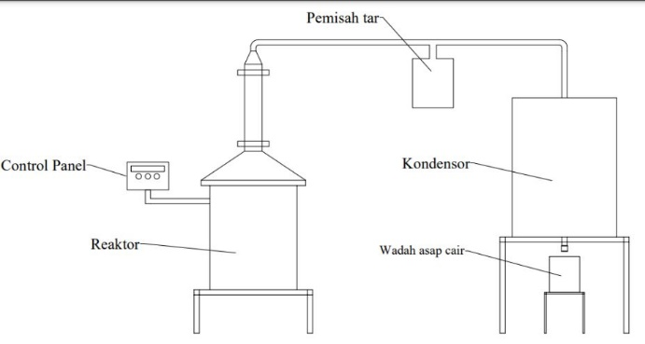
Control Panel
Reactor
Liquid smoke container
Condensor
Tar Separator
Figure 1. Pyrolysis Equipment

- The filtered charcoal is then mixed according to the variations specified in Table 1, the mixture of ingredients is then added with tapioca flour adhesive solution according to the predetermined concentration to form a briquette dough (Wahyudi et al., 2022).
- The finished briquette dough is then printed using a manual briquette press, then the briquette samples are dried using an oven at 105℃ (Saeed et al., 2021).

- Proximate Testing and Calorific Value
Proximate testing in this study aims to determine the quality of biobriquettes from durian skin, corn skin and fish bones. The parameters analyzed in this test include moisture content, ash content, volatile matter content, bound carbon content and heating value. The test standards carried out in this study can be seen in Table 2.

Table 2. Proximate Parameter Testing Standard and Calorific Value
Parameters | Value | unit | Reference
Moisture Content | ≤ 8 | % | SNI 1-6235-2000
Ash Content | ≤ 8 | % | SNI 1-6235-2000
Volatile Matter | ≤ 15 | % | SNI 1-6235-2000
Fixed Carbon | ≥ 77 | % | SNI 1-6235-2000
Calorific Value | ≥ 5000 | Cal/gr | SNI 1-6235-2000

- Statistical analysis
The research data that has been obtained is then analyzed using the Multivariate Analysis of Variance (MANOVA) test. MANOVA is a statistical technique used to calculate the simultaneous mean difference significance test between groups for two or more dependent variables (Sutrisno and Wulandari, 2018).Statistical analysis in this test was carried out to analyze the effect of variations in material composition, pyrolysis temperature and adhesive concentration on the proximate value and calorific value test results.

- Selection of the Best Variation Samples
Determination of the best variety of briquettes in this study was carried out using the scoring method. This scoring method consists of 2 criteria, where the sample gets a score of 1 if it has a value according to SNI 1-6235-2000 and will get a score of 0 if the parameter value does not match SNI 1-6235-2000. The selection of this scoring value was carried out in accordance with the research conducted by Dewilda and Maryam (2017).

- CO and SO2 Emission Tests
Emission testing in this study was conducted to determine the levels of CO and SO2 emissions produced during the burning process of briquette samples. Emission testing in this study was carried out referring to the Government Regulation of the Republic of Indonesia No. 41 of 1999 concerning National Ambient Air Quality Standards. The method used to analyze CO emission levels is NDIR using the NDIR Analyzer tool. SO2 parameters were analyzed using pararosaniline using a spectrophotometer.

- Result and Discussion
  - Analysis of Proximate Test Results
- Moisture Content
The parameter of water in the briquettes is one of the important elements because it is related to the amount of smoke produced, the ignition of the briquettes and the durability of the briquettes. The results of testing the water content of each sample variation can be seen in Figure 2.
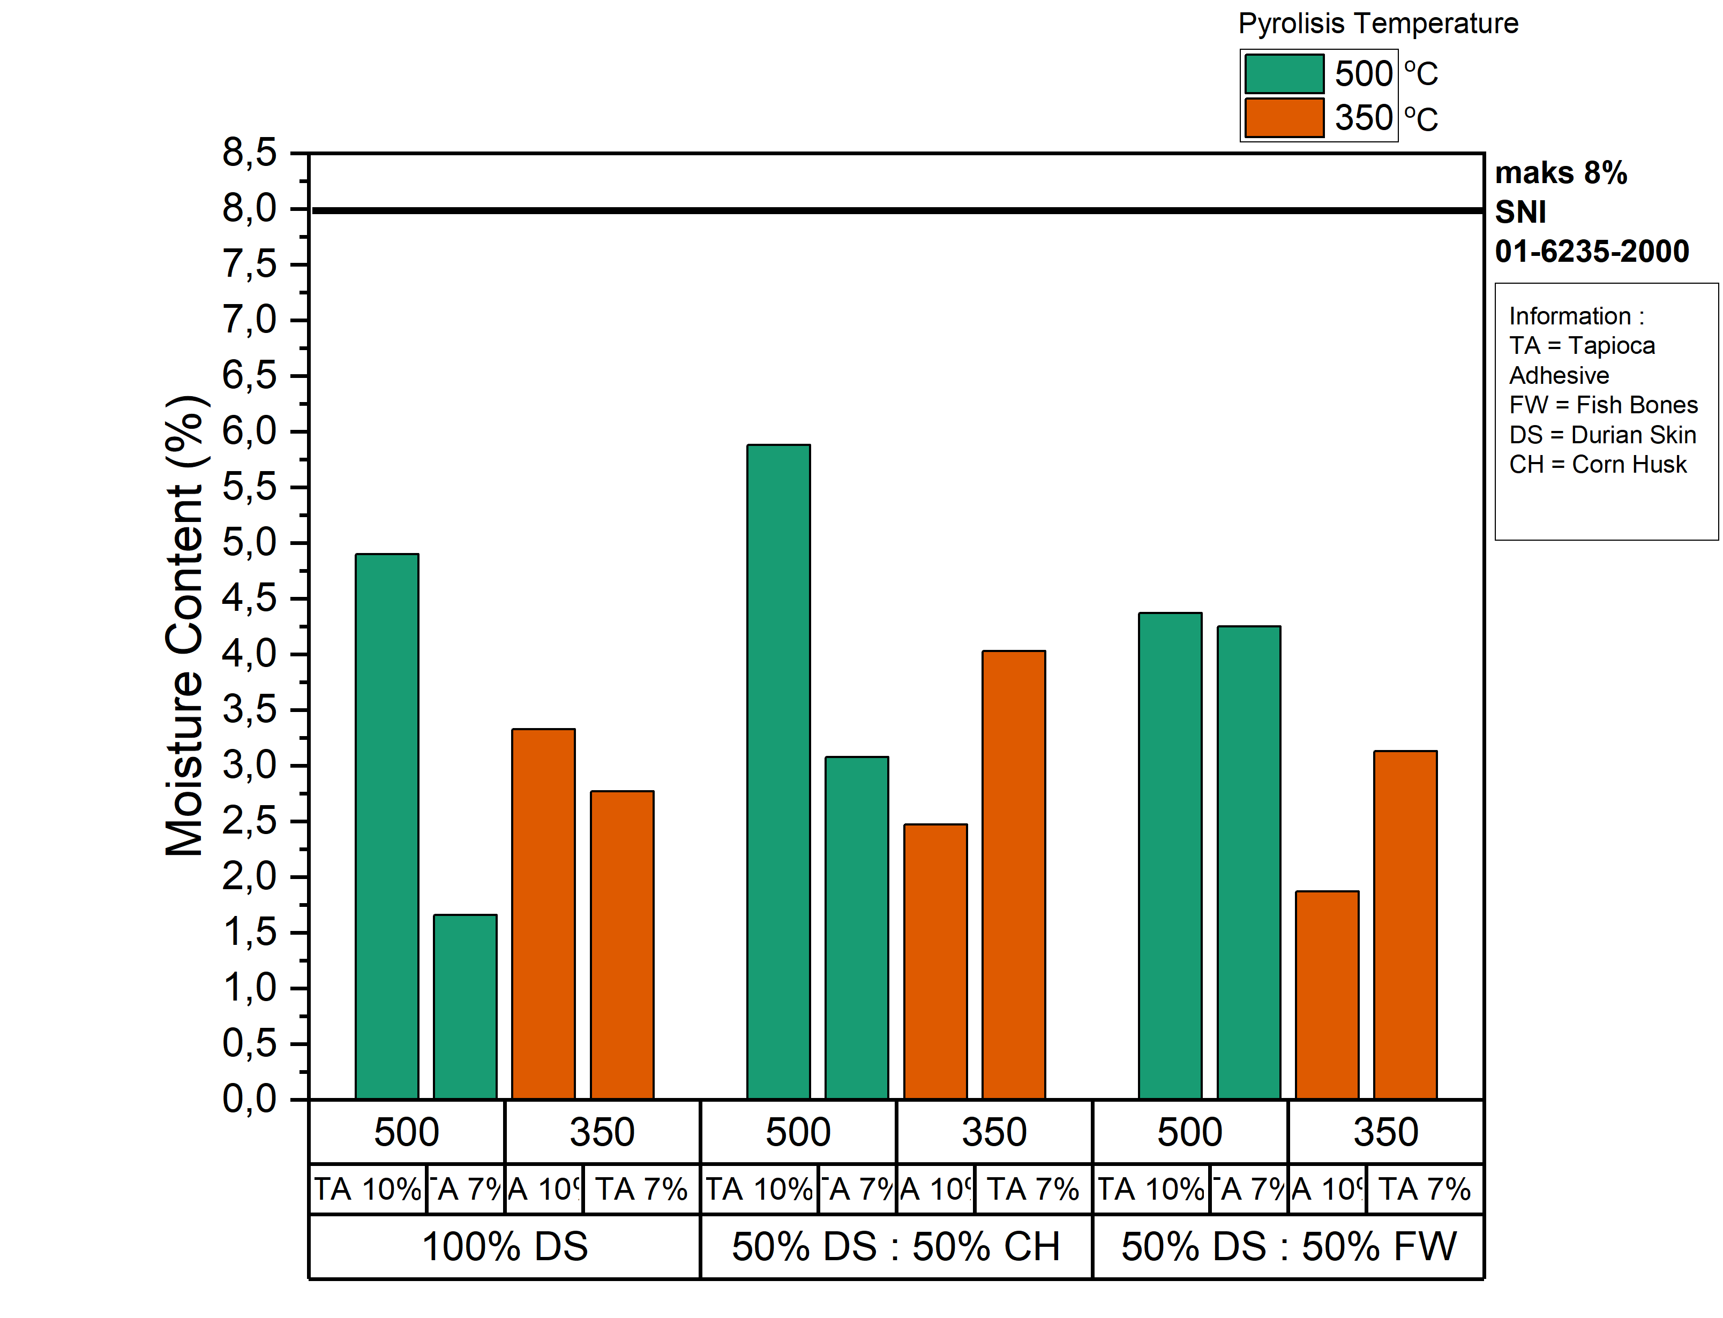
Figure 2. Moisture Content of Biobriquette Samples

Figure 2 shows that the water content of the variations in the composition of the durian peel biobriquettes increased with the amount of adhesive concentration, namely the water content of the samples with 10% adhesive concentration was greater than the 7% adhesive concentration. The concentration of tapioca adhesive affects the value of the water content because the higher the concentration of the adhesive, the more water ratio used. Biobriquettes with a composition of 100% durian peel and 7% adhesive concentration at 500℃ have a lower water content than 350℃. The high pyrolysis temperature can also be the cause of the decrease in the water content in the briquettes, because the higher the temperature, the water content in the raw material will decrease and produce charcoal with a low water content. (Purwanto and Sofyan, 2014).
The highest water content of 5.88% was obtained from a variation of 50% durian skin: 50% corn husk with an adhesive concentration of 10% at a pyrolysis temperature of 500℃. The cause of the high water content, variations in the composition of durian peels and corn husks, is due to the water content in durian skins of 82.26% and corn husks containing a moisture content of 20%, while the water content of fish bones is 6.32%. High water content can make briquettes difficult to light and will also break easily. In addition, briquettes with high water content are very susceptible to mold growth (Chusniyah et al., 2022).

- Ash Content
Ash is the remaining part of the combustion products, the main element of ash is silica mineral and has a bad effect on the resulting calorific value, so the higher the ash content produced, the lower the quality of the briquettes. (Ajimotokan et al., 2019).
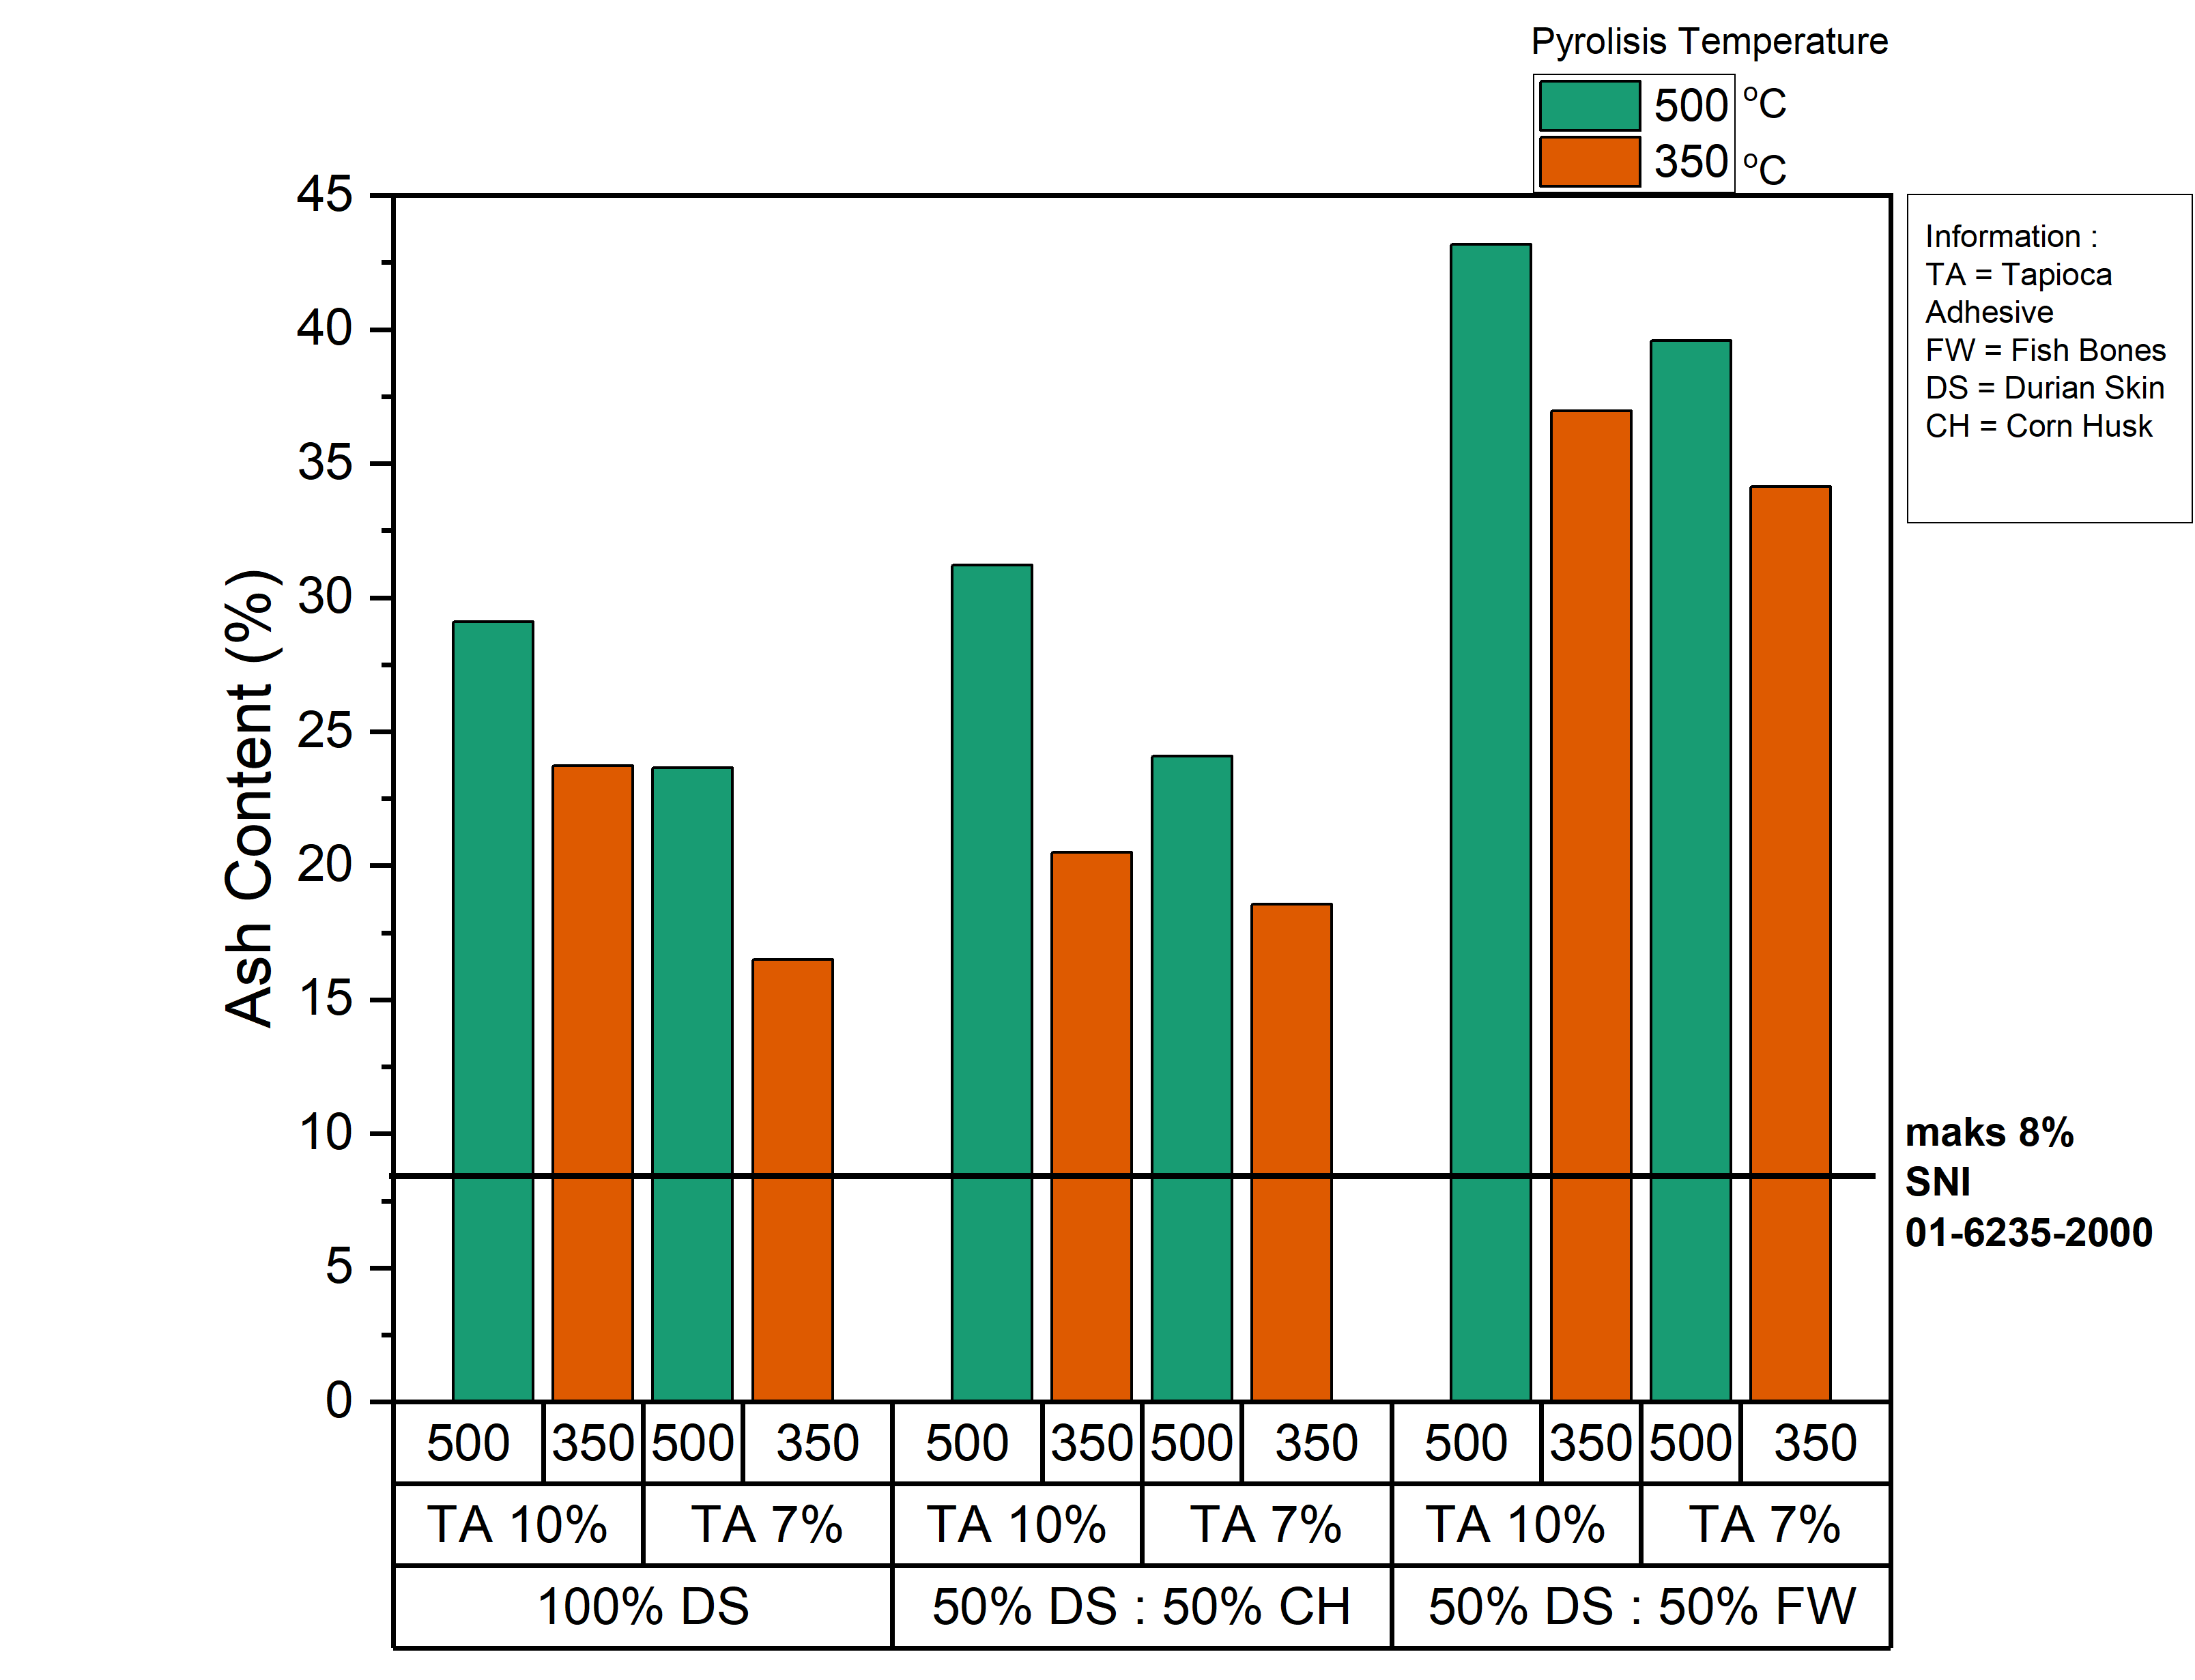
Figure 3. Ash Content of Biobriquette Samples

Figure 3 shows that the higher the adhesive concentration, the greater the ash content. This is in line with the research conducted (Sofyana et al., 2021) where the higher the adhesive content, the higher the ash content produced, due to the addition of ash from starch adhesive which is completely burnt. Pyrolysis temperature is also a factor causing the high value of the ash content. It can be seen in Figure 3.2 that the ash content at 350℃ is lower than at 500℃. The high value of the ash content can be caused by the high temperature and the length of the pyrolysis process. The higher the temperature and pyrolysis time, the higher the ash content. This is because the carbon particles that burn to ashes are increasing (Ajimotokan et al., 2019).

- Volatile Matter
The volatile matter content affects the completeness of combustion and the intensity of the flame. Testing for volatile matter levels in this study was carried out according to procedures based on SNI 06-3730-1995. The results of testing the levels of volatile substances can be seen in Figure 4.
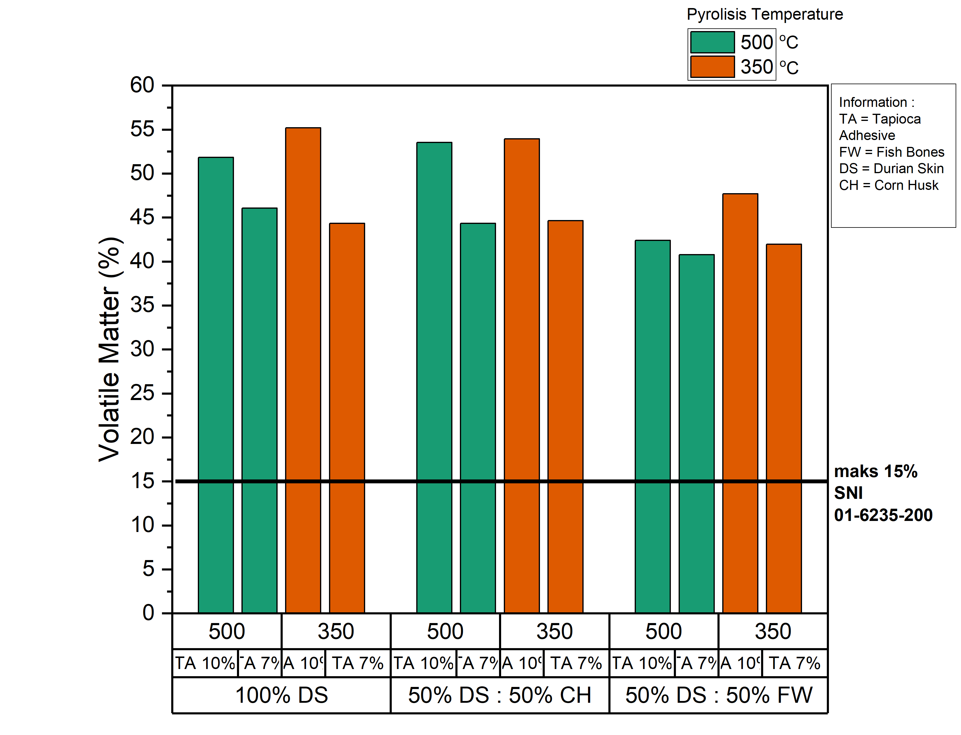
Figure 4. Volatile Matter Content of Biobriquette Samples

Figure 4 shows that all sample variations have very large values because they exceed the value based on SNI, which is 15%. The highest levels of volatile matter were found in samples with variations of 100% durian skin with a pyrolysis temperature of 350℃ and an adhesive concentration of 10%. The higher the concentration of the adhesive, the greater the level of volatile matter. The increase occurred due to the presence of volatile substances contained in the adhesive, such as CO, CO2, H2 and CH4. The higher the level of adhesive, the content of these substances is increasing (Yuliah et al., 2017). The addition of adhesive concentration is also the reason for the high levels of volatile matter in briquettes, this is because the amount of adhesive that has not been carbonized will have a higher volatile matter than charcoal, so the more adhesive concentration the higher the volatile matter content. (Deglas and Fransiska, 2020).
The value of the volatile matter content also decreased due to the increase in temperature. The temperature and the length of time of pyrolysis are factors for the rise and fall of the volatile matter content in the briquettes. The large amount of wasted volatile matter occurs due to the increasing temperature and pyrolysis time so that when tested it will yield low levels of volatile matter (Anizar et al., 2020). The higher the temperature, the lower the volatile matter content, this is because the volatile matter content in the raw material is running out so that if the calculation is carried out, a small volatile matter content will be obtained. The results of testing the levels of volatile substances in this study still do not meet the minimum standard of SNI 1-6235-2000 which is 15%. The highest volatile matter content in this study was produced by briquettes composed of 100% durian rind with an adhesive concentration of 10% at 350℃. This is due to the content of volatile substances in the durian skin of 85.54%. The lowest volatile matter content in this study was found in variations in the composition of 50% durian skin and 50% fish bones with an adhesive concentration of 7% at 500℃. In addition to the low concentration of adhesive and high temperature, the low level of volatile matter can also be caused by the content of volatile matter in the composition of the material, where fish bones have a volatile matter content of 48.16% while corn husk is 53.70%. This is in line with research conducted by (Deglas and Fransiska, 2020). The content of volatile matter in raw materials can affect the value of the volatile matter content of briquettes.

- Fixed Carbon Content
The fixed carbon content will be of high value if the value of the ash content and the decomposition rate of volatile compounds is low. The results of testing the fixed carbon content can be seen in Figure 5.
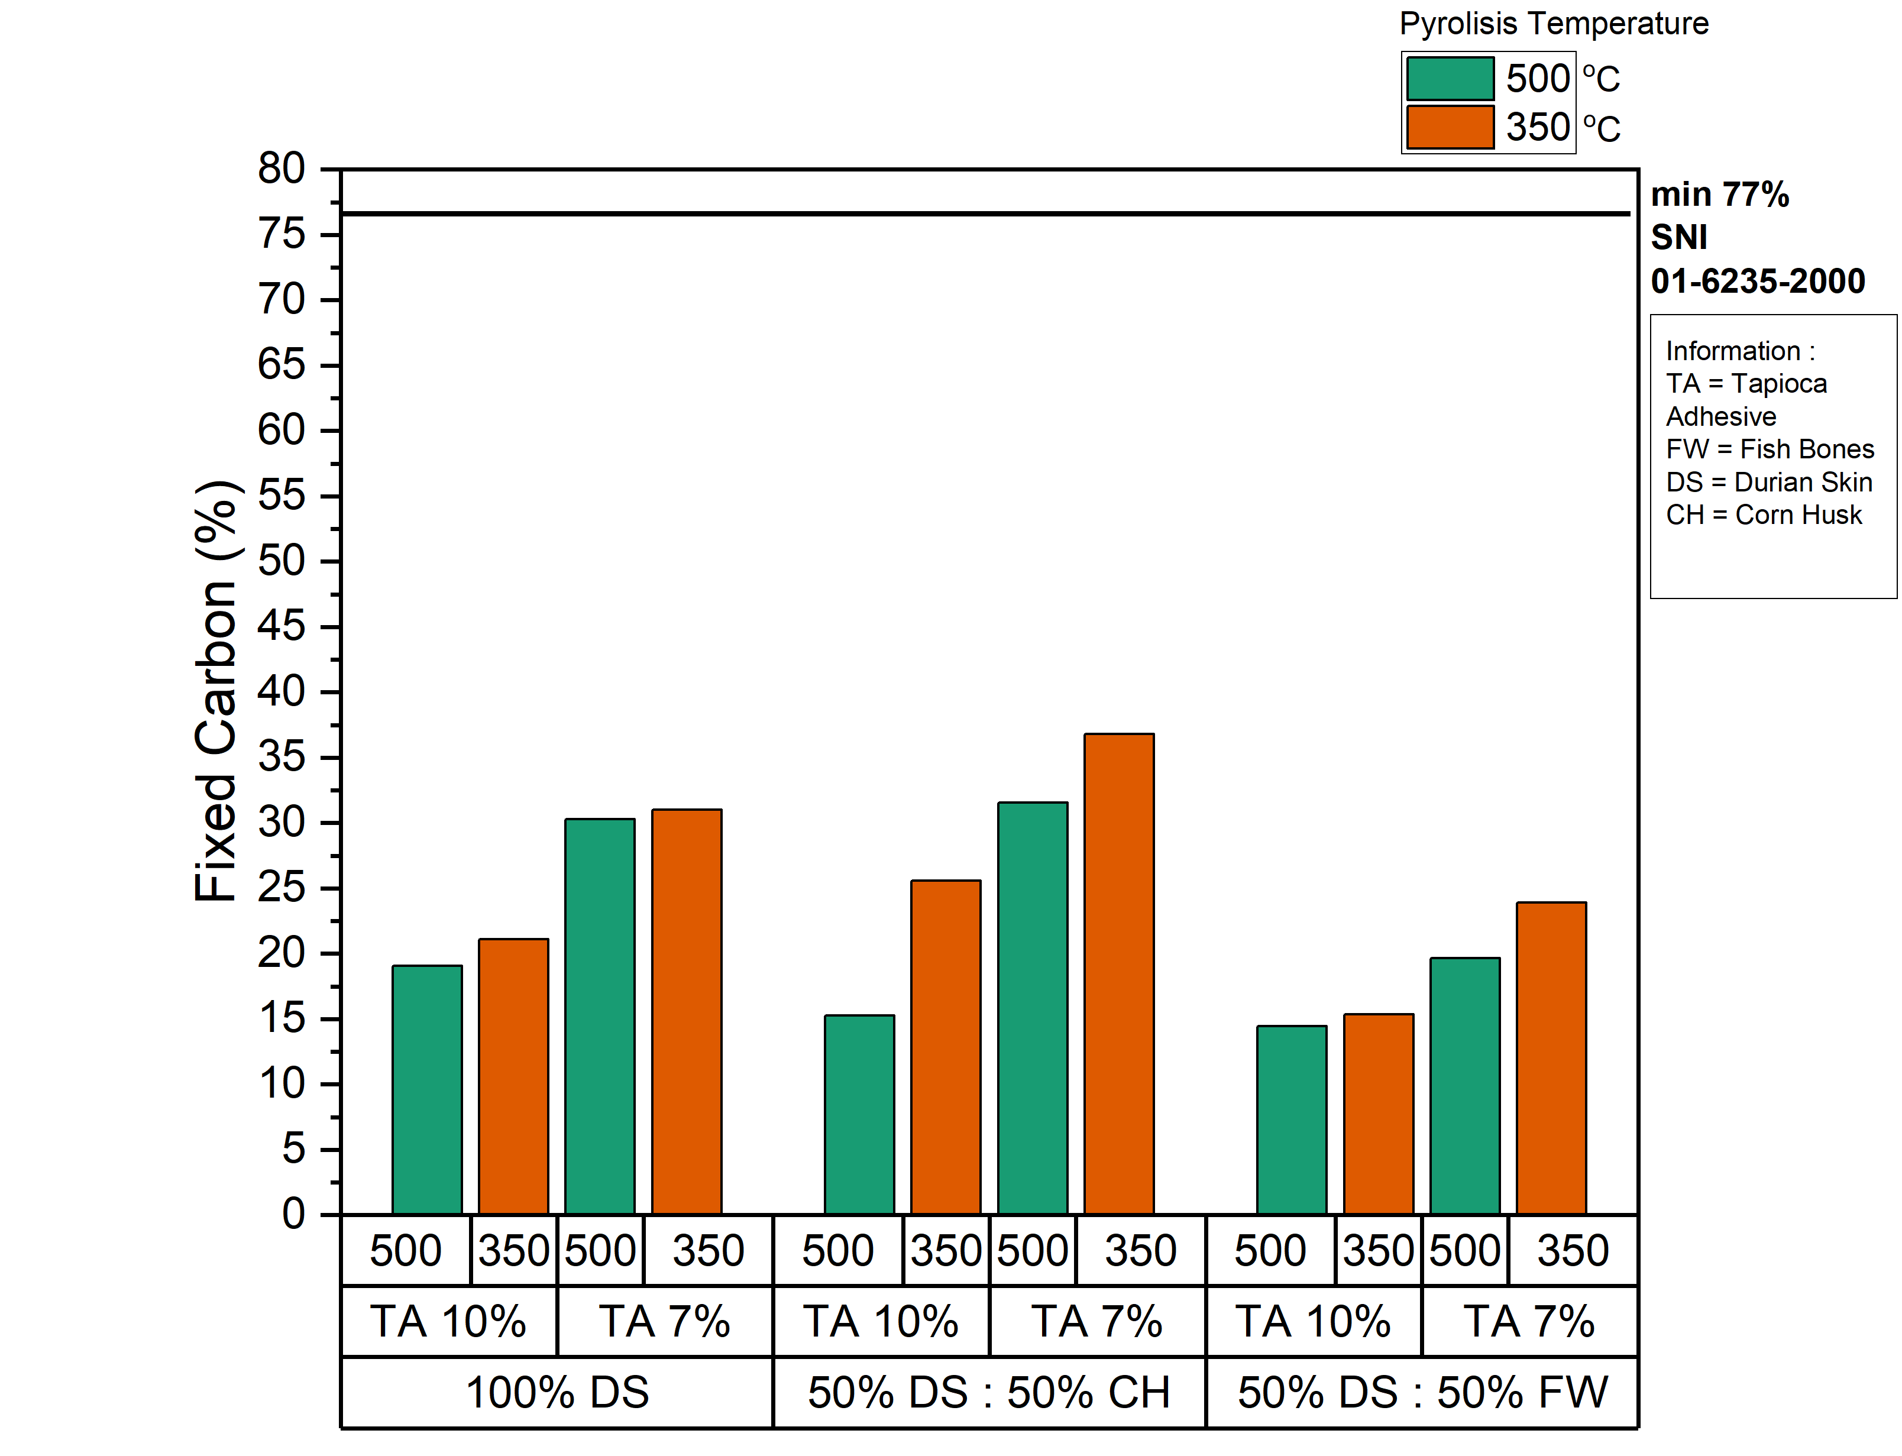
Figure 5. Fixed Carbon Content of Biobriquette Samples

Figure 5 shows that the fixed carbon content in this study is still below the minimum limit based on SNI. The highest fixed carbon content was found in samples with variations of 50% durian peel and 50% corn husk with a pyrolysis temperature of 350℃ and an adhesive concentration of 7%. The concentration of the adhesive affects the size of the fixed carbon content, the higher the adhesive concentration, the lower the fixed carbon content. The decrease was due to the higher concentration of adhesive, the greater the need for water as a solvent. Given the high content of fixed carbon when the water content, ash content and volatile matter in briquettes are low (Norhikmah et al., 2021).
The higher the pyrolysis temperature, the lower the fixed carbon content. As in briquettes with a pyrolysis temperature of 350 ℃ has a greater fixed carbon content than a temperature of 500 ℃. This is probably due to the carbonation process with high temperatures for a long time can damage the walls of the carbon pores so that the carbon burns and leaves ashes (Erwin Junary et al., 2015). This fixed carbon value depends on the ash and volatile matter content in the briquettes, where the higher the ash and volatile matter content, the lower the carbon content in the briquettes..
The test results for the volatile matter content of all variations are still far below the minimum standard of SNI 1-6235-2000 which is 77%. The highest bonded carbon content of 30.22% was obtained from a sample with a composition of 50% durian rind: 50% corn husk with an adhesive concentration of 7% at a pyrolysis temperature of 350℃, this is because the carbon content in the durian rind is 9.16% and corn husk was 35.31%, while the carbon content bound to fish bones was 10.16%. Good briquettes have a high carbon content. The presence of bound carbon in charcoal briquettes is influenced by moisture content, ash content and volatile matter content. The level will be of high value if the water content, ash content and volatile matter content in the briquettes are low. Bonded carbon affects the heating value of burning charcoal briquettes. The calorific value of charcoal briquettes will be high if the bonded carbon value is also high. The level of bound carbon or fixed carbon shows the amount of carbon element content present in the biobriquette (Saputra et al., 2021).

  - Calorific Value Yield Analysis
The heating value is the most important quality parameter for charcoal briquettes as fuel so that the heating value greatly determines the quality of charcoal briquettes. The higher the burning value of charcoal briquettes, the higher the quality of the resulting briquettes (Lukum et al., 2012).
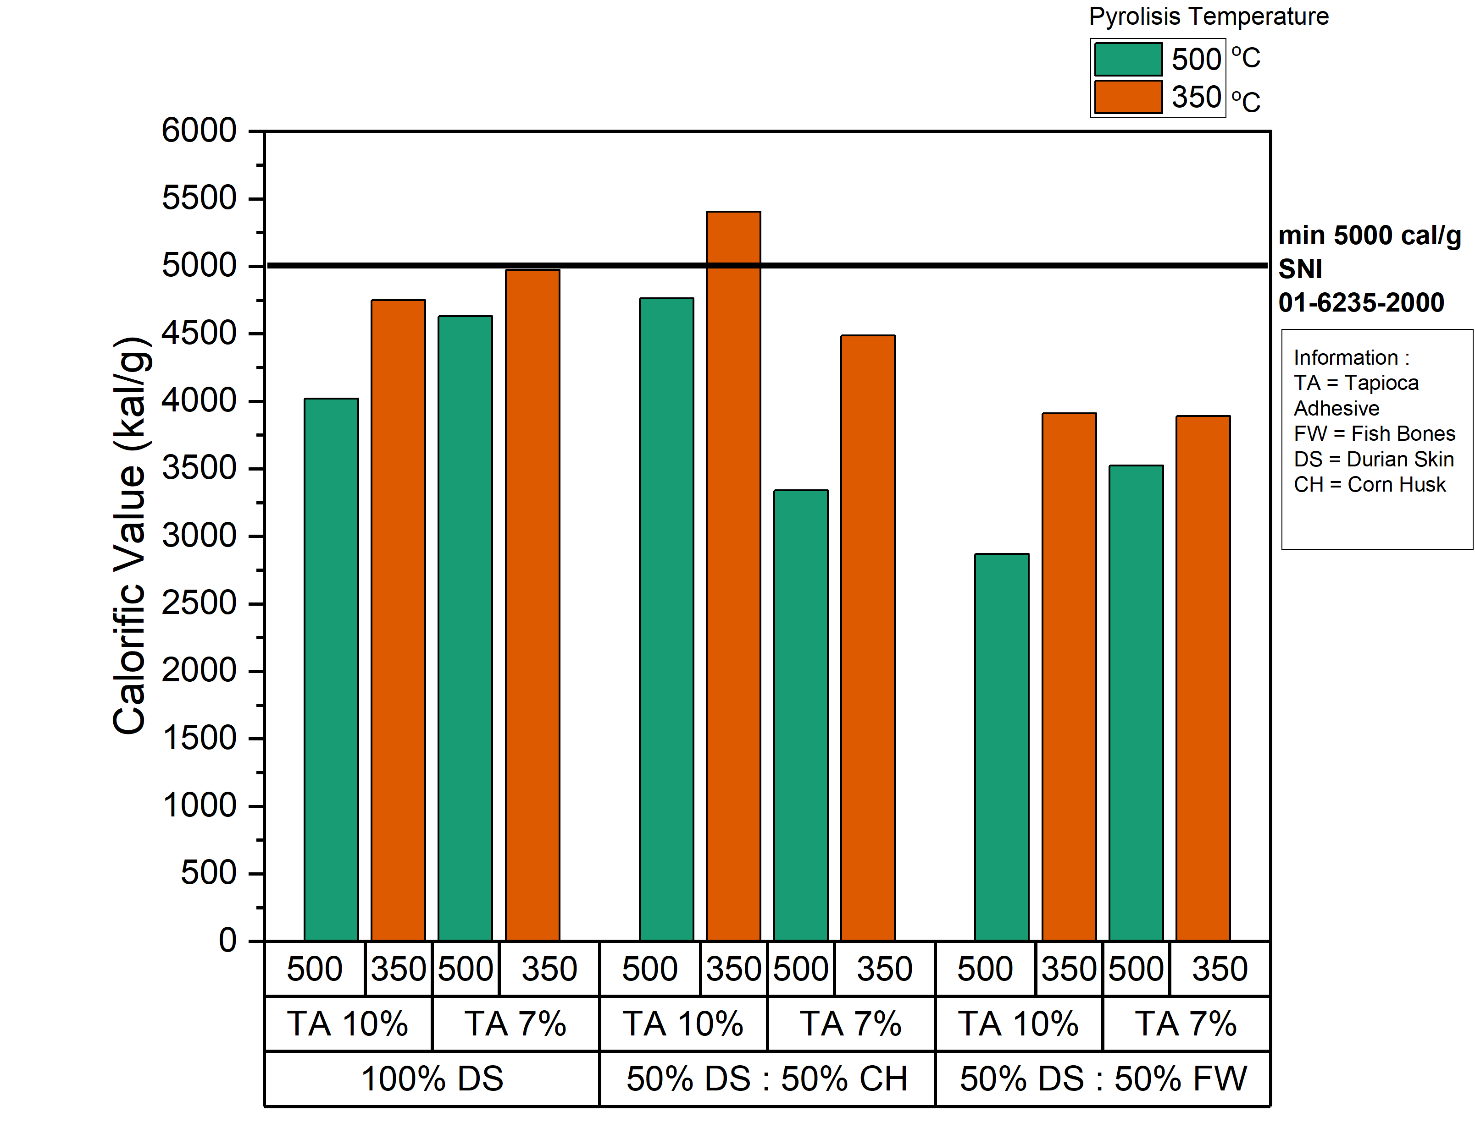
Figure 6. Biobriquette Sample Calorific Value

The highest calorific value in this study was found in variations of 50% durian skin and 50% corn husk with 10% adhesive concentration at 350℃ which is 5404.4 cal/gr. The lowest calorific value was found in variations of 50% durian skin and 50% fish bones with 10% adhesive at 500℃ which was 2868.2 cal/gr. This difference can be influenced by the ash content in each material, where the ash content of fish bones is 35.91%.(Mismawati et al., 2022), while the ash content of corn husk was 11.67%. Ash is the remaining part of the combustion products, the main element of ash is silica mineral and has a bad effect on the resulting calorific value, so the higher the ash content produced, the lower the quality of the briquettes (Situmorang and Kusmartono, 2022).
Temperature affects the calorific value of briquettes, where briquettes with a pyrolysis temperature of 350℃ are greater than those with a temperature of 500℃. This incident was caused by the length of time the material was written so that it increased the ash content in the charcoal (Purwanto and Sofyan, 2014). The ash content will increase because the carbon will burn out and leave ash which is the result of combustion. The carbon content will decrease if there is an increase in the ash content because the carbon content is a reduction in the amount of water content, ash content and volatile content contained in the charcoal. If the carbon content decreases, the heating value will also decrease because the carbon content is directly proportional to the calorific value produced (Erwin Junary et al., 2015).
The calorific value of 100% durian skin with 7% adhesive has a greater calorific value than durian skin briquettes with 10% adhesive concentration. The greater the adhesive, the greater the need for water as a solvent. This is in line with research Sofyana et all., (2021) The greater the concentration of the adhesive, the lower the calorific value of the briquettes. Considering that tapioca flour as an adhesive is an insulator and its calorific value is very low. The higher the adhesive concentration, the greater the ash content produced. The higher the ash content, the lower the calorific value produced (Aziz et all., 2019).

  - MANOVA Statistical Analysis
The MANOVA test is a statistical technique used to calculate the significance test of the mean difference simultaneously between groups for two or more dependent variables (Sutrisno and Wulandari, 2018). The independent variables in this MANOVA test are material composition, pyrolysis temperature and adhesive concentration while the dependent variable is the proximate test parameter and calorific value. The MANOVA test results can be seen in Table 3.

Table 3. MANOVA Test Results
Independent Variable | Nilai Sig | Batas Sig | Hypothesis | Information
Composition
Moisture Content | 0.003 | <0.05 | H₁ accepted | Influential
Ash Content | 0.001 | <0.05 | H₁ accepted | Influential
Volatile Matter | 0.020 | <0.05 | H₁ accepted | Influential
Fixed Carbon | 0.021 | <0.05 | H₁ accepted | Influential
Calorific Value | 0.024 | <0.05 | H₁ accepted | Influential
Temperature
Moisture Content | 0.046 | <0.05 | H₁ accepted | Influential
Ash Content | 0.025 | <0.05 | H₁ accepted | Influential
Volatile Matter | 0.001 | <0.05 | H₁ accepted | Influential
Fixed Carbon | 0.001 | <0.05 | H₁ accepted | Influential
Calorific Value | 0.001 | <0.05 | H₁ accepted | Influential
Adhesive
Moisture Content | 0.001 | <0.05 | H₁ accepted | Influential
Ash Content | 0.023 | <0.05 | H₁ accepted | Influential
Volatile Matter | 0.000 | <0.05 | H₁ accepted | Influential
Fixed Carbon | 0.001 | <0.05 | H₁ accepted | Influential
Calorific Value | 0.006 | <0.05 | H₁ accepted | Influential
Composition, Temperature and Adhesive
Moisture Content | 0.002 | <0.05 | H₁ accepted | Influential
Ash Content | 0.006 | <0.05 | H₁ accepted | Influential
Volatile Matter | 0.003 | <0.05 | H₁ accepted | Influential
Fixed Carbon | 0.005 | <0.05 | H₁ accepted | Influential
Calorific Value | 0.017 | <0.05 | H₁ accepted | Influential

Table 3 is the result of testing using MANOVA which aims to determine whether or not there is an effect of material composition, pyrolysis temperature and adhesive concentration on the proximate test results and calorific value. Table 3 shows that variations in composition, pyrolysis temperature and adhesive concentration can affect the results of testing for moisture content, ash content, volatile matter content, carbon content and heating value. this is because the value of the P-value <0.05.

  - Selection of the Best Varieties
Determining the best variation of briquettes in this study was carried out using the scoring method. The determination of the scoring value is carried out based on the criteria for the maximum and minimum parameter values in SNI 1-6235-2000. This scoring method consists of 2 criteria, where the sample gets a score of 1 if it has a value according to SNI 1-6235-2000 and will get a score of 0 if the parameter value does not match SNI 1-6235-2000. The selection of this scoring value was carried out in accordance with the research conducted by Dewilda and Maryam (2017). The scoring of each variation can be seen in Table 4.

Table 4. Determination of the Best Variation Using the Scoring Method
Variation | Parameter |  |  |  |  | Score
 | Moisture Content (%) | Ash Content (%) | Volatile Matter  (%) | Fixed Carbon  (%) | Calorific Value  (kal/g)
S1 | 2,77  (1) | 16,51  (0) | 52,50  (0) | 30,99  (0) | 4971,1  (0) | 1
S2 | 4,03  (1) | 18,55  (0) | 44,64  (0) | 36,81  (0) | 4488,2  (0) | 1
S3 | 3,13  (1) | 34,14  (0) | 41,96  (0) | 23,90  (0) | 3889,3  (0) | 1
S4 | 3,33  (1) | 23,72  (0) | 55,19  (0) | 21,09  (0) | 4749,9  (0) | 1
S5 | 2,47  (1) | 20,50  (0) | 53,93  (0) | 25,58  (0) | 5404,4  (1) | 2
S6 | 1,87  (1) | 36,97  (0) | 47,70  (0) | 15,33  (0) | 3909,2  (0) | 1
S7 | 1,66  (1) | 23,65  (0) | 46,06  (0) | 30,29  (0) | 4628,6  (0) | 1
S8 | 3,08  (1) | 24,09  (0) | 44,33  (0) | 31,57  (0) | 3339,7  (0) | 1
S9 | 4,25  (1) | 39,58  (0) | 40,76  (0) | 19,67  (0) | 3524,2  (0) | 1
S10 | 4,9  (1) | 29,10  (0) | 51,82  (0) | 19,08  (0) | 4018,4  (0) | 1
S11 | 5,88  (1) | 31,21  (0) | 53,53  (0) | 15,27  (0) | 4762,9  (0) | 1
S12 | 4,37  (1) | 43,18  (0) | 42,38  (0) | 14,44  (0) | 2868,2  (0) | 1

Table 4 shows that the sample variation that has the highest score is the S5 sample variation. Sample S5 is a briquette made from variations in the composition of durian peel: corn husk with an adhesive concentration of 7% at a pyrolysis temperature of 350℃. This is because these variations have met the values in SNI 1-6235-2000 on the parameters of water content and heating value.

  - Analysis of Emission Test Results
The use of bio-briquettes as fuel certainly goes through a combustion process that allows emissions to form. Emission testing in this study was carried out in order to determine the levels of CO and SO2 emissions produced during the biobriquette burning process. The sample used for this test is the best sample made from a composition of 50% durian rind : 50% corn husk with a pyrolysis temperature of 350℃ and an adhesive concentration of 7%. The results of emission testing can be seen in Table 5.

Table 5. Best Variation Emission Test Results
No | Parameters | Result | Standars | Unit
1. | SO₂ | 0,741 | *800 | mg/Nm³
2. | CO | 1700 | **726 | mg/Nm³
Source : * Pergub Jatim No. 10 Tahun 2009 tentang Baku Mutu Udara Ambien dan Emisi
Sumber Tidak Bergerak.
** Peraturan Menteri Energi dan Sumber Daya Mineral Tahun 2006 Standar Emisi
Kompor Dengan Bahan Bakar Batu Bara dan Kompor Dengan Bahan Bakar Padat
Berbasis Batu Bara

Table 5 shows that the sample produces emissions in the form of carbon monoxide (CO) whose values exceed the quality standards based on Pergub Jatim No. 10 Tahun 2009 tentang baku mutu udara ambien dan emisi sumber tidak bergerak. Incomplete carbon combustion results in the formation of CO emissions. The high CO content occurs due to the lack of oxygen during combustion. The high CO content can also be attributed to the high lignin content of the briquette composition (Senila et al., 2022). Biobriquettes are composed of chemical compounds C, H, O, N and sulfur. Durian skin has a C content of 48.95% and 38.75% O (Brunerová et al., 2017). Meanwhile, corn husk has a C content of 31.06% and O content of 32.63% (Maj et al., 2019). The content of carbon, nitrogen and sulfur in biobriquettes when in contact with oxygen during combustion will form gaseous compounds such as carbon monoxide and others.
SO2 emissions produced in the process of burning bio-briquettes are still below the quality standards based on the Minister of Energy and Mineral Resources Regulation of 2006 Emission Standards for Coal-Fired Stoves and Coal-Based Solid Fuel Stoves. This is due to the high or low levels of SO2 depending on the sulfur content present in the raw material (Setiani et al., 2019). The sulfur content in durian skin is 0.13% (Brunerová et al., 2017), while corn husk has a sulfur content of 0.48% (Maj et al., 2019).

Conclusions
Based on the research that has been done in this study it is known that the best sample variation is found in briquettes with a composition of 50% durian rind : 50% corn husk with a pyrolysis temperature of 350℃ and an adhesive concentration of 7%. It is known that the emission levels generated when burning briquettes CO emissions exceed the established quality standard of 1700 mg/Nm³, while the SO2 content produced is still below the established quality standard of 0.741 mg/Nm³. To improve the quality of biobriquettes that do not meet the standards, it can be rearranged the percentage of the ingredients by increasing the composition of corn husks instead of durian peels.

References
Ajimotokan, H. A., Ehindero, A. O., Ajao, K. S., Adeleke, A. A., Ikubanni, P. P., & Shuaib-Babata, Y. L. (2019). Combustion Characteristics Of Fuel Briquettes Made From Charcoal Particles And Sawdust Agglomerates. Scientific African, 6, E00202.
Anizar, H., Sribudiani, E., & Somadona, S. (2020). Pengaruh Bahan Perekat Tapioka Dan Sagu Terhadap Kualitas Briket Arang Kulit Buah Nipah.
Aziz, M. R., Siregar, A. L., Rantawi, A. B., & Rahardja, I. B. (2019). Pengaruh Jenis Perekat Pada Briket Cangkang Kelapa Sawit Terhadap Waktu Bakar.
Badan Standarisasi Nasional. 1995. Standar Nasional 06-3730-1995 Tentang Arang Aktif Teknis. Jakarta : Badan Standarisasi Nasional.
Badan Standarisasi Nasional. 2000. Standar Nasional 01-6235-2000 Tentang Briket Arang Kayu. Jakarta : Badan Standarisasi Nasional.
Bot, B. V., Sosso, O. T., Tamba, J. G., Lekane, E., Bikai, J., & Ndame, M. K. (2023). Preparation And Characterization Of Biomass Briquettes Made From Banana Peels, Sugarcane Bagasse, Coconut Shells And Rattan Waste. Biomass Conversion And Biorefinery, 13(9), 7937–7946.
Brunerová, A., Roubík, H., Brožek, M., Herák, D., Šleger, V., & Mazancová, J. (2017). Potential Of Tropical Fruit Waste Biomass For Production Of Bio-Briquette Fuel: Using Indonesia As An Example. Energies, 10(12).
Chusniyah, D. A., Pratiwi, R., Benyamin, B., & Suliestyah, S. (2022). Uji Kualitas Briket Berbahan Arang Ampas Kelapa Berdasarkan Nilai Kadar Air. Jurnal Penelitian Dan Karya Ilmiah Lembaga Penelitian Universitas Trisakti, 7(1).
Deglas, W., & Fransiska, F. (2020). Analisis Perbandingan Bahan Dan Jumlah Perekat Terhadap Briket Tempurung Kelapa Dan Ampas Tebu: Teknologi Pangan : Media Informasi Dan Komunikasi Ilmiah Teknologi Pertanian, 11(1).
Dewilda, Y., & Maryam, A. (2017). Pengaruh Komposisi Bahan Baku Kompos (Sampah Pasar, Arang Ampas Tebu Dan Rumen Sapi) Terhadap Kualitas Kompos. Jurnal Dampak, 14(2), 87.
Erwin Junary, Julham Prasetya Pane, & Netti Herlina. (2015). Pengaruh Suhu Dan Waktu Karbonisasi Terhadap Nilai Kalor Dan Karakteristik Pada Pembuatan Bioarang Berbahan Baku Pelepah Aren (Arenga Pinnata). Jurnal Teknik Kimia Usu, 4(2), 46–52.
Haliza, H. N., & Saroso, Hadi. (2022). Pembuatan Bio-Briket Dari Sabut Kelapa Dan Serbuk Kayu Jati Dengan Menggunakan Perekat Tepung Tapioka. Distilat: Jurnal Teknologi Separasi, 8(1).
Irhamni, I., Saudah, S., Diana, D., Ernilasari, E., Suzanni, M. A., & Israwati, I. (2019). Karakteristik Briket Yang Dibuat Dari Kulit Durian Dan Perekat Pati Janeng. Jurnal Kimia Dan Kemasan, 41(1),
Lukum, H., Isa, I., & Sihaloho, M. (2012). Pemanfaatan Arang Briket Limbah Tongkol Jagung Sebagai Bahan Bakar Alternatif. Jurnal Sainstek, 6(05), Article 05.
Maj, G., Szyszlak-Bargłowicz, J., Zając, G., Słowik, T., Krzaczek, P., & Piekarski, W. (2019). Energy And Emission Characteristics Of Biowaste From The Corn Grain Drying Process. Energies, 12(22), 4383.
Mismawati, A., Pamungkas, B. F., Diachanty, S., & Zuraida, I. (2022). Komposisi Proksimat Dan Profil Mineral Tulang Dan Sisik Ikan Papuyu (Anabas Testudineus).
Norhikmah -, Sari, N. M., & Mahdie, M. F. (2021). Pengaruh Persentase Perekat Tapioka Terhadap Karakteristik Briket Arang Tempurung Kelapa. Jurnal Sylva Scienteae, 4(2), Article 2.
Patabang, D. (2012). Karakteristik Termal Briket Arang Sekam Padi Dengan Variasi Bahan Perekat. Jurnal Mekanikal, 3(2).
Purwanto, J., & Sofyan, S. (2014). Pengaruh Suhu Dan Waktu Pengarangan Terhadap Kualitas Briket Arang Dari Limbah Tempurung Kelapa Sawit. Jurnal Litbang Industri, 4(1), 29.
Ridhuan, K., & Suranto, J. (2017). Perbandingan Pembakaran Pirolisis Dan Karbonisasi Pada Biomassa Kulit Durian Terhadap Nilai Kalori. Turbo : Jurnal Program Studi Teknik Mesin, 5(1), Article 1.
Saeed, A. A. H., Yub Harun, N., Bilad, M. R., Afzal, M. T., Parvez, A. M., Roslan, F. A. S., Abdul Rahim, S., Vinayagam, V. D., & Afolabi, H. K. (2021). Moisture Content Impact On Properties Of Briquette Produced From Rice Husk Waste. Sustainability, 13(6), 3069.
Saputra, D., Siregar, A. L., & Rahardja, I. B. (2021). Karakteristik Briket Pelepah Kelapa Sawit Menggunakan Metode Pirolisis Dengan Perekat Tepung Tapioka. Jurnal Asiimetrik: Jurnal Ilmiah Rekayasa Dan Inovasi, 143–156.
Senila, L., Tenu, I., Carlescu, P., Scurtu, D. A., Kovacs, E., Senila, M., Cadar, O., Roman, M., Dumitras, D. E., & Roman, C. (2022). Characterization Of Biobriquettes Produced From Vineyard Wastes As A Solid Biofuel Resource. Agriculture, 12(3), 341.
Setiani, V., Rohmadhani, M., Setiawan, A., & Maulidya, R. D. (2019). Potensi Emisi Dari Pembakaran Biobriket Ampas Tebu Dan Tempurung Kelapa. Seminar Master Ppns, 4(1), Article 1.
Situmorang, A. R., & Kusmartono, B. (2022). Pembuatan Briket Tempurung Kelapa Dengan Menggunakan Perekat Tepung Terigu (Variabel Konsentrasi Perekat Dan Ukuran Partikel). Jurnal Inovasi Proses, 7(1), Article 1.
Sofyana, S., Iqfal, M., & Zuhra, M. R. (2021). Pembuatan Biobriket Dari Limbah Sekam Padi Dan Tempurung Kelapa Dengan Perekat Tepung Tapioka. Jurnal Inovasi Ramah Lingkungan, 2(1), Article 1.
Sutrisno, S., & Wulandari, D. (2018). Multivariate Analysis Of Variance (Manova) Untuk Memperkaya Hasil Penelitian Pendidikan. Aksioma : Jurnal Matematika Dan Pendidikan Matematika, 9(1), 37.
Wahyudi, Y., Amrullah, S., & Oktaviananda, C. (2022). Uji Karakteristik Briket Berbahan Baku Bonggol Jagung Berdasarkan Variasi Jumlah Perekat. Jurnal Pengendalian Pencemaran Lingkungan (Jppl), 4(2), Article 2.
Yuliah, Y., Suryaningsih, S., & Ulfi, K. (2017). Penentuan Kadar Air Hilang Dan Volatile Matter Pada Bio-Briket Dari Campuran Arang Sekam Padi Dan Batok Kelapa. Jiif (Jurnal Ilmu Dan Inovasi Fisika), 1(1), Article 1.

