Perbaikan yang dilakukan di DMA Terpillih
No | Nama Service DMA | Jenis Perbaikan
1 | Elit Kota Mataram | - Sambungan Rangkaian SR:  - Male thread adaptor ½ inch: 1 pcs  - Bend long MF GI ½ inch: 1 pcs  - Seal tape: 1 pcs  - Perbaikan Pemasangan Stopkrant 2 Inch:  - Straight coupler 2 inch: 1 pcs  - Street box: 1 pcs  - Seal tape: 2 pcs
2 | Graha Permata Kota | - Perbaikan Valve resilience 3 inch 1 pcs  - Valve resilience 3 inch: 1 pcs  - Gobult joint 3 inch: 2 pcs  - Pipa pvc 3 inch: 1 meter  - Perbaikan Bocor Pipa HDPE 1 Inch Blok EJ-02:  - Straight coupler ½ inch: 1 pcs  - Pipa HDPE ½ inch: 1 meter  - Seal tape: 1 pcs  - Perbaikan Bocor Pipa HDPE 2 Inch Blok CI-02:  - Pipa PVC 1,5 inch: 1 meter  - Pipa PVC 1 inch: 1 meter  - Giboult joint 2 inch: 2 pcs  - Reducer PVC 2 x 1,5 inch: 2 pcs  - Tee PVC 1,5 x 1 inch: 1 pcs  - Straight coupler 1 inch: 1 pcs  - Seal tape: 3 pcs  - Lem pipa PVC  - Rabat beton (lean concrete)  - Perbaikan Bocor Pipa GI 0,5 Inch Blok BF-01:  - Male thread adaptor ½ inch: 1 pcs  - Elbow GI ½ inch: 1 pcs  - Pipa HDPE ½ inch: 3 meter  - Seal tape: 1 pcs  - Perbaikan Bocor Pipa HDPE 2 Inch Blok BM-11:  - Clamp sadle 2 inch: 1 pcs  - Seal tape: 2 pcs  - Rabat beton (lean concrete)  - Reposisi Pipa HDPE 1 Inch Terjepit Akar Pohon Blok AM-07:  a. Pipa HDPE ½ inch: 3 meter  b. Pipa PVC 1 inch: 5 meter  c. Pipa PVC ½ inch: 1 meter  d. Elbow PVC 1 inch: 4 pcs  e. Tee 1 x ½ PVC: 2 pcs  f. Male thread adaptor ½ inch: 2 pcs
No | Nama Service DMA | Jenis Perbaikan
2 | Graha Permata Kota | - Male thread adaptor ½ inch: 2 pcs  - Equal elbow HDPE ½ inch: 2 pcs  - Lem pipa PVC  - Pergantian Stopkrant 0,5 Inch Blok AM-10:  - Stopkrant drat UK ½ inch kuningan: 1 pcs  - Seal tape: 1 pcs  - Pergantian Pipa Service GI Keropos Blok DB-02:  - Pipa HDPE ½ inch: 1 meter  - Equal elbow HDPE ½ inch: 1 pcs  - Straight coupler ½ inch: 1 pcs  - Rabat batu sikat  - Pergantian Stopkrant 0,5 Inch Blok AG-08:  - Stopkrant drat UK ½ inch kuningan  - Seal tape: 1 pcs

Rencana Anggaran Biaya
No | Uraian | Satuan | Jumlah | Harga Satuan (Rp) | Jumlah Biaya (Rp)
I | Perbaikan Kebocoran
1 | Elbow Bend Long MF 90° GI ½ Inch | pcs | 1 | 24.400 | Rp 24.400
2 | Clamp Sadle 2 Inch | pcs | 1 | 130.000 | Rp 130.000
3 | Elbow GI 90° ½ Inch | pcs | 1 | 12.000 | Rp 12.000
4 | Elbow PVC 90° 1 Inch | pcs | 4 | 21.000 | Rp 84.000
5 | Equal Elbow HDPE ½ Inch | pcs | 3 | 55.100 | Rp 165.300
6 | Giboult Joint 2 Inch | pcs | 2 | 559.000 | Rp 1.118.000
7 | Giboult Joint 3 Inch | pcs | 2 | 763.000 | Rp 1.526.000
8 | Lem Pipa PVC (Kaleng) | pcs | 1 | 120.000 | Rp 120.000
9 | Male Thread Adaptor ½ Inch | pcs | 4 | 28.400 | Rp 113.600
10 | Manometer ½ Inch | pcs | 2 | 258.000 | Rp 516.000
11 | Pipa HDPE ½ Inch | meter | 8 | 12.000 | Rp 96.000
12 | Pipa PVC 1 Inch | meter | 6 | 21.000 | Rp 126.000
13 | Pipa PVC 1.5 Inch | meter | 1 | 48.000 | Rp 48.000
14 | Pipa PVC 3 Inch | meter | 1 | 151.000 | Rp 151.000
15 | Rabat Batu Sikat | m2 | 1 | 175.000 | Rp 175.000
16 | Rabat Beton (Lean Concrete) | m2 | 2 | 150.000 | Rp 300.000
17 | Reducer Sock PVC 2 X 1.5 Inch | pcs | 2 | 161.500 | Rp 323.000
18 | Seal Tape | rol | 12 | 7.000 | Rp 84.000
19 | Stopkrant Drat UK ½ Inch Kuningan | pcs | 2 | 120.000 | Rp 240.000
20 | Straight Coupler ½ Inch | pcs | 2 | 55.600 | Rp 111.200
21 | Straight Coupler 1 Inch | pcs | 1 | 82.000 | Rp 82.000
22 | Straight Coupler 2 Inch | pcs | 1 | 265.700 | Rp 265.700
23 | Street Box | pcs | 1 | 340.000 | Rp 340.000
24 | Reducer Tee All Socket PVC 1 X ½ | pcs | 2 | 18.500 | Rp 37.000
No | Uraian | Satuan | Jumlah | Harga Satuan (Rp) | Jumlah Biaya (Rp)
25 | Reducer Tee All Scoket PVC 1.5 X 1 Inch | pcs | 1 | 45.700 | Rp 45.700
26 | Valve Resilience 3 Inch | pcs | 1 | 3.846.900 | Rp 3.846.900
27 | Biaya Lembur Pegawai Tetap | oj | 90 | 15.000 | Rp 1.350.000
28 | Biaya Lembur Pegawai Tidak Tetap | oj | 90 | 10.500 | Rp 945.000
II | Optimalisasi DMA
1 | Water Meter ½ Inch | pcs | 3 | 499.000 | Rp 1.497.000
2 | Pergantian Meter Pelanggan | pcs | 3 | 36.500 | Rp 109.500
3 | Peninggian Meter Tertimbun | pcs | 1 | 91.000 | Rp 91.000
4 | Penindakan Pencurian Air | SR | 4 | 100.000 | Rp 400.000
5 | Bahan Bakar Surveyor | liter | 21 | 12.000 | Rp 252.000
Total Keseluruhan |  |  |  |  | Rp 14.725.300

Dokumentasi Penelitian
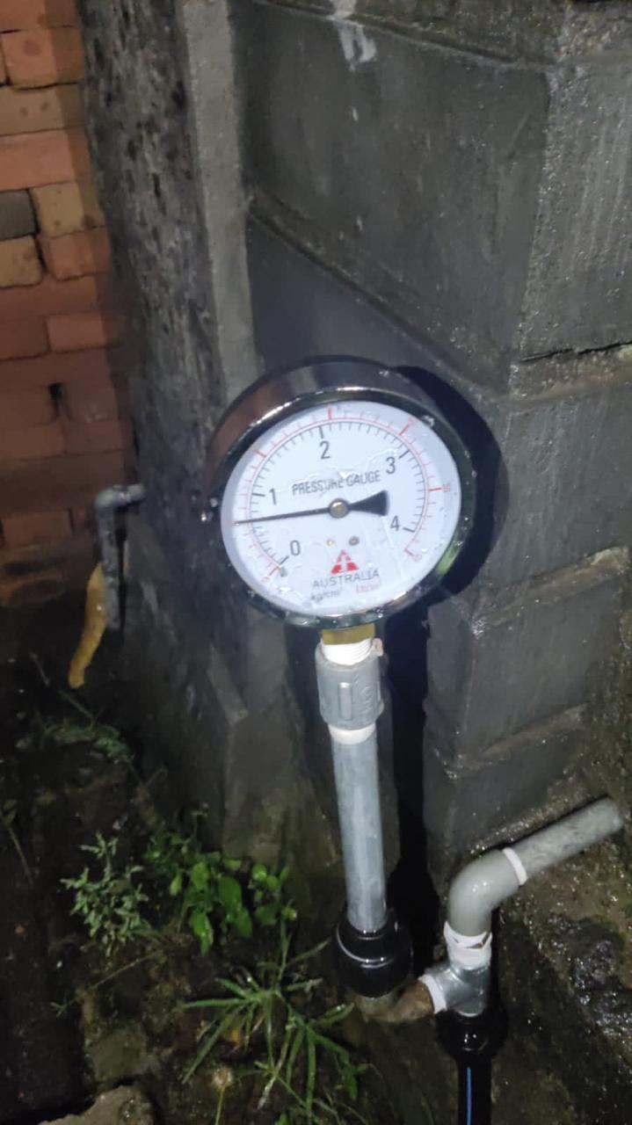  Manometer DMA Elit Kota Mataram |  | 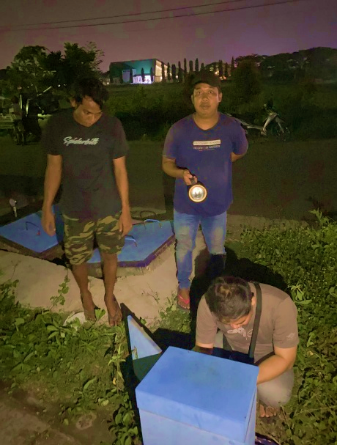  Meter Induk DMA Elit Kota Mataram
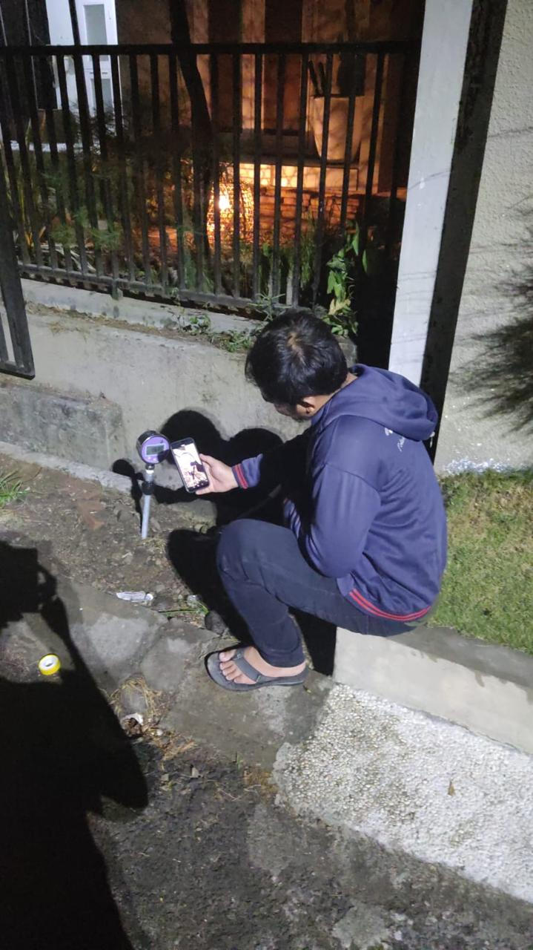 |  | 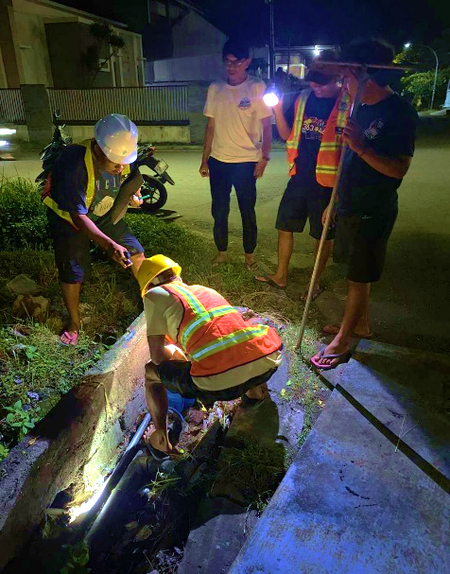
Monitor DMA Elit Kota Mataram |  | Penutupan Valve DMA Graha Permata Kota
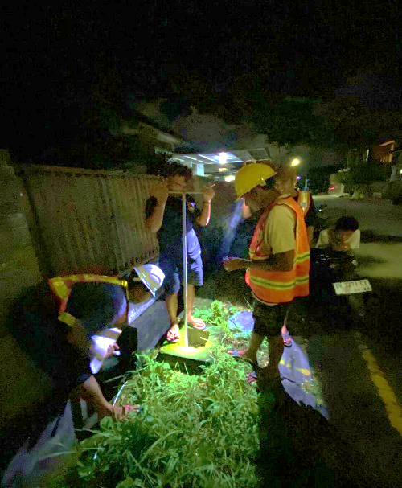 |  | 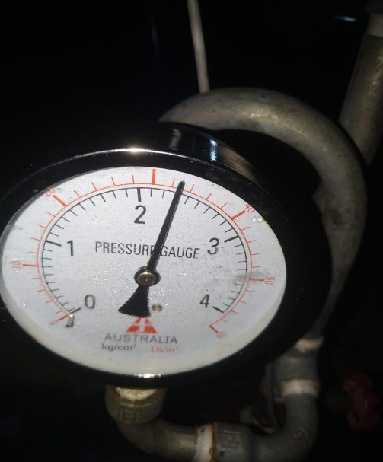
Penutupan Valve DMA Graha Permata Kota |  | Manometer DMA Graha Permata Kota
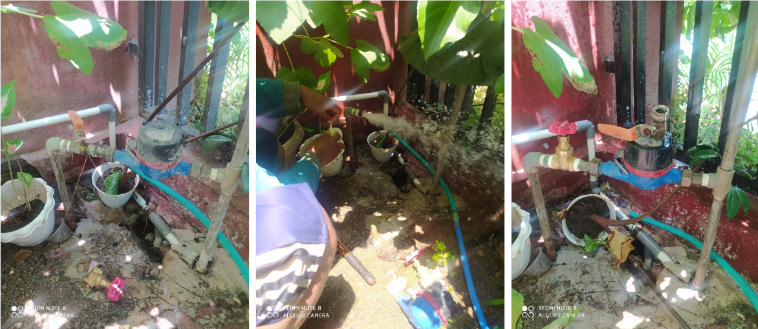
Perbaikan Kebocoran – Pergantian Stopkrant

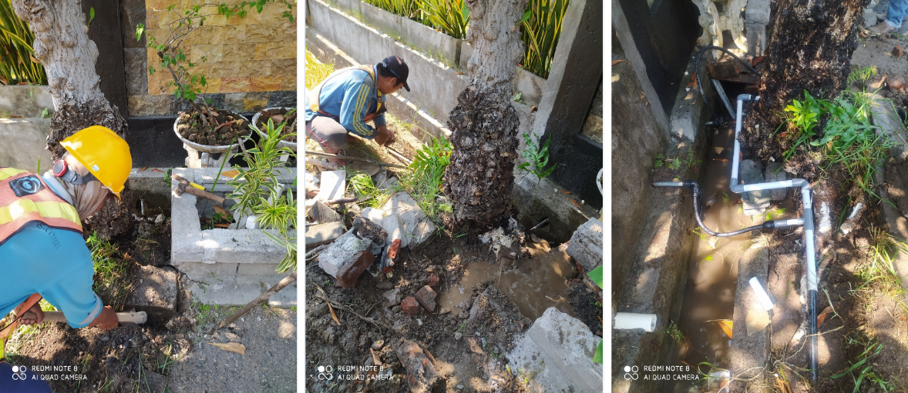
Perbaikan Kebocoran – Reposisi Pipa

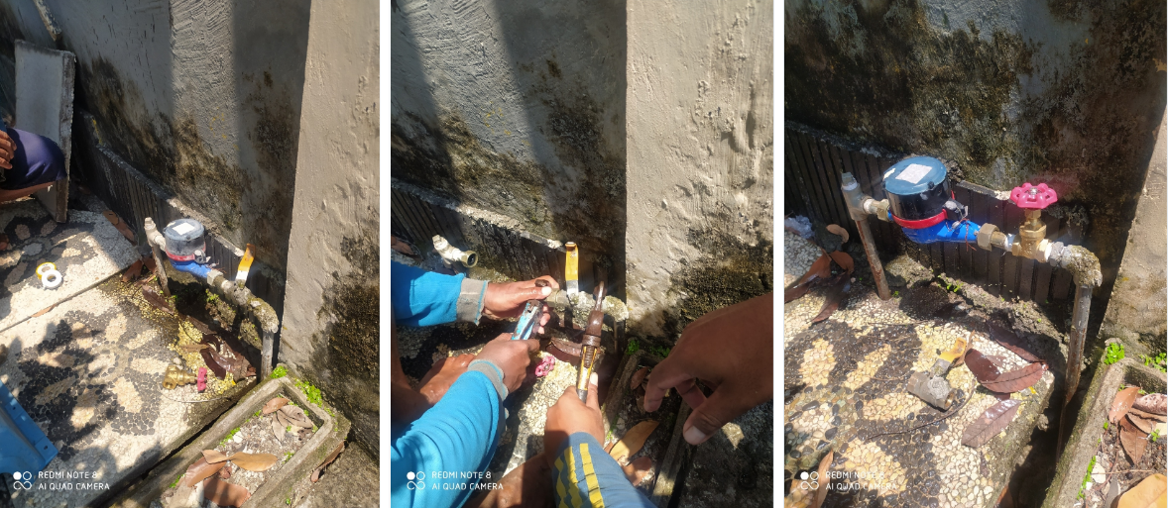
Perbaikan Kebocoran – Pergantian Stopkrant

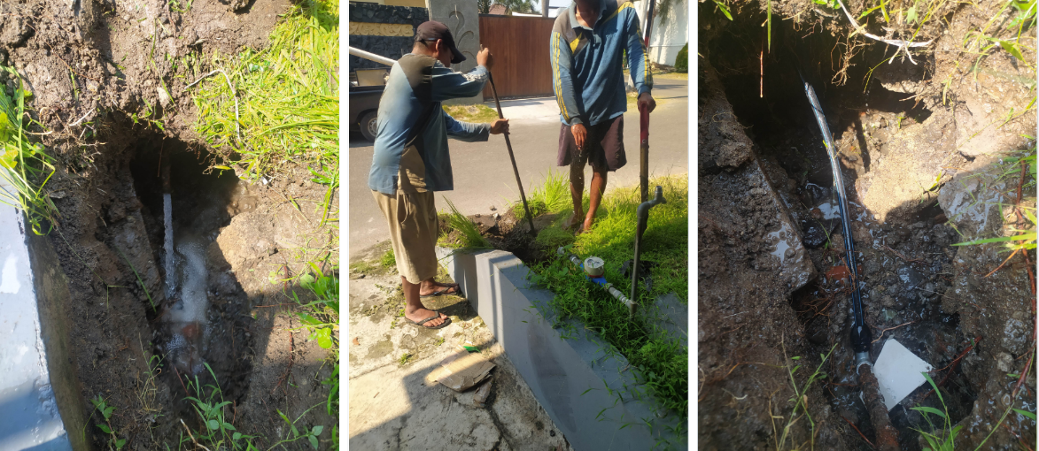
Perbaikan Kebocoran – Rehab Pipa SR

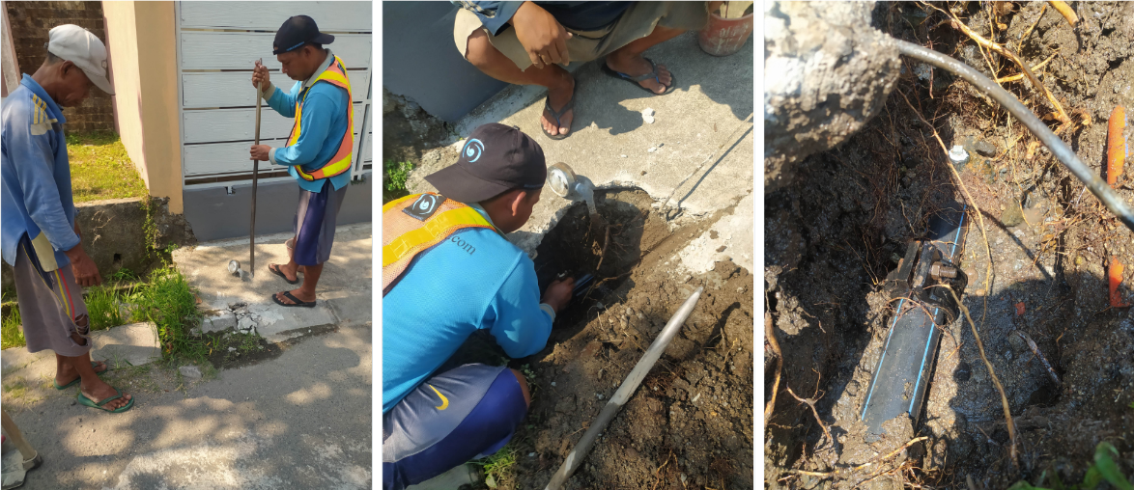
Perbaikan Kebocoran – Pergantian Clamp Sadle

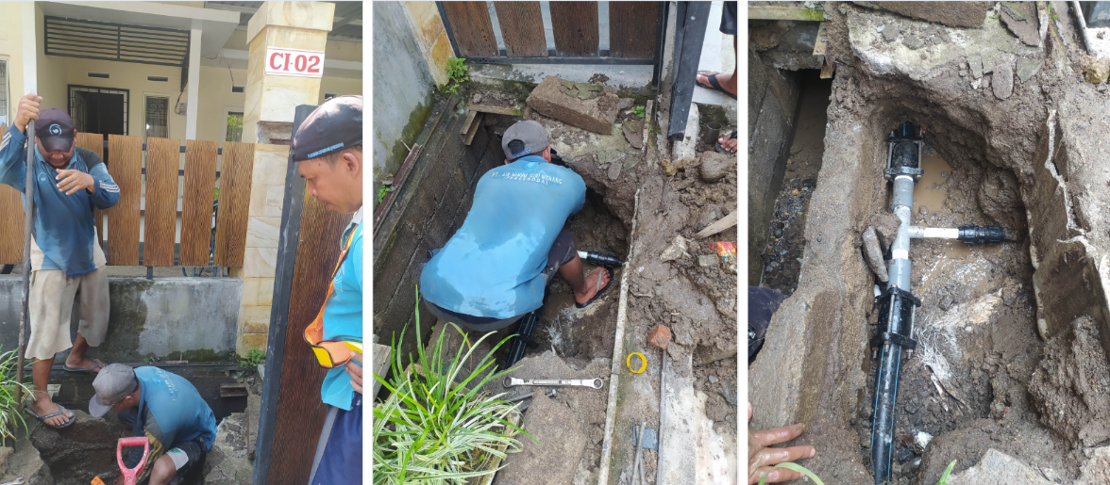
Perbaikan Kebocoran – Rehab Jaringan Pipa

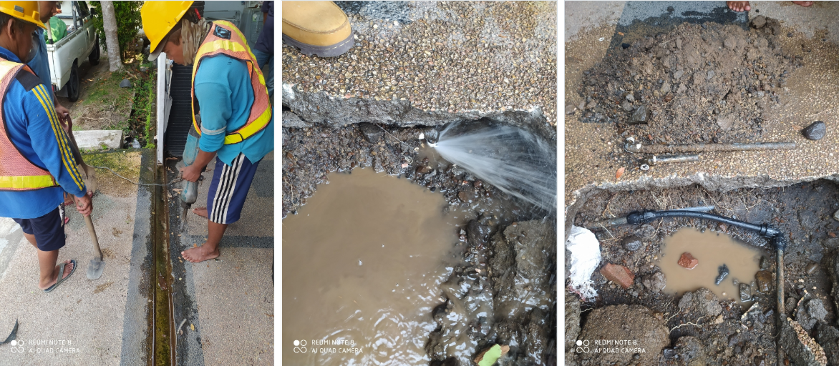
Perbaikan Kebocoran – Bocor Pipa HDPE

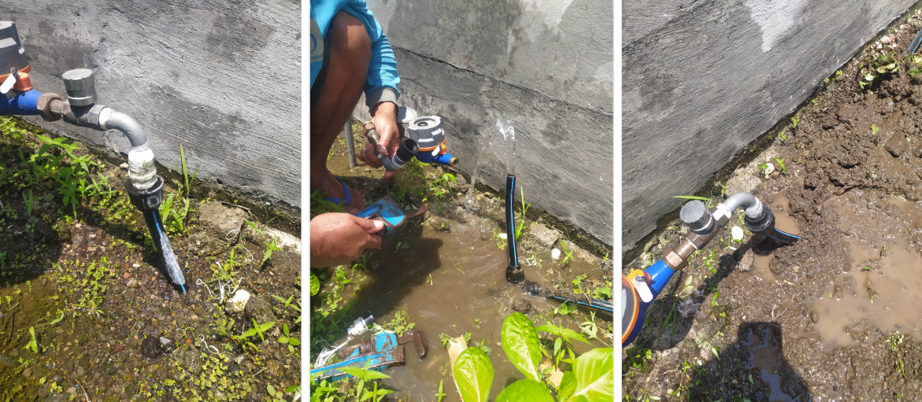
Perbaikan Kebocoran – Pergantian Stopkrant

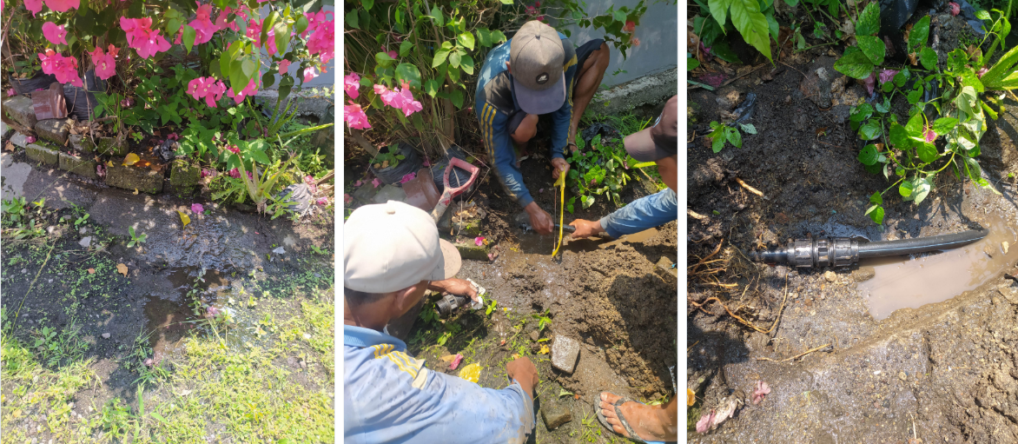
Perbaikan Kebocoran – Bocor Pipa HDPE

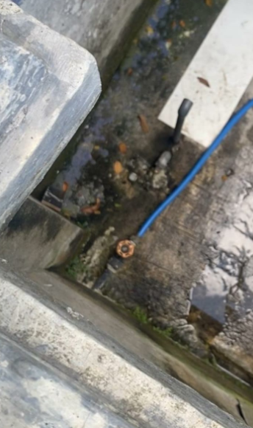  Pencurian Air Elit Kota | 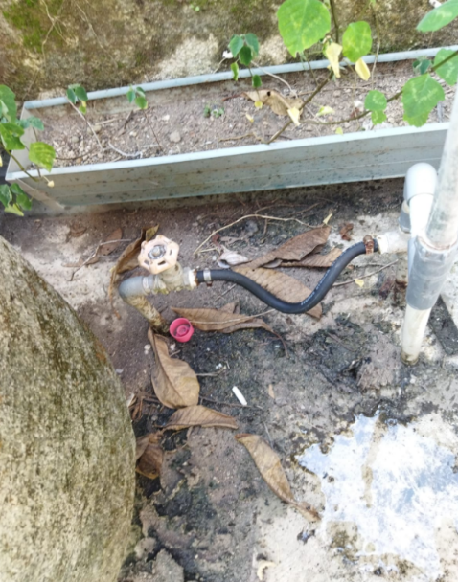  Pencurian Air GPK
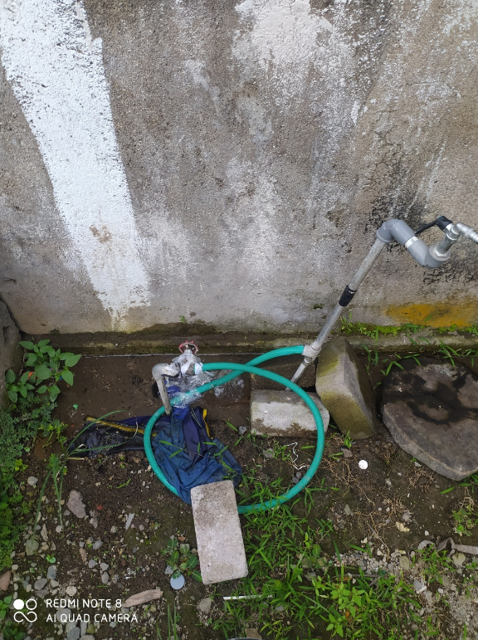  Pencurian Air GPK 2 | 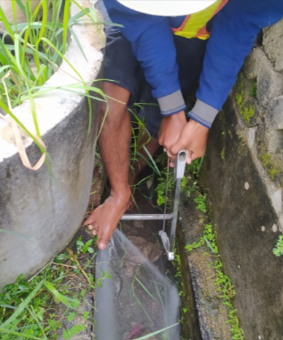  Penindakan Pencurian Air

