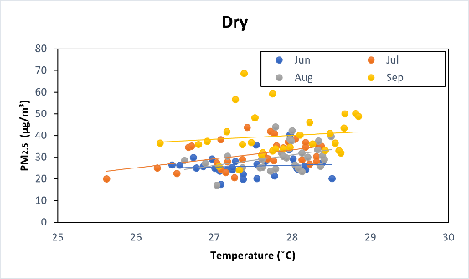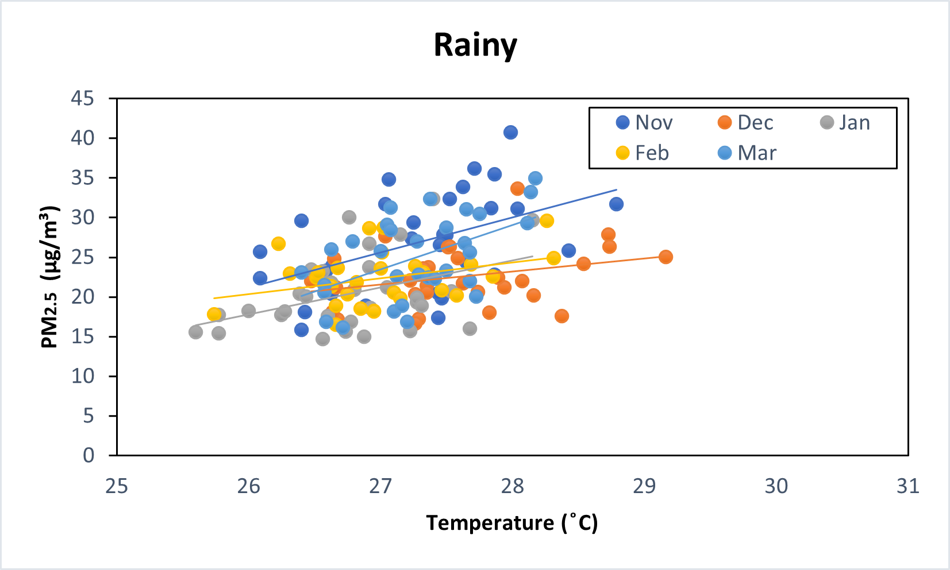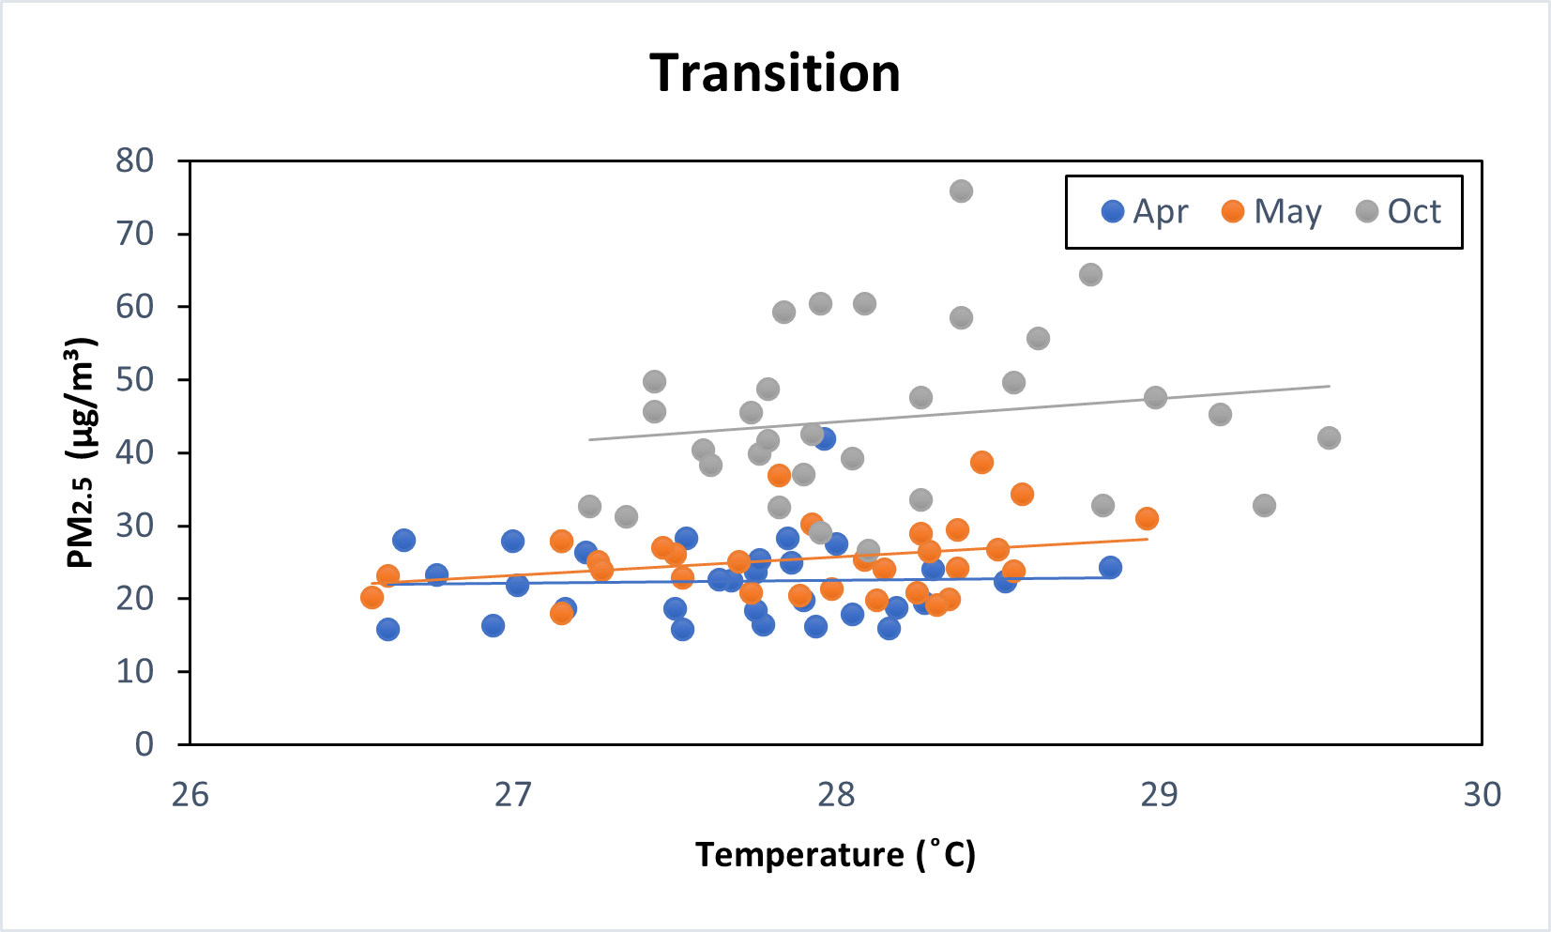
Figure S1. The relationship between PM_{2.5} and temperature over seasons
in the Jambi City

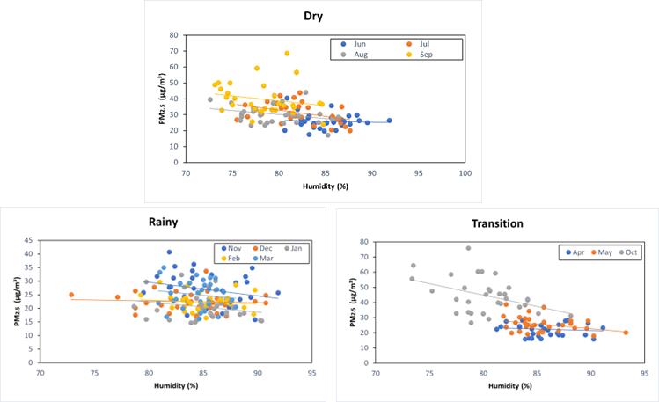
Figure S2. The relationship between PM_{2.5} and humidity over seasons
in the Jambi City

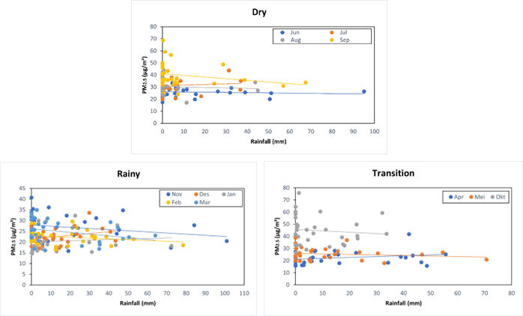
Figure S3. The relationship between PM_{2.5} and rainfall over seasons
in the Jambi City

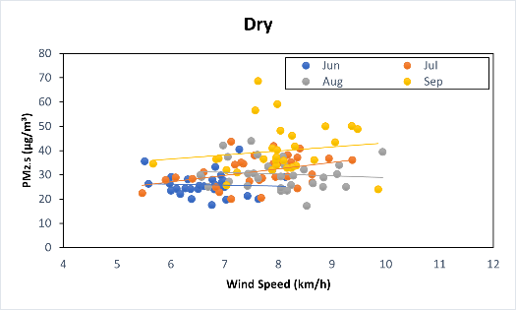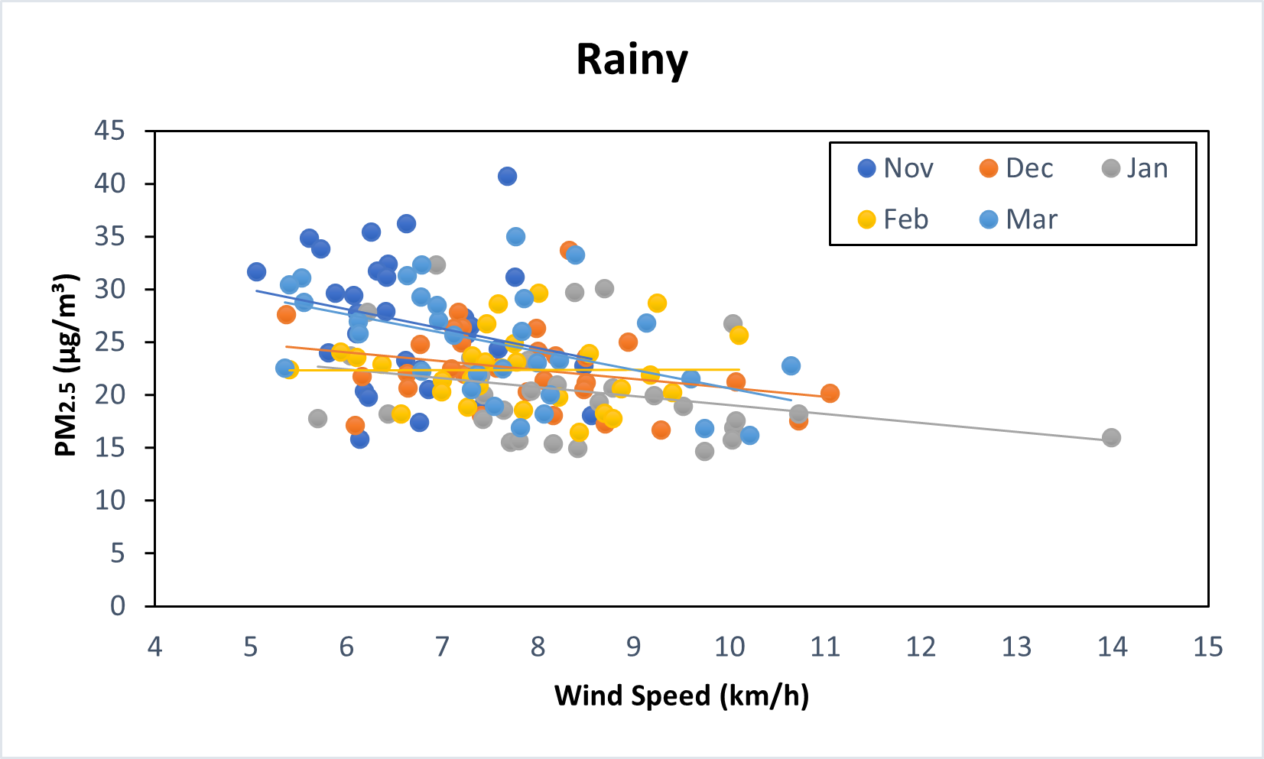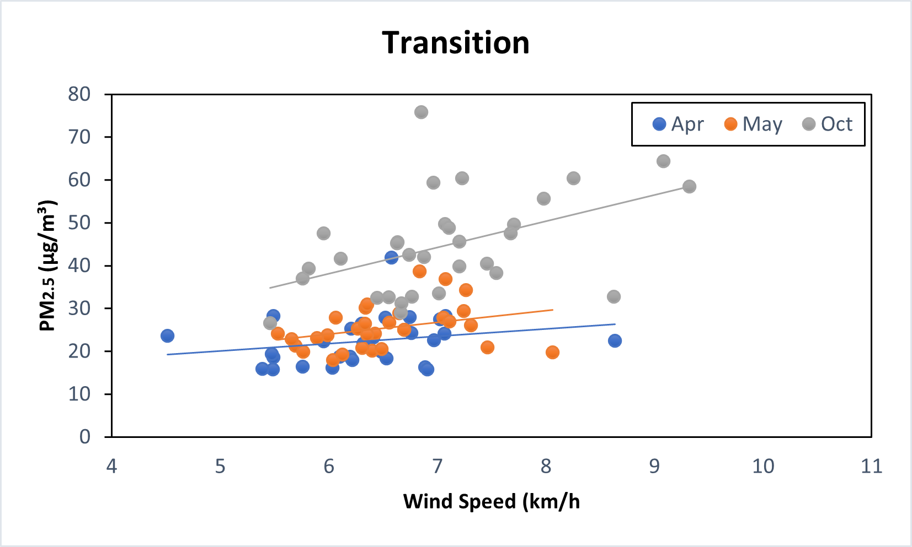
Figure S4. The relationship between PM_{2.5} and wind speed over seasons
in the Jambi City

