Original Research Article
Performance Evaluation of Glassfibre Reinforced Concrete (GRC) with the Addition of Ferric Oxide Waste as a Filler

Vivin Setiani¹, Wiwik Dwi Pratiwi¹*, Denny Dermawan¹, Luqman Cahyono², Mohamad Hakam³, Ryan Yudha Adhitya⁴, Mochammad Karim Al Amin⁵, Nur Fajar Aprilia Sari¹, Wanda Cahyaning Ati¹ Lina Indawati⁶
¹ Study Program of Waste Treatment Engineering, Politeknik Perkapalan Negeri Surabaya, Street on Teknik Kimia, Kampus ITS Sukolilo, Surabaya
² Study Program of Design and Construction Ship Engineering, Politeknik Perkapalan Negeri Surabaya, Street on Teknik Kimia, Kampus ITS Sukolilo, Surabaya
³ Study Program of Sustainable Engineering Energy Technology, Politeknik Perkapalan Negeri Surabaya, Street on Teknik Kimia, Kampus ITS Sukolilo, Surabaya
⁴ Study Program of Automation Engineering, Politeknik Perkapalan Negeri Surabaya, Street on Teknik Kimia, Kampus ITS Sukolilo, Surabaya
⁵ Study Program of Welding Engineering, Politeknik Perkapalan Negeri Surabaya, Street on Teknik Kimia, Kampus ITS Sukolilo, Surabaya
⁶ Department of Civil Engineering, National Central University, Chung-Li, 32001, Taiwan
* Corresponding Author, email: wiwik.pratiwi@ppns.ac.id


Abstract
The production of Portland cement is one of the major contributors to carbon emissions in the construction sector due to the high-temperature calcination process, which generates CO₂ emissions nearly equivalent to the mass of cement produced. This study aims to reduce the carbon footprint while managing steel industry waste by utilizing ferric oxide as a filler in the production of Glassfibre Reinforced Concrete. Ferric oxide waste, which is rich in Fe₂O₃, does not require a calcination process, thereby offering the potential to lower carbon emissions and support the implementation of circular economy principles. The ferric oxide waste used in this study was obtained from steel coating and thinning industries, specifically from the rolling process of steel sheets. Lumajang sand was employed as fine aggregate, with glass fibers added as reinforcement. This research applied a quantitative experimental approach. Preliminary material characterization included X-Ray Fluorescence (XRF), X-Ray Diffraction (XRD), Particle Size Distribution, sand gradation, and silt content analyses. The mix proportion used was a binder-to-aggregate ratio of 1:1 with a constant glass fiber content of 3%, while ferric oxide was substituted for cement at varying levels from 0% to 40%. Compressive strength, flexural strength, water absorption, dry density, and wet density tests were conducted. The results showed that the use of ferric oxide at an optimum substitution level produced Glassfibre Reinforced Concrete with superior mechanical performance compared to the control mix without ferric oxide. Water absorption and density values complied with the standards of the Glassfibre Reinforced Concrete Association International and the material exhibited a natural red hue that enhanced its aesthetic value. These findings confirm that ferric oxide has significant potential as an environmentally friendly cement substitute and can be widely implemented in sustainable construction industries.

Keywords: Ferric Oxide Waste; Glassfibre Reinforced Concrete (GRC); Flexural Strength, Glass Fiber

- Introduction
Ferric oxide (FO) waste originates from steel coating and rolling industries, particularly from the hot rolling process of steel sheets. This waste is formed as a result of surface oxidation during the hot rolling stage, which converts semi-finished steel into final products. The rolling process operates at temperatures ranging from 800°C to 1200°C. The scale formed during this process must be thoroughly removed to prevent surface defects, corrosion on the final product, and wear on the rolling equipment. The removal of this scale is typically carried out through a process known as pickling, which involves immersing steel in aqueous acid solutions. Several inorganic acids such as hydrochloric acid, sulfuric acid, and hydrofluoric acid, or their mixtures, are commonly used for pickling, with hydrochloric acid being the preferred choice in the steel industry (Khanna et al., 2023). In Indonesia, steel production capacity reached approximately 13.67 million tons in 2020, potentially generating between 341,750 and 390,571 tons of mill scale waste (Nurjamana Fajar, 2019). According to Government Regulation No. 22 of 2021, Annex IX, mill scale originating from the smelting of iron or steel is classified as hazardous and toxic waste (B3) from specific sources, coded as B406 and categorized as hazard class 2. Mill scale primarily consists of iron oxides, including ferric oxide (Fe₂O₃). However, ferric oxide waste generated from the thinning process has not been specifically categorized under this classification.
Ferric oxide waste predominantly consists of Fe₂O₃, which contains the heavy metal element iron (Fe). According to Cahyono et al (2024), the solidification–stabilization method can be applied to reduce the leaching potential of heavy metals into the environment. This method treats liquid or semi-solid waste by converting it into a more stable solid form through the addition of binding materials such as cement, which react with contaminants in the waste to form a stable matrix that encapsulates hazardous components. Ferric oxide waste typically appears as fine powder with micrometer-sized particles. Its main component, ferric oxide (Fe₂O₃), primarily exists in the form of hematite (α-Fe₂O₃), which is the most thermodynamically stable phase with a hexagonal close-packed crystal structure. The iron content in this waste can reach approximately 97% (Pravana et al., 2017). This powder is obtained from steel industry waste after removing impurities such as silica using concentrated HCl solution (Al Hadi, 2019).
Portland cement production is a major source of CO₂ emissions due to the calcination of limestone at approximately 1500°C. The amount of CO₂ released is nearly equivalent to the mass of cement produced, making Portland cement production environmentally unsustainable. One of the chemical constituents of Portland cement is ferric oxide (Fe₂O₃), which acts as a pigment and contributes to cement strength. However, the high CO₂ emissions associated with its production have raised environmental concerns (Irawan et al., 2015). Partial substitution of Portland cement with ferric oxide waste can significantly reduce CO₂ emissions since FO waste does not require calcination. This substitution not only lowers the carbon footprint of cement production but also enhances the aesthetic quality of concrete or mortar products by imparting a natural red hue. Thus, the use of FO waste as a partial cement substitute creates a more environmentally friendly material while providing added aesthetic value (Habibah et al., 2019).
Glassfibre Reinforced Concrete (GRC) is a composite material consisting of cement and sand reinforced with glass fibers. Generally, hardened cement-sand mixtures possess high compressive strength but limited flexural capacity. Conversely, glass fibers exhibit excellent tensile and flexural properties. The combination of these materials produces a composite that integrates the mechanical characteristics of the cement-sand matrix and glass fibers, resulting in improved compressive, flexural, and shear performance (Hendrawati et al., 2024). GRC products are widely used in interior applications such as partition panels and decorative elements, as well as in exterior applications including building façades, due to their high mechanical strength, relatively low weight, and weather resistance (Qorina et al., 2016). The partial substitution of Portland cement with ferric oxide (FO) is of great interest, as it not only reduces carbon emissions generated during cement production but also aligns with evidence showing that secondary cementitious material substitution can lower energy consumption and greenhouse gas (GHG) emissions by 1–94%, depending on the type and proportion of the substitute (Akintayo et al., 2023). The use of FO as a cement replacement effectively reduces clinker consumption—the primary contributor to CO₂ emissions in cement manufacturing. Furthermore, the natural red pigment of ferric oxide offers a distinctive aesthetic advantage in concrete or mortar products. The incorporation of iron oxide pigments has been shown to alter color without affecting the crystal structure or composition of cement (Okoh & Dim, 2024).
This study investigates the mechanical and physical properties of Glassfibre Reinforced Concrete (GRC) utilizing ferric oxide waste as a partial cement substitute. The objective of this research is to evaluate the influence of ferric oxide substitution levels on the compressive strength, flexural strength, and water absorption of GRC products in accordance with the standards established by the Glassfibre Reinforced Concrete Association International (2017).

- Methods
This study employed a quantitative method with an experimental approach. The materials used included ferric oxide waste obtained from a steel industry in East Java, which had an average particle size of 8 μm and a specific gravity in Saturated Surface Dry (SSD) condition of 2.475 g/cm³ (SNI 1969–2008). The cement used was Portland Composite Cement (PCC) with an average particle size of 3.4 μm.
Table 1. Results of Particle Size Distribution (PSD) Test of Ferric Oxide Waste and Portland Composite Cement (PCC)
Sample Code | Median (μm) | Mean (μm) | Modulus (μm) | Absorbance | Std Dev
Fe₂O₃ | 12,33 | 8,016 | 17,138 | 0,035 | 0,565
Fe₂O₃ | 11,694 | 8,055 | 17,138 | 0,046 | 0,521
PCC Cement | 3,996 | 3,465 | 5,348 | 0,233 | 0,523
PCC Cement | 3,985 | 3,460 | 5,348 | 0,239 | 0,522

Based on the particle size distribution (PSD) analysis, the ferric oxide waste had an average particle size of approximately 8 μm, which indicated its potential to provide a filler effect within the cement matrix. According to Taylor (1997), particles ranging from 1 to 100 μm could enhance packing density and reduce the porosity of the cement paste. Considering its particle size and physical characteristics, ferric oxide was considered to have the potential to partially replace cement as an additive material in concrete or mortar mixtures. This finding was consistent with the study conducted by Yuwana and Purnomo (2022), who reported that finer particles played an important role in improving the density and strength of concrete materials, as smaller particles could occupy the voids between larger ones. This mechanism resulted in a denser and more homogeneous microstructure, thereby reducing air voids within the matrix and improving the interparticle bonding of concrete components.
The X-Ray Diffraction (XRD) analysis of the ferric oxide waste showed that it predominantly consisted of hematite (99.94 % Fe₂O₃), with minor traces of maghemite (0.01 % Fe₂O₃) and magnetite (Fe₃O₄). The XRD results for the ferric oxide waste are presented in Table 2.

Table 2. X-Ray Diffraction (XRD) Results of Ferric Oxide (FO) Waste
Cystal Name | Chemical Formula | Content %  Fe Oxide
Magnetite | Fe₃O₄ | 0,05
Maghemite | Fe₂O₃ | 0,01
Hematite | Fe₂O₃ | 99,94

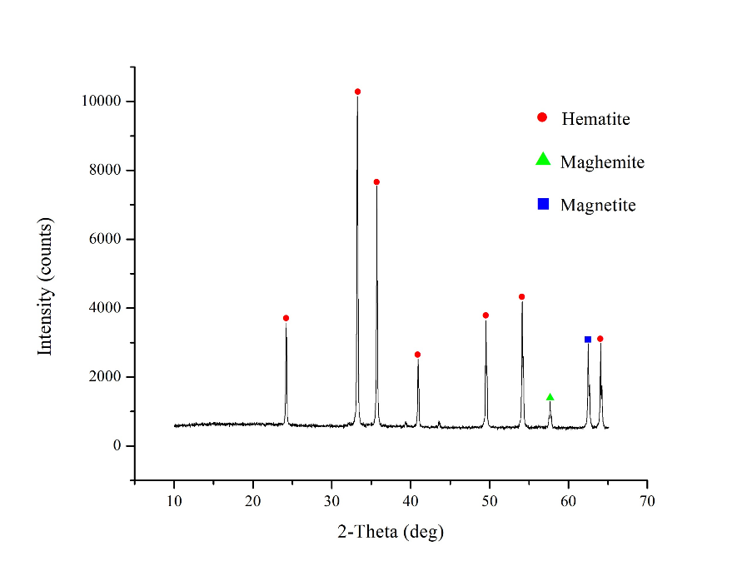
Figure 1. XRD Pattern of Ferric Oxide Waste

Figure 1. showed the intensity peaks at 20 angles of 24.15°, 33.15°, 35.61°, 40.85°, 49.46°, 54.06°, and 64.0°. These peaks corresponded to the main hematite peaks based on Joint Committee on Powder Diffraction Standards (JCPDS) No. 33-0664. The intensity peaks of magnetite (Fe₃O₄) were observed at around 62.48° according to JCPDS No. 19-0629, while the intensity peaks of maghemite (Fe₃O₄) appeared at approximately 57.2° based on JCPDS No. 39-1346. These results indicated that the hematite phase dominated the sample. According to Deepa et al. (2018), the presence of hematite in the cement mixture contributed significantly to the increase in density and compressive strength of concrete, as well as accelerating the hydration process. Magnetite exhibited high magnetism, facilitating the removal of impurities and producing high-quality concentrate (Budiman et al., 2015). Maghemite was strongly magnetic, stable, environmentally friendly, and suitable for use as a magnetic pigment (Rodliya, 2018).

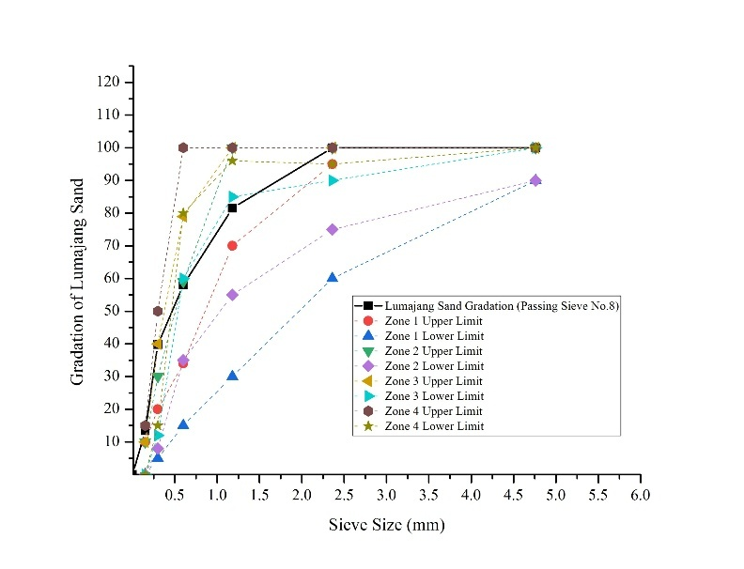
Figure 2. Gradation Curve of Lumajang Sand
Figure 2. showed the gradation curve of Lumajang sand that had passed through a No. 8 sieve, compared with the upper and lower limits of each gradation zone according to SNI 03-2834-2000. The analysis indicated that the particle size distribution of Lumajang sand predominantly fell within Zone 2 and approached the lower limit of Zone 1, with the cumulative passing percentage increasing sharply for sieve sizes between 0.3 mm and 1.18 mm. These results suggested that Lumajang sand had a suitable particle size distribution for use as fine aggregate in concrete mixtures, in accordance with the standard criteria. The gradation exhibited a transition between medium-graded and coarse-graded zones, which potentially enhanced workability and compressive strength when used in appropriate proportions. The SSD (saturated surface-dry) specific gravity of Lumajang sand was 2.841 g/cm³ (SNI 1969-2008), with a moisture content of 2.6% (SNI 1970-2008). The fineness modulus was 2.073 (ASTM C-33), and the sand contained 3.3% fines (ASTM C 117-95). E-glass fibers with a length of 3 cm and a high-range water reducer (HRWR) superplasticizer of polycarboxylate ether type (Sika Viscocrete® 3115N) were incorporated into the mix.
The mix design referred to the guidelines from the Glassfibre Reinforced Concrete Association (GRCA, 2017), with a cement-to-aggregate ratio of 1:1 and a water-cement ratio (w/c) of 0.31. The variations of the mix design are presented in Table 3.
Table 3. Mix Design Proportions of Glassfibre Reinforced Concrete (GRC)
Specimen Code | Composition Ratio by Weight |  |  |  | Superplasticizer (%) by Cement Weight | Glass Fiber (%) by total mix weight
Specimen Code | Cement | Ferric Oxide | Lumajang Sand | Water Cement Ratio | Superplasticizer (%) by Cement Weight | Glass Fiber (%) by total mix weight
FO₀ | 1 | 0 | 1 | 0,31 | 1,5 | 3
FO_{0,2} | 0,8 | 0,2 | 1 | 0,31 | 1,5 | 3
FO_{0,3} | 0,7 | 0,3 | 1 | 0,31 | 1,5 | 3
FO_{0,4} | 0,6 | 0,4 | 1 | 0,31 | 1,5 | 3

The compressive strength specimens without glass fibers were cast in cube molds measuring 5 × 5 × 5 cm and tested at the ages of 7 and 28 days, in accordance with ASTM C39. The flexural strength specimens were cast in molds measuring 62 × 46 × 1 cm. The curing process was carried out using the wet curing method for 28 days, following ASTM C945. After curing, the flexural strength specimens were cut into dimensions of 47 × 5 × 1 cm for testing in accordance with ASTM C1228-96. The flexural strength test was conducted at 28 days of age, following ASTM C947-03, while the water absorption test was performed based on ASTM C948-81. The dry and wet density tests were also carried out in accordance with ASTM C948-81.
- Result and Discussion
  - Compressive Strength
This test aimed to analyze the effect of variations in the composition of constituent materials, particularly the proportion of ferric oxide waste used as a filler. The results of the compressive strength test for mixtures containing ferric oxide waste are presented in Figure 3
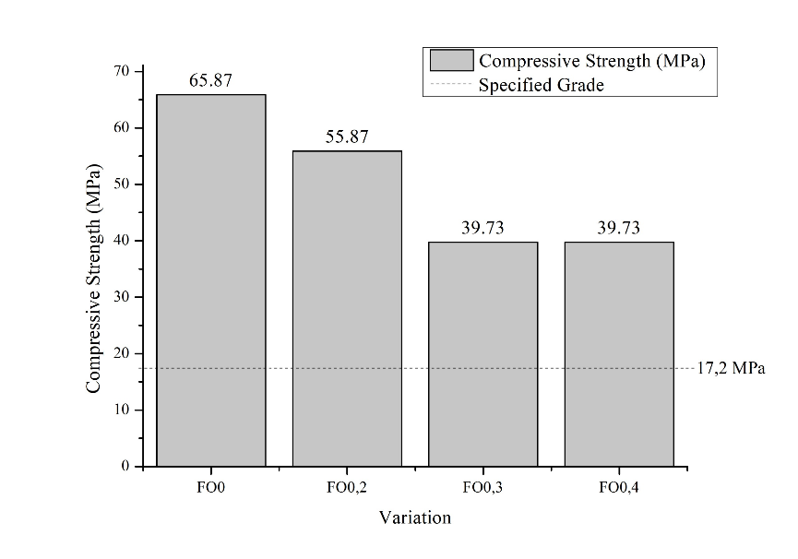
Figure 3. Compressive Strength Graph of Ferric Oxide Waste

Based on Figure 3, the compressive strength of the mortar decreased as the ferric oxide waste content increased. The highest compressive strength was obtained in the FO0 variation at 65.87 MPa, which then decreased to 55.87 MPa in the FO0.2 variation, and further declined to 39.73 MPa in both the FO0.3 and FO0.4 variations. Although a reduction was observed, all variations still exceeded the design strength value of 17.2 MPa. The test results indicated that the obtained compressive strength values surpassed the requirements of ASTM C270-80a, in which Type M mortar is required to have a minimum compressive strength of 175 kg/cm² (equivalent to 17.2 MPa). This type of mortar was classified as a high-strength mortar, commonly applied in reinforced brick wall construction, foundations, retaining walls, and sewer pipe masonry (Sihombing et al., 2019). Thus, the results indicated that all variations of GRC mixtures with the addition of ferric oxide waste still met the required compressive strength standards, making them suitable for use in both structural and non-structural construction applications.
The clay content in aggregates significantly influenced the compressive strength of concrete. A lower clay content in the aggregates generally resulted in higher concrete quality. Consequently, the increase in compressive strength was closely related to the reduction of clay content in the aggregates used. Based on the data, the compressive strength of concrete decreased as the proportion of ferric oxide used as a substitute increased. This phenomenon was attributed to the high Fe₂O₃ content in the waste, particularly when combined with high cement content. Fe₂O₃ contributed to the formation of C₄AF (tetracalcium aluminoferrite, 4CaO·Al₂O₃·Fe₂O₃), which did not adversely affect cement properties in moderate amounts. However, an excess of this compound potentially slowed the setting and hardening processes of concrete (Amalia, 2009). The reduction in compressive strength was also caused by the use of fine particles beyond the optimum level, which increased the mixture's porosity and decreased the matrix density, thereby directly reducing the mortar strength (Rasikbhai Thoriya et al., 2023).

  - Flexural Strength
This test aimed to analyze the effect of variations in the composition of the constituent materials, particularly the proportion of ferric oxide waste used as a filler. The results of the flexural strength tests with ferric oxide waste mixtures are presented in Figure 4.
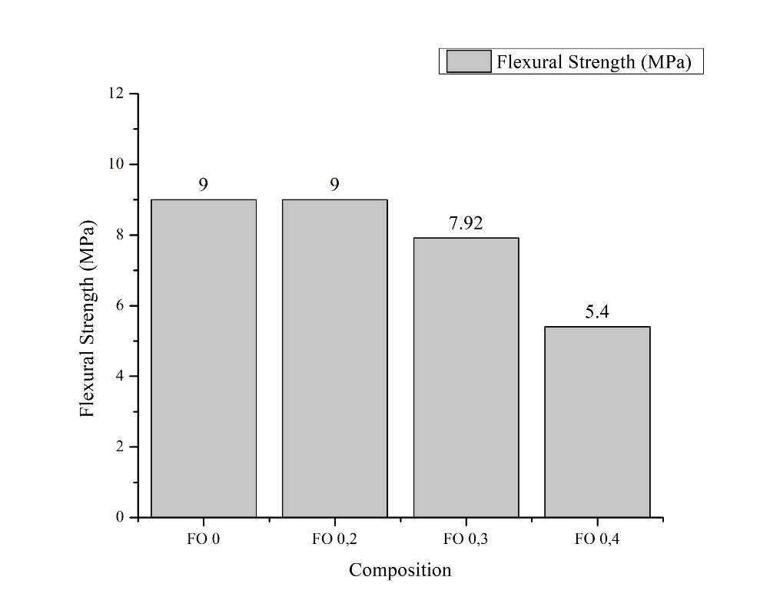
Figure 4. Flexural Strength of Ferric Oxide Waste Mixtures

Based on Figure 4, the flexural strength test results showed that the highest values were obtained for the FO0 and FO0.2 variations, both reaching 9 MPa. In the FO0.3 variation, the flexural strength decreased to 7.92 MPa, and in the FO0.4 variation, it further declined to 5.4 MPa. The results indicated that increasing the proportion of ferric oxide waste in the GRC mixture was generally accompanied by a reduction in flexural strength. In other words, the flexural strength of the concrete decreased as the proportion of ferric oxide waste increased. The study also showed that the addition of ferric oxide up to 20% (FO0.2) maintained a flexural strength comparable to the mixture without substitution (FO0), at 9 MPa. This indicated that the use of ferric oxide at this proportion did not significantly reduce the mechanical performance of the material. Therefore, the FO0.2 composition could be categorized as the optimum variation for producing GRC with high flexural strength while supporting sustainable utilization of industrial waste. The increase in flexural strength was attributed to the incorporation of glass fibers (fiberglass), which reinforced the internal structure of the concrete. The presence of glass powder in the mixture filled the pores within the concrete, resulting in a denser matrix. This densification positively affected the concrete's ability to withstand flexural loads (Wijaya & Sudjatmiko, 2023). The glass fibers acted as bridging elements between cracked concrete portions, further enhancing overall structural integrity. Additionally, the fibers functioned as micro-reinforcements within the concrete matrix, effectively minimizing the effects of non-uniform loading and external disturbances such as temperature and moisture variations (Kurniati, 2024). These findings were consistent with Utami & Cahyo (2022), who reported that in fiber-reinforced composite materials, applied loads were transferred and distributed from the matrix phase to the fibers, thereby improving the material's toughness. The presence of fiberglass also enhanced mechanical properties such as strength, stiffness, and durability without increasing the overall mass of the concrete. Overall, the addition of glass fibers contributed significantly to improving the mechanical performance of the concrete, particularly in resisting flexural loads and controlling crack propagation. The combination of glass powder and fibers not only increased matrix density but also improved internal cohesion, resulting in concrete with higher durability and toughness.

  - Water Absorption
This test aimed to analyze the effect of variations in the composition of constituent materials, particularly the proportion of ferric oxide waste used as a filler. According to the Glassfibre Reinforced Concrete Association International (2017), the water absorption value was between 5% and 11%. The results of the water absorption test for mixtures containing ferric oxide waste are presented in Figure 5.

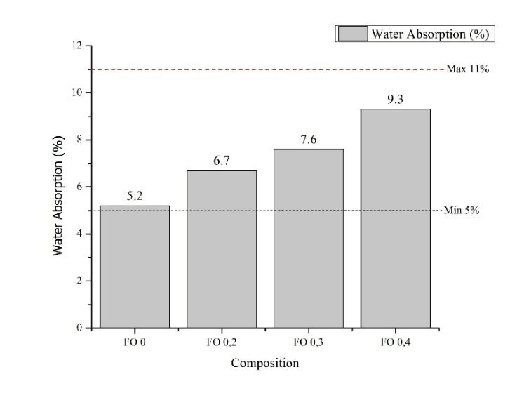
Figure 5. Water Absorption of Ferric Oxide Waste Mixtures

Based on Figure 5, the water absorption test results showed that the water absorption values increased with the rising proportion of ferric oxide waste in the GRC mixtures. The FO0 variation exhibited a water absorption value of 5.2%, which increased to 6.7% in the FO0.2 mixture. In the FO0.3 variation, the water absorption reached 7.6%, while the FO0.4 mixture recorded the highest value of 9.3%. All measured water absorption values remained within the range specified by the Glassfibre Reinforced Concrete Association International (2017), which is between 5% and 11%. These results indicated that all mixture variations met the water absorption criteria required for Glassfibre Reinforced Concrete (GRC) materials. According to the standard, water absorption values within this range reflected a porosity and density level suitable for construction applications, both as lightweight structural elements and non-structural panels. Therefore, all GRC variations containing ferric oxide waste were considered acceptable from the water absorption perspective. The obtained values also suggested that the produced GRC possessed adequate durability against environmental influences, in accordance with quality standards. The incorporation of high proportions of ferric oxide resulted in less homogeneous GRC mixtures with more porous structures, thereby increasing the material’s water absorption capacity (Pereira et al., 2011). The non-reactive nature of ferric oxide with cement hydration also contributed to limited formation of dense interparticle bonds, which are crucial for resisting water penetration into the matrix (Hassani & Kazemian, 2024). Consequently, increasing the proportion of ferric oxide as a partial cement replacement directly led to higher open porosity and weaker interparticle bonding, ultimately resulting in increased water absorption in both mortar and concrete structures.

  - Dry and Wet Bulk Density
This test aimed to determine the bulk density of the material in both dry and wet conditions. The minimum values for dry and wet bulk density, according to the Glassfibre Reinforced Concrete Association International (2017), were 1800 kg/m³ and 2000 kg/m³, respectively. The results of the dry and wet bulk density tests for mixtures containing ferric oxide waste are presented in Figure 6.

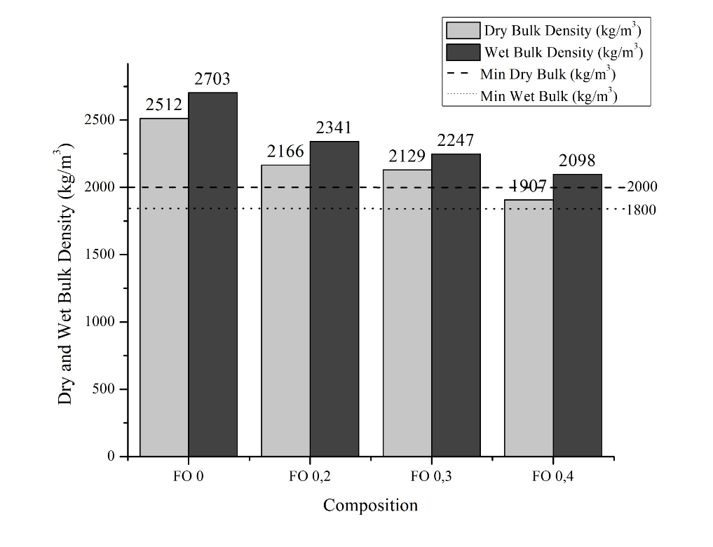
Figure 6. Dry and Wet Bulk Density of Ferric Oxide Waste Mixtures

Based on Figure 6, the dry bulk density test results showed a gradual decrease with changes in the material composition across each GRC mixture variation. The FO0 variation exhibited a dry bulk density of 2512 kg/m³, which decreased to 2166 kg/m³ in the FO0.2 mixture. Subsequently, the FO0.3 variation recorded a value of 2129 kg/m³, and the FO0.4 mixture reached the lowest value of 1907 kg/m³. All obtained values met the requirements of the Glassfibre Reinforced Concrete Association International (2017), which specified a minimum dry density of 1800 kg/m³. These results indicated that all mixture variations produced GRC with adequate dry density in accordance with the quality standards. The compliance with the dry density criteria suggested that the produced material possessed sufficient compactness and volumetric stability for construction applications, demonstrating that all mixtures met the applicable standard requirements. Regarding wet bulk density, the results also showed a decreasing trend with increasing proportions of ferric oxide. The FO0 mixture exhibited a wet density of 2703 kg/m³, which decreased to 2341 kg/m³ for FO0.2, 2247 kg/m³ for FO0.3, and reached the lowest value of 2098 kg/m³ for FO0.4. According to the Glassfibre Reinforced Concrete Association International (2017), the minimum required wet density for GRC products was 2000 kg/m³. The test results indicated that all mixture variations met the minimum requirement. Therefore, all GRC mixtures satisfied the wet density criteria, making them suitable for various GRC elements that require strength, durability, and dimensional stability. These findings confirmed that the addition of ferric oxide contributed to an increase in both dry and wet bulk density. All tested variations remained within the range specified by the Glassfibre Reinforced Concrete Association International (2017), indicating that the produced material complied with the established standards. According to Taylor (1997), fine particles played an important role in enhancing the material's microstructure through a pore-filling mechanism, thereby increasing matrix density. The results also demonstrated a positive correlation between compressive strength and density, where an increase in compressive strength corresponded with higher material density. These findings were consistent with the study conducted by Iffat (2015), which reported that concrete with higher density tended to exhibit greater compressive strength due to reduced porosity and water absorption within the material structure.

3.5 Glassfibre Reinforced Concrete (GRC)
The figure 7 showed that the results indicated that the addition of ferric oxide (FO) waste significantly affected the compressive and flexural strength of the GRC. In the FO0 variation (control without FO waste), the compressive strength was 65.87 MPa with a flexural strength of 9.0 MPa. These values decreased progressively with the addition of FO, reaching 39.73 MPa for compressive strength and 5.4 MPa for flexural strength in the FO0.4 mixture. The sharpest reduction occurred in the FO0.3 and FO0.4 variations, where both mechanical parameters decreased by more than 30% compared to the control sample. A positive correlation was observed between compressive and flexural strength: higher compressive strength was accompanied by higher flexural strength, and vice versa. However, the sensitivity of flexural strength reduction was more pronounced at FO0.3 and FO0.4 substitution levels, indicating that the material lost flexural toughness more readily than compressive strength when excessive FO was added.
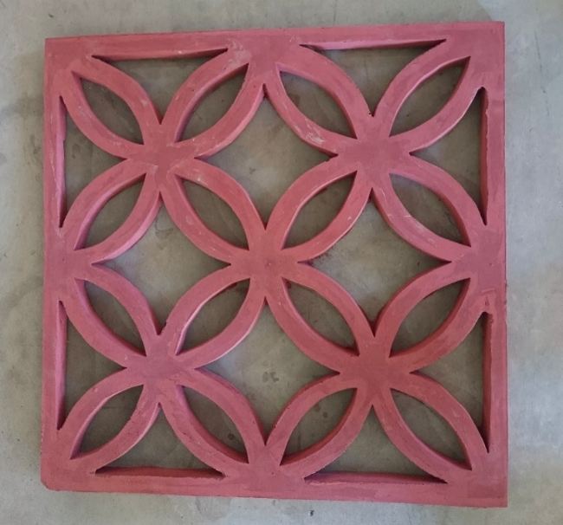
Figure 7. Glassfibre Reinforced Concrete (GRC) Products from Krawangan

The interrelation of the test results suggested that mechanical and physical parameters influenced each other. In general, increases in compressive and flexural strength corresponded with decreases in water absorption. Higher dry and wet density values indicated denser materials, although at high FO contents, this effect did not always enhance strength, as material density also played a role. The reduction in compressive strength was attributed to the formation of voids between particles or uneven distribution of fillers, weakening the material’s load-bearing capacity (Miah et al., 2020). The use of ferric oxide as partial cement replacement reduced the availability of active binding material, limiting the formation of hydration products, particularly C–S–H gel and portlandite, which reinforced the mortar structure. Consequently, compressive strength tended to decrease because the replacement material did not reactively contribute to the matrix (Hansu & Etli, 2025). The effectiveness of fillers in improving mechanical properties applied only up to a certain limit. Beyond the optimal dosage, excessive filler caused disturbances such as reduced active binder content, micro-cracking, and inhibited interaction among cement particles (Noori & Ibrahim, 2018). The increase in flexural strength was attributed to the role of glass fibers as effective crack-bridging elements and the contribution of fine Fe₂O₃ particles as micro-fillers and C–S–H nucleation sites, which improved matrix density and strengthened the interfacial transition zone (ITZ). The synergy of these mechanisms enhanced flexural deformation, crack resistance, and toughness (Jose et al., 2023). Factors contributing to reduced flexural strength included non-uniform dispersion of glass fibers during GRC casting, resulting in suboptimal fiber orientation, clumping, or ineffective fibers, thereby reducing flexural performance and crack resistance (Cheng et al., 2024). The increase in water absorption in mortars or concrete containing FO as a filler was due to increased porosity and reduced structural density. High FO content made the mixtures less homogeneous and more porous, facilitating water penetration (Pereira et al., 2011). oreover, FO was non-reactive to cement hydration, limiting the formation of dense interparticle bonds required to resist water ingress (Hassani & Kazemian, 2024). Consequently, higher FO percentages as a partial cement replacement resulted in increased water absorption due to higher porosity and weaker interparticle bonding within the mortar or concrete matrix. This increase in density was accompanied by a rise in water absorption from 5.2% to 9.3%.
This phenomenon indicated that although the total density increased, the open porosity also increased. The rise in open porosity was likely caused by agglomeration of ferric oxide particles at high contents, creating micro-voids between agglomerates and enhancing water absorption capacity (Wang et al., 2022). In other words, high density in this system did not fully represent reduced capillary voids, but rather reflected the increased material bulk density due to high ferric oxide content.
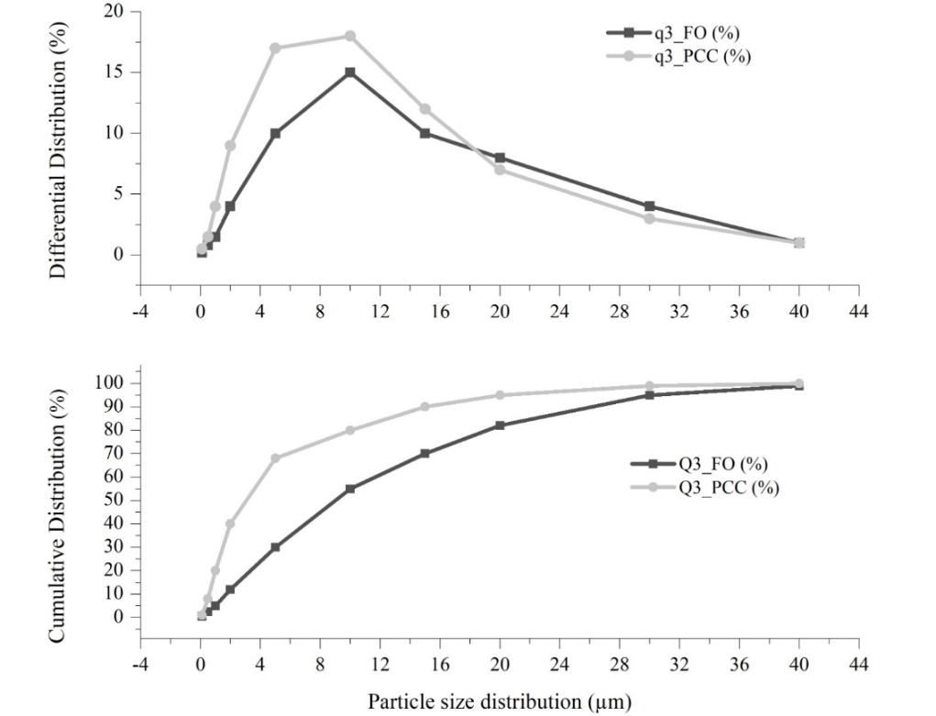
Figure 7. Particle Size Distribution (PSD) of Ferric Oxide and PCC
The particle size distribution played a critical role in determining the mechanical and physical properties of GRC. The results showed that ferric oxide (FO) and PCC particles exhibited size variations capable of forming a more efficient packing density. Fine particles filled the voids between larger particles, thereby reducing the empty space within the matrix. This condition produced a denser microstructure and a stronger interfacial transition zone (ITZ), which enhanced flexural strength by making crack initiation more difficult and hindering crack propagation through a crack-bridging mechanism reinforced by glass fibers (Singh et al., 2021). The increase in packing density significantly influenced the mechanical properties of the composite material. Optimal packing density resulted in a particle distribution that maximized space-filling, reducing porosity. The reduction in porosity directly contributed to increases in compressive and flexural strength by improving stress transfer between particles and minimizing voids that could serve as crack initiation points (Mehta & Monteiro, 2014). Conversely, an imbalanced particle size distribution caused micro-voids to form, increasing porosity and decreasing interparticle bond efficiency, which was reflected in the decreased compressive and flexural strength of FO0.3 and FO0.4 mixtures.
Furthermore, higher packing density also affected physical properties, particularly water absorption. A denser matrix reduced open pores and capillary transport pathways, resulting in significantly lower water absorption. Reduced porosity restricted water penetration, ultimately enhancing resistance against wet–dry cycle degradation. These findings aligned with Neville (2011), who emphasized a negative correlation between matrix density and water absorption, where fine fillers effectively reduced capillarity in the cement paste. The positive effects of well-distributed particles were also observed in dry and wet density. When voids between particles were optimally filled by a combination of large and small particles, the material’s bulk density increased. Higher dry density indicated a reduction in internal void volume, while higher wet density suggested that the material could better maintain structural integrity when saturated. These observations were consistent with Hansu dan Etli, (2025), who reported that improved packing density directly increased the bulk density of cementitious materials. Therefore, a strong correlation existed between particle size distribution, flexural strength, water absorption, and density through the packing density mechanism in the GRC matrix. However, higher porosity also enlarged capillary pathways, increasing water absorption (Wang et al., 2022). Data indicated that mixtures with excessive filler showed water absorption values up to 9.3%, reflecting increased open voids. Increased dry and wet density in mixtures with high PCC content did not necessarily correspond to improved mechanical strength, as the rise in density was primarily due to higher particle mass rather than reduced porosity. Therefore, achieving optimal packing density was key to obtaining the best mechanical properties while minimizing water absorption in the material (Taylor, 1997; Mindess et al., 2003).

- Conclusions
This study demonstrated that ferric oxide waste could be utilized as a filler. An optimal composition of 20% produced Glassfibre Reinforced Concrete (GRC) with an average flexural strength of 9 MPa, which was higher compared to the mixture without ferric oxide substitution. All mixture variations met the requirements for water absorption as well as minimum dry and wet density indicating suitability for construction applications. However, increasing the ferric oxide content beyond 20% caused a significant reduction in compressive and flexural strength due to the formation of micro-voids and a decrease in the amount of active binder. The use of ferric oxide as a filler provided notable benefits by reducing cement demand, which is a major contributor to CO₂ emissions in the construction industry. Ferric oxide, containing stable and non-toxic Fe₂O₃, functioned as a micro-filler, enhancing matrix density up to a certain limit. Its application supported sustainable steel industry waste management and reduced the carbon footprint of construction materials, making it more environmentally friendly than pure cement. These findings highlighted the potential for implementing circular economy concepts in the construction sector while contributing to greenhouse gas emission reduction targets in infrastructure.

Acknowledgement
The authors would like to express their sincere gratitude to the Shipbuilding Institute of Polytechnic Surabaya (PPNS) for their support and the opportunity to conduct this research. Appreciation is also extended to the research funding providers and all contributors who offered assistance, enabling the successful completion of this study. Special thanks are directed to the industry partners for their contribution through the provision of raw materials, supporting data, and fruitful collaboration throughout the research. Furthermore, the authors sincerely acknowledge the Department of Waste Treatment Engineering, Shipbuilding Institute of Polytechnic Surabaya, for providing laboratory facilities and technical guidance during the research process. It is hoped that the results of this study will be beneficial and serve as a foundation for further research in the field of sustainable construction materials.

References
Akintayo, B. D., Akintayo, D. C., & Olanrewaju, O. A. 2023. Material Substitution Strategies For Energy Reduction And Greenhouse Gas Emission In Cement Manufacturing. Atmosphere, 14 (8), 1–14.
Al Hadi, F. H. 2019. Pemanfaatan Pasir Besi Dalam Sintesis Hematite (Α-Fe2o3) Secara Hidrotermal Dengan Variasi Temperatur Dan Waktu. 68–74.
Amalia. 2009. Studi Eksperimental Perilaku Mekanik Beton Normal Dengan Substitusi Limbah Debu Pengolahan Baja (Dry Dust Collector). Program Magister Teknik Sipil, 56.
Budiman, A., Trilismana, H., Fisika, L., Jurusan, B., & Andalas, U. 2015. The Effects Of Oxidation On The Concentration Of Superparamagnetic Grains Of Magnetite Of Iron Sand. 9–15.
Cahyono, L., Carina, A., Pratiwi, W. D., Fardina, F., Widiana, D. R., Utomo, A. P., & Fahmi, M. R. 2024. Sustainable Materials Melalui Solidifikasi-Stabilisasi Limbah Sandblasting Menjadi Beton Ferosemen. 04 (02), 108–118.
Cheng, C., He, J., Li, X., & Hong, S. 2024. Flexural Behavior Of Glass Fiber Reinforced Cement Incorporating Foam. Journal Of Engineered Fibers And Fabrics, 19.
Deepa, R., Geethamozhi, E., Monika, S., Shalina, S. P., & Swathy, K. 2018. Experiment On High Density Concrete Incorporating Hematite. Indian Journal Of Scientific Research, 20 (2), 49–53.
Habibah, R., Ningsih, R., & Jannah, A. 2019. Sintesis Pigmen Hematit (Α-Fe2o3) Dari Limbah Bubut Besi Dengan Variasi Konsentrasi Agen Pengendap Urea. Αγαη, 8 (5), 55.
Hansu, O., & Etli, S. 2025. Evaluation Of The Usability Of Scms Produced By Adding Aluminum And Iron Oxide To Mortar Waste Powder Under Different Conditions. Buildings, 15 (17), 1–25.
Hassani, A., & Kazemian, F. 2024. Case Studies In Construction Materials Investigating Geopolymer Mortar Incorporating Industrial Waste Using Response Surface Methodology : A Sustainable Approach For Construction Materials. Case Studies In Construction Materials, 21 (May), E03609.
Hendrawati, L. K., Khusna, L., Magfiroh, R., Oktavina, D. 2024. Glass Reinforced Concrete (Grc). 2 (2), 209–218.
Iffat, S. 2015. Relation Between Density And Compressive Strength Of Hardened Concrete Relation Between Density And Compressive Strength Of Hardened Concrete. Concrete Research Letters, 6 (4), 182–189.
Irawan, R. R., Hardono, S., & Budiman, Y. I. 2015. Beton Dengan Sedikit Semen Portland Dan Tanpa Semen Portland Dengan Memanfaatkan Abu Terbang Pltu Batubara.
Jose, P. A., Alex, A. G., Gebrehiwet, T., & Murugan, S. 2023. Influence Of Fe2o3 Nanoparticles On The Characteristics Of Waste Marble Powder Mixed Cement Mortars. International Journal Of Concrete Structures And Materials, 17 (1).
Khanna, R., Konyukhov, Y., Li, K., Jayasankar, K., Maslennikov, N., Zinoveev, D., Kargin, J., Burmistrov, I., Leybo, D., Kravchenko, M., & Mukherjee, P. S. 2023. Innovative Transformation And Valorisation Of Red Mill Scale Waste Into Ferroalloys: Carbothermic Reduction In The Presence Of Alumina. Sustainability (Switzerland), 15 (24).
Kurniati, D. 2024. Ketahanan Kuat Tekan Beton Serat Fiber Glass. 10 (2).
Mehta, P. K., & Monteiro, P. J. M. 2014. Theoretical concepts of stress wave propagation in solids. In Concrete: Microstructure, Properties, and Materials.
Miah, M. J., Ali, M. K., Paul, S. C., Babafemi, A. J., Kong, S. Y., & Šavija, B. 2020. Effect of recycled iron powder as fine aggregate on the mechanical, durability, and high temperature behavior of mortars. Materials, 13 (5), 1–19.
Noori, K. M., & Ibrahim, H. H. 2018. Mechanical Properties of Concrete Using Iron Waste as a Partial Replacement of Sand. Eurasian Journal of Science and Engineering, 3 (3), 75–82.
Nurjaman, F., Prilitasari, N. M., Prasetyo, A. E., & Nugroho, E. 2019. Pemanfaatan Limbah Industri Baja Sebagai Bahan Baku Pembuatan Logam Pig Iron: Peleburan Mill Scale Menggunakan Submerged Arc Furnace. 37–48.
Okoh, J. S., & Dim, P. E. 2024. P066 - Investigation On The Effect Of Iron Oxide ( Feo 3 ) Pigment On The Production Of Coloured Cement For. 9 (7), 66.
Pereira, F. M., Carlos, J., Verney, K. De, & Lenz, D. M. 2011. Evaluation Of The Use Of Mill Scale As Fine As Fine Aggregate In Concrete. 64(4), 463–469.
Pravana, N. K., Piryani, S., Chaurasiya, S. P., Kawan, R., Thapa, R. K., Shrestha, S., Brouwer, I. D., Jager, I. De, Borgonjen, K., Azupogo, F., Rooij, M., Folson, G., Abizari, R., Frempong, R. B., Annim, S. K., Boah, M., Azupogo, F., Amporfro, D. A., Abada, L. A. 2017. Sintesis Pigmen Geothit (Α-Feooh) Dari Limbah Bubut Besi Dengan Variasi Suhu Sintesis. Development Studies Research, 3 (1), 43.
Qorina, U., Mahyudin, A., & Handani, S. 2016. Pengaruh Persentase Massa Gipsum Dan Serat Terhadap Kuat Tekan Dan Kuat Lentur Papan Semen - Gipsum Berserat Enceng Gondok. Jurnal Fisika Unand, 5 (3), 233–237.
Rasikbhai Thoriya, K., Singh, A., Agrawal, V., & Chandra Gupta, R. 2023. Preliminary Study On Utilization Of Steel Mill Scale In Concrete. Materials Today: Proceedings, Xxxx.
Rodliya, L. S. 2018. Sintesis Pigmen Maghemit (Γ-Fe2o3) Dari Limbah Bubut Industri Kerajinan Besi Dengan Variasi Suhu Kalsinasi. 1–120.
Sihombing, A. P., Afrizal, Y., & Gunawan, A. 2019. Pengaruh Penambahan Arang Batok Kelapa Terhadap Kuat Tekan Mortar. Inersia, Jurnal Teknik Sipil, 10 (1), 31–38.
Singh, B., Pathania, A., Gupta, M., Saini, A., & Shukla, A. 2021. Influence Of The Packing Density Of Fine Particles In Ternary, Quaternary And Quinary Blends On High Performance Concrete. Rilem Bookseries, 29(January), 465–482.
Taylor, H. F. W. 1997. Cement Chemistry. 2nd Ed. Academic Press, 20(4), 335.
Utami, N., & Cahyo, E. 2022. Sifat Mekanik Komposit Fiberglass Melalui Uji Lentur. Teknika Sttkd: Jurnal Teknik, Elektronik, Engine, 8 (2), 322–329.
Wang, Y., Li, L., An, M., Sun, Y., Yu, Z., & Huang, H. 2022. Factors Influencing the Capillary Water Absorption Characteristics of Concrete and Their Relationship to Pore Structure. Applied Sciences (Switzerland), 12 (4).
Wijaya, S. P. I., & Sudjatmiko, A. 2023. Analisis Pengaruh Limbah Serbuk Kaca Pada Beton Terhadap Kuat Tekan, Kuat Lentur Dan Absorbsi. Universitas Muhammadiyah Surakarta, 1 (1), 53–54.
Yuwana, H. P., & Purnomo, S. 2022. Pengaruh Gradasi Pasir Terhadap Kekuatan Tekan Mortar Dalam Perencanaan Sementasi Limbah Radioaktif. Jurnal Pengawasan Tenaga Nuklir, December, 42–51.

