Regional Case Study
Improving Low Carbon Development Performance through Multi Criteria Decision Analysis: A Case Study of Mojokerto Regency

Fariz Basyiruddin¹*, Arief Rachmansyah², Bunga Hidayati³, Reny Tiarantika³, Naziatul Aziah Mohd Radzi⁴
¹ Department of Environmental Resource Management and Development, Graduate School, Universitas Brawijaya, Malang, Indonesia
² Department of Civil Engineering, Universitas Brawijaya, Malang, Indonesia
³ Graduate School, Universitas Brawijaya, Malang, Indonesia
⁴Universiti Kebangsaan Malaysia, Bangi, Malaysia
* Corresponding Author, email: farizbasy15@gmail.com


Abstract
Climate change demands real mitigation action at the local level to maintain environmental stability. Although Mojokerto Regency has committed to emission reduction targets, the effectiveness of low-carbon development implementation represents only 0,12% of total emissions, indicating a very limited mitigation impact. This study aims to examines the enabling and constraining factors that influence low carbon development performance using thematic analysis and formulate priority strategies for reducing greenhouse gas emissions using the Analytic Hierarchy Process (AHP) method. Data collection was conducted through a dept interview and paired comparison questionnaire involving experts from local government planning and academision. The analysis results show that the enabling and constraining factors are multi sector engagement, cross program intersection, limited budgetary capacity and availability of activity data, limited political commitment and human resource, lack of regulatory and institution framework. The Community Involvement criterion is the most critical factor (31,32%), surpassing economic and technical factors. In line with this, Waste Management at TPS3R was determined to be the highest priority strategy with a global weight of 26,12%, followed by Tree Planting (20,09%) and Organic Fertilizer Use (13,88%). These three community-based solutions collectively dominate more than 60% of the priority weight, beating capital-intensive technology options such as Intelligent Transportation Systems (ITS) or Area Traffic Control System (ATCS). These findings recommend that local governments shift their policy focus from physical infrastructure development alone to social empowerment programs and nature-based solutions to achieve sustainable emission reduction targets.

Keywords: climate change, low carbon development, AHP, mojokerto regency
- Introduction
Climate change is an urgent global issue that contributes to environmental instability and rising average global temperatures (Fahmi, 2025). In 2024, the Earth’s average temperature reached its highest level in the past 44 years since 1981, as reported by data from Indonesia’s national meteorological agency (2025). The Government of Indonesia has responded by establishing the Enhanced Nationally Determined Contribution (ENDC), aiming to increase the national emission reduction target to between 31,89% and 43,20% by 2030, depending on the level of international support. This national commitment is operationalized through key initiatives outlined in Indonesia’s National Medium-Term Development Plan 2025–2029, which include the transition to renewable energy, peatland restoration, and waste management (Bappenas, 2024).
Mojokerto Regency has integrated low-carbon development planning into its regional development mission under the Regional Medium-Term Development Plan (RPJMD) 2021–2026, aiming to align infrastructure expansion with environmental conservation. Statistics from the PPRK AKSARA Bappenas for 2024 indicate a regional emission reduction of 3.094,67 tons of CO₂-equivalent, representing approximately 0,12% of total existing emissions (Bappenas, 2024). Several factors influence this level of effectiveness. Studies conducted across various regions in Indonesia reveal that weak cross-sectoral coordination, limited institutional capacity, and suboptimal budgetary support constitute major barriers to the implementation of mitigation actions (Handayani, 2021; Husein et al., 2025; Kartikasari et al., 2019). These findings indicate that institutional and governance aspects play a significant role in the implementation of low-carbon development, in addition to technical considerations. In Mojokerto Regency, however, these factors have not yet been clearly identified, which contributes to the low level of effectiveness.
Ambitious targets for the forthcoming planning period require a significant improvement in the effectiveness of low-carbon development, particularly in terms of emission reductions. However, the implementation of low-carbon development remains sectoral across local government agencies, resulting in low-carbon development strategies for emission reduction in Mojokerto Regency that are still fragmented, subjective, and not yet comprehensive.
Although previous studies have examined greenhouse gas emissions at the local level, most have primarily focused on the analysis of planning documents without integrating multi-criteria assessments that comprehensively consider environmental, social, economic, and technical dimensions (Hardyanti et al., 2022; Huboyo et al., 2024; Samadikun et al., 2022). Furthermore, only a limited number of studies have combined the identification of context-specific factors based on local empirical conditions with the prioritization of strategies using quantitative approaches grounded in stakeholder preferences. Mojokerto Regency represents a significant case study, as it has demonstrated formal commitment to low-carbon development while still exhibiting relatively low emission reduction performance, thereby necessitating a more comprehensive and context-sensitive analytical approach.
To address this complexity, the Analytical Hierarchy Process (AHP) offers a systematic approach to decision-making through the structuring of hierarchical criteria and the assignment of weights based on expert and stakeholder preferences (A. Nugroho et al., 2023). This method has been widely applied in various studies to determine strategic priorities by considering aspects such as cost, time, benefits, and other technical factors (Ardhiansyah & Novani, 2022) and (R. E. Nugroho & Iskandar, 2020). Nevertheless, the application of AHP preceded by factor identification grounded in thematic analysis of local empirical conditions remains limited, particularly in the context of low-carbon development at the regional level.
Therefore, the novelty of this study lies in the integration of qualitative and quantitative approaches, namely thematic analysis to identify enabling and constraining factors based on empirical data, which is subsequently combined with the AHP to determine strategic priorities grounded in local expert preferences. This integrated approach is expected to generate recommendations that are not only analytically comprehensive but also realistic and implementable within the regional context.
In line with this, the study pursues two primary objectives. First, the analytical objective is to identify the enabling and constraining factors in the implementation of low-carbon development and to determine the priority strategies for enhancing greenhouse gas emission reduction performance in Mojokerto Regency. Second, the policy objective is to formulate evidence based and actionable strategic recommendations to strengthen the effectiveness of low-carbon development and to support cross-sectoral decision-making at the local government level.

- Materials and Methods
- Study Area
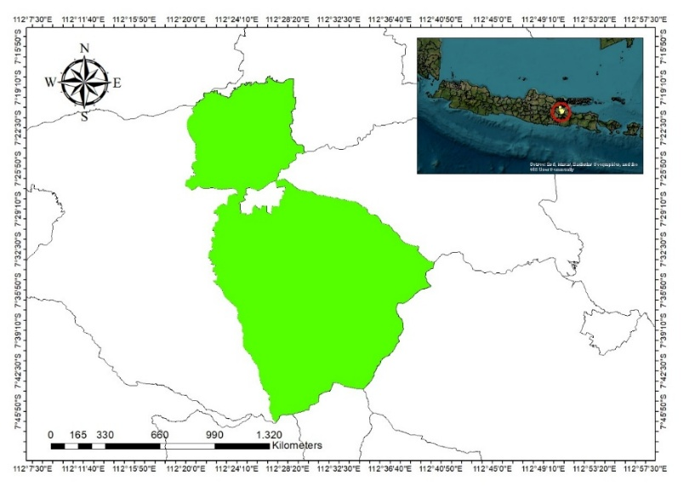
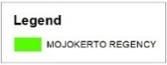
This research was conducted in Mojokerto Regency, East Java, Indonesia as shown in Figure 1, with a total area of 98,438.09 hectares. Astronomically, Mojokerto Regency is located between 111°20′13″ and 111°40′47″ East Longitude and between 7°18′35″ and 7°47′30″ South Latitude. The study area was selected due to the unavailability of a greenhouse gas (GHG) emissions baseline in Mojokerto Regency, even though such a baseline serves as a fundamental reference for formulating climate change mitigation strategies within a low-carbon development framework.
Figure 1. Study Area
- Data Collection
This study employed a mixed-methods approach that combines qualitative and quantitative techniques. Primary data were collected through in depth interviews with key informants and the distribution of questionnaires to expert respondents for the purposes of the AHP. The selection of informants and respondents was conducted using purposive sampling, whereby individuals were chosen based on their capacity, authority, and technical knowledge related to climate change issues and low-carbon development policies. This approach was intended to ensure substantive validity in identifying enabling and constraining factors, as well as in determining strategic priorities.
In depth interviews were conducted with four key informants representing institutions responsible for the implementation of low-carbon development in Mojokerto Regency. The selection of four informants was based on the principle of information adequacy in qualitative research, given the specific focus of the study and the fact that the selected informants held direct authority in policy planning and implementation.
Subsequently, pairwise comparison questionnaires within the AHP framework were distributed to nine expert respondents who hold strategic roles in low-carbon development. The inclusion of nine respondents is considered adequate in AHP studies, as the method emphasizes the quality and consistency of expert judgments rather than a large sample size (Ardhiansyah & Novani, 2022; A. Nugroho et al., 2023; R. E. Nugroho & Iskandar, 2020). The AHP literature indicates that a limited yet competent number of experts can generate stable weighting results, provided that the Consistency Ratio (CR) satisfies the required threshold. Accordingly, the validity of the results is determined more by respondent expertise than by a large sample size.
The expert respondents consisted of representatives from the East Java Provincial Government, the Mojokerto Regency Government, and academia with experience in development planning, environmental management, and climate change mitigation policy formulation. In general, the respondent profile included (1) structural and functional officials within local government agencies responsible for development planning and environmental affairs, (2) provincial officials involved in coordinating low-carbon development policies, and (3) academics with expertise in regional planning, environmental studies, or climate change. All selected experts possessed a minimum of three years of experience in planning or implementing policies related to climate change and low-carbon development. This criterion was established to ensure that the judgments provided were grounded in empirical experience, regulatory understanding, and direct involvement in policy formulation and implementation processes.
- Thematic Analysis
The analysis was conducted to identify enabling and constraining factors in the implementation of low-carbon development in Mojokerto Regency. A thematic analysis approach was employed, involving data familiarization, the generation of initial codes, theme construction and development, and theme definition.
The coding and theme development process was conducted systematically with the assistance of NVivo qualitative data analysis software to enhance auditability and ensure analytical consistency.
To ensure the validity and credibility of the analytical results, source triangulation was conducted by comparing information across informants from different institutions. To minimize subjective bias in data interpretation, the researchers internally discussed the emerging themes through a peer debriefing process.

- Analytical Hierarchy Process (AHP)
Data analysis was conducted using the Analytic Hierarchy Process (AHP) method developed by Thomas L. Saaty. This method was selected due to its capacity to address complex and unstructured multi-criteria decision-making problems. Problem-solving is carried out through the decomposition of the main issue into a linear hierarchical structure. The analytical process then proceeds with pairwise comparison assessments among elements at each level of the hierarchy in order to derive priority weights.
Pairwise comparison assessments refer to the Saaty Fundamental Scale (1–9) introduced by Thomas L. Saaty (1980). This scale converts respondents’ qualitative judgments into quantitative values to measure the relative importance of one element compared to its paired element. The details of the assessment scale are presented in Table 1.
Tabel 1. Skala Saaty
Numerical Values | Description | Penjelasan
1 | Equal importance of both elements | Two elements contribute equally
3 | Moderate importance of one element over another | Experience and judgement favour one element over another
5 | Strong importance of one element over another | An element is strongly favoured
7 | Very importance of one element over another | An element is very strongly favoured
9 | Extreme importance of one element over another | An element is favoured by at least order of magnitude
2, 4, 6, 8 | Intermediate values between two adjacent judgements | Used to compromise between two judgements

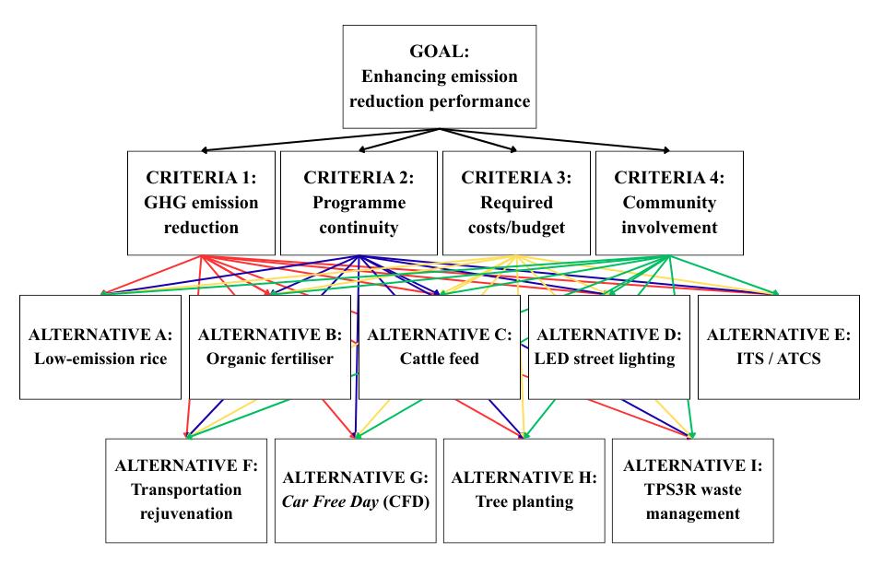
The hierarchical structure of this study consists of three main levels: (1) the primary goal, namely enhancing the effectiveness of low-carbon development in reducing greenhouse gas emissions; (2) evaluation criteria; and (3) alternative mitigation strategies. The evaluation criteria employed in this study encompass environmental, social, economic, and technical dimensions. The selection of these four criteria is based on the consideration that low-carbon development represents a sustainable development concept that requires the integration of ecological integrity, social welfare, economic feasibility, and technical readiness for implementation. Furthermore, previous studies applying AHP within the context of environmental and energy policy have adopted similar combinations of criteria to capture the complexity of decision-making processes (Ardhiansyah & Novani, 2022; A. Nugroho et al., 2023; R. E. Nugroho & Iskandar, 2020). Accordingly, these four criteria are deemed relevant and representative for evaluating strategic priorities in low-carbon development at the regional level. The alternative strategies within the AHP hierarchical structure were not determined unilaterally by the researchers; rather, they were formulated based on interview findings, documentation review of actions that have been and will be implemented in accordance with the regency’s authority, as well as expert input. This approach ensures that the selected alternatives reflect the empirical conditions and contextual needs of Mojokerto Regency. The visualization of the decision hierarchy structure is presented in Figure 2.
Figure 2. AHP Hierarchical Structure of the Study
The geometric mean was used to calculate the pairwise comparison weights from the nine expert respondents during the aggregation process. This is the standard way to combine group judgments in AHP. The use of the geometric mean aims to preserve the proportionality of ratios among elements and to avoid distortions that may arise when applying the arithmetic mean. The aggregated matrix was subsequently used to compute the eigenvector values, which represent the final priority weights at each level of the hierarchy.
The validation step was carried out through a consistency test of the comparison matrices. The validity of the weighting results was determined by the Consistency Ratio (CR) value. A CR value of ≤ 0.1 (10%) indicates that the respondents’ judgments are consistent and methodologically acceptable. If the CR value exceeds this tolerance threshold, the comparison matrix is re-evaluated to ensure logical consistency among the decision elements.

- Result and Discussion
  - Enabling Factors
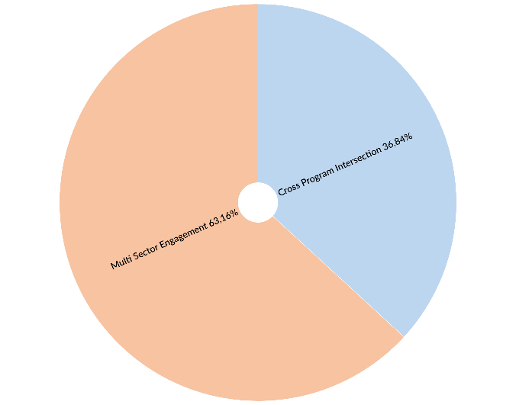
Based on the findings derived from in-depth interviews with the Regional Development Planning Agency, Environmental Agency, Department of Agriculture, and Department of Housing, Settlement Areas, and Transportation, several enabling factors were identified, as illustrated in Figure 3.
.
Figure 3. Enabling Factors for the Implementation of Low-Carbon Development
The findings indicate that the implementation of low-carbon development in Mojokerto Regency requires active engagement from multiple stakeholders. This result underscores that climate change mitigation at the local level represents a complex policy challenge, thereby necessitating a collaborative governance framework. As argued by (Mcnaught, 2024), cross-sectoral collaboration enhances policy capacity, which is reflected in the strengthening of inter-organizational networks, the achievement of policy consensus, and the improvement of policy development processes. Collaborative arrangements also help make climate action plans more effective by making them easier to create and carry out. This strengthens the long-term sustainability of mitigation and adaptation initiatives within the larger framework of climate and disaster resilience. Cross-sectoral collaboration is therefore a crucial enabling condition for enhancing the efficacy of climate change mitigation, as such efforts necessitate a holistic approach that includes governance frameworks, institutional capacity, community involvement, and thorough environmental management (Husein et al., 2025).
Accordingly, multi-stakeholder engagement in Mojokerto Regency can be understood as both social capital and institutional capital. The participation of non-governmental organizations (NGOs) helps make up for the local government agencies' lack of resources, while working together between different agencies improves the coordination needed for public programs and activities that cross different areas.
The second enabling factor is the alignment of low-carbon initiatives with other thematic programs. This programmatic overlap indicates that mitigation efforts at the local level are often operationalized through a mainstreaming strategy, whereby emission reduction objectives are integrated into more established development programs. This approach is particularly important, as local mitigation initiatives frequently face constraints related to budgetary support and sectoral prioritization. When mitigation objectives are embedded within other thematic programs such as health, sanitation, economic development, and food security the initiatives become more visible, more socially and politically acceptable, and more feasible in terms of financing.
This phenomenon is consistent with the study conducted by (Fernandez-guzman et al., 2023) which demonstrates that climate change mitigation generates co-benefits for public health. Furthermore, the statement put forward by the Department of Agriculture aligns with the findings of (Abd et al., 2024), which indicate that the addition of feed supplements in cattle production can enhance milk and meat yields, thereby supporting food security programs.
Programmatic alignment can be seen as a smart way to tackle climate change because it makes programs more credible, increases support from institutions, and creates various benefits that local governments and communities can directly enjoy.
In synthesis, the enabling factors of low-carbon development in Mojokerto Regency are anchored in two main aspects, strengthening institutional capacity through multi stakeholder engagement and mainstreaming mitigation strategies into regional thematic programs. These two factors not only enhance coordination effectiveness and implementation efficiency but also increase the likelihood of policy sustainability by generating co-benefits aligned with regional development needs. The findings indicate that successful mitigation at the local level does not depend solely on technical innovation but rather on the capacity for policy integration and the optimization of existing institutional support.

  - Constraining Factors
There are six factors constraining the implementation of low-carbon development in Mojokerto Regency, namely limited budget allocation, the absence of activity data, insufficient commitment from the regional leadership, the lack of established institutional arrangements, limited human resource capacity, and the absence of supporting regulations or policy frameworks, as illustrated in the Figure 4.
Figure 4. Constraining Factors for the Implementation of Low-Carbon Development
Conceptually, budgetary constraints indicate that low-carbon development has not yet been positioned as a strategic fiscal priority, but rather as an additional initiative that must compete with other sectoral programs. This condition is commonly observed within local government policy and program management systems, where a persistent gap exists between global climate agendas and local financing capacity.
Research conducted by (Lin et al., 2026) indicates that financing barriers in the clean energy transition in ASEAN are closely associated with funding gaps, policy uncertainty resulting from regulatory inconsistencies, as well as policy fragmentation and market design weaknesses, all of which simultaneously undermine investor confidence and constrain private capital inflows.
In addition, a study on the institutional design of climate finance conducted by (Bhandary, 2024) indicates that without robust financing structures and adequate institutional arrangements, implementation efforts are unlikely to be sustainable and tend to remain short-term, project-based initiatives.
In the context of low-carbon development policy, activity data constitute a key component of the Measurement, Reporting, and Verification (MRV) system. In the absence of reliable activity data, low-carbon development risks becoming merely a programmatic claim without quantitative evidence. This issue represents a significant barrier, as also identified in the study by (Perosa et al., 2023) on the development of MRV systems in the low-carbon agriculture sector, where the principal challenges include data availability, cross-institutional integration, and measurement reliability. Other studies further emphasize that MRV is not merely a technical procedure but rather a governance system that requires standardized methodologies, clear protocols, and sufficient institutional capacity to ensure that emission reductions can be accurately assessed (Thornbush & Govind, 2025).
The commitment of local political leadership constitutes a decisive factor in the successful implementation of low-carbon development, as regional leaders play a central role in setting policy priorities, mobilizing budgetary resources, and establishing cross-sectoral institutional arrangements. Insufficient leadership commitment prevents the low-carbon development agenda from evolving into a binding and institutionalized policy framework.
This finding is consistent with the study conducted by (Jannah et al., 2025) on the institutional dynamics of climate knowledge in rural Indonesia, which reveals a disconnect between global climate commitments and local realities in the study area, including political considerations and the priorities of local officials.
Institutional arrangements constitute the organizational framework required to ensure that mitigation programs possess cross-sectoral coordination structures, clearly defined roles, data reporting mechanisms, and accountability systems. In the absence of such institutional arrangements, low-carbon development efforts are likely to become fragmented. This condition aligns with the study conducted by (Hapsari et al., 2025), which emphasizes that climate-related challenges are not merely technical issues but rather problems of coordination and multi-level institutional governance.
Limited human resource capacity results in knowledge related to low-carbon development not being institutionalized as an organizational asset but rather remaining embedded within specific individuals. This condition creates systemic vulnerability, as mitigation-related systems tend to weaken when those individuals are reassigned or their responsibilities change.
Without a set of rules, low-carbon development lacks official legal support, causing agencies to be careful and not actively push forward climate change programs. Regulation serves as an instrument of legitimacy and governance stabilization in the implementation of low-carbon development. In the absence of a regulatory framework, sectoral agencies lack a formal obligation to provide data, institutional arrangements become difficult to establish, and budget allocations are challenging to sustain. This condition is consistent with the findings of (Lin et al., 2026), which indicate that fragmented regulations and weak policy frameworks hinder climate transition efforts and limit access to green financing at the regional level.
The analysis of enabling and constraining factors indicates that low-carbon development in Mojokerto Regency has not yet been fully institutionalized within the regional development system but rather remains at the level of programmatic adjustment or alignment, without integration into institutional structures, performance indicators, and budgetary frameworks. While aligning low-carbon development with other thematic programs such as health and economic growth may enhance political legitimacy (Fernandez-guzman et al., 2023), it does not necessarily guarantee increased budget allocation. This raises a critical question as to whether such alignment serves as a mechanism for strengthening mitigation efforts or instead renders mitigation subordinate to other development agendas. Meanwhile, limited human resource capacity and the lack of activity data suggest that mitigation implementation continues to face structural barriers of both an institutional and a technical nature.
  - Model Consistency Validation
The initial stage in interpreting the AHP results requires testing the logical validity of respondents’ judgments. Thomas L. Saaty established that human judgments are considered acceptable when the Consistency Ratio (CR) is less than or equal to 0.1 (CR ≤ 10%). This threshold indicates that respondents’ perceptions in assigning priority weights among elements are logically consistent and free from contradictory inconsistencies.
The results of the consistency ratio calculations for all pairwise comparison matrices in this study indicate an acceptable level of consistency. A detailed summary of the CR values for both the inter-criteria comparison matrices and the alternative comparison matrices under each criterion is presented in Table 2.
Tabel 2. Recap of CR Results
Comparison Matrix | CR Value | Validity Status
Main Matrix: Inter Criteria | 0,002 | Consistent
Alternative Matrix: Emission Reduction Criteria | 0,06 | Consistent
Alternative Matrix: Sustainability Criteria | 0,04 | Consistent
Alternative Matrix: Cost Criteria | 0,02 | Consistent
Alternative Matrix: Community Engagement Criteria | 0,02 | Consistent
  - Criteria Priority Analysis: Dominance of Social Aspects
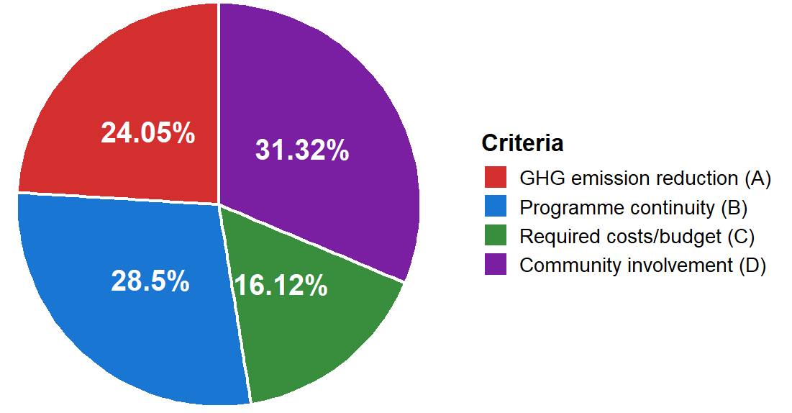
The results of the expert judgment synthesis regarding the criteria for determining mitigation strategies reveal an interesting pattern of preferences, as illustrated in Figure 5. The highest priority within the decision hierarchy is assigned to the Community Engagement criterion, with the greatest weight of 31,32%. The second position is occupied by Program Sustainability (28,50%), followed by Emission Reduction Potential (24,05%). The Implementation Cost criterion ranks last, with a weight of 16,11%. This distribution of weights visualizes the hierarchy of importance upheld by the experts in formulating mitigation strategies.
Figure 5. Percentage of Priority Criteria
The dominance of the Community Engagement criterion indicates a paradigm shift in regional development from a purely technocratic approach toward a more participatory framework. The experts consider that the effectiveness of greenhouse gas emission reduction in Mojokerto Regency is highly dependent on social acceptance and behavioral change among citizens (Lennon et al., 2019; Menegatto et al., 2025). Studies have shown that technologically advanced mitigation programs with minimal public involvement such as rigid communal waste management systems tend to fail or lack long-term sustainability. The high weighting assigned to this criterion underscores that social legitimacy is regarded as the most critical asset in the execution of environmental policy (Cheng et al., 2019; Nielsen et al., 2022).
The program sustainability criterion, ranked second, reinforces the argument that policy orientation has shifted toward long term impacts. Respondents tend to avoid instant solutions that merely generate short term effects (one off projects). This sustainability dimension is closely associated with a program’s capacity to operate independently once government budgetary intervention has ended (Dushkova et al., 2025; Dushkova & Ivlieva, 2024). It is positively correlated with the Emission Reduction criterion in third place, indicating that the technical target of reducing CO₂ equivalent emissions remains a primary performance indicator; however, its achievement must be pursued through participatory and sustainable mechanisms (Novaes, 2025; Sebunya & Gichuki, 2024).
The placement of the Implementation Cost criterion at the lowest priority level provides strategic insight into the region’s resource readiness. The relatively low weight assigned to cost does not imply that budget efficiency is disregarded; rather, it signals the willingness of the Mojokerto Regency Government to allocate greater financial resources to programs that promise broad social impacts and high sustainability (Prastika & Candradewi, 2019; Supriono & Efendi, 2024). Decision-makers no longer regard the “lowest cost” as the sole determinant of project feasibility but instead prioritize the benefit-to-impact ratio in terms of long term value for money (Yasmi et al., 2023).
  - Evaluation of Strategy Alternatives Based on Criteria
A comprehensive evaluation of the alternative mitigation strategies was conducted by synthesising expert judgements based on the four main criteria that had been previously weighted. The data analysis reveals significant variations in preferences across each criterion, reflecting the complexity of emission reduction challenges in Mojokerto Regency. The percentage priorities assigned to each alternative within each criterion dimension are presented in Figure 6.
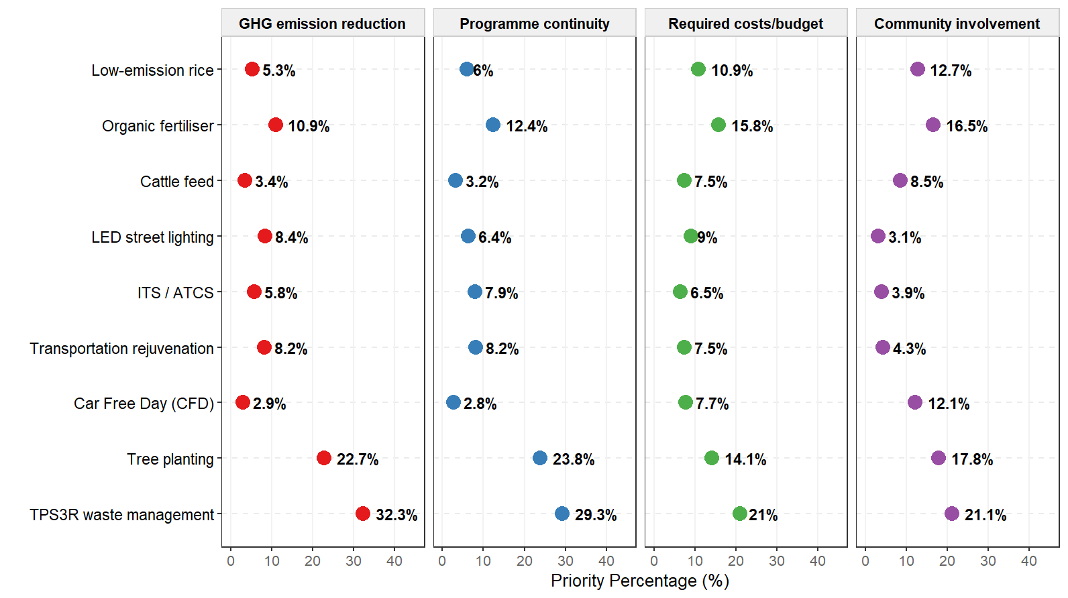
Figure 6. Percentage of Priority for Each Criteria
The dominance of the social dimension is clearly reflected in the Community Engagement criterion, which holds the highest global weight of 31,32% within the hierarchical structure. Expert preferences under this criterion identify waste management through reduce reuse recycle based community waste processing facilities (TPS3R) as the top priority, achieving a score of 21,1%. The second position is occupied by tree planting (17,8%), followed by the use of organic fertilizers (16,5%). The high scores assigned to these three alternatives indicate that community-based strategies are perceived as more capable of accommodating active public participation compared to purely technical solutions (Irwan et al., 2025; Muhtadi et al., 2025). In contrast, technology-intensive and centralized alternatives such as the use of LED lighting for public street lighting and the implementation of Intelligent Transportation Systems (ITS) or Area Traffic Control Systems (ATCS) receive the lowest levels of attention, with scores of 3.1% and 3.9%, respectively. These findings underscore that the social legitimacy of mitigation programs in Mojokerto Regency is highly dependent on the extent to which participatory spaces are provided for communities during the implementation phase.
The subsequent analysis focuses on the program sustainability criterion, which carries an influence weight of 28,5%. The data reveal a linear pattern in which waste management through TPS3R once again ranks first, achieving a score of 29,3%. This advantage is followed by tree planting, which attains a score of 23,8%. The experts consider that both strategies possess long program life cycles and cumulative environmental impacts (Fidyariska et al., 2025; Sarahswati & Wedagama, 2025). In contrast, the Car-Free Day (CFD) initiative receives the lowest assessment in terms of sustainability, with a score of only 2,8%. This low rating suggests a perception that ceremonial or event-based activities are less capable of ensuring the long-term continuity of impacts required within the framework of regional low-carbon development (Glazener et al., 2022; Wahyudin et al., 2021).
The environmental technical perspective, reflected in the Greenhouse Gas Emission Reduction criterion with a weight of 24,05%, demonstrates a strong expert consensus converging on the waste management sector. Waste processing through TPS3R overwhelmingly dominates the assessment, achieving a score of 32,3%, significantly outperforming all other alternatives. Tree planting ranks second with a score of 22,7%, contributing to CO₂ sequestration throughout the life cycle of the trees and generating cumulative emission reductions, while the remaining alternatives fall considerably below ten percent (Pataki et al., 2021). These findings reflect the urgency of addressing methane emissions from the waste sector, which is perceived to offer the largest and most measurable emission reduction potential compared to the transportation or agricultural sectors within the study area. The transportation sector represented by alternatives such as public transport fleet renewal and the use of LED street lighting is considered to provide comparatively less substantial emission reduction impacts (Liang et al., 2025).
The economic dimension, represented by the cost or budget criterion with a weight of 16,12%, reveals an interesting preference pattern regarding budget efficiency. Waste management through TPS3R is assessed as having the highest cost efficiency, achieving a score of 21%. This evaluation is followed by the use of organic fertilizers (15,8%) and tree planting (14,1%). The relatively high preference for these three alternatives suggests that nature-based and circular economy strategies are perceived to offer a more optimal cost–benefit ratio compared to technology-intensive infrastructure investments (Akaravarothai et al., 2025; Jara-Samaniego et al., 2017). In contrast, the capital-intensive ITS/ATCS alternative receives only 6,4% budget priority, indicating that high-technology investments are not currently viewed as fiscally efficient options.
  - Priority Synthesis
The calculation of global weights, integrating the preference values of the criteria with the performance evaluation of the alternatives, produces a comprehensive ranking of mitigation strategy priorities for Mojokerto Regency, as presented in Table 3.
Table 3. Low-Carbon Development Strategy Priorities
Priority | Code | Low-Carbon Development Strategy Alternative | Global Weight
1 | I | TPS3R Waste Management | 26,12%
2 | H | Tree Planting | 20,09%
3 | B | Organic Fertilizer | 13,88%
4 | A | Low Emission Rice | 8,72%
5 | F | Transportation Rejuvenation | 6,86%
6 | G | Car Free Day (CFD) | 6,50%
7 | D | LED Street Lighting | 6,28%
8 | E | ITS/ATCS | 5,92%
9 | C | Cattle Feed | 5,59%

The final synthesis results position waste management through TPS3R as the highest priority mitigation strategy, with a global weight of 26,12%. The second strategic position is occupied by tree planting, with a global weight of 20,09%, followed by the use of organic fertilizers in third place at 13,88%. The cumulative weight of these three top ranked strategies reaches a dominant share of 60,09% of the overall decision preferences, indicating a convergence of expert opinion toward ecosystem based and community empowerment oriented mitigation solutions.
The significant advantage of waste management through TPS3R within the decision hierarchy reflects a strong alignment between the characteristics of this strategy and the priority criteria of regional development, which emphasize community engagement and sustainability. This strategy is considered capable of addressing multidimensional challenges simultaneously, namely effectively reducing methane emissions from waste generation, empowering the community through circular economy practices, and maintaining adequate budget efficiency (Astiti et al., 2025). The positioning of tree planting and the use of organic fertilizers within the top priority cluster further reinforces the direction of regional mitigation policy toward improving environmental quality through participatory, nature-based approaches, commonly referred to as Nature-based Solutions (NbS) (Badagliacca et al., 2024).
The medium priority cluster is represented by the strategy of using low emission rice varieties, with a weight of 8,72%. Research indicates that newly developed rice varieties and irrigation techniques such as alternate wetting and drying (AWD) can reduce methane emissions by up to 40% while simultaneously increasing crop yields, thereby supporting low carbon agriculture objectives (Xuan et al., 2025). Transportation rejuvenation alternative receives a score of 6,86% and is considered important for transforming the public transportation sector to reduce carbon emissions, although its urgency remains moderate compared to the agricultural and environmental sectors (Khatri-chhetri et al., 2021). CFD initiative attains a score of 6,50%, reflecting its effectiveness as a public health campaign and an instrument for raising environmental awareness. However, its impact on pollution reduction and long term environmental sustainability is relatively limited (Glazener et al., 2022). Strategies within this cluster are regarded as moderately urgent yet still necessary to support the diversification of mitigation actions. The mid ranking position of Public Transport Fleet Renewal suggests that the transformation of the public transportation sector is viewed as important but not yet sufficiently pressing to dominate the allocation of primary resources compared to the urgency of waste management and urban greening initiatives.
The lowest priority strategies include the use of LED lighting for public street lighting (6,28%), the implementation of Intelligent Transportation Systems (ITS/ATCS) at 5,92%, and the use of cattle feed supplements at 5,59%. The relatively low ranking of technology-intensive strategies such as ITS/ATCS and LED lighting confirms earlier findings that capital intensive solutions with limited social dimensions receive lower preference within the current sociological context of Mojokerto Regency. The implementation of smart technologies appears to be positioned as a long term objective that requires adequate basic infrastructure readiness and greater societal behavioral maturity before being prioritized as a central mitigation focus (Niamir et al., 2024; Zhou et al., 2024).
  - Managerial Implication and Implementation Plan
The findings of this study provide significant managerial implications for the Mojokerto Regency Government in formulating low carbon development policies. The dominance of community based strategies comprising TPS3R waste management, tree planting, and the use of organic fertilizers collectively accounts for 60,09% of the total priority weight. These data call for a fundamental policy reorientation from a predominantly infrastructure-based (hard approach) toward a social empowerment oriented (soft approach) strategy. The principal implication is that the success of emission reduction efforts should no longer be measured solely by the sophistication of the technologies adopted but rather by the extent to which community participation is effectively integrated into each mitigation strategy. In this context, community engagement must be recognized as a valuable asset in program implementation (Gunawan, 2025; Øjvind Nielsen et al., 2024).
The first ranked position of waste management through TPS3R, with a global weight of 26,12%, calls for short term policy prioritization over the next one to two years to be aggressively directed toward revitalizing waste management systems. Managerially, the relevant sectoral agencies should not focus solely on the physical construction of TPS3R facilities but must reallocate resources toward operational financing and managerial training for non-governmental organizations (NGOs) involved in implementation. The local government should also issue supporting regulations mandating the absorption of recycled products generated by TPS3R facilities such as compost and maggot based feed by villages, alongside fiscal incentives for villages that successfully reduce waste sent to landfills through independent waste segregation. Such measures would contribute to methane emission reductions and alleviate landfill capacity constraints (Astiti et al., 2025; Irawansyah et al., 2025).
The high priority assigned to tree planting and organic agriculture implies the need to integrate NbS more seriously into regional spatial planning. Tree adoption programs that incorporate periodic maintenance incentives can improve plant survival rates compared to ceremonial planting initiatives while simultaneously strengthening local community engagement (Barrios et al., 2025; Seddon et al., 2021). The reallocation of agricultural subsidies from chemical fertilizers to organic fertilizers supports greater cost efficiency and sustainability impacts while also enhancing cross sectoral synergies through the conversion of organic waste into compost, which sustains local agricultural productivity within a closed loop system (McPhearson et al., 2025; Nassary et al., 2022). The planning and implementation of NbS must take into account local contexts, inclusivity, and cross sectoral collaboration in order to optimize long term social and ecological benefits (Albert et al., 2021; Kabisch et al., 2022). This approach also requires strengthened governance mechanisms that promote active participation of communities and stakeholders to ensure that NbS deliver equitable and durable outcomes (Dushkova & Haase, 2020; Seddon et al., 2021).
The low priority given to high technology strategies such as ITS/ATCS and LED public street lighting clearly signals policymakers to pursue efficiency measures or postpone capital intensive technological expenditures. From a managerial perspective, these infrastructure modernization strategies should be positioned as long term plans extending beyond five years, pending improved regional fiscal readiness and greater maturity in public traffic behavior (Alvarez et al., 2022; Gagliardi et al., 2020). Budget allocations initially earmarked for advanced transportation technologies may be reallocated (refocused) to support community empowerment programs that have demonstrated more immediate and substantial impacts on emission reduction and social welfare (Bachanek et al., 2021; Elassy et al., 2024; Gagliardi et al., 2020).
The overall implementation roadmap in Mojokerto Regency can be designed in a phased manner, beginning with a foundational social phase focused on the execution of waste management and urban greening strategies. Once environmental awareness has been strengthened, the subsequent phase may target the transition of the transportation sector through public transport fleet renewal before eventually progressing to the modernization of smart infrastructure. This synthesis underscores that social legitimacy constitutes the most critical asset that must be prioritized before advancing toward more complex technocratic solutions.
- Conclusions
The effectiveness of low-carbon development in Mojokerto Regency is determined not only by technical aspects but is also strongly influenced by governance quality, data availability, institutional capacity, and political commitment, which at present remain insufficient to drive a substantial transformation toward significant emission reductions. Nevertheless, the potential for cross program synergies and multi stakeholder partnerships represents a strategic opportunity to enhance the effectiveness of low-carbon development in Mojokerto Regency. Such efforts are proven to be most optimal when adopting a participatory approach that positions the community as a primary asset. The priority analysis identifies waste management through TPS3R as the leading strategy, followed by tree planting and the use of organic fertilizers, which are considered to generate direct economic benefits for local residents. These three community-based solutions collectively account for 60% of overall decision preferences, surpassing costly technological options such as ITS/ATCS, which are not yet perceived as efficient under current conditions. This finding indicates the urgency of reallocating budget priorities from high-technology capital expenditures toward social and environmental empowerment programs. The local government is therefore advised to strengthen independent waste management systems and urban greening initiatives before advancing toward more complex infrastructure modernization. Theoretically, this study illustrates the value of integrating governance considerations and stakeholder preferences in multi criteria decision making at the subnational level through the combination of thematic analysis and AHP. Although limited to a single case study and a relatively small number of experts, this research opens avenues for further investigation through comparative inter regional studies as well as integration with emission scenario modeling and cost effectiveness analysis to strengthen the foundation for long term policy formulation.
Acknowledgement
The authors would like to thank the Mojokerto Regency Government for their support, collaboration and valuable contributions in providing the data essential for this study. Appreciation is also extended to the Graduate School of Universitas Brawijaya for its guidance, academic supervision, and research facilitation throughout the completion of this research.
Credit Author Statement
Authors must include a responsibility statement in their manuscripts, even for review-type articles, detailing each contributor's role. The required level of detail may differ: in some disciplines, contributions are distinct and easily outlined, while in others, collaboration occurs collectively across all stages of the process.

Author 1: Fariz Basyiruddin
√ | Conceived and designed the analysis  Specify contribution in more detail (optional; no more than one sentence)
√ | Collected the data  Specify contribution in more detail (optional; no more than one sentence)
√ | Contributed data or analysis tools  Specify contribution in more detail (optional; no more than one sentence)
√ | Performed the analysis  Specify contribution in more detail (optional; no more than one sentence)
√ | Wrote the paper  Specify contribution in more detail (optional; no more than one sentence)
☐ | Other contribution  Specify contribution in more detail (required; no more than one sentence)

Author 2: Arief Rachmansyah
√ | Conceived and designed the analysis  Specify contribution in more detail (optional; no more than one sentence)
☐ | Collected the data  Specify contribution in more detail (optional; no more than one sentence)
☐ | Contributed data or analysis tools  Specify contribution in more detail (optional; no more than one sentence)
√ | Performed the analysis  Specify contribution in more detail (optional; no more than one sentence)
√ | Wrote the paper  Specify contribution in more detail (optional; no more than one sentence)
☐ | Other contribution  Specify contribution in more detail (required; no more than one sentence)

Author 3: Bunga Hidayati
√ | Conceived and designed the analysis  Specify contribution in more detail (optional; no more than one sentence)
☐ | Collected the data  Specify contribution in more detail (optional; no more than one sentence)
☐ | Contributed data or analysis tools  Specify contribution in more detail (optional; no more than one sentence)
√ | Performed the analysis  Specify contribution in more detail (optional; no more than one sentence)
√ | Wrote the paper  Specify contribution in more detail (optional; no more than one sentence)
☐ | Other contribution  Specify contribution in more detail (required; no more than one sentence)

Author 4: Reny Tiarantika
☐ | Conceived and designed the analysis  Specify contribution in more detail (optional; no more than one sentence)
☐ | Collected the data  Specify contribution in more detail (optional; no more than one sentence)
☐ | Contributed data or analysis tools  Specify contribution in more detail (optional; no more than one sentence)
√ | Performed the analysis  Specify contribution in more detail (optional; no more than one sentence)
√ | Wrote the paper  Specify contribution in more detail (optional; no more than one sentence)
☐ | Other contribution  Specify contribution in more detail (required; no more than one sentence)

Author 5: Naziatul Aziah Mohd Radzi
☐ | Conceived and designed the analysis  Specify contribution in more detail (optional; no more than one sentence)
☐ | Collected the data  Specify contribution in more detail (optional; no more than one sentence)
☐ | Contributed data or analysis tools  Specify contribution in more detail (optional; no more than one sentence)
☐ | Performed the analysis  Specify contribution in more detail (optional; no more than one sentence)
√ | Wrote the paper  Specify contribution in more detail (optional; no more than one sentence)
☐ | Other contribution  Specify contribution in more detail (required; no more than one sentence)
References
Abd, A. M., Tawab, E., Liu, Q., Xu, G., & Han, X. (2024). Feed additives strategies to control methanogenesis in ruminants , Review. 90–125. https://doi.org/10.2478/azibna-2024-0017
Akaravarothai, A., Dansawad, N., Jitrabiab, P., Boruah, I., & Chetia, R. (2025). Economic Value-Added Innovative Management of Leaf Waste in Green Areas of Government Agencies , Bangkok , Thailand. Sustainability, 1–15.
Albert, C., Brillinger, M., Guerrero, P., Gottwald, S., Henze, J., Schmidt, S., Ott, E., & Schröter, B. (2021). Planning nature-based solutions: Principles, steps, and insights. Ambio, 50(8), 1446–1461. https://doi.org/10.1007/s13280-020-01365-1
Alvarez, R., Duarte, F., Frenchman, D., & Ratti, C. (2022). Sensing Lights: The Challenges of Transforming Street Lights into an Urban Intelligence Platform. Journal of Urban Technology, 29(4), 25–40. https://doi.org/10.1080/10630732.2022.2082825
Ardhiansyah, B. N., & Novani, S. (2022). Decision Making in Determining the Best Field Development Scenario using Analytical Hierarchy Process (AHP): Case Study of SANDHIGH Field. Global Journal of Management and Business Research: G Interdisciplinary, 22(1), 27–33.
Astiti, N. P. D. S., Frandika, P. K. T., Suwardika, W., Adileo, M. R., & Susena, P. M. A. (2025). Organic Waste Processing Based on A Circular Economy as an Environmentally Friendly Solution. Wicaksana: Jurnal Lingkungan Dan Pembangunan, 9(1), 1–10.
Bachanek, K. H., Tundys, B., Wiśniewski, T., Puzio, E., & Maroušková, A. (2021). Intelligent street lighting in a smart city concepts—a direction to energy saving in cities: An overview and case study. Energies, 14(11), 1–19. https://doi.org/10.3390/en14113018
Badagliacca, G., Testa, G., Giovanni, S., Malfa, L., Cafaro, V., Presti, E. Lo, & Monti, M. (2024). Organic Fertilizers and Bio-Waste for Sustainable Soil Management to Support Crops and Control Greenhouse Gas Emissions in Mediterranean Agroecosystems : A Review. Horticulturae, 10(427), 1–13.
Barrios, L., Arnott, D., Thompson, R., & Marchant, R. (2025). Archetypes of nature-based solutions for farming in the North York Moors National Park. Ecological Solutions and Evidence, 6(1), 1–14. https://doi.org/10.1002/2688-8319.70003
Bhandary, R. R. (2024). The role of institutional design in mobilizing climate finance : Empirical evidence from. 1–16. https://doi.org/10.1371/journal.pclm.0000246
Cheng, T., Wu, H. C., Wang, J. T., & Wu, M. (2019). Community Participation as a mediating factor on residents ’ attitudes towards sustainable tourism development and their personal environmentally responsible behaviour. 22(14), 1764–1782.
Dushkova, D., & Haase, D. (2020). Not simply green: Nature-based solutions as a concept and practical approach for sustainability studies and planning agendas in cities. Land, 9(1). https://doi.org/10.3390/land9010019
Dushkova, D., & Ivlieva, O. (2024). Empowering Communities to Act for a Change : A Review of the Community Empowerment Programs towards Sustainability and Resilience.
Dushkova, D., Ivlieva, O., Pouget, C., & Vandewalle, M. (2025). How to support communities in the long-term sustainability transition : The tailored empowerment program. 7(1). https://doi.org/10.2166/bgs.2025.049
Elassy, M., Al-Hattab, M., Takruri, M., & Badawi, S. (2024). Intelligent transportation systems for sustainable smart cities. Transportation Engineering, 16(December 2023), 100252. https://doi.org/10.1016/j.treng.2024.100252
Fahmi, Y. (2025). Renewable energy development towards indonesia ’ s energy transition : Technological innovations for a sustainable future. 2(2), 95–109.
Fernandez-guzman, D., Lavarello, R., Yglesias-gonzález, M., Hartinger, S. M., & Rojas-rueda, D. (2023). Series A scoping review of the health co-bene fi ts of climate mitigation strategies in South America. The Lancet Regional Health - Americas, 100602. https://doi.org/10.1016/j.lana.2023.100602
Fidyariska, P. J., P, K. W. S. P., & Lasmi, N. W. (2025). Integrating sustainability values through a workshop on utilizing environmentally friendly materials at SDN 6 Padangsambian Klod as a waste management solution. Penamas: Journal of Community Service, 5(1), 103–110.
Gagliardi, G., Lupia, M., Cario, G., Tedesco, F., Gaccio, F. C., Lo Scudo, F., & Casavola, A. (2020). Advanced adaptive street lighting systems for smart cities. Smart Cities, 3(4), 1495–1512. https://doi.org/10.3390/smartcities3040071
Glazener, A., Wylie, J., Waas, W. Van, & Khreis, H. (2022). The Impacts of Car-Free Days and Events on the Environment and Human Health. Current Environmental Health Reports, 165–182. https://doi.org/10.1007/s40572-022-00342-y
Gunawan, A. (2025). Collaborative Governance in Urban Waste Management: Policy Evaluation of Malang City in the Post-Pandemic SDGs Era. Pangripta, 8(1), 73–85. https://doi.org/10.58411/qbxhb898
Handayani, A. (2021). Local government response to the impacts of climate change: A review of climate change strategies in Pekalongan, Central Java, Indonesia. IOP Conference Series: Earth and Environmental Science, 724(1), 12088.
Hapsari, I., Putri, S., Handayani, W., Agung, F., Ichihara, J., Anggraeni, M., Setiadi, R., & Sudarno, S. (2025). Urban Governance Examination of barriers to climate change adaptation : Experience from Semarang city , – Indonesia. Urban Governance, 5(3), 314–330. https://doi.org/10.1016/j.ugj.2025.08.005
Hardyanti, N., Samadikun, B. P., Saputri, A. R., & Yuwono, A. P. (2022). Greenhouse Gas Emission Reduction Strategies in the Transportation and Solid Waste Sector in Cilacap Regency. Jurnal Presipitasi: Media Komunikasi Dan Pengembangan Teknik Lingkungan, 19(2), 239–250.
Huboyo, H. S., Hardyanti, N., Durrotunnisa, I. M., Amani, I. H., & Febriana, T. F. (2024). Greenhouse Gas Emission Reduction Strategies in the Transportation, Waste, and Domestic Sectors. Jurnal Presipitasi: Media Komunikasi Dan Pengembangan Teknik Lingkungan, 21(2), 504–512.
Husein, R., Hanif, N. A., & Bulaybulay, R. L. (2025). Climate Change Mitigation for Sustainable Development in Yogyakarta. IOP Conference Series: Earth and Environmental Science, 1475(1). https://doi.org/10.1088/1755-1315/1475/1/012012
Irawansyah, A., Ani Agus Puspawati, & Prihantika, I. (2025). Governance Community Empowerment Through the EMAK.ID Waste Bank Program in Bandar Lampung City. Journal Governance Bureaucratic Review, 2(1), 56–65. https://doi.org/10.31629/jgbr.v2i1.7472
Irwan, S. N. R., Yuwono, N. W., Utami, R. N., & Ilmiah, H. H. (2025). Peningkatan Kapasitas Masyarakat melalui Pengolahan Limbah Organik untuk Pupuk Tanaman di Pekarangan Perkotaan ( Community Capacity Building through Treatment of Organic Waste for Plant Fertilizer at Urban Home Garden “ Pekarangan ” ). Agrokreatif Jurnal Ilmiah Pengabdian Kepada Masyarakat, 9(2), 164–172.
Jannah, R., Kolopaking, L. M., Adiwibowo, S., & Maarif, S. (2025). Global climate commitments and local disconnect : Imagining climate change through Indonesia ’ s community climate program. Global Transitions, 7, 387–402. https://doi.org/10.1016/j.glt.2025.06.008
Jara-Samaniego, J., Perez-Murcia, M. D., Bustamante, M. A., Paredes, C., Perez-Espinosa, A., Gavilanes-Teran, I., Lopez, M., Marhuenda-Egea, F. C., Brito, H., & Moral, R. (2017). Development of organic fertilizers from food market waste and urban gardening by composting in Ecuador. PLoS ONE, 1–17.
Kabisch, N., Frantzeskaki, N., & Hansen, R. (2022). Principles for urban nature-based solutions. Ambio, 51(6), 1388–1401. https://doi.org/10.1007/s13280-021-01685-w
Kartikasari, K., Anggraini, S. D., & Suharto, A. (2019). Challenges in Development of Mitigation Options: A Case of Bogor City. IOP Conference Series: Earth and Environmental Science, 363(1). https://doi.org/10.1088/1755-1315/363/1/012015
Khatri-chhetri, A., Sapkota, T. B., Sander, B. O., Arango, J., & Nelson, K. M. (2021). Financing climate change mitigation in agriculture : assessment of investment cases OPEN ACCESS Financing climate change mitigation in agriculture : assessment of investment cases. Environmental Research Letters, 16, 1–18.
Lennon, B., Dunphy, N. P., & Sanvicente, E. (2019). Community acceptability and the energy transition : a citizens ’ perspective.
Liang, J., Himes, A., & Siegert, C. (2025). A meta-analysis of afforestation impacts on soil greenhouse gas emissions. Journal of Environmental Management, 386(April), 125709. https://doi.org/10.1016/j.jenvman.2025.125709
Lin, O. Z., Juchelkova, D., Stepanec, L., Aye, H. Y., & Adam, K. B. (2026). Bridging the Energy Gap in ASEAN : Scaling Green Finance and Carbon Markets for a Sustainable Transition. 1–20. https://doi.org/10.1002/wene.70020
Mcnaught, R. (2024). The application of collaborative governance in local level climate and disaster resilient development – A global review. 151(July 2023).
McPhearson, T., Frantzeskaki, N., Ossola, A., Diep, L., Anderson, P. M. L., Blatch, T., Collier, M. J., Cook, E. M., Fatti, C. C., Grabowski, Z. J., Grimm, N. B., Haase, D., Cantis, P. H., Kavonic, J., Lin, B. B., Meneses, D. H. L., Matsler, A. M., Moglia, M., Morató, J., … Zhou, W. (2025). Global synthesis and regional insights for mainstreaming urban nature- based solutions. Proceedings of the National Academy of Sciences, 122(29), 1–10. https://doi.org/10.1073/pnas
Menegatto, M., Bobbio, A., Freschi, G., & Zamperini, A. (2025). The Social Acceptance of Renewable Energy Communities : The Role of Socio-Political Control and Impure Altruism. 1–19.
Muhtadi, M. F., Maolida, S., Corinningtyas, S., Qonita, A. D., Ayu, A. S., Kurniani, Y. I., Azman, M. K., Hakim, H., & Hanif, M. (2025). Empowering the Bonosari Village Community in Household Waste Management Through Organic Fertilizer Production Workshops. Interdisciplinary Journal of Social Science and Education, 3(2), 81–94.
Nassary, E. K., Msomba, B. H., Masele, W. E., Ndaki, P. M., & Kahangwa, C. A. (2022). Exploring urban green packages as part of Nature-based Solutions for climate change adaptation measures in rapidly growing cities of the Global South. Journal of Environmental Management, 310(January), 114786. https://doi.org/10.1016/j.jenvman.2022.114786
Niamir, L., Verdolini, E., & Nemet, G. F. (2024). Social innovation enablers to unlock a low energy demand future OPEN ACCESS. Environmental Research Letters, 19.
Nielsen, J. A. E., Stavrianakis, K., & Morrison, Z. (2022). Community acceptance and social impacts of carbon capture , utilization and storage projects : A systematic meta-narrative literature review. https://doi.org/10.1371/journal.pone.0272409
Nugroho, A., Zm, A. A., & Winardi, B. (2023). Integration of AHP method in best employee selection : a multi-criteria decision analysis approach for decision making. 12(2), 40–45.
Nugroho, R. E., & Iskandar, M. S. (2020). Application of AHP for Supplier Selection in Construction Companies. 6272, 179–186. https://doi.org/10.36348/sjet.2020.v05i04.008
Øjvind Nielsen, R., Sørensen, E., & Torfing, J. (2024). Drivers of collaborative governance for the green transition. Public Management Review, 26(12), 3715–3740. https://doi.org/10.1080/14719037.2024.2358321
Pataki, D. E., Alberti, M., Cadenasso, M. L., Felson, A. J., Mcdonnell, M. J., Pincetl, S., Pouyat, R. V, Setälä, H., & Whitlow, T. H. (2021). The Benefits and Limits of Urban Tree Planting for Environmental and Human Health. Frontiers in Ecology and Evolution, 9(April), 1–9. https://doi.org/10.3389/fevo.2021.603757
Perosa, B., Newton, P., & Felipe, R. (2023). A monitoring , reporting and verification system for low carbon agriculture : A case study from Brazil. Environmental Science and Policy, 140(December 2022), 286–296. https://doi.org/10.1016/j.envsci.2022.12.006
Prastika, N. P. Y., & Candradewi, M. R. (2019). Pengaruh Profitabilitas, Struktur Aktiva, dan Likuiditas Terhadap Struktur Modal Perusahaan Subsektor Konstruksi Bangunan di BEI. E-Jurnal Manajemen, 8(7), 4444–4473.
Samadikun, B. P., Hardyanti, N., Wijayanti, D., & Sa’adah, Z. (2022). Planning of Conventional Air Emission Reduction Strategy from the Transportation, Domestic, and Solid Waste Sector in Salatiga City. Jurnal Presipitasi : Media Komunikasi Dan Pengembangan Teknik Lingkungan, 19(2), 262–270. https://doi.org/10.14710/presipitasi.v19i2.262-270
Sarahswati, M. D. K., & Wedagama, D. A. T. A. (2025). Integration of urban farming and waste management in realizing a sustainable environment in Dauh Puri Kaja Village. Penamas: Journal of Community Service, 5(1), 121–128.
Sebunya, J., & Gichuki, A. (2024). The Impact of Participatory Planning on Sustainable Development : A Literature Review. 4(4), 1–9.
Seddon, N., Smith, A., Smith, P., Key, I., Chausson, A., Girardin, C., House, J., Srivastava, S., & Turner, B. (2021). Getting the message right on nature-based solutions to climate change. Global Change Biology, 27(8), 1518–1546. https://doi.org/10.1111/gcb.15513
Supriono, R. E., & Efendi, M. A. B. (2024). Manajemen Pengendalian Waktu dan Biaya pada Proyek Daerah Irigasi Saluran Primer Ketonggo dengan Menggunakan Metode PERT. Jurnal Ilmiah Ilmu : Ilmu Teknologi, 9(September), 22–46.
Thornbush, M., & Govind, A. (2025). Monitoring , Reporting , and Verification ( MRV ) Protocols Used in Carbon Trading Applied to Dryland Nations in the Global South for Climate Change Mitigation. 1–24.
Wahyudin, D., Widianingsih, I., & Abdullah, O. A. (2021). Interorganizational Coordination On Car Free Day For Low Carbon Transportation. Jurnal Reformasi Administrasi : Jurnal Ilmiah Untuk Mewujudkan Masyarakat Madani, 8(2), 120–129.
Xuan, T. D., Thi, T., Minh, N., Rayee, R., Duy, N., Nguyen, D., & Chien, X. (2025). Advances in mitigating methane emissions from rice cultivation : past , present , and future strategies. Environmental Science and Pollution Research, 32(34), 20232–20247. https://doi.org/10.1007/s11356-025-36776-8
Zhou, S., Chen, J., Teng, S., Zhang, H., Wang, F., Chen, J., Teng, S., Zhang, H., & Wang, F. (2024). Integrating Sustainability in Future Traffic Lighting: Designing Efficient Light Systems for Vehicle, Road, and Traffic. IEEE Transactions on Intelligent Vehicles, 9(1), 65–68.

Author’s checklist for manuscript submission

Important note:

a) The corresponding author is kindly advised to read this document carefully and fill this checklist on behalf of the co-authors and return it to the guest editors.

b) Kindly place a tick mark (√ meaning YES) or a cross mark (× meaning NO) in each row in order to confirm the approval/denial of the checklist.

c) Do not leave any box unanswered. This checklist will take at least 4-5 hours to complete and we encourage all the authors to check the manuscript carefully before answering the items specified with a √ or × sign.

d) The authors are advised to strictly follow the author guidelines of the journal and also the guidelines provided in the checklist by the guest editors.

e) Please provide the following details:

Manuscript title: Improving Low Carbon Development Performance through Multi Criteria Decision Analysis: A Case Study of Mojokerto Regency

Author(s): Fariz Basyiruddin, Arief Rachmansyah, Bunga Hidayati, Reny Tiarantika, Naziatul Aziah Mohd Radzi

Corresponding author: Fariz Basyiruddin

Email of the corresponding author: farizbasy15@gmail.com

CHECK LIST

Aspects to be carefully considered while preparing the manuscript | Indicate your response (√ or ×)
1) The title is concise and it reflects the contents of the manuscript | √
2) All the names and affiliations of the authors are written correctly | √
3) There is only one corresponding author for the manuscript | √
4) The manuscript should contain a list of keywords (mandatory):  - Provide a maximum of 6 keywords  - Avoid using abbreviations | √
5) Abstract is less than 200 words  - State briefly the purpose of the research, the principal results and major conclusions | √
6) Introduction  - Do not summarize the existing literatures in this section  - The main and specific objectives of this work are clearly specified as (i), (ii), (iii), etc. in the form of a continuous text  - Provide recent literature references on the topic | √
7) Materials and methods  - All the methods and techniques used in this study are clearly explained  - Source of biomass, inoculation, conditions tested, etc are specified  - The name of the instruments used, their model number, country of manufacture, etc are specified  - Grade of chemicals used in this study is mentioned  - Sample collection, pre-treatment done on the samples, etc, should be specified clearly  - Specify the analytical conditions used to quantify the samples, column specifications in the case of a gas chromatograph, etc  - Statistical analysis of the samples, the use of duplicate or triplicate measurements, analysis of variance (ANOVA), etc should be clearly stated in one sub-section  - Details of the software’s used should also be specified | √
8) Results and discussions  - Results and discussions can be separate or combined together  - If they are separate, avoid presenting the results once again in the discussions  - Provide more mechanism oriented scientific discussions and cite adequate literatures to support the facts presented in the manuscript  - Wherever applicable, provide stoichiometric equations and facilitate good science based discussions | √
9) Practical application and future perspectives (mandatory)  - Add a separate section before the conclusions and provide practical discussion on how the results obtained from this work can be applied in practice  - Highlight the limitations of this work and give your expert opinion on how things can be improved/designed better in the future  - Discuss the application of your work in developing countries  - Provide future research directions and give a wide perspective to the reader | √
10) Conclusions  - The take home message should be clear to the reader  - Present only the main conclusions drawn from your results | √
11) Acknowledgements  - Please do not thank the reviewer or the guest editors  - Thank the individuals/organization/government who provided help during this research (for sampling, analytical, funding for research, student fellowships, etc) | √
12) References  - Follow the authors guideline and check the formatting requirements of the journal carefully  - Check if all the names of the authors are correctly written (example: some Latin names have accents)  - If you are using a software, please manually check all the references line by line and correct all obvious errors made by the software  - Make sure that biological names are written in italics  - Check if all the publishing details are provided in references from book chapters, edited books, conference proceedings, internet reports, etc  - Make sure that all the references listed in the list are also cited in the main text and vice versa | √
13) Preparing graphs  - Make sure that the font size of the text is clearly readable  - All the units are correctly written (sub-script, super-script, etc)  - Do not use unwanted graph borders (box type)  - Make sure that the x and y axis lines are in black colour and not in grey colour  - Check if all the legends are clearly distinguished for the parameters that are represented in the graph  - The figure caption clearly explains the content displayed in the graph  - Do not use vertical or horizontal grid lines  - Use major tick marks (outside)  - Provide error bars in the profiles  - Do not use excessive colours in the graphs  - All the graphs should be professionally prepared | √
14) Preparing tables  - Avoid duplicating the values presented in the table and the text  - Wherever applicable, provide adequate standard deviation (SD) values  - Do not use vertical lines  - Check a recent issue of the journal to see the table formatting requirements  - Provide adequate footnotes below the table (if required) | √
15) Other comments  - Use proper English throughout the manuscript  - Please make sure that the entire manuscript is prepared using constantia font, size 10, with 1,15 spacing. This will help the reviewer to read the manuscript at ease and provide good feedbacks  - Please format the references carefully (both in text and also the reference list). Check a recent issue of the journal if you have doubts  - Avoid all punctuation errors in the manuscript  - Make sure that the tables, figures and equations are properly numbered and correctly cited in the text  - All biological names should be written in italics | √
16) In the case of a review paper  - Provide a good conceptual scheme of the review done, and define the scope of the review clearly  - Ensure that the review is focused on a particular environmental aspect, but it should provide broad perspective and interest to the readers from different disciplines  - Do not merely summarize all the existing literatures  - Provide critical scientific discussion and support new/emerging concepts in the field  - Please do not submit the literature review section from an existing MS or PhD thesis  - Provide adequate infographics that describes the concepts/technologies or mechanisms that was reviewed  - Check copyright requirements (in case of using already published figures or tables)  - Provide good summary tables of existing work(s), the conditions tested by others, important results obtained, etc  - Provide industrial case-studies wherever applicable  - Review of existing patents is also highly encourages  - The guest editors encourage authors of review papers to draw their own figures (or modified versions) rather than using figures published by other authors | √

