LAMPIRAN
PERSETUJUAN IJIN PENGGUNAAN ALAT UKUR

Lampiran : Ijin penggunaan Basic Psychological Need at Work Scale
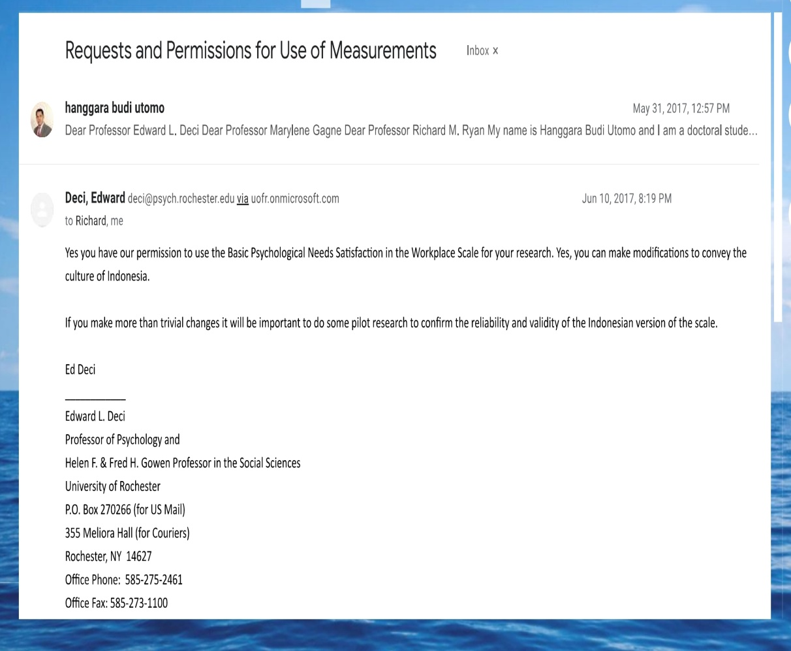

Lampiran : Autonomous Motivation for Teaching

