JURNAL PSIKOLOGI COPYRIGHT TRANSFER AGREEMENT
I am the undersigned, on behalf of all authors, hereby declaring that the following article is the original work of the author and has never been published.

Article title | : | THE UNTOLD STORY OF HAVING A FAMILY MEMBER AS TERRORISM CONVICT: A STUDY TO UNDERSTAND FAMILY HARDINESS & FAMILY PERSPECTIVE
Authors | : | 1. Sabiqotul Husna  2. Muslim Hidayat
Affiliated organization or institution | : | Department of Psychology, Faculty of Social Science & Humanitiies, UIN Sunan Kalijaga Yogyakarta

If this article is accepted for publication in published numbers in the Jurnal Psikologi, then I hereby hand over all copyright to the Jurnal Psikologi and the Faculty of Psychology, Diponegoro University, as journal publishers.
Copyright includes rights to reproduce and provide articles in all forms and media, including reprints, photographs, microfilm and any other similar reproduction, as well as translations. However, the authors still have the right to the following:
- duplicate all or part of the material published for use by the author himself as classroom teaching material or oral presentation material in various forums;
- reuse part or all of the material as a compilation material for the author's next work;
- make copies of material published for distribution within the institution where the author works.
I am responsible for the entire contents of the article sent. I agree that this transfer of rights also applies to all copies made in connection with the submission of this article and I will also inform this agreement to other authors.
Date : February, 06, 2023
Author name : Sabiqotul Husna
Signature of the main author or corresponding author: (use handwriting)

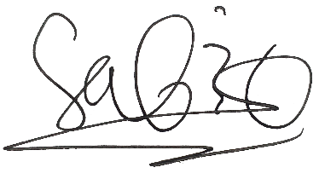

(Sabiqotul Husna)

Note:
- If the article is not accepted, this letter is declared invalid.
- The completed and signed form is scanned and save as PDF format and must be sent as a supplementary file when sending the article. If there is a problem, the author can send it to an email: jurnalpsikologi@live.undip.ac.id.

©2020, Jurnal Psikologi Copyright Transfer Agreement Form

