**Appendix 1**

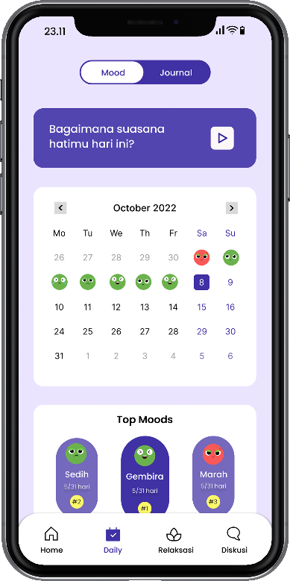 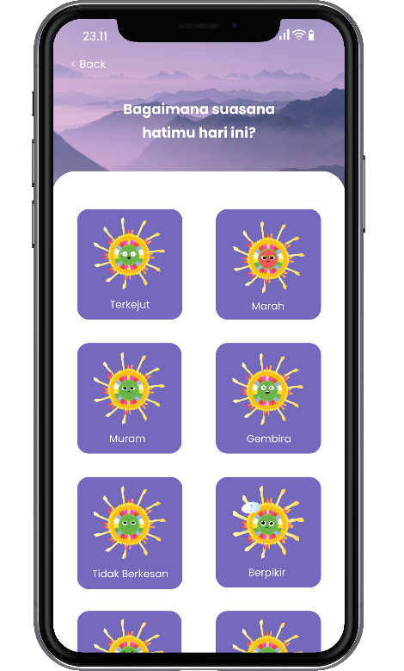

Figure 2. Mood Tracker page Figure Figure 3. Mood Submit page

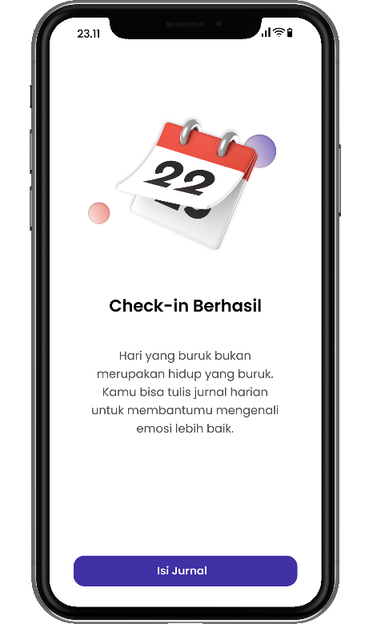 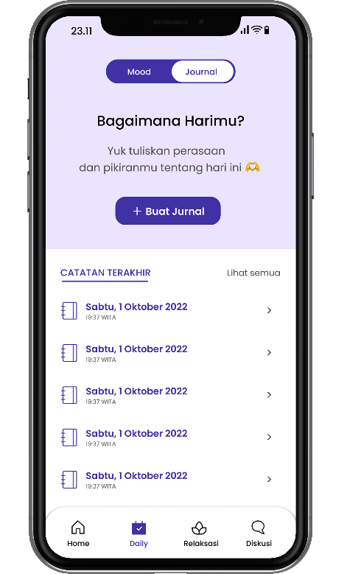

Figure 4. Mood Validation Page Figure Figure 5. Journal Contents Page

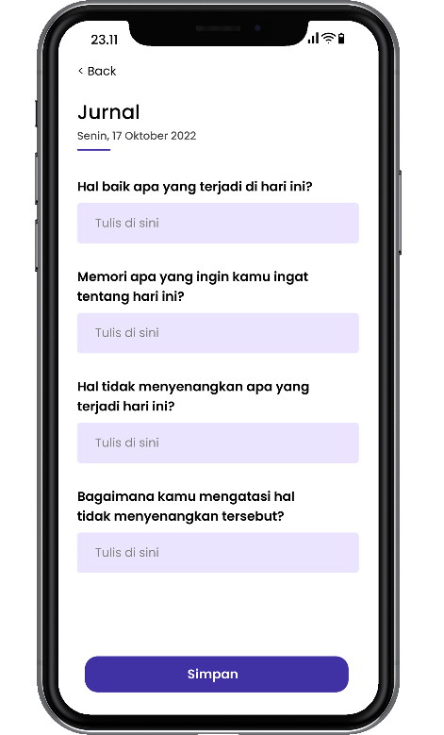 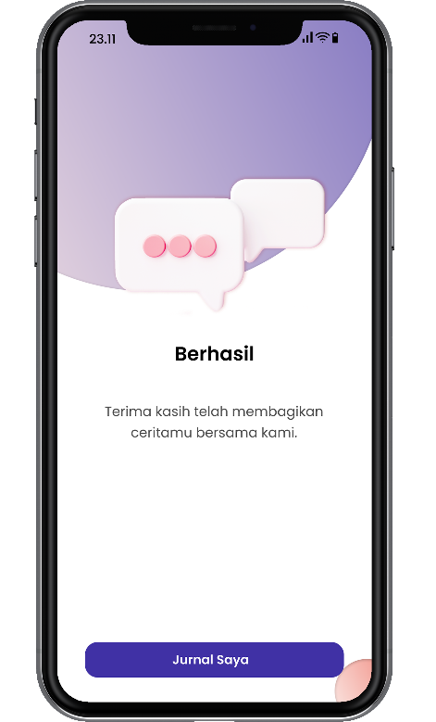

Figure 6. Journal Contents Page Figure Figure 7. Journal Validation Page

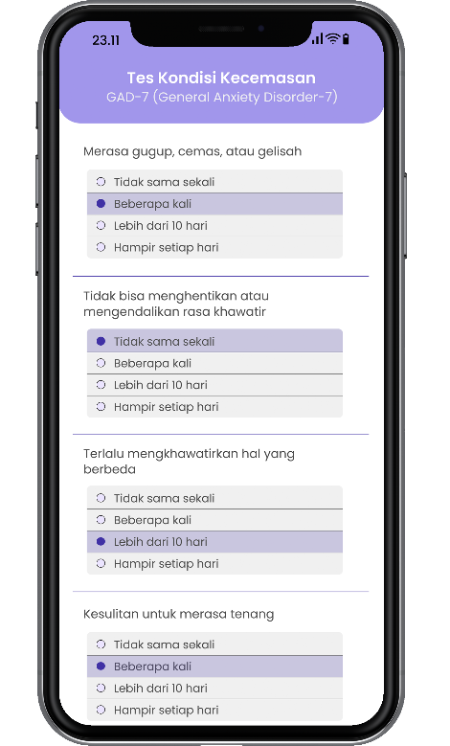 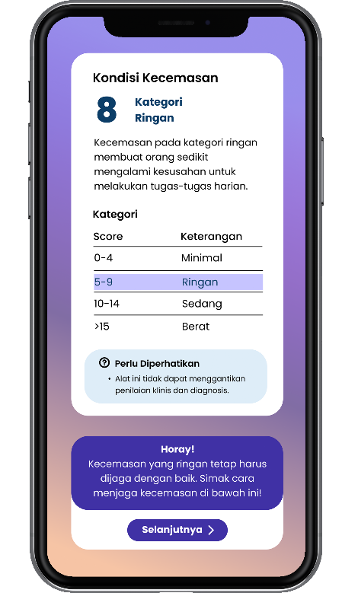

Figure 8. Anxiety Condition Test Figure Figure 9. Mild Anxiety Condition

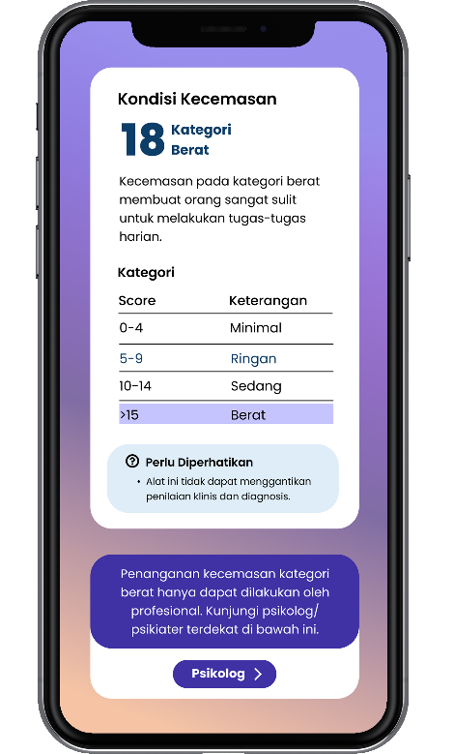 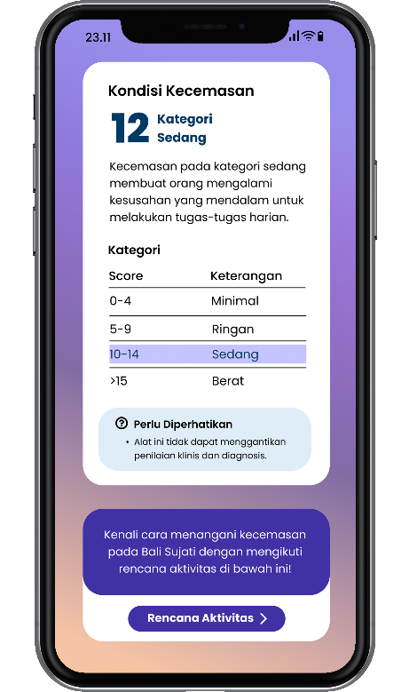

Figure 10. Severe Anxiety Condition Figure Figure 11. Moderate Anxiety Condition

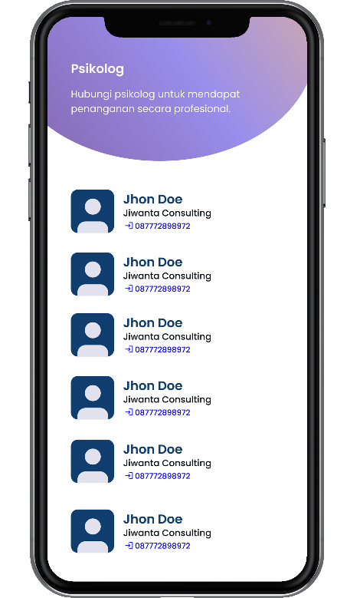 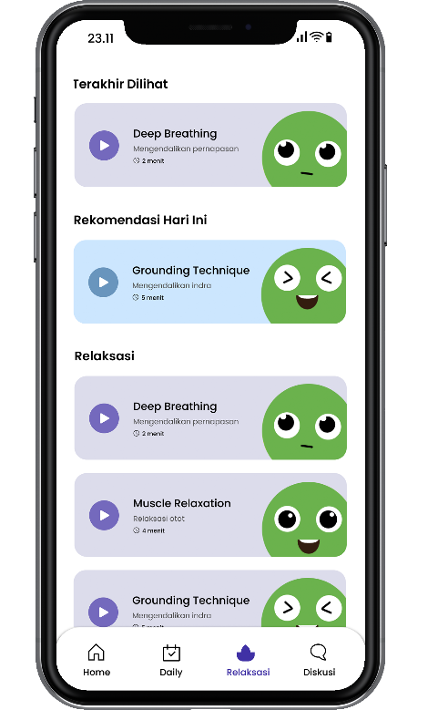

Figure 12. Psychologist Contact Figure 13. Relaxation page

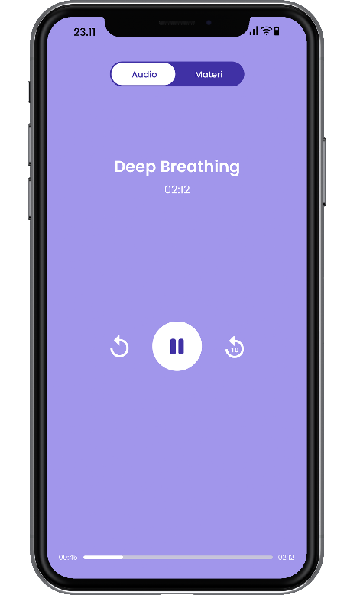

Figure 14. Deep Breathing Technique Audio