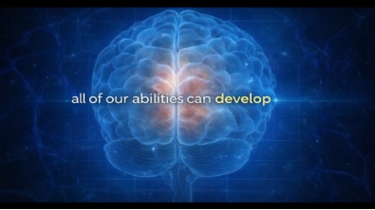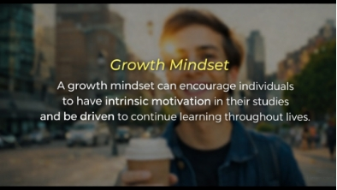
Sample Video Intervention.
Note: Excerpts from research documentation by researchers (2025).

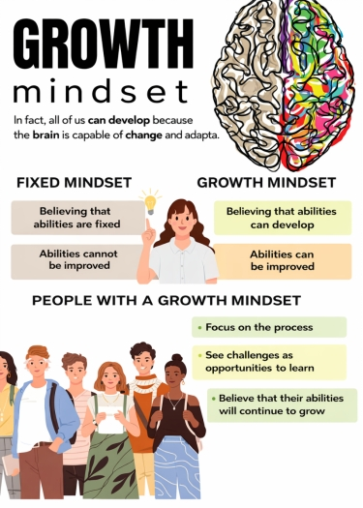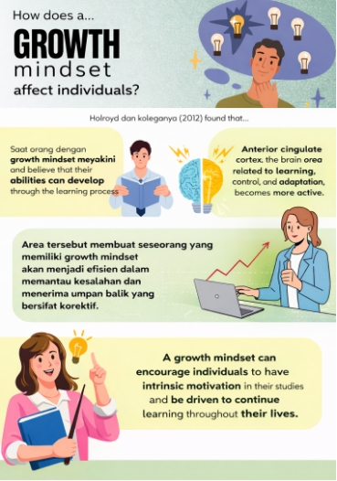
Sample Infographic Intervention, Fixed and Growth Mindset (Left), Use of a Growth Mindset in Thesis Work (Right)
Note: Excerpts from research documentation by researchers (2025).

