Results of Quantitative Analysis

Figure 1. Hypothesis Model
Romantic Loneliness

H2
H1
H4
Reframing Mechanism
Personal Branding

- Descriptive Analysis

- Cumulative Descriptive Analysis
The cumulative descriptive analysis presents a comprehensive examination of the data summarized by predetermined categories. The cumulative results of this study are presented in the following tables:

Table 7. Cumulative Description of Romantic Loneliness
Category | Score |  | Total | %
Strongly Disagree | 1 | (SD) | 47 | 5
Disagree | 2 | (D) | 87 | 10
Neutral | 3 | (N) | 114 | 13
Agree | 4 | (A) | 348 | 38
Strongly Agree | 5 | (SA) | 310 | 34
Total |  |  | 906 | 100
Source: Primary Data Processed, 2025
The cumulative description of the romantic loneliness variable shows that the majority of respondents gave a positive assessment. As many as 348 respondents (38%) stated that they agree, and 310 respondents (34%) stated that they strongly agree with the statements in the questionnaire measuring this variable. This indicates that, in general, most respondents have a high tendency to experience romantic loneliness.
Meanwhile, there were 114 respondents (13%) who indicated a neutral stance, reflecting a group that is not fully convinced or does not have a clear tendency toward statements related to romantic loneliness. As for the groups that disagree, there were 87 respondents (10%) who disagreed and 47 respondents (5%) who strongly disagreed. Overall, 72% of respondents gave positive responses (agree and strongly agree), indicating that the level of romantic loneliness is relatively high among Generation Z in West Java, which is the population studied.
Table 8. Cumulative Description of Reframing Mechanism
Category | Score |  | Total | %
Strongly Disagree | 1 | (SD) | 58 | 6
Disagree | 2 | (D) | 96 | 11
Neutral | 3 | (N) | 121 | 13
Agree | 4 | (A) | 338 | 37
Strongly Agree | 5 | (SA) | 293 | 32
Total |  |  | 906 | 100
Source: Primary Data Processed, 2025
The cumulative description of the reframing mechanism variable shows that the majority of Generation Z respondents in West Java gave positive assessments of reframing efforts in dealing with romantic loneliness. As many as 338 respondents (37%) stated that they agree, and 293 respondents (32%) stated that they strongly agree with the statements in the questionnaire measuring this variable. This finding indicates that most of Generation Z in West Java have a strong tendency to adaptively and constructively reframe the experience of loneliness through reframing mechanisms.
Meanwhile, there were 121 respondents (13%) who remained neutral, showing a group without a distinct tendency regarding the use of reframing as a strategy for coping with loneliness. As for those who disagreed, there were 96 respondents (11%), and 58 respondents (6%) strongly disagreed. Altogether, 69% of respondents provided positive responses (agree and strongly agree), indicating a rather high level of use and acceptance of the reframing mechanism among Generation Z in West Java as the researched population.
Table 9. Cumulative Description of Personal Branding
Category | Score |  | Total | %
Strongly Disagree | 1 | (SD) | 31 | 5
Disagree | 2 | (D) | 68 | 11
Neutral | 3 | (N) | 106 | 18
Agree | 4 | (A) | 224 | 37
Strongly Agree | 5 | (SA) | 175 | 29
Total |  |  | 604 | 100
SSource: Primary Data Processed, 2025
The cumulative description of the personal branding variable shows that most Generation Z respondents in West Java gave positive assessments of the elements of personal branding measured in this study. As many as 224 respondents (37%) stated that they agree, and 175 respondents (29%) stated that they strongly agree with the statements in the questionnaire measuring personal branding. This suggests that, in general, the majority of Generation Z in West Java tend to build and strengthen their personal brands.
Meanwhile, 106 respondents (18%) indicated a neutral stance, showing a group that is not fully convinced or does not have a clear tendency toward statements related to personal branding. As for those who disagreed, there were 68 respondents (11%), and 31 respondents (5%) strongly disagreed. In total, 66% of respondents provided positive responses (agree and strongly agree), reflecting a relatively high level of acceptance and implementation of personal branding among Generation Z in West Java, the population studied.
- Partial Descriptive Analysis
The partial descriptive analysis presents a detailed account based on the results of the questionnaire, categorized according to each item. The following describes the partial descriptive analysis from this study, as displayed in Table 10 below:

Table 10. Partial Description of Romantic Loneliness

No | Questionnaire Items | SD |  | D |  | N |  | A |  | SA
No | Questionnaire Items | F | % | F | % | F | % | F | % | F | %
Q1 | How often do you feel that your relationship with your partner or someone special (other than family) does not make you feel emotionally close? | 9 | 5,96 | 16 | 10,6 | 6 | 3,97 | 55 | 36,42 | 65 | 43,05
Q2 | I feel there is an emotional distance between myself and my partner/someone special (other than family). | 14 | 9,27 | 7 | 4,64 | 7 | 4,64 | 58 | 38,41 | 65 | 43,05
Q3 | My partner and I/someone special (other than family) rarely discuss our deepest feelings. | 3 | 1,99 | 22 | 14,57 | 33 | 21,85 | 39 | 25,83 | 54 | 35,76
Q4 | How often do you feel that your romantic relationship with your partner/someone special (other than family) does not meet your expectations? | 8 | 5,3 | 12 | 7,95 | 27 | 17,88 | 67 | 44,37 | 37 | 24,5
Q5 | How often do you compare your relationship to the relationships of others you see on social media? | 7 | 4,64 | 15 | 9,93 | 23 | 15,23 | 63 | 41,72 | 43 | 28,48
Q6 | I often hide my true feelings from my partner/someone special (other than family). | 6 | 3,97 | 15 | 9,93 | 18 | 11,92 | 66 | 43,71 | 46 | 30,46
Source: Primary Data Processed, 2025
Note: This table combines two types of measurement scales: a frequency scale (1 = Never to 5 = Very Often) and a Likert agreement scale (1 = Strongly Disagree to 5 = Strongly Agree).
Based on the partial descriptive results above, respondents' views on the romantic loneliness variable are as follows:
- For item Q1, which uses a frequency scale regarding how often respondents feel that their relationship with their partner or someone special does not make them feel emotionally close, 36% of respondents reported that this happens often and 43% reported very often. Additionally, 4% answered neutral/sometimes, 11% answered rarely, and 6% answered very rarely or never. These findings indicate that the majority of respondents often experience a lack of emotional closeness in their romantic relationships.
- For item Q2, which uses an agreement scale regarding perception of emotional distance between respondents and their partner/someone special, 38% agreed and 43% strongly agreed, 5% were neutral, 8% disagreed, and 9% strongly disagreed. These results highlight that emotional distance is a prominent issue among Generation Z.
- For item Q3, using an agreement scale about rarely discussing deepest feelings with a partner, 26% agreed and 36% strongly agreed, 22% were neutral, 15% disagreed, and 2% strongly disagreed. This finding indicates that deep emotional communication is still not a main practice.
- For item Q4, using a frequency scale per the feeling that the romantic relationship does not meet expectations, 44% of respondents answered often, and 25% very often, 17% neutral/sometimes, 8% rarely, and 5% very rarely. This finding emphasizes frequent dissatisfaction experienced by most of Generation Z.
- For item Q5, also using a frequency scale regarding the tendency to compare their relationship with others seen on social media, 41% answered often and 28% very often, 15% sometimes, 10% rarely, and 5% very rarely. These data show that social media has a significant influence on perceptions of romantic relationships.
- For item Q6, with a frequency scale regarding hiding true feelings, 44% often and 30% very often did so, 12% neutral/sometimes, 10% rarely, and 4% very rarely. This finding confirms a continued tendency toward emotional concealment.

Table 11. Partial Description of Reframing Mechanism

No | Questionnaire Items | SD |  | D |  | N |  | A |  | SA
No | Questionnaire Items | F | % | F | % | F | % | F | % | F | %
Q1 | I intentionally reframe loneliness as fuel for creativity. | 11 | 7,28 | 19 | 12,58 | 8 | 5,3 | 55 | 36,42 | 58 | 38,41
Q2 | I transform negative perceptions about loneliness into personal challenges for self-growth. | 16 | 10,6 | 9 | 5,96 | 7 | 4,64 | 59 | 39,07 | 60 | 39,74
Q3 | My creative or productive activities help reduce internal conflict regarding romantic relationships. | 5 | 3,31 | 23 | 15,23 | 33 | 21,85 | 43 | 28,48 | 47 | 31,13
Q4 | How often do you use new skills or engage in activities outside your comfort zone as a coping mechanism for loneliness? | 10 | 6,62 | 13 | 8,61 | 27 | 17,88 | 56 | 37,09 | 45 | 29,8
Q5 | I receive emotional support from the community when experiencing romantic loneliness. | 9 | 5,96 | 17 | 11,26 | 26 | 17,22 | 64 | 42,38 | 35 | 23,18
Q6 | My peer group or organization provides constructive feedback on my skill-based activities. | 7 | 4,64 | 15 | 9,93 | 20 | 13,25 | 61 | 40,4 | 48 | 31,79
Source: Primary Data Processed, 2025
Note: This table combines two types of measurement scales: a frequency scale (1 = Never to 5 = Very Often) and a Likert agreement scale (1 = Strongly Disagree to 5 = Strongly Agree).
Based on the partial descriptive results above, respondents’ perspectives on the Reframing Mechanism variable are as follows:
- For item Q1, which uses a frequency scale regarding how often respondents reframe loneliness as fuel for creativity, 36% of respondents reported often and 38% reported very often, 5% responded neutral/sometimes, 13% rarely, and 7% very rarely or never. This finding indicates that the majority of Generation Z in West Java tend to actively manage loneliness constructively by reframing it to boost creativity.

- For item Q2, which also uses a frequency scale regarding the habit of transforming negative perceptions about loneliness into challenges for self-growth, 40% of respondents reported often engaging in such reframing, another 40% reported very often, 5% were neutral/sometimes, 6% rarely, and 9% very rarely or never. This result suggests that most respondents adopt reframing as an active self-development strategy.

- For item Q3, assessed using an agreement scale on the role of creative or productive activities in reducing internal conflict regarding romantic relationships, 29% agreed and 31% strongly agreed, 22% were neutral, 10% disagreed, and 7% strongly disagreed. These data indicate that productive activities are considered a primary strategy for managing stress or internal conflict resulting from romantic loneliness by most respondents.

- For item Q4, using a frequency scale on how often respondents use new skills or engage in activities outside their comfort zone as a coping mechanism for loneliness, 37% answered often, 30% very often, 18% neutral, 9% rarely, and 7% very rarely or never. This finding demonstrates a strong tendency among Generation Z to seek adaptive and exploratory strategies to cope with loneliness.

- For item Q5, again using a frequency scale regarding the experience of receiving emotional support from the community during romantic loneliness, 42% of respondents reported often, 23% very often, 17% neutral/sometimes, 11% rarely, and 6% very rarely or never. This highlights the crucial role of social-community support in the reframing process for this population.

- For item Q6, using a frequency scale in measuring the receipt of constructive feedback from peer groups or organizations, 40% responded often, 32% very often, 13% neutral, 10% rarely, and 5% very rarely or never. These data signify that social and organizational participation serves as an important source of support to facilitate the respondents’ reframing capacity.

Table 12. Partial Description of Personal Branding

No | Questionnaire Items | SD |  | D |  | N |  | A |  | SA
No | Questionnaire Items | F | % | F | % | F | % | F | % | F | %
Q1 | I feel that I have grown through creative activities or organizational involvement. | 5 | 3,31 | 23 | 15,23 | 33 | 21,85 | 43 | 28,48 | 47 | 31,13
Q2 | I feel free to express my uniqueness in creative or social activities. | 10 | 6,62 | 13 | 8,61 | 27 | 17,88 | 56 | 37,09 | 45 | 29,8
Q3 | I intentionally try new roles in organizations or learn new skills to get to know myself better. | 9 | 5,96 | 17 | 11,26 | 26 | 17,22 | 64 | 42,38 | 35 | 23,18
Q4 | To what extent does romantic loneliness with a partner/someone special (other than family) motivate you to try new things? | 7 | 4,64 | 15 | 9,93 | 20 | 13,25 | 61 | 40,4 | 48 | 31,79
Source: Primary Data Processed, 2025
Note: This table combines two types of measurement scales: a Likert agreement scale (1 = Strongly Disagree to 5 = Strongly Agree) and a motivation scale (1 = Not at All Motivating to 5 = Highly Motivating).
Based on the partial descriptive data above, respondents’ views on the Personal Branding variable are as follows:
- For item Q1, concerning the feeling of growth through creative activities or organizational involvement (agreement scale: 1 = Strongly Disagree, 5 = Strongly Agree), 28% of respondents agreed and 31% strongly agreed, 22% were neutral, 15% disagreed, and 3% strongly disagreed. This finding shows that the majority of Generation Z in West Java perceive creative activity and organizational participation as positive contributors to their self-development.

- For item Q2, regarding the freedom to express uniqueness in creative or social activities (agreement scale), 37% of respondents agreed and 30% strongly agreed, 18% were neutral, 9% disagreed, and 7% strongly disagreed. These results reinforce that most respondents have found the space and freedom to express their uniqueness through their involvement in social or creative activities.

- For item Q3, on the endeavor to try new roles in organizations or learn new skills for self-awareness (agreement scale), 42% agreed and 43% strongly agreed, 13% were neutral, 2% disagreed, and none strongly disagreed. This data indicates a high motivation among Generation Z to explore and improve themselves through new roles and skills.

- For item Q4, regarding how much romantic loneliness with a partner or someone special motivates respondents to try new things (motivation scale: 1 = Not at All Motivating, 5 = Highly Motivating), 40% of respondents felt moderately motivated and 32% highly motivated, 13% were neutral, 10% were less motivated, and 5% were not at all motivated. This finding demonstrates that experiences of romantic loneliness can serve as a significant impetus for Generation Z to pursue new experiences as a form of self-development.

- Descriptive Statistics
Descriptive statistics are used to illustrate the distribution and characteristics of data for each variable in this study. The table below presents a summary of data for the variables Romantic Loneliness, Reframing Mechanism, and Personal Branding among Generation Z in West Java, including the number of respondents (N), minimum value, maximum value, mean, and standard deviation.
Table 13. Results of Descriptive Statistical Tests
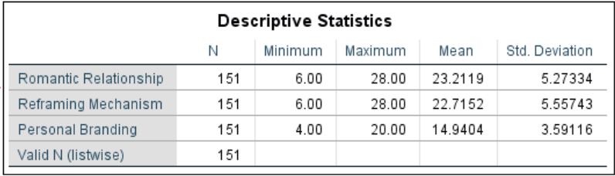
Source: SPSS 24 Output, Secondary Data Processed

The table above shows the results of the study variables, consisting of minimum values, maximum values, means, and standard deviations for each variable. The following is an explanation of the processed descriptive data.
- Romantic Loneliness Variable:
The average score for the romantic loneliness variable is 23.21 out of a maximum of 28, with a minimum value of 6 and a standard deviation of 5.27. These results indicate that the majority of Generation Z respondents in West Java experience a relatively high level of romantic loneliness. The relatively large standard deviation suggests substantial variation in loneliness experiences among individuals, with some respondents reporting low levels and others experiencing very high emotional loneliness.

- Reframing Mechanism Variable:
The average score for the reframing mechanism is 22.72 out of a maximum of 28, with a minimum value of 6 and a standard deviation of 5.56. This finding indicates that respondents generally have a high ability to reinterpret negative experiences as positive opportunities. However, the relatively large data spread reflects considerable differences in reframing capacity among respondents.

- Personal Branding Variable:
The average personal branding score is 14.94 out of a maximum of 20, with a minimum of 4 and a standard deviation of 3.59. These results illustrate that most respondents are actively aware of and engaged in building their personal branding. The smaller standard deviation compared to the other two variables implies a lower degree of variation, meaning that the majority of Generation Z in West Java show consistency in efforts to develop their social self-image.

- Classical Assumption Tests

  - Normality Test (Kolmogorov-Smirnov Test)
The normality test aims to assess whether, in the regression model, the disturbance variables or residuals are normally distributed. This is important because both the t-test and F-test assume that the residuals are normally distributed. If this assumption is not met, the statistical tests become invalid. To detect whether the residuals are normally distributed, the Kolmogorov-Smirnov test results are used. Normality is considered fulfilled if the resulting residual value is greater than 0.05 (Ghozali, 2018). In this case, to determine whether the distribution of residuals is normal or not:
- If the significance value > 0.05, the data are normally distributed.
- If the significance value < 0.05, the data are not normally distributed.
Table 14. Kolmogorov–Smirnov Test
Romantic Loneliness for Reframing Mechanism
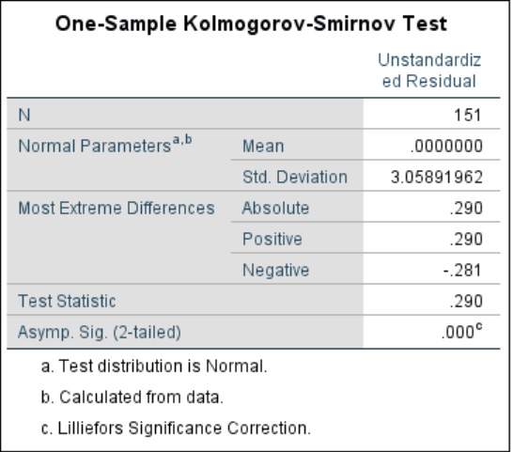
Source: SPSS 24 Output, Secondary Data Processed

Table 15. Kolmogorov–Smirnov Test
Romantic Loneliness and Reframing Mechanism for Personal Branding
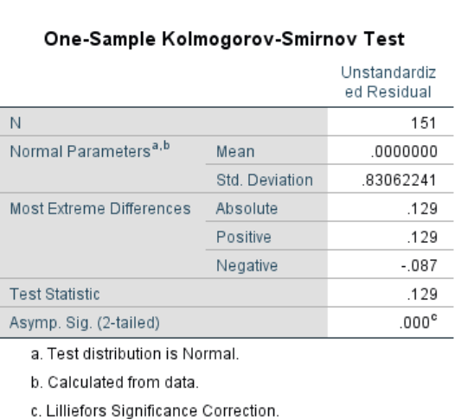
Source: SPSS 24 Output, Secondary Data Processed

The results of the Kolmogorov-Smirnov test are presented in Figure 2 as follows:
Figure 2. Normal Probability Plot
Romantic Loneliness for Reframing Mechanism
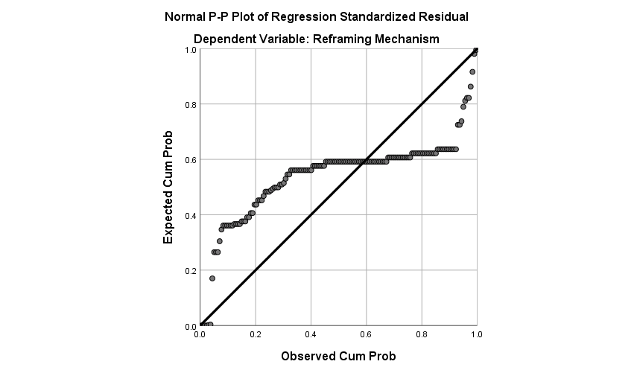
Source: SPSS 24 Output, Secondary Data Processed

Figure 3. Normal Probability Plot
Romantic Loneliness and Reframing Mechanism for Personal Branding
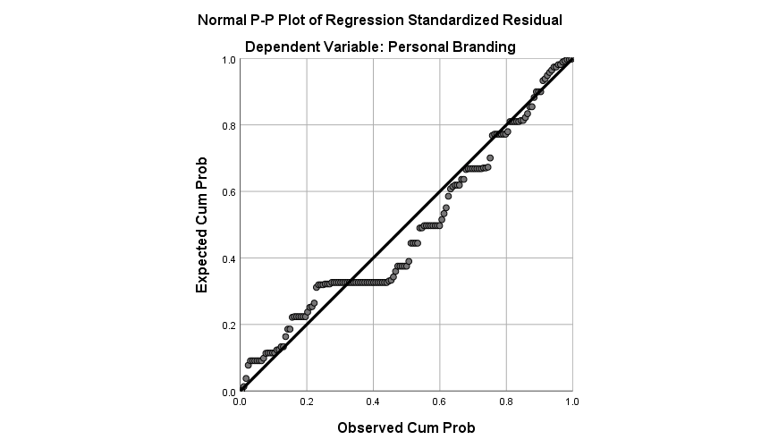
Source: SPSS 24 Output, Secondary Data Processed

Based on Tables 14 and 15 as well as Figures 2 and 3 above, it can be seen that the data are distributed around the diagonal line and follow the direction of that line. Thus, it can be concluded that, according to the results of the Kolmogorov–Smirnov test on the regression residuals, the obtained significance value (Asymp. Sig.) is 0.000, which is less than 0.05 (Asymp. Sig. = 0.000). This indicates that, according to statistical criteria, the residuals are not normally distributed. Therefore, the assumption of residual normality in the regression model is not statistically fulfilled.
  - HETEROSCEDASTICITY
    - Scatter Plot
The results of the heteroscedasticity test using the scatter plot are shown in the following figures:

Figure 4. Scatter Plot Test Results
Romantic Loneliness for Reframing Mechanism

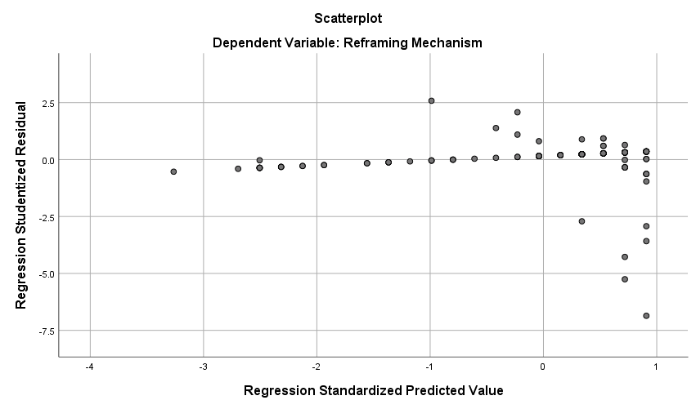

Source: SPSS 24 Output, Secondary Data Processed

Figure 5. Scatter Plot Test Results
Romantic Loneliness and Reframing Mechanism for Personal Branding
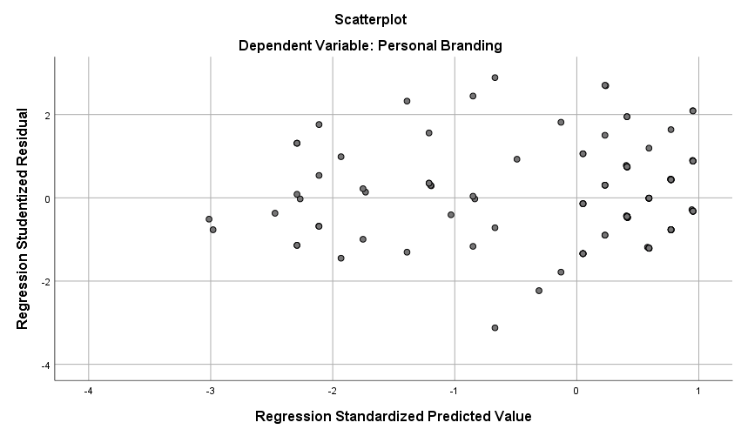
Source: SPSS 24 Output, Secondary Data Processed

The scatter plot analysis between standardized residuals and standardized predicted values shows that in the model with the dependent variable Reframing Mechanism, there is still an indication of a certain pattern in the residual distribution, suggesting the presence of heteroscedasticity. Meanwhile, in the Personal Branding model, the residual distribution appears random and does not form a specific pattern, leading to the conclusion that the model meets the homoscedasticity assumption. This finding should be considered when interpreting the regression results, especially regarding the Reframing Mechanism model. If necessary, researchers may consider data transformation or use robust or non-parametric regression methods to address potential heteroscedasticity.
  - Multicollinearity Test
The multicollinearity test aims to examine whether there is correlation among the independent variables in a regression model. A tolerance value ≥ 0.10 indicates no multicollinearity. A Variance Inflation Factor (VIF) below or less than 10.0 also signals the absence of multicollinearity. The results of the multicollinearity test are presented in the tables below:

Table 16. Multicollinearity Test
Romantic Loneliness for Reframing Mechanism
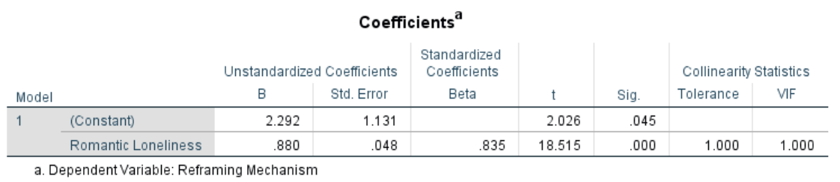
Source: SPSS 24 Output, Secondary Data Processed

Table 17. Multicollinearity Test
Romantic Loneliness and Reframing Mechanism for Personal Branding
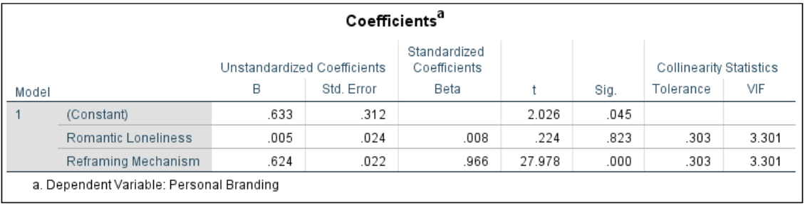
Source: SPSS 24 Output, Secondary Data Processed

Based on Tables 16 and 17 above, the tolerance and VIF values for each research variable are as follows:
Regression analysis results show that romantic loneliness has a significant and positive effect on the reframing mechanism (β = 0.835; p < 0.001). However, the direct effect of romantic loneliness on personal branding is not significant (β = 0.008; p = 0.823). Conversely, the reframing mechanism has a very significant and strong influence on personal branding (β = 0.966; p < 0.001). The entire model is free from multicollinearity problems, with VIF values of all predictors below 10 and tolerance values above 0.1. These findings support the hypothesis that the reframing mechanism is a key mediator in the relationship between romantic loneliness and personal branding.

METHOD TRANSITION
BBased on the results of classical assumption tests, the residual data in this study do not fully meet the normality and homoscedasticity requirements. Therefore, the analysis was conducted using a non-parametric approach through Partial Least Squares-based Structural Equation Modeling (PLS-SEM) with the assistance of SmartPLS software. The bootstrapping process was applied to ensure the significance estimation of the model’s paths remains robust against violations of classical assumptions. The use of PLS-SEM is highly recommended in such situations because the procedure does not require normally distributed data and is more tolerant of heteroscedasticity issues (Hair et al., 2020), thereby ensuring the analysis results remain valid and reliable within the context of this research.

- Partial Least Squares-based Structural Equation Modeling (PLS-SEM) with Bootstrapping

- Inferential Analysis
Inferential analysis is a statistical technique used to draw conclusions or make predictions about a population based on data obtained from a sample. The goal is to determine whether the sample results can be generalized to the larger population or group. The analysis was conducted using SmartPLS version 4 software, which implements the Partial Least Squares (PLS) method and variance-based Structural Equation Modeling (SEM). PLS is a technique used to analyze relationships among variables in complex models, whereas SEM tests causal relationships among involved variables. Figure 6 shows the latent variable model that will be analyzed in this study.

Figure 6. Latent Variable Model of the Study

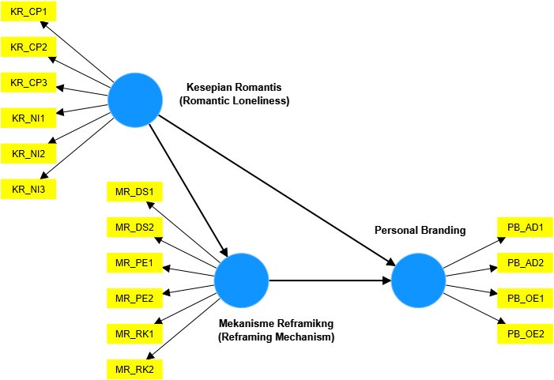

Source: SmartPLS 4 Output, Secondary Data Processed

The model testing consists of two stages: Outer Model and Inner Model. The Outer Model focuses on the validity and reliability of indicators used to measure latent variables, tested through Convergent Validity, Discriminant Validity, and Construct Reliability. The Inner Model focuses on relationships among latent variables and tests the strength and significance of these relationships through assessments of R², path coefficients, and path significance:

- Outer Model
The outer model focuses on the relationship between latent variables and their indicators. The goal is to ensure that the instruments measuring latent variables have adequate validity and reliability. There are three main tests in the outer model: Convergent Validity, Discriminant Validity, and Construct Reliability.

- Convergent Validity
Convergent validity has two evaluable criteria: the loading factor value or the Average Variance Extracted (AVE) value.

- Loading Factor Value
The output of the outer loading estimation is measured by the correlation between the indicator score (instrument) and its construct (variable). An indicator is considered valid if the correlation value is above 0.70; values above 0.60 are considered sufficient. Indicators failing to meet this criterion must be removed. The results of the first stage convergent validity test in this study are shown in Table 18.

Table 18. Outer Loading Results for Convergent Validity Test Stage 1
Instruments | Romantic Loneliness | Reframing Mechanism | Personal Branding | Description
KR_CP1 | 0.735 |  |  | Valid
KR_CP2 | 0.767 |  |  | Valid
KR_CP3 | 0.765 |  |  | Valid
KR_NI1 | 0.806 |  |  | Valid
KR_NI2 | 0.811 |  |  | Valid
KR_NI3 | 0.739 |  |  | Valid
MR_DS1 |  | 0.745 |  | Valid
MR_DS2 |  | 0.796 |  | Valid
MR_PE1 |  | 0.766 |  | Valid
MR_PE2 |  | 0.759 |  | Valid
MR_RK1 |  | 0.792 |  | Valid
MR_RK2 |  | 0.819 |  | Valid
PB_AD1 |  |  | 0.788 | Valid
PB_AD2 |  |  | 0.790 | Valid
PB_OE1 |  |  | 0.751 | Valid
PB_OE2 |  |  | 0.807 | Valid
Source: SmartPLS 4 Output, Secondary Data Processed

Convergent validity assessment of the research instruments was conducted by referring to the loading factor values of each indicator, as detailed in Table 1. All indicators for the variables Romantic Loneliness, Reframing Mechanism, and Personal Branding showed loading factor values above 0.70. For Romantic Loneliness, loading factors ranged from 0.735 to 0.811; for Reframing Mechanism, from 0.745 to 0.819; and for Personal Branding, from 0.751 to 0.807.

Achieving loading factor values above the 0.70 threshold fully satisfies the standards set by current research methodology literature (Hamid & Anwar, 2019; Savitri et al., 2021; Haryono, 2016; Wiyono, 2020). According to this rule of thumb, an indicator is considered convergently valid if the loading factor is ≥ 0.70.

Therefore, all indicators in this research instrument are proven valid, and no indicator needs to be eliminated. This result confirms that each indicator has a strong and significant correlation with its construct, so the measurement model achieves optimal convergent validity. This condition ensures the instrument can effectively measure constructs as expected, making the model ready to proceed to the next stage of structural analysis.

- Average Variance Extracted (AVE)
The output of the average variance extracted (AVE) estimation can be seen in Table 19. A variable is considered valid if it has an average variance extracted (AVE) > 0.5.
Table 19. AVE Results for Convergent Validity Test
Variable | Average variance extracted (AVE) | Description
Romantic Loneliness | 0.594 | Valid
Reframing Mechanism | 0.608 | Valid
Personal Branding | 0.615 | Valid
Source: SmartPLS 4 Output, Secondary Data Processed
Based on the test results presented in Table 19, the Average Variance Extracted (AVE) values for each research variable are as follows: Romantic Loneliness at 0.594, Reframing Mechanism at 0.608, and Personal Branding at 0.615. All of these AVE values exceed the minimum threshold of 0.50 as recommended by current research methodology literature.
This achievement indicates that each variable in the model meets the convergent validity criteria, where AVE ≥ 0.50 signifies the proportion of indicator variance adequately explained by the latent construct. Therefore, the research constructs have demonstrated solid convergent validity and can serve as a reliable foundation for structural analysis and subsequent hypothesis testing in structural equation modeling-based research.

- Discriminant Validity
Discriminant validity is used to ensure that constructs or variables within the measurement model truly measure distinct or non-overlapping concepts. In other words, discriminant validity assesses the extent to which different constructs in the measurement model can be distinguished from one another. Discriminant validity can be evaluated using one of three criteria: cross loading values, Fornell-Larcker criterion, and latent variable correlation.

- Cross Loading
An indicator/item is considered valid if its correlation with its own construct/variable (cross loading value) is higher than its correlation with other constructs. The following data were processed using SmartPLS version 4, with cross loading results presented in the table below.
Table 20. Cross Loading Results for Discriminant Validity Test Stage 1
Instruments | Romantic Loneliness | Reframing Mechanism | Personal Branding | Description
KR_CP1 | 0.735 | 0.628 | 0.663 | Valid
KR_CP2 | 0.767 | 0.595 | 0.609 | Valid
KR_CP3 | 0.765 | 0.688 | 0.692 | Valid
KR_NI1 | 0.806 | 0.677 | 0.600 | Valid
KR_NI2 | 0.811 | 0.697 | 0.619 | Valid
KR_NI3 | 0.739 | 0.579 | 0.601 | Valid
MR_DS1 | 0.640 | 0.745 | 0.751 | Unvalid
MR_DS2 | 0.691 | 0.796 | 0.807 | Unvalid
MR_PE1 | 0.622 | 0.766 | 0.788 | Unvalid
MR_PE2 | 0.617 | 0.759 | 0.790 | Unvalid
MR_RK1 | 0.667 | 0.792 | 0.698 | Valid
MR_RK2 | 0.681 | 0.819 | 0.732 | Valid
PB_AD1 | 0.622 | 0.766 | 0.788 | Valid
PB_AD2 | 0.617 | 0.759 | 0.790 | Valid
PB_OE1 | 0.640 | 0.745 | 0.751 | Valid
PB_OE2 | 0.691 | 0.796 | 0.807 | Valid

Source: SmartPLS 4 Output, Secondary Data Processed
Based on the cross loading test at Stage 1, all indicators of Romantic Loneliness show good discriminant validity (for example, KR_NI2 has a loading of 0.811 on its original construct, which is relatively higher than its loading on Reframing Mechanism at 0.697 and Personal Branding at 0.619). However, four indicators in the Reframing Mechanism variable MR_DS1 (0.745 < 0.751), MR_DS2 (0.796 < 0.807), MR_PE1 (0.766 < 0.788), and MR_PE2 (0.759 < 0.790) have higher loadings on Personal Branding than on their original construct. Therefore, following literature recommendations (Haryono, 2016; Budhi, 2018; Wiyono, 2020), these four indicators were removed to ensure discriminant validity according to international academic standards, and retesting was conducted. Table 21 below presents the cross loading results for Stage 2.
Table 21. Cross Loading Results for Discriminant Validity Test Stage 2
Instruments | Romantic Loneliness | Reframing Mechanism | Personal Branding | Description
KR_CP1 | 0.726 | 0.488 | 0.657 | Valid
KR_CP2 | 0.765 | 0.497 | 0.614 | Valid
KR_CP3 | 0.765 | 0.592 | 0.698 | Valid
KR_NI1 | 0.813 | 0.737 | 0.600 | Valid
KR_NI2 | 0.818 | 0.755 | 0.620 | Valid
KR_NI3 | 0.734 | 0.472 | 0.597 | Valid
MR_RK1 | 0.673 | 0.871 | 0.699 | Valid
MR_RK2 | 0.687 | 0.880 | 0.733 | Valid
PB_AD1 | 0.619 | 0.635 | 0.784 | Valid
PB_AD2 | 0.610 | 0.610 | 0.783 | Valid
PB_OE1 | 0.639 | 0.642 | 0.757 | Valid
PB_OE2 | 0.691 | 0.675 | 0.812 | Valid
Source: SmartPLS 4 Output, Secondary Data Processed
The Cross Loading values for the variables Romantic Loneliness, Reframing Mechanism, and Personal Branding show that the correlations between indicators (instruments) and their constructs (variables) are higher than the correlations of the indicators with other constructs. The results of the convergent validity and discriminant validity tests are consistent, with all indicators declared valid. This indicates that the model used has a good fit and effectively distinguishes between different constructs. Thus, it can be concluded that the measurement instruments employed in this study are valid.
- Latent variable correlation
Latent variable correlation is part of the steps to examine discriminant validity by assessing the strength of relationships among constructs within the model. High correlations between constructs may indicate issues with discriminant validity and multicollinearity. The estimation output is presented in the following table:

Table. Latent Variable Correlation, AVE, and Square Root of AVE
Variable | Romantic Loneliness | Reframing Mechanism | Personal Branding | AVE | √AVE | Description
Romantic Loneliness | 1.000 | 0.777 | 0.817 | 0.594 | 0.771 | Unvalid
Reframing Mechanism | 0.777 | 1.000 | 0.818 | 0.767 | 0.875 | Valid
Personal Branding | 0.817 | 0.818 | 1.000 | 0.615 | 0.784 | Unvalid
Source: SmartPLS 4 Output, Secondary Data Processed
The latent variable correlation values can be assessed by comparing them to the square root of AVE (√AVE). The square root of AVE should be greater than the correlation values between latent variables in the same row/column. If the square root of AVE is greater, discriminant validity is fulfilled. Based on the correlation values between latent variables in the same row/column, if the √AVE is greater than these correlations, discriminant validity is met. The test results show that:
- Romantic Loneliness (√AVE = 0.771): All correlation values below it (0.777, 0.817) are greater than 0.771, thus it is concluded as invalid.
- Reframing Mechanism (√AVE = 0.875): All correlation values below it (0.777, 0.818) are smaller than 0.875, thus it is concluded as valid.
- Personal Branding (√AVE = 0.784): All correlation values below it (0.817, 0.818) are greater than 0.784, thus it is concluded as invalid.

- Fornell-Larcker Criterion
The Fornell-Larcker criterion is effectively used to assess whether constructs in a PLS model exhibit good discriminant validity. If the square root of AVE (√AVE) is greater than the correlation values in the same row, the construct is labeled as valid. Conversely, if √AVE is not greater than the correlation values in the same row, it is labeled as invalid. This indicates that the measurement model is valid in distinguishing between different constructs.
Table. Fornell-Larcker Criterion
Variable | Romantic Loneliness | Reframing Mechanism | Personal Branding | Description
Romantic Loneliness | 0.771 |  |  | Unvalid
Reframing Mechanism | 0.777 | 0.876 |  | Unvalid
Personal Branding | 0.817 | 0.818 | 0.784 | Valid
Source: SmartPLS 4 Output, Secondary Data Processed
Based on Table above, it can be seen that:
- For the row of Romantic Loneliness (√AVE = 0.771), the correlation values with other variables, Reframing Mechanism (0.777) and Personal Branding (0.817), are greater than 0.771, thus declared invalid.
- For the row of Reframing Mechanism (√AVE = 0.876), the correlation values with other variables, Romantic Loneliness (0.777) and Personal Branding (0.818), are smaller than 0.876, thus declared valid.
- For the row of Personal Branding (√AVE = 0.784), the correlation values with other variables, Romantic Loneliness (0.817) and Reframing Mechanism (0.818), are greater than 0.784, thus declared invalid.

- Construct Reliability
Construct reliability can be analyzed using either of two methods: by analyzing Cronbach's Alpha and composite reliability. Both methods are used to test the reliability of indicators within a variable.

- Cronbach’s Alpha
Cronbach’s Alpha is an important indicator for testing the reliability of variables in a PLS-SEM model. A high Cronbach’s Alpha value indicates that the construct/variable is well measured and consistent for measurement validity in PLS analysis. Conversely, a low Cronbach’s Alpha may indicate that the indicators/items used are not sufficiently reliable and require improvement or replacement.
Table 22. Cronbach’s Alpha
Variable | Cronbach's alpha | Description
Romantic Loneliness | 0.863 | Reliabel
Reframing Mechanism | 0.696 | Reliabel
Personal Branding | 0.791 | Reliabel
Source: SmartPLS 4 Output, Secondary Data Processed
The analysis results in the table show that the Cronbach’s Alpha values for the constructs/variables Romantic Loneliness, Reframing Mechanism, and Personal Branding are 0.863, 0.696, and 0.791 respectively. All Cronbach’s Alpha values are ≥ 0.60, so all variables are declared to have good reliability.
- Composite Reliability
Composite Reliability is used to ensure the internal consistency of indicators that form latent variables. In SmartPLS, composite reliability is a primary tool to measure reliability, and a CR value ≥ 0.70 is considered to meet research standards.

Table 23. Composite Reliability Values
Variable | Composite reliability (rho_c) | Description
Romantic Loneliness | 0.898 | Reliabel
Reframing Mechanism | 0.868 | Reliabel
Personal Branding | 0.865 | Reliabel
Source: SmartPLS 4 Output, Secondary Data Processed

This analysis shows that the composite reliability values for the constructs/variables Romantic Loneliness, Reframing Mechanism, and Personal Branding are 0.898, 0.868, and 0.865 respectively. All composite reliability values are ≥ 0.70, so all variables are declared to have good reliability.

- Model Fit Test
The model fit test was conducted by examining the estimation outputs from SmartPLS version 4.0, compared to criteria as explained in the following table.

Table 24. Model Fit Test Results
Parameter | Rule of Thumb | Result | Interpretation
SRMR (Standardized Root Mean Square Residual) | < 0.10 | 0.125 | Not Fit
d_ULS (Unweighted Least Squares Discrepancy) | >0.05 | 1.214 | Fit
d_G (Geodesic Discrepancy) | > 0.05 | 2.275 | Fit
Chi-square | χ² statistic ≥ χ² table | 1.235.553 ≥ 19.675 | Fit
NFI (Normed Fit Index) | Close to 1 | 0.393 | Not Fit
GoF (Goodness of Fit) | 0.1 (small), 0.25 (moderate), 0.36 (strong) | 0,666 | Fit
Q² Predictive Relevance | > 0 (has predictive relevance), < 0 (lacks) | Q² Reframing = 0.595, Q² Personal Branding = 0.659 | Fit
Source: SmartPLS 4 Output, Secondary Data Processed

Based on the model fit test table, this study’s model can be used to analyze relationships among latent variables with confidence that the model accurately reflects the data and has relevant predictive capability:
- SRMR value is 0.125, which is higher than the maximum cutoff of 0.10, indicating the model has a relatively large mismatch between observed data and the hypothesized model. Thus, the model is declared not fit on this parameter.
- d_ULS value is 1.214, exceeding the minimum 0.05 threshold, indicating this parameter is fit and the structural model does not show significant deviation and is acceptable by general rule of thumb.
- d_G value is 2.275, also above the 0.05 threshold, indicating the model on this aspect is acceptable with no significant structural difference from the actual data, thus declared fit.
- Chi-square statistic is 1,235,553 ≥ 19,675, far exceeding the table value, so according to structural model testing criteria, the model is fit statistically.
- NFI value is 0.393, indicating the model is not fit, as the value is far from the ideal close to 1, meaning relatively low fit.
- GoF value is 0.666, well above the 0.36 strong category cutoff, meaning the model has very good overall fit and is very appropriate to describe relationships among latent variables in this study.
- Q² predictive relevance values are 0.595 for Reframing Mechanism and 0.659 for Personal Branding, both > 0, indicating the model is fit for predictive relevance. This means the model has a strong capability to predict dependent variables based on the applied model structure.
Although the model shows an SRMR value of 0.125, slightly exceeding the common cutoff (<0.10), and an NFI value below the common cutoff (>0.90), these fit indices in PLS-SEM should not be the sole criteria for model adequacy—especially for complex models with many indicators and data not fully meeting classical assumptions. Other parameters such as d_ULS, d_G, GoF, and Q² predictive relevance demonstrate the model is valid and strongly relevant for prediction. All construct validity, reliability, and predictive relevance indicators are also adequate. According to Hair et al. (2020), fit indices like SRMR and NFI in PLS-SEM require flexible evaluation and tolerance if the overall model is valid and supported by a strong theoretical foundation. Therefore, this model is decided to be suitable for use without removing indicators so as to preserve the richness of the research variable information.
- Inner Model
The inner model in PLS-SEM describes the relationships among latent variables and is evaluated to assess the strength and significance of these relationships. The evaluation includes three main aspects: significance of relationships (hypothesis testing), R Square, and effect size.

- R Square (R²)
R-Square in PLS-SEM measures how well the latent independent variables in the model explain the variability of the latent dependent variables. The R² value indicates the overall predictive strength of the model. R² values range from 0 to 1, where higher values indicate better explanatory power. The following are the R-Square values from this analysis.

Table 25. R Square (R²) Test Results
Variabel Dependent | R-square | R-square adjusted
Reframing Mechanism | 0.604 | 0.601
Personal Branding | 0.752 | 0.749

Source: SmartPLS 4 Output, Secondary Data Processed

The analysis revealed an R-Square (R²) value of 0.604 for the Reframing Mechanism variable, indicating that 60.4% of the variation in this variable can be explained by the independent variables in the model, while the remaining 39.6% is influenced by other external factors not included in this study. These findings indicate that the relationship between the independent variables and the Reframing Mechanism variable is categorized as moderately strong. Meanwhile, the R-Square value of 0.752 for the Personal Branding variable shows that 75.2% of the variation in this variable can be explained by the independent variables in the model, with 24.8% influenced by external factors. This value reflects a very strong relationship, leading to the conclusion that this research model substantially explains the factors affecting Personal Branding. This interpretation follows the criteria of relationship strength from previous studies (Hamid & Anwar, 2019; Savitri et al., 2021). Therefore, the developed model has good explanatory power for the two main dependent variables, especially in explaining Personal Branding. The image below shows the PLS SEM Algorithm output highlighting the R² of the research model.

Figure 7. PLS SEM Algorithm Model Output
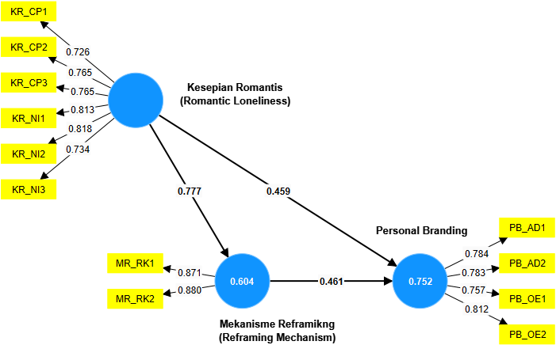
Source: SmartPLS 4 Output, Secondary Data Processed

- Significance (Hypothesis Testing)
Significance testing of relationships in PLS-SEM is performed to determine whether the relationships among latent variables in the model are statistically significant. This process typically uses bootstrapping, where data is resampled to calculate path coefficients and standard errors. The results are reported as t-statistics or p-values. A relationship is considered significant if the p-value is less than the predetermined significance level (0.05 in this study). Significant path coefficients indicate strong statistical support for the relationship between independent and dependent latent variables, thus supporting the hypothesized relationships. Below are the bootstrapping results for direct and indirect effects.
- Bootstrapping Results of Direct Effects
The bootstrapping results for direct effects are shown in Table 26 below:
Path Coefficient | Original sample (O) |  | Sample mean (M) | Standard deviation (STDEV) | T statistics (|O/STDEV|) | P values | Description
Romantic Loneliness -> Reframing Mechanism | 0.777 |  | 0.778 | 0.056 | 13.817 | 0.000 | Proven
Romantic Loneliness -> Personal Branding | 0.459 |  | 0.491 | 0.176 | 2.602 | 0.005 | Proven
Reframing Mechanism -> Personal Branding | 0.461 |  | 0.428 | 0.177 | 2.602 | 0.005 | Proven
Table 26. Bootstrapping Path Coefficient Results for Direct Effects
Source: SmartPLS 4 Output, Secondary Data Processed

- Effect of Romantic Loneliness on Reframing Mechanism
The path analysis shows that romantic loneliness has a positive and significant effect on the reframing mechanism (coefficient = 0.777, t = 13.817 > 1.65, p = 0.000 < 0.05). This finding indicates that the higher the level of romantic loneliness experienced by Generation Z in West Java, the greater the tendency for individuals to apply reframing in facing psychosocial challenges. This supports the adaptive coping framework of Lazarus & Folkman (1984) and the loneliness model of Peplau & Perlman (1982), asserting that loneliness can be a driver of cognitive adaptation rather than merely a source of distress. Kaushik et al. (2024) identify that Generation Z, particularly during the pandemic, developed reframing strategies to manage alienation, foster positive mindsets, and build psychological resilience. Additionally, the SEEJPH (2024) study confirms that young people increasingly integrate modern coping mechanisms like reframing to handle emotional fluctuations due to digital relationship dynamics. Practically, this extends the perspective that romantic loneliness, if adaptively managed, can enhance young people’s ability to transform negative experiences into opportunities for empowerment.

- Effect of Romantic Loneliness on Personal Branding
Further analysis shows that romantic loneliness positively and significantly affects personal branding (coefficient = 0.459, t = 2.602 > 1.65, p = 0.005 < 0.05). This means Generation Z individuals experiencing romantic loneliness tend to be more motivated to strategically express their identities in social and digital spaces. This finding aligns with self-actualization concepts (Maslow; Rogers) and digital identity formation theory (Guo & Luo, 2023), viewing personal branding as a catalyst for personal growth when facing emotional challenges. Kaushik et al. (2024) emphasize that limited romantic interactions during the pandemic have driven Generation Z to divert energy into creativity-based personal branding on social media. Similarly, SEEJPH (2024) highlights that personal branding has become a key adaptation for Generation Z to seek social recognition, actualize potential, and create authentic connection spaces amid the hyperconnectivity paradox. Thus, this result confirms that romantic loneliness is not a barrier but a strategic driver in identity construction and digital career development.

- Effect of Reframing Mechanism on Personal Branding
Further path testing confirms that the reframing mechanism also has a positive and significant effect on personal branding (coefficient = 0.461, t = 2.602 > 1.65, p = 0.005 < 0.05). As a psychological strategy, reframing allows individuals to reinterpret emotional experiences, including loneliness, more constructively, thereby strengthening self-image across social platforms. Drawing on adaptive coping literature (Freud; Mutiarrama, 2024; Lazarus & Folkman, 1984), reframing increases cognitive flexibility and opens opportunities for the formation of a more authentic and positive self-narrative. Kaushik et al. (2024) note that Generation Z increasingly relies on reframing to manage relational dynamics and cultural pressures, making it a foundational element in creating innovative personal branding. Confirmed by SEEJPH (2024), the effectiveness of reframing directly relates to skills in identity building and self-positioning in the digital era, enhancing individual competitiveness in social ecosystems. These findings are highly relevant to educators and personal development practitioners, highlighting the urgency of reframing strategy training as key to building highly competitive personal branding among Generation Z.

- Bootstrapping Results of Indirect Effects
The bootstrapping results of indirect effects are presented in Table 27 as follows:
Path Coefficient | Original sample (O) | Sample mean (M) | Standard deviation (STDEV) | T statistics (|O/STDEV|) | P values | Note
Romantic Loneliness -> Reframing Mechanism -> Personal Branding | 0.358 | 0.326 | 0.126 | 2.831 | 0.002 | Proven
Table 27. Bootstrapping Path Coefficient Results for Indirect Effects
Source: SmartPLS 4 Output, Secondary Data Processed

- Pengaruh Romantic Loneliness terhadap Personal Branding melalui Reframing Mechanism
The analysis shows that romantic loneliness has a significant indirect effect on personal branding through the reframing mechanism, with a coefficient of 0.358, a T-statistic of 2.831 (>1.96), and a P-value of 0.002 (<0.05). This indicates that higher levels of romantic loneliness can encourage Generation Z individuals to utilize the reframing mechanism in responding to these feelings, which ultimately contributes to strengthening their personal branding. This finding confirms that experiences of romantic loneliness, when adaptively managed through reframing, can redirect energy and creativity into efforts to build a more positive and authentic self-image in both social and digital environments.

This supports Lazarus and Folkman’s (1984) coping theory, which states that cognitive appraisals such as reframing play a crucial role in transforming perceptions of stressful experiences into opportunities for personal growth. Additionally, these results align with Freud’s (1936) concept of ego defense, where individuals channel negative emotional energy into productive and creative activities, which in this context manifests as efforts to build an authentic self-image in social and digital domains.

Furthermore, according to Hayes' (2013) mediation criteria, since both the direct effect of romantic loneliness on personal branding and the indirect effect through the reframing mechanism are significant, the reframing mechanism acts as a partial mediator. This means the reframing mechanism not only serves as a pathway transferring influence but also strengthens and complements the direct impact of romantic loneliness on personal branding among Generation Z.

This interpretation enriches the literature on adaptation psychology and self-development by emphasizing the importance of cognitive coping strategies during early adult transitions in the digital era. These results also provide important implications for psychologists, counselors, and intervention program developers, highlighting the need to enhance reframing abilities as a core competency for building strong and resilient personal branding in younger populations.

- Effect size (f²)
Effect size (f²) is used to evaluate the specific impact of an independent variable on the prediction of a dependent variable. This measurement is conducted by examining the change in R² when a particular independent variable is removed from the model. An f² value is interpreted as small if below 0.02, moderate if between 0.02 and 0.15, and large if above 0.35. By calculating f², researchers can identify which independent variables exert the greatest influence on dependent variables within the model, providing deeper insights into latent variable relationship dynamics.
Table 28. Effect Size (f²) Test Results
Variable | Romantic Loneliness | Reframing Mechanism | Personal Branding
Romantic Loneliness |  | 1.524 | 0.337
Reframing Mechanism |  |  | 0.340
Personal Branding
cSource: SmartPLS 4 Output, Secondary Data Processed

Based on Table 28, the following can be explained:
  - Effect of Romantic Loneliness on Reframing Mechanism
The f² value for the path from Romantic Loneliness to Reframing Mechanism is 1.524. This is a very large effect size (>0.35). This finding indicates that romantic loneliness exerts a very strong influence in explaining variance in the reframing mechanism. In other words, the level of romantic loneliness experienced strongly determines how intensely individuals employ reframing mechanisms when facing psychosocial pressures or situations. It highlights the critical role of romantic loneliness as a primary factor in developing reframing skills among Generation Z.

  - Effect of Romantic Loneliness on Personal Branding
The f² value for the path from Romantic Loneliness to Personal Branding is 0.337. This falls within the moderate effect category (0.15–0.35, near the upper boundary). This means that romantic loneliness has a moderately strong effect on personal branding. Thus, romantic loneliness plays an important role in forming and strengthening personal branding among Generation Z, although its effect is not as large as on the reframing mechanism. This indicates that while personal branding is influenced by various factors, the role of romantic loneliness remains significant in the process.

  - Effect of Reframing Mechanism on Personal Branding
The f² value for the path from Reframing Mechanism to Personal Branding is 0.340, also within the moderate effect range (>0.15–0.35). This finding shows that the reframing mechanism significantly contributes to shaping personal branding. Individuals who effectively use reframing mechanisms in response to romantic loneliness tend to have a stronger ability to build a positive and unique personal brand.

