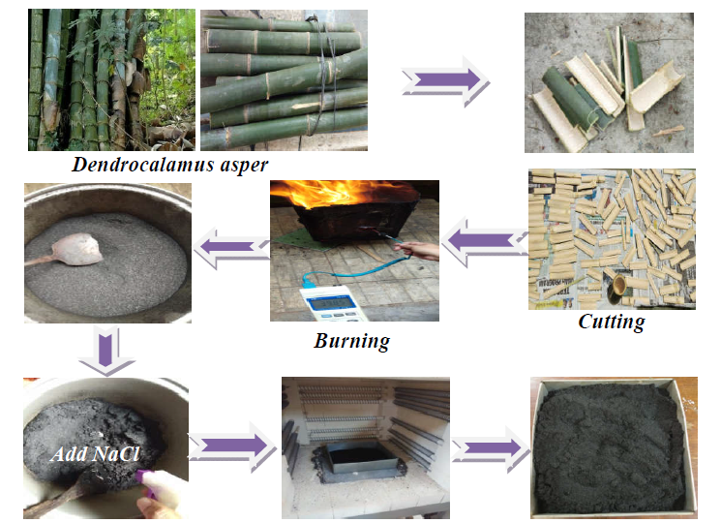
Figure 1. Preparation of bio-adsorbent

