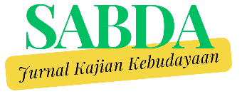
Fear of Missing Out as a Reflection of Generation Z's Participatory Culture: A Study of Language Variation among TikTok Users in Indonesia

Putri Oktarin Nadya
Malay Literature Study Program, Faculty of Cultural Sciences, University of North Sumatra, Indonesia
putryoktarin@gmail.com

Muhammad Safwan Jamil
Alumni of the Anthropology Study Program, Faculty of Social and Political Sciences, Al Washliyah Darussalam University, Banda Aceh, Indonesia
safwanjamil01@gmail.com

Arie Azhari Nasution
Malay Literature Study Program, Faculty of Cultural Sciences, University of North Sumatra, Indonesia
arieazhari@usu.ac.id

Prayogo
Malay Literature Study Program, Faculty of Cultural Sciences, University of North Sumatra, Indonesia
prayogo@usu.ac.id

Putri Utami
Malay Literature Study Program, Faculty of Cultural Sciences, University of North Sumatra, Indonesia
putriutamii2004@gmail.com

Received: …; Revised: …; Accepted:…

Abstract
This study aims to examine the sociolinguistic language variations brought about by Fear of Missing Out (FoMO) among Generation Z TikTok users in Indonesia as a reflection of digital participatory culture. Using a qualitative netnographic approach integrated with sociolinguistic matching methods, this study analyzes 15 speech data from viral content representing a broad spectrum of FoMO, ranging from fashion and wellness trends to socio-political participation. The results of the study identify that FoMO pressure encourages the formation of specific registers that function as structured linguistic adaptation mechanisms. Five main register clusters were found: (1) Urgency and Competitive Register (e.g., “anjir, cakep poll,” “Gas dm jastip”) which creates socio-economic pressure and affirms the status of the knowledgeable in-group. (2) Aesthetic Affiliation Register (e.g., “fomo Hindia nih,” “fomo trend fuji”) which mediates the conversion of cultural consumption into Digital Capital. (3) Reflective and Mitigation Register (e.g., "Do you really like it or is it just FOMO
?“, ”It's okay to be called tacky") which is used to conduct authenticity testing and manage social stigma. (4) Maturation and Detachment Register (e.g., “the important thing is to be healthy, okay?”) which shows the resolution of FoMO anxiety into a more mature attitude. Sociolinguistically, this language variation acts as a social discipline mechanism that maintains Gen Z cohesion. This study concludes that FoMO has shaped linguistic structures.

Keywords: Generation Z, TikTok, Language Variation, Fear of Missing Out (FoMO), Sociolinguistics.
Abstrak

Penelitian ini bertujuan menelaah variasi bahasa sosiolinguistik yang dimunculkan oleh Fear of Missing Out (FoMO) pada pengguna TikTok Generasi Z di Indonesia sebagai cermin dari budaya partisipatif digital. Menggunakan pendekatan kualitatif netnografis yang diintegrasikan dengan metode padan sosiolinguistik, studi ini menganalisis 15 data tuturan dari konten viral yang merepresentasikan spektrum luas FoMO, mulai dari tren fashion, wellness, hingga partisipasi sosial-politik. Hasil penelitian mengidentifikasi bahwa tekanan FoMO mendorong pembentukan ragam register spesifik yang berfungsi sebagai mekanisme adaptasi linguistik yang terstruktur. Ditemukan lima klaster register utama: (1) Register Urgensi dan Kompetitif (misalnya, &quot;anjir, cakep poll&quot;, &quot;Gas dm jastip&quot;) yang menciptakan tekanan sosio-ekonomis dan menegaskan status in-group yang berpengetahuan. (2) Register Afiliasi Estetik (misalnya, &quot;fomo Hindia nih&quot;, &quot;fomo trend fuji&quot;) yang memediasi konversi konsumsi budaya menjadi Modal
Budaya digital. (3) Register Reflektif dan Mitigasi (misalnya, &quot;Emang beneran suka apa FOMO
doang?&quot;, &quot;GPP dikatain norak&quot;) yang digunakan untuk melakukan uji keaslian (authenticity testing) dan mengelola stigma sosial. (4) Register Maturasi dan Detasemen (misalnya, &quot;yg penting bias sehat aja dehhh&quot;) yang menunjukkan resolusi kecemasan FoMO menjadi sikap yang lebih matang. Secara sosiolinguistik, variasi bahasa ini bertindak sebagai mekanisme disiplin sosial yang menjaga kohesi Gen Z. Penelitian ini menyimpulkan bahwa FoMO telah membentuk struktur kebahasaan.

Kata Kunci: Generasi Z, TikTok, Variasi Bahasa, Fear of Missing Out (FoMO), Sosiolinguistik.

Copyright © 2024 by Sabda: Jurnal Kajian Kebudayaan, Published by Fakultas Ilmu Budaya, Universitas Diponegoro. This is an open access article under the CC BY-SA License (http://creativecommons.org/licenses/by-sa/4.0/).

- Introduction
Generation Z, born approximately between 1997 and 2012, grew up in an era of smartphones, high connectivity, and instant content sharing platforms; these conditions make Gen Z a demographic group that is highly susceptible to the phenomenon of FoMO (Ramadian, 2025). Numerous quantitative and qualitative studies indicate a high prevalence of FoMO among this age group (Putranto, 2025).
FoMO (Fear of Missing Out) is defined as anxiety or concern that others are having more enjoyable or meaningful experiences, causing a person to feel the need to stay constantly connected so as not to “miss out” (Sabila, 2025). This concept is now widely studied in media and psychology because of its strong connection to social media use (Kirana, 2025).
The culture of FoMO (Fear of Missing Out) on TikTok is very strong because this platform provides unlimited, easily accessible content that is presented in short durations, encouraging users to keep scrolling and following the latest trends so they don't feel “left out” or “out of date.” FoMO on TikTok manifests in varying degrees, ranging from mild curiosity to severe anxiety that can disrupt daily activities and even trigger severe stress (Darmayanti et al., 2023).
Algorithms and product design (notifications, “duets/stitches,” endless feeds) create soft pressure for continuous engagement; this design reinforces social feedback loops that can then amplify feelings of FoMO. Some researchers cite platform design aspects as crucial structural triggers (Jain, 2025). The FoMO phenomenon has a significant impact on consumptive behavior among Generation Z, encouraging the purchase of viral products (fashion, cosmetics, culinary, and tourist attractions) as a symbolic strategy to maintain relevance and self-confidence on social networks (Putri & Apriadi, 2025; Hermawan & Rinawati, 2025; Sofiana, 2025). This impact is reinforced by media practices on TikTok that involve micro-rituals (performing challenges, rapid editing) as markers of participation and confirmation of digital social status (Geisel-Zamora, 2023).
Furthermore, FoMO also contributes to TikTok addiction, where users spend hours staying connected, which impacts self-control (Manek & Virlia, 2025; Maharani et al., 2025). In a commercial context, TikTok Shop and features such as live streaming, discount offers, and urgency/scarcity (flash sales, limited drops) utilize the FoMO mechanism to reinforce impulsive shopping behavior (Adyantari et al., 2025; Rizki, 2025; Elistyawati, 2025).
In sociolinguistic studies, Fear of Missing Out (FoMO) can be understood as a linguistic and social phenomenon that reflects individuals' anxiety about missing out on social experiences that are considered important, especially in the context of social media. Linguistic analysis shows that the term FoMO evolved from older expressions such as “keeping up with the Joneses” and has now become part of digital discourse that reflects changes in the culture of participation and individual well-being (Khassanova et al., 2025; Reagle, 2015). FoMO is also related to communication behavior on social media that is influenced by social comparison and the need to stay connected, which can trigger social media fatigue and narcissistic dynamics (Jabeen et al., 2023).
The phenomenon of Fear of Missing Out (FoMO) in the context of sociolinguistic language variation can be seen as part of the social dynamics that influence how individuals choose and use language variation in social interactions. FoMO, which is related to the anxiety of missing out on information or social experiences, can encourage individuals to adjust their language style or dialect to fit in with a particular social group, thereby reflecting their identity and social attachment. Language variation in sociolinguistics itself is a manifestation of differences in language use influenced by social factors, identity, and communication context, which can change in response to social pressures such as FoMO (Pichler, 2025; Rodríguez-Ordóñez et al., 2022). For example, in situations where someone feels afraid of losing social connections, they may be more inclined to use language variations that are considered more “trendy” or accepted within their social group, which can also reinforce or negotiate their social position. Modern sociolinguistic approaches emphasize the importance of understanding language variation as a performative social practice closely linked to identity and ongoing social change (Eckert, 2019).
The research gap that this study aims to address is the lack of in-depth analysis of how FoMO pressure in Indonesia's participatory TikTok culture influences Generation Z's choice and use of language variation. A theoretical integration that brings together platform structure, FoMO pressure, and language variation practices is needed to build a comprehensive analytical framework. Based on the above background, this study aims to examine the sociolinguistic language variation brought about by FoMO among Generation Z TikTok users in Indonesia as a reflection of digital participatory culture.
Theoretically, this study will link the theory of language variation in sociolinguistics with FoMO to enrich interdisciplinary studies. Practically, the results of this study are relevant for: (1) providing input on digital literacy education policies and (2) designing mental health interventions that are sensitive to Gen Z cultural dynamics. Using a contextual qualitative netnographic approach, this study seeks to formulate conceptual understanding and relevant intervention policies.
- Method
A qualitative approach using netnography integrated with sociolinguistic matching methods is highly relevant for examining the culture of Fear of Missing Out (FoMO) on TikTok, as it allows for in-depth and contextual observation of language interactions and social behavior within digital communities. Netnography observes viral content and user interactions on TikTok that trigger FoMO, while sociolinguistic matching methods help analyze the linguistic variations and social meanings that emerge in such communication (Darmayanti et al., 2023; Hermawan & Rinawati, 2025).
Related research shows that FoMO on TikTok triggers anxiety, consumptive behavior, and even digital stress, especially among young people who actively follow viral trends (Darmayanti et al., 2023; Husna et al., 2025). TikTok, as a platform with fast-paced and unlimited content, reinforces the fear of missing out, which can be analyzed through language patterns and social interactions recorded in netnography and sociolinguistics (Khoa et al., 2025; Putri & Apriadi, 2025). By integrating these methods, research can reveal how digital language and culture shape the FoMO experience and its impact on TikTok user behavior holistically.
The research location is within the TikTok platform ecosystem, focusing on Generation Z creator accounts (ages 15-26) in Indonesia whose content falls into the trending or viral (FYP) category. The research data includes verbal data (speech in videos/voice-overs) and written data (captions, text in videos, and comments) that linguistically reflect social anxiety and trends. Sampling was conducted purposively on content containing hashtags or topics that trigger FoMO, such as viral product recommendations (#RacunTikTok), lifestyle trends (#Cobain), and social challenges.
Data collection using the Simak Method with the Simak Bebas Libat Cakap (SBLC) Sudaryanto technique allows researchers to collect data on language and user behavior objectively without intervention, so that the data obtained is authentic and natural for analysis (Imam et al., 2024). The data collection procedure uses the Note-taking Technique and digital documentation. Researchers download videos and take screenshots of relevant interactions, then transcribe the linguistic data into data cards. Data cards are classified based on the form of language variation (lexicon, code-mixing, register) and its social function.
Data analysis adapted the interactive model of Miles, Huberman, and Saldaña (2014), which consists of three activity streams: (1) Data Condensation: Sorting utterances containing linguistic markers related to FoMO and discarding irrelevant data (such as spam). (2) Data Presentation: Organizing selected linguistic data into language variation classification tables and social function matrices to identify patterns of correlation between language forms and FoMO pressure. (3) Drawing Conclusions: Interpreting these language patterns using sociolinguistic and participatory culture theories to answer the research questions. To ensure data validity, this study uses source triangulation, which is comparing language variations that appear in different types of trending content (for example, comparing language in culinary trends with fashion trends) to ensure consistency in the language patterns formed by FoMO culture (Denzin & Lincoln, 2018).

- Results
A. FoMO as Identity Anxiety and a Trigger for Social Discipline
The phenomenon known as Fear of Missing Out (FoMO) is a type of social anxiety that arises when individuals feel left out of information, trends, or social activities that are widely discussed. In the digital age, this feeling has increased with the emergence of social media platforms that enable participation, such as TikTok. Generation Z, who grew up in the digital world, are the group most susceptible to FoMO because they consider social media an important part of their identity and their primary social space (Przybylski et al., 2013).
TikTok has emerged as a platform that supports a participatory culture, where each individual functions not only as a consumer of content but also as a creator (prosumer). With features such as duets, stitches, hashtag challenges, and trend-based algorithms, TikTok triggers its users' desire to stay engaged with popular content streams. This engagement creates a fertile environment for FoMO to arise among Generation Z (Jenkins, 2006; Rahmawati & Aditia, 2023).
Social connectedness on TikTok is created through a rapid feedback system in the form of likes, comments, duets, and views. This mechanism strengthens a sense of togetherness while also serving as a symbol of digital social status. Within Bourdieu's framework (1990), this can be understood as a form of digital social capital, namely recognition obtained from active participation. In everyday practice, Generation Z interprets social connectedness on TikTok as a space for affection and empathy. They support each other through positive comments, sharing life experiences, or showing solidarity on social issues. This phenomenon shows that media can be a means of forming emotional communities (Papacharissi, 2016). However, these emotional relationships are often temporary and dependent on current trends. When trends change, social connections weaken. This illustrates the fluid nature of digital communities in the algorithmic era (Bauman, 2000).
Through TikTok, Generation Z also negotiates the boundaries between private and public spaces. They publish aspects of their personal lives, but in an aesthetic and controlled format. This shows how this generation is developing a reflective awareness of themselves and society (Turkle, 2011). Generation Z interprets participation as a form of deep social connection, even if it is virtual. They feel part of a global community that shares similar values, tastes, and lifestyles. This shows a shift in the form of social solidarity from being physically based to algorithmically based (Marwick & Boyd, 2011).
In this context, Generation Z expresses new cultural values such as creativity, spontaneity, and connectivity through their participation on TikTok. They not only imitate but also adapt global trends to the local Indonesian context, making this platform an arena for cultural globalization (Appadurai, 1996). TikTok also serves as a space for Generation Z to build a collective identity. Through hashtags such as #GenZIndonesia or #AnakTikTok, they affirm their generational position as a social group with its own style of communication and cultural expression (Sabila & Tawaqal, 2023).
The social connectedness that emerges on TikTok often transcends traditional social boundaries such as class, gender, and region. This platform opens up space for inclusivity, where everyone can participate as long as they have digital access. This demonstrates a new form of cultural democratization (Miller et al., 2016). However, social relations on TikTok also have layers of inequality. Users with a large number of followers have greater cultural influence than ordinary users. This illustrates the reproduction of social hierarchies in the digital space (Marwick, 2013).
B. The Role of Algorithms and Attention Economics in Driving Urgency Registration
TikTok's algorithm plays an important role in reinforcing FoMO culture. The content recommendation system keeps users exposed to videos that are relevant to their interests, while also displaying the popularity of others as a measure of existence. This phenomenon creates comparative anxiety, which is a feeling of dissatisfaction with oneself because one feels that one is not as popular as other users (Marengo et al., 2022).
Challenges such as #GlowUpChallenge or #OutfitCheck, for example, are tangible forms of participatory culture that reinforce FoMO. When a new challenge emerges, users rush to upload their versions so as not to be left behind by the trend. This shows how participation has become a mechanism of social reproduction influenced by media logic (Royantara et al., 2025).
FoMO reproduction is also reinforced by likes, comments, and views, which serve as indicators of popularity. In participatory culture, social recognition is measured quantitatively, encouraging users to continuously produce content in order to maintain social validation. This is in line with the concept of the attention economy, where attention becomes a form of cultural capital (Marwick, 2013). From a local Indonesian perspective, FoMO is also related to the value of togetherness (digital mutual cooperation) and the fear of missing out on moments of virtual togetherness. When online communities celebrate certain trends, being absent from these moments is considered a loss of part of the “digital cultural ritual” (Rahmawati, 2023).
TikTok's participatory culture also creates digital solidarity. Although superficial, interactions in the comments section or duet content show a form of social cohesion that is unique to the digital age. However, this solidarity is fragile because it depends on algorithms and rapidly changing trends (Marwick & Boyd, 2013).
Beyond the social aspect, the participatory culture on TikTok also reinforces consumptive values. Many Gen Zers experience FoMO in the context of lifestyle, wanting to own the same products as influencers, follow fashion trends, or attend events that go viral on the platform (Putra & Hayati, 2025). FoMO here creates a pattern of symbolic digital consumption oriented towards self-image. Participatory culture also serves as a means of reproducing neoliberal values, such as competition, personal branding, and content productivity. In this context, FoMO is not only a form of social anxiety but also a side effect of digital capitalism ideology (Fuchs, 2021).
Research by Sabila & Tawaqal (2025) found that Indonesian TikTok teens tend to use media as a space for self-affirmation, but at the same time feel anxious if they don't get enough attention. This shows a contradiction between the desire for existence and dependence on social validation. Participatory culture also reinforces what is known as algorithmic culture, a condition in which culture is shaped by algorithmic logic. Generation Z forms its identity based on what the system likes, following trends in order to remain visible on other people's timelines (Striphas, 2015).
C. Participatory Culture: Digital Rituals and the Reproduction of Affiliation
Generation Z uses TikTok as a performative arena to assert their social existence. They create content that not only follows trends, but also showcases their lifestyle, musical tastes, and personal opinions. In this context, FoMO is not just the fear of missing out on information, but also the fear of losing one's identity and social connections.
Challenges such as #GlowUpChallenge or #OutfitCheck, for example, are tangible forms of participatory culture that reinforce FoMO. When a new challenge emerges, users rush to upload their versions so as not to be left behind by the trend. This shows how participation has become a mechanism of social reproduction influenced by media logic (Royantara et al., 2025).
Generation Z, as the most digitally connected generation, faces a dilemma: the desire for freedom of expression, yet being trapped in a pattern of homogeneous participation. FoMO becomes a social mechanism that maintains order in TikTok's participatory culture, where anyone who does not participate is considered “out of date” (Boyd, 2014). Netnographic research has found that TikTok users often feel guilty if they do not follow certain trends. This feeling is not merely individual, but part of a collective social dynamic, where participation in trends becomes a cultural norm. TikTok also creates an internal social structure through its influencer hierarchy system, where highly popular users become role models who determine the direction of trends. This reflects the reproduction of cultural power in digital media, similar to the patronage system in traditional societies (Bourdieu, 1990).
- Discussion
A. Analysis of Slang Variation (Sociolect) and Register Variation as a Mechanism of FoMO Attachment
Netnographic data analysis shows that Fear of Missing Out (FoMO) pressure influences the use of slang variations among Generation Z on TikTok, which functions as a linguistic adaptation mechanism to affirm belonging and identity within online communities. These language variations can be classified based on their social functions triggered by FoMO. Thus, participatory cultural practices on TikTok not only create feelings of FoMO but also become a new social system that structures Generation Z's behavior. FoMO functions as a “social discipline mechanism” that keeps users active in digital culture. Finally, this phenomenon shows that social media such as TikTok is not only a means of entertainment but also part of Indonesian society's activities, where identity, social relations, and cultural values are continuously produced and negotiated. Below is an analysis of data that falls under the category of slang variations related to FoMO.
Data 1: @ssa “The premium shimmer one isn't like this, damn, it's really cool.”
The above quote was written by @ssa on April 5, 2024, who is a TikTok user in the comments section of @blueberries__'s content https://vt.tiktok.com/ZSP1w8bR1/. The comment represents the use of slang as a register of urgency driven by Fear of Missing Out (FoMO), where language variation serves as a marker of affiliation and social validation. From a sociolinguistic perspective, the use of strong emotive interjections in the word “anjir” and slang intensifiers in the word “poll” are performative acts that pragmatically create social pressure and emotional attachment to a trend on TikTok, aiming to attract attention in the attention economy while affirming the speaker's status as an up-to-date member of the in-group. thus, this slang variation is not merely slang but a linguistic adaptation mechanism of Gen Z to overcome identity anxiety in the digital space.

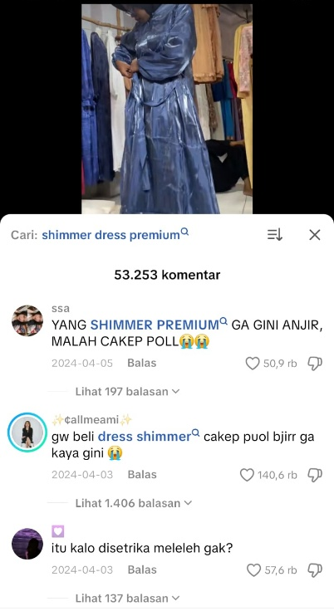

Data 2: @callmeami “I bought shimmer caep puol bjirr, not like this”
Comment data on April 3, 2024, created by TikTok user @callmeami in the content @blueberries__ https://vt.tiktok.com/ZSP1w8bR1/ shows the use of slang as a Competitive Urgency Register driven by the dynamics of Fear of Missing Out (FoMO) and the desire to stay ahead of trends. Sociolinguistically, the speaker uses a combination of intensive and hyperbolic lexical variations, such as the informal pronoun “gw,” the strong emotional lexicon “bjirr,” and a combination of orthographic variations and intensifiers “caep puol,” which serve to create claims of superiority and attract attention in the attention economy. The closing phrase “ga kaya gini” is a linguistic marker that pragmatically performs gatekeeping, rejecting existing trends and asserting that the speaker's products or information are more valid. Gaulish language in this context functions as a strategic tool to dampen personal FoMO and simultaneously create new FoMO in the audience, affirming a more informative in-group status.
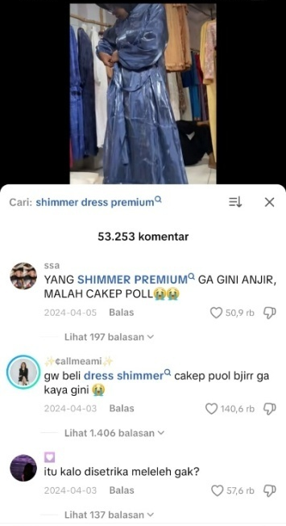

Data 3: @Evolveris “The winner is still chez”
The fact that the quote in the comment by @Evolveris on December 1, 2024, which is in the content uploaded by @Kris Who https://vt. tiktok.com/ZSP1wGBc4/ stating “the winner remains chez” went viral and became a pattern replicated in TikTok comment sections, especially when the trend peaked, is empirical evidence supporting the analysis that this slang variation is driven by FoMO. When a phrase reaches a high level of virality in Gen Z comment sections, it transforms into a collective linguistic norm. The pressure of FoMO at that time was not only the fear of missing out on information, but also the fear of missing out on the opportunity to participate in collective consensus. By replicating the phrase “the winner stays chez” using the Affiliative Certainty Register, including the use of specific slang variations, users actively performed linguistic rituals to affirm their affiliation. Thus, the commotion in the comments proves that this slang functions as a social discipline mechanism that maintains Gen Z cohesion and validates their position as up-to-date members amid trends.
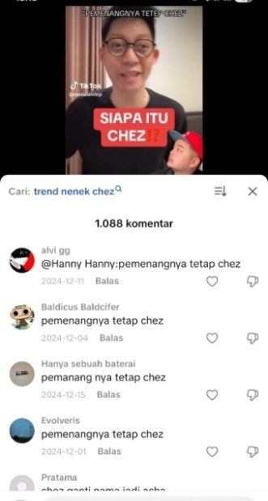

Data 4: @juaa “it's really good, wow!! Pls try it too”
The quote from the caption of the lip stain promotional content from the Timephoria brand created by @juaa https://vt.tiktok.com/ZSP1Kku3r/ on February 23, 2025, is a manifestation of the Urgency and Emotive Register Variety expressed through Gen Z Sociolect. As a register that is part of language variation in terms of usage, it is shaped by an urgent communicative function, namely to trigger impulsive purchases among peer groups. The characteristics of Gen Z sociolect are used to carry out this function, as seen in the use of hyperbolic intensifiers “bgttt” and “woii!!” and code-mixing “pls”. Sociolinguistically, this linguistic choice functions as a FoMO Bonding Mechanism, where speakers use an urgent and inclusive register to ensure that the audience converges their behavior (joins in the purchase), thereby avoiding social anxiety due to being left behind by the collective trend that is taking place.

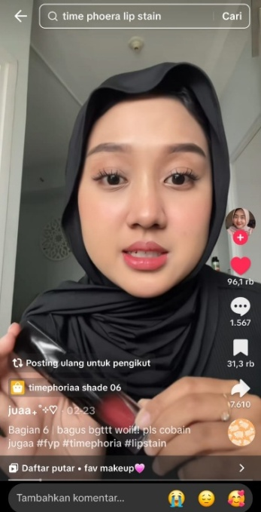
Data 5: @abell "The shade Nerose is good, wow, what shade do you buy next?"
Comment from user @abell on June 3, 2025, made by @juaa https://vt.tiktok.com/ZSP1Kku3r/, which is a comment on the Timephoria lip stain review content created by @juaa above, represents a shift to the Affiliative Consultative Register that is manifested in the sociolect of Generation Z, serving a dual function as an affirmation of attachment and a trigger for a new FoMO cycle. This attachment is evidenced by linguistic convergence through the repetition of the interjection “woii” and the acknowledgment of having made a purchase, indicating success in avoiding the first stage of FoMO. This Register Variety then leads to sustained FoMO through the Code Mix “next” and the consultative question “what shade should I get?”. Sociolinguistically, @abell uses this register not only to seek advice, but to maintain his status as an active and up-to-date member, making this Affiliative Register Variety a mechanism that binds individuals in a cycle of FoMO driven by community validation.

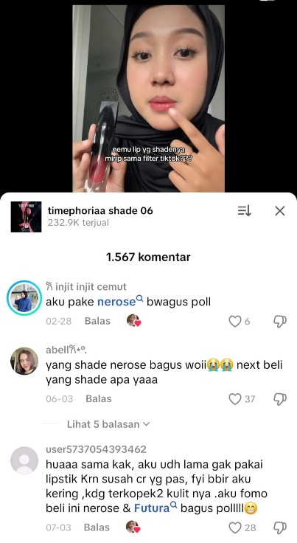

Data 6: @FT “You don't know Mio Mirza yet”
Comments from TikTok user @FT posted on March 20, 2024, in @Gerald Vincent's content https://vt.tiktok.com/ZSP1ENyjG/ are a manifestation of Competitive Register Variety, which is a gateway to knowledge expressed through Gen Z sociolect. This register aims to create a hierarchy of knowledge and trigger FoMO by emphasizing that the speaker has exclusive information, using the key jargon “Mio Mirza” which went viral in 2024. This is evidenced by the use of the informal pronoun ‘lo’ (a characteristic of sociolect) and the diction “belum tau” (don't know yet). Sociolinguistically, this statement compels audiences who feel uninformed to immediately seek information so as not to be left behind. The effect of this Register Variety is reinforced by the platform's features, where clickable blue text functions as an instant FoMO-breaking mechanism, thereby binding users longer in the cycle of digital knowledge consumption and validation.

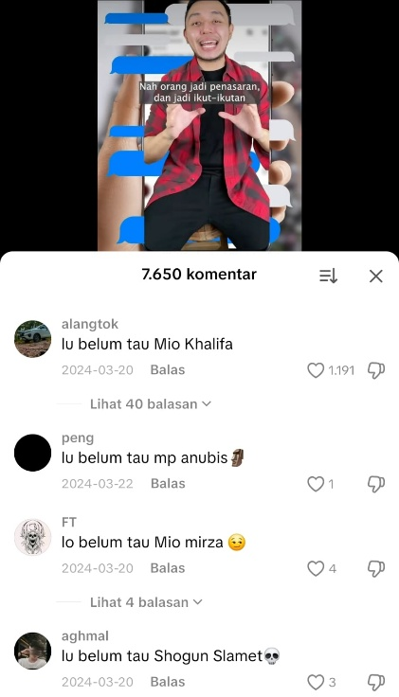

Data 7: @informatika “Day 1, typing Glinda”
The content created on data 7 by TikTok user @informatika https://vt.tiktok.com/ZSP1EBvBJ/ on November 27, 2025, is a manifestation of the Documentary-Ironic Register Variety embodied in Gen Z Sociolect. This register uniquely serves to document participation in a trend while explicitly acknowledging social pressure, evidenced by the use of the chronological jargon “Day 1” and the term “fomo” itself. This lexical choice creates clever irony, where users choose not to hide their motivations but instead make them part of their affiliation. Sociolinguistically, this Ironic Register functions as a documented FoMO attachment mechanism, transforming personal anxiety into a shareable collective experience, which ultimately validates and prolongs the cycle of the dichotomous identity trend of Glinda, a character in the movie Wicked. FoMO here is triggered by the fear of losing social validation and collectively shared humorous experiences. This phenomenon, which is currently trending among Gen Z, is based on TikTok's algorithmic mechanism where typing the keyword “Glinda” directly generates visuals of the character on the search screen, creating Indexicality of Dichotomous Identity.
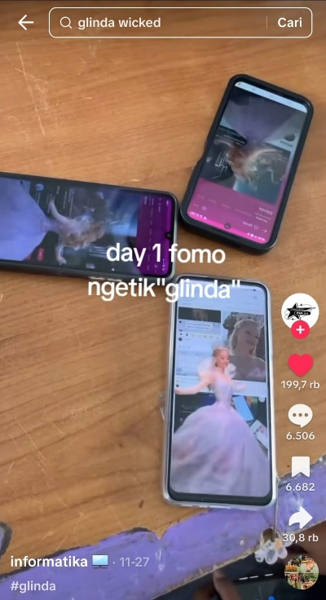

Data 8: @Rama.nrr “PADEL! Do you really like it or is it just FOMO?”
Content uploaded by @Rama.nrr https://vt.tiktok.com/ZSP1EKNpH/ on July 2, 2025, regarding the mention of Padel as a FoMO sport. The caption uploaded in the content of the @Rama.nrr account shows the use of the Interrogative-Reflective Register wrapped in Gen Z Sociolect. With the caption "PADEL! Do you really like it or is it just FOMO?“, the speaker uses informal lexicon in the words ‘Emang’ and ”doang" to test the authenticity of trend participants. Sociolinguistically, this question dissects the motivation behind participatory culture, separating genuine interest from social pressure (FoMO). This proves that Gen Z has reflective awareness (metacognition) of their own behavior, where the term “FoMO” has shifted in function from a mere psychological description to a social category for labeling lifestyle consumption behaviors that are considered performative or merely imitative.
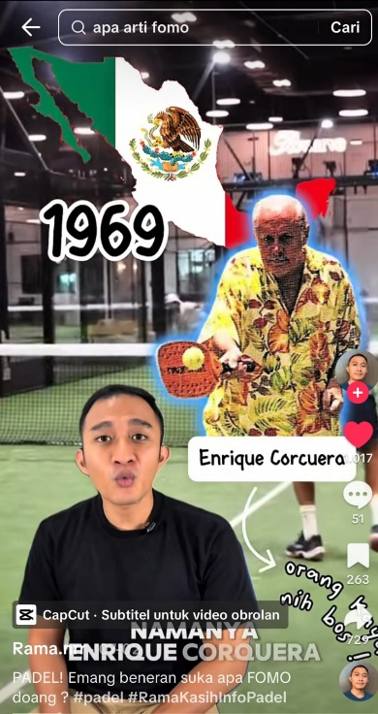

Data 9: @Beauraa: “fomo trend fuji” (Video imitating Fuji's bowling dance).
The content created by @Beauraa https://vt.tiktok.com/ZSP1oYS5M/ on March 11, 2025 manifests the Register of Identity and Affiliative Compliance driven by Digital Patronage. Sociolinguistically, this data is unique because the speaker explicitly uses the label FoMO in the caption “fomo trend fuji”. The explicit use of this label functions as Direct Indexicality. The speaker does not need to use metaphors, hyperbole, or mitigation; the label directly indexes the source of pressure (Fuji) and the purpose of the action in following the trend, thus ensuring instant social validation from a community that equally idolizes Fuji. FoMO in this context is ritual compliance FoMO, which is the fear of missing out on the opportunity to participate in collective rituals sanctioned by dominant figures. This reinforces the finding that Gen Z language is becoming increasingly efficient in communicating their social motivations. By simply writing “fomo trend fuji,” speakers effectively communicate their affiliation and justification for their actions, demonstrating that FoMO has become a legitimizing jargon for social participation.
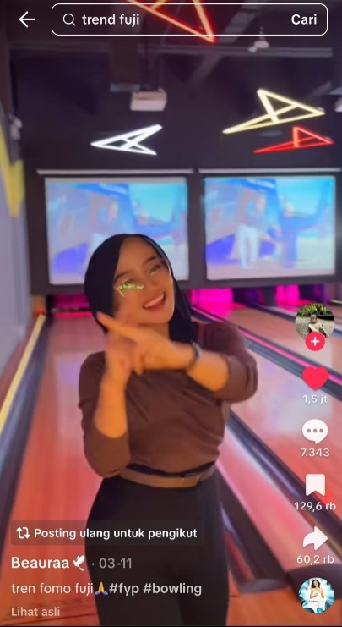

Data 10: @aprilianda43 (Content): “Finally I can buy Adidas Samba, my wishlist shoe.” (Caption): “GPP is also called tacky.”
The content and caption created by @aprilianda43 https://vt.tiktok.com/ZSP1o3Y5Y/ on August 27, 2025, manifests the Variety Register of FoMO Resolution and Affiliate Mitigation. This statement emphasizes that FoMO is not only an impulsive urge, but also an anxiety rooted in a wishlist (unfulfilled desires). Linguistically, the word “finally” marks the speaker's success in achieving a long-desired goal of participation, resolving personal FoMO. However, this moment is validated and accompanied by the caption “GPP is also considered tacky”. This phrase is a form of Pragmatic Mitigation. The speaker consciously indexes themselves as a late adopter who could potentially be labeled “norak” (outdated or behind the times). By acknowledging this stigma early on, the speaker linguistically defuses social criticism. This proves that digital participatory culture has a strict FoMO timeline. Amidst the stigma, the speaker emphasizes that personal satisfaction or the happiness of completing a wishlist is more important than the social cost (the tacky stigma). This register variation shows that Gen Z uses language to balance the need for affiliation (following trends) with socio-temporal pressure (time of adoption).
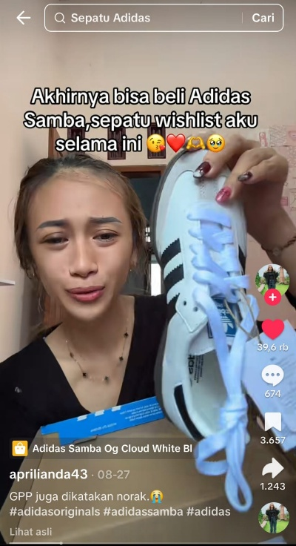
Data 11: @jalomm: “I'm wondering about Hindia”
The Spotify Wrapped content created by @jalomm https://vt.tiktok.com/ZSPJ15M3c/ on December 4, 2025 manifests the Register of Taste Validation and Aesthetic Compliance. Structurally, the annual release of Spotify Wrapped triggers massive FoMO (Fear of Missing Out) by compelling users to publish their personal consumption data, which then becomes a cultural status marker on TikTok. The speaker uses the Jedag-Jedug (JJ) video presentation style, popular for viral content, to maximize the visibility of their listening data. Linguistically, the caption “fomo Hindia nih” is an act of Direct Aesthetic Indexing. FoMO here is not the fear of missing out on listening to Hindia's music, but rather the fear of missing out on the opportunity to show off that one has musical tastes that conform to the aesthetic norms of the Gen Z in-group. The phrase serves a dual purpose: as an Affiliation that instantly identifies the speaker with the Hindia audience (associated with social awareness), and as an ironic Justification for the act of showing off their personal data. Thus, this Register Variation proves that FoMO drives Gen Z to use language to transform consumption data (song history) into Cultural Capital that is traded for social recognition on digital platforms.
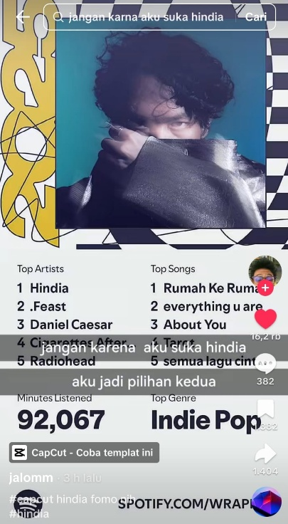

Data 12: @Utovaproject: Photos 8 Slides
(Slide 1): “What's FOMO? FOMO discount colorbox 99k 2 shirts” (Slide 8): “Full catalog? Gas dm jastip free shipping, please”
The carousel content created by @Utovaproject https://vt.tiktok.com/ZSPJ1hgVk/ on November 9, 2025 explicitly manifests the Transactional Urgency and Jargon Marketing Register. This data proves the commodification of FoMO, where jastip directly exploits customers' anxiety about economic loss. The use of the phrase “FOMO APA/ fomo discount...” serves as a rhetorical hook, openly acknowledging that the main motivation for viewing the content is social pressure reinforced by financial gain (a price of 99k for 2 shirts). This makes consumers consciously accept that they are being FoMO-ed. Linguistically, the phrase “Gas dm jastip free ongkir dong” in the closing slide is a Commercial Jargon Imperative aimed at encouraging instant conversion. The word “Gas” (slang for ‘come on, hurry up’) and the instruction “dm jastip” mean direct message for delivery service, which directly directs users to make an immediate purchase, reinforced by the incentive of “free ongkir” or free shipping. The carousel format itself is a Digital Sequencing strategy to build visual tension before the call to action on the last slide. This variety of registers shows that FoMO language has become an efficient and transparent marketing tool in triggering scarcity- and time-based purchases.
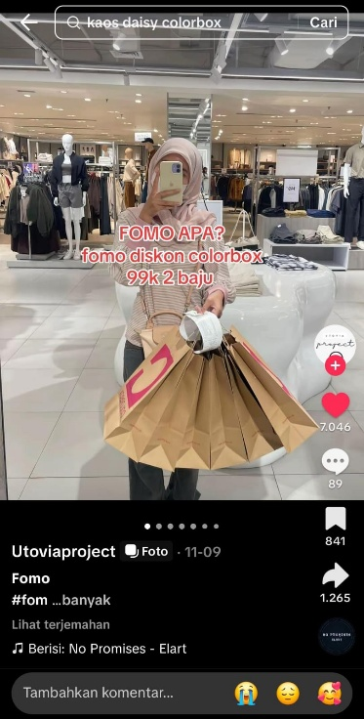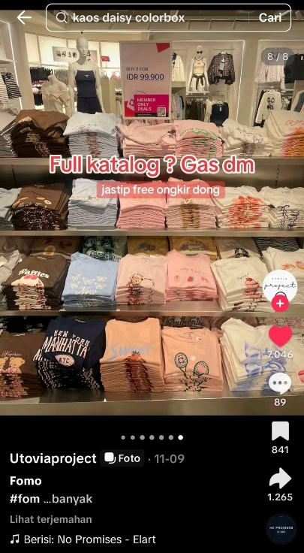

Data 13: @callmebintanggg (Content): “I used to be really obsessed with my bias, basically I had to follow every activity he did. Now I don't really follow him, the main thing is that my bias is healthy.”
The content uploaded by @callmebintanggg https://vt.tiktok.com/ZSPJ1uNvT/ represents the Fandom Maturation and Detachment Register. This data presents the narrative of the user's journey from compulsive FoMO to healthy detachment. The narrator explicitly uses the label “used to be really FoMO” to index their past behavior as extreme and driven by pressure. The phrase “basically, I had to follow all of their activities” shows a rigid and obligatory form of self-discipline in the past, which is strong linguistic evidence of participatory FoMO. However, the focus of the narrative has shifted to resolution through the phrase “the important thing is to be healthy, okay?” This phrase shows a value shift from mandatory involvement to altruistic concern and acceptance. The use of the closing particle “aja dehhh” gives a relaxed and final tone, indicating that anxiety (FoMO) has been successfully overcome and replaced by a more mature attitude. Sociolinguistically, this content functions as Collective Recognition and Social Education among fellow fans, providing a linguistic role model for healthier fandom behavior. This proves that FoMO is not permanent and that Gen Z uses language as a tool to narrate the progression of their digital identity towards maturity.
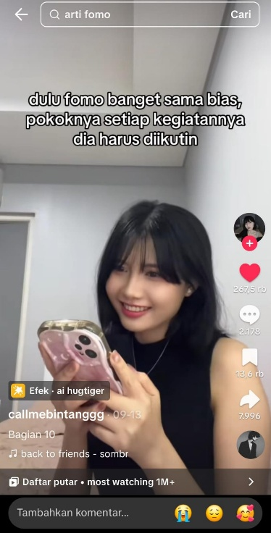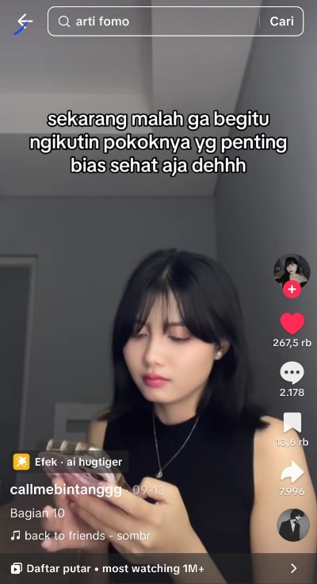

Data 14: @Dailymeme (Content): “POV: You're still young and have the urge to join the demonstration”, (Recorder's Sentence): “Who told you to come here, go home?”
The content created by the @Dailymeme account https://vt.tiktok.com/ZSPJJrSEv/ manifests Participatory Parody and Social-Political Criticism. This data is unique because FoMO is shifted from aesthetic motives to civil participation motives. Speakers use “POV” (Point of View) to frame the scene as situational comedy, immediately indexing the serious actions (demonstrations) of children as naive and driven by peer pressure. The explicit labeling of “fomo pengen ikut demo” is a linguistic marker that reduces political motivation to purely social motivation (following trends). This shows that FoMO is a narrative simplification used by Gen Z to explain participatory behavior that lacks a strong ideological basis. Linguistically, the term “small-scale demonstration” functions as a diminutive that reduces the political weight of the action, while the audio intervention from the recorder in the sentence “who told you to come here, go home” creates authoritative social discipline, ending the FoMO performance. This variety of registers proves that FoMO has become an interpretive lens for Gen Z to understand and laugh at all forms of public participation, including civil participation.
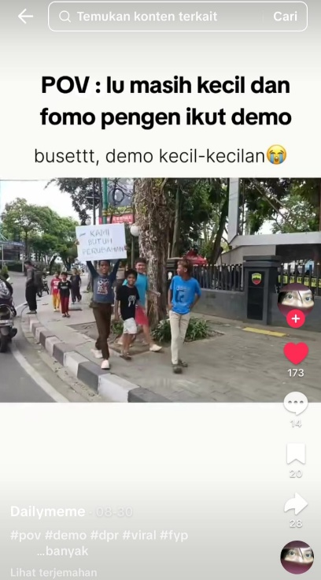

Data 15: @Mella Carli (Spoken): “Are you lazy but want to jog? Jogging RELAXED JOGGING” (Caption): “For lazy people who are afraid to run”
The content uploaded by @Mella Carli https://vt.tiktok.com/ZSPJJnYha/ on July 18, 2025 represents the Trend Accommodation and Lexical Innovation Register. This data shows a sociolinguistic phenomenon in which language is manipulated to bridge the gap between social pressure (FoMO) and individual capacity limitations (laziness). Morphologically, speakers innovate by creating the acronym or blending of the words “Sjogging” (Santai Jogging). This lexical innovation serves a strategic function in redefining the activity of running. In Gen Z wellness culture, “jogging” often has a high participation threshold (discipline, stamina, speed). With the term “Sjogging,” speakers linguistically lower these standards, creating a new category of activity that is more inclusive and low-effort. The explicit use of the phrase “for lazy people who are afraid of missing out on running” in the caption is a form of Paradoxical Identity Validation. Speakers do not deny their FoMO motivation, but rather embrace it. This proves that FoMO on TikTok has evolved into a socially accepted identity, where the linguistic variation in the phrase “Sjogging” serves as a pragmatic solution for the “lazy” group to still gain social validation from the running trend without having to actually exert physical effort. Language here serves as a tool to democratize trends, ensuring that no one is missing out simply because they are not athletic.
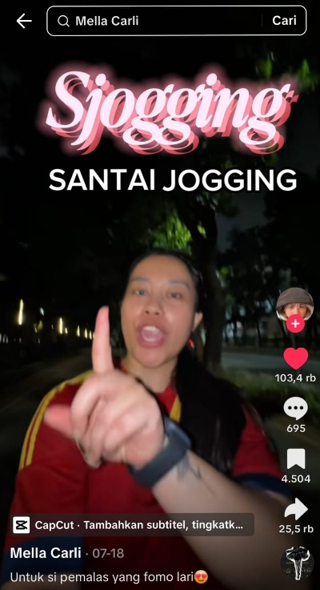

- Conclusion
Based on the results of the above analysis, it can be concluded that Fear of Missing Out (FoMO) among Generation Z TikTok users in Indonesia is a sociolinguistic phenomenon that fundamentally reflects an algorithmically structured digital participatory culture. FoMO functions as a social discipline mechanism that greatly influences language choice and usage, which in turn serves to maintain social relevance and engagement. Through the analysis of 15 speech data, it was found that language is the main tool Gen Z uses to manage FoMO in three main domains:
- Economics and Status: Through the Register of Urgency and Affiliation, language is used proactively to create artificial scarcity, encourage transactional conversion (jastip), and assert ownership of cultural capital (aesthetic taste).
- Attachment and Identity: Reflective, Maturation, and Accommodation registers demonstrate a high level of metacognitive awareness. FoMO is overcome through the lexical innovation “Sjogging” to declare inclusivity, personal narratives to demonstrate identity maturity in the sentence “I used to have FoMO,” and irony to manage the stigma of being a late adopter.
- Social Performance: Language is used as an interpretive lens to narrate FoMO even in serious contexts (civil participation), reducing actions to social parodies such as “fomo pengen ikut demo” (I want to join the demonstration), which shows the role of FoMO in encouraging sociopolitical performativity.
Theoretically, this study enriches sociolinguistic research by showing that Gen Z's social indexicality is closely linked to the speed of trend adoption (temporal urgency) and rapidly changing cultural capital. The practical implication is that digital literacy must consider how digital language (sociolects and registers) is used to trigger and justify FoMO anxiety in the attention economy culture.

Daftar Pustaka
Adyantari, A., Nugraha, A., & Dharomesz, V. (2025). Impulsive Buying Behavior in Live Streaming Shopping Mechanism: Do Fear of Missing Out Matter?. Review of Management and Entrepreneurship. https://doi.org/10.37715/rme.v9i1.5125
Appadurai, Arjun. "Modernity at large: Cultural dimensions of globalization." U of Minnesota P (1996).
Apriyanti, S., & Wijayani, Q. (2024). The Phenomenon Of Fear Of Missing Out (Fomo) On Tiktok Application Users with an analysis of Islamic Educational Psychology Perspectives Among Trunojoyo Madura University Students. Edusoshum: Journal of Islamic Education and Social Humanities. https://doi.org/10.52366/edusoshum.v4i1.78
Bourdieu, Pierre. The logic of practice. Stanford university press, 1990.
Boyd, Danah. It's complicated: The social lives of networked teens. Yale University Press, 2014.
Bräuchler, Birgit, and John Postill, eds. Theorising media and practice. Vol. 4. Berghahn Books, 2010.
Darmayanti, D., Arifin, I., & Inayah, M. (2023). FoMO: Kecemasan Digital di Kalangan Pengguna TikTok. Emik. https://doi.org/10.46918/emik.v6i2.2041
Denzin, Norman K., and Yvonna S. Lincoln. "The Sage handbook of qualitative research (Fifth edit)." (2018).
Eckert, P. (2019). The limits of meaning: Social indexicality, variation, and the cline of interiority. Language, 95, 751 - 776. https://doi.org/10.1353/lan.0.0239
Elistyawati, I, A. (2025). The Phenomenon of FOMO as Consumptive Behavior of Generation Z in Purchasing Traditional Food (Case Study of Lawar Macho Rena). BIJMT : Brilliant International Journal Of Management And Tourism, Vol. 5, No. 2, 194 of 199.
Fuchs, Christian. "The digital commons and the digital public sphere: How to advance digital democracy today." Westminster Papers in Communication and Culture 16.1 (2021).
Geisel-Zamora, S. A. (2023, May). Tackling TikTok.
Gopal, Deoprakashsingh, et al. "TikTok and the fear of missing out: Analyzing social media consumption and mental wellbeing." Applied Psychology Research 3.2 (2024): 1483-1483. https://doi.org/10.59400/apr1483
Hermawan, E., & Rinawati, R. (2025). Fenomena FoMO dalam Perilaku Konsumtif Berburu Produk Kosmetik Hanasui di TikTok. Bandung Conference Series: Public Relations. https://doi.org/10.29313/bcspr.v5i1.17700
Husna, D., Wiranatakusuma, B., Aprizal, A., Husna, J., Kunci, K., & FoMO, P. (2025). The Effects of FoMO on Student Consumption Behavior in the Digital Economy Era. Jurnal Manajemen, Akuntansi, Ekonomi. https://doi.org/10.59066/jmae.v3i3.1129
Hormazábal, Cristian. "Bauman, Zygmunt (2000) Liquid Modernity. Cambridge: Polity Press. 2000." Athenea Digital: revista de pensamiento e investigación social (2001): 10.
Imam, A., Umayyah, A., Siswoyo, M., & Lestari, A. (2024). Analysis Coldplay Jakarta Concert: Fear Of Missing Out (Fomo) Phenomenon On Tiktok Platform. Edunity Kajian Ilmu Sosial dan Pendidikan. https://doi.org/10.57096/edunity.v3i8.297
Jabeen, F., Tandon, A., Sithipolvanichgul, J., Srivastava, S., & Dhir, A. (2023). Social media-induced fear of missing out (FoMO) and social media fatigue: The role of narcissism, comparison and disclosure. Journal of Business Research. https://doi.org/10.1016/j.jbusres.2023.113693
Jain, Lakshit, et al. "Exploring Problematic TikTok Use and Mental Health Issues: A Systematic Review of Empirical Studies." Journal of primary care & community health 16 (2025): 21501319251327303. https://doi.org/10.1177/21501319251327303
Jenkins, H. (2006). Convergence Culture: Where Old and New Media Collide. New York: NYU Press. https://doi.org/10.1177/0894439307306088
Khassanova, M., Yersultanova, G., & Nurtayeva, A. (2025). From Fear to Joy: A Corpus Analysis of FOMO and JOMO. Forum for Linguistic Studies. https://doi.org/10.30564/fls.v7i2.8140
Khoa, B., Tuan, N., & Phuong, N. (2025). Exploring the Impact of Fear of Missing Out (FoMO) on Youth Shopping Intentions in Social Commerce Landscape. Qubahan Academic Journal. https://doi.org/10.48161/qaj.v5n1a1403
Kirana, Veranus Sidharta Theda. "The Fear of Missing Out (FoMO) in a Fast Scrolling World: Gen Z’s Social Experience with Tiktok Velocity." (2025): 5867-5877.
Maharani, G., Kholidin, F., & Prasetia, A. (2025). Understanding TikTok Users : How FoMO and TikTok Engagement Affect Self-Control. Jurnal Pembelajaran, Bimbingan, dan Pengelolaan Pendidikan. https://doi.org/10.17977/um065.v5.i1.2025.9
Manek, T., & Virlia, S. (2025). The Impact of FoMO and TikTok Addiction Among Emerging Adults in Indonesia: A Social Psychological Analysis. IJIP : Indonesian Journal of Islamic Psychology. https://doi.org/10.18326/ijip.v7i1.3904
Marengo, Davide, et al. "Smartphone and social media use contributed to individual tendencies towards social media addiction in Italian adolescents during the COVID-19 pandemic." Addictive behaviors 126 (2022): 107204. https://doi.org/10.1016/j.addbeh.2021.107204
Marwick, Alice. (2013). "They’re really profound women, they’re entrepreneurs’: Conceptions of authenticity in fashion blogging." 7th international AIII conference on weblogs and social media (ICWSM). Vol. 8.
Marwick, Alice, and Danah Boyd. "To see and be seen: Celebrity practice on Twitter." Convergence 17.2 (2011): 139-158.
Miller, Daniel, et al. How the world changed social media. UCL press, 2016.
Miles, Matthew B., A. Michael Huberman, and Johnny Saldana. "Qualitative data analysis: A methods sourcebook." (No Title) (2014).
Papacharissi, Zizi. "Affective publics and structures of storytelling: Sentiment, events and mediality." Information, communication & society 19.3 (2016): 307-324.
Putra, Zaki Rahman, and Nur Hayati. "Pengaruh Konten Media Sosial terhadap Perilaku Fear of Missing Out (FOMO) untuk meningkatkan Konsumerisme pada Generasi Z." Papsel Journal of Humanities and Policy 2.2 (2025): 175-186.
Pichler, H. (2025). Performing Language Variation to Promote Sociolinguistic Equality. Journal of English Linguistics, 53, 93 - 104. https://doi.org/10.1177/00754242241311257
Putranto, Panji. "The Application of Behaviorist Theory in Changing FoMO (Fear of Missing Out) Behavior in Generation Z." American Journal of Economic and Management Business (AJEMB) 4.2 (2025): 115-123. https://doi.org/10.58631/ajemb.v4i2.175
Putri, A., & Apriadi, D. (2025). Pengaruh Konten Viral Terhadap Fomo Generasi Z Dalam Konsumsi Fashion Di Tiktok. Jurnal Publikasi Ekonomi dan Akuntansi. https://doi.org/10.51903/jupea.v5i1.4566
Przybylski, Andrew K., et al. "Motivational, emotional, and behavioral correlates of fear of missing out." Computers in human behavior 29.4 (2013): 1841-1848. https://doi.org/10.1016/j.chb.2013.02.014
Ramadian, Fista Naia, and Agitia Kurniati Asrila. "Mengejar Eksistensi di Era Digital: Keterkaitan Fear of Missing Out dan Online Self-Presentation pada Gen Z Pengguna TikTok." Jurnal Ilmu Sosial dan Humaniora 1.3 (2025): 821-829. https://doi.org/10.63822/wkeagq74
Rahmawati, Nur Diah, and Henry Aditia Rigianti. "Upaya Pelestarian Budaya Melalui Ekstrakurikuler Seni Tari Di Sd N Kepuharjo." Didaktik: Jurnal Ilmiah PGSD STKIP Subang 9.3 (2023): 1686-1694. https://doi.org/10.36989/didaktik.v9i3.1464
Reagle, J. (2015). Following the Joneses: FOMO and conspicuous sociality. First Monday, 20. https://doi.org/10.5210/fm.v20i10.6064
Rizki, D. M., Asyraq, H. A., Adrinofa, S., & Imawan, K. (2025). The Phenomenon of Fear of Missing Out (FOMO) and Consumption Practices on TikTok Shop Among Generation Z. Greenation International Journal of Tourism and Management, 3 (2), 174-183.
Rodríguez-Ordóñez, I., Kasstan, J., & O’Rourke, B. (2022). Responding to sociolinguistic change: New speakers and variationist sociolinguistics. International Journal of Bilingualism, 26, 529 - 541. https://doi.org/10.1177/13670069221110381
Royantara, Muhamad Oldy, et al. "Peran FOMO (Fear of missing out) dalam Meningkatkan Kecemasan Terhadap Media Sosial pada Generasi Z. EduInovasi: Journal of Basic Educational Studies, 5 (1), 426â€“441." 2025.
Sabila, K., & Tawaqal, R. S. (2025). Fenomena Budaya FoMO (Fear of Missing Out) di Media Sosial Tiktok pada Kalangan Gen Z. Jurnal Audience, 8(1), 110-129.
Sofiana, Eva, and Rina Suthia Hayu. "FoMO And Discounts: Why Generation Z Can't Resist Online Shopping?." Management Analysis Journal 14.2 (2025): 160-169.
Striphas, Ted. "Algorithmic culture." European journal of cultural studies 18.4-5 (2015): 395-412.
Turkle, S. (2011). Alone together: Why we expect more from technology and less from each other. Basic Books/Hachette Book Group.

