Data Penelitian

Pola Respons
 |  | ST | 4
 |  | SD | 21 | 24
 |  | LD | 3 | 24
 |  | LP | 5
 |  | DL | 7
 |  | TOTAL | 40
 |  | ST | 4
STAGNAN |  | SD | 9 | 14
langsung menuju gelap |  | LD | 5 | 14
masuk area lampu |  | LP | 16
masuk area gelap |  | DL | 6
 |  | TOTAL | 40
 |  | ST | 4
 |  | SD | 6 | 13
 |  | LD | 7 | 13
 |  | LP | 18
 |  | DL | 5
 |  | TOTAL | 40

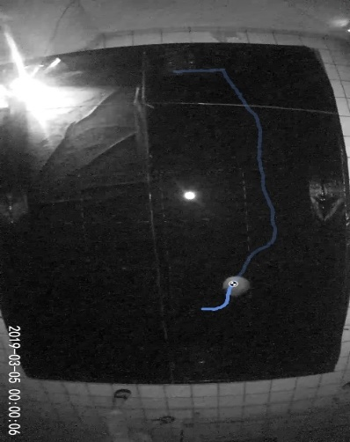
Figure 1 tracking with kinovea

Kecepatan respons
kecepatan respons menjauhi (detik)
rendah | sedang | tinggi
45 | 36 | 110
25 | 53 | 18
26 | 16 | 8
60 | 13 | 25
10 | 314 | 8
30 | 14 | 67
47 | 20 | 39,33333333
45 | 10
28 | 59,5
57
11
19
15
22
18
15
8
20
71
24
77
32,04761905
(3.68 × 10-6 W/cm2) | (5.47 × 10-6 W/cm2) | (1.05 × 10-5 W/cm2)
32,05 | 59,06 | 39,33
45,05 | 45,06 | 33,58

