Spatial Distribution Analysis Of Field Bathymetry And Landsat 8 Satellite Imagery on The Catch of Pots in Jepara Regency

Zulyani, Agus Hartoko, Herry Boesono S

Aquatic' resource management, fisheries department,
Faculty of Fisheries and Marine Sciences, Diponegoro University, Semarang, Indonesia

Attachment:
Appendix Results of SPSS 22 Data Length and Weight Fish as Y, Batimetry as X. (Simple Linear Regression Test with Model Feasibility Requirements, Normality Test, Linearity Test, and Heteroscedasticity Test).
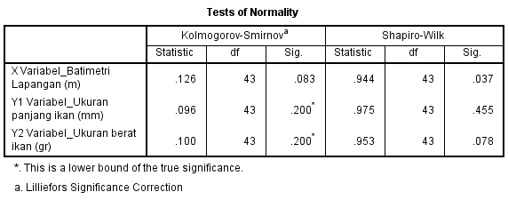
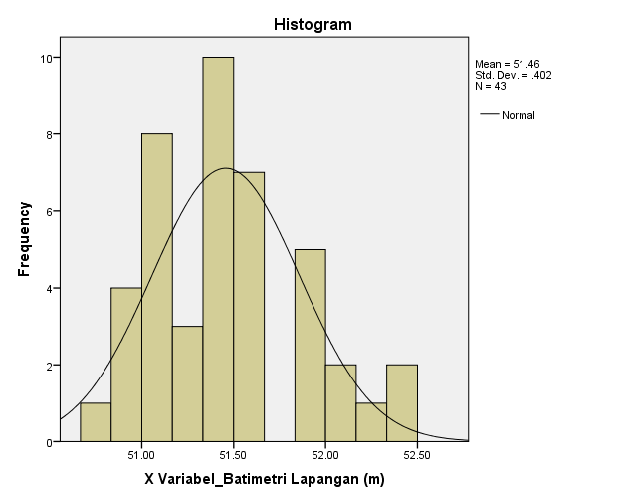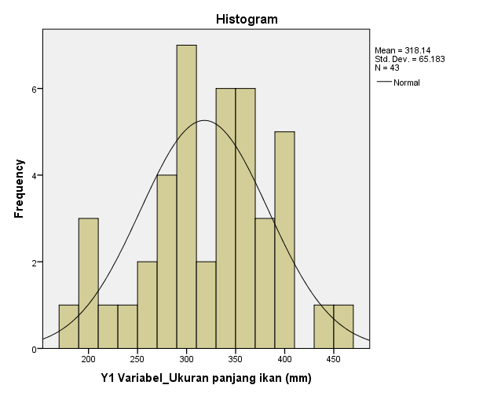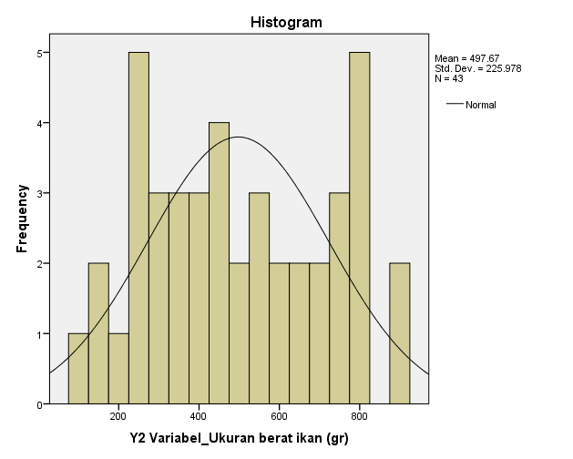

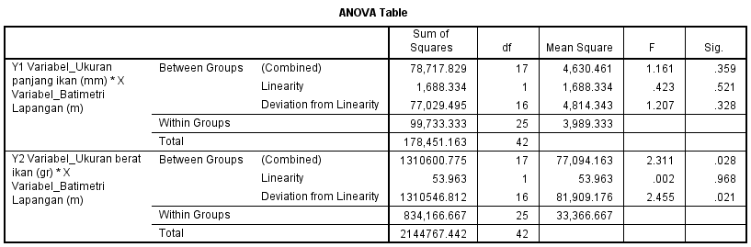

Regression:
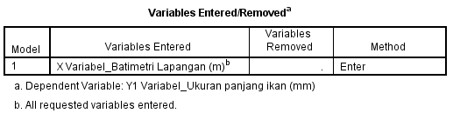
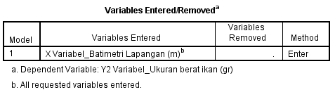

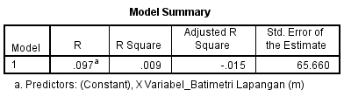
Y=size length
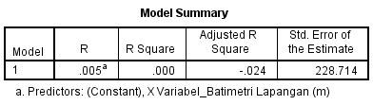
Y=weigth measure
