SPATIAL DISTRIBUTION ANALYSIS OF FIELD BATHYMETRY AND LANDSAT 8 SATELLITE IMAGERY ON THE CATCH OF POTS

IN JEPARA REGENCY

Zulyani, Agus Hartoko, and Herry Boesono
Coastal Resources Management, Fisheries Department,
Faculty of Fisheries and Marine Science Diponegoro University, Indonesia
St. Prof. Soedarto,SH Tembalang, Semarang
Email : izulperdana1@gmail.com, agushartoko.undip@gmail.com, herryboesono@gmail.com

ABSTRACT
Pots operated at the bottom of water are passive and entrapping, making fish easier to get in and yet difficult to escape. Problems faced by pots fishermen include the difficulty of finding ideal fishing areas for reasonable and valuable economic yields. The aim of this study is to analyze the spatial distribution of real and Landsat 8 Satellite Imagery of bathymetry on the operation of pots in Jepara. It is objected to find out the bathymetry distribution, whether it affects the catch or not. The primary data parameters are water depth (bathymetry), coordinates, and pots catch. The secondary data are local waters tidal data and Landsat 8 satellite imagery. The primary data is processed with numerical computation and tidal correction—while the secondary data uses ErMapper 7.1 software. Result of polynomial regression Landsat 8 bathymetry in explaining the actual (absolute) bathymetry is 25,88% of the bathymetry value that can be explained by Landsat 8 satellite imagery field, whereas results of the Landsat 8 bathymetry against fish long size of catched is only 5% able to explain the fish length size variables and 3,3% was able to explain the fish weight variables. On polynomial regression real bathymetry measurement with fish long size of catched is only 3, 6% bathymetry define fish long size variables and define 1,6% of the fish weight variables. The hypothesis is tested with linear regression on SPSS 22. This study uses methods purposive sampling of primary data in situ, bathymetry data corrected for tides, and the catch measured for length and weight of fish per species according to the sampling point. The test results on SPSS 22 assumed that the bathymetry distribution had no effect on the catch of pots. Based on a simple linear regression test, the effect of bathymetryc on fish length values only 0,9 % -- while on fish weight there was no effect at all. The results of field bathymetry analysis on Landsat 8 images have a polynomial regression relationship with a coefficient of determination (R²) value of 0.258.

Keywords: Spatial distribution; bathymetry; pots; landsat 8; erMapper; Jepara.

INTRODUCTION
Fishing tools are objects of equipment and facilities used to catch fish, according to its nature are static (settled and not being moved for a long time), passive (settled in a short time), and active (marine and fishery regulations and fisheries number 71 2016). Pots is included in traps group according to SNI 8187: 201589, and a passive fishing device is in accordance with the Regulation of Minister of Maritime Affairs and Fisheries Number 71 of 2016.
In the Law of the Republic of Indonesia number 31 of 2004 concerning Fisheries, Indonesian Fisheries Management was conducted to achieve guaranteed, optimal, and sustainable fish resource. One of the objectives of the Regulation of the Minister of Maritime Affairs and Fisheries Number 71 of 2016 is to realize the use of that concerned matters for fish resources. The criteria as required by FAO 1984 regarding environmentally friendly fishing include capture devices having high selectivity pots encompass this as the fish is caught alive so as possible to release it again if it is not taken.
The difficulty of fishermen in the north coast region of Java is finding out the ideal fishing ground to gain a good result. To this point, fishermen are doing a seabed detection (using fish finder) which is assumed to have coral reefs and seagrass as the habitat of the pots-targetted coral fish. This takes a long time to scan thorugh a wide-ranging sea area (Kunarso et al., 2016). Furthermore, fishermen do not acknowledge the changing fishing ground location, causing a less efficient and wasteful in time and cost (Mahabror et al., 2017).
According to Sejati et al., (2017), reefs are one of the most complex and productive ecosystems as habitats growing place and feeding ground for types of fish, animals, and plants that are essential for human. Coral reefs ecosystems need sunlight for the process of photosynthesis and its development. The sunlight entry to the water level is affected by water clarity, and this water clarity is prompted by suspended particles (Setiady and Ediar Usman, 2018).
The remote sensing method using satellite image data is able to display broad coverage of earth’s suface. The result can be used for various interests through processing, analyzing, and interpreting the data so that information from object sensed is gained—it’s one of remote sensing technologies (Hartoko et al., 2019).
This study aims to analyze the spatial distribution of bathymetry (approachment to coral reefs ecosystem as habitat) to find out the effect on the catch of pots in Jepara regency.

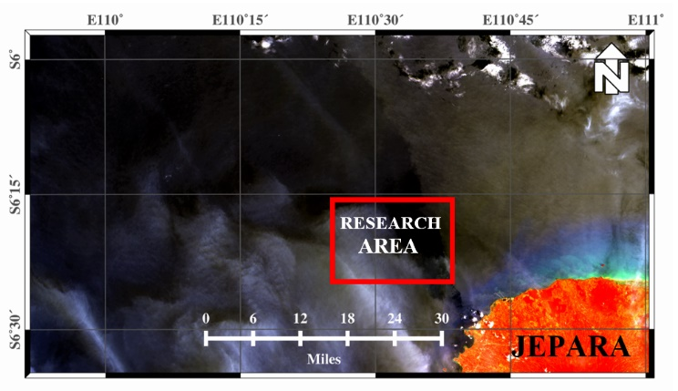
Figure 1. Research Area

According to Hartono (2016), the spatial database is a set of spatial data from several themes (layers) that have similarities (hydrography, topography, transportation, land coverage, toponymy). Spatial data representation is grouped into two parts, namely raster and vector data (Hartoko et al., 2019).

RESEARCH METHODS
Methods used in this study uses purposive sampling, that is the operation of the pots on the location appointed by fishermen as the fishing ground with sampling comprises coordinates, water bathymetry, and measurement of the length and weight of catches. Secondary data applies tidal data taken from pasut.maritimsemarang.com and data on the Landsat 8 OLI/TIRS from earthexplorer.usgs.gov (acquired on 18 November, 2020, Path 120/ Row 64). The field data was obtained on 11 November 2020 up to 17 November 2020 in the waters of Jepara Regency.
According to Hartoko et al. (2019), the OLI/TIRS Landsat 8 satellite has a temporal resolution (durations for satellite sensor to sense the same place for the second time) of 16 days, and radiometric resolution (dimension of the sensor in recording the smallest difference of one object to another) of 16 bits.
The processing of coordinates by converting the coordinates of longitude and altitude into numerical values is referred to Hartoko and Helmi (2004), it uses formula (1); bathymetry data corrected with tidal data of waters is referred to Hasriyanti et al. (2015), it uses formula (2) and (3).
In order to obtain the accurate average depth of waters, it is necessary to consider the tides because measurement of waters in the area obtained are not carried out at the same time (Setiady et al., 2018).

Numerical value (latitude; longitude)
= Degree + {minute + (second / 60)} / 60 .................. (1)
ΔD = DT- (HT-MSL-DWL) .............................................(2)
Ht = ht0 + {m (np0 - np1) / 60} .......................................(3)

$∆d$ : Bathymetry a point of the sea bed
dt : Bathymetry a point of the sea bed at a time
ht : height of the surface of water at t time
MSL : Mean Sea Level
DWL : draft/tranduser position level on hull
ht₀ : tides on the hour before the minute of measurement
M : minutes (excess minutes of tide measurement hour moment)
NP₁ : tide (the hour moment after the minute of tide
measurement)
60 : minute conversion to hour

Data of landsat 8 imagery uses 542 band composition, corrected radiometrically. The Satellite Derived Bathymetry (SDB) process of algorithm is conducted with thresholding approach, referring to Hartoko, (2010); Sartika, (2018) with the following formula:

SDB : Log Blue – Log Near Infrared ............................... (4)

Blue log : Band 2 variant log
Log near infrared: log value variant band 5

From the SDB formula, the Digital Number (DN) is achieved as relative depth. To get an absolute bathymetry, analysis of polynomial regression equations relationship is conducted. Estimation of bathymetry data analysis with thresholding approach resulted accurate value for shallow waters 0-19 m with a coefficient of determination (R²) of 0.849 (Sartika et al., 2018). Data on the absolut bathymetry results is presented in the map layout to be clearly comprehended through the gridding process of ErMapper 7.1. software.
The data processing on catch are total amount of fish length (mm unit) and fish weight (g unit). The data is recorded for each species according to the sampling coordinate. To answer the hypothesis of whether bathymetry affects the catch, F/ linear regression test is carried out using SPSS 22.

RESULTS AND DISCUSSION
- Field Bathimetry Results
Distribution of field bathymetry corrected by tide is in the range of 50-53 metres, with mean value of 51,50 meters.

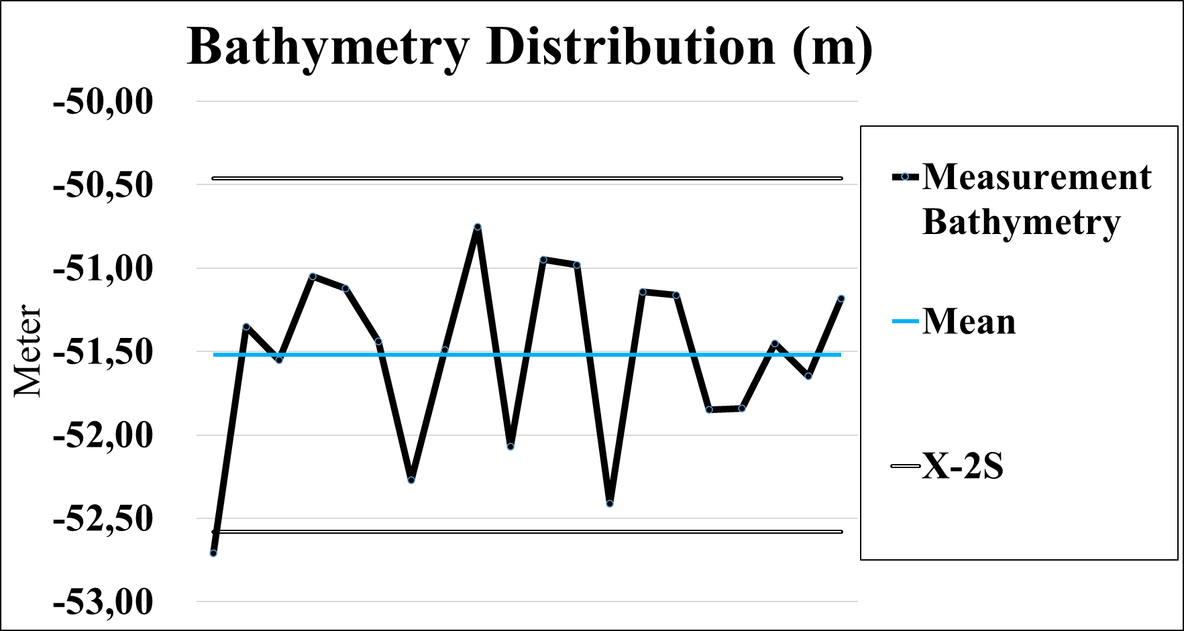
Graph 1. Measurement Bathymetry Distribution

The result of corrected depth is processed with gridding on ErMapper 7.1. software. The gridding result is presented with pseudocolour color mode layout, countour color table, as shown in Figure 2.

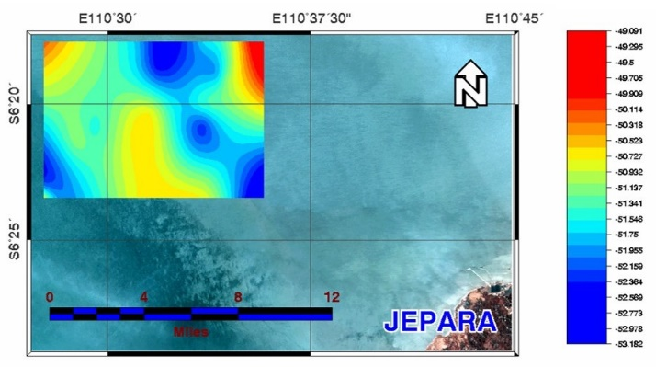
Figure 2. Field Bathymetry Contour Gridding

According to Hartoko et al., (2019), the gridding processed is done by interpolating the nearest points having horizontal value. The values of these points are close to one another. Data used in this gridding process are ASCII XYZ data with X and Y component as longitude and altitude coordinate and Z data component that is going to be proceed in gridding.
As shown in figure 2 presenting field bathymetry contour gridding, it is known that the distribution pattern is distinguished by the colour of red, yellow, green, and blue. Red indicates shallowest depth in meters, while blue indicates vice versa—the deepest.

- Bathymetry Results of Landsat Image 8 OLI/TIRS
The secondary field of Landsat 8 satellite imagery uses 245 band composition. Upon radiometrically corrected, the SDB algorithm resulted colour contours from DN value as relative depth as in the following figure:

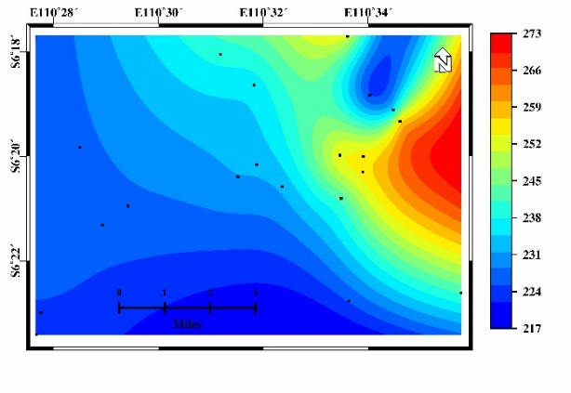
Figure 3. Relative Depth of Landsat 8

From the results of the Landsat 8 relative depth figure, it can be seen that the red contour shows the maximum value, while the blue color shows the minimum value. Contrary to the arrangement of bathymetryc measurement results because the indicated value is not a minus value as in the bathymetry measurement results.
Landsat 8 satellite imagery has a 16-bit radiometric resolution, meaning that every image has a color gradation (grayscale) of 216, so that the value of DN ranges from 0 - 65355 (Angraeni et al., 2018). The greater the bits have a sensor, the higher the radiometric resolution, therefore the higher the ability to distinguish objects on the surface of the earth (Hartoko et al., 2019).

- Polynomial Batimetry Regression Equation
The results of the DN value analysis are used to find out polynomial regression equations on field batymetry to reveal the absolute depths.

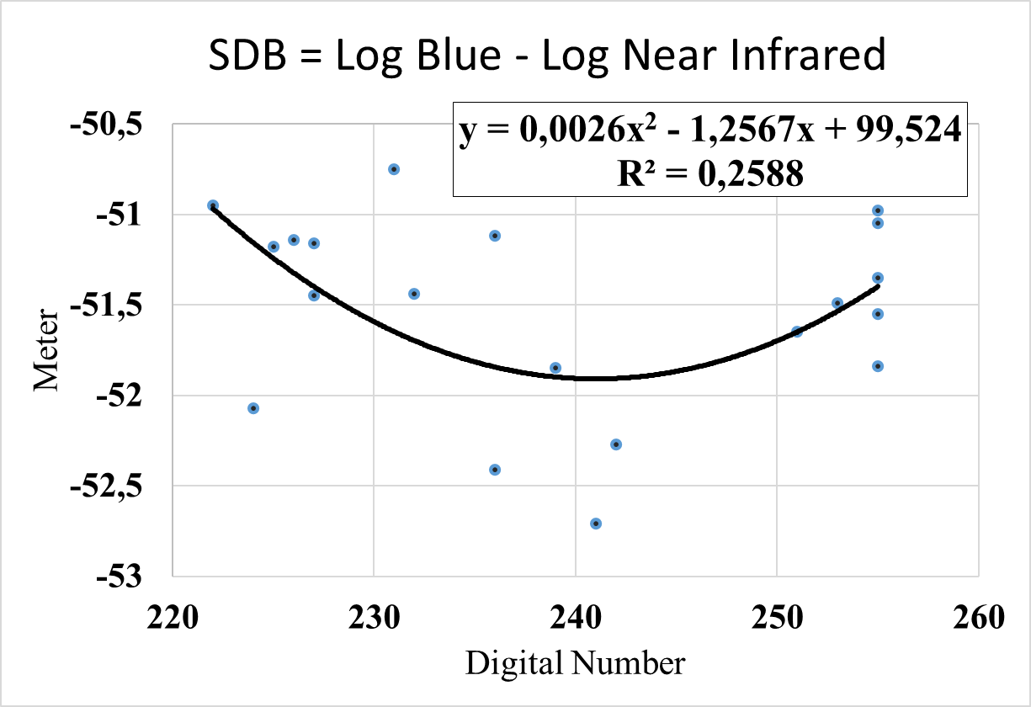
Graph 2. SDB Landsat 8 Depth Relationship

From the graph of polynomial regression it is obtained the subsequent equation Y = 0.0026x2 - 1.2567x + 99,524 with a value of R² = 0.2588.
The value of R² shows the magnitude of the Landsat 8 bathymetry in explaining the actual (absolute) bathymetry, that is 25,88% of the bathymetry value that can be explained by Landsat 8 satellite imagery field from the acquisition date after bathymetry measurements have been taken.

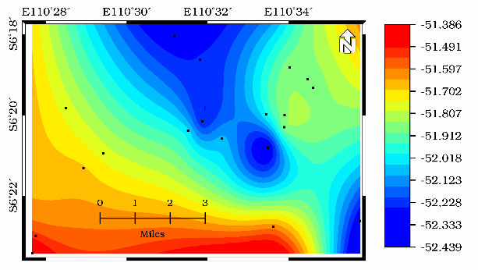
Figure 4. The absolute depth results of Landsat 8

The result of the absolute batymetry of secondary data on Landsat 8 images is presented in Figure 4. The red contour shows a minimum bathymetry (51.38 m) while the blue color shows a maximum bathymetry (52.43 m).

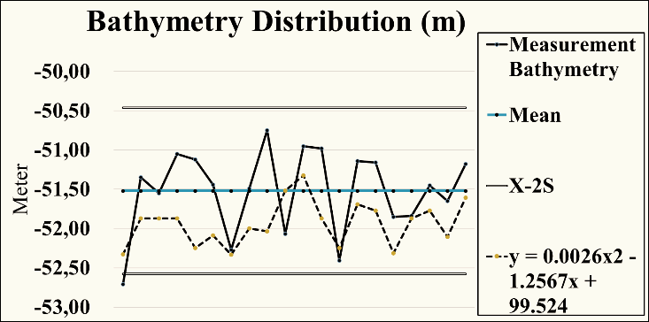
Graph 3. Bathymetry Distribution

From graph 3, it is known that the bathymetry distribution of Landsat 8 imagery result is slightly different from the bathymetry values ​​taken from field measurements. At the deepest bathymetry, the result of the Landsat 8 imagery appear shallower, while at the shallowest bathymetry the result of Landsat 8 appears deeper, meaning that the bathymetry values ​​result Landsat 8 imagery on the acquisition date is within the range of field bathymetry.

- Pots catch results
The fish results from each fishing ground were measured for the length and weight of each species. Of the 28 sampling coordinate points, only 25 points were managed to catch 106 fishes consisting of 15 species: Abalistes stellaris, Aluterus monoceros, Arothron hispidus, Caranx hippos, Diagramma pictum, Ephinepelus bleekeri, Ephinepelus coioides, Lethrinus Lentjhan, Lutjanus malabaricus, Lutjanus rusellii, Lutjanus sebaee, Neotrygon kuhlii, Plectromomus moculatus, siganus canaliculatus, dan Upeneus sulphureus.
According to Setiyono et al., (2016), the composition of catching pots in his research in the Bay waters of the Pusuk Village, there are species types such as : Paraplotosus albilabris, Scatophagus argus, Siganus canaliculatus, Lutjanus russelli, Epinephelus timorensis, Chelmon rostratus, Acreichthys tomentosus, Lethrinus lentjan, Drepane punctata, Tetranodon lunaris dan Plectorhynchus Pictus.
From 106 field of length and weight (of the catch) statistical test is carried out using SPSS 22 software to answer the hypothesis. The test used is a linear regression test with independent variables (bathymetry) and dependent variables (1. Length; 2. The requirements) for the feasibility of the linear regression test model, namely: normality test, linearity test, and heteroscedasticity test.
There are extreme data and outlier data from 106 data, passing the normality test of only 43 data, so that there are 43 data that can be teseted for linear regression tests, as the following graph 4 presents.
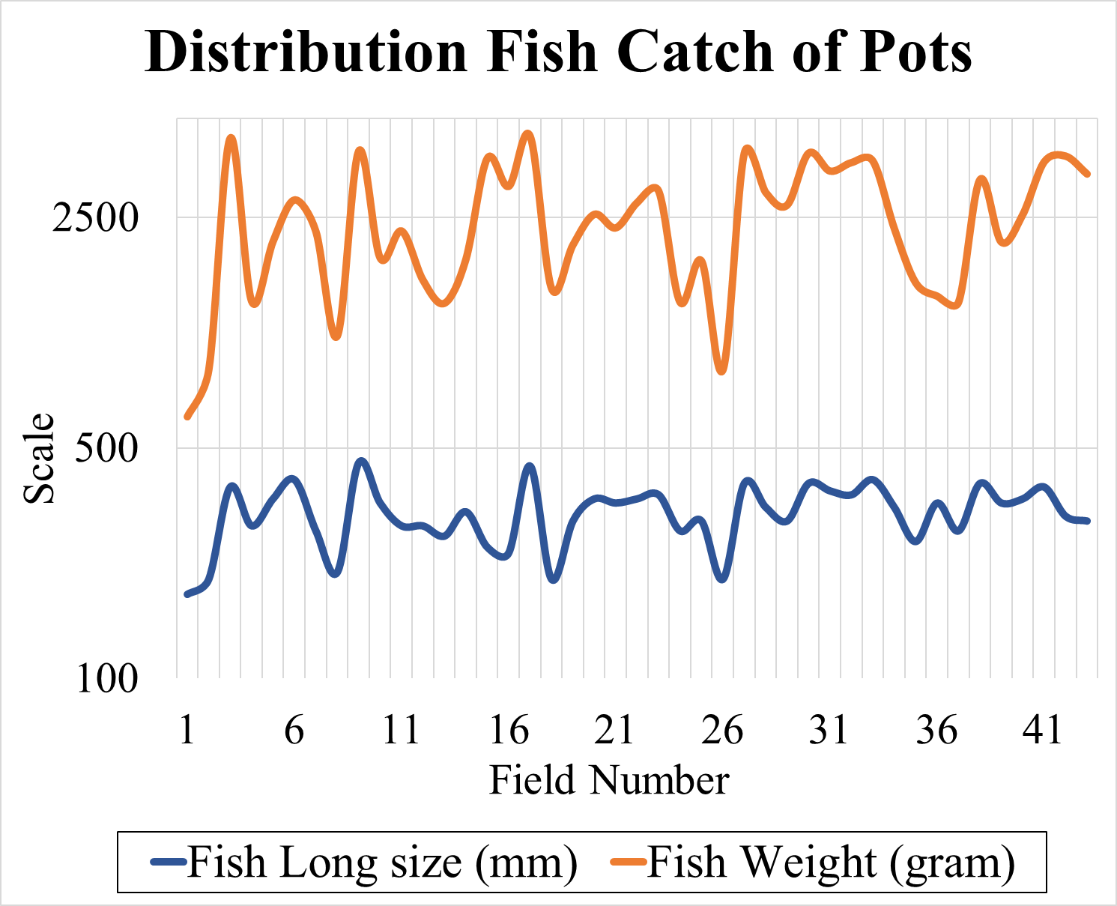
Graph 4. Distribution Fish Catch of Pots
Hypothesis Analysis

From graph 4. it is known that the size distribution of fish length in millimeters ranges from 180 mm to 450 mm with an average of 318,1 mm. While the weight is between 441 gram to 3.960 gram. According WWF Indonesia (2015), the size is worth capturing for grouper fish range of 290 mm to 420 mm while the snapper range is around 350 mm to 490 mm.

- Polynomial Regression Bathymetry on the Catch of Pots
The relationship bathymetry on the catch of pots is known by analysis of polynomial regression between the measurement depth/ depth of the image of Landsat-8 on the size of the fish length (mm) and the size of the fish weight (gram), as the following graph image:

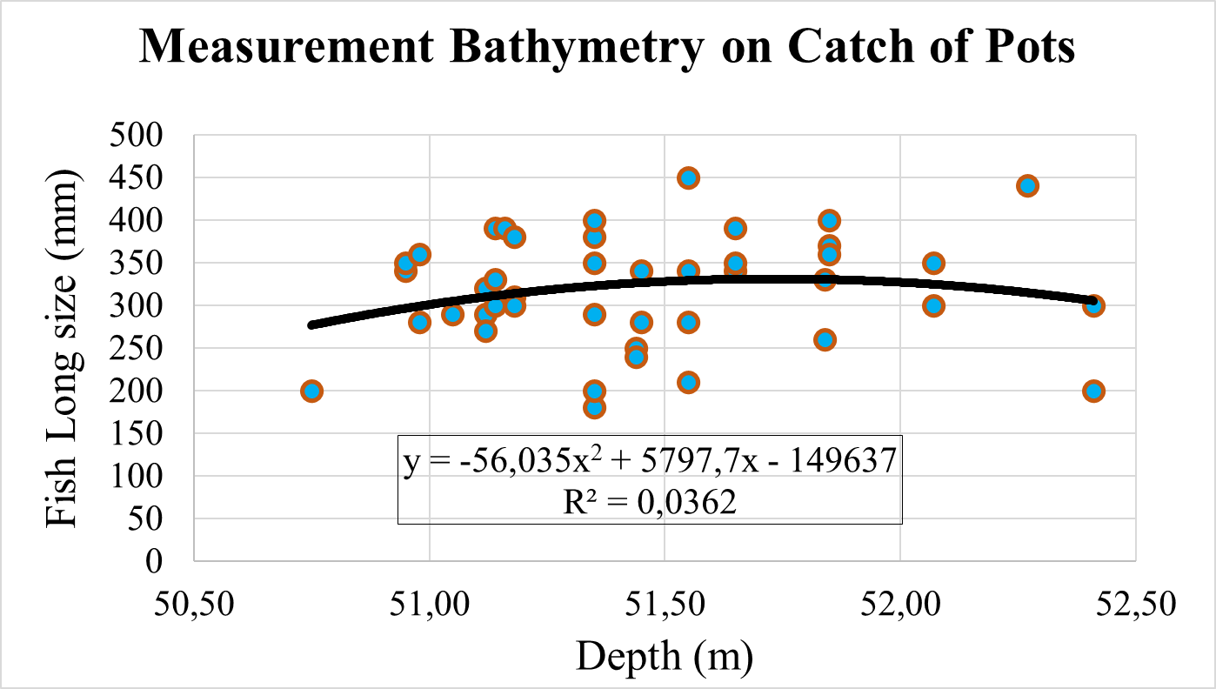
Graph 6. Bathymetry measurement Relationship Fish
Long size on catch of Pots

From the results of the regression analysis obtained equation Y= -56,035X² + 5797,7X – 149637 result coefficient of determination from the linear regression model is only 0,036. its means the x variable (depth) can only define 3, 6% of the y variable (fish long size). Next, to determine the relationship bathymetry with catch of pots, a regression test is carried out between the depth of weight (gram) fish, us follow:
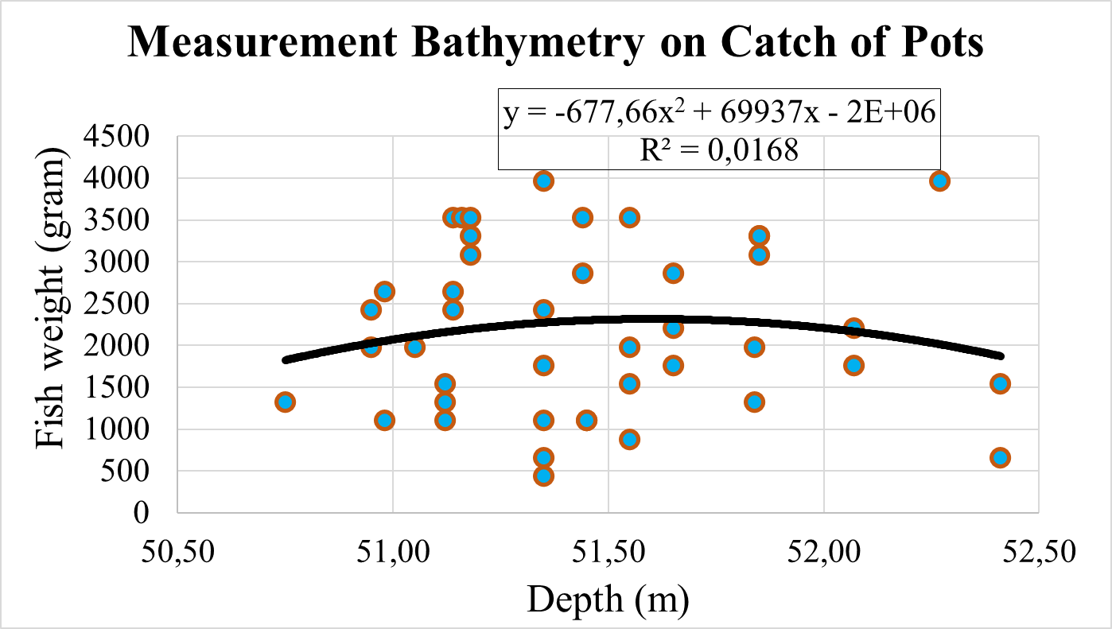
Graph 7. Bathymetry measurement Relationship Fish
Weight on catch of Pots

The equation obtained from the regression model is Y=-677,66X² + 69937X – 2E+06, with a coefficient of determination of 0,016 meaning the depth variable can only define 1,6% of the fish weight variables.
The test results of the bathymetry measurement with catch of pots using polynomial regression, bathymetry as a variable x while fish length size and fish weight as a variable Y can be interpreted does not have a significant relationship, other assumptions of variables (bathymetry measurement) is not affect the variable Y (results catch of pots). According to Kour (2018), in his study stated that the type of pots had an effect on the catch.
From the results of Landsat-8 imagery, with the same treatment as the measurement bathymetry to test its relationships / influence on the catch of pots, the polynomial regression test is carried out as the following graph image:
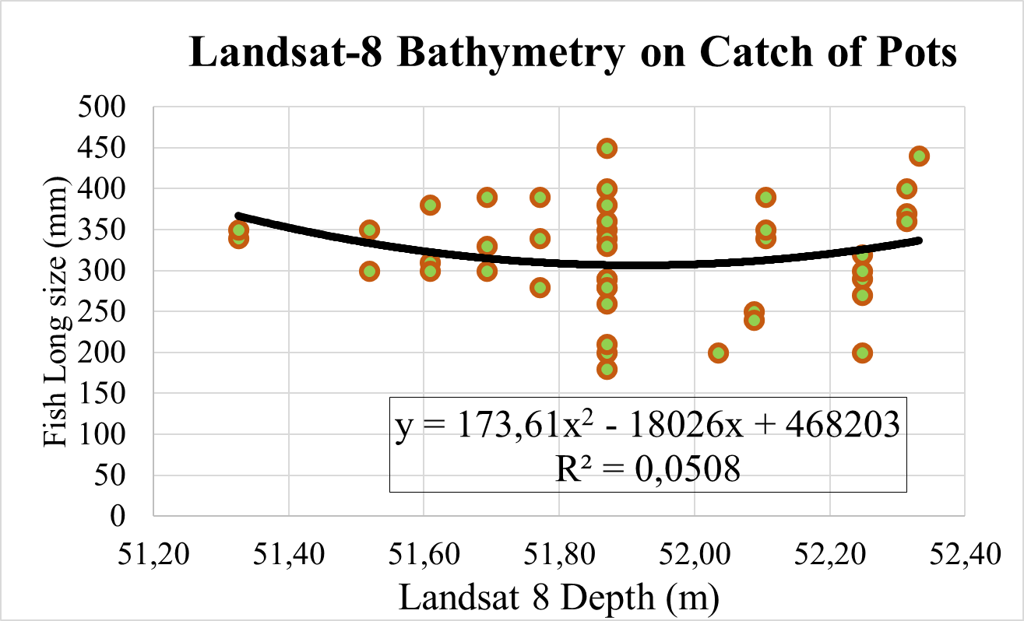Graph 9. Bathymetry Landsat-8 Relationship Fish Long
size on catch of Pots

From Graph 9. be obtained regression equation is Y= 173,61 X² – 18026X + 468203. The coefficient value of the determination is obtained by 0,050 which means that only 5% of the bathymetry variables from Landsat-8 are able to explain the fish length size variables.
Next the Landsat-8 bathymetry variable on the size of the fish weight is carried out the same regression test as the following:
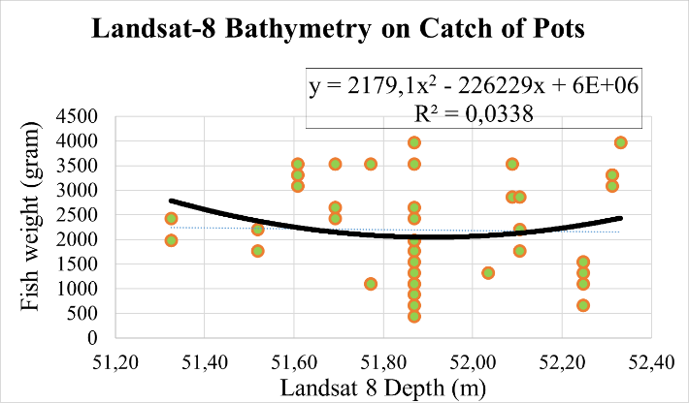
Graph 10. Bathymetry Landsat-8 Relationship Fish
weight on catch of Pots

Landsat-8 bathymetry as variable x while fish weight is as a variable y the regression test results obtained equation Y=2179,1X² – 226229X + 6E+06. From the equation results the coefficient of the determination is 0,033 that meaning only by 3,3% of the X variable was able to explain the variable Y. According to Sinaga (2019), the large number main catches of pots significantly influenced by the modification of the number of Funnels. Saraswati et al (2020), added that the catch of pots in her research was influenced by feedback and immersing duration.
From the results of Polynomial Regression Test the measurement bathymetri and Landsat-8 Bathymetry for overall fish catch of Pots, maximum of only 5% of the capabilities of variables X explain the Y variable, so it is assumed that there is no significant influence on the bathymetry on the catch of pots to the measurement bathymetry and Landsat-8 satellite image bathymetry. But these results need to be proven further with statistical tests on SPSS software.

- Results of SPSS analysis
The results of the normality test using the Liliefors method, based on Kolmogorov-Smirnov, the value of the sig. is greater than alpha (0,05) so it was concluded that data is normally distributed.
Sig. value. Deviation from the linearity of the bathymetry variable on the size of the fish is 0,328—this value is greater than alpha (0,05), meaning that it is significantly indicates linearity. In the bathymetry variable on the size of weight the Sig. value amounts 0,021, smaller than 0,05 meaning that there is no linear relationship between the size of the bathymetry and the weight of the fish.
Linear regression test using the Enter variable input method on all dependent variables include all variables, the bathymetry to the length and to the weight of the fish. The value of R Square shows the amount of the influence of X to Y variable. The bathymetry variable on the length of the fish values 0,009 meaning only 0,9% the influence of bathymetry to the length of fish; while there is no slightest influence of bathymetry to the fish weight. According to Setiyono et al. (2016), the catch of pots is influenced by the duration of soaking, habitat, pots and bait design. Based on the Kruskal Wallis Test the duration of pots soaking has a real influence on the catch. Based on the catch of pots with gunny sack as attrator, with the difference in depth, there is no significant relationship. Operation of pots at 15 meters deep is more efficient than that of 5 (Sejati et al., 2017). Based on the effectiveness of pots catches, Papaya fruit as bait is quite effective in catching rabbitfish (Siganus Puellus) as it is supported by the condition of the waters in Bajo Village (Bakari et al., 2018). Considering the production of pots using inorganic baits are more optimal than the organic, however, based on the Mann-Withney test there is no significant difference (Soamole et al., 2020).
In general, the simple linear regression equation is Y= a + bX. From the Coefficients table, it can be derived the regression equation is: Y = – 492,867 + 15,761 X. This means that the constant number of fish length, if there is no influence from bathymetry is – 492,876. The regression coefficient value is 15,761 meaning that for every 1% addition of bathymetry, the length will increase by 15,761. While the constant number of fish weight, if there is no influence from bathymetry is consistent at 352,682. The value of the regression coefficient is 2,818 meaning that for every 1% addition of bathymetry, the weight of the fish will increase by 2,818 hence the equation is Y = 352,682 + 2,818 X.

CONCLUSION
Based on the results of the Batimetry analysis to Landsat 8 satellite image to determine the absolute depth, it is obtained the polynomial regression equation, y = 0,0026x2 – 1,2567x + 99.24 with a value of R² = 0.2588.
Based on the results of a simple linear regression test, analysis of the bathymetryc spatial distribution (51 m to 52 m) on the catch of pots in Jepara Regency, in general, there is no significant effect. In detail, only 0.9% of the effect of bathymetry on the size of the fish length.

REFERENCE

Anggraeni, D., M. N. Fauzi., And c. Ngesti H., 2018. Mapping the distribution of seagrasses in the Tanimbar Islands of West Southeast Maluku Regency Province Maluku. Geomatika National Seminar 2018: Use and Development of Geospatial Information Products Support National Competitiveness: 871-880.

Bakari, Y., A.h. Olii., And a.s.r. New. 2018. Effectiveness of bubu capture devices with different bait for baronang fish. Fisheries and marine scientific journals. 6 (1): 8-10.

Hartoko, A., and M. Helmi. 2004. Development of Digital Multilayer Ecological Model for Padang Coastal Water (West Sumatra). Journal of Coastal Developtment. 7 (3): 129-136.

Hartoko, A., N. Latifah, and S. Febrianto. 2019. Teaching Books Inderaaja and Fisheries Mapping Coastal Sea Habitat. Water Resource Management Study Program. Faculty of Fisheries and Marine Science. Undip Press. Semarang. 114 p.

Hartono. 2016. Utilization of remote sensing cartography and geographic information systems in improving spatial intelligence for development. Proceedings of the 2016 National Geography Seminar, Geography Department of Faculty of Social Sciences, Padang State University: 1 - 22 p.

Hasriyanti., E. Syarif, and Maddatuang. 2015. Analysis of the characteristics of the depth of the waters, currents and waves on the Dutungan Island of Barru Regency. Journal of Scientific Pinisi 1 (1): 44-54.

Kunarso., Irwani, A. Satriadi, M. Helmi, and Ab. Candra. 2016. Season of Fish in Jepara Jawa Sea Waters and the Prediction of the Fishing Ground Location. Proceedings of the annual seminar to V fisheries and marine research results. F2 05: 636-646.

Mahabror, D., A.B. Zaky, and J.j. Hidayat. 2017. Spatial analysis and temporal fishing season with remote sensing data and a Vessel Monitoring System in the waters of Aru Islands. Proceedings of the National Marine and Fisheries Seminar III: 131-140.

National Standardization Agency. 2015. Indonesian National Standard (SNI) 8187: 2015. ICS.65,150. Fishing Tools - Classification of Fishing Tools (API).

Sartika, D., A. Hartoko., And Kurniawan. 2018. Analysis of field batymetry data and 8 oil landsat images in the waters of the Strait of Lepar in South Bangka Regency. Fisheries Saintek Journal. 13 (2): 75-81.

Sejati, L.P., H. Boesono, and F. Kurnohman. 2017. Effect of Depth and Use of Goni Cover against Buton Bubu catches in Karimunjawa waters. Journal of Fisheries Resources Utilization Management and Technology. 6 (4): 284-290.

Setiady, D., and E. Usman. 2018. Coral reefs based on the depth of the sea and the influence of the waters of the Aruah Islands, Rokan Hilir Regency Riau Province. Environmental journals and geological disasters. 9 (1): 21-30.

Setiyono, E., W. Adi., And Kurniawan. 2016. Comparison of the old soaking base of the base using coconut leaf cover against fish catches in the Bay of Bangka Bangka Barat Village. Journal of Waters Resources (Aquatik). 10 (2): 1-5.

Soamole, M. R., U. Utangke., And S.S. Titiseluw. 2020. Productivity Bubu Basic with different types of bait in South Ternate waters. PSP IPTEks Journal. 7 (13): 1-14.

WWF-Indonesia Fisheries Team. 2015. Grouper Fishery and Snapper, Guide to Arrest and Handling. WWF-Indonesia. Jakarta Indonesia. ISBN 978-979-1461-67-2.

Kour F., 2018. Analysis of Traps catches in the waters of the district of Babar Island district in Southwest Maluku Regency. Journal of Hibualamo 2(1): 58 – 63.

Sinaga. I., dan Sahat P.S., 2019. Study of catch traps wire with different funnel in the Central Tapanuli area. Juornal Applied Fisheries and Marine Research. 1(2):21 – 29. EISSN: 2715-3096 PISSN: 2715-5323.

Saraswati. N., Herry. B, dan Indradi. S, 2020. The Effect of Differences of Using Bait and Immersing Time of Result of Catch in Batang Waters. Journal of Fisheries Resources Utilization Management and Technology. 9(2): 7-13.

