The Effect of Product Quality and Service Speed on the Purchase Decisions for Coffee Carts on Gen Z in Medan City

Abstract
Coffee consumption trends among Generation Z have shown a significant increase, along with the proliferation of coffee cart businesses that offer practical products at affordable prices. However, amid increasingly fierce competition, business actors face challenges in maintaining the purchasing decisions of young consumers, especially among Gen Z. This study aims to analyze the effect of product quality and service speed on purchasing decisions for Gen Z consumers in Medan City. The approach used is quantitative with the Structural Equation Modeling-Partial Least Squares (SEM-PLS) method. Data were obtained from 100 respondents, namely Gen Z who live in Medan City, and were collected through questionnaires and analyzed using SmartPLS. The results of the outer model evaluation show that all variable indicators are valid and reliable. The inner model evaluation also shows an R² value of 0.446, which means that product quality and service speed simultaneously explain 44.6% of the variability in purchasing decisions. The relationship between the independent and dependent variables partially and simultaneously both have a significant effect. The Q² value of 0.231 also indicates that the model has sufficient predictive relevance. The findings suggest that coffee cart businesses need to prioritize improving product quality and service speed to drive purchasing decisions among Generation Z Medan City.

Keywords: Product Quality, Service Speed, Purchase Decision, Gen Z, Medan City

© 2025 by Authors, Published by Management Departement Faculty of Economics and Business Diponegoro University. This is an open access article under the CC-BY-SA License (https://creativecommons.org/licenses/by-sa/4.0).

INTRODUCTION

The Coordinating Ministry for Food Affairs of the Republic of Indonesia (2025) explained that Indonesia is the fourth largest coffee producer in the world, showing the strategic role of coffee commodities in the national agricultural sector. This is also in line with data from the 2019-2023 export commodity analysis presented by the Indonesian Central Bureau of Statistics (2024) that coffee commodities are agricultural products with the largest export value in 2023, with an average contribution value of 35.24 percent of annual crop agricultural sector exports. Not only does it play a role in international trade, but domestic coffee consumption also shows a significant increase, with the average consumption of coffee beans/powder reaching around 1.39 grams and instant coffee (sachet) around 0.21 grams (Badan Pusat Statistik, 2024). This development is triggered by a fundamental shift in people's consumption patterns, especially among Generation Z where coffee is no longer perceived solely as a caffeinated beverage, but has been integrated as an essential element in their contemporary lifestyle; coffee serves as a means of identity expression, a medium of social interaction, as well as a component of daily rituals that emphasize aesthetic value and multisensory experiences.
Figure 1. Prevalence of Coffee Consumption of Millennials and Generation Z
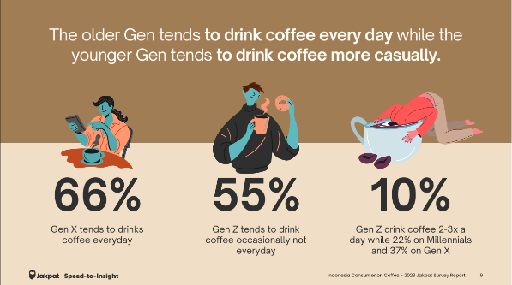
Source: Jakpat survey report
Anastasya (2023)Based on the Indonesia Consumer on Coffee 2023 report compiled by Jakpat, data collection was conducted through a proportional random sampling method online on May 26, 2023. From the report, it was noted that as many as 55.78% of Gen Z consume coffee occasionally, and around 10.55% consume coffee 2-3 times a day, indicating that the habit of drinking coffee has become part of their lifestyle, although not dominant every day (Maria et al., 2025). This finding shows the high intensity of coffee consumption in the young age segment. Gen Z, or Generation Z, is those born between 1997 and 2012 and prioritize quick access (Lestari et al, 2024) (Zahira & Nasution, 2025) (Wahyudi & P, 2025). Along with this trend, various business models have emerged that are oriented towards flexibility and accessibility for consumers. One of the emerging business models is mobile coffee. The mobile coffee business is increasingly developing in the midst of modern lifestyles, especially for the younger generation who want quick and practical access to coffee(Amadea et al., 2025).
Changes in today's lifestyle that began to be dominated by Gen Z have encouraged entrepreneurs to innovate to create businesses that are able to follow the lifestyle of Gen Z. One of these business innovations is coffee carts. As the name implies, coffee carts are an innovative sales strategy for selling coffee using a cart on the side of the road. The coffee cart trend was born from the public's need for easier, faster, and more affordable access to quality coffee without having to come to a traditional shop or cafe.
Medan, as one of the metropolitan cities in Indonesia, has very diverse social, economic, and cultural dynamics. With a population dominated by Gen Z, which was born in 1997-2012 (Badan Pusat Statistik Kota Medan, 2024). Medan is a potential market for the development of the food and beverage industry, especially coffee. In the city of Medan itself, coffee carts operate around campuses or front offices and have attracted the attention of many students and office workers, until they went viral on social media and have grown very rapidly until now. Kopi Gerobakan is unique in its sales strategy that can easily move and move, and make it easier for consumers to make purchases.
Along with the high consumption of coffee by Generation Z and the development of coffee cart business models that offer practicality and high mobility. It is important to understand what factors influence purchasing decisions in the Gen Z market segment. The purchase decision is an important aspect because it determines the sustainability of the business in the midst of dynamic market competition.
Researchers suspect that there are two factors that influence the decision to purchase coffee carts for Gen Z in Medan City, namely product quality and service speed. Product quality is the perceived suitability of a product and the product meets the needs (Hidayat, 2021), while service speed is the target service time that can be completed within the time specified by the service delivery unit (Manguntara, 2023).
Various previous studies have shown that product quality has a positive influence on purchasing decisions, namely in the results of research by Safrida et al (2020) showing that the higher the quality of coffee products offered, the tendency of consumers to make purchases at coffee shops will also increase. In line with this, there is also a positive relationship between service speed and purchasing decisions, this is evidenced in research conducted by Irman (2024) showing the effect of service speed on purchasing decisions. However, there are still few studies that specifically examine the effect of product quality variables and service speed variables on the purchase decision of coffee carts, especially in the Gen Z market segment in Medan City.
Therefore, this study aims to fill this gap by analyzing the effect of product quality and service speed on purchasing decisions for coffee carts for Gen Z in Medan City. The findings of this study are also expected to contribute to the cart coffee business in developing more effective and efficient marketing strategies and strengthening competitiveness in a dynamic market, and can serve as a basis for future research that wants to explore other factors that influence purchasing decisions in the context of cart coffee.
LITERATURE REVIEW AND HYPOTHESE
Consumer Behavior

Syafrianita et al (2022) define consumer behavior as actions that are directly involved in obtaining, consuming and spending products and services which also include the decision process that precedes these actions. According to the Theory of Planned Behavior, human behavior is guided by three types of considerations, namely (Bosnjak et al., 2020):
- Behavioral Beliefs
A person's attitude in behaving either favorable or unfavorable and occurs when facing an object, person institution or event.
- Normative Beliefs
The level of influence such as norms, environment, or encouragement that comes from others or outside when making an individual's decision.
- Control Beliefs
The impetus that comes from consumers in making decisions, namely based on inner intentions
In research on purchasing decisions for coffee carts by Gen Z in Medan City, perceived product quality forms behavioral beliefs, where consumers assess the benefits and satisfaction obtained from these products. Service speed is related to control beliefs, namely the extent to which consumers find it easy and efficient to make purchases. Normative beliefs are also a reflection of the distinctive characteristics of Gen Z who value practical experience and speed in transactions. This trait makes Gen Z tend to adopt norms that support efficiency and convenience, thereby strengthening the intention to make a purchase.
Purchase Decision

Purchasing decisions are identifying all possible options for solving problems and assessing options systematically and objectively as well as goals that determine the advantages and disadvantages of each (Gunarsih et al., 2021). Decision making can also be interpreted as the process of choosing various alternative actions that may be chosen in the hope that it will result in the best decision (Hastuti & Anasrulloh, 2020). In line with research from Rumagit et at (2023) consumer purchasing decisions are buying the most preferred brand, the indicators of purchasing decisions, namely:
- The decision to buy a product because of a need.
- The decision to buy a product because of the acquisition of information.
- Purchasing decisions due to product availability
- Purchase decision due to promotion
- Purchasing decisions due to ease of access
Purchasing decisions in everyone are basically the same, but the decision-making process is based on the personality traits, age, income and life style of each consumer (Sari, 2021).
Product Quality

Product quality can be interpreted as a product’s ability to perform in accordance with its intended benefits, such as long-term durability, functionality, and ease of use in daily activities (Hafilah et al, 2019). A product is considered to have good quality if it is able to fulfill the expectations, needs, and preferences of consumers. One essential factor that influences how quality is perceived lies in the user’s experience during the consumption process, whether the product in question is a physical good or a service (Katili et al., 2018). This experience-based assessment allows customers to evaluate whether a product meets their standards. Supporting this notion, Dharmmesta and Handoko (2022) emphasize that product quality is closely tied to technical excellence, which refers to measurable and demonstrable attributes that give a product a competitive edge in the market. These attributes allow a product to be objectively assessed based on performance and reliability, the following are indicators of product quality, namely (Aditi & Hermansyur, 2018):
- Ease of Use
- Durability
- Clarity of Function
- Product Diversity
Service Speed

In addition to product quality, service speed also plays a crucial role in shaping customer satisfaction and business performance. According to Silvestri et al (2020) in today’s fast-paced and competitive business environment, the speed of service delivery can significantly influence consumer purchasing decisions, impact a company’s reputation, and determine overall organizational effectiveness. Service speed refers to how efficiently and promptly a business, organization, or individual is able to interact with customers to deliver products or services in a timely manner (Permata et al, 2024). This capability becomes even more essential as consumer expectations continue to shift toward instant or real-time experiences.
Putri and Rino (2023) also argue that service speed represents the company's ability to fulfill customer demands quickly, thus aligning with or exceeding customer expectations. When businesses are able to respond swiftly, it builds trust and enhances consumer loyalty. T vhe indicators of service speed are as follows (Azar & Efendi, 2020) :
- Service time standard
- Service completeness
- Efficiency and effectiveness
- Service consistency
- Improvement
Generation Z

Generation Z (Gen Z), also commonly referred to as the iGeneration, Net Generation, or Internet Generation, represents a demographic cohort that has grown up immersed in the digital era (Nurlaila et al., 2024) From a young age, members of this generation have been exposed to and engaged with various forms of digital technology, making them exceptionally adept at navigating the online world. Saebah et al (2022) highlight that Gen Z was raised during a time of rapid technological advancement, especially in the areas of internet access and social media platforms. This constant exposure has contributed to their deep familiarity with digital environments and virtual interactions. As a result, they are sometimes labeled albeit stereotypically as "technology addicts," due to their frequent and intense use of digital devices. According to Salmah et al (2025) Generation Z typically includes individuals born between 1997 and 2007, a period that coincides with major milestones in the evolution of digital technology.
Coffee Cart

Coffee carts are an innovation in the business world that combines coffee drinks with wheeled vehicles. The existence of coffee carts makes it easier for people to meet their daily caffeine needs without having to adjust their time and location to traditional cafes (Amadea et al., 2025) This business innovation shows a separation between coffee lovers in the upper, middle, and lower classes. The objective of the mobile coffee cart business is to reach a broader market by offering a variety of coffee options, similar to traditional cafes (Guterres et al., 2025)

Figure 2. Photo of One of The Coffee Carts Products
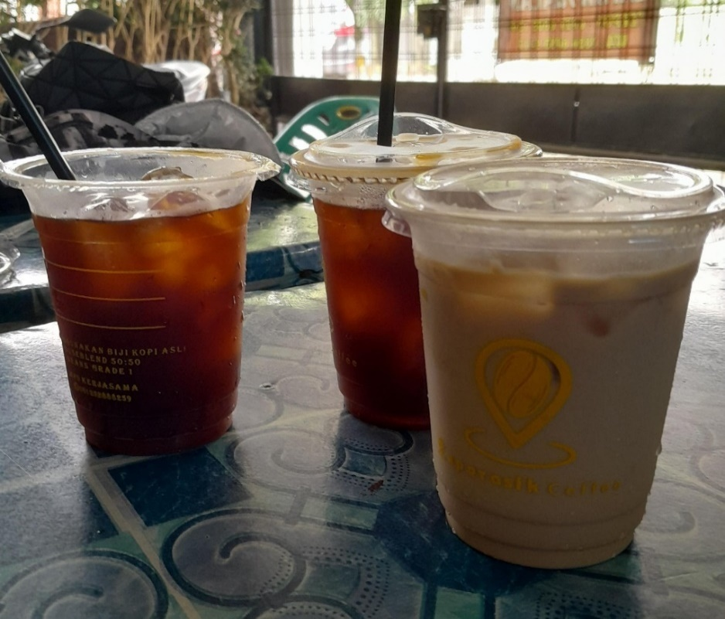
Source: Researcher’s camera capture
The Effect on Product Quality on The Purchase Decisions of Coffe Carts
Coffee carts entrepreneurs, despite operating on a small scale, are still required to maintain consistency and product quality in order to compete amid the abundance of available options, particularly among Gen Z consumers who are accustomed to alternative consumption choices. Research conducted by Anggraeni & Soliha (2020) found that product quality has a positive and significant impact on purchasing decisions. The better the product quality, the higher the purchasing decision. Similarly, research conducted by Purnama & Nainggolan (2023) found that product quality significantly influences consumer purchasing decisions at the “Coffe Sugar” coffee shop. Based on the above explanation, the researcher formulated the following hypothesis:
H1: Product quality has a positive and significant effect on purchase decisions for coffee carts.
The Effect of Service Speed on the Decision to Purchase Coffee from a Carts
Gen Z consumers are known for their dynamic and instant lifestyle. This means that mobile coffee vendors are required to not only provide quality products, but also serve them quickly and efficiently. A study conducted by Permata et al (2024) found that service speed significantly influences purchasing decisions, meaning that the faster the service is provided, the greater the likelihood of consumers making a purchase. In line with this research, Irman (2024) concluded that there is a significant influence between service speed and purchasing decisions. Based on this explanation, the researchers formulated the following hypothesis:
H2: Service speed has a significant effect on purchasing decisions for street coffee
The Effect of Product Quality and Service Speed on Purchasing Decisions
Although product quality and service speed have individually been proven to influence purchasing decisions, there has been little research examining both simultaneously in the mobile coffee business, especially among Gen Z consumers. Gen Z consumers have characteristics that demand both quality and speed in transactions. The combination of high product quality and fast service is believed to significantly increase purchasing appeal. This study aims to address this gap by analyzing the combined influence of both variables on purchasing decisions. Based on the above explanation, the researcher formulated the following hypothesis:
H3: Product quality and speed have a significant impact on purchasing decisions regarding Coffe Carts.

Figure 3. Conceptual Framework
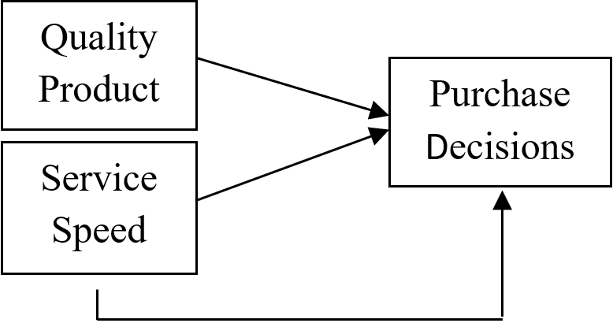
Source: Researcher
METHODS

This study adopts a quantitative research approach, which is characterized by the use of numerical data and statistical tools to examine relationships between variables in a structured and objective manner. Specifically, the method of analysis applied is Structural Equation Modeling using the Partial Least Squares (SEM-PLS) technique. This method was chosen because it is well-suited for analyzing complex causal relationships involving latent variables, even when the sample size is relatively small and data distribution does not follow a normal pattern. SEM-PLS is particularly advantageous in exploratory studies where model development is a key objective, and it allows researchers to estimate both the measurement and structural models simultaneously with high flexibility.
For data collection, the researchers utilized a structured questionnaire that was distributed to respondents. The questionnaire was designed using a 5-point Likert scale, in which respondents were asked to express their level of agreement with a series of statements. The Likert scale ranged from 5 (strongly agree) to 1 (strongly disagree), allowing for nuanced responses that reflect varying degrees of perception, attitude, or behavior.
To determine the appropriate sampling technique, the researchers employed purposive sampling, a non-probability sampling method where participants are selected based on specific, pre-established criteria that align with the research objectives. In this study, the sample consisted of individuals who met the following conditions: (1) belonged to Generation Z, which includes those born between the years 1997 and 2012; (2) currently reside in Medan City; and (3) have previously made a purchase from a coffee cart vendor. These criteria were selected intentionally to ensure that the respondents had relevant experience and contextual understanding necessary to provide meaningful insights related to the research topic.
Due to the lack of official or specific data on the total population of coffee cart buyers in Medan, the researchers could not apply a traditional probability sampling method based on population parameters. As a result, to (Rezeki et al., 2025) determine the sample size, the study employed the Cochran Formula, which is commonly used in survey research when the population size is unknown or assumed to be infinite. Based on this formula, a total of 106 respondents were deemed adequate to provide reliable and valid findings This number satisfies the minimum sample size recommendation for SEM-PLS analysis, especially given the number of indicators and latent variables involved in the study. Furthermore, based on demographic data, the respondents consisted of 39.6% males and females 60.4%.
Figure 4. The gender composition
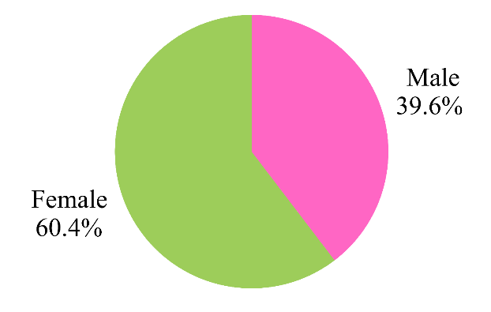
Source: Researcher

Finally, for the data analysis process, the software SmartPLS was used. SmartPLS is a powerful statistical tool designed to perform SEM-PLS analysis efficiently. It facilitates the estimation of path coefficients, evaluates model validity and reliability, and supports hypothesis testing. Its user-friendly interface and ability to handle complex models with small to medium-sized samples make it highly suitable for academic and applied research in various social science disciplines, including marketing, psychology, and management.
Table 1. Questionnaire Statements
Variable | Indicator | Statement (Questionnaire Item)
Product Quality  (Aditi & Hermansyur, 2018) | Ease of Use | Coffee cart products are easy to consume without the need for additional ingredients.
Product Quality  (Aditi & Hermansyur, 2018) | Durability | The coffee cart I bought has a delicious taste even if I don't drink it immediately.
Product Quality  (Aditi & Hermansyur, 2018) |  | The quality of the coffee cart remains intact even when purchased in different weather conditions.
Product Quality  (Aditi & Hermansyur, 2018) | Clarity of Function | The coffee cart products have clear information about the type and flavor of the coffee.
Product Quality  (Aditi & Hermansyur, 2018) | Product Diversity | I can choose the type of coffee according to my taste from the coffee cart seller.
Service Speed  (Azar & Efendi, 2020) | Service time standard | I received my coffee promptly after ordering.
Service Speed  (Azar & Efendi, 2020) |  | The service at coffe chart met my expectations
Service Speed  (Azar & Efendi, 2020) | Service Completeness | The service I received from the coffe cart was always thorough and flawless.
Service Speed  (Azar & Efendi, 2020) |  | Every order I made was prepared correctly and completely.
Service Speed  (Azar & Efendi, 2020) | Efficiency and effectiveness | The service process from ordering to receiving the coffee was very efficient.
Service Speed  (Azar & Efendi, 2020) | Service Consistency | Coffe cart’s service time was consistent every time I ordered.
Service Speed  (Azar & Efendi, 2020) |  | I always received the same quality of service from coffe cart
Service Speed  (Azar & Efendi, 2020) | Improvement | I noticed an improvement in service over time.
Purchase Intention  Rumagit et at (2023) | The decision to buy a product because of a need. | I buy coffee from a coffe cart because I feel like I need it.
Purchase Intention  Rumagit et at (2023) |  | Coffee from a coffe cart is a solution when I want a quick cup of coffee.
Purchase Intention  Rumagit et at (2023) | The decision to buy a product because of the acquisition of information. | I buy coffee from a coffe cart after receiving information from friends or social media.
Purchase Intention  Rumagit et at (2023) |  | The information I received convinced me to buy coffee from a coffe cart.
Purchase Intention  Rumagit et at (2023) | Purchasing decisions due to product availability | I tend to buy coffee from a coffe cart because it's always available when I need it.
Purchase Intention  Rumagit et at (2023) | Purchase decision due to promotion | I'm attracted to coffee from a coffe cart because of the attractive promotions they offer.
Purchase Intention  Rumagit et at (2023) | Purchasing decisions due to ease of access | The strategic location of the coffee from a street vendor influences my decision to buy.

RESULT AND DISCUSSION
Outer Model Evaluation

Evaluation of the outer model includes a convergent validity test, declared valid, this is considered valid because it has a loading factor value of more than 0.6 ( Wiyono & Kirana, 2020) and the Average Variance Extracted (AVE) value is declared valid because it is> 0.5 with a value of 0.524 for the product quality variable and 0.586 for the service speed variable and 0.544 for the purchase decision variable (Hair et al., 2021). Next is the discriminant validity test by analyzes the cross-loading value and the Fornell-Lacker value. If the value of the variable is greater than the other variables, it meets the cross-loading criteria and the AVE square root value (Fornell-Lacker) if the value on the diagonal line is greater than the value of the other constructs, it meets the criteria for the AVE square root value (Duryadi, 2021) and based on the data analyzed, the test results are declared valid. The final stage of evaluating the outer model carried out by researchers is the reliability test, at this stage, an analysis will be carried out on the Cronbach's Alpha (CA) and Composite Reliability (CR) values, where the value is considered valid if it has a value of> 0.7 at the CA value as the lower limit and <0.9 at the CR value as the upper limit (Hair et al., 2021).

Figure 5. Descriptive Outer Loading
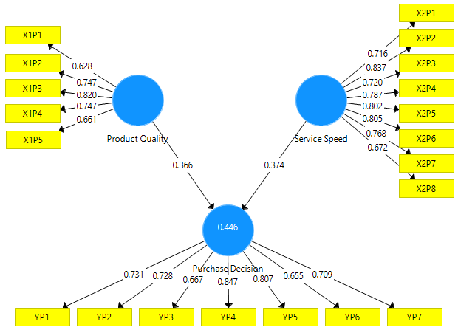
Source: Results of data processing using SmartPLS

Tabel 2. Descriptive Outer Loading
 | Product Quality | Service  Speed | Purchase Decision
X1P1 | 0.628 | 0.563 | 0.353
X1P2 | 0.747 | 0.377 | 0.460
X1P3 | 0.820 | 0.472 | 0.546
X1P4 | 0.747 | 0.472 | 0.408
X1P5 | 0.661 | 0.446 | 0.378
X2P1 | 0.409 | 0.716 | 0.404
X2P2 | 0.460 | 0.837 | 0.454
X2P3 | 0.453 | 0.720 | 0.395
X2P4 | 0.503 | 0.787 | 0.496
X2P5 | 0.515 | 0.802 | 0.396
X2P6 | 0.536 | 0.805 | 0.474
X2P7 | 0.487 | 0.768 | 0.562
X2P8 | 0.490 | 0.672 | 0.468
YP1 | 0.435 | 0.420 | 0.731
YP2 | 0.337 | 0.451 | 0.728
YP3 | 0.370 | 0.308 | 0.667
YP4 | 0.545 | 0.558 | 0.847
YP5 | 0.480 | 0.494 | 0.807
YP6 | 0.505 | 0.360 | 0.655
YP7 | 0.401 | 0.486 | 0.709
Source: Results of data processing using SmartPLS

Table 3. Descriptive Average Variance Extracted (AVE)
 | Average Variance Extracted (AVE)
Purcahe | 0.544
Product Quality | 0.524
service speed | 0.586
Source: Results of data processing using SmartPLS

Table 4. Descriptive Cross Loadings
 | Product Quality | Service Speed | Purchase Decision
X1P1 | 0.628 | 0.563 | 0.353
X1P2 | 0.747 | 0.377 | 0.46
X1P3 | 0.82 | 0.472 | 0.546
X1P4 | 0.747 | 0.472 | 0.408
X1P5 | 0.661 | 0.446 | 0.378
X2P1 | 0.409 | 0.716 | 0.404
X2P8 | 0.49 | 0.672 | 0.468
X2P2 | 0.46 | 0.837 | 0.454
X2P3 | 0.453 | 0.72 | 0.395
X2P4 | 0.503 | 0.787 | 0.496
X2P5 | 0.515 | 0.802 | 0.396
X2P6 | 0.536 | 0.805 | 0.474
X2P7 | 0.487 | 0.768 | 0.562
YP1 | 0.435 | 0.42 | 0.731
YP76 | 0.401 | 0.486 | 0.709
YP2 | 0.337 | 0.451 | 0.728
YP3 | 0.37 | 0.308 | 0.667
YP4 | 0.545 | 0.558 | 0.847
YP5 | 0.48 | 0.494 | 0.807
YP76 | 0.505 | 0.36 | 0.655
Source: Results of data processing using SmartPLS

Table 5. Descriptive Forrael Larcker
 | Product Quality | Purchase Decision | Service  Speed
Product Quality | 0.724
Purchase Decision | 0.602 | 0.738
Service Speed | 0.632 | 0.605 | 0.765
Source: Results of data processing using SmartPLS

Table 6. Descriptive Realibilitas
 | Cronbach’s Alpha | Composite Reliability
Product Quality | 0.772 | 0.845
Purchase Decision | 0.859 | 0.892
Service Speed | 0.898 | 0.918
Source: Results of data processing using SmartPLS
The results of the outer model analysis that have been carried out produce a composite conclusion that all variables in the hypothesis held in this study have met the requirements of each test. The results that have met the requirements can be used in the next analysis, namely testing the inner model (Puspitasari, 2021)
Inner Model Evaluation
The value of R Square or Coeffecient Diterminance is 0.446, this value indicates that the purchasing decision variable is influenced by the product quality and service speed variables by 44.6%, which means that the other 55.4% is influenced by other variables not examined in this study (Dr. Duryadi, 2021). The next test is the path coefficient test, namely by analyzing the T-statistical value and P-value. The Path Coefficient test begins with an analysis of the original sample value to see the relationship between product quality variables and service speed on purchasing decisions, the results of analyzing the relationship between variables show a positive relationship where the relationship between product quality variables to purchasing decisions has a value of 0.366 and service speed variables to purchasing decisions has a value of 0.374. This value is stated to be positive because the coefficient value is closer to +1 while the value closer to -1 has a negative relationship (Hair et al., 2021).
Two-sided test critical values have different levels, including 1.65 (significance level = 10%), 1.96 (significance level = 5%), and 2.57 (significance level = 1%). In this study using a significance level of 1% or 0.01, the significance level test compares the T-statistic value> 2.57 so that the hypothesis can be accepted, besides that it also uses the P-value value <0.01 to state the hypothesis is accepted (Hair et al., 2021). In the results of this study, it is stated that the first hypothesis and second hypothesis are accepted because they meet the comparison requirements. The third hypothesis is evaluated through the Coefficient of determinant (R2) value which is 44.6% and both partial tests have significant results, so the third hypothesis is accepted, namely the simultaneous influence of the independent variable on the independent variable (Puspitasari, 2021)

Table 7. Descriptive Tabel R Squere
 | R Square
Purchase Decision | 0.446
Source: Results of data processing using SmartPLS

Table 8. Descriptive Path Coeffecient
 | Original Sample (O) | T Statistics (|O/STDEV|) | P Values
Product Quality -> Purchase Decision | 0.366 | 2.68 | 0.008
Service Speed -> Purchase Decision | 0.374 | 3.619 | 0
Source: Results of data processing using SmartPLS
Furthermore, predictive relevance is a structural model that proves exogenous variables can influence endogenous variables, a Q² value greater than 0 indicates that the model has predictive relevance for an endogenous construct. Conversely, values of 0 and below indicate a lack of predictive relevance (Hair et al., 2021). In this study, predictive relevance can be stated because it has a Q2 value of 0.231.

Table 9. Descriptive Predictive Relevance
 | Q²
Purchase Decision | 0.231
Source: Results of data processing using SmartPLS

CONCLUSION AND SUGGESTION
Based on the results of the analysis conducted using SEM-PLS, this study concludes that product quality and service speed have a positive and significant influence on decisions, both partially and simultaneously. The outer model test results show that all indicators in each variable have met the validity and reliability criteria, both through factor loading value analysis. AVE, Fornell-Larcker, as well as Composite Reliability and Cronbach’s Alpha values. In the inner model evaluation, the coefficient of determination (R²) was found to be 0.446, indicating that product quality and service speed can explain 44.6% of the variability in purchase decisions. Path coefficient testing showed that product quality has a positive and significant effect on purchasing decisions with a T-statistic value of 2.68 (p-value = 0.008). Similarly, service speed also has a positive and significant impact on purchasing decisions with a T-statistic value of 3.619 (p-value = 0.000). This model also exhibits adequate predictive relevance, with a Q² value of 0.231, indicating that it can predict endogenous constructs sufficiently well. Based on these findings, the researcher recommends that coffee cart entrepreneurs in Medan City improve product quality and service speed for Generation Z consumers to encourage them to make purchase decisions. In future research, it is also hoped to investigate other variables, given the large proportion of untested variables at 55.4%.
REFERENCES
Aditi, B., & Hermansyur, H. (2018). The Influence of Product Attributes, Product Quality, and Promotion on the Decision to Purchase Honda Cars in Medan City. Scientific Journal of Management and Business, 19(1), 64–72. https://doi.org/10.30596/jimb.v19i1.1743
Amadea, M. B., Ariani, M., Wibowo, J. M., & Surabaya, U. (2025). Analysis of consumer behavior of mobile coffee as a modern lifestyle of the younger generation. 8, 252–263.
Anastasya, J. (Ed. . (2023). Indonesia Consumer on Coffe-2023 Jakpat Survey Report 40023. Jakpat. https://share.google/bKW2UpJZqBM970HW9
Anggraeni, A. R., & Soliha, E. . (2020). Product quality, brand image, and price perception on purchasing decisions (A study of consumers of Lain Hati Lamper coffee in Semarang City).Al Tijarah, 6(3), 96. https://doi.org/10.21111/tijarah.v6i3.5612
Azar, M. A. S., & Efendi, A. (2020). The Effect of Service Speed and Friendliness on Customer Satisfaction at Lamongan Coffee House. HUMANIS: Jurnal Ilmu-Ilmu Sosial Dan Humaniora, 12(2), 136–148. https://doi.org/10.52166/humanis.v12i2.1969
Badan Pusat Statistik. (2024). Average Weekly Per Capita Consumption by Beverage Category per District/City. In Badan Pusat Statistik. https://www.bps.go.id/id/statistics-table/2/MjEyMyMy/rata-rata-pengeluaran-perkapita-seminggu--menurut-kelompok-makanan-minuman-jadi-per-kabupaten-kota--rupiah-kapita-minggu-.html
Badan Pusat Statistik Kota Medan. (2024). Population of Medan City by Age Group and Gender (Souls)2023-2024. In Bps.Go.Id (p. 2). https://medankota.bps.go.id/indicator/12/102/1/jumlah-penduduk-kota-medan-menurut-kelompok-umur-dan-jenis-kelamin.html
Bosnjak, M., Ajzen, I., & Schmidt, P. (2020). The Theory of Planned Behavior: Selected Recent Advances and Applications. Europe’s Journal of Psychology, 16(3), 352–356. https://doi.org/10.5964/ejop.v16i3.3107
Dharmmesta, B. S., & Handoko, H. (2022). Marketing Management: Consumer Behavior Analysis First Edition Seventh Printing (1st ed.). BPFE.
Duryadi, M. S. (2021). Scientific Research Methods Empirical Research Methods Path Analysis Model and Analysis Using SmartPLS. In Penerbit Yayasan Prima Agus Teknik (Vol. 7, Issue 1).
Gunarsih, C. M., Kalangi, J. A. F., & Tamengkel, L. F. (2021). The Effect of Price on Consumer Purchasing Decisions at Pelita Jaya Buyungon Amurang Store. Productivity, 2(1), 69–72. https://ejournal.unsrat.ac.id/index.php/productivity/article/view/32911
Guterres, F. X., Budianto, K. D., & Adianto, I. A. (2025). The Influence of Digital and Word of Mouth Marketing on Brand Awareness Popularity in Mobile Coffee Business in Surabaya. Al Qodiri: Jurnal Pendidikan, Sosial Dan Keagamaan, 23(1), 1–23. https://doi.org/https://doi.org/10.53515/qodiri.2025.23.1.1-15 Article
Hafilah, N. E., Chaer, V. P., Usman, O. (2019). The Effect Of Brand Ambassador, Brand Image, Product Quality, And Price on Purchase Decisions Samsung Smartphones. Sustainability (Switzerland), 11(1), 1–14. http://scioteca.caf.com/bitstream/handle/123456789/1091/RED2017-Eng-8ene.pdf?sequence=12&isAllowed=y%0Ahttp://dx.doi.org/10.1016/j.regsciurbeco.2008.06.005%0Ahttps://www.researchgate.net/publication/305320484_SISTEM_PEMBETUNGAN_TERPUSAT_STRATEGI_MELESTARI
Hair, J. F., Hult, G. T. M., Ringle, C. M., Sarstedt, M., Danks, N. P., & Ray, S. (2021). Partial Least Squares Structural Equation Modeling (PLS-SEM) Using R. https://doi.org/10.1007/978-3-030-80519-7_5
Hastuti, M. A. S. W., & Anasrulloh, M. (2020). The Effect of Promotion on Purchasing Decisions. Ecobuss Scientific Journal, 8(2), 99–102. https://doi.org/10.51747/ecobuss.v8i2.622
Hidayat, M. S. (2021). The Influence of Product Quality, Price, Location, Promotion, and Service Quality on Consumer Purchasing Decisions at Coffee Shops in Gresik City. Performa:Journal of Management and Business Start-Up, 6(4), 360–369. https://doi.org/10.37715/jp.v6i4.2558
Indonesia, K. K. B. P. R. (2025). Zulhas said that Indonesia, the world's fourth largest coffee producer, lost to Vietnam. https://www.kemenkopangan.go.id/detail-berita/zulhas-sebut-ri-produsen-kopi-terbesar-keempat-di-dunia-kalah-dari-vietnam
Irman, A. K. (2024). THE EFFECT OF PROMOTIONS AND SERVICE SPEED ON CONSUMER PURCHASING DECISIONS AT THE SAKINAH MART ONLINE STORE. Dinar Journal of Sharia Economics Study Program,7(2), 108–132.
Katili, B., Mandey, S. L., & Saerang, I. S. (2018). The Influence of Product Quality and Price Perception on the Decision to Purchase Yamaha Speakers at Fortino Audio Manado. EMBA Journal: Journal of Economic, Management, Business, and Accounting Research. 6(1), 91–100.
Lestari, P. P., Rifana, S. P., Amira, N. (2024). THE IMPACT OF E-COMMERCE ON GENERATION Z IN. 2(12).
Manguntara, L. (2023). Public satisfaction with the quality of service provided by PT PLN (PERSERO) ULP Konawe Selatan. ...: Indonesian Multidisciplinary Scientific Journal. 2(6), 379–386. https://jurnal.arkainstitute.co.id/index.php/nautical/article/view/866%0Ahttps://jurnal.arkainstitute.co.id/index.php/nautical/article/download/866/753
Maria, V., Firnanda, D., Yani, D., Nabilah, F. N., & Anggraini, R. (2025). The Influence of Kopi Kenangan's Opportunities and Challenges on Gen Z's Lifestyle Compared to Other Coffee Shops in Serang City.4(1), 97–104.
Nurlaila, C., Aini, Q., Setyawati, S., & Laksana, A. (2024). The Behavioral Dynamics of Gen Z as the Internet Generation. 1, 95–102. https://doi.org/10.62383/konsensus.v1i6.433
Permata, R. R., Rustina, D Karnowati, N. B. (2024). THE EFFECT OF FRIENDLINESS, SPEED OF SERVICE, AND PROMOTIONS ON CONSUMER PURCHASING DECISIONS AT ALFAMART. Journal of Economics, Accounting, and Management. 14(1), 33–44.
Purnama, I. B. O. V, & Nainggolan, R. (2023). The Influence of Product Quality, Service Quality, and Price on Consumer Purchasing Decisions at the Coffee Shop “COFFE SUGARi.” Performance: Journal of Management and Business Start-Ups.8(3), 281–293. https://doi.org/10.37715/jp.v8i3.3964
Puspitasari, V. (2021). Analysis of the Influence of Records Management and Risk Management on Company Business Processes Using Structural Equation Modeling (SEM). Journal of Information Science, Library Science, and Archival Science, 23(2). https://doi.org/10.7454/jipk.v23i2.001
Putri, R. J., & Rino. (2023). The Effect of Service Speed and Information System Security on Satisfaction Moderated by the Trust of Padang State University Students in the Use of BRIZZI Trans Padang. Salingka Nagari Journal,2(1), 72–86. https://doi.org/10.24036/jsn.v2i1.85
Rezeki, F., Puspasari, A., Yuniarti, R., Kurdaningsih, D., Nurhayati, N., Yuliyanti, E., Siringoringo, R., Turmudhi, A., Kartika, A., & Napitupulu, R. (2025). Research Methodology. PT. Kimhsafi Alung Cipta.
Rumagit, I. A., Lapian, S. L. H. V. J., Tampenawas, J. L. A. (2023). The Influence of Digital Marketing, E-WOM, and Product Variation on Consumer Purchasing Decisions during the COVID-19 Pandemic (Study: Kopi Kenangan Consumers in Manado City). Jurnal EMBA, 11(1), 1242–1252.
Saebah, N., & Zaenal Asikin, M. (2022). The Effectiveness of Digital Business Development in Gen-Z with the Business Model Canvas. Syntax Transformation Journal,3(11), 1534–1540. https://doi.org/10.46799/jst.v3i11.649
Safrida, S., Marsudi, E., & Jannah, P. (2020). Analysis of Factors Affecting Coffee Purchase Decisions at Solong Ulee Kareng Coffee Shop in Banda Aceh City. Agrisep Journal, 21(2), 70–80. https://doi.org/10.17969/agrisep.v21i2.17223
Salmah, A. F., Fania, J. S., Mazaya, Z, A., & Putri, P. L. (2025). YUME : Journal of Management The Influence Of Gen Z On Family Business Strategy In The Digital Era : A Literature Review. 8(1), 1259–1267.
Sari, D. P. (2021). Factors Affecting Purchasing Decisions, Product Quality, Competitive Pricing, Location (Literature Review of Marketing Management). Journal of Applied Management Science. 2(4), 524–533. https://doi.org/10.31933/jimt.v2i4.463
Silvestri, C., Piccarozzi, M., & Aquilani, B. (2020). Customer Satisfaction and Sustainability Initiatives in the Fourth Industrial Revolution. In IGI Global Disseminator of Knowledge.
Statistik, B. P. (2024). Analysis of Export Commodities, 2019-2023: Agriculture, Forestry, and Fisheries Sector; Manufacturing Sector; and Mining and Other Sectors - Central Statistics AgencyIndonesia.https://www.bps.go.id/id/publication/2023/07/07/ec5db0292d5541f95c4b6231/analisis-komoditas-ekspor-2018-2022-sektor-pertanian-kehutanan-dan-perikanan-industri-pengolahan-dan-pertambangan-dan-lainnya.html
Syafrianita, N., Muhammad, A., & Firah, A. (2022). Analysis of Consumer Behavior in Product Purchasing Decisions at CV. Syabani in Medan Market Center. Corporate Business Journal. 7(2), 31–40.
Wahyudi, A., & P, C. A. H. (2025). GENERATION Z EMPLOYEE ENGAGEMENT (STRATEGIES TO IMPROVE PRODUCTIVITY). 3(2), 123–134.
Wiyono, G., & Kirana, K. C. (2021). The Effect of Fintech Impressions on the Financial Behavior of Small and Medium Enterprises (SMEs). Scientific Journal of Management and Business, 21(1), 69–81. https://doi.org/10.30596/jimb.v21i1.3889
Zahira, N., Nasution, M. I. P. (2025). Comparison of Information Management Behavior Between Generation Z and Millennials in the Digital Age. 2(1), 51–59.

