LAMPIRAN II
KODE PROGRAM

Kode Program Arduino
- Untuk Sensor Gas TGS 2442
/*****************************************************
#include <LiquidCrystal.h>
#include <SoftwareSerial.h>

LiquidCrystal lcd(13, 12, 11, 10, 9, 8);
SoftwareSerial Serial1(2, 3);

byte i;
float val1, CO, m2442, RS, RASIO, PPM;
int circ = 5, heat = 6, buzz = 7;

void setup() {
// put your setup code here, to run once:
lcd.begin(16, 2);
lcd.clear();
lcd.print(" TGS 2442 ");
lcd.setCursor(0, 1);
lcd.print(" CO Sensor ");
Serial.begin(9600);
analogReference(EXTERNAL);
pinMode(circ, OUTPUT);
pinMode(heat, OUTPUT);
pinMode(buzz, OUTPUT);
analogWrite(heat, 255);
digitalWrite(circ, LOW);

Serial1.begin(9600); // WiFly UART Baud Rate: 9600

delay(3000);
lcd.clear();
lcd.print(" Connecting ");
lcd.setCursor(0, 1);
Serial1.print("$$$");
delay(500);
Serial1.print("set ip proto 0x2\r");
delay(500);
Serial1.print("set ip host 192.168.0.110\r");
delay(500);
Serial1.print("set ip remote 2000\r");
delay(500);
Serial1.print("open\r");
delay(500);

lcd.print(" Connected ");
delay(3000);

}

void loop() {
// put your main code here, to run repeatedly:
GetCO();
lcd.clear();
lcd.print(" Sensor CO ");
lcd.setCursor(0, 1);
lcd.print(" CO = ");
// lcd.print(m2442);

if (CO <= 0)CO = 0;
Serial1.print('$');
Serial1.print(CO);
Serial1.print('#');
if (CO > 50) digitalWrite(buzz, HIGH);
else
digitalWrite(buzz, LOW);
lcd.print(CO);
lcd.print(" ppm ");

delay(1000);
}
void GetCO()
{
digitalWrite(circ, LOW);
analogWrite(heat, 245);
delay(14);
analogWrite(heat, 50);
delay(986);
digitalWrite(circ, HIGH);
delay(5);
val1 = 0;
for (int t = 1; t <= 100; t++) {
val1 += analogRead(A5);
}
digitalWrite(circ, LOW);
m2442 = val1 / 100;
// Serial.print(m2442);
// Serial.print('\n');
// if (m2442 <=200) m2442=200;
// if (m2442 >=270) m2442=270;
RS = map(m2442, 200, 270, 40916.5, 27878.78);
RASIO = RS / 12300;
CO = ((988 * RASIO) - 3999.64) / -3.92;
// CO = map(val1, 100 , 200, 0, 100);
analogWrite(heat, 245);
}}/*****************************************************

- Untuk sensor Gas TGS 2620 dan 2602

/*****************************************************
#include <LiquidCrystal.h>
#include <SoftwareSerial.h>

LiquidCrystal lcd(13, 12, 11, 10, 9, 8);
SoftwareSerial Serial1(2, 3);

unsigned int buzz = 7;
float ch, h2s, temp, m2620, m2602, RS, RASIO, PPM;
byte i;
void setup() {
// put your setup code here, to run once:
lcd.begin(16, 2);
lcd.clear();
lcd.print(" TGS 2602 ");
lcd.setCursor(0, 1);
lcd.print(" TGS 2620 ");
delay(90000);
Serial.begin(9600);
analogReference(EXTERNAL);
Serial1.begin(9600); // WiFly UART Baud Rate: 9600
pinMode(buzz, OUTPUT);
delay(3000);
Serial1.print("$$$");
delay(500);
Serial1.print("set ip proto 0x2\r");
delay(500);
Serial1.print("set ip host 192.168.0.110\r");
delay(500);
Serial1.print("set ip remote 1000\r");
delay(500);
Serial1.print("open\r");
delay(3000);
}

void loop() {
// put your main code here, to run repeatedly:

temp = 0;
for (int x = 1; x <= 100; x++) {
temp += analogRead(A5);
}
m2620 = temp / 100;
if (m2620 <= 48) m2620 = 48;
if (m2620 >= 272) m2620 = 272;
RS = map(m2620, 48, 272, 20276.6, 2762.227);
RASIO = RS / 1000;
ch = ((4960 * RASIO) - 89892) / -15.3;
if (ch <= 0) ch = 0;
//ch = map(m2620, 50 , 250, 0, 100);

temp = 0;
for (int x = 1; x <= 100; x++) {
temp += analogRead(A4);
}
m2602 = temp / 100;
if (m2602 <= 5) m2602 = 5;
if (m2602 >= 200) m2602 = 200;
RS = map(m2602, 5, 200, 207333.3333, 4112.474438);
RASIO = RS / 10000;
h2s = ((1.9 * RASIO) - 1.575) / -0.55;
if (h2s <= 0) h2s = 0;
//h2s = map(m2602, 90 , 200, 0, 100);

lcd.clear();
lcd.setCursor(0, 0);
lcd.print("ch = ");
lcd.print(ch);
lcd.print(" ppm ");

lcd.setCursor(0, 1);
lcd.print("h2s = ");
lcd.print(h2s);
lcd.print(" ppm ");

Serial1.print('$');
Serial1.print(ch);
Serial1.print(',');
Serial1.print(h2s);
Serial1.print('#');

if (ch > 300 || h2s > 10)digitalWrite(buzz, HIGH);
else
digitalWrite(buzz, LOW);
delay(1000);
}

- Program Delphi untuk Tampilan Depan

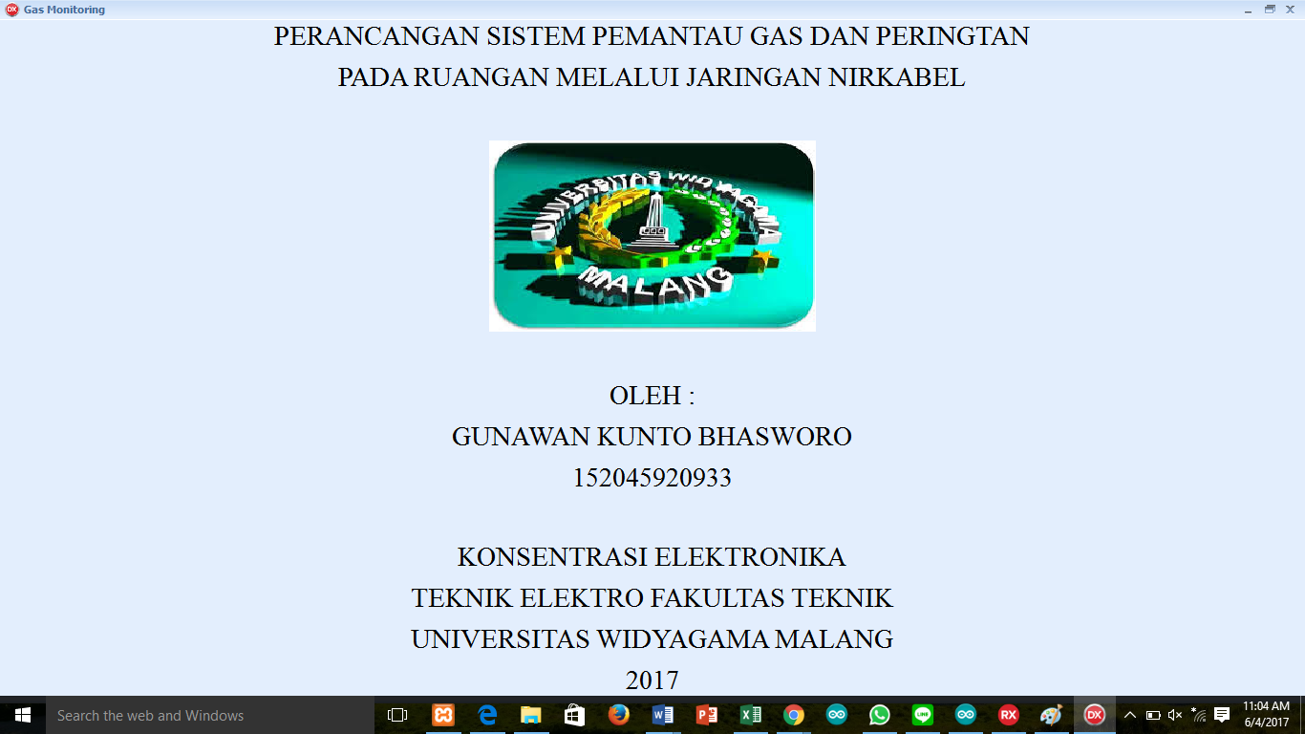

Source Code :
unit Unit1;

interface

uses
Winapi.Windows, Winapi.Messages, System.SysUtils, System.Variants, System.Classes, Vcl.Graphics,
Vcl.Controls, Vcl.Forms, Vcl.Dialogs, Vcl.ExtCtrls, Vcl.StdCtrls,
Vcl.Imaging.jpeg;

type
TfrmCover = class(TForm)
Panel1: TPanel;
Label1: TLabel;
Panel2: TPanel;
Label2: TLabel;
Panel3: TPanel;
Panel4: TPanel;
Label3: TLabel;
Panel5: TPanel;
Panel6: TPanel;
Image1: TImage;
Panel7: TPanel;
Panel8: TPanel;
Label4: TLabel;
Panel9: TPanel;
Panel10: TPanel;
Panel11: TPanel;
Panel12: TPanel;
Label5: TLabel;
Label6: TLabel;
Label7: TLabel;
Label8: TLabel;
Label9: TLabel;
procedure Image1Click(Sender: TObject);
private
{ Private declarations }
public
{ Public declarations }
end;

var
frmCover: TfrmCover;

implementation

{$R *.dfm}

uses Unit2;

procedure TfrmCover.Image1Click(Sender: TObject);
begin
frmMain.ShowModal;
//mCover.Hide;
end;

end.

- Untuk Tampilan Logging Data

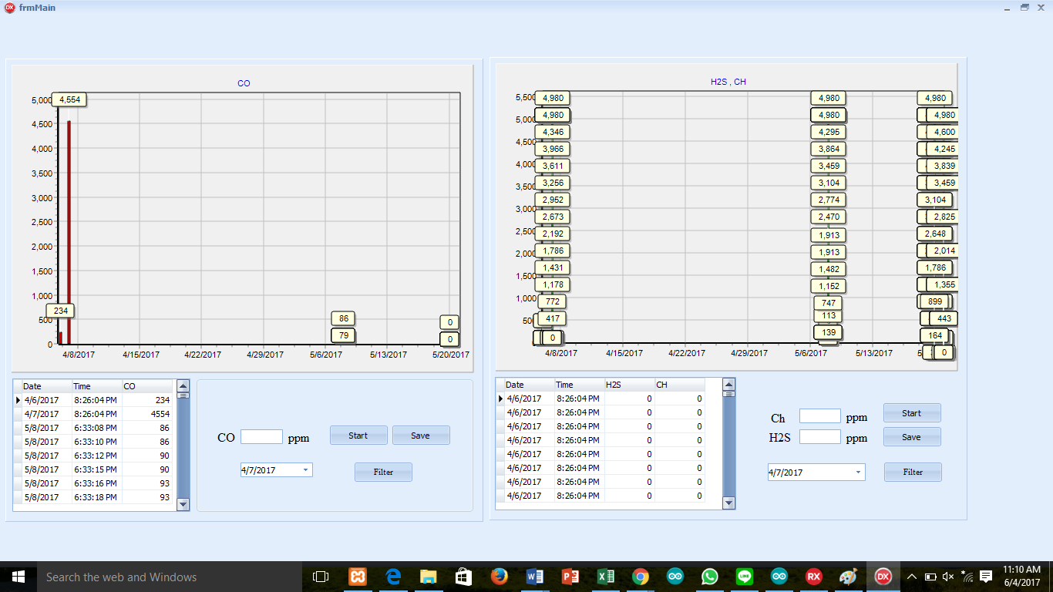

Source Code :

unit Unit2;

interface

uses
Winapi.Windows, Winapi.Messages, System.SysUtils, System.Variants, System.Classes, Vcl.Graphics,
Vcl.Controls, Vcl.Forms, Vcl.Dialogs, Data.DB, Vcl.StdCtrls, Vcl.ComCtrls,
Vcl.Grids, Vcl.DBGrids, ZAbstractRODataset, ZDataset,
ZAbstractConnection, ZConnection, ZSqlProcessor, VclTee.TeeGDIPlus,
VCLTee.Series, VCLTee.TeEngine, Vcl.ExtCtrls, VCLTee.TeeProcs, VCLTee.Chart,
VCLTee.DBChart, System.Win.ScktComp;

type
TfrmMain = class(TForm)
ZConnection1: TZConnection;
ZQsensor1: TZReadOnlyQuery;
ZQsensor2: TZReadOnlyQuery;
DataSource1: TDataSource;
DBGrid1: TDBGrid;
DataSource2: TDataSource;
DBGrid2: TDBGrid;
ZSQLP: TZSQLProcessor;
DBChart1: TDBChart;
Panel1: TPanel;
Panel2: TPanel;
DTP1: TDateTimePicker;
GroupBox1: TGroupBox;
Series1: TBarSeries;
ServerSocket1: TServerSocket;
ServerSocket2: TServerSocket;
BtnSens2: TButton;
Memo1: TMemo;
Label1: TLabel;
Label2: TLabel;
txtCh: TEdit;
txtH2s: TEdit;
Label3: TLabel;
Label4: TLabel;
DTP2: TDateTimePicker;
BtnFilter2: TButton;
btn2Save: TButton;
Label5: TLabel;
Label6: TLabel;
txtCO: TEdit;
BtnSens1: TButton;
btn1Save: TButton;
BtnFilter1: TButton;
DBChart2: TDBChart;
BarSeries1: TBarSeries;
Memo2: TMemo;
Series2: TBarSeries;
procedure BtnSens2Click(Sender: TObject);
procedure ServerSocket2ClientConnect(Sender: TObject;
Socket: TCustomWinSocket);
procedure ServerSocket2ClientRead(Sender: TObject;
Socket: TCustomWinSocket);
procedure BtnFilter2Click(Sender: TObject);
procedure btn2SaveClick(Sender: TObject);
procedure BtnSens1Click(Sender: TObject);
procedure btn1SaveClick(Sender: TObject);
procedure BtnFilter1Click(Sender: TObject);
procedure ServerSocket1ClientRead(Sender: TObject;
Socket: TCustomWinSocket);
private
{ Private declarations }
public
{ Public declarations }
end;

var
frmMain: TfrmMain;
ch,h2s,co:string;
d2save,d1save:Boolean;
implementation

{$R *.dfm}

procedure TfrmMain.BtnFilter1Click(Sender: TObject);
begin
ZQsensor1.Filtered:=false;
zqsensor1.Filter:='Date='+QuotedStr(FormatDateTime('yyyy-mm-dd',DTP1.Date));
ZQsensor1.Filtered:=true;
end;

procedure TfrmMain.BtnFilter2Click(Sender: TObject);
begin
ZQsensor2.Filtered:=false;
zqsensor2.Filter:='Date='+QuotedStr(FormatDateTime('yyyy-mm-dd',DTP2.Date));
ZQsensor2.Filtered:=true;
end;

procedure TfrmMain.btn1SaveClick(Sender: TObject);
begin
if d1save then
begin
btn1Save.Caption:='Save';
d1save:=False;
end
else
begin
btn1Save.Caption:='Stop Saving';
d1save:=True;;
end;
end;

procedure TfrmMain.btn2SaveClick(Sender: TObject);
begin
if d2save then
begin
btn2Save.Caption:='Save';
d2save:=False;
end
else
begin
btn2Save.Caption:='Stop Saving';
d2save:=True;;
end;
end;

procedure TfrmMain.BtnSens1Click(Sender: TObject);
begin
if ServerSocket1.Active = False then
begin
ServerSocket1.Active:=True;
BtnSens1.Caption:='Stop';
end
else
begin
ServerSocket1.Active:=False;
BtnSens1.Caption:='Start';
end;
end;

procedure TfrmMain.BtnSens2Click(Sender: TObject);
begin
if ServerSocket2.Active = False then
begin
ServerSocket2.Active:=True;
BtnSens2.Caption:='Stop';
end
else
begin
ServerSocket2.Active:=False;
BtnSens2.Caption:='Start';
end;
end;
//SELECT * FROM sensor01 s1,SENSOR02 s2 WHERE s1.date='' AND s1.date=s2.date
procedure TfrmMain.ServerSocket1ClientRead(Sender: TObject;
Socket: TCustomWinSocket);
var
s:string;
i,j:Integer;
stt:Boolean;
begin
Memo2.Clear;
Memo2.Text:=Socket.ReceiveText;
s:=Memo2.Text;
s:='';
stt:=False;
for I := 1 to length(Memo2.Text) do
begin
if copy(Memo2.Text,i,1)='$' then
begin
stt:=True;
j:=1;
co:='';
end
else
if copy(Memo2.Text,i,1)='#' then
begin
stt:=False;
j:=0;
txtCO.Text:=co;
if d1save then
begin
zsqlp.Script.Clear;
zsqlp.Script.Text:='Insert into sensor01 (date,time,co) VALUES('+QuotedStr(FormatDateTime('yyyy-mm-dd',Now))+','+
QuotedStr(FormatDateTime('HH:MM:SS',Now))+','+
QuotedStr(co)+')';
zsqlp.Execute;
ZQsensor1.Refresh;
end;
end
else
if stt then
co:=co+copy(Memo2.Text,i,1);
end;
end;

procedure TfrmMain.ServerSocket2ClientConnect(Sender: TObject;
Socket: TCustomWinSocket);
begin
Socket.SendText('Connected');
end;

procedure TfrmMain.ServerSocket2ClientRead(Sender: TObject;
Socket: TCustomWinSocket);
var
s:string;
i,j:Integer;
stt:Boolean;
begin
Memo1.Clear;
Memo1.Text:=Socket.ReceiveText;
s:=Memo1.Text;
s:='';
stt:=False;
for I := 1 to length(Memo1.Text) do
begin
if copy(Memo1.Text,i,1)='$' then
begin
stt:=True;
j:=1;
ch:='';
h2s:='';
end
else
if copy(Memo1.Text,i,1)='#' then
begin
stt:=False;
j:=0;
txtCh.Text:=ch;
txtH2s.Text:=h2s;
if d2save then
begin
zsqlp.Script.Clear;
zsqlp.Script.Text:='Insert into sensor02 (date,time,H2S,CH) VALUES('+QuotedStr(FormatDateTime('yyyy-mm-dd',Now))+','+
QuotedStr(FormatDateTime('HH:MM:SS',Now))+','+
QuotedStr(h2s)+','+QuotedStr(ch)+')';
zsqlp.Execute;
ZQsensor1.Refresh;
end;
end
else
if copy(Memo1.Text,i,1)=',' then
inc(j)
else
if stt then
begin
if j=1 then
ch:=ch+copy(Memo1.Text,i,1)
else
h2s:=h2s+copy(Memo1.Text,i,1);
end;
end;

end;

end.

