Lampiran A

Standart Standart Losses trafo TRAFINDO ( internasional IEC 60076-1)

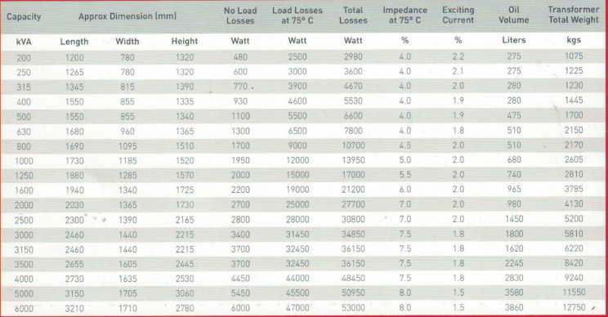
Lampiran B

Photo Transformer 3 MVA

