

Performance and Antifouling Evaluation of PSf/GO Nanohybrid Membrane on Removing Dye Pollutant from Batik Wastewater

Tutuk Djoko Kusworo1*), Dita Aulia Azizah1,2), Andri Cahyo Kumoro1)

1Chemical Engineering Dipoengoro University, Semarang, Indonesia

2Master of Chemical Engineering, Diponegoro University, Semarang, Indonesia

Email: [tdkusworo@che.undip.ac.id](mailto:tdkusworo@che.undip.ac.id)

**Abstract** - *Membrane technology is the most widely used technology in the field of separation and purification of wastewater. Most of the problems that arise in the application of membrane technology are the high resistance of the membrane during the filtration process, so that fouling is easily formed in both the pores and the membrane surface. The incorporation of nanoparticles in the membrane matrix has been widely known as a method to improve membrane performance. In this study, we introduce the incorporation of graphene oxide (GO) advanced material nanoparticles in a polysulfone (PSf) membrane matrix as an effort to treat dye wastewater from the batik industry. The results of the SEM-EDX test showed the membrane smooth surface with larger pore and minimal defects indicating GO nanoparticles were well changed the polysulfone membrane matrix. In addition, an increase in oxygen content in the membrane matrix was also detected as a result of GO incorporation confirming the increased hydrophilicity of the polysulfone membrane. This is also supported by data on increasing water uptake and decreasing contact angle of PSf/GO membranes compared to native PSf. Evaluation of membrane performance showed that the incorporation of GO in the PSf matrix produced permeate with higher quantity and quality than the native PSf membrane. Quantitative analysis of fouling behavior also shows that the incorporation of GO as much as 2 wt-% has succeeded in increasing flux recovery ratio and reducing the PSf membrane resistance which reflects the tendency to form fouling is also getting lower. This membrane material has good prospects in the future as the first step in processing dye wastewater from various industries, especially the batik industry.*

***Keywords*** *– Batik, Dye wastewater, Fouling, Graphene oxide, Nanohybrid membrane*

**Doi**: http://dx.doi.org/10.14710/wastech.10.1.7-16

[How to cite this article: Kusworo, T.D. (2022). Treatment of Natural Rubber Wastewater using Photoactive Nanocomposite Membrane PSf/sulfonated ZnO: Performance Evaluation, HAZOP, and Risk Analysis. Waste Technology, 10(1), 7-16 doi: http://dx.doi.org/10.14710/wastech.10.1.7-16]

**1. Introduction**

Batik is Indonesia's original cultural heritage whose existence has been recognized internationally by UNESCO. No half-hearted, in just 5 years the development of the batik business in Indonesia has increased by 14.7% from the initial 41,623 to 47,755 business units in 2011-2015 (Pujiastuti, 2015). However, this increase in the economic sector is proportional to the large amount of water required in the production process of the batik industry. This is also exacerbated by the abundance of wastewater generated by this industry. Of the total water demand of 25 billion m3/year, as much as 85% is discharged back into the environment as wastewater with a thick color and pungent odor (Kusumawati et al., 2021). Sulaksono et al. (2015) reported that the pollutant load of batik wastewater in water bodies for BOD5 reached 5.9-39.5 tons/year, 112-426 tons/year for COD, and 4.88-16.3 tons/year for TSS. The liquid waste of the batik and textile industries generally comes from the coloring process containing heavy metals, waxes, surfactants, and organic halogens which have high compound complexity and are non-biodegradable, causing serious problems for the surrounding water environment (Hassanzadeh et al., 2017). Several methods have been used to overcome the problem of water pollution caused by the batik and textile industries, including coagulation, adsorption, membrane filtration, ozonation, and bacterial-activated sludge (Kusumawati et al., 2021). Among the previously mentioned methods, membrane filtration has proven to be the most effective wastewater treatment technology, especially in textile wastewater treatment. This is due to its ability to restore the quality of the produced water so that the water can be reused for industrial processes (Ağtaş et al., 2020). In its application, membrane technology does not take up much space, has low chemical consumption, easy maintenance, superior separation efficiency, and is environmentally friendly (Shi et al., 2019). However, a common drawback of applying membrane separation technology is the ease with which fouling occurs.

It has been widely reported in previous studies that the incorporation of nanomaterials into the polymer matrix is able to overcome the problem of membrane fouling (Chai et al., 2020; T.D. Kusworo et al., 2021a; Liang et al., 2012; Mahlangu et al., 2017). Polymer membranes commonly used include polysulfone (PSf), polyethersulfone (PES), polyacrylonitrile (PAN), and polyvinylidene fluoride (PVDF). In this study, polysulfone (PSf) was chosen as a membrane support material because of its abundant availability, ease to modify, high mechanical strength, and has chemical and heat stability. However, the low hydrophilicity of PSf membrane is still an obstacle in its application for wastewater treatment so that further modifications are needed (Pouresmaeel-Selkjani et al., 2017). Graphene oxide (GO) is a graphite-derived material with a single layer – two-dimensional structure. Its use is very wide in numerous fields because it has a large specific surface area, transparency, conductive switching, and bioimaging (Wang et al., 2017). The use of GO as a nanofiller in membranes has been reported to have advantages such as being easily soluble in water or organic solvents and having high compatibility with polymeric and ceramic membranes (Kusworo et al., 2021b). The incorporation of GO into the polymer matrix is known to increase the hydrophilicity of the membrane due to the contribution of carboxyl and hydroxyl groups, thereby increasing the surface affinity of the membrane for water molecules (Du et al., 2020). The potential for improving membrane performance due to GO nanofiller is the basis of this research, with the hope that it can be a breakthrough in efforts to handle batik wastewater in Indonesia. Many studies have been conducted to evaluate the effect of GO nanofiller in the membrane matrix on the characteristics, flux performance, and rejection. Further analysis regarding increased water uptake ability, antifouling potential, and membrane resistance in the membrane filtration process has not been widely studied. Therefore, this study not only evaluates the effect of adding GO into the polysulfone matrix on its basic characteristics, but also further discusses changes water uptake ability, antifouling potential, and membrane resistance in its application as batik wastewater treatment technology.

**2. Materials and Methods**

**2.1 Materials**

Polysulfone pellets (PSf, 99%, UDEL ® PSU P-1700 NT) as the main membrane material were obtained from Solvay Advance Materials, USA. Subsequently, N-methyl-2-pyrrolidone (NMP, 99%, Merck, Germany) was used as a solvent for PSf. Graphite powder (99.5%) as raw material for the preparation of graphene oxide (GO) was obtained from Shanghai Chemicals, China. Sulfuric acid (H2SO4, 98%) and potassium permanganate (KMnO4, 99%) as required materials for the manufacture of GO were obtained from Merck, Germany. The batik wastewater sample was obtained from the Kampung Batik Semarang, Central Java, Indonesia. Detailed information about the characteristics of the effluent is shown in Table 1. Deionized (DI) water was used in the chemical preparation step and during the experiment.

**2.2 Characterization of batik wastewater**

The initial characterization of batik wastewater was carried out to determine the parameters of the wastewater content. Several parameters were measured such as physical appearance, pH using a pH meter (Y98, China) and total dissolved solids using a TDS meter (E-01, China). The dye concentration was analyzed using the spectrophotometric method (Triyati, 1985). Table 1. shows the initial characteristics of batik wastewater.

Table 1. Initial characteristics of batik wastewater

|  |  |  |  |
| --- | --- | --- | --- |
| No. | Parameter | Unit | Value |
| 1 | Appearance | - | Green-blue |
| 2 | TDS | ppm | 530 ± 2.5 |
| 3 | Dye concentration | ppm | 513.5 ± 2.6 |
| 4 | pH | - | 7,6 ± 0.08 |

**2.3 Fabrication of PSf/GO membrane**

PSf/GO nanohybrid membranes were synthesized by the non-induced phase separation (NIPS) method. A certain amount of synthesized GO powder was prepared, i.e. 2 wt-% of the total solids. Initially, GO NPs were mixed into NMP and sonicated for 1 h. At the same time, PSf pellets (18 wt-%) were dissolved using NMP using a hot plate magnetic stirrer at 60°C. The previously homogenized GO NPs were mixed into the PSf solution, and stirring was continued for a total of 6 h. Prior to the casting stage, the dope solution was degassed using a defoamer for 1 h to remove trapped gas. The dope solution was then cast on a glass plate using a casting knife with a thickness of 0.15 mm. The casted membrane was allowed to stand for a while so that it was perfectly oriented with air and then immersed in a coagulation bath filled with DI water for 24 hours. Finally, the membrane was then dried at room temperature for 24 h.

**2.4 Characterization of fabricated membrane**

The surface morphology and chemical composition of the fabricated membranes were evaluated using a scanning electron microscope – energy dispersive x-ray (SEM-EDX; JEOL Series, JSM-6510-LA) at 1000× magnification. The presence of changes or additions of functional groups on the PSf membranes were evaluated using Fourier transfer infrared (FTIR; Perkin Elmer Frontier, USA). Evidence of ZnO implantation in the PSf matrix as well as changes in membrane crystallinity were evaluated using x-ray diffraction (XRD; Panalytical Xpert Pro MPD, Netherlands) at a diffraction angle range of 10° to 90°. Mechanical strength properties consisting of tensile strength and elongation at break were evaluated using a mechanical test apparatus (UTSH001, China). The hydrophilicity of the membrane was evaluated using a contact angle meter (RSE contact angle meter, Japan).

**2.5 Membrane surface physicochemical properties measurement**

Further investigations were carried out to determine the hydrophilicity characteristics of the membranes. Among them are water uptake (WU) ability and membrane affinity (Ganesh et al., 2013). The WU measurement is shown in equation 1.

 (1)

Where WU is the water uptake ability (%), ww and wd are the wet and dry membrane weight, respectively. The membrane affinity for liquids with DI water as solvent was taken from the theoretical analysis of the Flory-Huggins model (FH model) using equation 2.

 (2)

Where χ is the FH interaction parameter and φ is the volume fraction calculated using equation 3.

 (3)

Where ww and wd are the wet and dry membrane masses, ρs and ρm are the solvent and membrane densities, respectively.

**2.6 Membrane performance**

The performance of the nanohybrid membrane was evaluated using a cross-flow filtration system as shown in Fig. 1. Untreated batik wastewater was used as a feed with an effective membrane area of 12.57 cm2 at a trans-membrane pressure of 5 bar.

**2.6.1 Flux**

Permeate flux on each membrane was recorded every 30 minutes for 3 hours of operation using equation 4.

 (4)

Where J is the permeate flux (L.m-2.h-1), V is the permeate volume (L), A is the effective membrane area (m2), and t is the filtration time (h).

**2.6.2 Pollutant removal**

It is important to evaluate the efficiency of pollutant removal to determine the level of selectivity of the membrane in separating pollutants from batik wastewater. TDS measurement was carried out using a TDS meter (ppm, E-1 TDS & EC meter, China) and the concentration of green-blue dye in batik wastewater was analyzed by spectrophotometric method at the optimum wavelength (610-750 nm) (Triyati, 1985). Equation 5 is used to calculate pollutant removal efficiency.

 (5)

Where R is removal efficiency (%), Cp and Cf are the pollutant concentration in permeate and feed solution, respectively (mg/L).

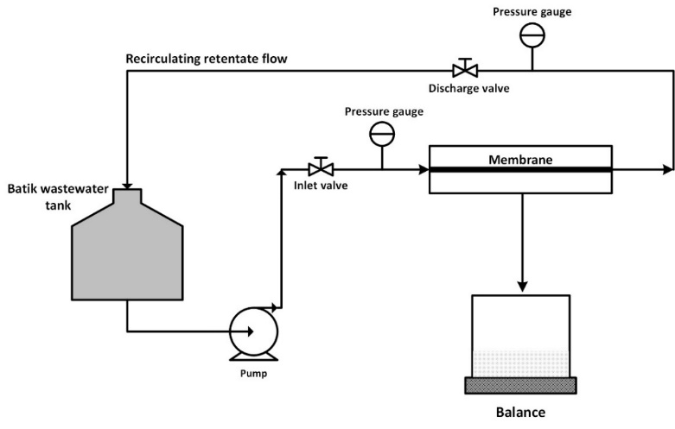

Figure 1. Membrane cross filtration system.

**2.7 Antifouling potential and fouling resistance studies of fabricated membranes**

Evaluation of antifouling potential was assessed to obtain the total fouling ratio (Rt, %), reversible fouling ratio (Rr, %), irreversible fouling ratio (Rir, %), and recovery flux ratio (FRR, %) using the following formula (Kusworo et al., 2021b).

 (6)

 (7)

 (8)

 (9)

Where Jpw0, Jww, and Jpw1 is initial PWF, permeate flux of batik wastewater, and PWF after cleaning, respectively.

Moreover, the membrane resistance during the filtration process was evaluated using the resistance-in-series model. This model involves each type of resistance such as intrinsic resistance (Rm), adsorptive fouling (Ra), deposition fouling (Rd), and concentration polarization (Rcp) (Younas et al., 2019).

 (10)

 (11)

 (12)

 (13)

Where ΔP is the trans-membrane pressure (Pa), is the viscosity of pure water (Pa.s), Ji, Ja, Jf, Jv are the initial membrane PWF, the measured PWF after fouled by static adsorption, PWF after fouled by the actual batik wastewater, and the measured flux during the batik wastewater filtration operation, respectively.

**3. Results and Discussion**

**3.1 Membrane characterization**

**3.1.1 Surface morphological and chemical composition analysis**

The investigation of the effect of adding graphene oxide (GO) advanced material on the morphological and elemental characteristics of polysulfone (PSf) membranes was studied using scanning electron microscopy – energy dispersive x-ray (SEM-EDX). Based on Figure 2A, it can be seen that the surface of the native PSf membrane tends to be smooth with some defects. This shows that native PSf has a low level of permeability and selectivity. The native PSf membrane consists of 83.45% carbon (C), 11.09% oxygen (O), and 5.46% Sulfur (S). Morphological differences emerged after GO incorporation. From Figure 2B, it can be seen that the surface of the PSf-GO membrane tends to be smooth, but with larger pores and minimal defects. The incorporation of GO nanoparticles into the polymer matrix is able to break the thermodynamic stability of the system and produce a faster coagulation rate resulting in a perfectly smooth surface and minimal defects (Mamah et al., 2021). Figure 2B also shows a slight GO bump on the membrane surface which indicates that most of the GO have been embedded in the membrane sub-layer. The chemical composition of the PSf-GO membrane was recorded as consisting of 79.76 carbon (C), 16.96 oxygen (O), and 3.29 sulfur (S). The decrease in carbon composition compared to the native PSf membrane is due to the increase in oxygen carried by GO in the polymer matrix. This phenomenon indicates an increase in the hydrophilicity of the polysulfone membrane which is characterized by a larger surface pore morphology that is expected to increase the permeate flux productivity.

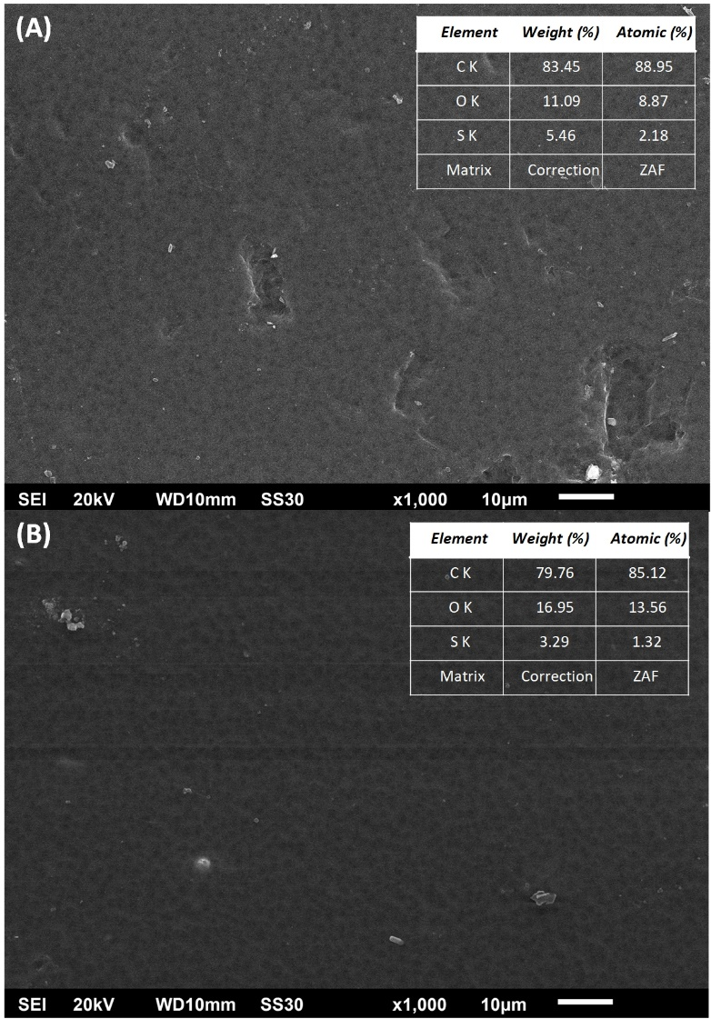

Figure 2. SEM-EDX analysis of (A) Native PSf and (B) PSf/GO membranes

**3.1.2 FTIR analysis**

FTIR analysis was carried out to determine changes in functional groups on the fabricated membrane due to the addition of GO nanoparticles. Fig. 3 shows the FTIR spectra of pure GO NPs, PSf/GO, and native PSf membranes. In the pure GO NPs spectrum, there is a wide valley at a wavelength of around 3400-3300 cm-1 which reflects the presence of O-H stretching vibration groups. This demonstrates the versatility of GO as a hydrophilic enhancer in various fields (Ningaraju et al., 2019). The FTIR spectrum of PSf/GO membranes has a similar pattern to the original PSf membranes; showed that PSf/GO membranes were composed of the same supporting polymer, namely polysulfone. Both membranes showed a significant valley consistency of the polysulfone chemical group, such as at the wave number 1241 cm-1 which is the strain valley and the absorption of the O=S=O group (Lemos et al., 2021). The absorption valley at 1681 cm-1 corresponds to the C=O stretch. The band 1238 cm-1 also shows a good agreement with the asymmetric strain of the C-O-C aryl-ether group. The C-H group appears in the PSf/GO FTIR spectrum pattern, namely at wave numbers 2970 and 2872 cm-1. The presence of the C-H group was contributed by GO which was successfully embedded in the membrane matrix. The existence of a small valley at 1910 cm-1 indicating the presence of C=O and -OH groups on the PSf/GO membrane was also found, whose presence was initiated by the GO layer (Lemos et al., 2021). The addition of the GO chemical functional group on the polysulfone membrane is expected to contribute to hydrophilic sites that can increase the wettability of the membrane.

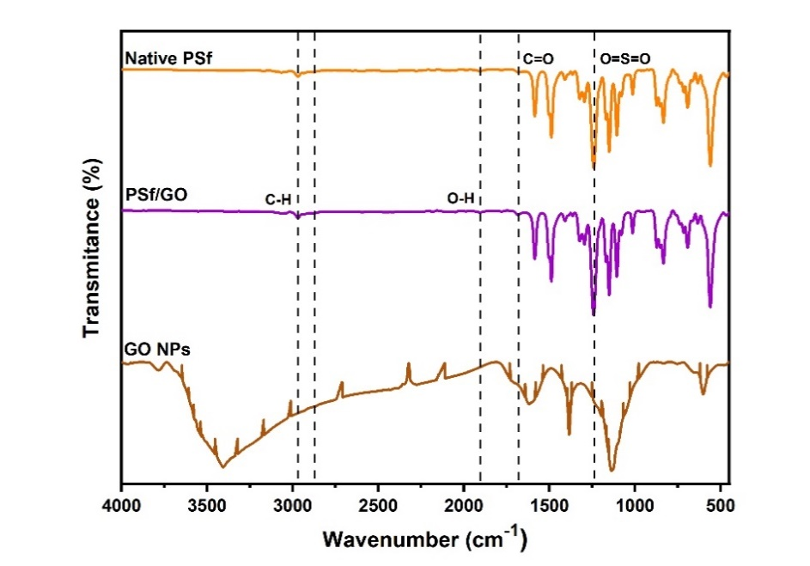

Figure 3. FTIR spectra of pure GO NPs, PSf/GO, and native PSf membranes

**3.1.3 XRD analysis**

XRD analysis was carried out to ensure the attainment of embedding GO NPs on the membrane matrix and to determine the degree of crystallinity of a material. Fig. 4 displays the x-ray diffraction patterns of native PSf, PSf/GO, and GO NPs membranes. Based on the results obtained, the original PSf has a wide peak at 2θ 19.82° which is a characteristic peak of polysulfone (Ningaraju et al., 2019). There is no sharp peak there, this indicates the polysulfone has an amorphous structure. The GO NPs diffractogram pattern shows a GO-specific peak at 2θ around 11° (Ganesh et al., 2013), followed by a broad peak at 2θ 23.48° and additional peaks at 2θ 31.25° and 43°. The PSf/GO membrane showed a diffraction pattern that was not much different from the original PSf, this confirmed that the modified membrane was composed of a similar backbone, namely polysulfone. The incorporation of GO NPs into the polysulfone matrix showed significant structural changes. It appears that there are sharp peaks at 2θ 37.8°, 43.97°, 64.4°, and 77.57° which are partly the same as the peaks of GO NPs. The presence of several non-identical peaks occurs might be due to the presence of contaminants with similar ionic sizes so that they can replace and occupy the polysulfone lattice structure (Qamar et al., 2021). However, this is not a problem because there are only a few. The alteration in the PSf membrane structure from amorphous to semi-crystalline due to the incorporation of GO NPs was supported by the results of the Peak Fit calculation which showed a crystallinity index of about 31.28%. In summary, the addition of GO NPs into PSf membrane has been successfully carried out.

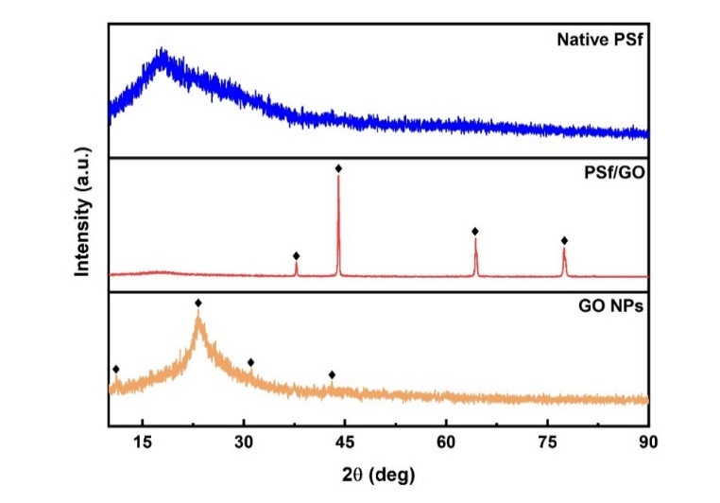

Figure 4. XRD spectra of native PSf, PSf/GO, and GO NPs

**3.1.4 Hydrophilicity analysis**

In its application as a wastewater treatment technology, the basic parameter that must be encountered by the membrane is its ability to pass water. The hydrophilicity of the membrane can be determined by measuring the water contact angle and water uptake ability. The water contact angle is the angle formed between the water droplet and the membrane surface. Meanwhile, water uptake is the percentage of the membrane's ability to absorb water. Fig. 5A combines the results of the water contact angle and the water uptake measurement of the fabricated membrane. Incorporation of GO NPs into the polymer matrix was shown to significantly reduce the water contact angle by almost half, i.e. 80° and 55° for the original PSf and PSf/GO membranes, respectively. The smaller the contact angle, the greater the tendency of the membrane surface to attract water so that the hydrophilicity increases. This was also validated by the results of the FTIR analysis which stated that the addition of GO NPs was able to increase the number of hydrophilic groups (O-H) in the composition of polysulfone chemical functional groups. On the other hand, the results of the measurement of water uptake ability showed an increase of more than 3 times after the incorporation of GO NPs in the polymer matrix, namely 18% and 60% for native PSf and PSf/GO membranes, respectively. The measurement of water uptake ability is strengthened by the theoretical model of Flory-Huggins (FH) which describes the level of affinity of the membrane to water. Qualitatively, the interaction parameter FH (χ) describes the affinity of the polymer to the solvent. The lower the value, the higher the affinity of the polymer to the solvent so that more solvent can be absorbed (Ganesh et al., 2013). Table 2. shows the results of the calculation of the volume fraction (φ) and the FH interaction parameter (χ). Based on the data, it can be seen that the native PSf χ value is far above the PSf/GO membrane. This indicates that the polysulfone membrane affinity increases in the presence of GO NP doping. Besides to the addition of hydrophilic sites, the increase in water uptake was also caused by the presence of macrovoids in the membrane sublayer whose appearance was caused by organic-inorganic interactions between polymers and GO NPs (Kusworo et al., 2017; Miao et al., 2020).

Table 2. The calculation result of volume fraction (φ) and FH interaction (χ) of fabricated membranes.

|  |  |  |
| --- | --- | --- |
| Membrane | φ | Χ |
| Native PSf | 0.21 | 1.24 |
| PSf/GO | 3.04 | 0.22 |

Another discussion point that can be evaluated in this regard is the ability of the fabricated membrane to produce water flux. Fig. 5B shows the effect of adding GO in producing pure water flux. A striking difference was seen between the original PSf and PSf/GO membranes, under the same operating conditions, the PSf/GO membrane was able to produce a pure water flux of 6.2 LMH, which was 400% greater than the original PSf. This very significant change is again due to the large number of hydrophilic sites on the PSf/GO nanohybrid membrane compared to the original PSf which is hydrophobic (Mamah et al., 2021). Thus, from the results of this study, it can be concluded that the addition of GO NPs proved to be successful in increasing the hydrophilicity of polysulfone membranes.

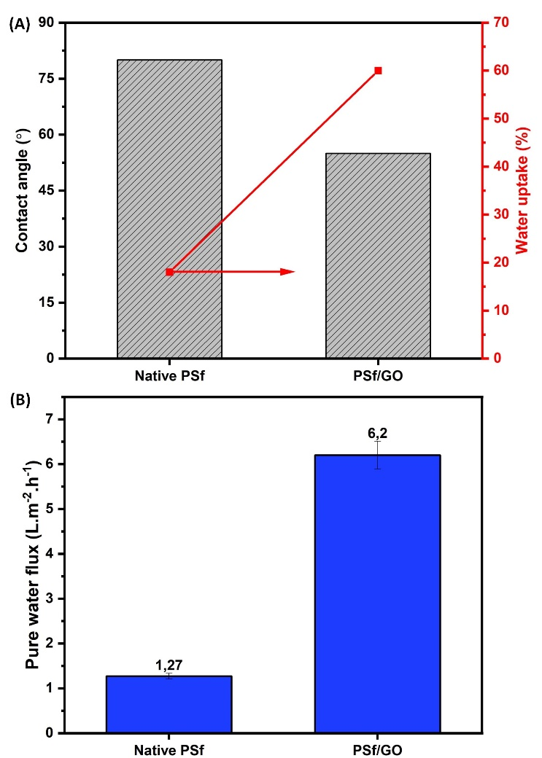

Figure 5. (A) Combination of water contact angle and water uptake ability and (B) effect of GO NPs incorporation on passing water flux.

**3.1.5 Mechanical strength analysis**

Analysis of the membrane’s mechanical strength is important to evaluate to determine the resistance of the membrane in pressurized filtration operations. In this regard, the tensile strength and elongation at break of the fabricated membranes will be discussed in more detail. Fig. 6. shows the combined bar chart of the tensile strength and the elongation at break in the fabricated membranes. As is well known, PSf is a polymer with superior mechanical properties (Mamah et al., 2021), so it is not surprising that the original PSf in this study had tensile strength and elongation at break of 3.8 MPa and 18%, respectively. The incorporation of GO NPs on the polymer matrix succeeded in increasing the tensile strength and elongation at break up to 4.2 MPa and 13.9%, respectively. This indicates that the incorporation of GO NPs in the polymer matrix initiates an increase in the membrane force load, so that the membrane is not easily broken in high-pressure applications (Dlamini et al., 2019). This increase in mechanical strength was also supported by XRD analysis of PSf/GO membranes which showed an increase in the crystallinity index of the original membrane, resulting in a modified membrane with superior durability.

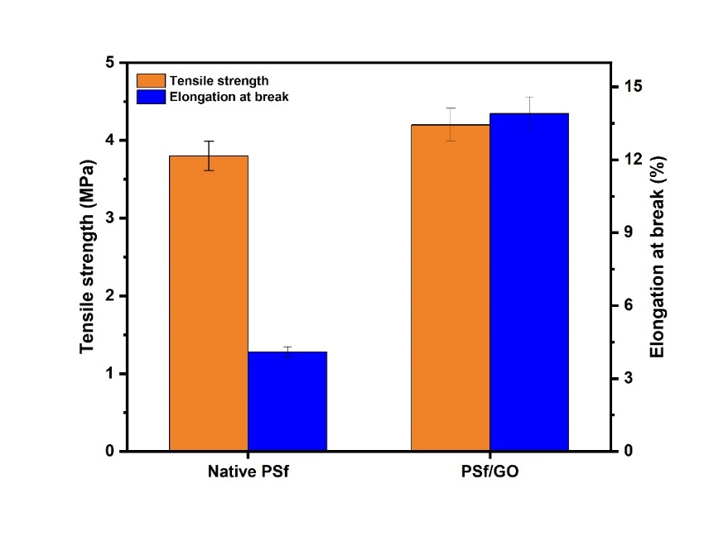

Figure 6. Mechanical strength of fabricated membranes

**3.2 Membrane’s performance study evaluation**

**3.2.1 Permeate flux**

Permeate flux is one of the main factors which determine the level of membrane performance. Fig. 7 shows the measured flux trend of native PSf and PSf/GO membranes in performing batik wastewater filtration operations. From Fig. 7A it can be seen that the GO embedded membrane is able to produce 3 times more permeate flux than the native PSf membrane, which is 2.8 LMH. This phenomenon is based on the presence of hydrogen bonds between polysulfone and GO NPs. The interaction between the two is known to able to cause the band shifting of the O-H group to be shorter, thereby increasing the adsorption ability of water molecules on the membrane surface (Ningaraju et al., 2019). The trend of permeate flux in the form of pseudo-steady on the native PSf membrane is caused by the high hydrophobicity of polysulfone so it is difficult to pass water. Even at the end of the operation was not able to pass water at all because the pores were completely blocked by foulant.

On the other hand, Fig. 7B shows the normalized flux profile of the fabricated membrane. The normalized flux was evaluated to find out the effect of fouling on membrane performance. A drastic decrease in PSf/GO membrane occurred after 60 minutes of operation. This may be due to the clogging of the membrane surface pores by organic pollutants and dyes. However, as the filtration process progresses, the normalized flux tends to remain unchanged due to the increase in porosity contributed by the hydrophilic sites of GO NPs. Periodic washing is necessary to maintain membrane performance. In contrast to the PSf/GO membranes, the native PSf membranes had a regular normalized flux decreasing pattern up to 0. This reflects that the native PSf membranes have high water resistance, making it difficult to recover flux.

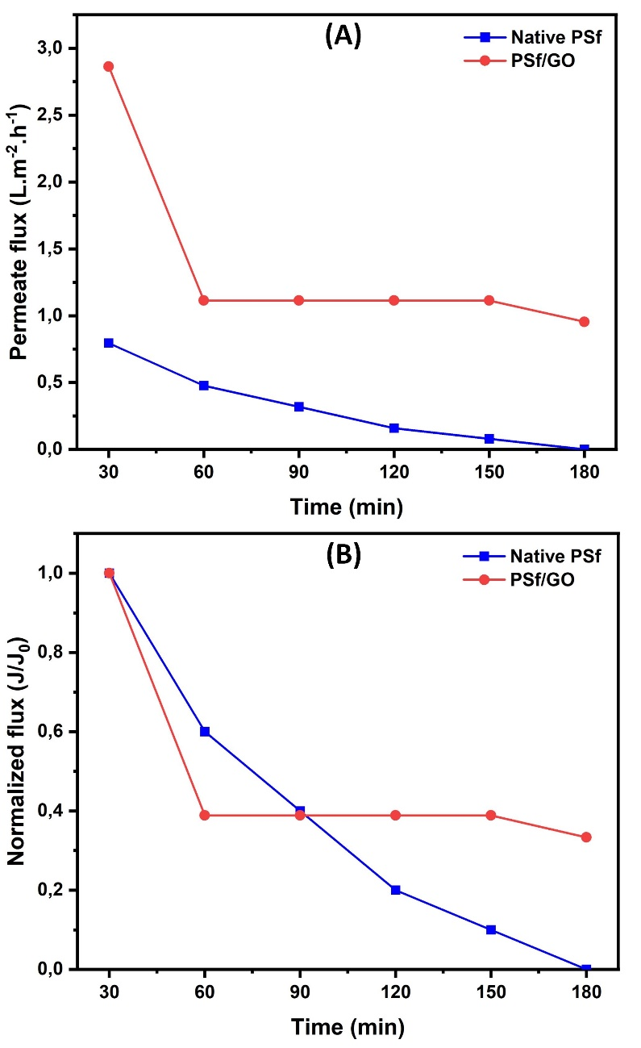

Figure 7. Flux measurement results; (A) Permeate flux and (B) Normalized flux

**3.2.2 Pollutant rejection**

Another key parameter which determines membrane performance is its ability to repel pollutants. Batik wastewater is included in the waste with complex pollutant content that is difficult to decompose naturally. In this study the efficiency of pollutant rejection will be seen from the parameters of the dye concentration and TDS. Fig. 8 shows the bar chart combination of the dye and TDS removal on the fabricated membrane. Both dye and TDS showed similar results, with the best rejection efficiencies for GO NPs embedded membranes, which were 93.6% and 87.7% for dye and TDS, respectively. This phenomenon occurs due to the incorporation of GO NPs into the polysulfone matrix which can change the pore structure to be more selective so that pollutants can be retained and produce permeate with superior quality. The presence of GO NPs in the chemical structure of polysulfone is known to overhaul and reduce the thermodynamic stability of the system so that the coagulation rate in the NIPS process runs faster and produces a selective pore structure (Alpatova et al., 2013). As has also been revealed in the SEM results, the low efficiency of pollutant separation from the native PSf is thought to be due to defects on the membrane surface resulting in non-selective voids that can easily pass pollutants (Mahmoudi et al., 2019).

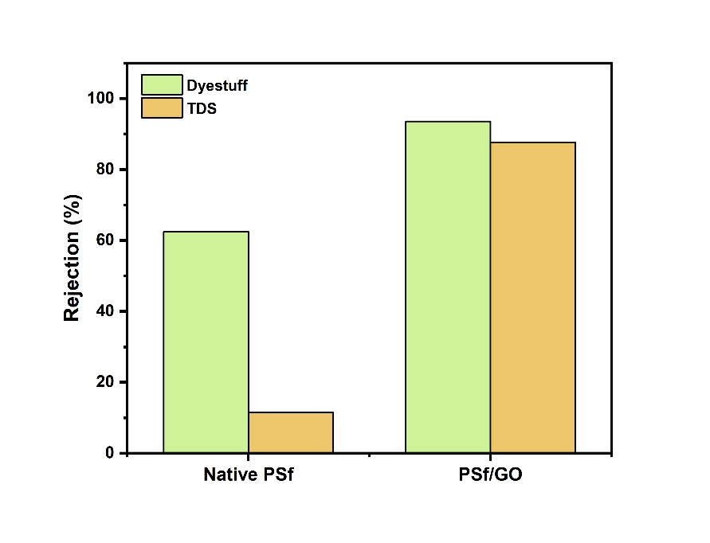

Figure 8. The removal efficiency of fabricated membranes

**3.3 Analysis of antifouling potential and fouling resistance of fabricated membranes**

Antifouling potential was analyzed to determine how vast the tendency of the membrane fouling occur. This analysis is expressed in terms of ratios, namely total fouling ratio (Rt), reversible fouling ratio (Rr), irreversible fouling ratio (Rir), and flux recovery ratio (FRR). From Fig. 9 it can be seen that the Rt and Rir values of the native PSf membrane are much higher than the PSf/GO membrane, which are 85% and 67%, respectively. A different phenomenon is shown by the RR value of the native PSf membrane, which is approximately 2 times smaller than the PSf/GO membrane, which is 18%. The value of the ratio is proportional to the membrane potential for fouling to arise. Although the Rr value of the native PSf membrane is literally lower than the PSf/GO membrane, it actually cannot break the the worst flux performance of the native PSf membrane which is reflected in the high value of the total fouling ratio (Rt). This is because Rt is a combination of Rr and Rir. The elevated Rir value makes the native PSf membrane hard to clean, thus causing pore clogging and resulting in low membrane's permeability. Incorporation of GO NPs significantly decreased the ratio of Rt and Rir on polysulfone membranes to 37% and 5%, respectively. This occurrence causes an increase in the FRR value, which indicates the superiority of the membrane in maintaining flux. Although the Rr ratio of PSf/GO membranes is greater than that of native PSf membranes, this is not a problem because reversible fouling in the form of an adhesive foulant enclosed to the membrane surface can be definitely cleaned (Nguyen et al., 2019). The FRR values for native PSf and PSf/GO membranes were 33% and 95%, respectively.

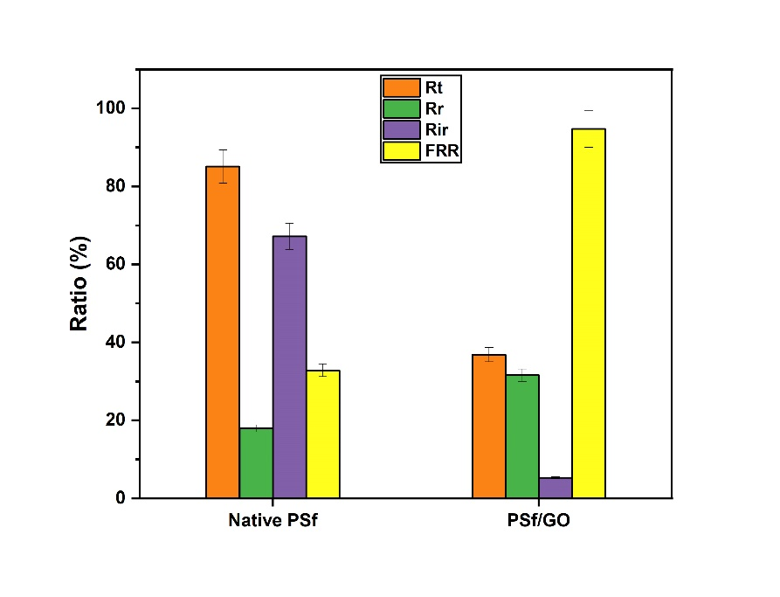

Figure 9. Antifouling potential properties of fabricated membranes

Membrane resistance to fouling is also an important factor affecting membrane performance. The fouling resistance analysis of the fabricated membrane was evaluated using the water flow method, using a resistance-in-series model. There are 4 types of fouling resistance in this model, namely intrinsic resistance (Rm), deposition fouling (Rd), adsorptive fouling (Ra), and concentration polarization (Rcp), each of which is estimated using equation 6-9, respectively. Table 3. displays the calculation result of fouling resistance of the fabricated membranes. Intrinsic resistance is related to the resistance of the membrane material, adsorptive resistance is closely related to the fouling adsorption mechanism, pore deposition/clogging resistance is also called the irreversible resistance which has the most influence on the production of permeate flux, and concentration polarization resistance describes the accumulation of a mixture of foulant and water on the membrane surface (cake formation). All fouling resistances demonstrate the superiority of the original PSf membrane. This is due to the presence of hydrophilic site donors from GO NPs on the PSf/GO nanohybrid membrane which can increase the porosity and water absorption ability so that water can easily pass through the membrane. This is also supported by the fact that the incorporation of nanoparticles in the polymer matrix is known to increase the surface roughness of the membrane. Rough membrane surfaces tend to have a high affinity for foulants, consequently the membrane resistance decreases (Kusworo et al., 2020; Tutuk Djoko Kusworo et al., 2021; Mamah et al., 2021). Finally, in this study it was demonstrated that the incorporation of GO NPs into the polysulfone matrix was able to significantly reduce the fouling resistance due to the large hydrophilic site contribution of GO NPs.

Table 3. Calculation result of membrane resistance

|  |  |  |  |  |  |
| --- | --- | --- | --- | --- | --- |
| Membrane | Rm x 1014  (m-1) | Ra x 1014  (m-1) | R­d x 1014  (m-1) | Rcp x 1014  (m-1) | RT  x 1014  (m-1) |
| Neat PSf | 25.4 | 2.83 | 6.11 | 8.02 | 42.4 |
| PSf/GO | 4.54 | 0.17 | 3.77 | 4.24 | 12.7 |

**4. Conclusion**

In this study, a more in-depth study was conducted on the characteristics, performance, and antifouling properties of PSf/GO nanohybrid membranes in treating batik wastewater. The addition of GO nanoparticles into the membrane matrix proved successful in changing the characteristics of polysulfone membranes. The SEM-EDX results revealed that the addition of GO NPs into the polymer matrix was able to produce a membrane with a smooth-large pores surface, with a higher oxygen composition. The addition of hydrophilic sites and an increase in the crystallinity index on PSf/GO membranes were also revealed through FTIR and XRD assays. Furthermore, this is evidenced by the lower contact angle and more than 3-fold increase in water uptake capability of the GO NPs embedded membrane. The tensile strength and elongation at break of PSf/GO membranes showed durability with values of 4.2 MPa and 13.9%, respectively. PSf/GO membranes also showed significant performance with much better pure water flux, permeate flux and pollutant removal than the native PSf. Analysis of antifouling potential and membrane resistance showed that in batik wastewater treatment, 2 wt% PSf/GO membrane was able to produce a flux recovery ratio of up to 95% ± 4.74% with a total membrane resistance of 12.7 ± 0.64 (× 1014 m-1). This research is expected to contribute to the discovery of suitable membrane technology for treating batik or textile wastewater.

**Acknowledge**

The authors would like to thank the Ministry of Education and Culture of the Republic of Indonesia for the research and educational funding through PMDSU scholarship with grant number of 345-45/UN7.6.1/PP/2022. We would also thank to Department of Chemical Engineering, Diponegoro University for the supporting laboratory and facilities.

**References**

Ağtaş, M., Yılmaz, Ö., Dilaver, M., Alp, K., Koyuncu, İ., 2020. Hot water recovery and reuse in textile sector with pilot scale ceramic ultrafiltration/nanofiltration membrane system. Journal of Cleaner Production 256, 120359. https://doi.org/10.1016/j.jclepro.2020.120359

Alpatova, A., Kim, E.-S., Sun, X., Hwang, G., Liu, Y., Gamal El-Din, M., 2013. Fabrication of porous polymeric nanocomposite membranes with enhanced anti-fouling properties: Effect of casting composition. Journal of Membrane Science 444, 449–460. https://doi.org/10.1016/j.memsci.2013.05.034

Chai, P.V., Law, J.Y., Mahmoudi, E., Mohammad, A.W., 2020. Development of iron oxide decorated graphene oxide (Fe3O4/GO) PSf mixed-matrix membrane for enhanced antifouling behavior. Journal of Water Process Engineering 38, 101673. https://doi.org/10.1016/j.jwpe.2020.101673

Dlamini, D.S., Mamba, B.B., Li, J., 2019. The role of nanoparticles in the performance of nano-enabled composite membranes – A critical scientific perspective. Science of the Total Environment 656, 723–731. https://doi.org/10.1016/j.scitotenv.2018.11.421

Du, J., Li, N., Tian, Y., Zhang, J., Zuo, W., 2020. Preparation of PVDF membrane blended with graphene oxide-zinc sulfide (GO-ZnS) nanocomposite for improving the anti-fouling property. Journal of Photochemistry and Photobiology A: Chemistry 400. https://doi.org/10.1016/j.jphotochem.2020.112694

Ganesh, B.M., Isloor, A.M., Ismail, A.F., 2013. Enhanced hydrophilicity and salt rejection study of graphene oxide-polysulfone mixed matrix membrane. Desalination 313, 199–207. https://doi.org/10.1016/j.desal.2012.11.037

Hassanzadeh, E., Farhadian, M., Razmjou, A., Askari, N., 2017. An efficient wastewater treatment approach for a real woolen textile industry using a chemical assisted NF membrane process. Environmental Nanotechnology, Monitoring & Management 8, 92–96. https://doi.org/10.1016/j.enmm.2017.06.001

Kusumawati, N., Rahmadyanti, E., Sianita, M.M., 2021. Batik became two sides of blade for the sustainable development in Indonesia, in: Green Chemistry and Water Remediation: Research and Applications. Elsevier, pp. 59–97. https://doi.org/10.1016/B978-0-12-817742-6.00003-7

Kusworo, T.D., Ariyanti, N., Utomo, D.P., 2020. Effect of nano-TiO2 loading in polysulfone membranes on the removal of pollutant following natural-rubber wastewater treatment. Journal of Water Process Engineering 35, 101190. https://doi.org/10.1016/j.jwpe.2020.101190

Kusworo, T.D., Aryanti, N., Dalanta, F., 2021a. Effects of incorporating ZnO on characteristic, performance, and antifouling potential of PSf membrane for PRW treatment. IOP Conference Series: Materials Science and Engineering 1053, 012134. https://doi.org/10.1088/1757-899x/1053/1/012134

Kusworo, T.D., Dalanta, F., Aryanti, N., Othman, N.H., 2021b. Intensifying separation and antifouling performance of PSf membrane incorporated by GO and ZnO nanoparticles for petroleum refinery wastewater treatment. Journal of Water Process Engineering 41, 102030. https://doi.org/10.1016/j.jwpe.2021.102030

Kusworo, T.D., Utomo, D.P., Aryanti, N., Qudratun, 2017. Synergistic effect of UV irradiation and thermal annealing to develop high performance polyethersulfone-nano silica membrane for produced water treatment. Journal of Environmental Chemical Engineering 5, 3290–3301. https://doi.org/10.1016/j.jece.2017.06.035

Lemos, H.G., Ragio, R.A., Conceição, A.C.S., Venancio, E.C., Mierzwa, J.C., Subtil, E.L., 2021. Assessment of mixed matrix membranes (MMMs) incorporated with graphene oxide (GO) for co-treatment of wastewater and landfill leachate (LFL) in a membrane bioreactor (MBR). Chemical Engineering Journal 425, 131772. https://doi.org/10.1016/j.cej.2021.131772

Liang, S., Xiao, K., Mo, Y., Huang, X., 2012. A novel ZnO nanoparticle blended polyvinylidene fluoride membrane for anti-irreversible fouling. Journal of Membrane Science 394–395, 184–192. https://doi.org/10.1016/j.memsci.2011.12.040

Mahlangu, O.T., Nackaerts, R., Thwala, J.M., Mamba, B.B., Verliefde, A.R.D., 2017. Hydrophilic fouling-resistant GO-ZnO/PES membranes for wastewater reclamation. Journal of Membrane Science 524, 43–55. https://doi.org/10.1016/j.memsci.2016.11.018

Mahmoudi, E., Ng, L.Y., Ang, W.L., Chung, Y.T., Rohani, R., Mohammad, A.W., 2019. Enhancing Morphology and Separation Performance of Polyamide 6,6 Membranes By Minimal Incorporation of Silver Decorated Graphene Oxide Nanoparticles. Scientific Reports 9, 1216. https://doi.org/10.1038/s41598-018-38060-x

Mamah, S.C., Goh, P.S., Ismail, A.F., Suzaimi, N.D., Yogarathinam, L.T., Raji, Y.O., El-badawy, T.H., 2021. Recent development in modification of polysulfone membrane for water treatment application. Journal of Water Process Engineering 40. https://doi.org/10.1016/j.jwpe.2020.101835

Miao, A., Wei, M., Xu, F., Wang, Y., 2020. Influence of membrane hydrophilicity on water permeability: An experimental study bridging simulations. Journal of Membrane Science 604, 118087. https://doi.org/10.1016/j.memsci.2020.118087

Nguyen, T.-T., Kook, S., Lee, C., Field, R.W., Kim, I.S., 2019. Critical flux-based membrane fouling control of forward osmosis: Behavior, sustainability, and reversibility. Journal of Membrane Science 570–571, 380–393. https://doi.org/10.1016/j.memsci.2018.10.062

Ningaraju, S., Jagadish, K., Srikantaswamy, S., Gnana Prakash, A.P., Ravikumar, H.B., 2019. Synthesis of graphite oxide nanoparticles and conductivity studies of PSF/GO and PSAN/GO polymer nanocomposites. Materials Science and Engineering: B 246, 62–75. https://doi.org/10.1016/j.mseb.2019.06.002

Pouresmaeel-Selkjani, P., Jahanshahi, M., Peyravi, M., 2017. Mechanical, thermal, and morphological properties of nanoporous reinforced polysulfone membranes. High Performance Polymers 29, 759–771. https://doi.org/10.1177/0954008316656742

Pujiastuti, L., 2015. Diakui Dunia, Ekspor Batik RI Meningkat Setiap Tahun [WWW Document]. Detik Finance. URL https://finance.detik.com/berita-ekonomi-bisnis/d-3034083/diakui-dunia-ekspor-batik-ri-meningkat-setiap-tahun (accessed 11.10.21).

Qamar, M.A., Shahid, S., Javed, M., Iqbal, S., Sher, M., Bahadur, A., AL-Anazy, M.M., Laref, A., Li, D., 2021. Designing of highly active g-C3N4/Ni-ZnO photocatalyst nanocomposite for the disinfection and degradation of the organic dye under sunlight radiations. Colloids and Surfaces A: Physicochemical and Engineering Aspects 614, 126176. https://doi.org/10.1016/j.colsurfa.2021.126176

Shi, Y., Huang, J., Zeng, G., Cheng, W., Hu, J., 2019. Photocatalytic membrane in water purification: is it stepping closer to be driven by visible light? Journal of Membrane Science 584, 364–392. https://doi.org/10.1016/j.memsci.2019.04.078

Sulaksono, A., Effendi, H., Kurniawan, B., 2015. Kajian Beban Pencemaran Limbah Cair Industri Kecil Menegah (IKM) Batik Klaster Trusmi Kabupaten Cirebon. Junal Pengelolaan Sumberdaya Alam dan Lingkungan 5, 17–24.

Triyati, E., 1985. SPEKTROFOTOMETER ULTRA-VIOLET DAN SINAR TAMPAK SERTA APLIKASINYA DALAM OSEANOLOGI 9.

Wang, Q., Yang, C., Zhang, G., Hu, L., Wang, P., 2017. Photocatalytic Fe-doped TiO2/PSF composite UF membranes: Characterization and performance on BPA removal under visible-light irradiation. Chemical Engineering Journal 319, 39–47. https://doi.org/10.1016/j.cej.2017.02.145

Younas, H., Zhou, Y., Li, Xiaogang, Li, Xue, Sun, Q., Cui, Z., Wang, Z., 2019. Fabrication of high flux and fouling resistant membrane: A unique hydrophilic blend of polyvinylidene fluoride/polyethylene glycol/polymethyl methacrylate. Polymer 179, 121593. https://doi.org/10.1016/j.polymer.2019.121593